**InsightStream: Navigating the News - Project Documentation**

# 1. Introduction

**Project Title: InsightStream: Navigating the News Team Members:**

* Pradeep N - Project Leader
* Email: <n.j.pradeepoffical93@gmail.com>
* Srinath R - Member
* Email: <srinathsri1164@gmail.com>
* Sumithira M – Member
* Email: [sumithramoorthy37@gmail.com](sumithramoorthy37@gmail.com%20)
* Sridhar S – Member
* Email: <Sridharsrinivasan2005@gmail.com>

**2. Project Overview**

# Purpose

InsightStream is an AI-powered news aggregation platform designed to provide real-time, personalized, and credible news insights to users. The platform leverages AI and machine learning to analyze and curate news articles based on user preferences and trends. **Features (Frontend)**

* **Personalized News Feed** – AI-driven recommendations based on user interactions.
* **Real-time Search & Filters** – Advanced filtering by category, region, and keyword.
* **News Summarization** – AI-generated article summaries.
* **Sentiment Analysis** – Highlights positive, neutral, or negative tones in news articles.
* **Bookmarks & Reading List** – Save articles for later reading.
* **Multi-Language Support** – Accessibility for a global audience.
* **Dark Mode & Custom Themes** – Enhanced readability and UI customization.
* **Social Sharing** – Share news articles directly on social media.

# Component Structure

* **App.js** – Root component managing routes and global state.
* **Layout.js** – Manages header, sidebar, and main content structure.
* **NewsFeed.js** – Displays news articles dynamically.
* **NewsCard.js** – Reusable component for displaying a single article.
* **SearchBar.js** – Handles search input and queries.
* **SentimentIndicator.js** – Displays sentiment analysis results.
* **BookmarkPage.js** – Lists saved articles for later reading.

# State Management

* **Redux Toolkit** is used for global state management:
* newsSlice.js – Manages fetched news articles.
* userPreferencesSlice.js – Stores user preferences.
* bookmarksSlice.js – Handles bookmarked articles.
* authSlice.js – Manages authentication.

# • useState and useContext for handling UI-related states. Routing (React Router)

* path: '/' – Home Page
* path: '/news' – News Feed
* path: '/search' – Search Results
* path: '/bookmarks' – Bookmarked Articles
* path: '*' – 404 Not Found

**4. Setup Instructions**

# Prerequisites

* Node.js (v16 or later)
* npm or yarn
* Git
* Code Editor (VS Code recommended)

**Installation Guide** # Clone the repository

git clone <https://github.com/godisgreat2674/Newsapp>

InsightStream

# Install dependencies npm install # or yarn install

# Set up environment variables cp .env.example .env

Configure .env with your API key and backend URL:

REACT_APP_API_KEY=your_api_key_here REACT_APP_API_BASE_URL=https://newsapi.org/v2 Run the development server: npm start # or yarn start

# 5. Folder Structure

InsightStream/

├── public/ # Static assets

├── src/

│ ├── components/ # Reusable UI components

│ ├── pages/ # Page components

│ ├── redux/ # Redux slices and store

│ ├── utils/ # Helper functions and custom hooks

│ ├── styles/ # Global styles and themes

│ ├── App.js # Main app component

│ ├── index.js # App entry point

├── .env # Environment variables

├── package.json # Project dependencies

└── README.md # Project documentation

**6. Running the Application**

# Frontend

npm start # or yarn start

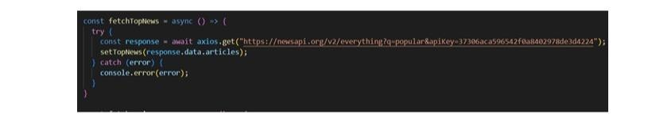

**7. Component Documentation**

# Key Components

* **NewsCard.js** – Displays individual news articles.
* **NewsFeed.js** – Fetches and renders a list of articles.
* **SearchBar.js** – Handles search functionality.
* **BookmarkPage.js** – Displays saved articles.

# Reusable Components

* **Button.js** – Customizable button component.
* **Loader.js** – Displays a loading spinner.
* **ErrorBoundary.js** – Catches and displays errors.

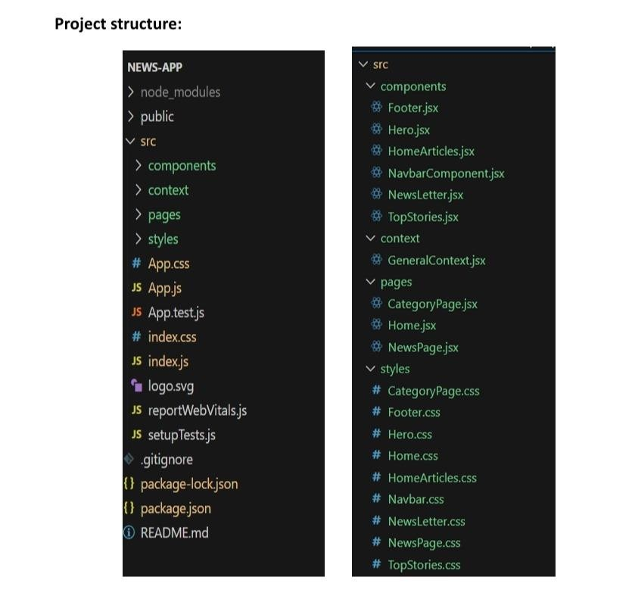

**8. State Management**

# Global State (Redux Toolkit)

* Centralized store for news articles, user preferences, and authentication.
* Utilizes createSlice() for modular state management.

# Local State

• useState for UI interactions like toggles and dropdowns.

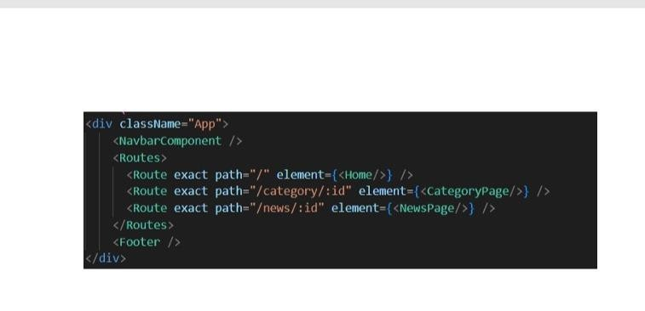

# 9. User Interface

Include screenshots of:

* Home Page

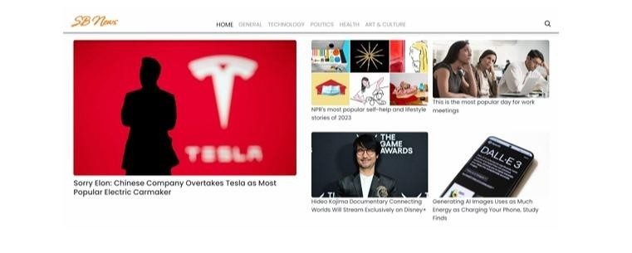

* News Feed

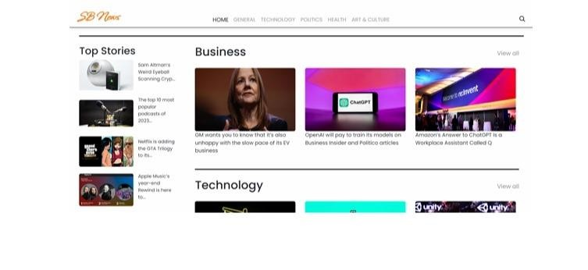

* Search Results

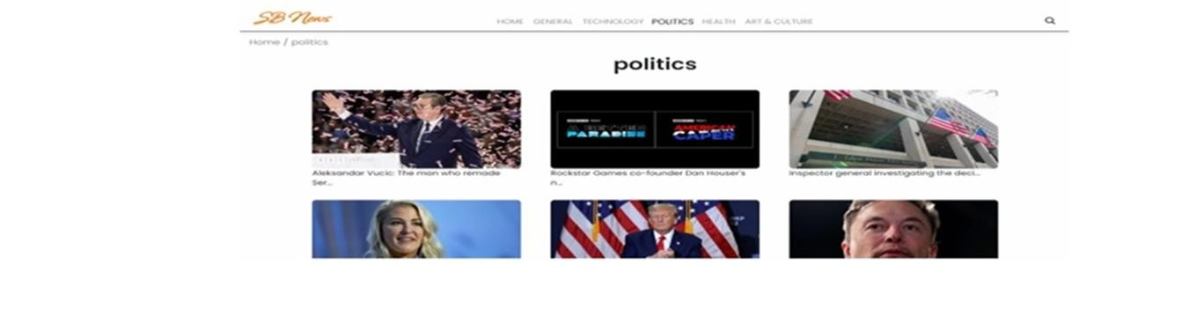

* Bookmark Page

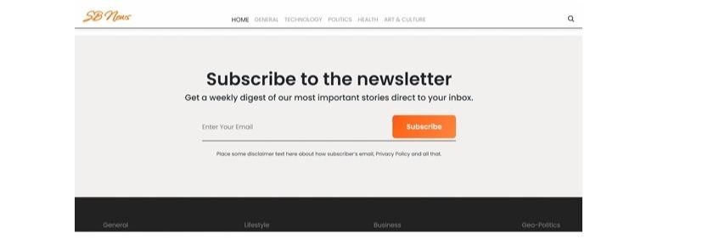

**10. Styling**

# CSS Frameworks/Libraries

* Tailwind CSS for responsive and modern styling.
* Styled-Components for dynamic styling.

# Theming

* Dark mode toggle with persisted user settings.
* Customizable color themes.

**11. Testing**

# Testing Strategy

* **Jest & React Testing Library** for unit tests.
* **Cypress** for end-to-end (E2E) testing. **Code Coverage** Run tests with:

npm test # or yarn test

# 12. Demolink

<https://drive.google.com/file/d/1nxCiG9hfmu1XLF51yjLRgC0ym5xXZbPX/view?usp=sharing>

# 13. Known Issues

* Some API endpoints may have rate limits.
* UI responsiveness improvements needed for smaller screens.
* Optimize search performance for large datasets.

# 14. Future Enhancements

* Implement user authentication (OAuth/Firebase/Auth0).
* Add AI-driven news topic summarization.
* Expand language support and regional filtering.
* Improve accessibility with screen reader support.