GIT & GITHUB
Workflow
Working with GitHub Projects Using VS Code
BRANCH → COMMIT → PUSH → PULL REQUEST → MERGE
Practical guide Create branches, commit changes, push code, pull updates, and create Pull Requests using VS Code.

Beginner-friendly team workflow
Use this guide before starting each shared-project task.

1 | Why Are We Using Branches?

The main branch is the shared, stable version of the project. Students should not make normal feature changes directly on main.
Student Branch → Push → Pull Request → Review → Merge → main
• main is the shared/stable branch.
• Create your own branch before changing the project.
• Work only on your own branch and assigned task.
• Push your branch to GitHub, then create a Pull Request.
• The repository owner reviews and merges the Pull Request into main.
Why this matters Separate branches reduce accidental overwrites and make it easier to review each student’s work before it becomes part of main.

The Golden Rule
NEVER WORK DIRECTLY ON main Before editing code, confirm the branch name shown in the bottom-left corner of VS Code.

2 | The Four Important Git Actions

Action | Simple Meaning
Pull | Get the latest changes from GitHub.
Commit | Save your changes as a local checkpoint.
Push | Send your commits to GitHub.
Pull Request | Ask to merge your branch into another branch.

Pull vs Push
GitHub → Pull → Your Computer
Your Computer → Push → GitHub

3 | Clone the Repository

Cloning makes a local copy of the GitHub project on your computer. Use the VS Code graphical workflow first.

Step 1 — Copy the repository URL
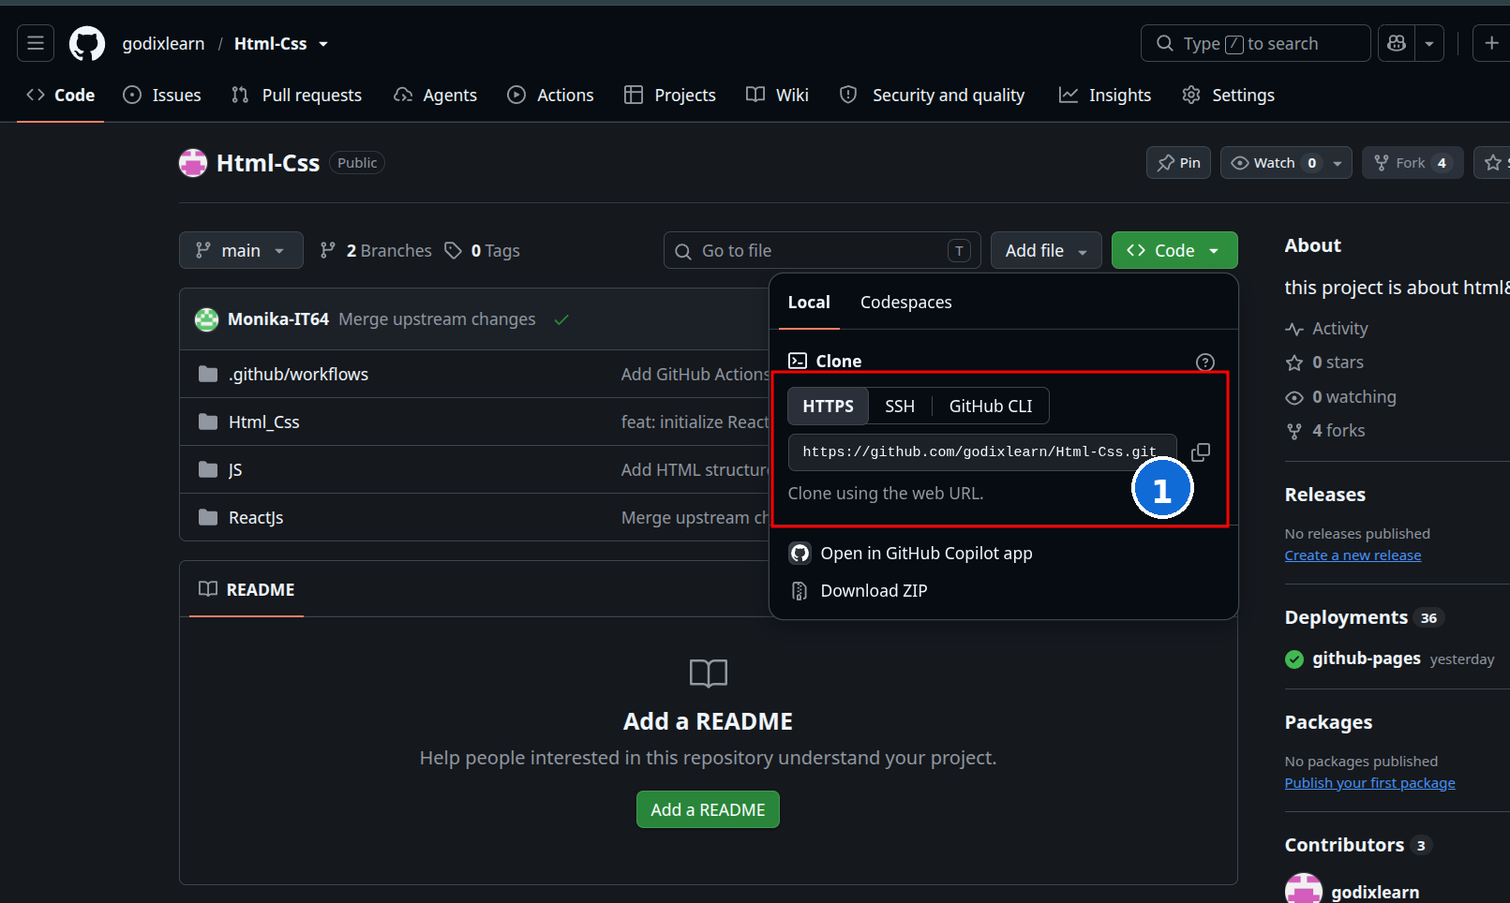
① Copy the HTTPS repository URL from GitHub.

Step 2 — Open Clone in VS Code
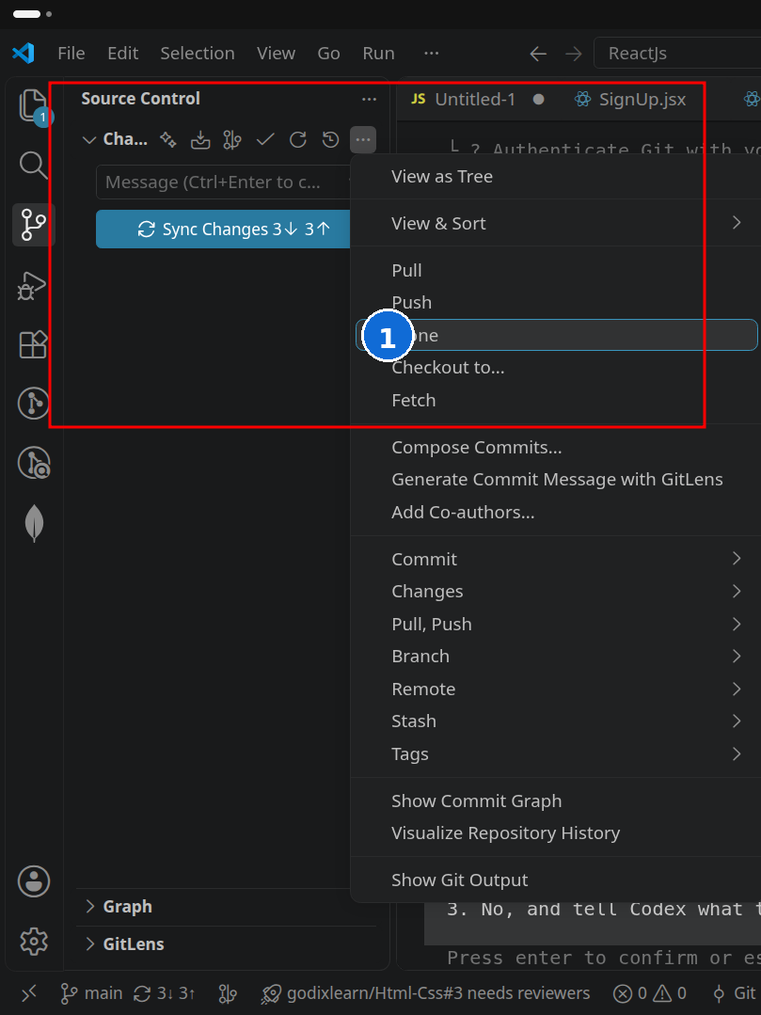
① In Source Control, open the … menu and choose Clone.

Step 3 — Paste the URL
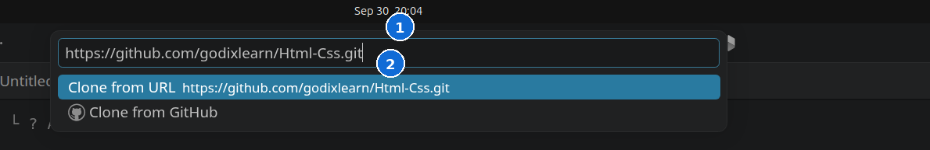
① Paste the GitHub URL. ② Choose “Clone from URL”.
1. Choose a folder on your computer when VS Code asks where to save the project.
2. Open the cloned project in VS Code.
3. Before editing anything, move to the branch workflow in the next section.

4 | Create Your Own Branch

Before making changes, create a branch for your own task. A simple naming convention is:
Branch naming student-name-feature — examples: gowri-signin, arun-navbar, priya-dashboard

Step 1 — Open the branch selector
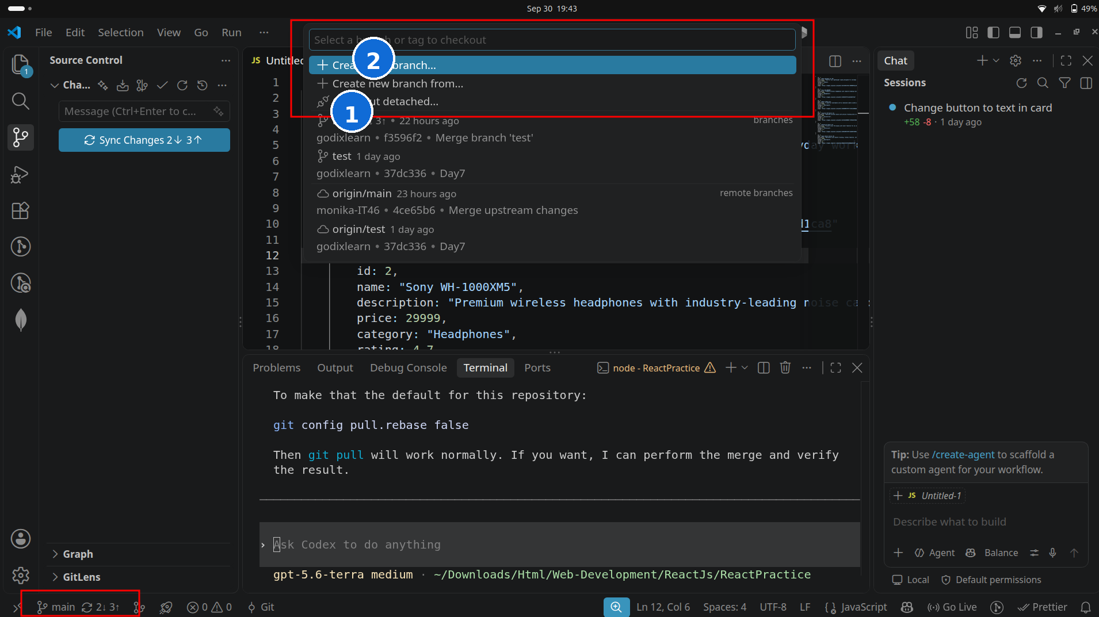
① The current branch is shown in the list. ② Choose “Create new branch…” for your task.

Step 2 — Confirm your branch is active
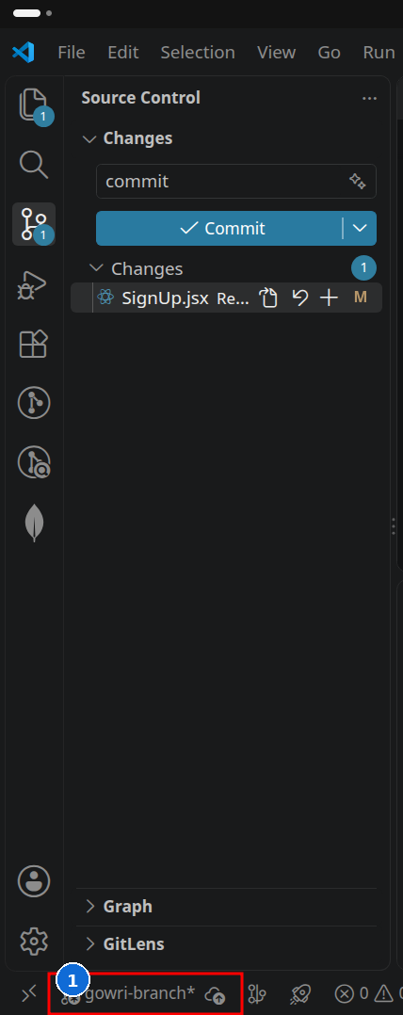
① The bottom-left status bar shows the active branch: gowri-branch.

5 | Make Your Changes

Now work only on the component or task assigned to you. Avoid changing unrelated files because unnecessary edits make reviews and conflicts harder.
Student | Example assigned task
Student A | SignIn component
Student B | SignUp component
Student C | Navbar
Student D | Dashboard
Before moving on Save and test your code so you know the change works before committing it.

6 | Source Control in VS Code

The Source Control panel is where VS Code shows changed files and provides Git actions such as stage, commit, pull, and push.
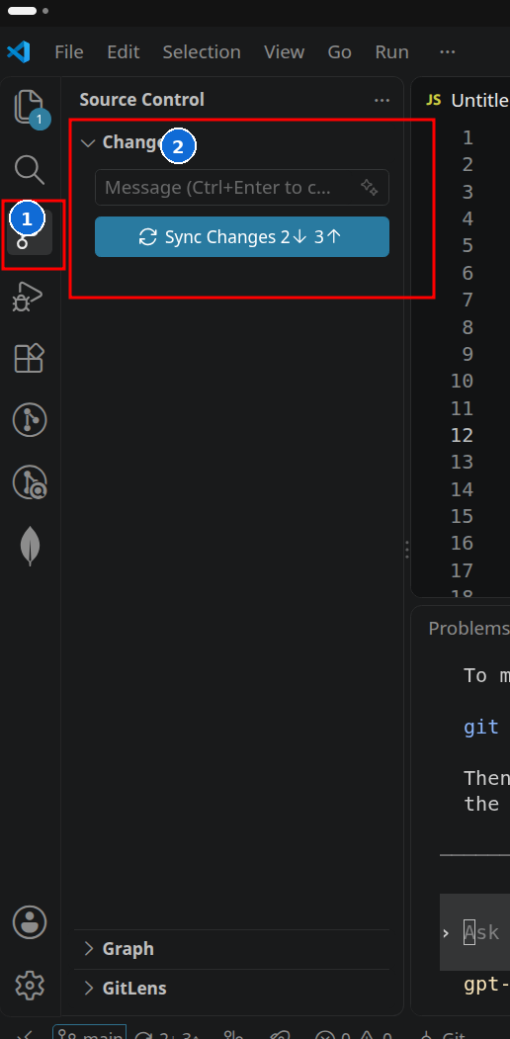
① Source Control icon. ② Changes area and commit controls.
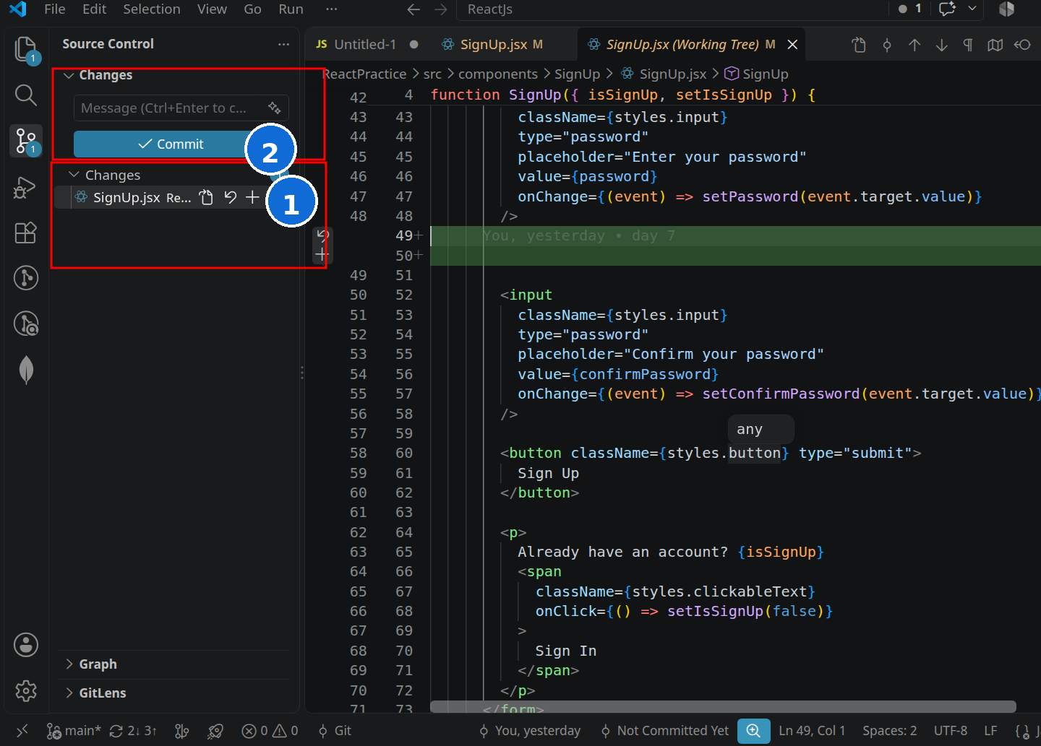
① A modified file appears under Changes. ② The + button stages that file.
• M means the file has been modified.
• The + button stages the selected file.
• The message field is where you describe the commit.

7 | Stage Changes

What does staging mean? Staging means selecting the changes that you want to include in your next commit.

Before staging
The modified file is still under Changes. Click + to stage it.

After staging
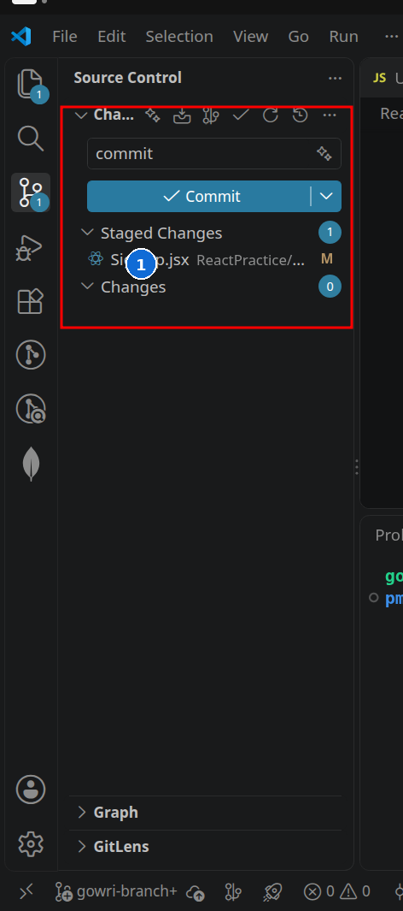
① SignUp.jsx has moved to Staged Changes. Changes now shows 0.

8 | Commit Changes

Commit = checkpoint A commit is a saved checkpoint of your work in Git. It is created locally first.

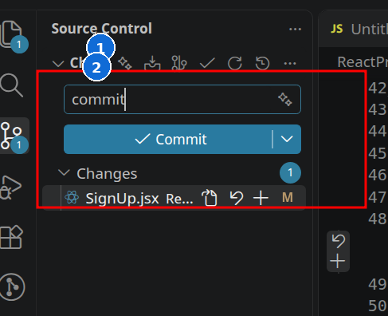
① Enter a meaningful message. ② Click Commit.

Good commit message examples
• Add SignIn component
• Fix navbar mobile layout
• Add validation to SignUp form
Avoid vague messages Messages such as “update”, “changes”, or “done” do not tell reviewers what changed.

9 | Push Changes

Push sends your local commits to your branch on GitHub. Pushing does not merge your work into main.
Your Computer → Push → GitHub Branch

First push of a new branch
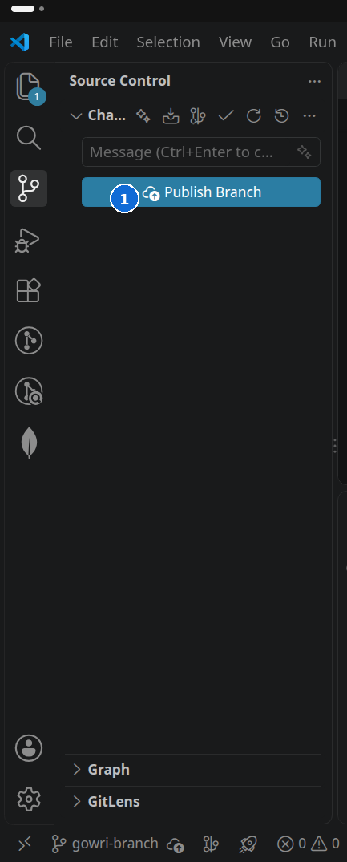
① VS Code may show Publish Branch the first time. This creates the branch on GitHub and publishes your commits.

Later pushes
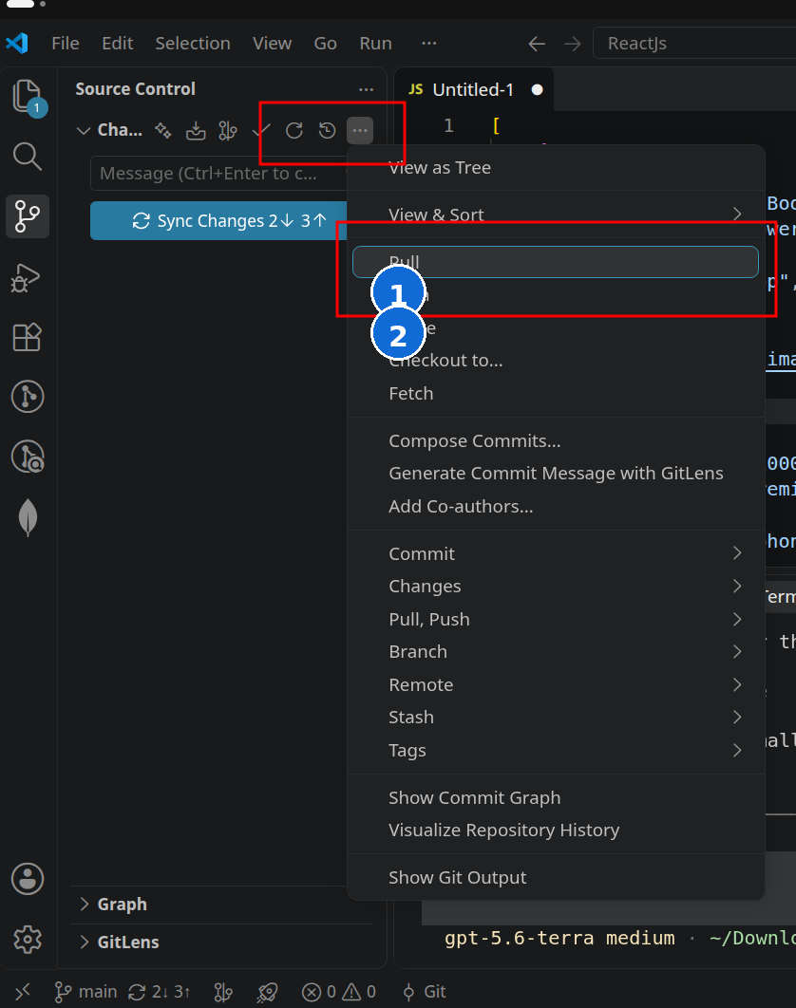
① Pull gets remote changes. ② Push sends your local commits to GitHub.
Important Push updates your branch on GitHub. It does NOT merge your branch into main.

10 | Pull Changes

Pull gets the latest changes from GitHub and brings them to your local branch.
GitHub → Pull → Your Computer
① Choose Pull from the Source Control … menu when you need the latest remote changes.

Safe start-of-task workflow
1. Switch to main.
2. Pull the latest main.
3. Create a new working branch for the new task.
4. Confirm the new branch is active.
5. Start working.

11 | Create a Pull Request

Pull Request A Pull Request (PR) asks to merge the changes from your branch into another branch.

Option A — Start from VS Code / GitLens
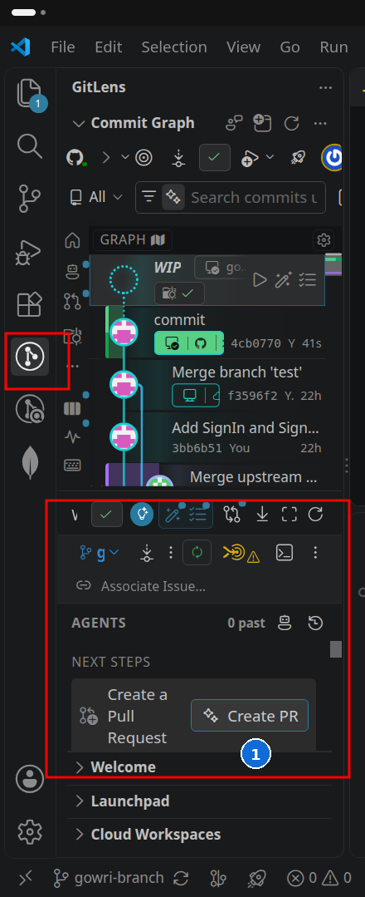
① GitLens shows a Create PR action after your branch is published.

Complete the Pull Request on GitHub
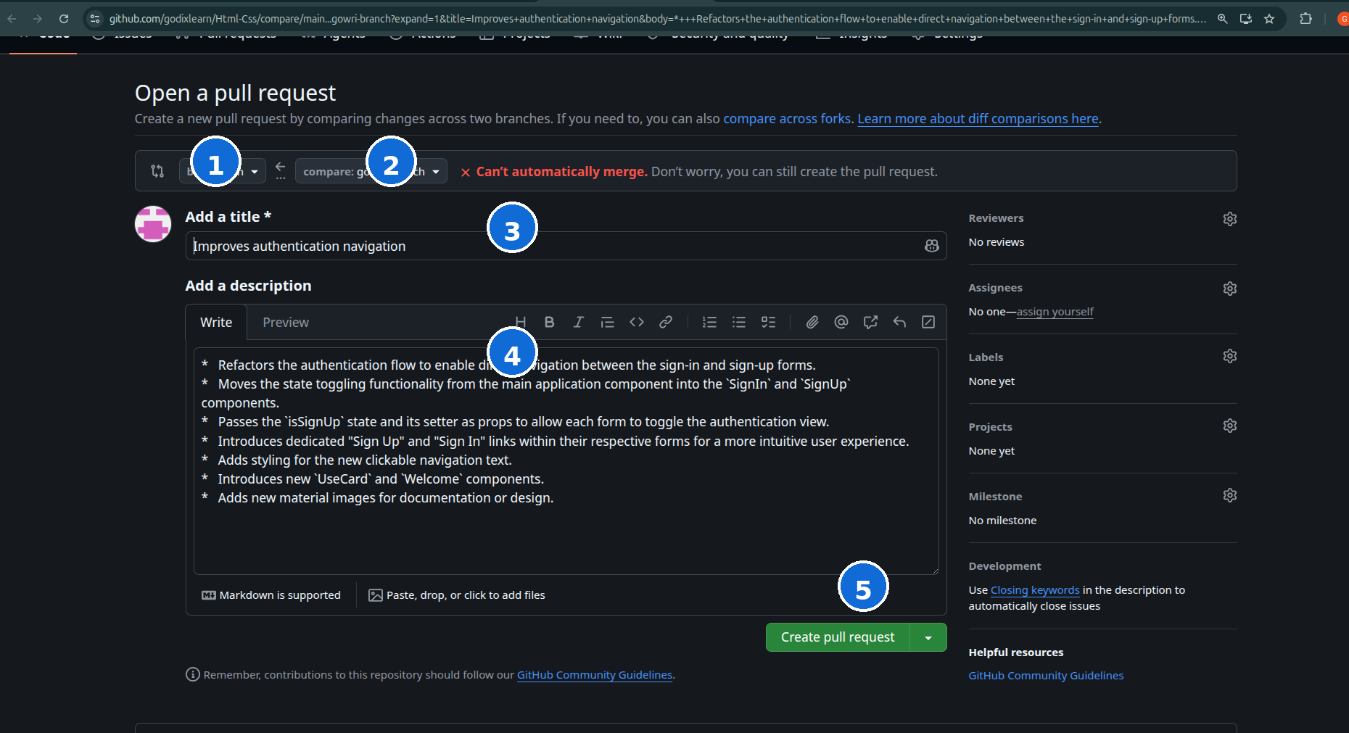
① base: main ② compare: student branch ③ title ④ description ⑤ Create pull request
Correct direction Source branch: your student branch → Target branch: main

What should the PR contain?
• A short title that describes the change.
• A description of what you changed and anything the reviewer should know.
• Your branch as the compare/source branch.
• main as the base/target branch.

12 | Pull Request Review

Student creates PR → Owner reviews → Fix if needed → Push again → PR updates → Approve → Merge
If the reviewer asks for changes, edit the code on the same student branch, commit the fix, and push again. The existing Pull Request updates automatically with the new commits.
Student rule Do not merge your own Pull Request unless the repository owner or mentor explicitly tells you to.

What the owner reviews
• Does the code solve the assigned task?
• Are unrelated files changed accidentally?
• Does the project still run correctly?
• Are the changes ready to become part of main?

13 | After the Pull Request Is Merged

Once the repository owner merges your Pull Request, your local main may be behind GitHub. Refresh it before starting your next task.
1. Switch to main.
2. Pull the latest changes.
3. Create a new branch for the next task.
4. Confirm the new branch is active.
5. Start the next task.
main → Pull → Create new branch → Work → Commit → Push → PR

14 | What NOT To Do

Team safety rules These habits prevent avoidable conflicts and accidental changes to shared work.

✕ Do not work directly on main.
✕ Do not push directly to main.
✕ Do not work on another student’s branch.
✕ Do not delete another student’s work.
✕ Do not force-push shared branches.
✕ Do not merge someone else’s PR without permission.
✕ Do not randomly delete code when you encounter a merge conflict.

15 | What To Do If You Get a Merge Conflict

What is a merge conflict? It happens when Git cannot automatically decide which changes should be kept. Conflicts can occur when multiple people edit overlapping code.

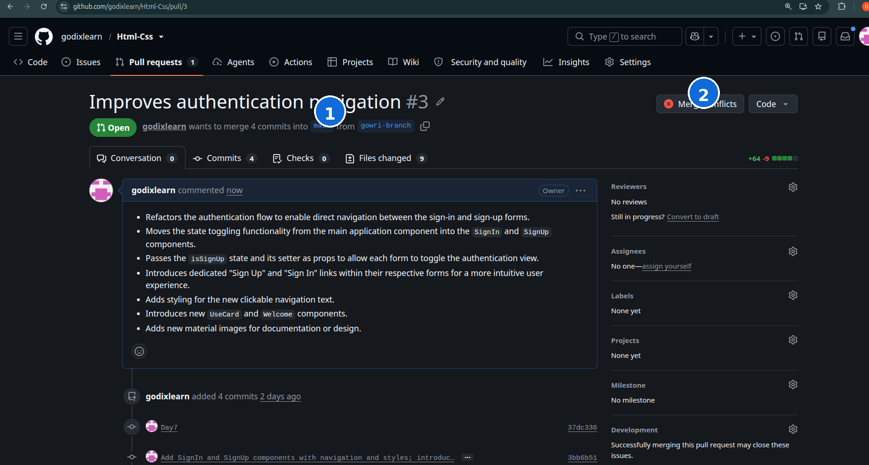
① The PR shows the student branch going into main. ② “Merge conflicts” indicates Git cannot merge automatically.
1. Don't panic.
2. Don't randomly delete code.
3. Don't force-push.
4. Tell the repository owner or mentor.
5. Resolve the conflict carefully with guidance, then test the project again.
Normal, but needs care A conflict does not mean the project is broken. It means the overlapping changes need a deliberate decision.

DAILY WORKFLOW CHECKLIST
Use this before every shared-project session

Before starting work
☐ Switch to main
☐ Pull latest changes
☐ Create your own branch
☐ Confirm you are on your own branch

While working
☐ Work only on your assigned task
☐ Save and test your changes
☐ Stage changes
☐ Commit changes

Before finishing
☐ Push / publish your branch
☐ Create a Pull Request
☐ Select main as the target branch
☐ Add a meaningful PR title and description
☐ Wait for review

GOLDEN RULE Never work directly on main.

Optional: Equivalent Git Commands
VS Code performs these Git actions for you. These commands are only a reference for understanding what happens behind the graphical interface.
VS Code action | Equivalent command
Clone repository | git clone <repository-url>
Check branch | git branch
Create + switch branch | git switch -c student-name-feature
Stage a file | git add <file>
Commit | git commit -m "message"
Pull | git pull
Push | git push
Use the GUI first For this course, follow the VS Code graphical workflow unless your instructor asks you to use terminal commands.

