Online Shopping System (Shopee)

Use-Case-Realization Specification: Order Management

Version 1.0

Revision History

|  |  |  |  |
| --- | --- | --- | --- |
| **Date** | **Version** | **Description** | **Author** |
| 07/12/2021 | 1.0 | Final Version | Nguyễn Xuân Bách |

Table of Contents

1. Introduction 4

1.1 Purpose 4

1.2 Scope 4

1.3 Definitions, Acronyms, and Abbreviations 4

1.4 References 4

1.5 Overview 4

2. Flow of Events—Design 5

2.1 Sequence Diagram 5

2.1 Class Diagram 6

3. Derived Requirements 6

Use-Case-Realization Specification: Order Management

# Introduction

## Purpose

This document describes how the Manage Account Use-Case with function: Find order is realized within the design model, in terms of collaborating objects.

## Scope

This document applies to the Online Shopping System named Shopee.

## Definitions, Acronyms, and Abbreviations

User – a person who use the system, can be seller or buyer

Seller Account – User with the seller account has the buyer account features plus the basic vendor permission such as: create product, edit product, manage process order, advertise product.

## References

No

## Overview

In the following section, Use-Case Realization Specification of the Order Management UseCase with function: Find order of the Shopee System is provided in detail. The first section is a textual description of the Use-Case specification. The following section contains diagrams (sequence and class diagrams). The sequence diagram describing how the use case is realized in terms of collaborating objects. The class diagrams with relationships that participate in the realization of the use case. The last section is an analysis of all requirements, such as non-functional requirements, on the use-case realization that are not considered in the design model, but that need to be taken care

# Flow of Events—Design

## Sequence diagram

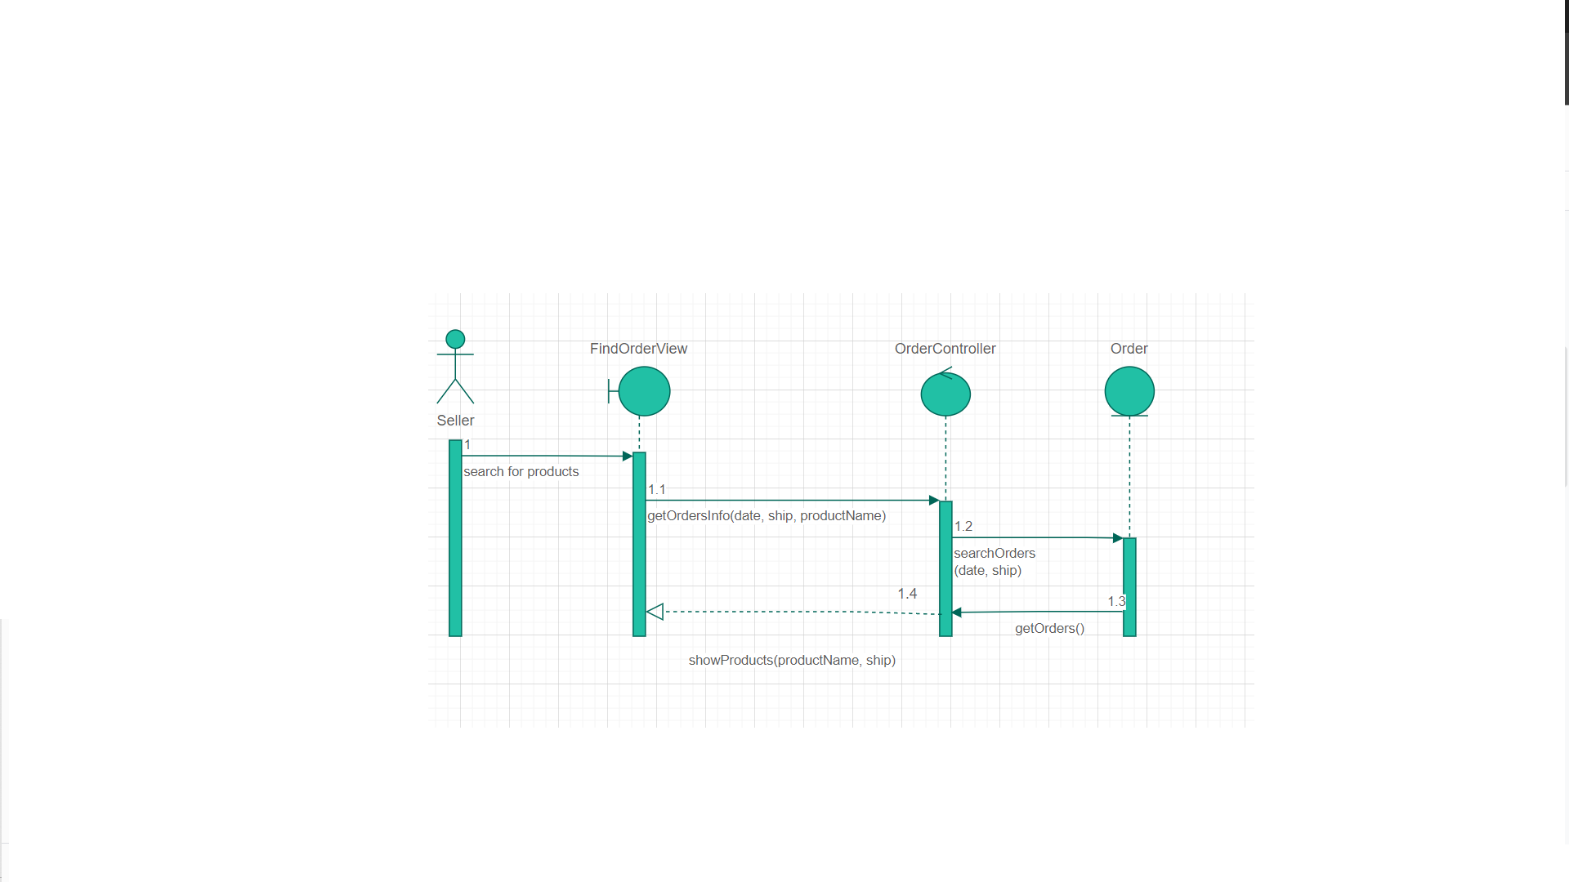

*Find orders*

## Class diagram

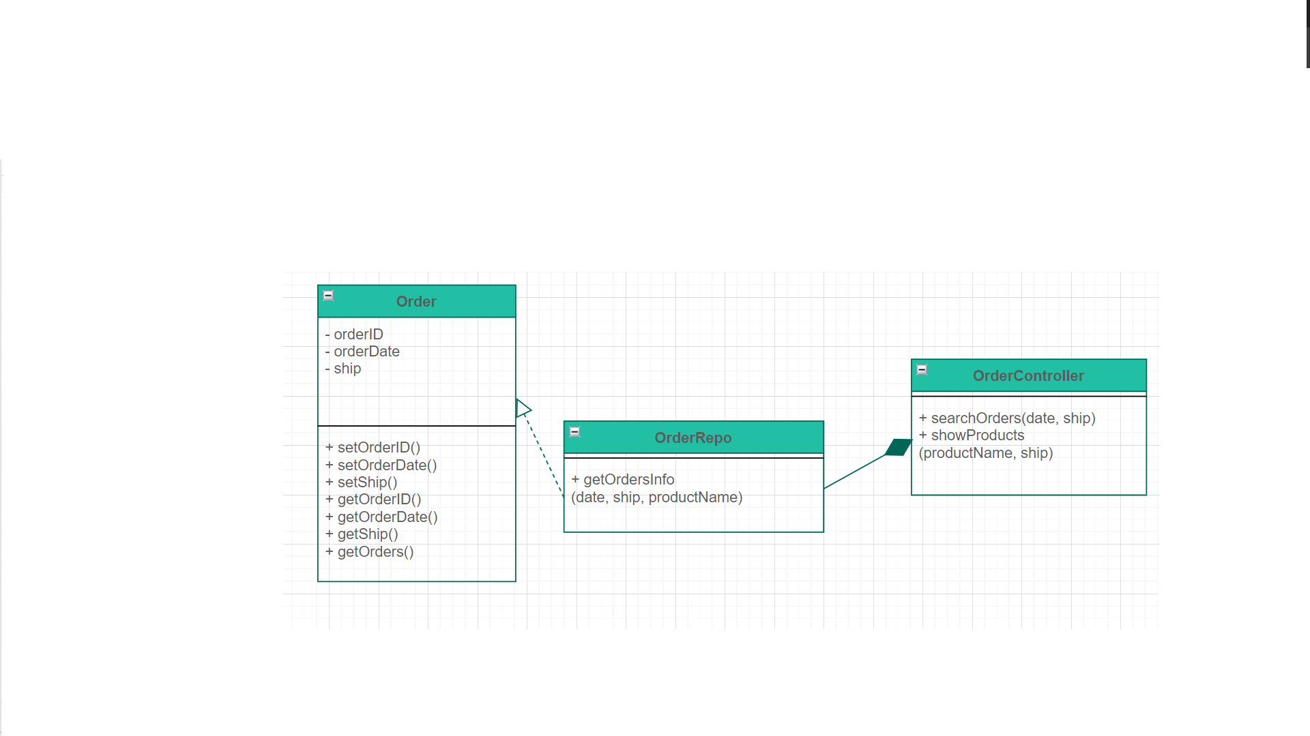

# Derived Requirements

No