1. **Define project aims and objectives for the film scenario**
2. **Present about the definition, key stages and advantages of Project Management**

* The definition of Project Management:

Project Management is the use of specific knowledge, skills, tools and techniques to deliver something of value to people. The development of software for an improved business process, the construction of a building, the relief effort after a natural disaster, the expansion of sales into a new geographic market—these are all examples of projects.

* The key stages of Project Management:

_Conception and Initiation: Project charter, project initiation.

_Definition and Planning: Scope & budget, WBS, Gantt Chart, Communication Plan, Risk Management.

_Launch or Execution: Status & Tracking, KPIs, Quality, Forecasts.

_Performance and Control: Objectives, Quality Delivarables, Effort & Cost Tracking, Performance.

_Project Close: Post mortem, Project Punchlist, Reporting.

* The advantages of Project Management:

The main advantage of project management is that it helps you to manage your projects effectively, enabling you to resolve problems more quickly. Following good practices can help you:

+ Improve your chances of achieving the desired result.

+ Gain a fresh perspective on your project, and how it fits with your business strategy.

+ Prioritise your business' resources and ensure their efficient use.

+ Set the scope, schedule and budget accurately from the start.

+ Stay on schedule and keep costs and resources to budget.

+ Improve productivity and quality of work.

+ Encourage consistent communications amongst staff, suppliers and clients.

+ Satisfy the various needs of the project's stakeholders.

+ Mitigate risks of a project failing.

+ Increase customer satisfaction.

+ Gain a competitive advantage and boost your bottom line.

Not having a process to manage your projects can result in lost time, wasted money, inconsistencies and poor performance.

1. **Project goal and objectives**

**PROJECT GOAL AND OBJECTIVES WORKSHEET**

|  |  |  |  |
| --- | --- | --- | --- |
|  | **PROJECT NAME** |  | **DATE CREATED** |
|  | Film management |  | 10/25/2022 |
|  | **PROJECT MANAGER** |  | **VERSION DATE** |
|  | Nguyễn Quang Vinh |  | 2.1.0 |
|  | **GOAL STATEMENT** |  |  |
|  | The goal of the project is to develop a website to increase the productivity of managing differents types of films. | | |
|  |  |  |  |
|  | **OBJECTIVES** | | |
| **1** | Accomplish project business goals and objectives within defined budget and time parameters. | | |
| **2** | Ensure that end users have input into the design process. | | |
| **3** | By the end of the project, less than 10% of funcionalities have bugs. | | |
| **4** | Submit rough version of the website after 15 days from the initiation. | | |
| **5** | Develop smart searching algorithm for the search engine. | | |
| **6** | Ensure that [our software developers](https://www.collectiveray.com/freelance-software-developer) are meeting their target productivity levels to ensure project deadlines are met and no delays are introduced | | |
| **7** | Prevent the loss of critical information by securing high-grade UPS machines by the third quarter. | | |

1. **Analyse the system requirements & design the website interface**

**Overall use case diagram**

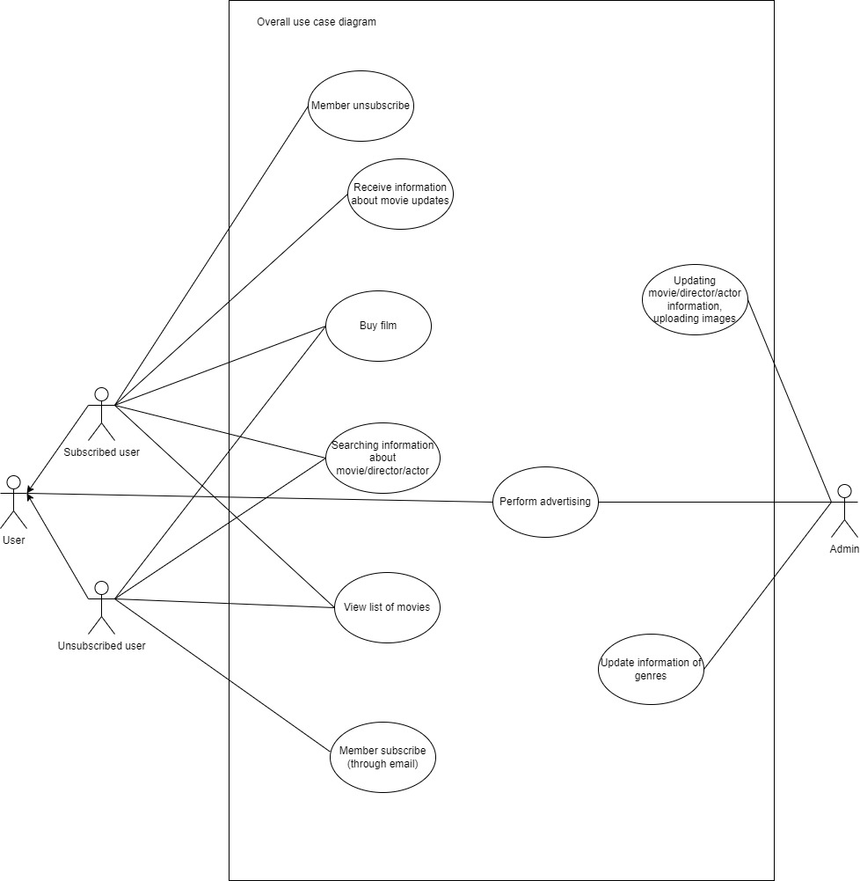

* **User roles**

1. **Member subscription** 
   1. **Use case diagram**

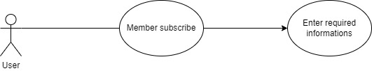

* 1. **Function description**

|  |  |
| --- | --- |
| Function name | Member subscription |
| Description | User accesses the website and clicks on “Subscribe”, after clicking, the website navigates to account subscription. User has to fill in:  _Name  _Email  _Password  _Re-enter password  After that, the user clicks the “Subscribe” button |
| Actor | User, people who access the website |
| Pre-condition | Successfully accessing the website |
| Post condition | The website response if the user subscribe succesfully  If the subcription is not made, show an error message and require the user to re-enter informations |
| Special requirements | N/A |

* 1. **Wireframe design**

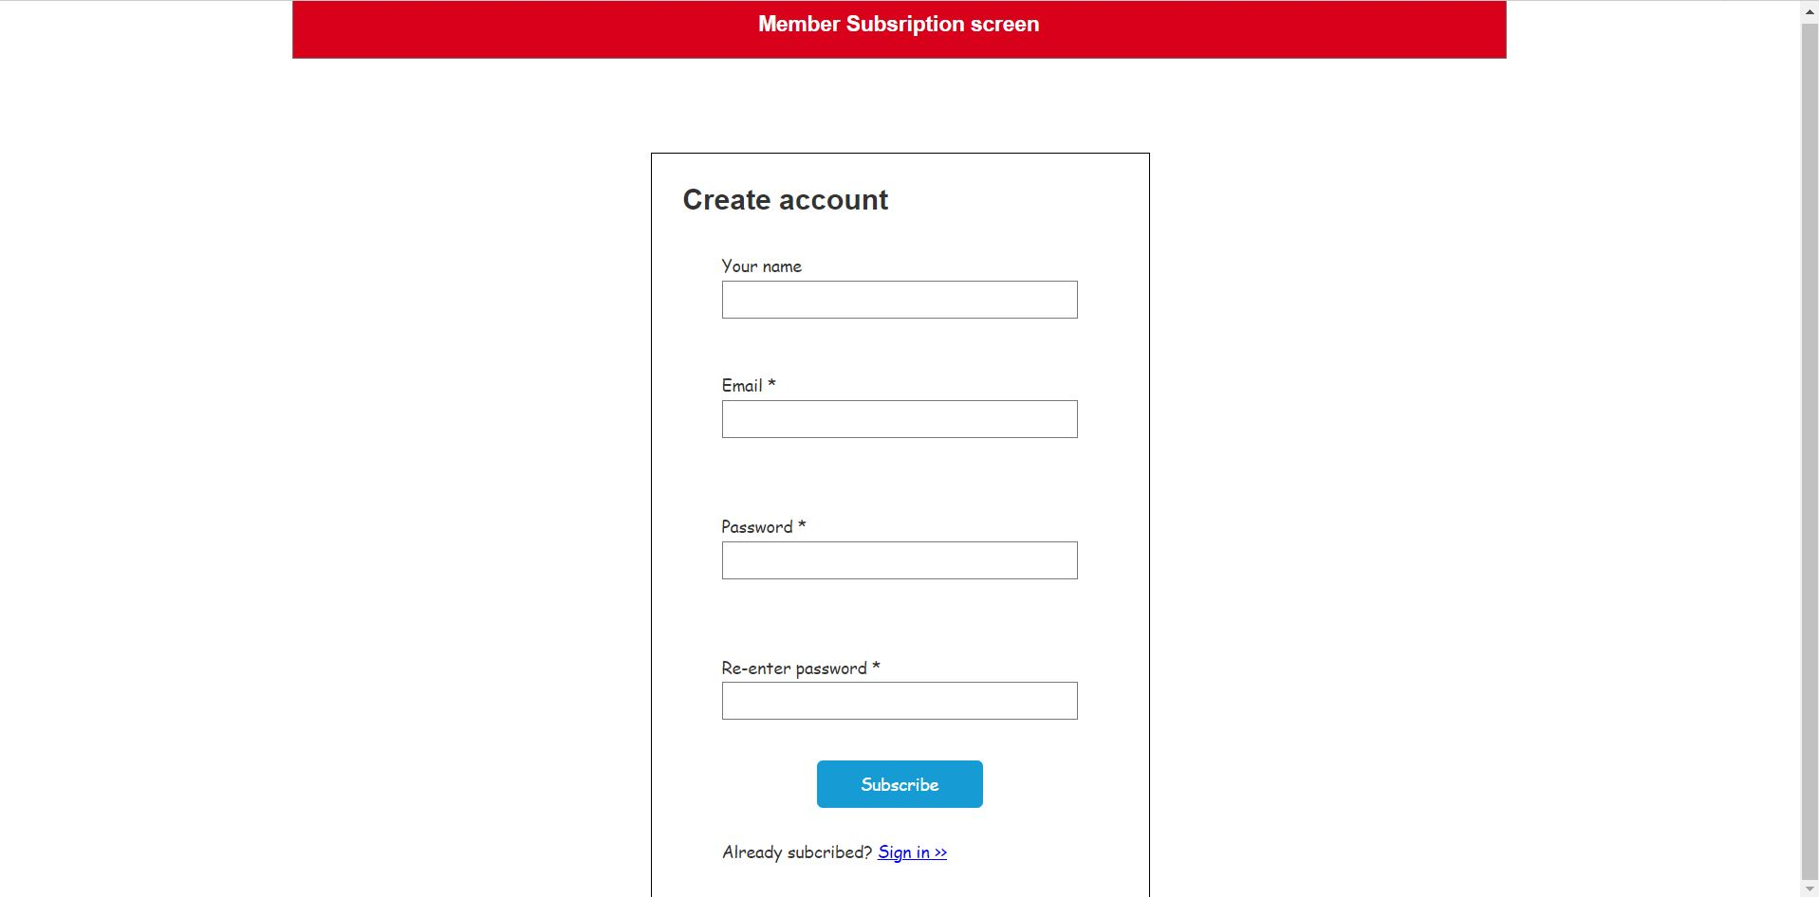

1. **Searching for information about the movie/director/actor**
   1. **Use case diagram**

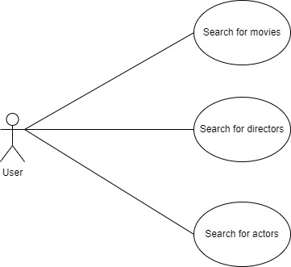

* 1. **Function description**

|  |  |
| --- | --- |
| Function name | Search for informations |
| Description | User accesses the website and clicks on the search bar. After clicking the user enter information that the user wants about movies/directors/actors  User can click the button on the left of the search bar to specify the the categories that the user want to search for, including:  _All  _Movie  _Director  _Actor |
| Actor | User, people who access the website |
| Pre-condition | Successfully accessing the website |
| Post condition | The website navigates to the search result |
| Special requirements | N/A |

* 1. **Wireframe design**

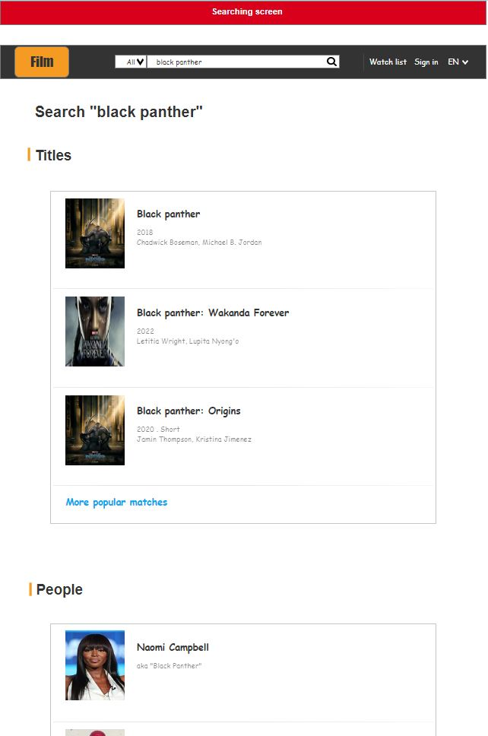

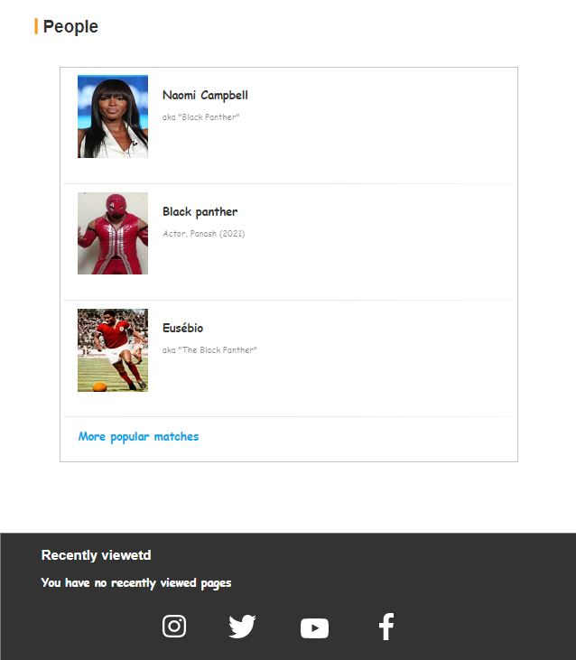

1. **Home page (view a list of movies according to many genres in the system)**
   1. **Use case diagram**

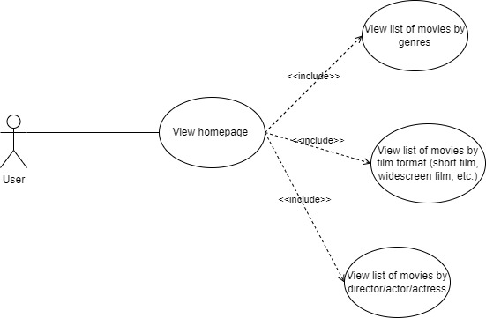

* 1. **Function description**

|  |  |
| --- | --- |
| Function name | View homepage |
| Description | The user access the website and view list of movies according to many genres in the system (with pictures) – shown by:  _Category (sentiment, action motion, etc.),  _Film format (short film, widescreen film, etc.)  _Director  _Actor/Actress |
| Actor | User, people who access the website |
| Pre-condition | Successfully accessing the website |
| Post condition | N/A |
| Special requirements | N/A |

* 1. **Wireframe design**

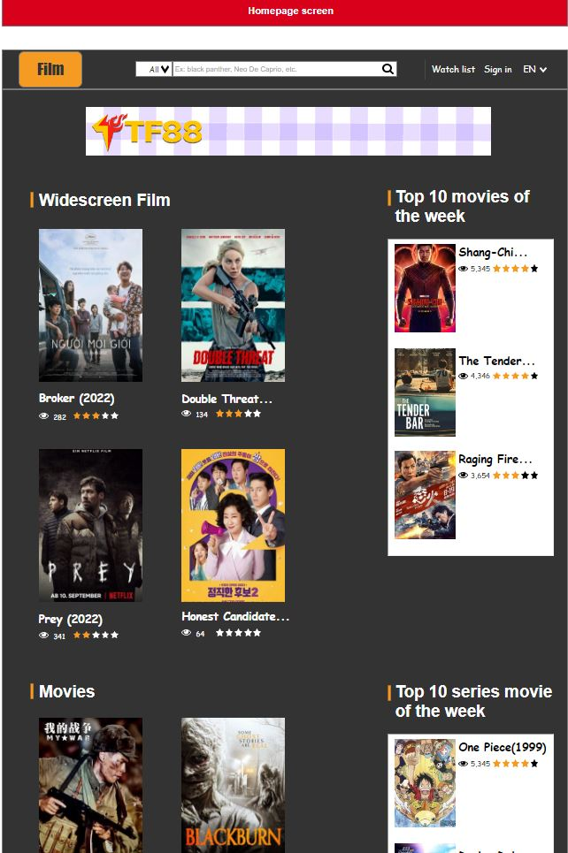

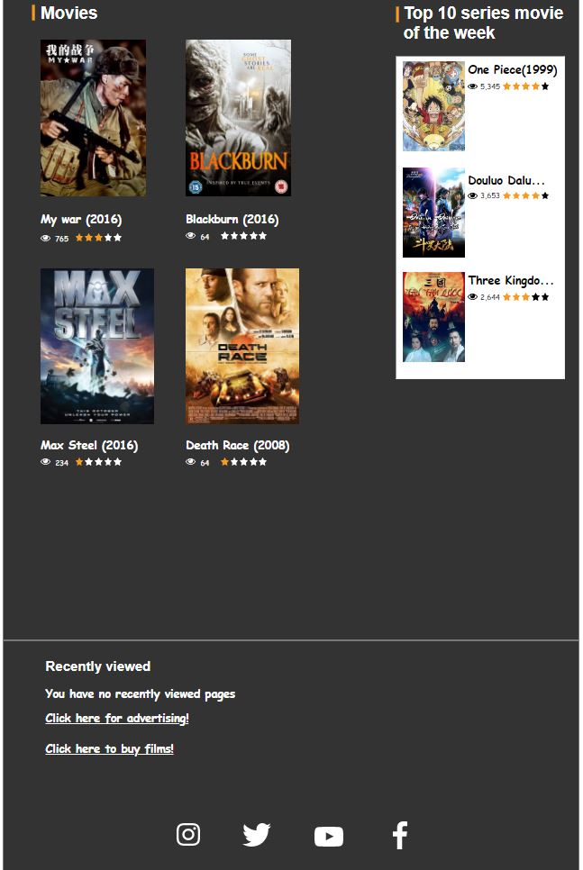

1. **Buy film**
   1. **Use case diagram**

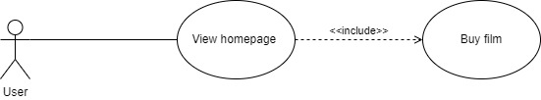

* 1. **Function description**

|  |  |
| --- | --- |
| Function name | Buy film |
| Description | User accesses the website and scroll down to the end of the web page. The user clicks on the “Click here to buy films!” button to start purchasing movies |
| Actor | User, people who access the website |
| Pre-condition | Successfully accessing the website |
| Post condition | The website navigates to the purchasing screen |
| Special requirements | N/A |

* 1. **Wireframe design**

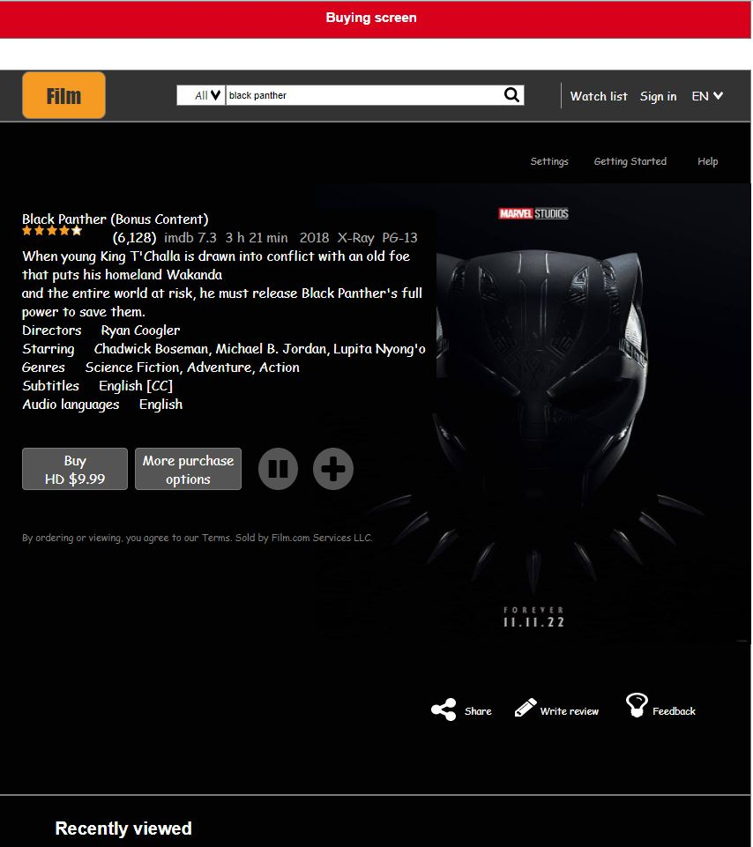

* **Admin role**

1. **Update movie/director/actor information**
   1. **Use case diagram**

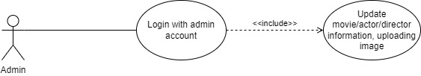

* 1. **Function description**

|  |  |
| --- | --- |
| Function name | Update movie/director/actor information |
| Description | Admin accesses the website and sign in with the admin account. The user clicks on the “Update information” button to start updating |
| Actor | Admin of the website |
| Pre-condition | Successfully accessing the website  Sign in with the admin account |
| Post condition | The website navigates to the admin screen |
| Special requirements | N/A |

* 1. **Wireframe design**

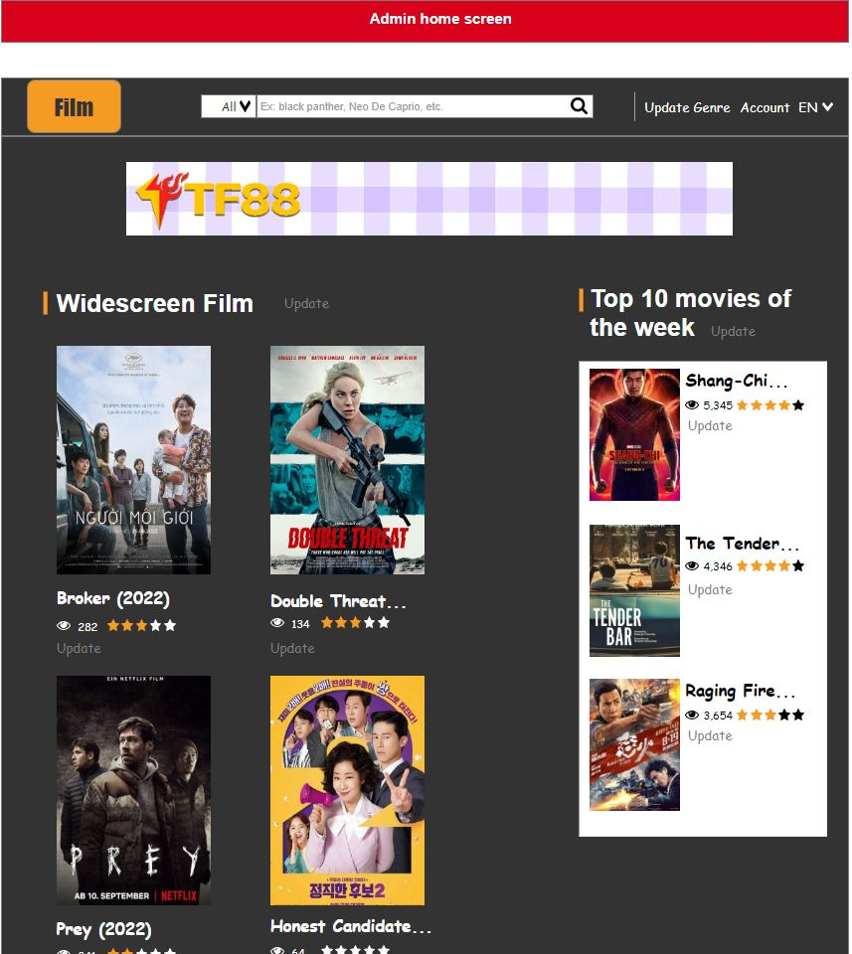

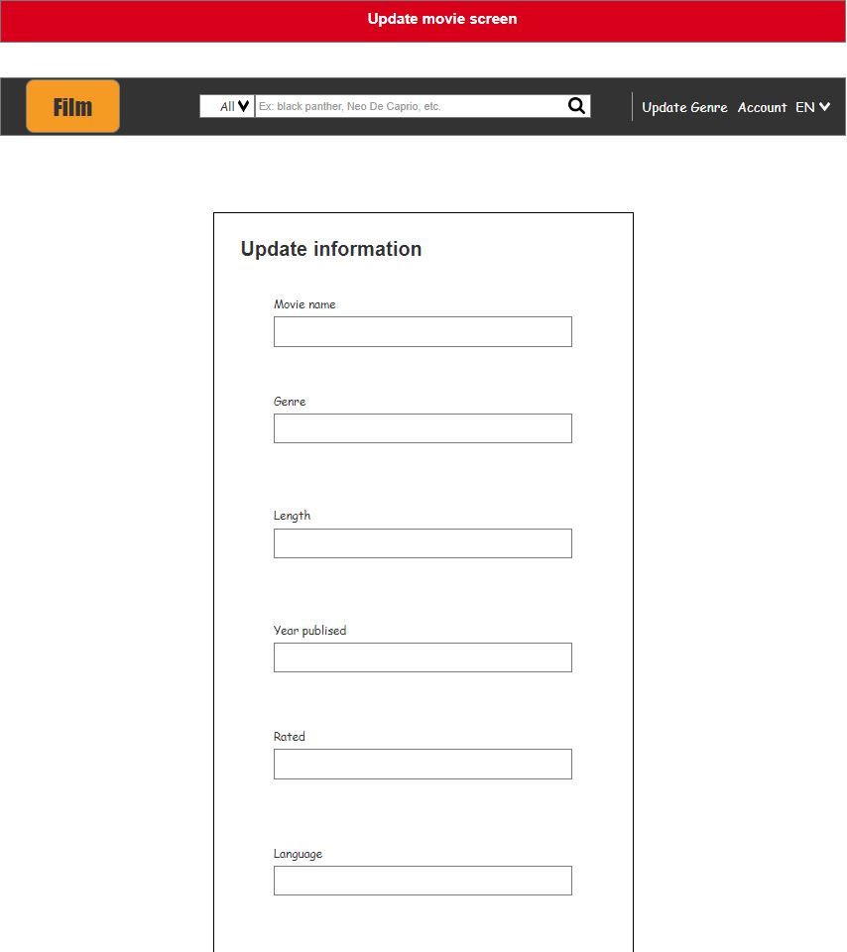

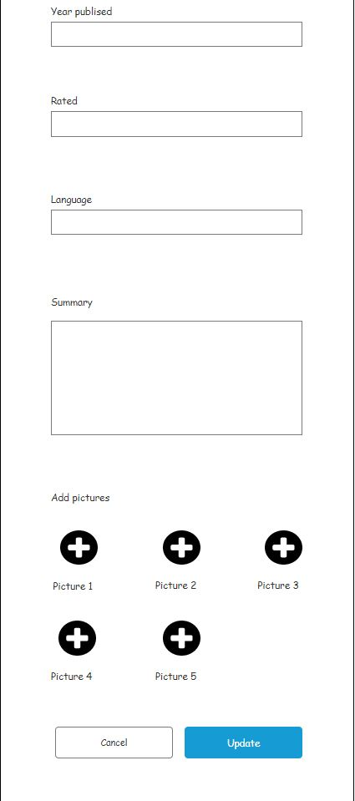

1. **Update genres**
   1. **Use case diagram**

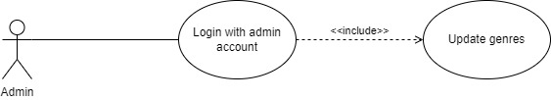

* 1. **Function description**

|  |  |
| --- | --- |
| Function name | Update genres |
| Description | Admin accesses the website and sign in with the admin account The user clicks on the “Update genres” button to start updating genres |
| Actor | Admin of the website |
| Pre-condition | Successfully accessing the website  Sign in with the admin account |
| Post condition | The website navigates to the admin screen |
| Special requirements | N/A |

* 1. **Wireframe design**

