Unified Credentials Manager
Adarsh Krishna  B.Tech IT-C  Roll 58 · Reg. 240911660 | Shreyash Singh  B.Tech IT-C  Roll 60 · Reg. 240911682 | Karanam Kartikeya  B.Tech IT-C  Roll 57 · Reg. 240911648
Information Security Lab · ICT 3121 · Faculty guide Dr. Krishna Prakash
Version 0.5.0 · 4 November 2026 · Source commit 371bf36

Abstract—Unified Credentials Manager (UCM) is a self-hosted authentication service for websites needing registration, sign-in, recovery, and access control. It combines salted Argon2id verifiers, local compromised-password screening, revocable sessions, signed Android recovery, and security-event monitoring. A password begins a pending session; an enrolled main phone must approve a fresh challenge with a biometric-gated Android Keystore signature before account or remote data opens. The same request may reach office level when any two distinct registered Bluetooth witness nodes send valid signatures. A FastAPI backend enforces this policy while a Next.js portal displays progress. It also supports independent websites. PostgreSQL records audit events; a secured local Elasticsearch and Kibana pipeline supports investigation. For version 0.5.0, 53 backend tests and four Android JVM tests passed, and a 19-check HTTPS probe passed on the temporary lab origin. The software and monitoring flows are demonstrated; the final two-node physical office trial remains the contextual-access acceptance check.
Keywords—authentication, Argon2id, Android Keystore, contextual access, security monitoring, OWASP

I. INTRODUCTION
Independent websites often repeat password registration, recovery, session handling, and resource checks, creating inconsistent security decisions. UCM centralizes these functions behind a reusable API. A separate Lab Library site demonstrates integration by validating the UCM session before returning notes. The objective is to protect credentials and sensitive operations through cryptography, authorization, transport security, and monitoring.
Three access states apply: a password creates a pending session; a signed main-phone challenge opens remote data; and two distinct enrolled node signatures can add short-lived office access. Backend endpoints enforce the policy. This paper presents guidance, implementation, test results, and remaining physical validation.

II. RELATED WORK
NIST SP 800-63B-4 recommends blocklists and account-level rate limiting [1]. OWASP ASVS 5.0 defines authentication, session, access-control, and cryptography requirements [2]. The OWASP Top 10:2025 highlights broken access control and authentication failures [3]. UCM uses selected guidance as design targets without claiming certification.
OWASP recommends salted password verifiers, server-side session controls, and CSRF defenses [4]. Android Keystore and BiometricPrompt provide key protection and user activation [5], [6]. UCM's experiment is the tiered policy in which two nearby witness keys can raise an already phone-approved session to office level. Bluetooth contact signals presence, not precise location.

III. METHODOLOGY

A. System architecture
The Next.js portal and trusted sample site call the FastAPI authorization service. SQLAlchemy and Alembic manage persistence. PostgreSQL is the deployment account and audit store; an isolated SQLite database supports phone-lab testing. The Android main phone signs challenge and recovery messages. Browser Bluetooth contact sends a request ID to nearby trusted nodes; each node sends its signature directly to UCM. An optional exporter sends committed audit events to a secured Elasticsearch index visualized in Kibana.
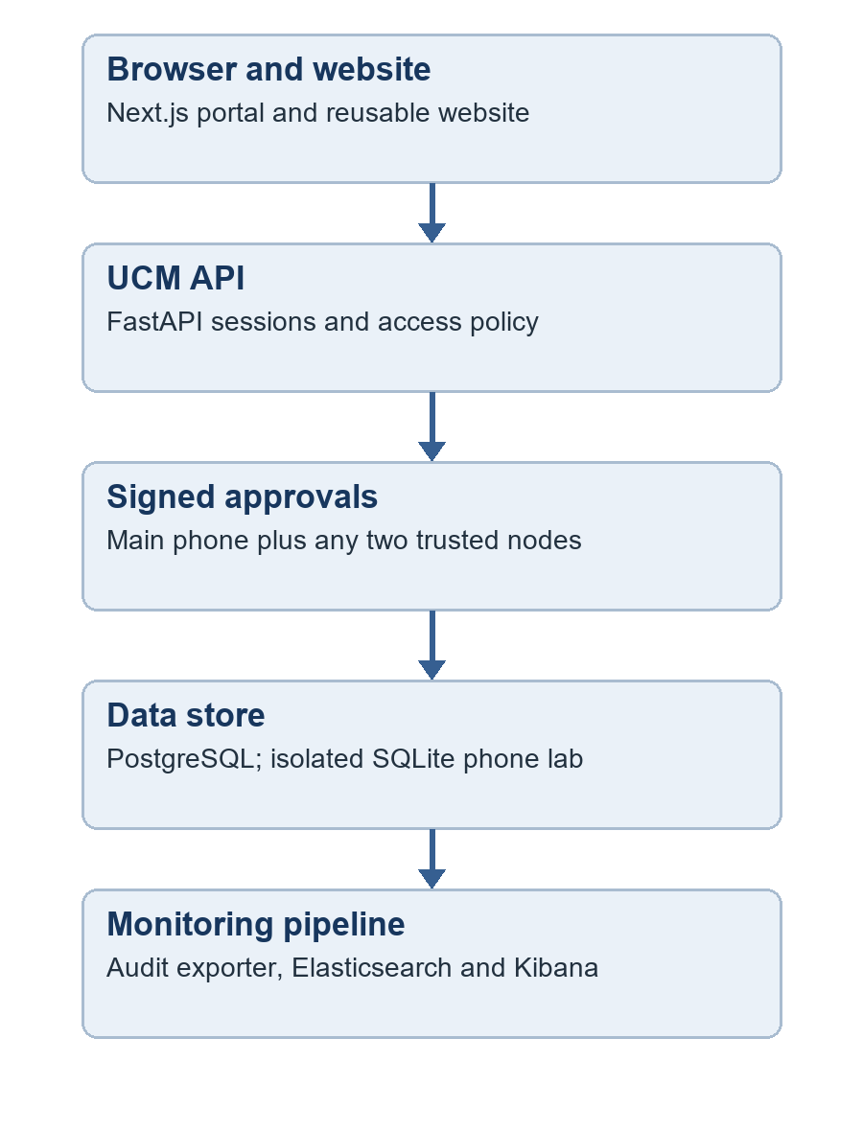
Fig. 1. UCM architecture and signed approval path.

B. Credential and session management
Registration normalizes and screens a 15-128-character password before storing a salted Argon2id verifier. A local index of 1,510,213 common and sampled breach hashes supports offline checking without sending entered passwords to an external service. Five recent verifiers prevent immediate reuse. Login issues a 256-bit opaque session credential, while the database stores only its SHA-256 verifier. HttpOnly, SameSite cookies, idle and absolute expiry, logout, and per-session revocation protect the browser session.
The recoverable per-session CSRF secret is encrypted with AES-256-GCM, a fresh nonce, and associated session/account data. Browser writes require its matching header and an allowed Origin. Passwords are not reversibly encrypted, and this mechanism does not claim whole-database encryption.

C. Signed identity and trust policy
TABLE I. ACCESS CONDITIONS
Stage | Server decision
Password | Pending approval only
Main phone | Valid RSA-PSS signature opens remote
Two nodes | Distinct P-256 signatures open office
The eight-digit code locates a pending request; it is not an OTP factor. The phone signs a role-bound message containing the request ID and fresh random nonce after biometric activation. Each node signs its own role-bound message. The API checks expiry, signature validity, enrollment, distinct node identities, and revocation. Starting a new request clears prior trust. Office access requires the main-phone approval plus any two distinct active node keys.

D. Recovery, monitoring, and test setup
Password recovery uses a five-minute challenge signed by the enrolled main phone and bound to the proposed password digest. The server consumes it once and invalidates existing sessions after reset. Operator lost-phone and node-revocation commands record high-risk events and clear affected grants. The administrator monitoring page requires an operator-assigned role and a current main-phone approval; it provides risk summaries, filters, charts, and alert-review notes.
Tests used synthetic accounts and audit records. The backend suite verifies password policy, ownership, rate limits, signatures, replay rejection, quorum counting, recovery, and monitoring gates. Separate local Caddy/PostgreSQL and secured Elasticsearch/Kibana rehearsals exercised TLS and event export. The temporary ngrok HTTPS origin joined browser and Android devices for the phone lab. Measures were passed tests, HTTP denial and success codes, scoped scanner alerts, and observed device behavior; no latency or population-level benchmark was performed.

IV. RESULTS AND DISCUSSION

A. Synopsis module coverage
All eight proposed areas have working software paths: registration and password hygiene; compromised-password screening; sessions and authorization; AES-GCM protection of session data; public-key identity verification; signed recovery; event monitoring; and secure-communication testing. Table II summarizes the recorded evidence. The two-of-many office decision passes backend tests; physical two-node proximity remains the acceptance measurement for that path.
TABLE II. SYNOPSIS EVIDENCE
Area | Recorded result
Credentials | Argon2id, history, policy tests
Breach screening | Offline index; live rejection
Authentication | Phone gate, sessions, throttling
Cryptography | AES-GCM and Keystore tests
Identity | Emulator and quorum protocol tests
Recovery | Signed reset and expiry tests
Monitoring | Admin page and secured local export
Communication | TLS, capture, Nmap, HTTP/ZAP checks

B. Verification results
TABLE III. TEST RESULTS
Check | Observed result
Backend | 53 tests passed, version 0.5.0
Android | APK built; 4 JVM tests passed
HTTPS | 19 checks passed on lab origin
Access gate | Password-only resources returned 403
npm production | 0 known vulnerabilities
ZAP portal | 0 passive alerts after CSP fix
ZAP API | 10 routes, 0 passive alerts
Monitoring | 6 synthetic events indexed
A live disposable password-only session received HTTP 403 from remote, office, and sample private endpoints; a write without the CSRF header also received 403. The local monitoring overlay denied unauthenticated Elasticsearch reads and denied read access to the export-only key. The ZAP results apply to passive rules and reached routes, not to a complete penetration test. The earlier local TLS 1.3, selected-port Nmap, and packet-capture rehearsal supports the secure-communication module.

C. Monitoring visualization
The saved Kibana dashboard visualizes security events by type and risk level. The panels below contain synthetic lab data and illustrate the central monitoring path; PostgreSQL remains the primary audit record.
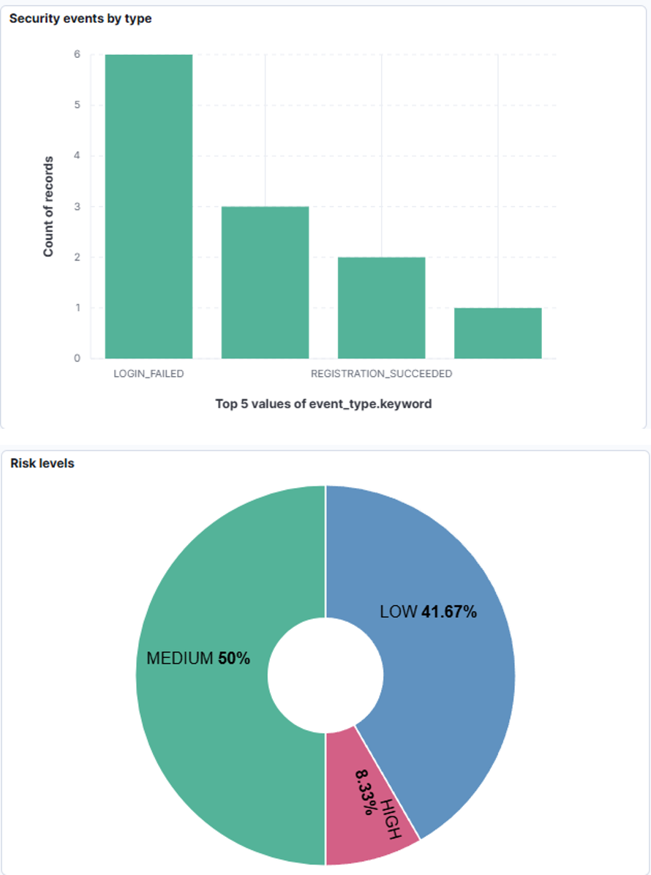
Fig. 2. Security event type and risk panels in Kibana.

D. Interpretation
A physical rehearsal recorded main-phone approval and one trusted-node signature on the same request. Remote access opened while office access stayed locked. The second node advertised but did not produce a verified report after a Bluetooth write error. Version 0.5.0 adds another BLE write mode and removes fixed A/B assignment; the full two-node physical result remains to be recorded. Fresh challenges prevent old signatures from being replayed, but a live relay remains a limitation of a Bluetooth presence signal.

V. CONCLUSION AND FUTURE WORK
UCM version 0.5.0 implements the eight synopsis areas in an integrated self-hosted service. Local results support password hygiene, session and CSRF protection, signed recovery, main-phone-gated account access, two-of-many node authorization, website reuse, and security monitoring. The distinguishing policy is a minimum main-phone approval for login and an additional two-node quorum for office data. The next validation step is a recorded physical office grant, missing-node and revocation sequence, followed by the prepared Burp access-control demonstration and wider deployment checks.

REFERENCES
[1] NIST, "Digital Identity Guidelines: Authentication and Authenticator Management," SP 800-63B-4, 2025. [Online]. Available: https://pages.nist.gov/800-63-4/sp800-63b.html
[2] OWASP, "Application Security Verification Standard," ver. 5.0.0, 2025. [Online]. Available: https://asvs.owasp.org/
[3] OWASP, "OWASP Top 10:2025." [Online]. Available: https://top10.owasp.org/2025/
[4] OWASP, "Cheat Sheet Series: Password Storage, Session Management, and CSRF Prevention." [Online]. Available: https://cheatsheetseries.owasp.org/
[5] Android Developers, "Android Keystore system." [Online]. Available: https://developer.android.com/privacy-and-security/keystore
[6] Android Developers, "Show a biometric authentication dialog." [Online]. Available: https://developer.android.com/identity/sign-in/biometric-auth

