# 

Integrating GraphQL with Next.js for Efficient Data Fetching and Advanced React Techniques

S VIGNESH (Masters in Computer Science)

Research Proposal

August 2024

# Abstract

Integrating GraphQL with Next.js is a flexible solution for improving the speed of data loading and utilizing complex React features in today's web projects. Next.js's versatile and optimized features for serving static/dynamic pages complement GraphQL with flexible and precise data querying features. Having adopted Next.js's strong and powerful fundamentals of what is known as server-side rendering (SSR) and static site generation (SSG), developers can work on optimum performance and user interfaces.

This integration promotes better management of data as it reduces cases of over-fetching while at the same time keeping response times low. Next.js primarily has integrated support for incremental static regeneration, while GraphQL enables querying only the necessary data, so the UI can be updated without a negative impact on speed(Bui and Mynttinen, 2023). Moreover, when using sophisticated elements of the React framework such as Suspense and Lazy Loading with the help of GraphQL integration, developers can guarantee a seamless user experience and fast page loading times.

This research aims to find out how Next.js can benefit from GraphQL and vice versa, as well as the difficulties that may be encountered in the process. It seeks to establish specific recommendations for updating the mechanisms for loading data, as well as improvements in web application architecture with reference to performance, SEO, and UX.

**Table of Contents**

Abstract 2

1. Background 6

2. Problem Statement OR Related Research OR Related Work 8

2.1 Related Research 8

3. Research Questions 9

4. Aim and Objectives 10

5. Significance of the Study 10

6. Scope of the Study 11

7. Research Methodology 12

8. Requirements Resources 13

9. Research Plan 13

9.1 Timeline: 14

References 15

**List of Figures**

Figure 1 Architecture for Integrating GraphQL with Next.js via Apollo Federation 7

Figure 2 Research Timeline: Integrating GraphQL with Next.js 14

**List of Tables**

Table 1 Timeline for completing the research 13

# 1. Background

This section explains the basics of using GraphQL with Next.js and highlights key features that make it easier to build modern web apps with React.

**1.1 Understanding GraphQL**

GraphQL is more than a new tool, it feels like an entirely different paradigm for how to think about data in our web apps. Facebook rolled out GraphQL back in 2015, to exceed the functionality required by a vast majority of applications because data is hard to use. If you think REST APIs then more commonly endpoints and calls, with one call compared to multiple, our request for data is simplified by GraphQL(Zanevych, 2024). This may especially be useful for applications that need to communicate data in the backend and frontend of any sort even simpler or complex ones.

**1.2 More than a simple React tool**

Next.js has a powerful toolset to build web pages, not only React(Fariz et al., 2022). Enjoy server-side rendering or static site generation and more without the headache(Hung Le, 2023). All these features make Next.js a great alternative to creating fast, SEO-friendly and user-optimized apps. It can be tailored to how the page is displayed, whether as a dynamic site or traditional static pages meshed work nicely with divergent needs in mind. And in today's digital world where everything moves fast, this flexibility is not just a bonus but its basic requirement(Bhamare et al., 2023).

**1.3 Advanced React Patterns for User Experience**

React is a powerful library on its own, however it can do all the magic to create an awesome user experience if used with some additional advanced features. Having control of how components load by using techniques like React Suspense and Lazy Loading means users also benefit from seamless user interactions(Desamsetti and Dekkati, 2021). With React Suspense you will get loading screens for our data or components while it is being queried, avoiding blank pages. That literally means, components will only be loaded when required, this makes our app more efficient. Beyond speed, these techniques make the app feel responsive and smooth to use.

**1.4 The Power of Combining Next.js with GraphQL**

Using GraphQL with Next.js merges two powerful tools. This allows you to request data that only you need, making the API more efficient as it removes server calls(Santosa et al., 2023). Next.js then plugs that data into the optimal method through server, client or static HTML output. This combination makes our web app very smart and fast responsive in all the ways, that help users for getting immediate results without any delays. The research will establish an understanding of how these technologies work in conjunction and evaluate the pros, cons, challenges faced and approaches a developer can take to optimize usage together(Thang Nguyen, 2022).

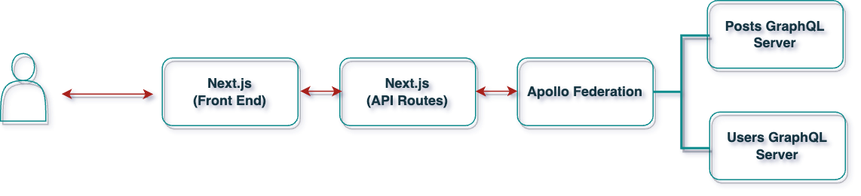

Figure 1 Architecture for Integrating GraphQL with Next.js via Apollo Federation

**1.5 Boosting Performance and SEO**

Both GraphQL and Next.js is dramatically increasing the performance and SEO notes for web applications. Opting for selective data fetching in GraphQL helps to lower loading times, and as well ensures you retain our users which is good news with respect to browser ranking for every little detail that contributes here(Bhamare et al., 2023). Next.js also helps SEO by server-side rendering to make our content friendly with search engines. It also helps in reducing the JavaScript payload resulting is a faster application, which is useful on slower networks. Better performance and SEO are important to increase the user experience as well as be ranked higher on searches(Vishal Patel, 2023).

# 2. Problem Statement OR Related Research OR Related Work

In today's fast-paced web development industry, developing websites and applications that are not only swift and scalable, but also simple to use, is more crucial than ever. Traditional solutions, such as REST APIs and simple client-side rendering, are beginning to fail, particularly when it comes to handling complicated, high-traffic websites(Mikuła and Dzieńkowski, 2020). That’s where modern tools like Next.js and GraphQL come in. They offer powerful solutions but bringing them together isn’t always straightforward. Developers face challenges like making sure the site is fast while balancing server-side and client-side work, keeping the app’s state consistent, and making sure data is fetched efficiently. Plus, there’s the ongoing task of improving things like how quickly the site responds to users and how well it performs in search engines.

This research focuses on how combining Next.js and GraphQL can help solve these challenges. The goal is to provide clear, actionable advice for developers on how to make the most of these tools, while also pointing out any potential issues that might come up during their integration(Yunita, 2023).

# 2.1 Related Research

There has been a lot of work done to understand how Next.js and GraphQL can be used effectively, both on their own and together:

*1. GraphQL for Smarter Data Management*

I tried to find out the reasons why GraphQL makes developers life easier and found a few studies show that unlike rest API(Niswar et al., 2024), with GrahpQL using query language we can get or even demand (in some cases) only necessary data preventing from getting extra fields (if not requested) or missing ones if response does not contain important keys already(Desamsetti and Dekkati, 2021). While more exact matches can result in better performance, it can also increase the load on the server's CPU especially during high traffic periods.

*2. Next.js for Speed and SEO*

One of the advantages of Next.js is that it can make web pages faster, and specifically on server-side rendering or static site generation(Vishal Patel, 2023). These characteristics mean pages load more quickly and are easier to be crawled by search engines, so that the site would get increased traffic as a result. There are other techniques however such as splitting code into smaller chunks or using image optimization that also lead to performant websites(Bhamare et al., 2023).

*3. Bringing GraphQL and Next.js*

Each of these tools has its strengths and there will always be use cases where npm scripts are preferred (or even the only option) but using them together, although a bit challenging sometimes, can also make for really rewarding configuration. Combining the two appears to help make web applications both more responsive and easier to scale, at least according to early research(Mikuła and Dzieńkowski, 2020). But introducing this state(Patil and Dhananjayamurty Javagal, 2022) also adds new problems, you want to keep the data consistent between server and client, manage real-time updates cleanly, make sure everything stays secure (both in-flight and at-rest).

# 3. Research Questions

Even though there’s been a lot of progress in understanding how to use Next.js and GraphQL, there are still some important areas that need more exploration(Paulsson, n.d.).

This study helps us to address these gaps by providing a detailed analysis of how Next.js and GraphQL can make fast scalable secure web applications. This will serve as actionable information for developers and expand the boundaries of what is possible with modern web development.

*RQ 1: How can GraphQL be integrated with Next.js to achieve efficient data fetching while ensuring optimal use of both server and client resources?*

*RQ 2: What are the best ways to keep state consistent between server-side and client-side rendering when using Next.js and GraphQL together?*

*RQ 3: How does integrating Next.js & GraphQL speed up, reduce CPU load and improve SEO for high-traffic websites?*

*RQ 4: Identify best practices in securing GraphQL APIs when we implement them with a Next.js world, especially those that handle real time data?*

*RQ 5: How do real-world implementations of Next.js and GraphQL compare in terms of scalability and performance, and what lessons can be drawn from these examples to guide future development?*

# 4. Aim and Objectives

This research project seeks to investigate methods for making the integration between GraphQL and Next.js more efficient, to enhance the performance of web applications in general, and to utilize more advanced features of React to build speedy, scalable and user-friendly websites.

To achieve this goal, this project will have the following objectives:

* To know the grip of GraphQL and Next.js if used correctly, can help us fetch data in highly optimized way and uses server-side resources as well client-side resources.
* To create strategies for preserving application state seamlessly during server-side rendering and client-side rendering with Next.js and GraphQL.
* To assess the effect of this interaction between GraphQL with Next.js on performance issues of interest, such as response time, CPU usage, SEO etc. while utilizing the program in high-volume circumstances.
* To provide best practices for securely leveraging GraphQL APIs in a Next.js environment, particularly for apps that serve real-time data.
* To examine use cases that focused on integrating Next.js with GraphQL, assess their success or failure, and analyze the consequences for web development in future projects.

# 5. Significance of the Study

This study is essential because it addresses some of the most serious issues in modern web development, providing answers that could have a genuine impact on developers and end users alike. By combining GraphQL and Next.js, the study hopes to achieve new levels of efficiency, security, and user experience that are critical in today's fast-paced digital world.

* *Enhancing Web Performance in The Real World*: Hundreds of milliseconds can be the difference between good and bad web applications; therefore, speeding up data retrieval or better resource consumption could change them(Bang Nguyen, 2021). This study explores how a blend of GraphQL and Next.js can inevitably lead to quicker, more sensitive webpages that maintain users interested or contented in extreme traffic periods.
* *Making SEO Work Smarter, Not Harder:* SEO isn’t just about keywords anymore; it’s about how well our website performs under the hood. By exploring how Next.js’s server-side rendering and static site generation can work together with GraphQL’s efficient data querying, this research could lead to websites that not only perform better but also rank higher on search engines. It leads to added visibility, increased organic footfall and at the end of it all more profitability.
* *Reliable Security frameworks:* Today, we live in an era when data breaches have become quite frequent so maintaining the security of web apps is more paramount than ever. This research will be very specific, to care about a right way to secure GraphQL APIs for an environment like Next.js where we deal with apps that use real-time data. Developers can leverage this intelligence to shrink attack surfaces, allowing for developers to develop more trustworthy and safe web applications that protect users and their data from invasions of privacy.

# 6. Scope of the Study

This research will explore how GraphQL can be integrated into Next.js to improve the performance, security and experience of web applications. The research looks at real-world cases where these technologies shine the best, namely: high-traffic websites that need fast data fetching with high levels of security(Hung Le, 2023).

In this research, we will see how to combo with a Graphql and Next.js while working on advanced React techniques like Suspense based Lazy Loading for the great user interaction as well using other avenues which can improve our page First Load(PFL) time. This will also touch upon the implications of this integration in terms of SEO, especially where visibility and search for ranking are concerned server-side rendering & static site generation is a must.

But again, this research looks at using Next.js and GraphQL together for scalable high performance webapps. This will overlap a bit with my other research into similar technologies but generally, it is about how GraphQL and Next.js work together to support different features. No other web development frameworks or ways of querying data will be accounted for in the study, besides GraphQL.

Although this research will be based on real-world examples to help businesses know what can work for them, it would not examine all use cases and specifics like how each industry sails in such a scenario. These are meant for general best practices and guidelines that can be applied to a various context, not an exhaustive dive on all possible applications.

# 7. Research Methodology

This research will take a hands-on approach to explore how well GraphQL and Next.js work together to improve data fetching, performance, and security in web applications. We'll be testing this integration in real-world scenarios to see how it affects the overall performance of a web application.

We'll build a sample web application using:

* *Frontend*: React with Next.js, leveraging server-side rendering (SSR) and static site generation (SSG).
* *Backend*: A GraphQL API, running on Node.js ,MongoDB, MySQL.

With this setup, we will conduct a series of tests to focus on key areas:

* *Data Fetching Efficiency*: We will measure how effectively GraphQL can retrieve data when used alongside Next.js, especially under conditions of heavy traffic.
* *Performance Metrics*: We will assess the impact of the integration on key performance indicators like response times, CPU usage, and server load to gauge any improvements.
* *Security Assessment*: We’ll take a deep dive into the security aspects of using GraphQL with Next.js, paying particular attention to potential API vulnerabilities and how well real-time data is handled.

For these tests, we'll use tools like Google Lighthouse and Apache JMeter to measure performance, and OWASP ZAP for security evaluations. The goal is to gather meaningful data that will help us understand how to make the most of this integration in modern web development.

# 8. Requirements Resources

* Dedicated computer hardware is required to perform the analysis with the following specifications:
  + Operating System (OS): Ubuntu 20.04 LTS or macOS or Windows 11
  + RAM: Minimum 16 GB
  + Storage: 512 GB SSD
  + Processor: Intel Core i5 or equivalent with a minimum clock speed of 2.5 GHz
  + Graphics: Integrated or dedicated graphics card with 1 GB memory
  + Internet Connectivity: Stable internet connection with a minimum speed of 100 Mbps
* Sample web application: Built using React with Next.js for server-side rendering (SSR) and static site generation (SSG), and a GraphQL API integrated with Node.js.
* Tools for testing and analysis:
  + Google Lighthouse and Apache JMeter for performance testing
  + OWASP ZAP for security evaluations
* **Datasets for Analysis**:
  + [Healthcare Dataset](https://www.kaggle.com/datasets/prasad22/healthcare-dataset)
  + [Brazilian E-Commerce Dataset](https://www.kaggle.com/datasets/olistbr/brazilian-ecommerce/)

# 

# 9. Research Plan

The idea is to create a sample application and test it in an experimental setup that should reveal the performance effects of adding GraphQL on top of Next.js for web applications(Drupal et al., 2023). That includes testing around data fetching efficiency, response time speeds and CPU usage with various traffic scenarios. We will also receive security reviews to find the possible flaws in our GraphQL API when it is employed at Next.js. Our goal with this study is to better understand how the integration impacts performance and security of the end-to-end application, as identify best practices for optimizing and securing the integration.

# 9.1 Timeline

The proposed timeline to complete the research on integrating GraphQL with Next.js:

Table 1 Timeline for completing the research

|  |  |
| --- | --- |
| **To-do tasks** | **Completion Date (end of)** |
| Testing environment setup | Sep-24 |
| Initial web application development and integration | Oct-24 |
| Performance and security testing | Oct-24 |
| Large scale evaluation and analysis | Nov-24 |
| Final Thesis report on the research evaluation | Nov-24 |
| Dissertation | Dec-24 |

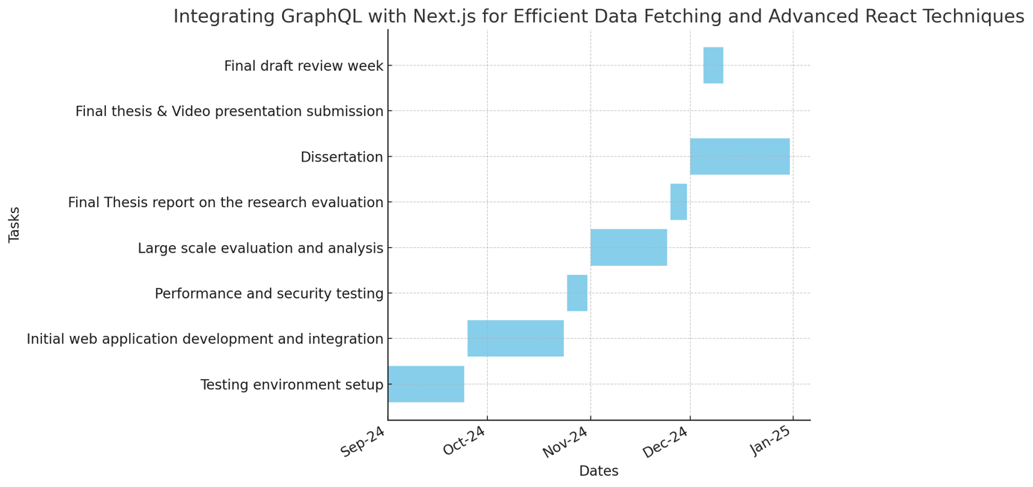

Figure 2 Timeline for Integrating GraphQL with Next.js

# References

1. Thang Nguyen, (2022) *JAMSTACK: A MODERN SOLUTION FOR E-COMMERCE*.
2. Hung Le, (2023) WEB DEVELOPMENT WITH T3 STACK.
3. Bang Nguyen, (2021) *Improving web development process of MERN stack*.
4. Bhamare, O., Gite, P., Lohani, A., Choudhary, K. and Choudhary, J., (2023) Design and Implementation of Online Legal Forum to Complain and Track UGC Cases using NextJs and GraphQL. In: *Proceedings of the 10th International Conference on Signal Processing and Integrated Networks, SPIN 2023*. Institute of Electrical and Electronics Engineers Inc., pp.230–234.
5. Bui, D. and Mynttinen, T., (2023) *Next.js for front-end and Compatible Backend Solutions Commissioned by XAMK Year 2023*.
6. Desamsetti, H. and Dekkati, S., (2021) *Getting Started Modern Web Development with Next.js: An Indispensable React Framework*.
7. Drupal, R., Lundqvist, L. and Stefan Berglund, S., (2023) *An Evaluation of Decoupled Drupal and ReactJS*.
8. Fariz, M., Lazuardy, S. and Anggraini, D., (2022) Modern Front End Web Architectures with React.Js and Next.Js. *International Research Journal of Advanced Engineering and Science*, 71, pp.132–141.
9. Mikuła, M. and Dzieńkowski, M., (2020) *Comparison of REST and GraphQL web technology performance Porównanie wydajności technologii webowych REST i GraphQL*.
10. Niswar, M., Safruddin, R.A., Bustamin, A. and Aswad, I., (2024) Performance evaluation of microservices communication with REST, GraphQL, and gRPC. *International Journal of Electronics and Telecommunications*, 702, pp.429–436.
11. Patil, K. and Dhananjayamurty Javagal, S., (2022) React state management and side-effects-A Review of Hooks. *International Research Journal of Engineering and Technology*. [online] Available at: www.irjet.net.
12. Paulsson, J., (n.d.) *Examensarbete 30 hp Maj 2024 Code Generation for Efficient Web Development in Headless Architecture Civilingenj örspr ogrammet i inform ati ons tek nologi*.
13. Santosa, B., Pratomo, A.H., Wardana, R.M., Saifullah, S. and Charibaldi, N., (2023) Performance Optimization of GraphQL API Through Advanced Object Deduplication Techniques: A Comprehensive Study. *Journal of Computing Science and Engineering*, 174, pp.195–206.
14. Vishal Patel, (2023) Analyzing the Impact of Next.JS on Site Performance and SEO. *International Journal of Computer Applications Technology and Research*.
15. Yunita, A., (2023) *Challenges in front-end JavaScript development for web applications Developers’ perspective*.
16. Zanevych, O., (2024) ADVANCING WEB DEVELOPMENT: A COMPARATIVE ANALYSIS OF MODERN FRAMEWORKS FOR REST AND GRAPHQL BACK-END SERVICES. *Grail of Science*, 37, pp.216–228.