Smart Tourist Safety Monitoring & Incident Response System

Technical Architecture & Engineering Research Report
Companion to: Domain Research Report (7 July 2026) — same problem statement (SIH25002 class). Audience: Team Leader, System Architect, senior engineers. Date: 7 July 2026. Labels: [REC] recommended · [ALT] alternative · [MVP] hackathon scope · [PROD] production scope · [ASSUMPTION] · [UNRESOLVED].
Version baselines assumed [ASSUMPTION — re-verify at build time]: Android 13–16 behaviour set (foreground-service types, background-location permission flow, Doze); iOS 16–19 behaviour set (region monitoring, significant-change service, background modes). OS rules cited here are stable across recent releases but must be re-checked against current developer docs before implementation.

Table of Contents
- Technical Executive Summary
- Complete Feature Decomposition
- Complete End-to-End Workflows
- Mobile Background Service Architecture
- High-Level System Architecture
- Architectural Style Decision
- Complete API Design
- API Contract Examples
- Real-Time Communication
- Database Architecture
- Geospatial & Geo-Fencing Architecture
- AI System Architecture
- Risk Engine Design
- Blockchain Architecture
- Event-Driven Architecture
- Security Architecture
- Privacy Architecture
- Offline & Poor Network Architecture
- Notification Architecture
- Scalability Research
- Reliability & Failure Engineering
- Observability
- DevOps & Deployment
- Testing Strategy
- Technology Selection Matrix
- Recommended MVP Architecture
- Recommended Production Architecture
- Architecture Decision Records
- Implementation Roadmap
- Final Architect Recommendation
- Sources & References

1. Technical Executive Summary
Purpose. Close the detection → verified response → trusted record loop for tourists: consent-tiered location monitoring with on-device geo-fencing, missed-check-in/anomaly escalation, context-rich SOS delivered to authority dashboards (and ultimately into state ERSS-112 PSAPs), multi-agency incident timelines, and tamper-evident audit anchoring.
Major technical challenges (ranked).
- Mobile background execution — Android OEM battery killers and iOS's refusal to run arbitrary background services make "continuous monitoring" a design negotiation, not an API call (§4).
- Offline-first correctness — the highest-risk zones have no network; SOS, fences, and check-ins must work from a local encrypted queue with SMS fallback and exactly-once semantics on sync (§18).
- GPS uncertainty vs. geo-fence truth — 3–100 m error means fence events need buffers, dwell timers, and accuracy gates or the system drowns responders in noise (§11).
- Emergency-grade reliability on commodity infrastructure — an SOS path with p95 < 5 s and no single point of failure, built by a small team (§21).
- Privacy-preserving tracking — DPDP-native consent tiers, retention, and access logging engineered into the data path, not bolted on (§17).
- Trust-boundary sprawl — tourists, police, hospitals, tourism dept, admins: five principals with conflicting interests sharing one incident record (§14, §16).
Recommended architectural style [REC]. Modular monolith + event-driven internals (transactional outbox → stream) for MVP and early production; extract high-churn/high-scale modules (Location ingestion, Notification) into services only when metrics force it. Full microservices from day one is rejected (§6, ADR-01).
Major components. Tourist mobile app (Flutter, native background modules), authority web dashboard (Next.js), API gateway + modular backend (FastAPI), PostgreSQL+PostGIS+TimescaleDB-style partitioning, Redis (cache/streams), object storage (S3-compatible), notification fan-out (FCM/APNs + SMS gateway), rules-based risk engine, blockchain adapter (hash-chain + anchoring), observability stack.
Critical engineering risks. Android/iOS killing the monitoring process silently; false-positive anomaly storms destroying responder trust; location-table write amplification; SMS fallback dependency on telecom approvals; ERSS integration being organisationally unavailable during the project window (mock it, design the seam).
MVP recommendation. One FastAPI monolith, one Postgres/PostGIS, Redis, Flutter app with a real Android foreground service, dashboard with WebSocket live updates, rules risk engine, simulated SMS/KYC/ERSS, 2-node Besu (or signed transparency log) anchoring incident-event Merkle roots. Demo must show a real fence breach on a walked route and a real offline SOS syncing on reconnect.
Production recommendation. Same logical modules deployed as 3–5 services (Core, Location-Ingest, Realtime/Notify, Risk-Workers, Blockchain-Adapter) on Kubernetes, Kafka event bus, per-state data partitions, MeitY-empanelled Indian cloud region [ASSUMPTION — government hosting norms], DPDP-compliant retention jobs, HSM-backed keys.

2. Complete Feature Decomposition

2A. Tourist Mobile App
Legend: P0 = MVP must; P1 = MVP if time; P2 = post-MVP.
Feature | Purpose | Trigger | Input | Processing | Output | Data stored | API deps | Security | Failure scenarios / edge cases | Priority
Registration | Create account + tourist profile | User action | Phone/email, name, nationality, ID type | OTP verify; create user; issue tokens | Account | User, Device | /auth/register, /auth/verify-otp | Rate-limit OTP; hash credentials | OTP delivery failure → resend/backoff; duplicate phone → login hint | P0
Login / Refresh / Logout | Session mgmt | User action / token expiry | Credentials / refresh token | Verify; rotate refresh token | JWT pair | Session, Device | /auth/* | Refresh rotation + reuse detection | Clock skew; stolen refresh token → family revoke | P0
Identity verification (Digital ID) | Time-bound verifiable tourist ID | Post-registration or entry-point kiosk | Aadhaar-DigiLocker consent / passport+visa scan | KYC check (mock in MVP); sign VC; QR generation | Digital ID (VC + QR), expiry=trip end | TouristProfile, credential | /identity/verify, /identity/credential | Issuer private key in KMS; PII encrypted | KYC API down → provisional unverified ID flagged everywhere | P0 (mock KYC)
Profile & medical profile | Responder context | User edits | Blood group, allergies, meds, insurer, conditions | Validate; mark self-declared | Emergency medical card | TouristProfile (sensitive class) | /users/me | Field-level encryption; break-glass access only | Wrong data harms treatment → provenance flag "self-declared" | P0
Emergency contacts | Family loop | User edits | Name, phone, relationship, channel prefs | Verify via OTP to contact (P1) | Contact list | EmergencyContact | /users/me/emergency-contacts | Contact can't see history; revocable silently | Abusive "trusted" contact → silent removal, no notification to contact | P0
Trip creation | Context for monitoring | User action | Destinations, dates, route/trek id, group members | Build itinerary; fetch zone pack for region | Trip draft | Trip | /trips | — | Overlapping trips → one active trip rule | P0
Start / pause / resume / stop trip | Monitoring lifecycle | User action | Trip id, consent tier | Start FG service (Android)/location session (iOS); download offline pack | Monitoring active | Trip.status, Consent | /trips/{id}/start… | Consent receipt signed & stored | Pause abused to hide? → pause is user's right; log only the state change [privacy-first] | P0
Background safety mode | Passive monitoring | Trip active | OS location/sensors | Mode engine (§4.4): sampling, on-device fences, check-in timers | Local events; batched sync | LocationPoint (buffered) | /locations/batch | Local queue encrypted (SQLCipher) | OS kills service → watchdog/reboot receiver; iOS limits (§4) | P0
Live location share | Family/authority visibility during incident | SOS or user opt-in | GPS stream | Elevated sampling; stream to server | Live track | LocationPoint | WS /realtime, /locations/batch | Only during incident/explicit share | Battery drain → emergency mode ignores battery saver | P0
Periodic location sync | Server awareness w/o streaming | Timer per mode | Buffered fixes | Batch, compress, dedupe | Ack + next-sync hint | LocationPoint | /locations/batch | Batch signed w/ device key | Duplicate batches → idempotency key per batch | P0
Manual SOS | Explicit distress | Button / power-button ×5 | Type (police/medical/general), optional note | Compose context packet; multi-channel send; start emergency mode | SOS active UI + acknowledgment status | SOSAlert, Incident | /sos | Auth'd but must also work pre-login? → device-bound anonymous SOS falls back to bare 112 dial [UNRESOLVED] | Offline → queue + SMS fallback; pocket trigger → 5-s cancel window | P0
Silent SOS | Coercion-safe distress | Volume pattern / disguised UI | none | Same as SOS, no screen change, no sound | Covert confirmation (vibration pattern) | SOSAlert | /sos (silent=true) | No visible trace; notification suppression | Attacker inspects phone → decoy screen | P1
Cancel SOS / false-alarm prevention | Reduce hoax/pocket triggers | User cancel within window or after | PIN | Cancel event; if already dispatched → operator notified, not auto-closed | Cancelled state | SOSAlert.status | /sos/{id}/cancel | PIN required post-window (duress: wrong-PIN-cancel = covert alarm P2) | Cancel after dispatch → responder still confirms visually | P0
Incident reporting (non-SOS) | Theft/harassment reports, e-FIR draft | User action | Category, narrative, location, attachments | Structured report; translate; route to jurisdiction | Ticket + status tracking | Incident (report class) | /incidents | Evidence hashing at capture | Jurisdiction unclear → Zero-FIR routing rule | P1
Photo/video/audio evidence | Proof capture | During report/SOS | Media | Hash on device → presigned upload → confirm | Evidence attached, hash anchored | Evidence, BlockchainAnchor | /incidents/{id}/evidence/* | Hash before upload; EXIF scrub optional [UNRESOLVED — EXIF GPS is also evidence] | Upload fails → local retained, retry; large video → chunked | P0 (photo), P1 (a/v)
Geo-fence warnings | Zone advisories/restricted alerts | On-device fence engine | Cached polygons + fixes | Point-in-polygon + buffer + dwell (§11) | Local notification; restricted-class → server event | GeoFenceEvent | /geofences/nearby (pack sync), /geofences/events | Advisory events stay on device [privacy] | GPS drift at boundary → hysteresis; stale pack → version check on sync | P0
Risk notifications | Situation risk changes | Risk engine push | — | Display, require ack for high | Ack status | Notification | WS/FCM | — | Alert fatigue → per-day advisory cap | P0
Safe-route / nearby services | Guidance | User query | Location | Curated corridors + POI lookup (police posts, hospitals) | Map overlay | — | /risk/zones, maps API | — | Stale POI data | P2 (nearby services P1)
Offline mode | Core loop w/o network | Connectivity loss | — | Queue everything; fences still evaluate; SOS→SMS | Degraded-mode banner | Local queue | none | Queue encrypted | Storage full → ring buffer, never drop SOS | P0
Low-battery mode | Survive the day | Battery <20%/15% | — | Drop sampling rate; defer sync; keep fence engine | Mode banner | — | — | — | Emergency overrides battery mode | P0
Poor-network mode | 2G/edge behaviour | Bandwidth probe | — | Compress batches; text-only sync; defer media | — | — | — | — | Captive portals → detect, warn | P1
Multilingual UI + AI assistant | Language gap | User setting / chat | Locale, queries | i18n bundles; translation API for dynamic text; assistant answers safety FAQs, guides SOS | Localised UX | — | translation svc | Assistant never triggers dispatch itself | Mistranslation in alerts → show source string too | P0 (i18n), P1 (assistant)
Incident status tracking | Trust in response | Incident exists | — | Timeline view (ack, dispatch, on-scene) | Status UI | — | /incidents/{id}, WS | — | Stale status on WS drop → poll fallback | P0
Emergency QR | Responder/hospital scan | Lock-screen widget / card | — | QR encodes credential ref, not PII; scanner resolves via API with role check | Verified profile view for responder | AuditLog on access | /identity/resolve | Access logged + reasoned | Offline scan → QR contains signed minimal card (blood group, contacts) [UNRESOLVED — offline PII on QR trade-off] | P1
Notification history | Auditability for user | User opens | — | List with read receipts | History | Notification | /notifications | — | — | P1

2B. Police/Responder Dashboard
Feature | Key spec | Priority
Authentication + role verification | SSO-ready (Keycloak/OIDC); org-scoped roles (state→district→station); MFA mandatory for evidence access | P0
Active incident queue | Priority-sorted (SOS > anomaly > report), SLA timers, colour states; dedup group view | P0
Map view | Live incidents, last-known fixes with accuracy circles + timestamp age, zone overlays, responder positions | P0
Incident priority | Computed (type, zone class, verified-ID flag, vulnerability flags) — operator can override with reason | P0
Accept / reject / reassign | Ack SLA clock stops on accept; reject requires reason code; reassign across units | P0
Responder assignment + navigation | Assign unit; deep-link nav (Google Maps/OSM) to coordinates; ETA back-report | P0 (nav P1)
Tourist live location | Only while incident open; watermarked UI; every view access-logged | P0
Incident timeline | Append-only event stream (system + operator notes); hash-chained | P0
Evidence access | Role- and incident-scoped; view events logged; download requires second approval [PROD] | P1
Status updates & escalation | State machine transitions (§3); escalate to supervisor/SDRF with snapshot | P0
Closure + audit history | Disposition codes; closure anchors record; full audit query for oversight role | P0

2C. Hospital/Emergency Dashboard
Feature | Key spec | Priority
Incoming emergency + ETA | Card created on medical dispatch: patient ref, ETA from ambulance fixes | P1
Patient handoff + profile access | QR scan or incident link → medical card (blood group, allergies, meds, contacts, insurer); access = break-glass logged with incident id | P1
Treatment acknowledgement & updates | "Admitted / stabilised / referred" events into incident timeline; closes medical leg | P1
Restricted medical access | Hospital role sees ONLY medical card + contact info — never location history or other incidents | P0 design rule

2D. Tourism Authority Dashboard
Feature | Key spec | Priority
Tourist density | Aggregate-only (k-anonymity ≥ k=20 per cell [ASSUMPTION]); H3/grid heat tiles; no individual points | P1
Risk heatmaps & incident analytics | Incident counts by zone/category/time; trend lines; export | P1
Zone management (geo-fences) | Draw polygons, class, schedule, expiry (mandatory for temporary), approval workflow (DM role), versioning, change audit | P0
Emergency zones + alert broadcasting | Declare temporary disaster polygon → roll-call + broadcast (push/SMS; CAP/SACHET bridge PROD) with pre-approved multilingual templates | P0 (broadcast sim in MVP)
Reports | Scheduled PDF/CSV; anonymised | P2

2E. System Admin
Feature | Key spec | Priority
User/role/org management | Org onboarding (police district, hospital, tourism dept); role grants with approval; least-privilege defaults | P0
Audit logs | Immutable query UI over AuditLog + anchor verification | P0
System health & configuration | Service health, queue depth, mode-engine parameters (sampling rates, thresholds) as versioned config | P1
Abuse detection | Repeat false-SOS flags (human review only), API abuse dashboards, anomalous access patterns (responder browsing profiles w/o incident) | P1

3. Complete End-to-End Workflows
Notation: services in bold; events in code; DB = Postgres write; Q = queue publish; BC = blockchain/anchor write; N = notification.
W1 Registration/Login. App → Auth /auth/register → DB(User) → OTP via Notify (N:SMS) → /auth/verify-otp → DB(Device registered) → tokens. Failure: OTP gateway down → email fallback → both down: retry-after with queue. Idempotency: phone number natural key; verify-otp idempotent on (user, otp-id).
W2 Trip creation & start. App /trips → Trip DB(Trip draft). /trips/{id}/start (Idempotency-Key) → Trip validates consent tier → DB(Trip.active, Consent receipt) → Q:TripStarted → Geofence returns regional zone-pack version → app downloads pack (cache-control, delta if version known) → Risk initialises baseline. Failure: pack download fails → app retries; trip still starts with stale/absent pack (flagged "advisories unavailable").
W3 Background location monitoring. Device buffers fixes → every T (mode-dependent) /locations/batch (batch id = idempotency key) → Location-Ingest validates (monotonic timestamps, speed sanity <250 km/h, accuracy field) → DB bulk insert (partitioned) → cache: Redis trip:{id}:lastfix → Q:LocationUpdated (latest only, not every point) → Risk consumes. Retry: client exponential backoff, batches merge; server dedupes on (device, batch id) and (trip, ts) unique.
W4 Geo-fence entry/exit. On-device engine detects candidate entry → applies accuracy gate (fix accuracy < class threshold), buffer, dwell → local notification; if class ∈ {restricted, disaster}: /geofences/events (event id = client UUID) → Geofence server re-validates against authoritative polygon (PostGIS ST_Contains) & zone version → DB(GeoFenceEvent) → Q:GeoFenceEntered → Risk raises score → Notify authority if policy says so. Exit mirrors with GeoFenceExited, closing dwell. Duplicate suppression: (device, zone, direction) cooldown 5 min + server unique constraint. GPS drift: server rejects events whose fix accuracy radius overlaps boundary by >50% → "uncertain" state, no authority alert.
W5 High-risk detection / anomaly. Risk worker evaluates streams + timers (missed check-in job scans check_in_due < now()) → threshold crossed → DB(RiskAssessment) → Q:RiskLevelChanged → user-challenge: N:push "Are you OK? respond in 10 min" → (a) user OK → deescalate, log; (b) timeout → N:emergency contacts; (c) second timeout or critical context → Incident auto-creates (type=anomaly) → dashboard queue. No automatic dispatch ever (§13).
W6 Manual SOS (online). App composes packet {sos client-UUID, type, fix+accuracy, batteryLvl} → /sos (Idempotency-Key=client UUID) → SOS DB(SOSAlert) + creates Incident atomically (outbox) → Q:SOSTriggered,IncidentCreated → Realtime pushes to dashboard WS ≤1 s → Notify N:emergency contacts (push+SMS) → app receives 202 {sosId} then WS/push status ("received → acknowledged by Unit-12 at 14:03"). Operator ack /sos/{id}/acknowledge → Q:ResponderAcknowledged → app UI. Failure: if no operator ack in 60 s → SOS escalation timer → supervisor queue + N:voice-call bridge [PROD]. Duplicate: same client UUID → same sosId (idempotent); user also dials 112 → operator "link external incident" merge tool.
W7 Silent SOS. Same as W6 with silent=true: no local sounds/UI change; confirmation via single vibration; dashboard flags COVERT (responders instructed: no call-back to victim phone; SMS decoy option).
W8 Offline SOS (critical path). No data network → app: (1) persists SOS to encrypted queue, (2) attempts SMS to shortcode: SOS|v1|<sosUUID>|<lat>|<lon>|<acc>|<ts>|<idRef> (~110 chars, fits one SMS) via silent SMS API where OS allows / user-visible composer otherwise [Android allows programmatic SMS with permission; iOS cannot send SMS programmatically → present pre-filled composer; document this honestly] → SMS gateway → SOS ingests, creates incident (source=sms, unverified-channel flag) → normal dispatch. (3) App keeps radio-scanning; on any connectivity: sync queue → server merges SMS-incident and app-incident by sosUUID (idempotent). Failure: no GSM either → device continues local alarm/strobe; queue persists across reboot; trek checkpoint logic (§11) provides the server-side detection fallback via missed expected sync.
W9 Incident lifecycle & dispatch. States: created → acknowledged → assigned → enroute → on_scene → resolved → closed (+ cancelled, false_alarm, merged). Each transition: /incidents/{id}/status (role-gated per transition matrix) → DB + append IncidentEvent (hash-chained, prevHash) → Q:IncidentStatusChanged → Realtime to app+dashboards → milestone events batched to Blockchain-Adapter (§14). Police dispatch = assign transition; ambulance dispatch = parallel medical assignment creating hospital card (W10).
W10 Ambulance/hospital handoff. Medical incident → Dispatch assigns 108 unit [mock in MVP] → hospital selected → Incident issues scoped medical-access grant (incidentId, hospitalOrg, TTL 24 h) → hospital dashboard card + QR resolve path → access events → AuditLog → treatment updates append to timeline.
W11 Evidence upload. App hashes file (SHA-256) locally → /incidents/{id}/evidence/presign {hash, size, mime} → Evidence returns S3 presigned PUT → app uploads → /evidence/confirm → server re-hashes object, must equal client hash → DB(Evidence) → Q:EvidenceUploaded → Blockchain-Adapter includes hash in next anchor batch → /evidence/{id}/verify recomputes + checks anchor inclusion proof. Failure: hash mismatch → reject, client re-uploads; presign expiry → re-request.
W12 Blockchain anchoring. Blockchain-Adapter consumes IncidentCreated|StatusChanged|EvidenceUploaded → appends to per-incident hash chain (eventHash = H(prevHash‖canonical(event))) in DB → every N minutes/M events builds Merkle tree of new event hashes → submits root via anchorBatch(root, count, fromTs, toTs) → on receipt: DB(BlockchainAnchor{txId, root, proofPaths}) → Q:BlockchainAnchorConfirmed. Failure: chain unreachable → anchors queue (DLQ after retries); system remains fully functional — anchoring is asynchronous and non-blocking by design; gap is visible in verify API ("pending anchor").
W13 Escalation. Triggers: ack SLA breach, severity upgrade, multi-victim, operator action. Incident snapshots state → notifies supervisor role + optionally SDRF org → escalation event appended. Idempotent per (incident, level).
W14 Duplicate incident handling. Dedup keys: same tourist active SOS (client UUID), spatial-temporal cluster (same reporter within 200 m/10 min), SMS+app twin (sosUUID). Server auto-merges twins; operator UI offers merge for clusters → merged state preserves both timelines under primary.
W15 False alarm. Cancel-in-window → cancelled, no dispatch, counters incremented (no punitive action first N). Post-dispatch cancel or operator determination → false_alarm with reason code; repeat pattern (≥3/30 d) → human-review flag only. All still anchored (false alarms are auditable events too).
W16 Network restoration sync. Connectivity regained → client sync order: (1) queued SOS/fence-critical events, (2) location batches oldest-first, (3) media. Server conflict rule: server timeline is authoritative for incident state; client events are inserts, never updates → no true conflicts; late location points accepted if within trip window, marked late_sync=true.
Sequence diagram — SOS happy path + offline fallback:
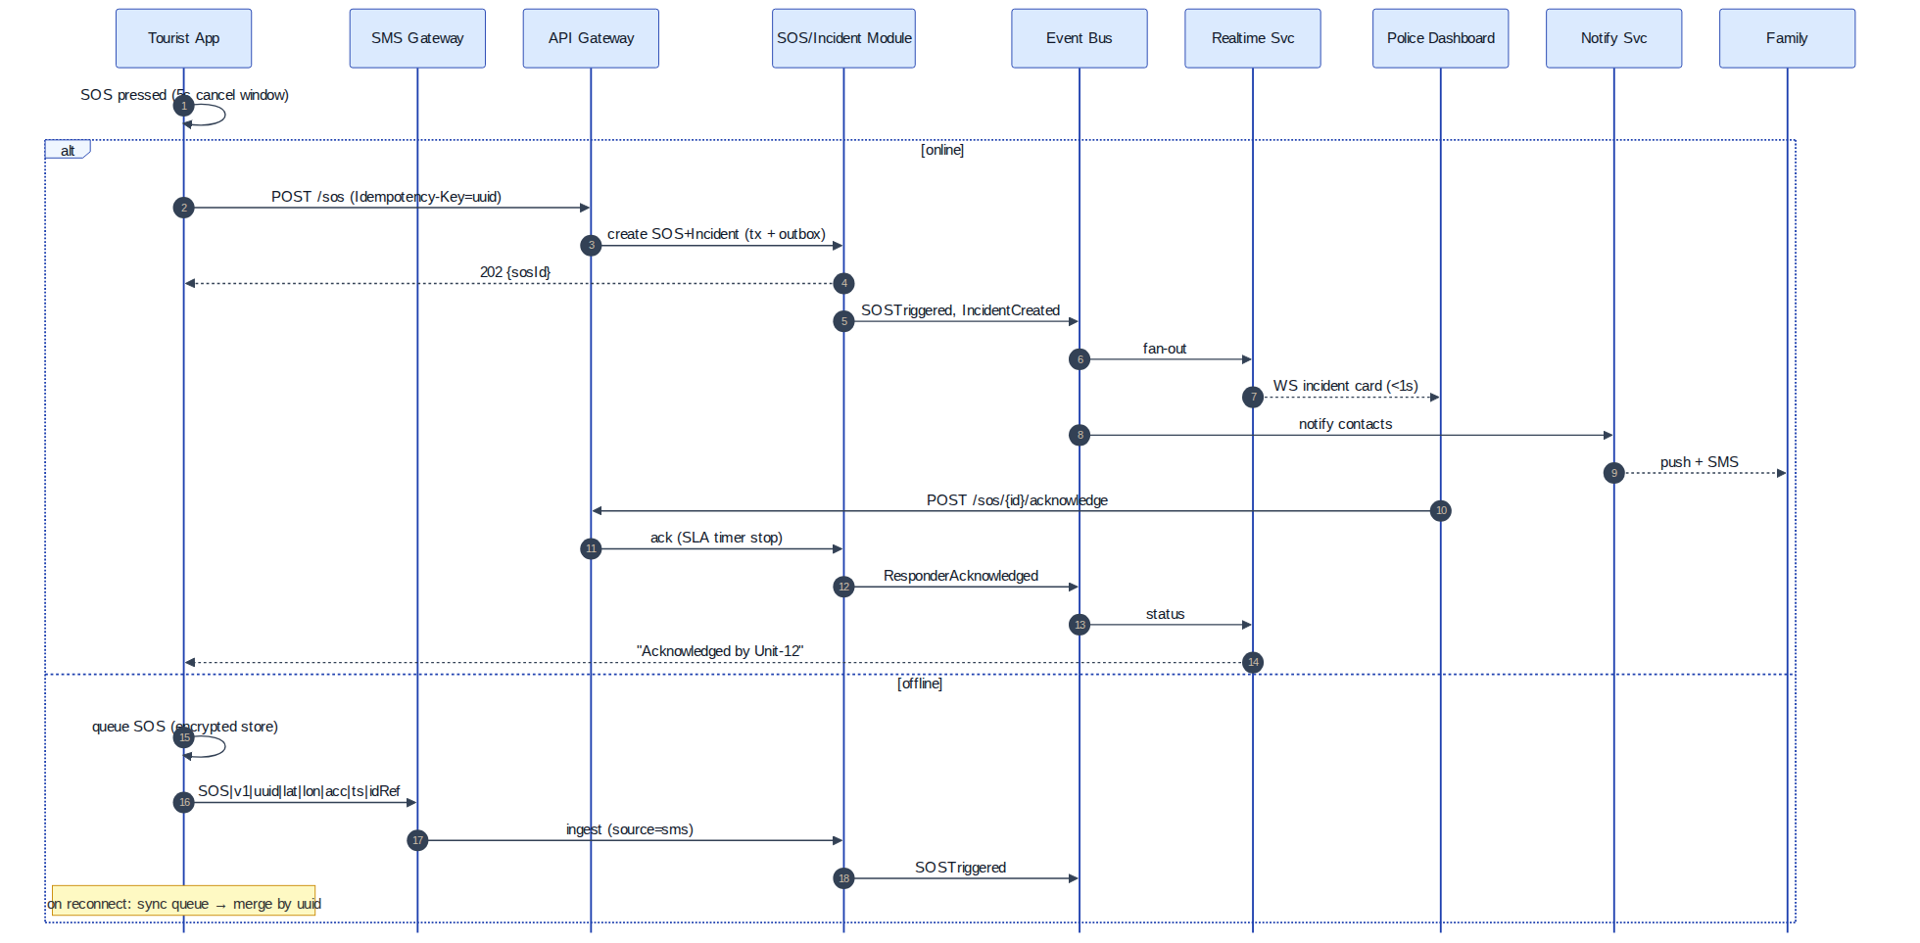
Figure 1 — SOS happy path with offline SMS fallback (sequence diagram)

4. Mobile Background Service Architecture (critical)

4.1 Android reality [stable platform behaviour; re-verify current API level]
- Permissions ladder: ACCESS_FINE_LOCATION (while-in-use) → separate user step for ACCESS_BACKGROUND_LOCATION ("Allow all the time") via settings redirect; Android 12+ users may grant coarse-only — app must detect and degrade. Play Store policy requires declared, in-app-disclosed background-location use; safety apps qualify but expect review friction.
- Foreground Service (FGS) with foregroundServiceType="location" and a persistent notification is the only sanctioned way to sample continuously. Android 14+ requires declaring FGS types in manifest and runtime justification; starting FGS from background is restricted (must start while app visible or from allowed triggers: high-priority FCM, alarm, boot receiver).
- Doze/App Standby: deep Doze defers network and jobs; FGS with location type is largely exempt from location throttling but network windows still batch; setExactAndAllowWhileIdle alarms for check-in timers; high-priority FCM pierces Doze for the user-challenge flow.
- OEM killers (Xiaomi/Oppo/Vivo/OnePlus aggressive task-killers) kill even FGS. Mitigations: battery-optimisation exemption prompt (ACTION_REQUEST_IGNORE_BATTERY_OPTIMIZATIONS — Play-policy-acceptable for safety category [ASSUMPTION — verify policy]), OEM-specific guidance screens (dontkillmyapp-style), server-side liveness watchdog: if a monitored trip's device misses 2× expected sync, that itself is a signal (this converts OS unreliability into a detection feature).
- Process death recovery: BOOT_COMPLETED receiver restarts monitoring for active trips; START_STICKY service; WorkManager periodic job (≥15 min) as belt-and-braces re-checker. Force-stop by user = total stop until next app open (OS guarantee) — must be disclosed in UX; server watchdog covers it.
- Geofencing API (Google Play services): ~100 fences/app, power-efficient but latency up to minutes and reliant on Fused Location — use it as a wake-up hint, with our own on-device polygon engine as truth (§11).

4.2 iOS reality
- No arbitrary background services exist. Options: (a) Standard location updates with allowsBackgroundLocationUpdates=true + "Always" authorization + background-mode location — continuous but battery-visible (blue indicator) and OS may still suspend on memory pressure; (b) Significant-Change Location Service (SLC) — wakes app on ~500 m cell-level changes, survives app termination and reboot; (c) Region monitoring — hardware-assisted, max 20 regions per app, circular only, radius ≥ ~100 m practical; survives termination; (d) Visit monitoring — too coarse. Background App Refresh off / Low Power Mode further constrain (b).
- "Always" location requires provisional flow (WhenInUse first, then upgrade prompt) and App Store justification; users can silently downgrade to WhenInUse — app must detect via authorizationStatus and warn.
- Push: APNs high-priority alerts wake UI but cannot silently run arbitrary code reliably (content-available background pushes are best-effort, throttled).
- SMS cannot be sent programmatically — offline SOS on iOS = pre-filled MFMessageComposeViewController (one user tap) + queue-for-sync. Document honestly.
- iPhone satellite SOS/Messages via satellite exist on recent hardware in supported regions — treat as OS-level complement, not an integratable API [UNRESOLVED — India availability].

4.3 “Should the app run as a background service?” — explicit answer
Android: YES — a location-type Foreground Service with persistent notification during active trips only, plus Play-services geofence wake-ups, boot/app-update receivers, WorkManager re-checker, and battery-optimisation exemption for the safety use case. Continuous background monitoring is legitimate and technically supported, with OEM-killer risk mitigated by the server-side missed-sync watchdog.
iOS: NO — not as a persistent service, because the platform forbids it. Instead compose: continuous updates (allowsBackgroundLocationUpdates) only during active trips, SLC as the resurrection mechanism after suspension, the 20-region budget spent dynamically on the nearest/highest-priority fences (re-seeded on each SLC wake), and check-in timers implemented server-side (push-challenge) rather than as local background timers. Accept and disclose: iOS fidelity < Android fidelity; the server watchdog + user-challenge design keeps the safety property (detection of silence) intact even when the app is suspended.

4.4 Monitoring mode engine
Mode | GPS sampling | Sync to server | Fence engine | Sensors | Battery strategy | Server comms
Normal (no trip) | none (SLC/passive only if user opted for standing safety) | none | off | none | zero-cost | none
Active Trip | adaptive 30–120 s (motion-gated: accelerometer stationary → back off to 5 min) | batch every 5–10 min or 50 points | on (cached pack) | significant-motion | balanced; Wi-Fi/cell fused fixes preferred | batched HTTPS
High Risk (in risky zone / night / trek corridor) | 10–30 s | 1–2 min | on, tightened buffers | motion + barometer (trek) | accepts higher drain; pre-warn user | batched, smaller batches
Emergency (SOS/incident open) | 1–5 s continuous | live stream (WS) + 15 s batch fallback | on | mic (consented), motion | ignore all savers; screen-off max brightness strobe optional | WS + redundant batch
Low Battery (<20%) | 2–5 min | 15–30 min | on (fences are cheap; evaluation is local math) | off | radio minimisation is the real saver (network > GPS cost) | opportunistic
Offline | per current mode | queue (encrypted, ring-buffered 10k points) | on — fully local | per mode | as mode | SMS for SOS/critical only; sync on restore
Mode transitions are events themselves (logged); parameters are server-versioned config so thresholds tune without app releases.

5. High-Level System Architecture

5.1 Component responsibilities
Component | Responsibility | Inputs → Outputs | Owns data | Key events produced / consumed | Scaling | Failure behaviour
Mobile App | Capture, local fence engine, offline queue, SOS UX | sensors → API/SMS | local queue | — | n/a | degrade per §4.4/§18
Web Dashboards | Authority/hospital/tourism/admin UX | WS+REST → operator actions | none | — | CDN/static | poll fallback on WS loss
API Gateway | TLS, authN offload, rate limits, routing, request IDs | HTTPS → services | none | — | horizontal | bypassable only by SMS path
Auth/Identity | Users, sessions, OTP, digital-ID issuance (VC signing) | credentials → tokens/VCs | User, Device, Credential | UserRegistered | stateless + Redis | login degraded ≠ SOS degraded (SOS uses long-lived device token)
User/Profile | Profiles, contacts, medical card | CRUD | TouristProfile, EmergencyContact | ProfileUpdated | trivial | read-cache serves stale
Trip | Trip lifecycle, consent tiers, check-in schedule | API → state | Trip, Consent | TripStarted/Stopped, CheckInMissed | trivial | —
Location-Ingest | Validate + bulk-write fixes, last-fix cache | batches → DB/cache | LocationPoint | LocationUpdated (latest) | hottest path: horizontal, partitioned tables | back-pressure: 429 with retry-after; client queues
Geofence | Zone CRUD/versioning, packs, server-side validation of events | polygons, events | GeoFence, GeoFenceEvent | GeoFenceEntered/Exited, ZoneUpdated | read-heavy: cache packs | stale packs acceptable (versioned)
Risk Engine | Rules evaluation, user-challenge orchestration, anomaly jobs | events+timers → assessments | RiskAssessment | RiskLevelChanged | worker pool | fail-safe: on engine down, missed-sync watchdog still runs as independent cron
SOS | SOS intake (API+SMS), SLA timers, escalation | SOS → incident | SOSAlert | SOSTriggered | small but HA-critical: ≥2 replicas always | SMS ingest path independent of gateway
Incident | State machine, timeline (hash chain), assignments, merge/dedup | transitions | Incident, IncidentEvent, Assignment | IncidentCreated/StatusChanged/Escalated | moderate | append-only design eases recovery
Dispatch | Responder/unit registry, assignment logic | assignments | Responder | ResponderAssigned/Acknowledged | trivial | manual assignment fallback
Notification | Multi-channel fan-out, fallback ladder, receipts | events → FCM/APNs/SMS/email/voice | Notification | NotificationSent/Failed | queue-driven horizontal | per-channel circuit breakers (§19)
Evidence | Presign, hash verify, retention | uploads | Evidence (metadata; blobs in S3) | EvidenceUploaded | S3 scales | uploads retry; metadata is source of truth
Realtime | WS sessions, subscriptions, presence | events → sockets | ephemeral | consumes most events | sticky-session pods + Redis pub/sub | clients poll on failure
Blockchain Adapter | Hash chains, Merkle batching, anchoring, verify API | incident/evidence events | BlockchainAnchor | AnchorRequested/Confirmed | async worker | never blocks core (§14)
Audit | Access logs, admin actions, query API | all privileged reads/writes | AuditLog | — | append-only, partitioned | write-ahead local buffer if DB blip
Analytics | Aggregates, heatmaps (k-anonymised) | warehouse ETL | aggregates | — | offline/batch | non-critical
Admin/Config | Orgs, roles, versioned runtime config | CRUD | Organization, Role, Config | ConfigChanged | trivial | config cached client-side
Message bus | Redis Streams [MVP] / Kafka [PROD] | — | — | — | — | outbox guarantees no event loss on bus blip
Cache | Redis: last-fix, sessions, rate-limit, zone packs, pub/sub | — | ephemeral | — | cluster [PROD] | cache-miss → DB (slower, correct)
Primary DB | PostgreSQL + PostGIS (+ time partitions) | — | everything relational | — | read replicas; partition pruning | §21
Object storage | S3-compatible: media, packs, exports | — | blobs | — | native | presign retries
Observability | OTel traces, Prometheus, Loki/ELK, alerting | telemetry | — | — | — | —

5.2 Component & data-flow diagram
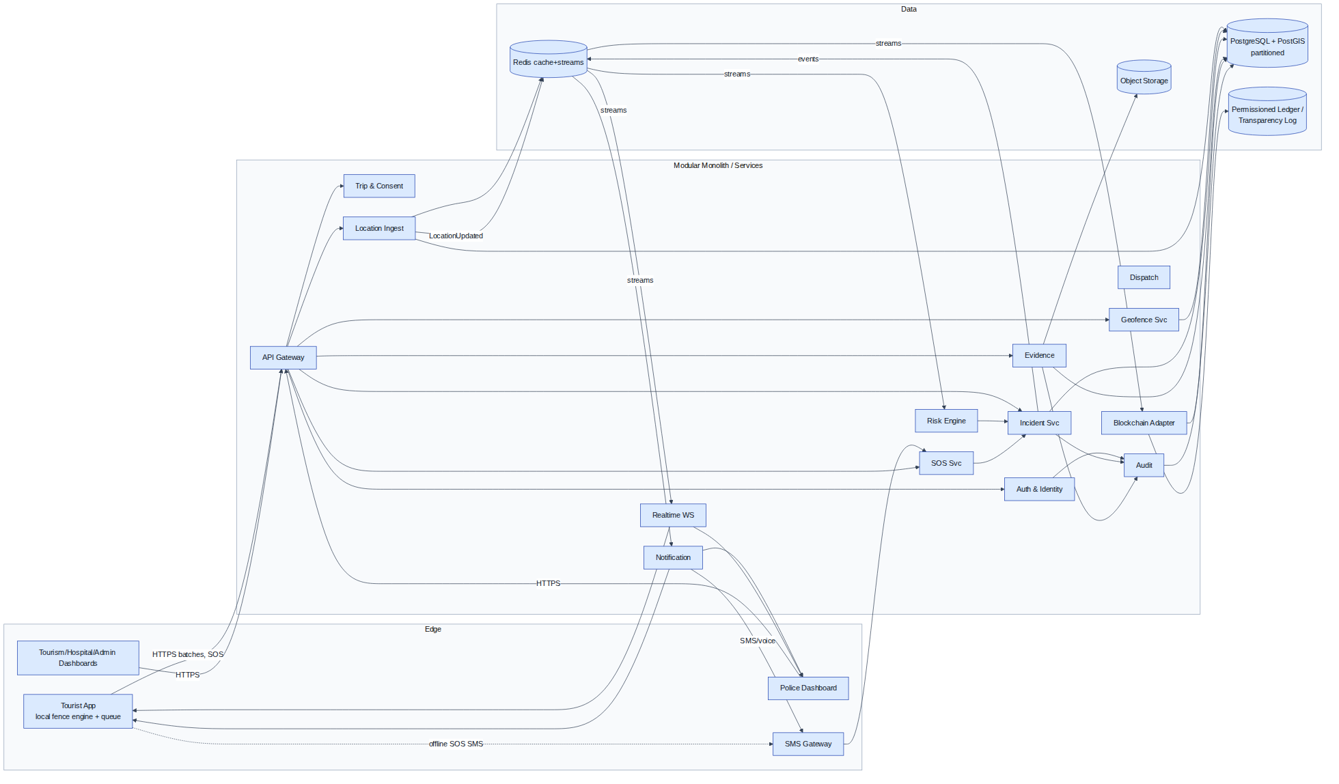
Figure 2 — Component and data-flow diagram

5.3 Deployment & trust boundaries
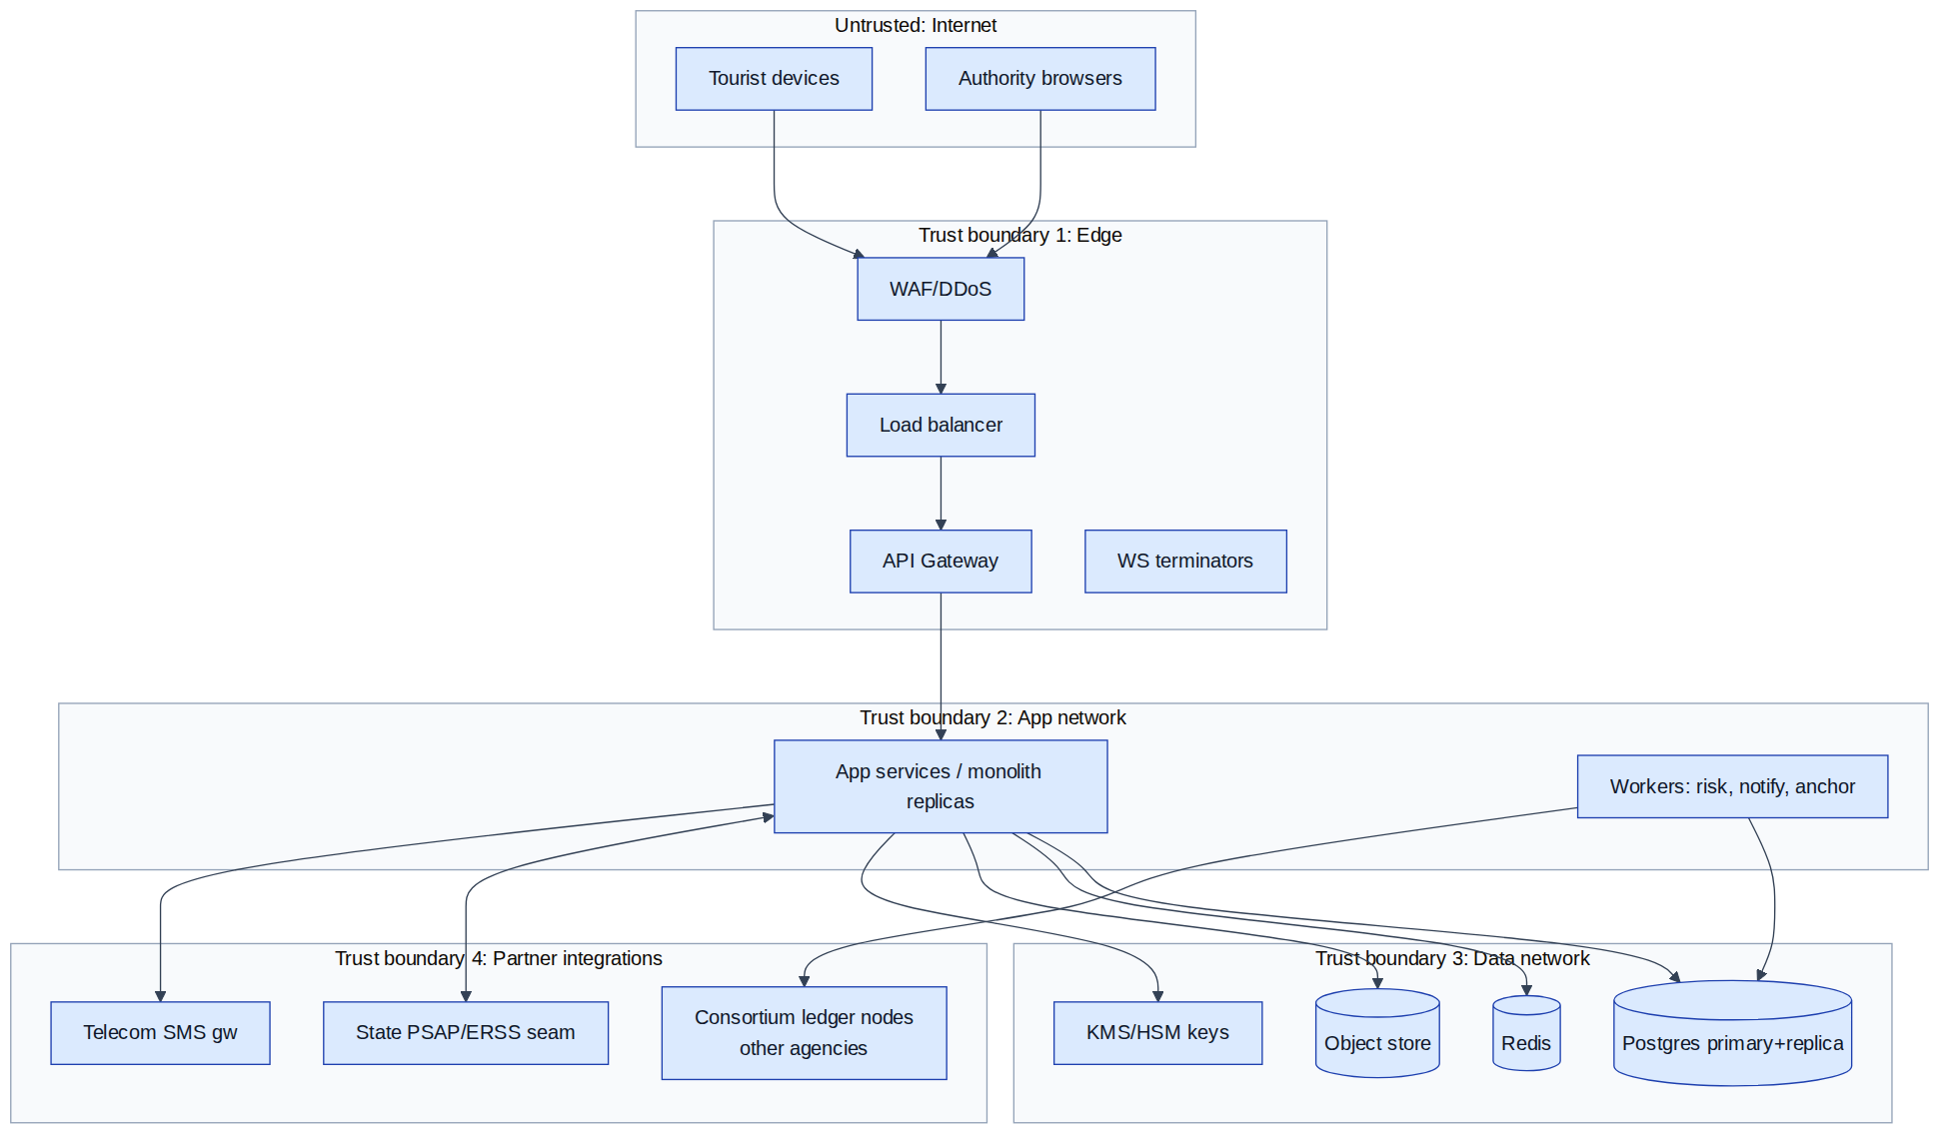
Figure 3 — Deployment topology and trust boundaries
Trust rules: nothing in AppZone holds long-term keys (KMS); Partner zone is mutually-authenticated (mTLS) and treated as semi-trusted (validate all inbound, e.g., SMS-origin SOS is flagged lower-verification); DataZone reachable only from AppZone security groups.

6. Architectural Style Decision
Criterion | Modular monolith | Microservices | Event-driven (orthogonal) | Serverless | Hybrid (rec.)
Complexity | Low | High (ops, contracts, distributed debugging) | Medium | Low ops, high modelling | Medium
Scalability | Vertical + replicas; module extraction later | Best per-hotspot | Enables both | Bursty-friendly; WS + long-lived FGS-ish workloads awkward; cold starts hurt SOS p95 | Targeted
Team size fit (4–8 devs) | ✔ | ✖ (needs platform team) | ✔ as internal pattern | partial | ✔
Hackathon feasibility | ✔✔ | ✖ | ✔ (outbox+streams is cheap) | partial | ✔
Cost | Lowest | Highest | — | Pay-per-use but SMS/WS pin costs | Low→grows with need
Reliability | Single blast radius — mitigated by replicas + module isolation | Partial-failure tolerant but adds failure modes | Decoupling helps | Vendor-dependent | Good
Dev speed | Fastest | Slowest early | — | Fast for glue | Fast

Decision [REC] (ADR-01): Modular monolith with strict module boundaries (package-level, separate schemas per module) + transactional outbox + Redis Streams events for MVP and v1 production. Migration path: (1) all inter-module calls go through interfaces + events from day one; (2) first extractions when metrics demand: Location-Ingest (write volume), Realtime/Notification (connection count), Blockchain-Adapter (isolation); (3) Kafka replaces Redis Streams when >1 consumer group lag or retention needs exceed Redis comfort (~weeks of events); (4) never extract Incident/SOS core early — it's the consistency heart.

7. Complete API Design
Conventions: base https://api.<domain>/v1; JSON; JWT bearer (access 15 min, refresh 30 d rotating); all mutating endpoints accept Idempotency-Key header (required where marked IK✔); X-Request-Id echoed; standard error envelope (§8.4); rate limits per token unless stated; RBAC roles: tourist, operator, dispatcher, hospital, tourism_admin, sys_admin, plus org scoping (ABAC attributes: orgId, districtId, incidentGrant).

AUTH
Method Path | Purpose | Auth | Key request fields | Success | Errors | Rate limit | IK
POST /auth/register | Create account, send OTP | none | phone/email, name, locale | 201 {userId, otpTxnId} | 409 duplicate, 422 | 5/h/IP | ✔
POST /auth/verify-otp | Verify OTP, activate | none | otpTxnId, code | 200 {tokens} | 401 bad code, 410 expired, 429 | 10/h/user | ✔
POST /auth/login | Password/OTP login | none | identifier, secret, deviceInfo | 200 {access, refresh, deviceId} | 401, 423 locked | 10/15min/IP | –
POST /auth/refresh | Rotate tokens | refresh | refreshToken | 200 new pair | 401 reuse-detected→revoke family | 60/h | –
POST /auth/logout | Revoke session/device | access | deviceId? | 204 | — | — | –
POST /auth/mfa/enroll·verify | TOTP for authority roles | access | — | 200 | — | — | –

USERS & IDENTITY
Method Path | Purpose | Auth/Role | Notes
GET /users/me | Profile | tourist+ | includes consent + credential status
PATCH /users/me | Update profile/medical card | tourist | field-level validation; medical fields flagged self-declared
POST /users/me/emergency-contacts | Add contact | tourist | max 5; optional contact-OTP verify
GET /users/me/emergency-contacts | List | tourist | —
DELETE /users/me/emergency-contacts/{id} | Remove | tourist | silent (no notification to contact)
POST /identity/verify | Run KYC (DigiLocker/passport) | tourist | 202 async; webhook/poll status
GET /identity/credential | Fetch VC + QR payload | tourist | short-TTL signed QR token
POST /identity/resolve | Scan QR → profile view | operator/hospital | requires purpose + open incidentId unless break-glass; logged

TRIPS
Method Path | Purpose | Auth | Notes | IK
POST /trips | Create draft | tourist | itinerary legs, group refs | ✔
GET /trips/{id} | Fetch | owner/operator-with-grant | — | –
POST /trips/{id}/start | Activate + consent tier | owner | returns zonePackVersion, checkInSchedule | ✔
POST /trips/{id}/pause · /resume | Suspend monitoring | owner | pause logs stateChange only | ✔
POST /trips/{id}/stop | End; triggers retention clock | owner | 409 if open incident (warn+confirm flow) | ✔
POST /trips/{id}/check-in | Manual "I'm OK" | owner | resets due timer | ✔

LOCATION
Method Path | Purpose | Auth | Notes | IK
POST /locations/batch | Upload buffered fixes | tourist(device token) | ≤500 points; gzip; batchId key; 429 with Retry-After on back-pressure | ✔(batchId)
GET /trips/{id}/latest-location | Last fix | owner, or operator with open-incident grant | served from Redis | –
GET /trips/{id}/location-history | Track | owner; operator only via incident grant + reason | paginated; audit-logged | –

GEOFENCES
Method Path | Purpose | Auth | Notes | IK
GET /geofences/nearby?lat&lon&radius | / GET /geofences/pack?region&sinceVersion | Zone pack sync | tourist | ETag/version delta; signed pack
POST /geofences | Create zone | tourism_admin/police-admin | class, geometry(GeoJSON), schedule, expiry(required for temporary), approval workflow | ✔
PATCH /geofences/{id} | Update → new version | same | old version retained | ✔
DELETE /geofences/{id} | Retire (soft) | same + approval | — | ✔
POST /geofences/events | Device-detected entry/exit (restricted/disaster classes) | tourist | server re-validates; clientEventId key | ✔

RISK
Method Path | Purpose | Auth | Notes
POST /risk/evaluate | On-demand evaluation (app query "how risky here?") | tourist | returns situation score + factors
GET /trips/{id}/risk | Current assessment | owner/operator-grant | —
GET /risk/zones?bbox | Advisory layers for map | tourist | cached tiles

SOS
Method Path | Purpose | Auth | Notes | IK
POST /sos | Trigger | tourist(device token; must succeed even with expired access token — device token is long-lived, SOS-scoped) | silent flag; creates incident atomically | ✔(client UUID)
POST /sos/{id}/cancel | Cancel | owner | in-window: auto; post-window: PIN; post-dispatch: flags operator | ✔
GET /sos/{id} | Status | owner/operator | — | –
POST /sos/{id}/acknowledge | Operator ack | operator | stops SLA clock | ✔
POST /sos/{id}/escalate | Manual escalate | operator/system | level, reason | ✔

INCIDENTS
Method Path | Purpose | Auth | Notes | IK
POST /incidents | Create (report class) | tourist/operator | category, narrative, loc | ✔
GET /incidents/{id} · GET /incidents?filters | Fetch/queue | role+org scoped | cursor pagination; queue sorted by priority,SLA | –
PATCH /incidents/{id} | Edit metadata | operator | append-only notes, not history rewrites | ✔
POST /incidents/{id}/assign | Assign responder/unit | dispatcher | — | ✔
POST /incidents/{id}/status | Transition | role-gated matrix | body: toState, reason; 409 on illegal transition | ✔
POST /incidents/{id}/close | Close with disposition | operator | requires dispositionCode; triggers final anchor | ✔
POST /incidents/{id}/merge | Merge duplicate | operator | primaryId, duplicateId | ✔
POST /incidents/{id}/grants | Issue scoped access (hospital, SDRF) | dispatcher | TTL-bound | ✔

EVIDENCE
Method Path | Purpose | Auth | Notes | IK
POST /incidents/{id}/evidence/presign | Get upload URL | tourist/operator | body: sha256, size, mime; virus-scan hook PROD | ✔
POST /incidents/{id}/evidence/confirm | Finalise | same | server hash must match | ✔
GET /incidents/{id}/evidence | List (metadata) | granted roles | view URLs short-TTL; every issue logged | –
POST /evidence/{id}/verify | Integrity check | any granted | recompute hash + anchor inclusion proof | –

NOTIFICATIONS & DEVICES
GET /notifications (cursor) · POST /notifications/{id}/read · POST /devices/register {platform, pushToken, model} (IK✔) · DELETE /devices/{id}.

BLOCKCHAIN
Method Path | Purpose | Auth
POST /blockchain/anchor | Force anchor batch (admin/ops) | sys_admin
GET /blockchain/verify/{incidentId} | Full-timeline verification report | granted roles
GET /blockchain/transactions/{incidentId} | Anchor tx list + proofs | granted roles

ADMIN
POST/GET/PATCH /admin/orgs · /admin/users (role grants w/ approval) · /admin/roles · /admin/config (versioned) · GET /admin/audit?filters (auditor role; export) · GET /admin/health · POST /admin/broadcasts (zone-targeted alert; tourism_admin + approval).
Added beyond the brief (required for completeness): /trips/{id}/check-in; /identity/*; /incidents/{id}/grants and /merge; /devices; /admin/broadcasts; /geofences/pack; WS endpoint /realtime (below).

8. API Contract Examples
Headers on all examples: Authorization: Bearer …, X-Request-Id: 9f1c…, Idempotency-Key where shown; responses echo X-Request-Id and add X-Correlation-Id (propagated through events/traces).
8.1 Start trip — POST /trips/trp_01H…/start (IK: f47a-…)
{
"consentTier": "GEOFENCE_ALERTS",
"shareWithContacts": ["ec_01","ec_02"],
"checkInIntervalMinutes": 240,
"regionHint": {"lat": 25.28, "lon": 91.72}
}
{ "tripId":"trp_01H…","status":"ACTIVE","consentReceiptId":"cr_889",
"zonePack":{"region":"IN-ML-EKH","version":42,"url":"https://cdn…/packs/IN-ML-EKH/42.pb","sha256":"ab12…"},
"checkInSchedule":{"nextDueAt":"2026-07-07T14:00:00Z"},
"modeParams":{"gpsIntervalSec":60,"syncIntervalSec":420} }
8.2 Location batch — POST /locations/batch (IK = batchId)
{ "batchId":"b_7d2e","tripId":"trp_01H…","deviceId":"dev_3a",
"points":[
{"ts":"2026-07-07T10:00:02Z","lat":25.28110,"lon":91.72065,"accM":8.2,"altM":1480,"speedMps":1.1,"battery":0.71,"provider":"fused"},
{"ts":"2026-07-07T10:01:03Z","lat":25.28131,"lon":91.72122,"accM":12.9,"battery":0.71,"provider":"gps"}
] }
200 {"accepted":2,"rejected":0,"lateSync":false,"nextSyncHintSec":420} · 429 {"error":{"code":"BACKPRESSURE"},"retryAfterSec":90}
8.3 SOS creation — POST /sos (IK = client UUID)
{ "clientSosId":"c0ffee-…","type":"MEDICAL","silent":false,
"location":{"lat":30.73512,"lon":78.44290,"accM":25.0,"ts":"2026-07-07T06:12:44Z"},
"battery":0.18,"network":"EDGE","note":"chest pain, near checkpoint 3" }
{ "sosId":"sos_9K2","incidentId":"inc_5T8","status":"RECEIVED",
"ackSlaSec":60,"channels":{"push":"SENT","contactSms":"QUEUED"},
"trackingMode":"EMERGENCY" }
8.4 Standard error envelope
{ "error":{"code":"VALIDATION_FAILED","message":"points[1].accM must be > 0",
"details":[{"field":"points[1].accM","issue":"non_positive"}],
"requestId":"9f1c…","retryable":false } }
8.5 Geo-fence event — POST /geofences/events (IK = clientEventId)
{ "clientEventId":"ge_44a","tripId":"trp_01H…","zoneId":"zone_rst_112","zoneVersion":7,
"direction":"ENTER","ts":"2026-07-07T11:03:19Z",
"fix":{"lat":27.1122,"lon":88.6021,"accM":34.0},"dwellSec":95,"confidence":0.83 }
Response: {"eventId":"gfe_812","serverValidation":"CONFIRMED","action":"AUTHORITY_NOTIFIED"} (or "UNCERTAIN_BOUNDARY","action":"NONE").
8.6 Risk response — GET /trips/{id}/risk
{ "assessmentId":"ra_71","situationScore":68,"severity":"HIGH","confidence":0.74,
"factors":[{"k":"ZONE_CLASS","v":"TREK_CORRIDOR_EDGE","w":0.35},
{"k":"TIME_NIGHT","v":true,"w":0.15},
{"k":"CHECKIN_OVERDUE_MIN","v":95,"w":0.30},
{"k":"WEATHER_ALERT","v":"IMD_ORANGE","w":0.20}],
"recommendedAction":"USER_CHALLENGE","evaluatedAt":"2026-07-07T11:05:00Z" }
8.7 Responder acknowledgement — POST /sos/sos_9K2/acknowledge
{ "operatorId":"op_112","unitId":"unit_UK_12","etaMinutes":22,"note":"SDRF informed" }
→ 200 {"status":"ACKNOWLEDGED","ackLatencySec":41}
8.8 Incident status update — POST /incidents/inc_5T8/status (IK)
{ "toState":"ON_SCENE","ts":"2026-07-07T06:41:10Z","reason":"unit arrived","evidenceRefs":[] }
→ 200 {"state":"ON_SCENE","eventId":"iev_204","prevHash":"9ac1…","eventHash":"77b0…"} · 409 ILLEGAL_TRANSITION.
8.9 Blockchain verification — GET /blockchain/verify/inc_5T8
{ "incidentId":"inc_5T8","events":37,"chainValid":true,
"anchors":[{"batchId":"anc_118","merkleRoot":"5fd0…","txId":"0x8a…","network":"besu-consortium","confirmedAt":"2026-07-07T07:00:03Z","coversEvents":[1,29]},
{"batchId":"anc_119","status":"PENDING","coversEvents":[30,37]}],
"evidence":[{"evidenceId":"evd_9","sha256":"ab77…","anchored":true,"inclusionProofValid":true}],
"verdict":"VALID_WITH_PENDING_TAIL" }
Pagination: cursor-based ?cursor=…&limit=50 returning {items, nextCursor}. Versioning: URI major (/v1), additive changes only within major; deprecation headers. Idempotency: server stores (key, requestHash, response) 48 h; mismatched body on same key → 422 IDEMPOTENCY_CONFLICT.

9. Real-Time Communication
Mechanism | Fit | Notes
WebSockets | Dashboards; app during EMERGENCY mode | bidirectional, low latency; needs sticky sessions + Redis pub/sub fan-out; battery cost fine for plugged-in dashboards, acceptable during incidents
SSE | [ALT] dashboards | simpler, one-way; no upstream ops; fine fallback
Push (FCM/APNs) | Primary tourist channel when app backgrounded | high-priority pierces Doze; delivery best-effort → pair with SMS for critical (§19)
Polling | Universal fallback | 15–30 s adaptive when WS down
MQTT | [ALT] if IoT wearables/bands ship | QoS levels attractive; skip until hardware exists — don't add a broker for phones that speak HTTPS/WS fine
Assignments [REC]: SOS alert to dashboard: WS (+ audible), with server-confirmed display-receipt; incident updates to tourist: push + WS-if-foreground + SMS for critical; live tourist location: app→server via batched HTTPS normally, WS stream in emergency mode; server→dashboard via WS; risk warnings: push (advisory) / push+SMS (critical).
Connection failure design: heartbeat ping/pong 25 s; client reconnect with jittered exponential backoff (1→2→4→…→60 s cap); on reconnect send lastEventId → server replays from stream (Redis Streams retains ≥24 h); dashboards show staleness indicator >10 s without heartbeat and auto-fall back to polling; an SOS is never delivered only via WS — it is durably in the queue table and the incident list poll picks it up regardless.

10. Database Architecture
Engine [REC]: PostgreSQL 16 + PostGIS (geometry, GiST) + native range partitioning (pg_partman) for time-series tables. TimescaleDB [ALT] if ops team prefers hypertable ergonomics.

10.1 ER diagram
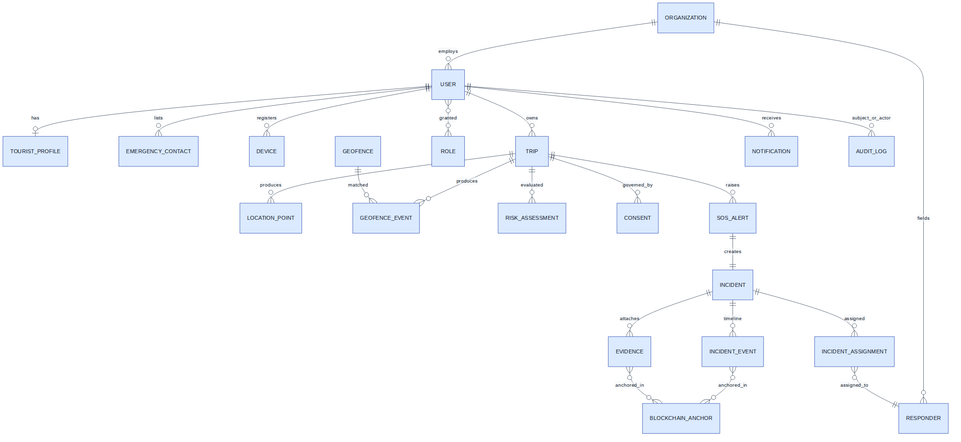
Figure 4 — Entity-relationship model (core entities)

10.2 Entity specifications (key fields; all tables get id UUIDv7 PK, created_at, updated_at)
Entity | Key fields (type) | Constraints / FKs | Indexes | Retention | Sensitivity
user | phone (citext UQ), email UQ null, password_hash, status, locale | — | UQ(phone) | account life + 90 d | PII
role / user_role | name; user_id FK, role_id FK, org_id FK, granted_by | UQ(user,role,org) | (user_id) | audit-permanent | —
organization | type ENUM(police,hospital,tourism,sdrf,admin), name, district, state | — | (state,district,type) | permanent | —
tourist_profile | user_id FK UQ, nationality, id_type, id_ref_encrypted, blood_group, allergies jsonb, medical jsonb, credential_id, credential_expires_at | — | (credential_expires_at) | purge ≤30 d after last trip end [ASSUMPTION — legal] | PII+medical: field-level encrypted
emergency_contact | user_id FK, name, phone_encrypted, relationship, channels jsonb, verified bool | ≤5/user | (user_id) | with profile | PII
device | user_id FK, platform, push_token, device_key_pub, model, last_seen_at | UQ(push_token) | (user_id) | with account | —
trip | user_id FK, status ENUM, consent_tier, itinerary jsonb, region, starts_at, ends_at, checkin_interval, next_checkin_due | status transitions via app logic | (user_id,status), (next_checkin_due) WHERE active | metadata 1 y; see location | —
location_point | trip_id FK, ts, geom geography(Point), acc_m, alt_m, speed, battery, provider, late_sync bool | partition BY RANGE(ts) monthly; PK(trip_id,ts) | GiST(geom) per partition; (trip_id, ts DESC) | raw 30 d post-trip → downsampled polyline 90 d → delete [ASSUMPTION] | sensitive: movement
geofence | class ENUM(restricted,advisory,disaster,wildlife,trek_corridor,crowd,night), geom geography(Polygon/MultiPolygon), buffer_m, schedule jsonb, version int, status, expires_at (NOT NULL for temporary), created_by, approved_by | soft-delete; version bump on geometry change | GiST(geom), (class,status), (expires_at) | versions permanent (audit) | —
geofence_event | trip_id, geofence_id+version, direction, ts, fix geom, acc_m, dwell_s, server_validation ENUM, client_event_id | UQ(client_event_id); cooldown enforced app-side + UQ(trip,zone,direction,ts::5min bucket) | (geofence_id,ts), (trip_id,ts) | 1 y | movement
risk_assessment | trip_id, score smallint, severity ENUM, confidence, factors jsonb, action ENUM, ts | — | (trip_id,ts DESC) | 90 d | derived-sensitive
sos_alert | trip_id, user_id, client_sos_id UQ, type, silent bool, status ENUM, source ENUM(app,sms,watch), fix geom, ack_at, ack_by | — | (status) partial WHERE open | tied to incident | sensitive
incident | type ENUM(sos,anomaly,report,external), state ENUM, priority smallint, jurisdiction_org FK, primary_of (merge) FK null, opened_at, closed_at, disposition | state machine in code + CHECK | (state,priority), (jurisdiction_org,state), GiST(fix) | 7 y [ASSUMPTION — legal evidence norms; validate] | case data
incident_event | incident_id FK, seq int, actor(user/system), type, payload jsonb, ts, prev_hash bytea, event_hash bytea | UQ(incident_id,seq); append-only (no UPDATE/DELETE grants) | (incident_id,seq) | with incident | case data
incident_assignment | incident_id, responder_id, role, state, assigned_at, ack_at | — | (responder_id,state) | with incident | —
responder | org_id, user_id, unit_code, capabilities jsonb, on_duty bool, last_fix geom | — | (org_id,on_duty), GiST(last_fix) | — | staff PII
evidence | incident_id FK, uploader, sha256 bytea UQ-per-incident, mime, size, s3_key, captured_at, anchored bool | — | (incident_id) | with incident; blobs lifecycle-tiered | evidence: strict access
notification | user_id, priority, channel, template, payload jsonb, status, sent_at, delivered_at, read_at | — | (user_id,created_at DESC), (status) partial | 180 d | —
consent | user_id, trip_id, tier, purposes jsonb, granted_at, withdrawn_at, receipt_sig bytea | — | (user_id,trip_id) | permanent (proof of lawful processing) | compliance
audit_log | actor_id, actor_org, action, resource_type, resource_id, reason, incident_grant_id null, ip, ts | append-only; partition monthly | (resource_type,resource_id,ts), (actor_id,ts) | 7 y | compliance
blockchain_anchor | batch_id, merkle_root bytea, tx_id, network, event_range, status ENUM, confirmed_at, proofs jsonb | — | (status), (confirmed_at) | permanent | —
Partitioning: location_point + audit_log + notification monthly range partitions, auto-create/detach jobs; partition pruning makes retention deletion = DROP PARTITION (fast, vacuum-free). Geospatial: GiST on all geometry; zone lookup = ST_Contains(zone.geom, point) with && bbox prefilter; last-fix reads served from Redis, Postgres is durability. Scaling path: read replicas → citus/sharding by state_id only if a national rollout demands [PROD].

11. Geospatial & Geo-Fencing Architecture
Where does fencing logic execute? [REC] HYBRID — device is the detector, server is the validator and authority-notifier.
- Device-side (primary): offline-capable, low-latency, privacy-preserving (advisory-zone hits never leave the device). Implementation: signed regional zone packs (protobuf: zone id, class, version, geometry simplified to ≤200 vertices with ST_SimplifyPreserveTopology, buffer, schedule) cached per trip region; evaluation = bbox prefilter → ray-casting point-in-polygon (or precompiled H3 cell membership sets for very complex polygons [ALT]); OS geofence APIs (Android Play-services fences; iOS's 20 circular regions seeded with nearest/highest-priority zones) used only as low-power wake-up triggers, our engine confirms.
- Server-side (secondary): authoritative PostGIS validation of restricted/disaster events (protects against tampered packs and stale versions); periodic sweep of latest fixes vs. newly created temporary zones (a device can't know a fence created after its last pack sync — the server closes that gap and pushes pack-update notifications); analytics.
GPS drift & event quality: accuracy gate (fix.accM must be < class threshold: restricted 30 m, advisory 75 m); boundary hysteresis: entry requires point inside shrunk polygon (buffer −accM), exit requires outside expanded polygon; dwell timers (restricted ≥60 s, advisory ≥30 s); N-consecutive-fix confirmation (≥2); speed sanity (drop teleport fixes >250 km/h implied). Duplicate suppression: per (zone,direction) cooldown 5 min device-side + server unique bucket constraint.
Zone lifecycle: create (draw GeoJSON) → validate (self-intersection, area caps, mandatory expiry for temporary) → approval workflow (class-dependent approver) → publish (version++, pack rebuild, delta push notification to affected active trips) → retire (soft). Every version immutable and audit-linked. Temporary disaster zones bypass the slow approval path via a two-person emergency publish (declarer + confirmer) with auto-expiry ≤72 h [REC].
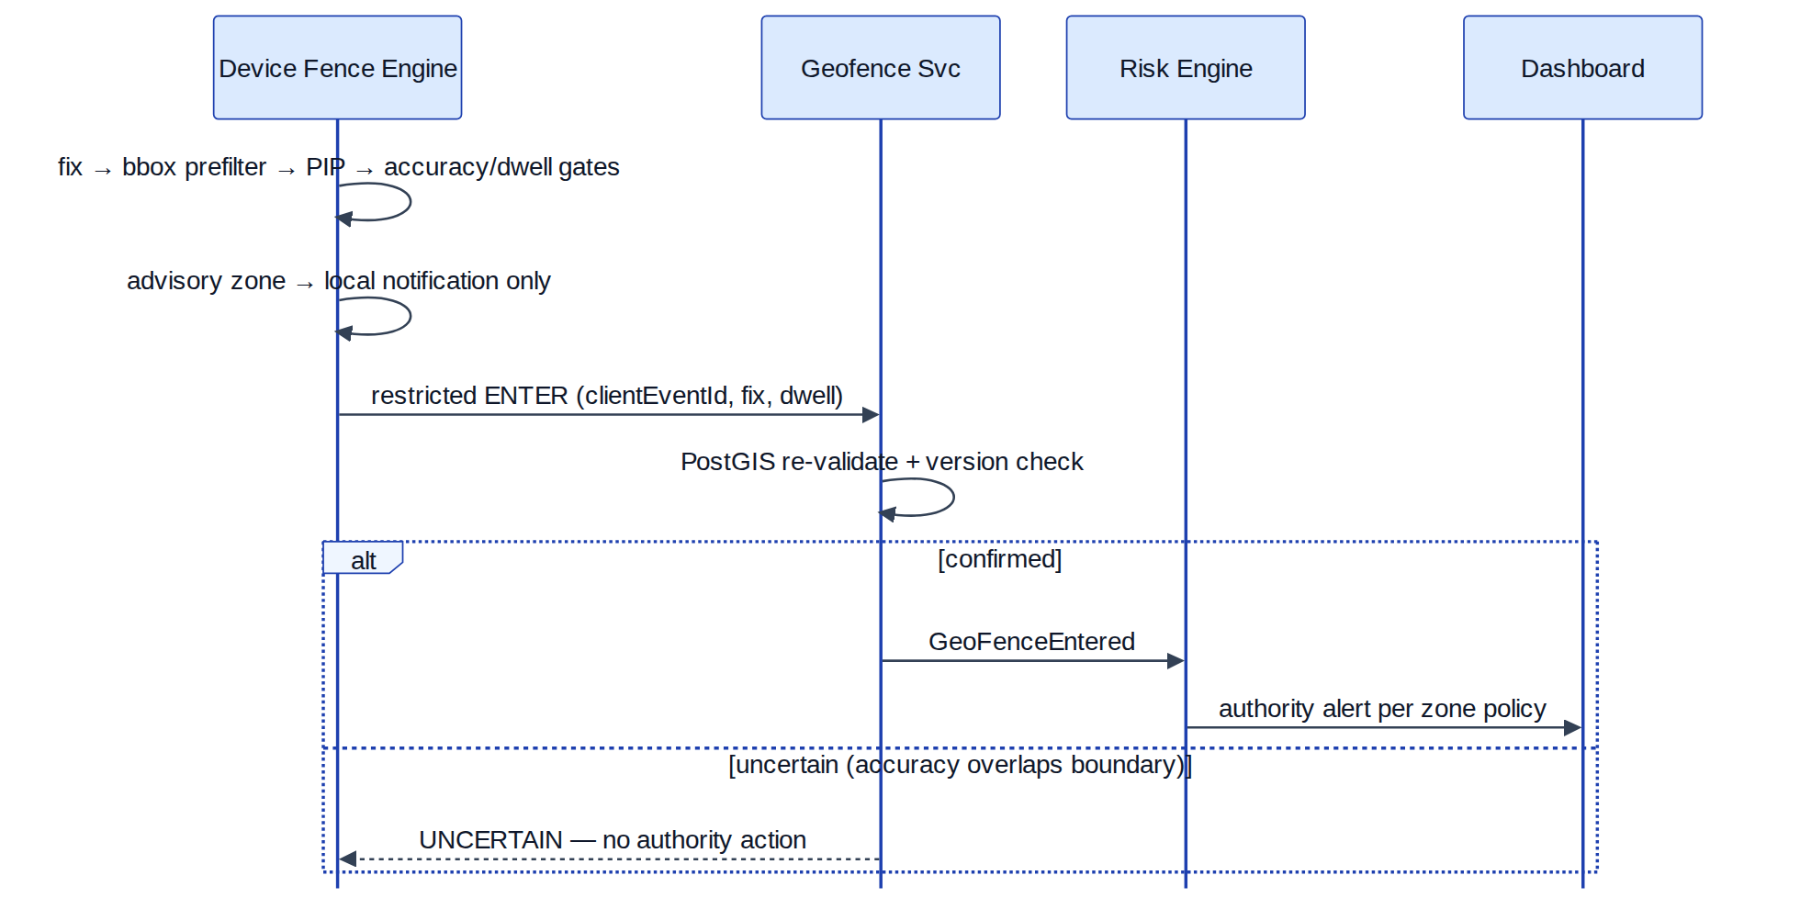
Figure 5 — Hybrid geo-fencing: device detection with server validation (sequence diagram)

12. AI System Architecture
Feature | Problem | Input → Output | Model type | Data need | Inference @ | Latency | Confidence/threshold | Fallback | Human review | MVP verdict
Risk scoring | Situation risk | context features → score 0–100 | Rules/weighted-linear (no ML) | zone tables, config | server | <100 ms | deterministic | n/a | thresholds reviewed by ops | Rules (§13)
Movement anomaly | Detect silent distress | location series + itinerary → anomaly flag | Rules v1; v2 supervised GBM/LSTM on pilot labels | needs ≥ months of labelled pilot data (cold start) | server workers | seconds OK | v2: flag ≥0.8, challenge ≥0.6 | rules remain as floor | always user-challenge before any escalation | Rules v1
Incident classification | Triage text/voice reports | narrative/audio → category+priority suggestion | LLM/API or fine-tuned transformer | none for zero-shot | server (API) | <2 s | display confidence; never auto-route <0.9 | keyword rules | operator confirms every suggestion | P1 assistive only
Safe-route scoring | Route advice | route → risk | — | incident geodata (sparse; bias risk) | — | — | — | curated corridors | — | Defer (redlining hazard)
Crowd analysis | Density risk | aggregate density → warning | time-series forecasting | telecom/gate feeds | server | minutes | — | manual event policing | required | Out of MVP
Multilingual assistant + alert translation | Language gap | text/speech ↔ target language | hosted MT/ASR (Bhashini/commercial) | none | server API; cache templates | <1.5 s | show source text alongside | pre-translated templates for all critical alerts (no live MT on the critical path) | interpreter escalation | P0 for templates, P1 for chat
Fake report detection | Hoax load | — | — | — | — | — | — | — | — | DO NOT BUILD (provide verification signals — verified ID, history — to humans)
Architecture: no training infrastructure in MVP; an ai-inference internal module wraps external APIs behind our own interface (swap vendors freely), with per-feature circuit breakers → deterministic fallbacks. All AI outputs stored with model/version + inputs hash for auditability; DPDP SDF algorithmic-assessment duty anticipated [carry-over from domain report].

13. Risk Engine Design
Model [REC]: deterministic, explainable, versioned rules with weighted scoring — ML later, behind the same interface.
score = clamp( Σ w_i · f_i(context), 0, 100 ) with factor examples:
Factor | Signal | Example contribution
Zone class occupancy | inside advisory +10 / restricted +35 / disaster +50 / trek-corridor-edge +25
Time of day | night in night-risk overlay +10
Weather | IMD warning level orange +15 / red +25 (feed)
Route deviation | distance-off-corridor tiered: >200 m +15, >1 km +30
Check-in overdue | +2/15 min, cap +30
Device inactivity / dark | no fix & no network expected? −(expected-offline flag) else +20 after 2× sync interval
Movement pattern | stationary >90 min mid-corridor daytime +15; erratic speed +10
Historical incidents cell | grid-cell incident quantile +0–10
Crowd density (future) | +0–15
Severity bands: 0–29 LOW (log), 30–54 MODERATE (in-app advisory), 55–74 HIGH (user-challenge, notify contacts on challenge timeout), 75–100 CRITICAL (challenge with short 5-min timeout → incident creation → dashboard). Confidence = data-freshness × fix-quality multiplier; low confidence caps severity at HIGH (never CRITICAL on stale data). Hard rule: the engine can never dispatch responders; it can only create a triaged incident for a human. Weights/thresholds are versioned config (admin UI), every assessment stores engine version + factor vector (explainability & tuning). ML future: replace f_i internals or add a learned factor; the challenge-first state machine is permanent regardless of model quality.

14. Blockchain Architecture
Evaluation. | Option | Verdict | |---|---| | Public chain (Ethereum L1) | ✖ — gas cost/volatility, PII-adjacency optics, no governance fit for state agencies | | Public L2 (Polygon PoS) | [ALT] as a public anchoring target for Merkle roots only (cheap, externally verifiable); acceptable because roots leak nothing; adds external-trust anchor beyond the consortium | | Permissioned consortium (Hyperledger Fabric / Hyperledger Besu QBFT) | [REC] if ≥3 agencies (police, tourism, SDMA/judiciary-NIC) run nodes; Besu preferred: Ethereum tooling (Solidity, web3 clients), simpler dev than Fabric's chaincode+MSP overhead for this narrow use | | No chain: signed hash-chained log + periodic public transparency-log/newspaper-style root publication | [ALT — fully acceptable] if consortium governance fails; identical product guarantees minus decentralised operation |
Trust model: watch-the-watchers — no single agency (including the operator) can silently rewrite incident history; tourists/courts verify via inclusion proofs. On-chain (only): batch Merkle roots; per-batch metadata (count, time range); anchor authority signatures. Even incident IDs stay off-chain in [REC] design — the root suffices and avoids linkability metadata. Off-chain (always): all PII, passports, GPS history, media, medical data, AI outputs, event payloads (encrypted in Postgres/S3; only hashes are chained).
Smart contract interface (Solidity sketch) & necessity audit:
contract IncidentAnchors {
event Anchored(bytes32 indexed root, uint64 count, uint64 fromTs, uint64 toTs, address submitter);
mapping(bytes32 => uint256) public anchoredAt;
function anchorBatch(bytes32 root, uint64 count, uint64 fromTs, uint64 toTs) external onlyRole(ANCHORER);
function isAnchored(bytes32 root) external view returns (uint256 blockTime);
}
- anchorBatch — necessary (the whole point).
- isAnchored/verify — necessary (read path).
- createIncidentAnchor per-incident — unnecessary (per-incident txs leak activity volume/timing and cost more; batch roots subsume it).
- addEvidenceHash on-chain per file — unnecessary (evidence hashes are leaves in the batch tree; inclusion proof gives per-file verification).
- addIncidentEvent on-chain — unnecessary and harmful (event-level on-chain writes = metadata surveillance channel).
- closeIncident on-chain — unnecessary (closure is just another anchored event).

Submission pipeline: adapter batches every 10 min or 500 events → builds Merkle tree → stores proofs in Postgres → submits via 2 redundant RPC endpoints → waits finality (QBFT: ~seconds) → marks confirmed. Failure handling: retries w/ backoff → DLQ → ops alert; verify API reports PENDING_TAIL honestly; core system never blocks on the chain. Keys: anchorer key in KMS/HSM, rotated; node ops runbooks per agency [UNRESOLVED — consortium MoU is an organisational, not technical, dependency; ship with transparency-log fallback switch].

15. Event-Driven Architecture
Transport: Redis Streams [MVP] / Kafka [PROD]. All events published via transactional outbox (event row committed atomically with state change; relay publishes). Envelope: {eventId(UUIDv7), type, version, occurredAt, correlationId, causationId, producer, payload}. Consumers are idempotent on eventId (processed-events table / Redis SETNX 7 d).
Event | Producer → Consumers | Payload core | Delivery | Retry | Dedup | Ordering
TripStarted / TripStopped | Trip → Risk, Analytics, Notify | tripId, userId, tier, region | at-least-once | consumer backoff 5× → DLQ | eventId | per-trip (stream key=tripId)
LocationUpdated (latest-fix) | Location-Ingest → Risk, Realtime | tripId, fix, accM, battery | at-least-once, lossy-OK (superseded by next) | 2× then drop | ts monotonic guard | per-trip required
GeoFenceEntered/Exited | Geofence → Risk, Notify, Audit | tripId, zoneId+ver, direction, validation | at-least-once | 5×→DLQ | clientEventId | per-trip
RiskLevelChanged | Risk → Notify, Incident, Realtime | assessmentId, score, severity, action | at-least-once | 5×→DLQ | assessmentId | per-trip
SOSTriggered | SOS → Incident, Realtime, Notify, Audit | sosId, incidentId, type, fix, silent | at-least-once, highest priority stream/topic | aggressive: 10× fast | clientSosId | per-incident
IncidentCreated / IncidentStatusChanged / IncidentEscalated / IncidentResolved | Incident → Realtime, Notify, Blockchain-Adapter, Analytics, Audit | incidentId, seq, state, actor, eventHash | at-least-once | 5×→DLQ | (incidentId,seq) | strict per-incident (partition key=incidentId)
ResponderAssigned / ResponderAcknowledged | Dispatch → Realtime, Notify, SLA-timers | incidentId, responderId, eta | at-least-once | 5× | eventId | per-incident
EvidenceUploaded | Evidence → Blockchain-Adapter, Notify(op), Audit | evidenceId, sha256, incidentId | at-least-once | 5× | sha256+incident | none
NotificationRequested/Sent/Failed | any → Notify → Analytics | channel, priority, target | at-least-once | channel ladder (§19) | notifId | none
BlockchainAnchorRequested/Confirmed | Adapter internal → Audit, verify cache | batchId, root, txId | at-least-once | long backoff (chain may be down hours) | batchId | batch sequence
ZoneUpdated | Geofence → Realtime(pack-push), Analytics | zoneId, version, class, bboxRegion | at-least-once | 5× | (zoneId,version) | per-zone
CheckInMissed | Trip cron → Risk | tripId, dueAt, missCount | at-least-once | 5× | (tripId,dueAt) | per-trip

16. Security Architecture
AuthN: OIDC provider (Keycloak [PROD] / library-JWT [MVP]); tourists: phone-OTP + optional password; authority users: username+password+mandatory TOTP MFA, org-admin provisioning only (no self-signup); device registration binds a device keypair (attestation via Play Integrity / App Attest [PROD]) — location batches and SOS are device-signed. Special token: long-lived, narrowly-scoped SOS device token so SOS works even with expired sessions.
AuthZ: RBAC (roles above) + ABAC for the sensitive reads: policy = role ∧ org-jurisdiction ∧ (open incident grant ∨ break-glass). Example: operator may read location-history(trip) iff exists incident(trip) ∧ incident.jurisdiction = operator.org ∧ incident.state ∈ open ∧ purpose supplied. Enforced in a single policy module (OPA [ALT] / in-code policy layer [MVP]) — never scattered per-endpoint.
Break-glass: requires target ref + declared reason + second-person approval (or post-hoc review within 24 h if solo at 3 a.m.) → time-boxed grant (≤4 h) → every read logged → tourist notified after incident closure.
Crypto: TLS 1.3 everywhere; mTLS service↔service and partner links; AES-256-GCM at rest (disk + field-level via envelope encryption for id_ref, contacts, medical via KMS data keys); secrets in Vault/cloud secret manager, never env-committed; key rotation: data keys 90 d, signing/anchor keys 1 y with overlap; JWT signing keys via JWKS rotation.
API protection: gateway rate limits (per token + per IP), request-size caps, JSON schema validation, WAF rules, OTP/login lockouts with exponential delay, audit on all admin routes.
Threat model:
Threat | Vector | Controls
Fake SOS / hoax floods | scripted or malicious users | device-signed SOS, verified-ID weighting, cancel-window analytics, per-device velocity limits, human triage retains authority, repeat-pattern human review (never auto-block a possible victim)
Account takeover | OTP interception, credential stuffing | refresh-rotation + reuse detection, device binding, new-device step-up, lockouts, SIM-swap heuristic (carrier change → re-verify) [PROD]
GPS spoofing | mock-location apps, external spoofers | mock-location flag (Android isMock), Play Integrity, plausibility checks (speed/teleport), cell/Wi-Fi cross-check [PROD]; accept residual risk — spoofing mainly enables self-harm of one's own record
Evidence tampering | modify media post-capture, DB edits | capture-time hashing, append-only tables (no UPDATE grants), Merkle anchoring, S3 object-lock [PROD], verify API
Insider threat (operator browsing) | curiosity/stalking via dashboard | ABAC incident-grant gating, purpose strings, full read-audit, anomalous-access detection (profile views without incidents), watermarked UI
API abuse/scraping | enumeration of tourists/incidents | UUIDv7 non-guessable ids, strict authZ on every object (no IDOR), rate limits, pagination caps
DDoS | volumetric on SOS path | CDN/WAF, anycast, SOS endpoint isolated pool + priority queue, SMS path as independent ingress
Stolen tourist device | attacker triggers/cancels SOS, reads data | app-lock (biometric) for profile/history; SOS trigger deliberately NOT locked (emergency>confidentiality); cancel requires PIN; remote logout
Malicious responder | false status updates, evidence deletion | append-only timeline, two-person evidence deletion [PROD: never delete, only legal-hold seal], all actions signed+logged
Blockchain key compromise | fake anchors | HSM custody, multi-sig anchorer [PROD], anchor monitoring (unexpected roots alert), chain is tamper-evidence — DB hash-chain still detects mismatch

17. Privacy Architecture
Engineered controls (DPDP-native, per domain report):
- Consent as data: consent receipts (tier, purposes, ts, signature) are first-class rows; every processing job checks tier before touching location data; withdrawal → immediate pipeline stop + retention clock start.
- Tiers in the data path: CHECKIN_ONLY → no location rows at all (only check-in events); GEOFENCE_ALERTS → advisory evaluation on-device, server stores no advisory events, only restricted/disaster; FULL → batched trail with retention. Default = least invasive.
- Minimisation: adaptive sampling already minimises; server stores accuracy-truncated coords for analytics (3 decimals ≈ 110 m) separately from operational precise fixes; aggregates use H3 cells with k≥20 suppression.
- Purpose limitation in code: location read APIs require purpose enum + incident grant; analytics reads only the truncated store; no export API for raw trails.
- Retention as jobs: partition-drop schedules per §10; deletion certificates logged; user-initiated deletion API honours legal holds (open incidents) transparently.
- Pseudonymisation: analytics pipeline re-keys user ids per-epoch; dashboards show credential ref, full PII on click-through with audit.
- Emergency override: break-glass §16 — bounded, logged, notified.
- Anti-surveillance guarantees (product commitments): no standing tracking outside active trips; no advisory-zone telemetry; no cross-trip movement profiling; access statistics published; independent audit hooks. The honest answer to "how does this avoid mass surveillance": by making the invasive tiers opt-in, the invisible tiers default, the sensitive reads incident-gated, and every read auditable — and by not building the features (standing tracking, face recognition, cross-referencing) that convert a safety tool into a surveillance tool.

18. Offline & Poor-Network Architecture
Failure | Behaviour
Internet gone (device) | local encrypted queue (SQLCipher; ring buffer 10k fixes, priority lanes: SOS > fence-critical > check-in > location > media); fence engine unaffected; SOS → SMS path (§3 W8); UI degraded-mode banner with last-sync time
GPS unavailable (canyon/indoor) | fall to fused/cell/Wi-Fi with honest accM; if accM > mode threshold, suspend fence decisions (mark UNCERTAIN), never emit low-confidence restricted events
Backend unavailable | gateway returns 503+Retry-After; clients backoff (exp, jitter, cap 5 min); SOS retries aggressively (1,2,4,8 s… cap 30 s) while SMS fires in parallel after 10 s of failure
Notification provider down (FCM/APNs) | channel circuit-breaker opens → ladder escalates to SMS/voice for ≥HIGH priority (§19); receipts reconcile later
Blockchain unavailable | anchoring queues (hours-tolerant); verify reports pending; zero core impact
Database blip | writes: outbox+WAL; API degraded read-only from Redis last-known for dashboards; SOS intake falls back to append-only lightweight store (flat log) drained on recovery [PROD hardening]
Sync semantics: store-and-forward with per-item idempotency keys; oldest-first within lane; duplicates impossible at server via unique keys; conflicts structurally avoided (client emits immutable events, never updates shared state); late_sync flag preserves analytic honesty. Exponential backoff everywhere with full jitter; retry budgets per lane so media never starves SOS.

19. Notification Architecture
Priority | Examples | Channel ladder (stop on confirmed delivery) | Tracking
INFO | tips, trip summaries | in-app only | read receipt
WARNING | advisory zone, weather watch | push → in-app | delivery receipt
HIGH-RISK | restricted entry, challenge prompts | high-priority push → SMS after 60 s no-receipt | delivery+response
CRITICAL | disaster zone, evacuation | high-priority push + SMS simultaneously → voice call (TTS) after 120 s | response required (roll-call)
SOS-class | to contacts & operators | push + SMS simultaneous; operator: WS + audible + escalation timer; voice bridge [PROD] | operator display-receipt; contact delivery
Design: template registry with pre-translated strings for every critical message (no live MT on critical path); per-channel providers behind adapter (FCM, APNs, SMS aggregator, TTS/voice); per-channel circuit breakers + health probes; delivery-receipt webhook ingestion normalises statuses; dedupe collapse keys so a user gets one coherent alert, not five channels shouting; quiet-hours respected for ≤WARNING only.

20. Scalability Research
Assumptions: 5% of registered users on an active trip at any time; Active-Trip mode ≈ 1 fix/60 s, batched every 7 min (~7 points/batch); dashboards ≈ 1 WS per 2k users; incidents ≈ 0.5% of active trips/day.
Metric | 1k users | 100k users | 1M users
Active trips | 50 | 5,000 | 50,000
Location fixes/sec (avg) | ~0.8 | ~83 | ~833
Batch requests/sec | ~0.12 | ~12 | ~120
Location rows/day | ~72k | 7.2M | 72M (~5–8 GB/day incl. indexes)
DB growth/month (raw, pre-retention) | ~0.3 GB | ~30 GB | ~250 GB → retention caps steady-state ≈ 1 month raw
Notifications/day | ~500 | 50k | 500k (SMS cost dominates → push-first ladder matters)
AI/translation calls/day | ~100 | 10k | 100k (cache templates: −90%)
Concurrent WS (dashboards+emergency apps) | ~10 | ~300 | ~3,000 (trivial) + emergency-mode tourists
Anchor txs/day (10-min batches) | ≤144 | ≤144 | ≤144 (batching makes chain load scale-invariant — key design win)
Incidents/day | ~0–1 | ~25 | ~250
Levers [REC]: Redis last-fix + zone-pack CDN caching (reads never hit PG hot path); monthly partitions + BRIN/ts indexes; batch inserts (COPY) in Location-Ingest; Redis Streams → Kafka at ~100k users; horizontal API replicas behind LB (stateless); rate limits per device with server-driven nextSyncHintSec for load-shedding by slowing sampling globally during spikes (grace degradation nobody notices); notification queue with priority lanes. Single beefy Postgres + replica comfortably serves 1M-user profile above; sharding is a >5M-user conversation.

21. Reliability & Failure Engineering
Defaults: client timeout 10 s (SOS 5 s), service-to-service 3 s; retries 3× exp+jitter on idempotent ops only; circuit breakers (50% error over 20 req → open 30 s) per dependency; DLQs on every consumer with replay tooling; idempotency per §7/§15; health: liveness (process) + readiness (DB, Redis, bus) endpoints; graceful degradation ladder: lose analytics → lose anchoring → lose advisory pushes → never lose SOS intake (isolated pool, minimal deps: LB → SOS module → PG-or-fallback-log).
Backups/DR: PG PITR (WAL archiving, 5-min RPO), nightly base backups, cross-region copy [PROD]; S3 versioning+replication; Redis is rebuildable cache (persistence AOF for streams); RTO targets: core API 30 min, dashboards 30 min, anchoring 24 h. Quarterly restore drills; game-day: kill the primary during a simulated SOS.
Failure matrix:
Component | Failure | Impact | Detection | Recovery
Postgres primary | crash | writes fail | health probe, error rate | auto-failover to replica (Patroni) ≤60 s; SOS fallback log
Redis | down | slower reads, stream pause | probe | restart/replica; consumers resume from stream ids; DB serves reads
Event relay (outbox) | stall | delayed events, no loss | outbox lag metric | restart; replay from outbox table
Notification provider | FCM outage | push undelivered | receipt gap, breaker | ladder → SMS/voice; backfill on recovery
SMS gateway | down | offline-SOS ingress degraded | synthetic test SMS q15min | secondary aggregator [PROD]; app keeps retrying data path
WS layer | node dies | dashboards stale | heartbeat gap | client reconnect+replay; polling fallback
Geofence pack CDN | stale/unreachable | old zones on device | version telemetry | server-side sweep covers new temp zones (§11)
Blockchain RPC | down hours | anchors pending | queue depth | retry/DLQ; verify reports pending tail
Mobile OS | kills service | telemetry gap | server missed-sync watchdog | push-challenge → contact ladder → incident (this is a feature path, tested)
Ops mistake | bad zone published | false alerts storm | alert-rate anomaly | zone version rollback (one click), incident comms

22. Observability
Structured JSON logs (no PII in logs — ids only) with requestId/correlationId propagated from gateway through events (causationId chains); OpenTelemetry traces across API→outbox→consumer (span links on event hops); Prometheus metrics + Grafana; log store Loki/ELK; PagerDuty-style alerting.
Critical SLIs/alerts: SOS end-to-end latency (press→dashboard render, synthetic canary every 5 min; page >5 s p95); SOS ack latency (page >60 s any); notification delivery rate per channel (<95% warn); location ingestion lag (batch ts vs. now; >10 min warn — also feeds watchdog); outbox/queue lag; fence event server-validation disagreement rate (device vs. PostGIS >2% = pack or engine bug); risk-engine challenge outcomes (FP proxy); WS session churn; DB replication lag; anchor queue depth; audit-log write failures (page immediately — compliance).

23. DevOps & Deployment
Environments: dev (docker-compose, seeded fixtures, fake SMS/KYC), test (CI ephemeral), staging (prod-shaped, synthetic load + GPS replay harness), prod.
Hackathon deployment [MVP]: docker-compose or single k3s node on one cloud VM: api (FastAPI monolith), worker, postgres+postgis, redis, minio, besu-node ×2 (or skip → transparency-log mode), dashboard static via nginx; Cloudflare tunnel/ngrok for the demo phone; Flutter app sideloaded APK + TestFlight-if-time; GitHub Actions: lint+test+build images; .env secrets; GPS-replay script drives the demo route deterministically.
Production [PROD]: Kubernetes (managed) in Indian region (MeitY-empanelled provider for gov data [ASSUMPTION]); Terraform IaC; Helm charts per service; GitHub Actions/GitLab CI → registry → ArgoCD GitOps; managed Postgres with HA or Patroni; Kafka (MSK/self-managed); Vault; blue-green for API, canary for risk-engine config; DB migrations expand-contract pattern; rollback = previous image + config version pin (config is versioned data, instantly revertible); chaos drills quarterly.

24. Testing Strategy
Layer | What & how
Unit | risk factor functions (table-driven), fence math (PIP edge vertices, antimeridian N/A for India but test anyway, holes in polygons), state-machine transition matrix, hash-chain builder, idempotency store
Integration | outbox→consumer delivery, PostGIS validation vs device engine parity (same fixtures both sides — the disagreement metric starts in CI), presign/confirm hash flow
API contract | schemathesis/dredd against OpenAPI; authZ matrix tests (every role × every endpoint, expect-deny by default)
Mobile background | Android: instrumented tests + firebase test lab across OEMs; scripted Doze (adb shell dumpsys deviceidle force-idle), force-stop, reboot, battery-saver scenarios asserting watchdog triggers server-side; iOS: XCUITest + simulator location; manual matrix for SLC resurrection
Geo-fence/GPS drift | replay harness feeding synthetic NMEA/fix traces: boundary oscillation, low-accuracy clouds, teleports, tunnel gaps; assert zero restricted-event false positives at accM>threshold
Offline | airplane-mode scripted runs: queue growth, SMS composer trigger, reconnect sync ordering, duplicate-free assertion
Load | k6/Locust: location-batch at 3× projected rps, SOS burst (100 concurrent), WS fan-out; soak 24 h
Security | authZ fuzzing, IDOR scans, dependency audit, secrets scan, rate-limit verification, mobile cert-pinning tests; external pentest [PROD]
AI eval | translation critical-template review by human speakers; classifier suggestion precision on labelled set; challenge-flow FP/FN tracking from staging
Blockchain | anchor/verify round-trip, tamper test (mutate a row → verify must fail), RPC-outage queue test
E2E emergency simulations | scripted scenarios: urban SOS, offline trek SOS, missed check-in ladder, disaster roll-call, duplicate merge — run before every release; the demo script is literally E2E test #1

25. Technology Selection Matrix
Slot | Options | Pros / Cons | Cost | Complexity | MVP | PROD
Mobile | Flutter [REC] | one codebase, strong perf, good bg-location plugins (still needs small native modules for FGS nuances & SMS) / Dart hiring niche | free | med | ✔✔ | ✔
 | React Native [ALT] | JS talent pool, mature / bridge overhead for high-freq sensor work, bg reliability plugins patchier | free | med | ✔ | ✔
 | Native ×2 | best OS fidelity / double effort — kills hackathon timeline | free | high | ✖ | ✔(later, if bg fidelity demands)
Web | Next.js [REC] | SSR+SPA, ecosystem, map libs (MapLibre/Leaflet/deck.gl) / heavier than needed | free | low | ✔✔ | ✔
Backend | FastAPI (Python) [REC] | async, pydantic contracts, GIS/data libs (shapely), team-friendly / GIL for CPU-bound (fine — IO-bound system) | free | low | ✔✔ | ✔
 | NestJS [ALT] | TS everywhere, structure / heavier DI ceremony | free | med | ✔ | ✔
 | Go [ALT] | perf, deploy simplicity / slower iteration for a hackathon | free | med | ✖ | ✔ (Location-Ingest extraction candidate)
DB | PostgreSQL+PostGIS [REC] | one engine: relational+geo+partitioning+JSONB; boring=good / ops at extreme scale | free/managed $ | low | ✔✔ | ✔
 | Mongo+geo [ALT] | easy start / weaker geo ops, transactions, joins for incident model | — | low | ✖ | ✖
Cache | Redis [REC] | last-fix, sessions, rate limits, Streams, pub/sub — five roles one tool | free | low | ✔✔ | ✔ (cluster)
Queue | Redis Streams [MVP-REC] → Kafka [PROD-REC] | Streams: zero extra infra / retention+consumer-group limits at scale; Kafka: durable, replayable / heavy ops → managed | $ | med | ✔ | ✔
 | RabbitMQ [ALT] | fine broker / no long replay log (we want event replay) | — | med | ok | ok
Object storage | S3/MinIO [REC] | presigned uploads, lifecycle, object-lock | cheap | low | ✔ (MinIO) | ✔
Maps | MapLibre + OSM tiles [REC-MVP]; Google Maps SDK [ALT] | free, no key friction / Google better POI & nav deep-links (use for navigation links regardless) | OSM free; Google $$ at scale | low | ✔ | mix
Push | FCM + APNs [REC] | the only real options | free | low | ✔ | ✔
SMS | MSG91/Twilio/route-mobile aggregator | India DLT template registration required [ASSUMPTION — factor lead time] | ₹/msg | low | simulate | ✔ dual-provider
AI serving | Hosted APIs (translation: Bhashini/commercial; LLM API for triage assist) [REC] | zero MLOps / vendor dependence → adapter interface | usage $ | low | ✔ | ✔ (+self-host later if volume)
Blockchain | Besu QBFT consortium [REC]; Fabric [ALT — heavier identity/chaincode model]; Polygon PoS [ALT — public root mirror]; transparency log [ALT — no-consortium fallback] | see §14 | infra-only | med | 2-node demo | consortium or fallback

26. Recommended MVP Architecture
Exact build: Flutter app (Android-first; iOS best-effort) · Next.js dashboard · one FastAPI monolith (modules: auth, users, trips, location, geofence, risk, sos, incident, evidence, notify, anchor) · Postgres+PostGIS · Redis (cache+Streams) · MinIO · 2-node Besu QBFT (feature-flag: transparency-log mode) · one worker process (risk cron, outbox relay, anchor batcher) · docker-compose on one VM.
Exact scope: rules risk engine (config file weights); on-device fence engine consuming a hand-authored zone pack for the demo region + dashboard polygon-drawing; SOS full path incl. WS to dashboard + FCM to a "family" phone; offline queue + simulated SMS ingress (button on a gateway-mock posts the SMS payload); missed-check-in ladder with real timers (shortened for demo); evidence photo hash→presign→verify; anchor every 60 s in demo mode with a working tamper-detection demo (mutate a DB row live, click Verify, watch it fail).
Mocked: KYC (fake verifier returning signed VC), ERSS/PSAP (webhook logger styled as "State PSAP"), 108/hospital assignment (scripted), SMS send/receive, IMD weather (canned JSON), voice calls.
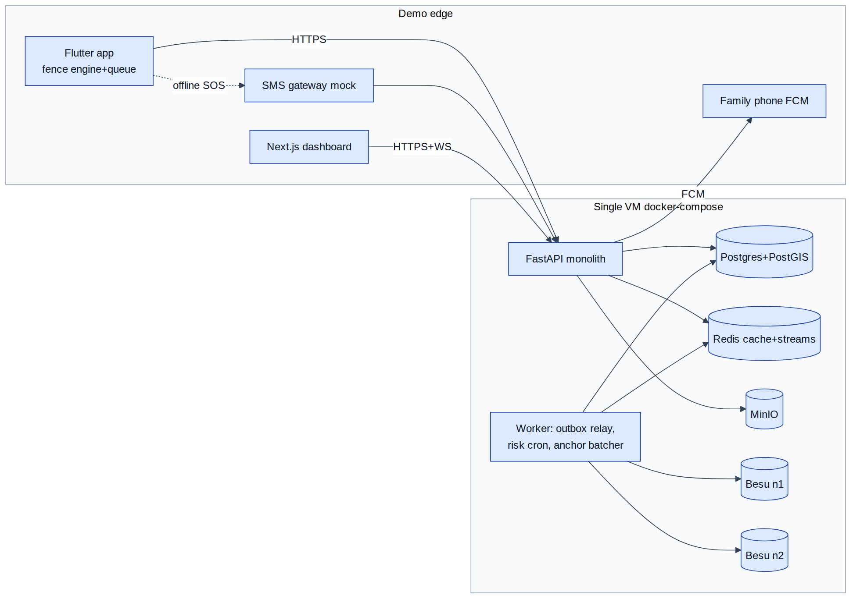
Figure 6 — Hackathon MVP architecture (single-VM deployment)
Must genuinely work in the demo (non-negotiable): live walked (or GPS-replayed) fence breach firing on-device offline; SOS press → dashboard card < 2 s with full context; offline SOS queued → visible sync on reconnect; missed-check-in escalation ladder end-to-end; tamper-detection verify. Everything else may be scripted.

27. Recommended Production Architecture
Service boundaries (extracted from the monolith when metrics demand): Core API (auth/users/trips/incident/sos/geofence-admin) · Location-Ingest (stateless, Go candidate) · Realtime+Notification · Risk Workers · Blockchain Adapter · Analytics (batch). Data ownership per §5 table; Kafka event bus (topics keyed per §15); Redis cluster; Postgres HA (Patroni) + read replicas, monthly partitions, per-state schemas [UNRESOLVED — one national deployment vs per-state instances is a governance decision more than technical]; S3 with object-lock for evidence; Keycloak; Vault+KMS/HSM; OTel/Prometheus/Grafana/Loki; WAF+DDoS at edge; multi-AZ mandatory, second-region warm standby for core+DB (disasters are exactly when this system must survive regional trouble); consortium Besu nodes operated by ≥3 agencies or transparency-log fallback; ERSS/PSAP integration via mTLS partner gateway per state.
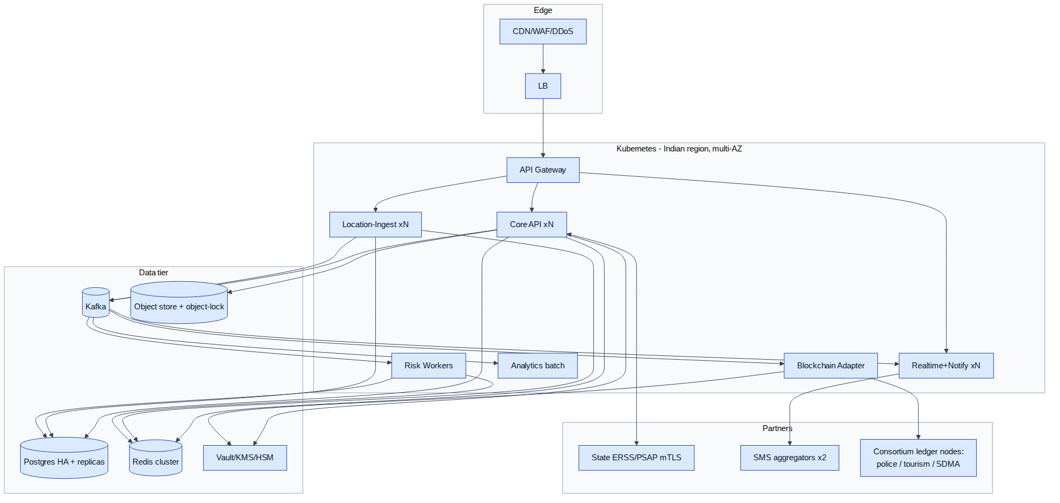
Figure 7 — Production architecture (Kubernetes, Kafka, consortium ledger)

28. Architecture Decision Records
ADR-01 Modular monolith vs microservices. Context: 4–8 devs, emergency-grade reliability, unknown scale. Options: monolith, modular monolith+events, microservices. Decision: modular monolith + outbox events. Reason: consistency-critical incident core benefits from local transactions; team too small for distributed ops; extraction path preserved. Consequences: single blast radius → mitigate with replicas; must police module boundaries in review.
ADR-02 REST vs GraphQL. Options: REST+OpenAPI, GraphQL. Decision: REST. Reason: idempotency keys, HTTP caching for packs, simpler rate-limiting/authZ per route, dashboard needs are predictable; GraphQL's flexible queries complicate ABAC on sensitive fields. Consequence: a few aggregate endpoints hand-built.
ADR-03 WebSocket vs SSE. Decision: WS for dashboards + emergency app mode; polling fallback; SSE rejected for lack of upstream channel (operator acks ride the socket) though acceptable fallback. Consequence: sticky sessions + Redis pub/sub required.
ADR-04 PostgreSQL/PostGIS. Decision: adopt — single engine covers relational, geospatial, JSONB, partitioning; boring, hireable, free. Consequence: time-series volume handled by partitioning discipline (or TimescaleDB later).
ADR-05 Redis. Decision: adopt for last-fix cache, sessions, rate limits, Streams (MVP bus), WS pub/sub. Consequence: treat as rebuildable except Streams (AOF on); migrate bus role to Kafka at scale.
ADR-06 Queue: Redis Streams → Kafka. Decision: Streams for MVP, Kafka at ~100k users (retention/replay/consumer-group needs). RabbitMQ rejected: no long replay log. Consequence: envelope + consumer idempotency designed transport-agnostic from day one.
ADR-07 Client vs server geofencing. Decision: hybrid — device detects, server validates restricted/disaster + sweeps new temp zones. Reason: offline requirement makes device-side mandatory; server closes stale-pack and tamper gaps. Consequence: parity test suite between the two engines is permanent CI.
ADR-08 Rules vs ML. Decision: deterministic versioned rules for risk/anomaly v1; hosted-API AI only for translation + assistive triage; ML behind same interface later. Reason: no training data exists; explainability for emergencies; FP cost is trust-fatal. Consequence: invest in config tooling + assessment logging to bootstrap future labels.
ADR-09 Public vs permissioned blockchain. Decision: permissioned Besu consortium, batched Merkle-root anchoring only; transparency-log fallback switch; optional public root mirror. Reason: §14 — governance fit, cost, privacy; roots leak nothing. Consequence: consortium MoU is a launch dependency for the "decentralised" claim, not for product function.
ADR-10 On-chain vs off-chain. Decision: on-chain = batch roots + signatures only; everything else off-chain encrypted. Reason: DPDP erasure vs immutability, honeypot avoidance, cost, metadata leakage. Consequence: verification requires our proof store — mitigated by giving tourists/oversight downloadable proofs.

29. Implementation Roadmap
Phase | Tasks | Depends on | Deliverables | Risks
0 Validation (wk 0) | confirm demo region + zone set, OS test devices matrix, DLT/SMS decision (simulate), consent copy | — | scope freeze doc | scope creep
1 Foundation (wk 1) | repo/CI, compose stack, schema+migrations, auth, outbox+streams skeleton, OpenAPI stub | 0 | running skeleton, contract tests | over-engineering
2 Tourist app core (wk 1–2) | Flutter shell, registration/OTP(mock), trip lifecycle, FGS + location batching + encrypted queue | 1 | app syncing real fixes | Android bg quirks — start OEM testing immediately
3 Geo-fencing (wk 2) | zone CRUD+draw UI, pack build/sign/sync, device PIP engine + gates, server validation, parity tests | 2 | live fence demo on replayed route | GPS drift tuning time
4 SOS & incident (wk 2–3) | SOS path (online/offline-queue/SMS-mock), incident state machine + hash chain, dedup/merge, family FCM | 2 | E2E SOS <2 s | WS reliability
5 Authority dashboard (wk 3) | queue, map (MapLibre), ack/assign/status, timeline, audit views | 4 | operator flow complete | map perf
6 AI (wk 3–4) | risk rules engine + challenge ladder + check-in cron; translation templates; triage-assist stub | 4 | anomaly demo (missed check-in) | FP tuning
7 Blockchain (wk 4) | hash-chain finalise, Besu 2-node, anchor batcher, verify API + tamper demo | 4 | verify button demo | chain env friction → flip to transparency-log flag
8 Security & privacy (wk 4) | authZ matrix tests, rate limits, field encryption, consent receipts, audit hooks | 1–7 | passing security checklist | time pressure — checklist is the guardrail
9 Testing (continuous, hardening wk 5) | E2E scenario suite, load smoke, offline scripted runs, OEM matrix | all | green scenario suite | device zoo access
10 Demo (wk 5) | GPS replay script, seeded story (Sahastra-Tal narrative), rehearsals ×3, fallback recordings | 9 | 8-min demo runbook | live-demo entropy → deterministic replay is the insurance

30. Final Architect Recommendation
Recommended architecture: modular monolith + transactional-outbox events + hybrid device/server geofencing + rules risk engine with human-gated escalation + batched Merkle anchoring — privacy-tiered end to end. MVP: §26 exactly. Production: §27, extracting Location-Ingest, Realtime/Notify, Risk-Workers, Blockchain-Adapter onto Kafka when metrics demand.
Service list: Gateway, Auth/Identity, User, Trip/Consent, Location-Ingest, Geofence, Risk, SOS, Incident, Dispatch, Notification, Evidence, Realtime, Blockchain-Adapter, Audit, Analytics, Admin/Config. API list: §7 (≈60 endpoints incl. added ones). Entities: §10 (21 tables). Events: §15 (16 types). Features: §2 with priorities.
Top 10 technical risks: (1) Android OEM kills → watchdog design is the mitigation, test on real Xiaomi/Oppo hardware early; (2) iOS fidelity gap oversold in demo claims — disclose; (3) anomaly false-positive storm → challenge-first ladder + conservative thresholds; (4) SOS path hidden dependency (auth outage blocks SOS) → dedicated device token, isolation tests; (5) location write amplification → partitions+COPY from day one; (6) GPS-drift restricted-zone false alarms → gates + parity suite; (7) SMS programmatic limits (iOS can't; Android policy) + DLT registration lead time; (8) WS state at scale → Redis pub/sub pattern from start; (9) consortium never materialises → transparency-log flag ships in v1; (10) demo-day live-GPS entropy → deterministic replay harness.
Top 10 unresolved architecture questions: ERSS/PSAP integration contract per state; per-state vs national deployment topology; SOS-before-login (anonymous SOS) policy; offline-QR PII trade-off; EXIF scrubbing vs evidentiary value; satellite-SOS hardware/API path for treks; CAP/SACHET bridge mechanics; DLT SMS templates & shortcode acquisition; legal retention numbers (30 d/90 d/7 y are assumptions); consortium node governance.
Avoid: microservices day-one; MQTT broker without hardware; GraphQL; on-chain PII/per-event writes; ML anomaly models pre-data; face recognition; custom map tiles; serverless for the SOS path; cross-platform bg-location plugins without native-module escape hatches.
Mock in demo: KYC, ERSS endpoint, SMS gateway, 108/hospital, weather, voice. Must genuinely work: on-device offline fence breach; SOS→dashboard <2 s; offline-SOS queue+sync; missed-check-in ladder; tamper-detect verify.

31. Sources & References
Platform documentation (verify current versions at build time): Android developers — background location limits, foreground service types, Doze/App Standby, Geofencing API, FGS-from-background restrictions; Apple developers — Core Location (significant-change, region monitoring ~20-region limit, allowsBackgroundLocationUpdates), Background Tasks, APNs; Google Play policy — background location & SMS permissions. Data/infra: PostgreSQL/PostGIS docs (GiST, ST_Contains, partitioning), Redis Streams, Kafka semantics, S3 presigned uploads & object-lock. Patterns: transactional outbox / idempotent consumer (microservices.io), circuit breaker (Fowler), OWASP ASVS & threat-modelling guidance, W3C Verifiable Credentials, RFC 6962 (Certificate Transparency — transparency-log fallback model), Hyperledger Besu QBFT docs. Domain inputs: companion Domain Research Report (7 Jul 2026) — ERSS-112 mechanics (112.gov.in, MHA, C-DAC), DPDP Act 2023 + DPDP Rules 2025 (Gazette Nov 2025), incident case studies (Sahastra Tal 2024; Sohra 2025), NCRB 2024. Uttarakhand registration precedent, NDMA SACHET/CAP.
End of report.

