To run this program, first install the python 3.6 or 3.7.
Recommend to install python in anaconda, the default version is 3.7, which is just suit.

Start the server:
Run serverStart.cmd can start it
Or you can run “python CServer.py” in command after changing the working dictionary to the path for this one.
If you want to let the commands run in root level, open a cmd windows in root.

Manage the server:
The legal user and password are saved in follow two files:
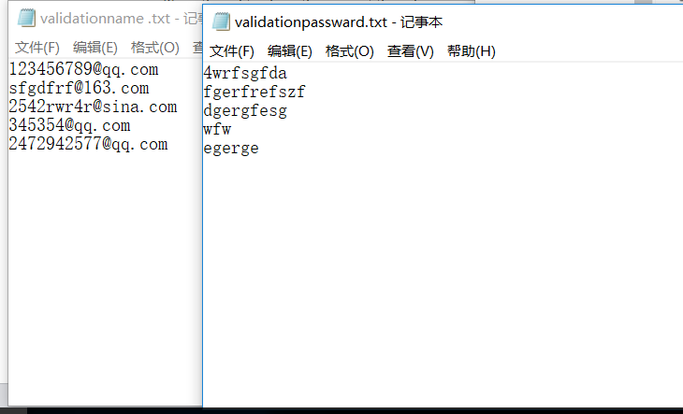
After run it:
Type stop to stop the server(may not work, in this case you can simply close it)
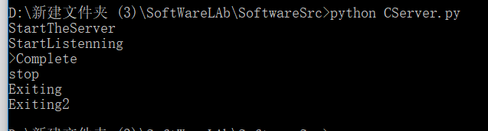
Type thread to show the current threads
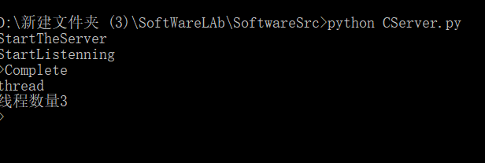

Start the client:
Similar to server way, just run the cmd file.
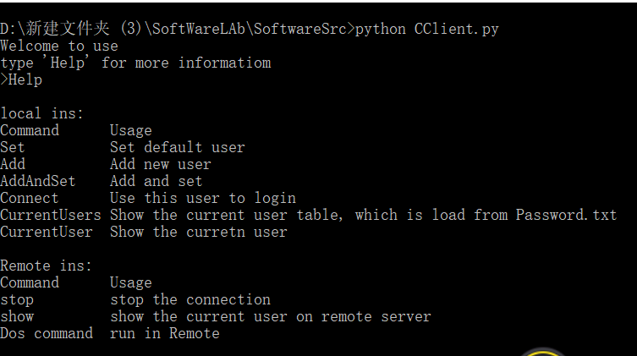
After start, type help for instructions help.

Use the client:
The first thing is to check your account by “CurrentUsers”
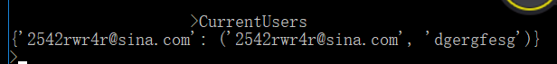
These are the users saved in local, which is in this file:
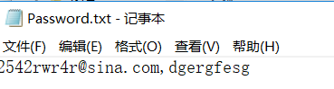
You can add the new users by Add command
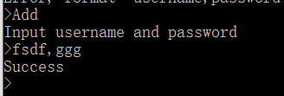

Then you should choose one account to login, by “Set” command
“CurrentUser” can show which one is selected.
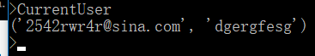
Then type Connect
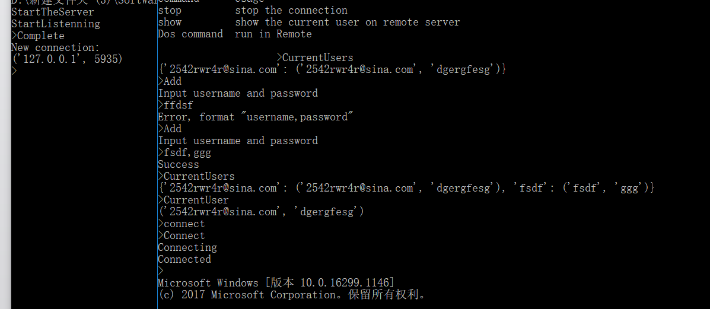
Then simply type instructions:
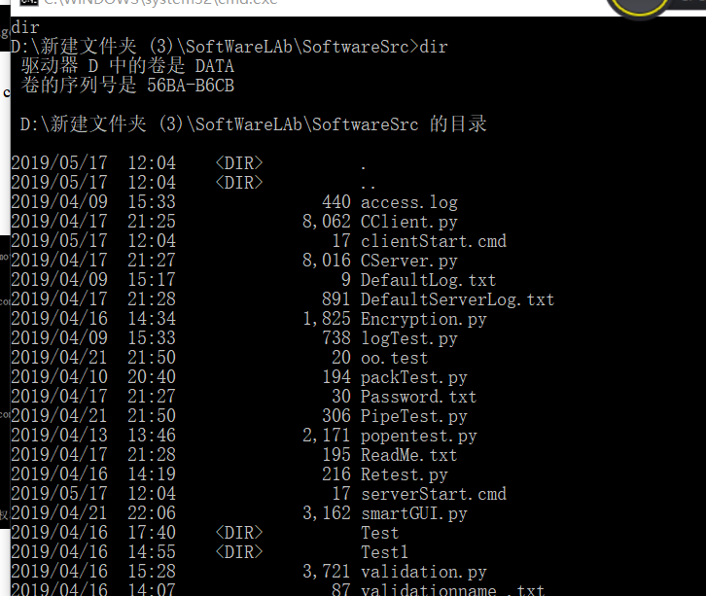
For some instructions, the interact might be strange.
Some instructions are build in command, such as show
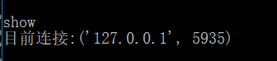

Finally, stop is used to end the log-in.

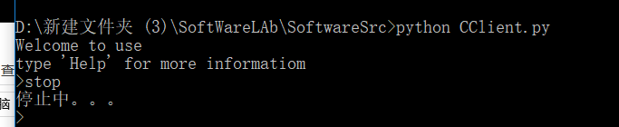
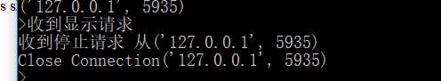
After quit the client, new user will automatically saved
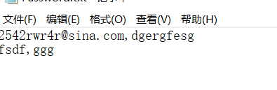

That’s all.

