# Database setup def init_db():
conn = sqlite3.connect('auction.db') cursor = conn.cursor() cursor.execute('''
CREATE TABLE IF NOT EXISTS items (
id INTEGER PRIMARY KEY AUTOINCREMENT, name TEXT NOT NULL,
description TEXT,
price REAL NOT NULL
conn.commit() conn.close()

init_db()

class Item(BaseModel): name: str
description: str = None price: float

@app.post("/items/", response_model=Item) def create_item(item: Item):
conn = sqlite3.connect('auction.db') cursor = conn.cursor() cursor.execute('''
INSERT INTO items (name, description, price) VALUES (?, ?, ?)
''', (item.name, item.description, item.price)) conn.commit()
conn.close() return item

@app.get("/items/", response_model=List[Item]) def get_items():
conn = sqlite3.connect('auction.db') cursor = conn.cursor()

cursor.execute('SELECT * FROM items') rows = cursor.fetchall()
conn.close()
return [Item(id=row[0], name=row[1], description=row[2], price=row[3]) for row in rows]

@app.get("/items/{item_id}", response_model=Item) def get_item(item_id: int):
conn = sqlite3.connect('auction.db') cursor = conn.cursor()
cursor.execute('SELECT * FROM items WHERE id = ?', (item_id,)) row = cursor.fetchone()
conn.close()
if row is None:
raise HTTPException(status_code=404, detail="Item not found") return Item(id=row[0], name=row[1], description=row[2], price=row[3])

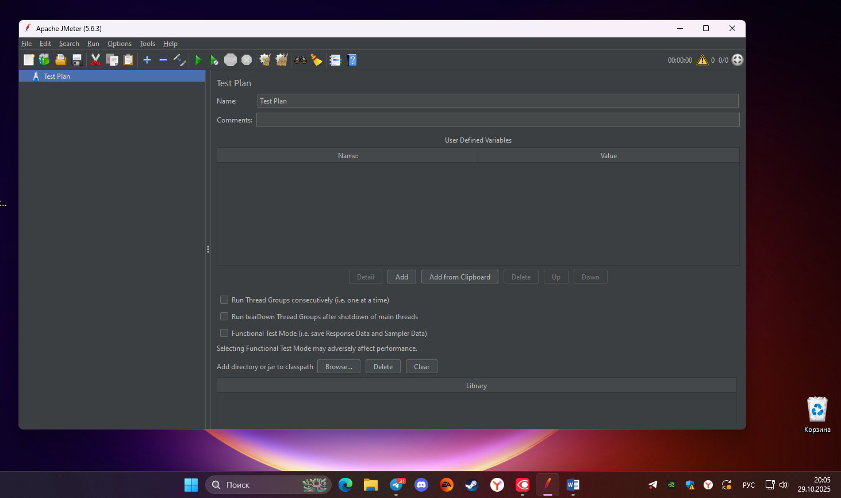
Рисунок 1 - Открытие JMeter и создание новый тестовый план (Test Plan)

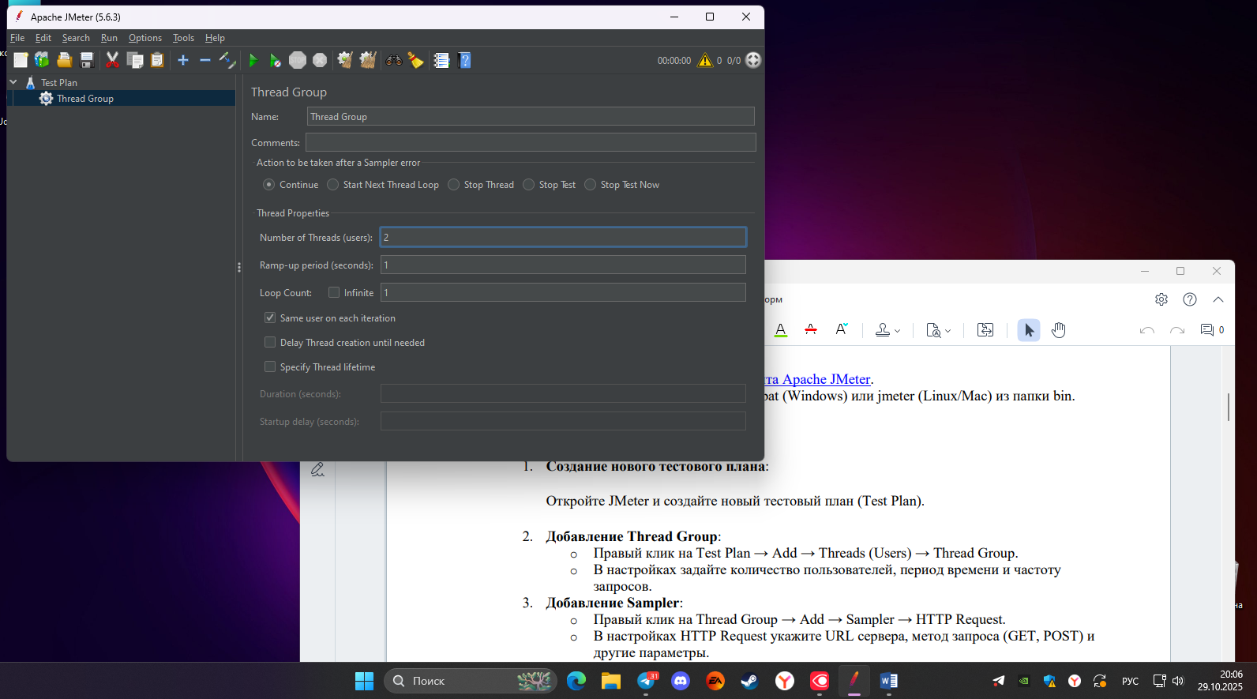
Рисунок 2 - Добавление Thread Group
{
"name": "Item 1",
"description": "A description of Item 1", "price": 100.0
}

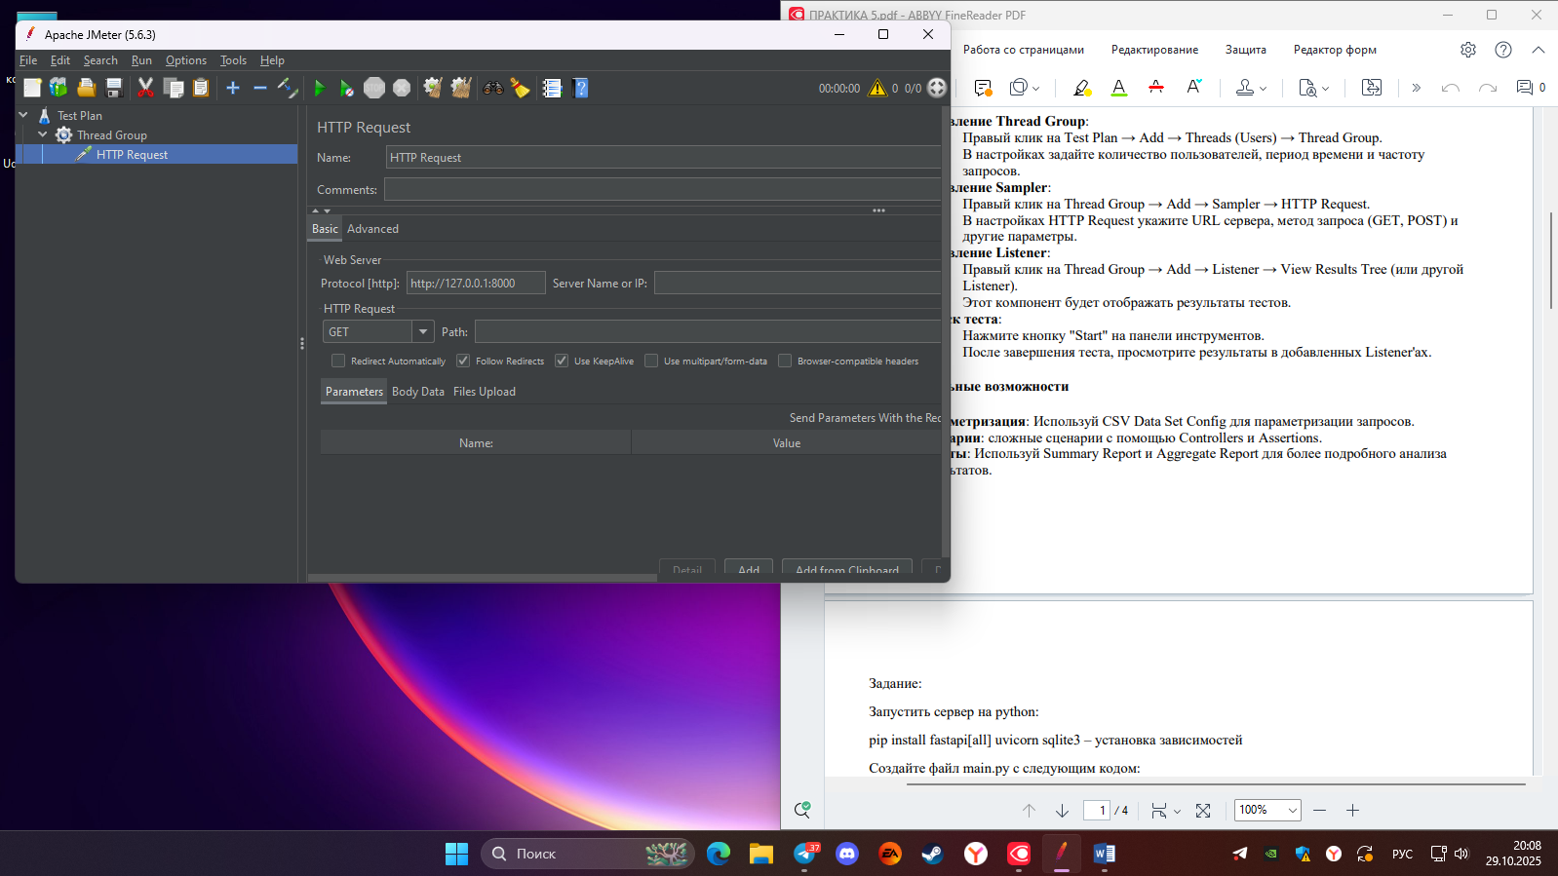
Рисунок 3 - Добавление Sampler

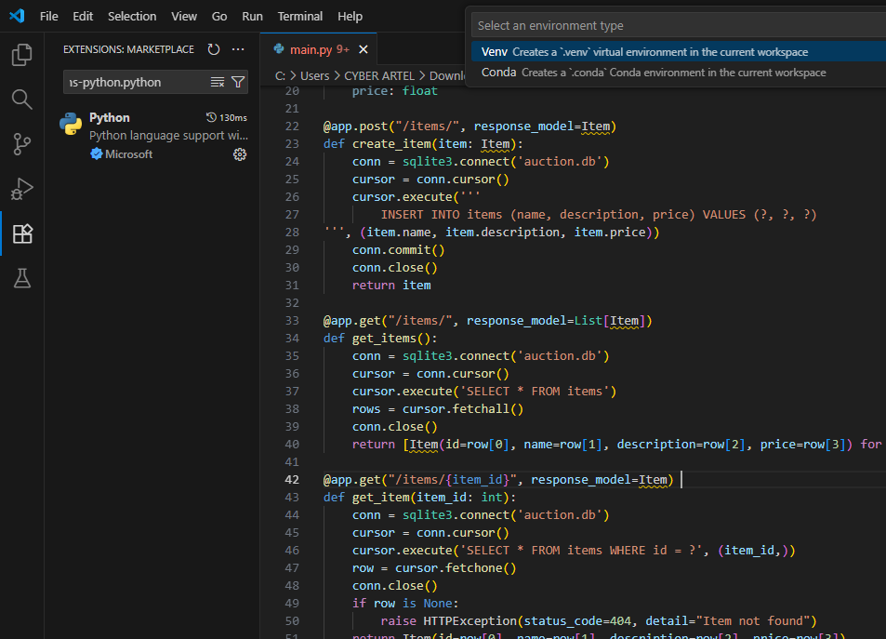

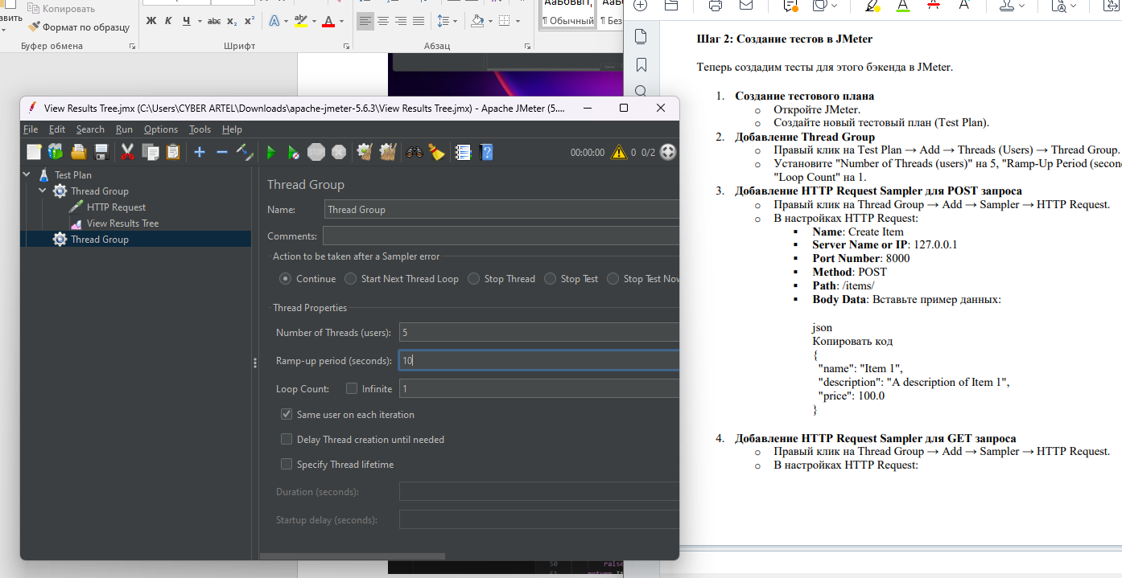
Рисунок 4 -Добавление Thread Group

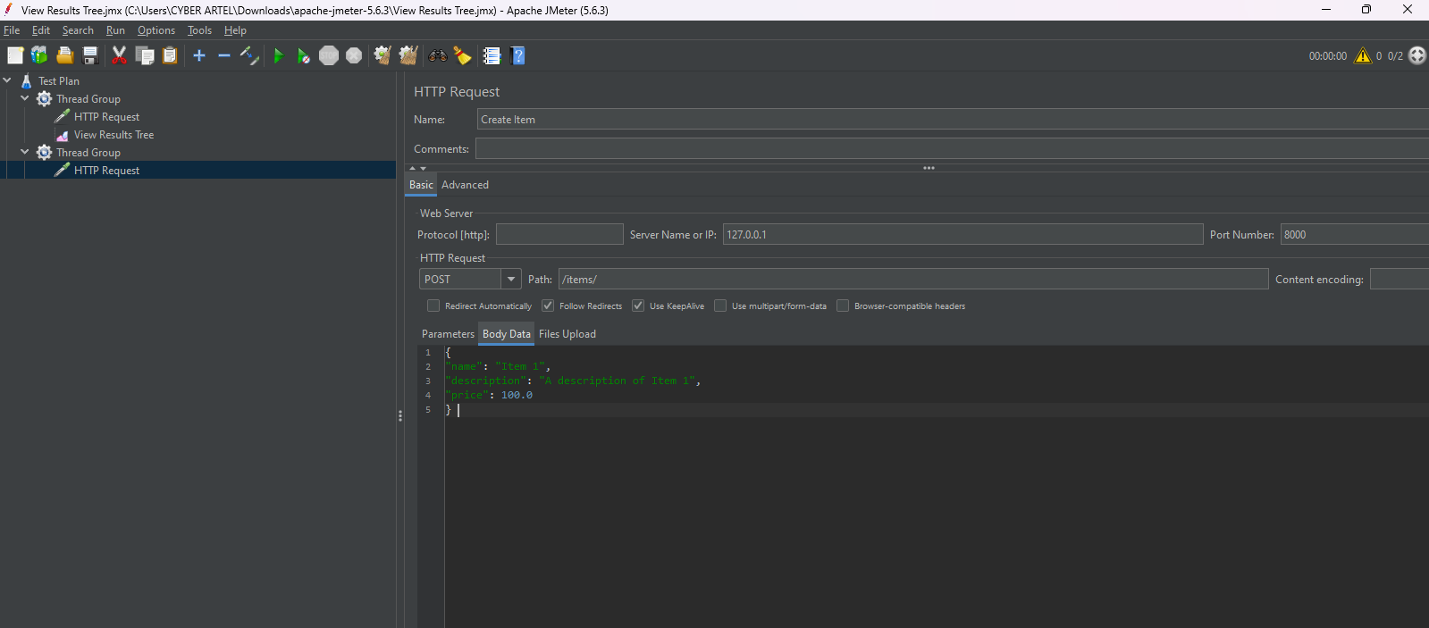
Рисунок 5 - Добавление HTTP Request Sampler для POST запроса

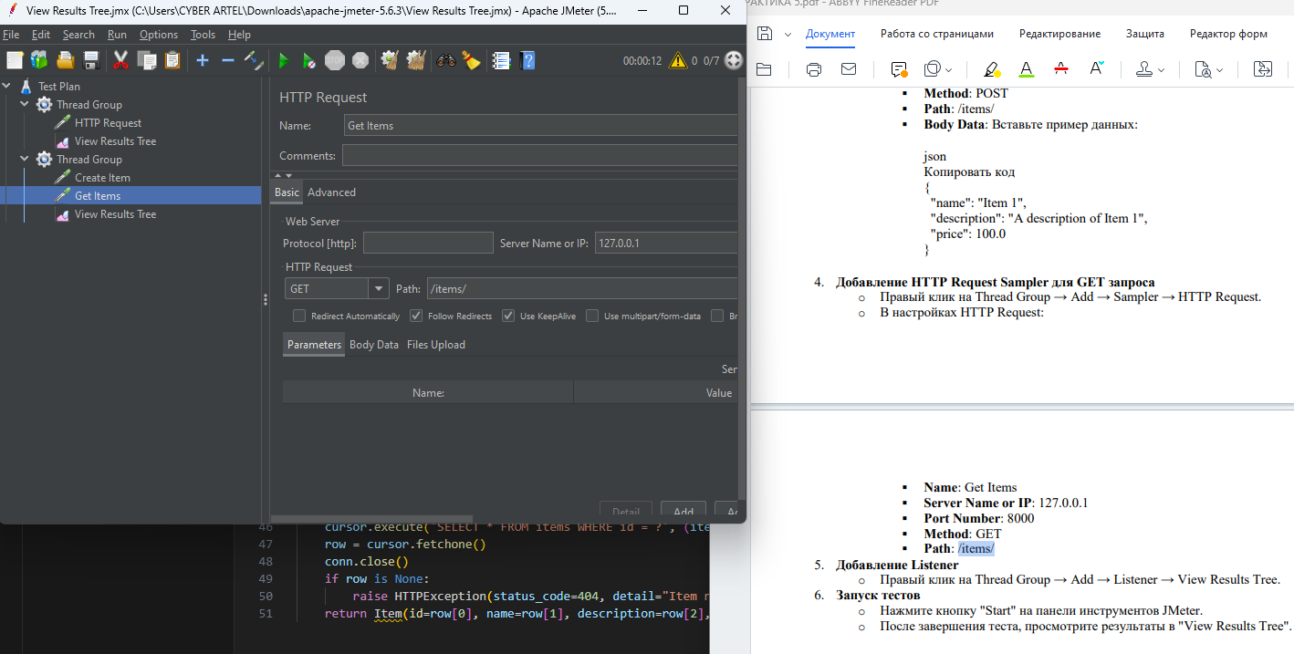
Рисунок 6 -Добавление HTTP Request Sampler для GET запроса

