GitHub Actions 任务报告 / GitHub Actions Task Report
项目：Express + Jest 示例项目 CI/CD 实践
Project: CI/CD practice for an Express + Jest sample project
完成日期 / Completion date: 2026-06-21
仓库 / Repository: https://github.com/godququ5-code/express-jest-actions-report-20260621

摘要
Executive Summary
本报告记录了从本地 Express/Jest 示例项目创建 Git 仓库、推送到 GitHub、配置 Node.js CI 工作流、创建 Issue、运行测试、上传并下载覆盖率报告 artifact 的全过程。
This report documents the full process of creating a Git repository from a local Express/Jest sample project, pushing it to GitHub, configuring a Node.js CI workflow, creating issues, running tests, uploading, and downloading the coverage-report artifact.
- 远程仓库已创建并推送到 GitHub。
The remote repository was created and pushed to GitHub.
- Node.js CI 工作流已配置在 .github/workflows/nodejs.yml。
The Node.js CI workflow was configured in .github/workflows/nodejs.yml.
- CI 运行成功，build job 的所有步骤均通过。
The CI run succeeded, and all build-job steps passed.
- 测试覆盖率 artifact code-coverage-report 已生成并下载到本地。
The code-coverage-report artifact was generated and downloaded locally.

1. 任务目标
1. Task Objectives
- 下载并解压学习项目。
Download and unzip the learning project.
- 创建本地 Git 仓库，并创建远程 GitHub 仓库。
Create a local Git repository and a remote GitHub repository.
- 创建 Node.js CI 工作流并提交推送。
Create, commit, and push a Node.js CI workflow.
- 创建 Issue 并查看 CI 工作流运行信息。
Create issues and inspect CI workflow information.
- 改进工作流：运行测试并上传代码覆盖率报告。
Improve the workflow by running tests and uploading a code coverage report.
- 下载 code-coverage-report artifact。
Download the code-coverage-report artifact.
- 探索 GitHub 的应用部署能力。
Explore GitHub application deployment capabilities.

2. 本地项目准备
2. Local Project Preparation
学习项目已解压到本地工作目录，并使用 npm ci 安装依赖。随后运行 npm test，Jest 测试全部通过，覆盖率为 100%。
The learning project was extracted into the local workspace, and dependencies were installed with npm ci. npm test was then executed successfully; all Jest tests passed and coverage was 100%.
Local command summary:
npm ci
npm test
Result:
Test Suites: 2 passed, 2 total
Tests: 8 passed, 8 total
Coverage: 100% statements / branches / functions / lines

3. GitHub 仓库创建与推送
3. GitHub Repository Creation and Push
项目初始化为 Git 仓库，主分支为 main。随后创建 GitHub 远程仓库并推送代码。
The project was initialized as a Git repository using the main branch. A GitHub remote repository was then created and the code was pushed.
Repository URL / 仓库链接: https://github.com/godququ5-code/express-jest-actions-report-20260621
Key commits:
001dcbe Initial Express Jest project
be213f1 Add Node.js CI workflow
e57f9c6 Run tests and upload coverage in CI

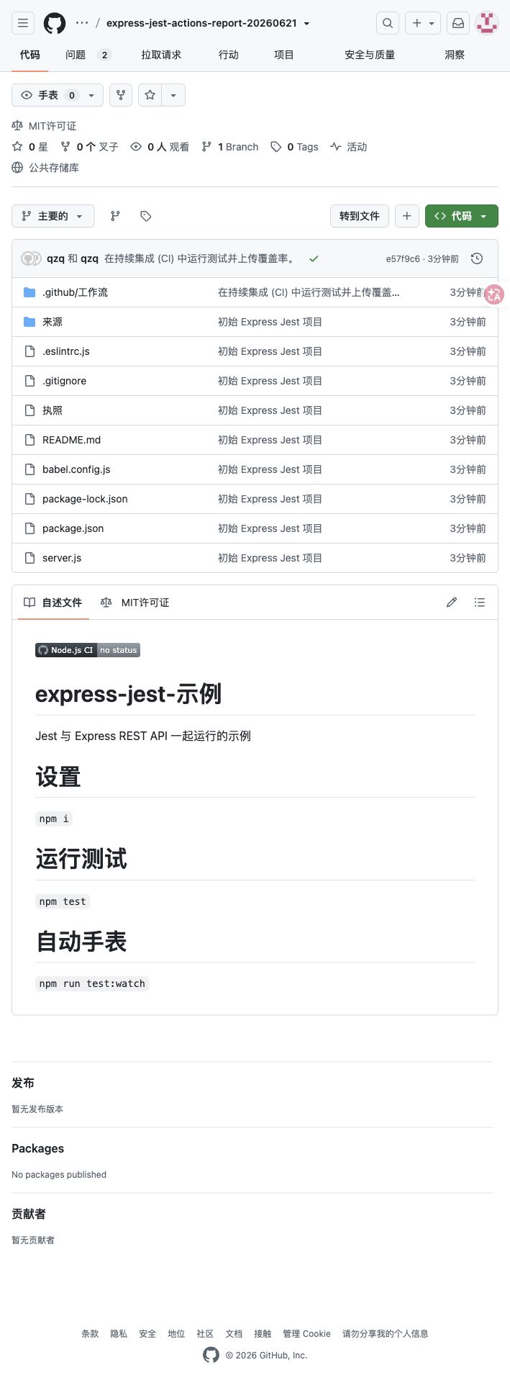
图 1：GitHub 远程仓库主页
Figure 1: GitHub remote repository home page

4. Node.js CI 工作流
4. Node.js CI Workflow
工作流文件创建在 .github/workflows/nodejs.yml。该工作流在 push 和 pull_request 到 main 分支时运行，使用 Ubuntu runner、Node.js 20、npm ci 安装依赖，并运行测试。
The workflow file was created at .github/workflows/nodejs.yml. It runs on push and pull_request events targeting the main branch, uses an Ubuntu runner and Node.js 20, installs dependencies with npm ci, and runs tests.
name: Node.js CI
on:
push:
branches: [main]
pull_request:
branches: [main]
jobs:
build:
runs-on: ubuntu-latest
steps:
- name: Checkout repository
uses: actions/checkout@v4
- name: Use Node.js
uses: actions/setup-node@v4
with:
node-version: 20
- name: Install dependencies
run: npm ci
- name: Run tests with coverage
run: npm test
- name: Upload code coverage report
uses: actions/upload-artifact@v4
with:
name: code-coverage-report
path: coverage/

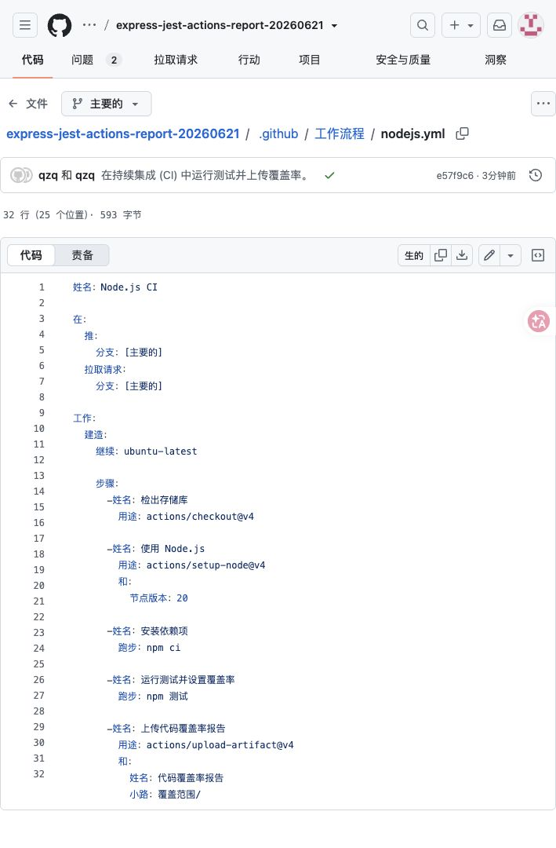
图 2：GitHub 中的 nodejs.yml 工作流文件
Figure 2: nodejs.yml workflow file on GitHub

5. 工作流改进：测试与覆盖率 Artifact
5. Workflow Improvement: Tests and Coverage Artifact
改进后的工作流添加了 Run tests with coverage 和 Upload code coverage report 两个关键步骤。npm test 生成 coverage/ 目录，actions/upload-artifact@v4 将该目录上传为 code-coverage-report。
The improved workflow added two key steps: Run tests with coverage and Upload code coverage report. npm test generates the coverage/ directory, and actions/upload-artifact@v4 uploads it as code-coverage-report.
Artifact name: code-coverage-report
Artifact size: 20.8 KB
Digest: sha256:7221358d8ad3f4ef3b503a1a0144c5e7fea165ccb587c559a1a5a71749dbeca1
Expires at: 2026-09-19T13:55:18Z

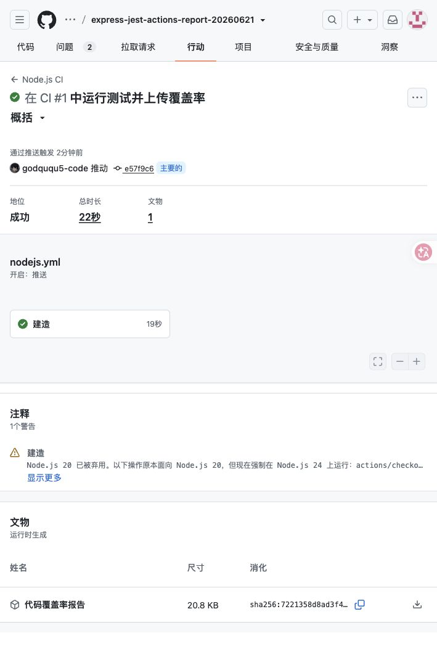
图 3：CI 运行成功并生成覆盖率 artifact
Figure 3: Successful CI run with generated coverage artifact

6. Issues 创建
6. Issues Created
根据任务要求创建了两个 Issue，分别记录初始 CI 工作流创建和 CI 改进完成情况。
Two issues were created as required: one for the initial CI workflow and one for the improved CI workflow with tests and coverage upload.
- Issue #1：Initial CI workflow created。
Issue #1: Initial CI workflow created.
- Issue #2：Improve CI with tests and coverage artifact。
Issue #2: Improve CI with tests and coverage artifact.

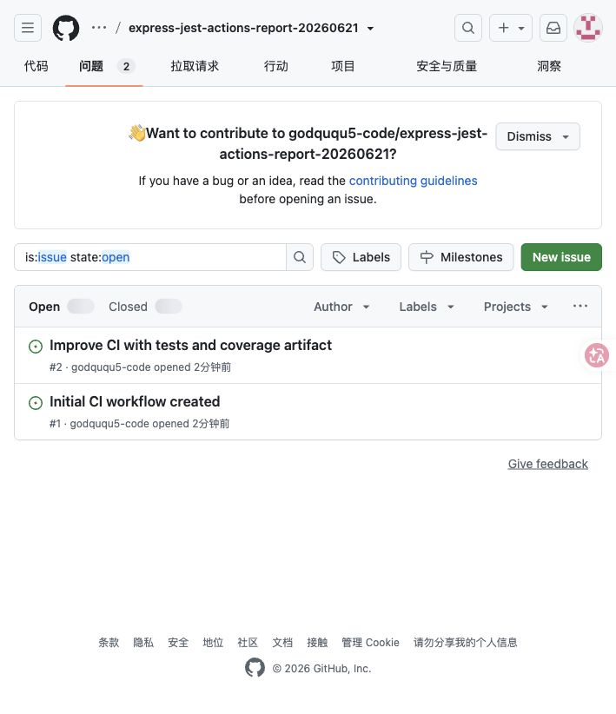
图 4：GitHub Issues 页面
Figure 4: GitHub Issues page

7. CI 工作流结果
7. CI Workflow Result
最终 CI 运行状态为 completed / success。build job 共包含 checkout、setup-node、npm ci、npm test 和 artifact upload 等步骤，全部成功。
The final CI run status was completed / success. The build job included checkout, setup-node, npm ci, npm test, and artifact-upload steps, and every step succeeded.
Field / 字段 | Value / 值 | Field / 字段 | Value / 值
Workflow | Node.js CI | Conclusion | success
Event | push | Branch | main
Run title | Run tests and upload coverage in CI | Run URL | https://github.com/godququ5-code/express-jest-actions-report-20260621/actions/runs/27906553081
Created at | 2026-06-21T13:55:18Z | Updated at | 2026-06-21T13:55:40Z
Run URL / 运行链接: https://github.com/godququ5-code/express-jest-actions-report-20260621/actions/runs/27906553081

8. 覆盖率报告下载
8. Coverage Report Download
通过 GitHub Actions artifact 下载了 code-coverage-report。下载后的报告包含 lcov.info、coverage-final.json、clover.xml 和可浏览的 lcov-report/index.html。
The code-coverage-report artifact was downloaded from GitHub Actions. The downloaded report contains lcov.info, coverage-final.json, clover.xml, and the browsable lcov-report/index.html.
Downloaded local files:
downloaded-code-coverage-report/clover.xml
downloaded-code-coverage-report/coverage-final.json
downloaded-code-coverage-report/lcov.info
downloaded-code-coverage-report/lcov-report/index.html
downloaded-code-coverage-report/lcov-report/src/app.js.html
downloaded-code-coverage-report/lcov-report/src/index.html

9. GitHub 应用部署能力探索
9. Exploration of GitHub Application Deployment Capabilities
GitHub Actions 不仅可用于 CI，也可用于 CD。它支持通过 workflow 自动构建、测试并部署应用，也支持使用 environments 对 staging、production 等环境进行审批、分支限制、环境密钥和部署保护。
GitHub Actions can be used for both CI and CD. It supports workflows that build, test, and deploy applications automatically. It also supports environments for staging, production, and similar targets, with approvals, branch restrictions, environment secrets, and deployment protection rules.
- GitHub Pages：适合部署静态站点或前端构建产物；可通过分支或 GitHub Actions 发布。
GitHub Pages is suitable for static sites or front-end build output and can publish from a branch or GitHub Actions.
- Environments：可定义 development、staging、production 等部署目标，并设置审批、secret、变量和分支限制。
Environments can define deployment targets such as development, staging, and production, with approvals, secrets, variables, and branch restrictions.
- 第三方平台部署：Actions 可部署到 Azure、AWS、Vercel、Netlify、Docker registry 等平台。
Third-party deployments are possible from Actions to platforms such as Azure, AWS, Vercel, Netlify, and Docker registries.
- Release/Artifact：可把构建结果上传为 artifact 或发布到 GitHub Releases，适合交付可下载包。
Release and artifact workflows can upload build output as artifacts or publish it to GitHub Releases for downloadable deliverables.
对于本 Express/Jest 项目，当前任务重点是 CI 和覆盖率产物。如果继续扩展为部署任务，可新增一个 deploy job：在测试通过后构建 Docker 镜像或部署到云平台；同时使用 production environment 管理部署密钥和审批。
For this Express/Jest project, the current task focuses on CI and coverage artifacts. To extend it into deployment, a deploy job could be added after tests pass, for example to build a Docker image or deploy to a cloud platform, while using a production environment to manage deployment secrets and approvals.

10. 结论
10. Conclusion
本次任务已完成：项目已上传 GitHub，CI 工作流已创建并改进，测试和覆盖率 artifact 已验证，Issues 已创建，报告已生成。
The task is complete: the project was uploaded to GitHub, the CI workflow was created and improved, tests and the coverage artifact were verified, issues were created, and this report was generated.

参考资料
References
- GitHub Actions Quickstart: https://docs.github.com/actions/get-started/quickstart
- Workflow syntax for GitHub Actions: https://docs.github.com/actions/using-workflows/workflow-syntax-for-github-actions
- Deploying with GitHub Actions: https://docs.github.com/actions/deployment/about-deployments/deploying-with-github-actions
- GitHub Actions deployment environments: https://docs.github.com/en/actions/concepts/workflows-and-actions/deployment-environments
- GitHub Pages publishing source: https://docs.github.com/en/pages/getting-started-with-github-pages/configuring-a-publishing-source-for-your-github-pages-site
- Future Studio: GitHub Actions with Node.js: https://futurestud.io/tutorials/github-actions-getting-started-with-node-js
- The Dreaming: GitHub CI: http://www.thedreaming.org/2019/09/10/github-ci/
- YouTube source listed in task: https://youtu.be/GhhoHOpp9HY

