客户端-服务器应用程序脚手架
Client-Server Application Scaffolding with JHipster
本次实验我主要尝试了 JHipster 从零生成一个前后端一体应用的能力。整体过程比手动搭项目快很多，但也能看到它对本机环境有一些要求，比如 Java、Node、数据库和 Docker。
In this lab, I tried to use JHipster to generate a full client-server application from scratch. The process was much faster than setting up the backend and frontend manually, although it also showed that JHipster depends quite strongly on the local Java, Node, database, and Docker environment.
仓库链接 / Repository link: https://github.com/godququ5-code/jhipster-quotes-assignment
本地项目路径 / Local project path: /Users/qzq/Desktop/软件开发先进技术/jhipster-quotes

1. 实验目标 / Objective
实验目标是探索 JHipster 构建客户端-服务器应用程序的能力。按照任务要求，我安装了 JHipster，生成了一个基于 JWT 认证、PostgreSQL 数据库和 React 客户端的单体应用，并用 JDL Studio 默认模型生成实体。
The objective was to explore how JHipster scaffolds a client-server application. Following the assignment requirements, I installed JHipster, generated a monolithic application with JWT authentication, PostgreSQL, and a React client, and then generated entities from the default JDL Studio-style model.

2. 技术栈 / Technology Stack
项目 / Item | 内容 / Result
JHipster | 9.0.0
后端 / Backend | Spring Boot 4.0.3 monolith, Maven build
认证 / Authentication | JWT
数据库 / Database | PostgreSQL 18.3, database jhipsterQuotes
客户端 / Client | React 19.2.4, Webpack, Jest
Java | OpenJDK 25.0.2 locally; generated project target is Java 21

3. 实现过程 / Implementation Process
- 安装 JHipster：npm install -g generator-jhipster。/ Installed JHipster with npm install -g generator-jhipster.
- 用 app.jdl 写出应用配置，包括 monolith、JWT、PostgreSQL、React 和 Maven。/ Wrote the application configuration in app.jdl, including monolith, JWT, PostgreSQL, React, and Maven.
- 使用默认数据模型生成 Region、Country、Location、Department、Task、Employee、Job 和 JobHistory。/ Generated Region, Country, Location, Department, Task, Employee, Job, and JobHistory from the default model.
- 因为本机没有 Docker，我改用 Homebrew PostgreSQL 来完成运行验证。/ Because Docker was not available on this machine, I used Homebrew PostgreSQL for the runtime verification.
过程中遇到两个小问题。第一个是 Homebrew Node 原来链接到了缺失的 simdjson 动态库，重装 Node 后解决。第二个是 Webpack 构建结束时桌面通知插件在当前机器上无法启动，我给 webpack-notifier 加了一个环境变量开关，不影响应用本身。
Two small environment issues appeared during the work. First, the Homebrew Node installation was linked against a missing simdjson dynamic library, which was fixed by reinstalling Node. Second, the desktop notification plugin used by Webpack could not start on this machine, so I added an environment-variable switch for webpack-notifier. This change does not affect the application itself.

4. 数据模型 / Data Model
实体模型来自 JDL Studio 默认示例，完整内容保存在仓库的 app.jdl。模型包含 8 个实体和 1 个枚举，并覆盖了 OneToOne、OneToMany、ManyToOne、ManyToMany 等关系。
The entity model is based on the default JDL Studio sample, and the full definition is saved in app.jdl in the repository. It contains eight entities and one enum, covering OneToOne, OneToMany, ManyToOne, and ManyToMany relationships.
类型 / Type | 内容 / Content
实体 / Entities | Region, Country, Location, Department, Task, Employee, Job, JobHistory
枚举 / Enum | Language: FRENCH, ENGLISH, SPANISH
主要关系 / Main relationships | Country-Region, Location-Country, Department-Location, Employee-Department, Job-Task, JobHistory-Job/Department/Employee

5. 功能检查 / Function Check
检查项 / Check | 结果 / Result
JHipster 安装 / Installation | jhipster --version returned 9.0.0.
项目生成 / Generation | Spring Boot monolith and React client were generated successfully.
构建 / Build | JHI_DISABLE_WEBPACK_NOTIFIER=true ./mvnw -DskipTests verify finished with BUILD SUCCESS.
前端测试 / Frontend tests | ./npmw test passed: 25 test suites and 266 tests.
JWT 登录 / JWT login | POST /api/authenticate with admin/admin returned 200 and an id_token.
实体创建 / Entity creation | POST /api/regions returned 201 and created a test Region record.
实体读取 / Entity listing | GET /api/regions returned 200.
UI 检查 / UI check | The React UI loaded, admin login worked, and all generated entities appeared in the Entities menu.

6. 主要截图 / Main Screenshots
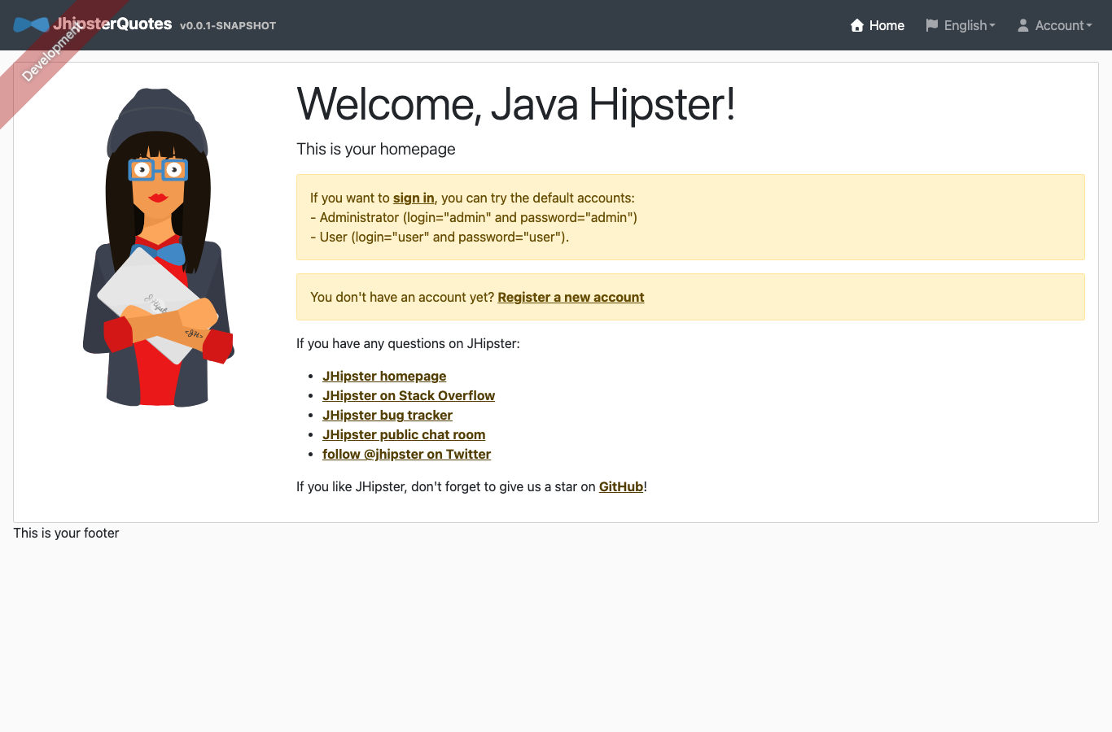
图 1 / Figure 1. JHipster React 首页 / JHipster React home page
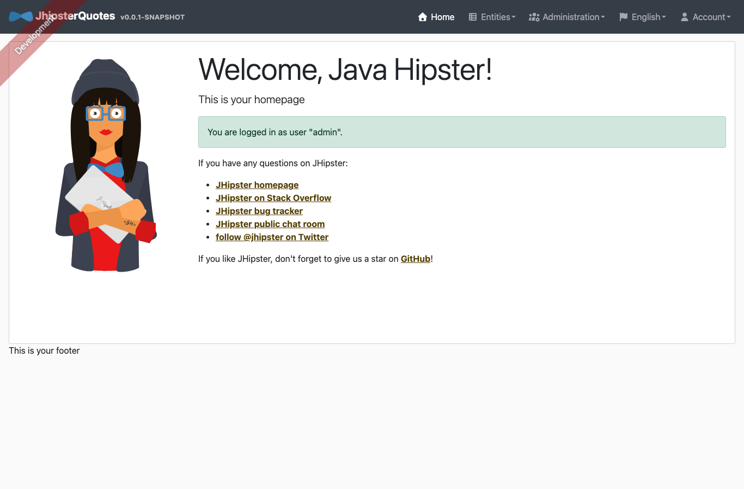
图 2 / Figure 2. admin 登录成功 / Successful admin login
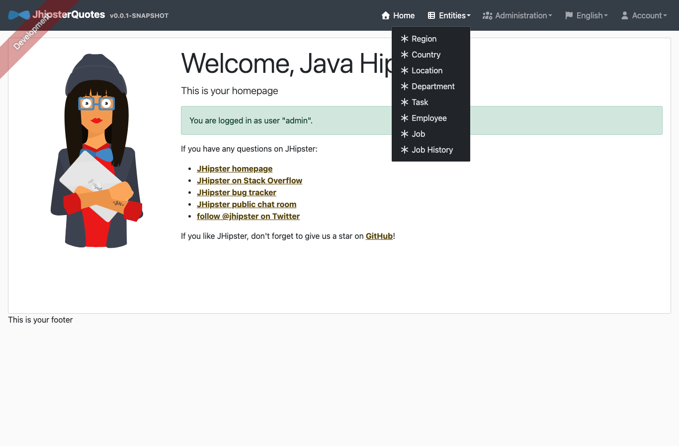
图 3 / Figure 3. 生成实体菜单 / Generated entity menu
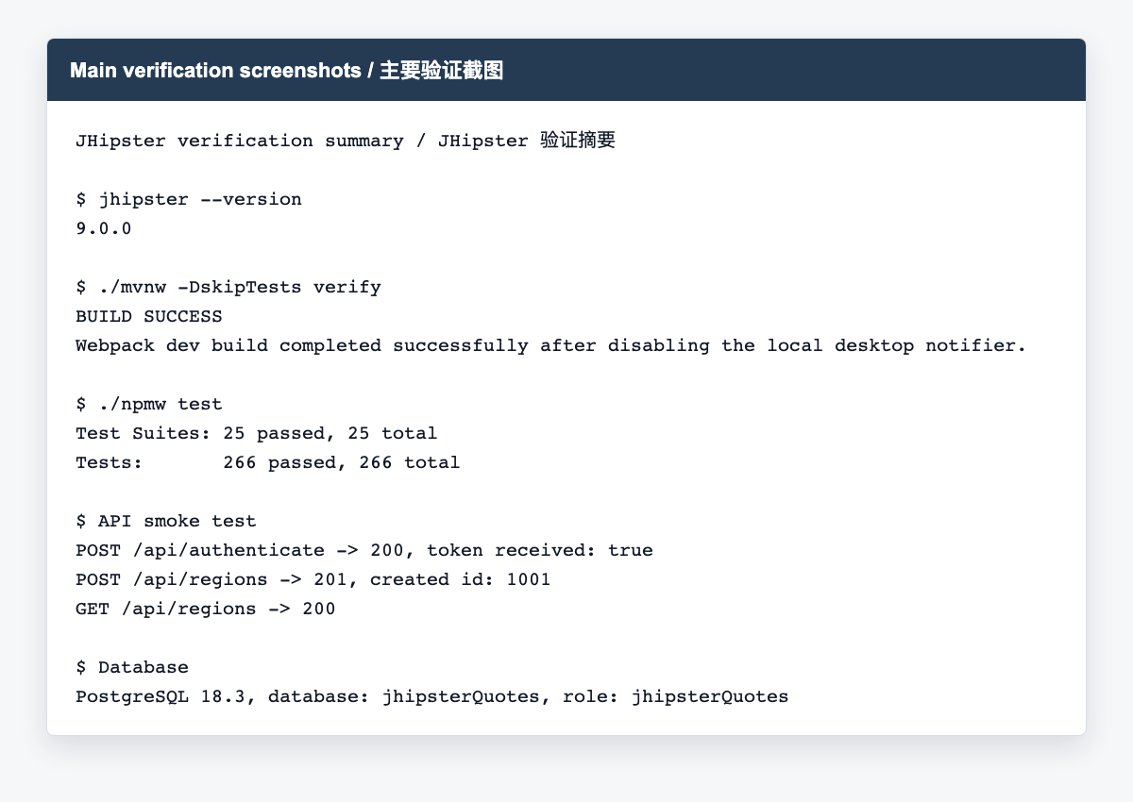
图 4 / Figure 4. 构建、测试和 API 验证摘要 / Build, test, and API verification summary

7. 运行方式 / How to Run
如果本机有 Docker，可以直接使用 JHipster 生成的 Docker Compose 配置。如果像本次实验一样没有 Docker，可以先启动本地 PostgreSQL，然后用下面的命令运行。
If Docker is available, the generated Docker Compose configuration can be used directly. In this lab Docker was not available, so I started a local PostgreSQL instance and ran the application with the following command.
brew services start postgresql@18
SPRING_DOCKER_COMPOSE_ENABLED=false SPRING_DATASOURCE_USERNAME=jhipsterQuotes JHI_DISABLE_WEBPACK_NOTIFIER=true ./mvnw
./npmw start

8. 参考资料 / References
- JHipster Creating an application: https://www.jhipster.tech/creating-an-app/
- JHipster Installation: https://www.jhipster.tech/installation/
- JHipster JDL documentation: https://www.jhipster.tech/jdl/intro/
- JDL Studio: https://start.jhipster.tech/jdl-studio/

9. 总结 / Conclusion
通过这次实验，我感觉 JHipster 的价值主要在于它把后端、前端、认证、数据库迁移、测试和 Docker 配置一次性连起来了。生成的代码量比较大，但结构清楚，适合快速做一个标准的 CRUD 系统原型。
After this experiment, my main impression is that JHipster is useful because it connects the backend, frontend, authentication, database migration, tests, and Docker configuration in one generation process. The generated codebase is large, but the structure is clear, so it is suitable for quickly producing a standard CRUD-style application prototype.

