W4111 – Introduction to Databases  
Section 002/V02, Spring 2024  
Homework 1, Part 1 Written Questions

**Draft: Please wait for final version before answering.**

# Introduction

Chapter 1 from the recommended textbook [Database System Concepts, Seventh Edition](https://codex.cs.yale.edu/avi/db-book/) covers general information and concepts about databases and database management systems. Lecturing on the general and background information is not a good use of precious class time. To be more efficient with class time, the chapter 1 information is a reading assignment.

Answering the written questions in HW 1, Part 1 does not require purchasing the textbook and reading the chapter. The [chapter 1 slides](https://codex.cs.yale.edu/avi/db-book/slides-dir/index.html) provided by the textbook authors provide the necessary information. In some cases, students *may* also have to search the web or other sources to “read” the necessary information.

When answering the written questions, do not “bloviate.” The quantity of words does not correlate with the quality of the answer. We will deduct points if you are not succinct. The answers to the questions require less than five sentences or bullet points.

*“If you can't explain something in a few words, try fewer.”*

# Questions

1. **What is a database management system and how do relational databases organize data?**

Answer:

1. **Columbia University uses several applications that use databases to run the university. Examples are SSOL and CourseWorks. An alternate approach could be letting students, faculty, administrators, etc. use shared Google Sheets to create, retrieve, update, and delete information. What are some problems with the shared spread sheet approach and what functions do DMBS implement to solve the problems?**

Answer:

1. **Explain the differences between SQL, MySQL Server and DataGrip.**

Answer:

1. **Crow’s Foot Notation has four endings for relationship lines. Briefly explain the meaning of each ending.**

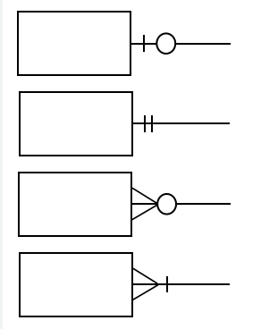

Answer:

1. **What is a primary key and why is it important?**

Answer:

1. **The relational algebra is closed under the operators. Explain what this means and give an example.**

Answer:

1. **SQL is a declarative data manipulation language. What are some pros and cons of declarative DMLs relative to procedural ones?**

Answer:

1. **Some of the Columbia University databases/applications represent the year/semester attribute of a section in the form "2023_2". The first four characters are the academic year, and the last character is the semester (1, 2, or 3). The data type for this attribute might be CHAR(6). Using this example, explain the concepts of domain and atomic domain. How is domain different from type?**

Answer:

1. **What is the semi-structured data model and how is it different from the relational data model?**

Answer:

1. **Briefly explain the difference between a database schema and database instance.**

Answer:

1. **What is Physical Data Independence?**

Answer:

1. **Briefly explain the concepts of data definition language and data manipulation language.**

Answer:

1. **Briefly explain a two-tier application architecture and a three-tier application architecture. Is DataGrip two-tier or three-tier?**

Answer:

1. **What is a database administrator? What are four types of database user?**

Answer: