基于深度Q网络（DQN）的雅达利乒乓球（Atari-Pong）游戏智能体训练
- 选题意义
- 强化学习的基础研究
  - 验证算法性能：
Atari Pong 是一个经典的强化学习基准任务，训练智能体玩 Pong 可以验证 DQN 算法的性能和鲁棒性。通过在 Pong 上的实验，可以测试和改进 DQN 的超参数、网络结构、经验回放机制等。
  - 算法对比：
可以与其他强化学习算法（如 Policy Gradient、A3C、PPO 等）进行对比，分析不同算法在简单任务上的表现差异。
  - 算法优化：
通过实验可以发现 DQN 的瓶颈（如样本效率低、训练不稳定等），从而为后续算法的改进提供方向。

- 强化学习的教学和科普
  - 入门工具：
Atari Pong 是一个非常适合初学者入门的任务，因为它简单且直观。通过训练一个 Pong 智能体，可以帮助初学者理解强化学习的基本概念（如状态、动作、奖励、Q值等）。
  - 教学案例：
可以将训练 Pong 智能体的过程作为教学案例，展示如何从零开始实现一个强化学习智能体，并逐步优化其性能。

- 游戏智能体的应用
  - 游戏测试与开发：
训练智能体玩 Pong 可以用于游戏测试，验证游戏的平衡性和可玩性。在游戏开发中，智能体可以作为对手或辅助工具，帮助玩家提升游戏体验。
  - 游戏 AI 研究：
通过训练 Pong 智能体，可以研究游戏 AI 的行为模式、策略选择和学习能力。

- 强化学习的实际应用
虽然 Pong 是一个简单的游戏，但强化学习在实际应用中具有广泛的潜力，训练 Pong 智能体可以为这些应用提供基础：
  - 机器人控制：
强化学习可以用于训练机器人完成复杂任务，如抓取物体、导航等。Pong 智能体的训练可以作为机器人控制的简化模型。
  - 自动驾驶：
强化学习可以用于训练自动驾驶系统在复杂环境中做出决策。Pong 智能体的训练可以作为自动驾驶决策系统的简化版本。
  - 推荐系统：
强化学习可以用于优化推荐系统，例如根据用户行为动态调整推荐策略。Pong 智能体的训练可以作为推荐系统策略优化的简化模型。

- 人工智能的伦理和哲学探讨
  - 智能体的自主性：
训练 Pong 智能体可以引发对人工智能自主性和决策能力的探讨。例如，智能体是否真正“理解”游戏规则？它的行为是否具有“智能”？

  - 伦理问题：
通过观察智能体的行为，可以探讨人工智能在决策过程中可能引发的伦理问题，例如公平性、透明性和责任归属。

- 娱乐和展示
  - 娱乐价值：
训练一个能够打败人类玩家的 Pong 智能体本身就具有娱乐价值，可以吸引更多人关注人工智能和强化学习。
  - 展示工具：
可以将训练好的 Pong 智能体作为展示工具，向公众展示人工智能的能力，激发对 AI 技术的兴趣。

训练一个基于 DQN 的 Atari Pong 游戏智能体不仅是一个有趣的实验，还具有多方面的实用意义和研究价值。它可以帮助验证和改进强化学习算法，作为教学和科普工具，探索游戏 AI 的应用，并为更复杂的实际问题提供基础。此外，它还可以引发对人工智能伦理和哲学的深入思考。

- 模型构建
• 输入层：Input 是一个84*84*4 的图像。使用了最近的4 帧
画面，每帧84*84 像素。
• 卷积层：
• 1st：32 个8*8 滤波器，步幅4。从输入图像中提取基础特
征，如边缘和简单形状。
• 2nd：64 个4*4 滤波器，步幅2。这一层提取更复杂的特征，
步幅减小以获得更详细的特征图。
• 3rd：64 个3*3 滤波器，步幅1。这一层进一步提取精细特
征，步幅更小以保持特征的细节。
• 全链接层：
• 1st：nn.Linear(64*7*7, 512)。输入特征数：3136，输出特征
数：512（神经元数）。
• ReLU：负值置0，正值不变。
• 2nd：nn.Linear(512, action-space.n)。输入特征数：512（接
上层），输出至动作空间。
- from gym import spaces
- import torch.nn as nn
- import torch.nn.functional as F

- class DQN(nn.Module):
- """
- A basic implementation of a Deep Q-Network. The architecture is the same as that described in the
- Nature DQN paper.
- """

- def __init__(self,
- observation_space: spaces.Box,
- action_space: spaces.Discrete):
- """
- Initialise the DQN
- :param observation_space: the state space of the environment
- :param action_space: the action space of the environment
- """
- super().__init__()
- assert type(
- observation_space) == spaces.Box, 'observation_space must be of type Box'
- assert len(
- observation_space.shape) == 3, 'observation space must have the form channels x width x height'
- assert type(
- action_space) == spaces.Discrete, 'action_space must be of type Discrete'

- self.conv = nn.Sequential(
- nn.Conv2d(in_channels=observation_space.shape[0], out_channels=32, kernel_size=8, stride=4),
- nn.ReLU(),
- nn.Conv2d(in_channels=32, out_channels=64, kernel_size=4, stride=2),
- nn.ReLU(),
- nn.Conv2d(in_channels=64, out_channels=64, kernel_size=3, stride=1),
- nn.ReLU()
- )

- self.fc = nn.Sequential(
- nn.Linear(in_features=64*7*7 , out_features=512),
- nn.ReLU(),
- nn.Linear(in_features=512, out_features=action_space.n)
- )

- def forward(self, x):
- conv_out = self.conv(x).view(x.size()[0],-1)
- return self.fc(conv_out)

- 训练过程
Train：
- # Inspired from https://github.com/raillab/dqn
- import random
- import numpy as np
- import gym

- from dqn.agent import DQNAgent
- from dqn.replay_buffer import ReplayBuffer
- from dqn.wrappers import *
- import torch
- import argparse

- if __name__ == '__main__':

- parser = argparse.ArgumentParser(description='DQN Atari')
- parser.add_argument('--load-checkpoint-file', type=str, default=None,
- help='Where checkpoint file should be loaded from (usually results/checkpoint.pth)')

- args = parser.parse_args()
- # If you have a checkpoint file, spend less time exploring
- if(args.load_checkpoint_file):
- eps_start= 0.01
- else:
- eps_start= 1

- hyper_params = {
- "seed": 42, # which seed to use
- "env": "PongNoFrameskip-v4", # name of the game
- "replay-buffer-size": int(5e3), # replay buffer size
- "learning-rate": 1e-4, # learning rate for Adam optimizer
- "discount-factor": 0.99, # discount factor
- "dqn_type":"nature",
- "num-steps": int(1e6), # total number of steps to run the environment for
- "batch-size": 32, # number of transitions to optimize at the same time
- "learning-starts": 10000, # number of steps before learning starts
- "learning-freq": 1, # number of iterations between every optimization step
- "use-double-dqn": True, # use double deep Q-learning
- "target-update-freq": 1000, # number of iterations between every target network update
- "eps-start": eps_start, # e-greedy start threshold
- "eps-end": 0.01, # e-greedy end threshold
- "eps-fraction": 0.1, # fraction of num-steps
- "print-freq": 10
- }

- np.random.seed(hyper_params["seed"])
- random.seed(hyper_params["seed"])

- assert "NoFrameskip" in hyper_params["env"], "Require environment with no frameskip"
- env = gym.make(hyper_params["env"])
- env.seed(hyper_params["seed"])

- env = NoopResetEnv(env, noop_max=30)
- env = MaxAndSkipEnv(env, skip=4)
- env = EpisodicLifeEnv(env)
- env = FireResetEnv(env)
- env = WarpFrame(env)
- env = PyTorchFrame(env)
- env = ClipRewardEnv(env)
- env = FrameStack(env, 4)
- env = gym.wrappers.Monitor(
- env, './video/', video_callable=lambda episode_id: episode_id % 50 == 0, force=True)

- replay_buffer = ReplayBuffer(hyper_params["replay-buffer-size"])

- agent = DQNAgent(
- env.observation_space,
- env.action_space,
- replay_buffer,
- use_double_dqn=hyper_params["use-double-dqn"],
- lr=hyper_params['learning-rate'],
- batch_size=hyper_params['batch-size'],
- gamma=hyper_params['discount-factor'],
- device=torch.device("cuda" if torch.cuda.is_available() else "cpu"),
- dqn_type=hyper_params["dqn_type"]
- )

- if(args.load_checkpoint_file):
- print(f"Loading a policy - { args.load_checkpoint_file } ")
- agent.policy_network.load_state_dict(
- torch.load(args.load_checkpoint_file))

- eps_timesteps = hyper_params["eps-fraction"] * \
- float(hyper_params["num-steps"])
- episode_rewards = [0.0]

- state = env.reset()
- for t in range(hyper_params["num-steps"]):
- fraction = min(1.0, float(t) / eps_timesteps)
- eps_threshold = hyper_params["eps-start"] + fraction * \
- (hyper_params["eps-end"] - hyper_params["eps-start"])
- sample = random.random()

- if(sample > eps_threshold):
- # Exploit
- action = agent.act(state)
- else:
- # Explore
- action = env.action_space.sample()

- next_state, reward, done, info = env.step(action)
- agent.memory.add(state, action, reward, next_state, float(done))
- state = next_state

- episode_rewards[-1] += reward
- if done:
- state = env.reset()
- episode_rewards.append(0.0)

- if t > hyper_params["learning-starts"] and t % hyper_params["learning-freq"] == 0:
- agent.optimise_td_loss()

- if t > hyper_params["learning-starts"] and t % hyper_params["target-update-freq"] == 0:
- agent.update_target_network()

- num_episodes = len(episode_rewards)

- if done and hyper_params["print-freq"] is not None and len(episode_rewards) % hyper_params[
- "print-freq"] == 0:
- mean_100ep_reward = round(np.mean(episode_rewards[-101:-1]), 1)
- print("********************************************************")
- print("steps: {}".format(t))
- print("episodes: {}".format(num_episodes))
- print("mean 100 episode reward: {}".format(mean_100ep_reward))
- print("% time spent exploring: {}".format(int(100 * eps_threshold)))
- print("********************************************************")
- torch.save(agent.policy_network.state_dict(), f'checkpoint.pth')
- np.savetxt('results/rewards_per_episode.csv', episode_rewards,
- delimiter=',', fmt='%1.3f')

loss&updating：
- def optimise_td_loss(self):
- """
- Optimise the TD-error over a single minibatch of transitions
- :return: the loss
- """
- device = self.device

- states, actions, rewards, next_states, dones = self.memory.sample(self.batch_size)
- states = np.array(states) / 255.0
- next_states = np.array(next_states) / 255.0
- states = torch.from_numpy(states).float().to(device)
- actions = torch.from_numpy(actions).long().to(device)
- rewards = torch.from_numpy(rewards).float().to(device)
- next_states = torch.from_numpy(next_states).float().to(device)
- dones = torch.from_numpy(dones).float().to(device)

- with torch.no_grad():
- if self.use_double_dqn:
- _, max_next_action = self.policy_network(next_states).max(1)
- max_next_q_values = self.target_network(next_states).gather(1, max_next_action.unsqueeze(1)).squeeze()
- else:
- next_q_values = self.target_network(next_states)
- max_next_q_values, _ = next_q_values.max(1)
- target_q_values = rewards + (1 - dones) * self.gamma * max_next_q_values

- input_q_values = self.policy_network(states)
- input_q_values = input_q_values.gather(1, actions.unsqueeze(1)).squeeze()

- loss = F.smooth_l1_loss(input_q_values, target_q_values)

- self.optimiser.zero_grad()
- loss.backward()
- self.optimiser.step()
- del states
- del next_states
- return loss.item()

- def update_target_network(self):
- """
- Update the target Q-network by copying the weights from the current Q-network
- """
- self.target_network.load_state_dict(self.policy_network.state_dict())

- def act(self, state: np.ndarray):
- """
- Select an action greedily from the Q-network given the state
- :param state: the current state
- :return: the action to take
- """
- device = self.device
- state = np.array(state) / 255.0
- state = torch.from_numpy(state).float().unsqueeze(0).to(device)
- with torch.no_grad():
- q_values = self.policy_network(state)
- _, action = q_values.max(1)
- return action.item()

- 验证过程
处理游戏画面：
- """
- Useful wrappers taken from OpenAI (https://github.com/openai/baselines)
- """

- import numpy as np
- from collections import deque
- import gym
- from gym import spaces
- import cv2

- cv2.ocl.setUseOpenCL(False)

- class NoopResetEnv(gym.Wrapper):
- def __init__(self, env, noop_max=30):
- """Sample initial states by taking random number of no-ops on reset.
- No-op is assumed to be action 0.
- """
- gym.Wrapper.__init__(self, env)
- self.noop_max = noop_max
- self.override_num_noops = None
- self.noop_action = 0
- assert env.unwrapped.get_action_meanings()[0] == 'NOOP'

- def reset(self, **kwargs):
- """ Do no-op action for a number of steps in [1, noop_max]."""
- self.env.reset(**kwargs)
- if self.override_num_noops is not None:
- noops = self.override_num_noops
- else:
- noops = self.unwrapped.np_random.randint(1, self.noop_max + 1) # pylint: disable=E1101
- assert noops > 0
- obs = None
- for _ in range(noops):
- obs, _, done, _ = self.env.step(self.noop_action)
- if done:
- obs = self.env.reset(**kwargs)
- return obs

- def step(self, ac):
- return self.env.step(ac)

- class FireResetEnv(gym.Wrapper):
- def __init__(self, env):
- """Take action on reset for environments that are fixed until firing."""
- gym.Wrapper.__init__(self, env)
- assert env.unwrapped.get_action_meanings()[1] == 'FIRE'
- assert len(env.unwrapped.get_action_meanings()) >= 3

- def reset(self, **kwargs):
- self.env.reset(**kwargs)
- obs, _, done, _ = self.env.step(1)
- if done:
- self.env.reset(**kwargs)
- obs, _, done, _ = self.env.step(2)
- if done:
- self.env.reset(**kwargs)
- return obs

- def step(self, ac):
- return self.env.step(ac)

- class EpisodicLifeEnv(gym.Wrapper):
- def __init__(self, env):
- """Make end-of-life == end-of-episode, but only reset on true game over.
- Done by DeepMind for the DQN and co. since it helps value estimation.
- """
- gym.Wrapper.__init__(self, env)
- self.lives = 0
- self.was_real_done = True

- def step(self, action):
- obs, reward, done, info = self.env.step(action)
- self.was_real_done = done
- # check current lives, make loss of life terminal,
- # then update lives to handle bonus lives
- lives = self.env.unwrapped.ale.lives()
- if lives < self.lives and lives > 0:
- # for Qbert sometimes we stay in lives == 0 condtion for a few frames
- # so its important to keep lives > 0, so that we only reset once
- # the environment advertises done.
- done = True
- self.lives = lives
- return obs, reward, done, info

- def reset(self, **kwargs):
- """Reset only when lives are exhausted.
- This way all states are still reachable even though lives are episodic,
- and the learner need not know about any of this behind-the-scenes.
- """
- if self.was_real_done:
- obs = self.env.reset(**kwargs)
- else:
- # no-op step to advance from terminal/lost life state
- obs, _, _, _ = self.env.step(0)
- self.lives = self.env.unwrapped.ale.lives()
- return obs

- class MaxAndSkipEnv(gym.Wrapper):
- def __init__(self, env, skip=4):
- """Return only every `skip`-th frame"""
- gym.Wrapper.__init__(self, env)
- # most recent raw observations (for max pooling across time steps)
- self._obs_buffer = np.zeros((2,) + env.observation_space.shape, dtype=np.uint8)
- self._skip = skip

- def reset(self):
- return self.env.reset()

- def step(self, action):
- """Repeat action, sum reward, and max over last observations."""
- total_reward = 0.0
- done = None
- for i in range(self._skip):
- obs, reward, done, info = self.env.step(action)
- if i == self._skip - 2: self._obs_buffer[0] = obs
- if i == self._skip - 1: self._obs_buffer[1] = obs
- total_reward += reward
- if done:
- break
- # Note that the observation on the done=True frame
- # doesn't matter
- max_frame = self._obs_buffer.max(axis=0)

- return max_frame, total_reward, done, info

- def reset(self, **kwargs):
- return self.env.reset(**kwargs)

- class ClipRewardEnv(gym.RewardWrapper):
- def __init__(self, env):
- gym.RewardWrapper.__init__(self, env)

- def reward(self, reward):
- """Bin reward to {+1, 0, -1} by its sign."""
- return np.sign(reward)

- class WarpFrame(gym.ObservationWrapper):
- def __init__(self, env):
- """Warp frames to 84x84 as done in the Nature paper and later work.
- Expects inputs to be of shape height x width x num_channels
- """
- gym.ObservationWrapper.__init__(self, env)
- self.width = 84
- self.height = 84
- self.observation_space = spaces.Box(low=0, high=255,
- shape=(self.height, self.width, 1), dtype=np.uint8)

- def observation(self, frame):
- frame = cv2.cvtColor(frame, cv2.COLOR_RGB2GRAY)
- frame = cv2.resize(frame, (self.width, self.height), interpolation=cv2.INTER_AREA)
- return frame[:, :, None]

- class FrameStack(gym.Wrapper):
- def __init__(self, env, k):
- """Stack k last frames.
- Returns lazy array, which is much more memory efficient.
- Expects inputs to be of shape num_channels x height x width.
- """
- gym.Wrapper.__init__(self, env)
- self.k = k
- self.frames = deque([], maxlen=k)
- shp = env.observation_space.shape
- self.observation_space = spaces.Box(low=0, high=255, shape=(shp[0] * k, shp[1], shp[2]), dtype=np.uint8)

- def reset(self):
- ob = self.env.reset()
- for _ in range(self.k):
- self.frames.append(ob)
- return self._get_ob()

- def step(self, action):
- ob, reward, done, info = self.env.step(action)
- self.frames.append(ob)
- return self._get_ob(), reward, done, info

- def _get_ob(self):
- assert len(self.frames) == self.k
- return LazyFrames(list(self.frames))

- class ScaledFloatFrame(gym.ObservationWrapper):
- def __init__(self, env):
- gym.ObservationWrapper.__init__(self, env)

- def observation(self, observation):
- # careful! This undoes the memory optimization, use
- # with smaller replay buffers only.
- return np.array(observation).astype(np.float32) / 255.0

- class LazyFrames(object):
- def __init__(self, frames):
- """This object ensures that common frames between the observations are only stored once.
- It exists purely to optimize memory usage which can be huge for DQN's 1M frames replay
- buffers."""
- self._frames = frames

- def __array__(self, dtype=None):
- out = np.concatenate(self._frames, axis=0)
- if dtype is not None:
- out = out.astype(dtype)
- return out

- def __len__(self):
- return len(self._frames)

- def __getitem__(self, i):
- return self._frames[i]

- class PyTorchFrame(gym.ObservationWrapper):
- """Image shape to num_channels x height x width"""

- def __init__(self, env):
- super(PyTorchFrame, self).__init__(env)
- shape = self.observation_space.shape
- self.observation_space = gym.spaces.Box(low=0.0, high=1.0, shape=(shape[-1], shape[0], shape[1]), dtype=np.uint8)

- def observation(self, observation):
- return np.rollaxis(observation, 2)

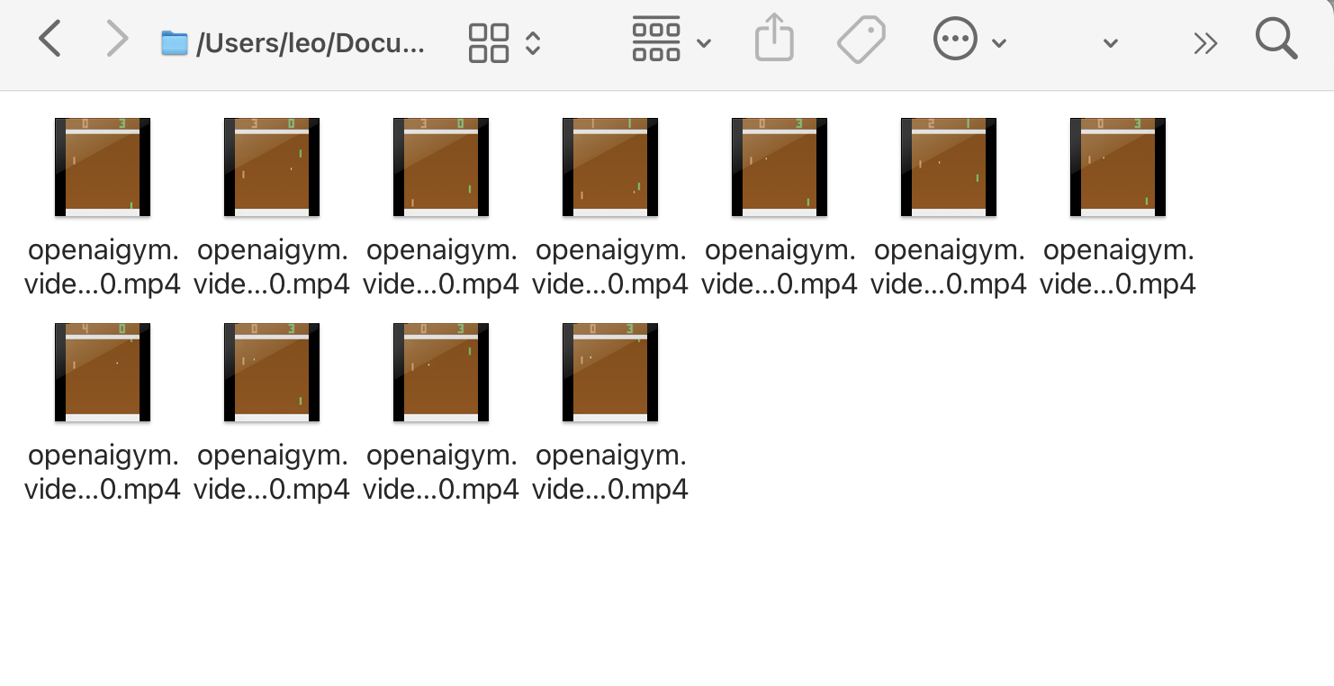
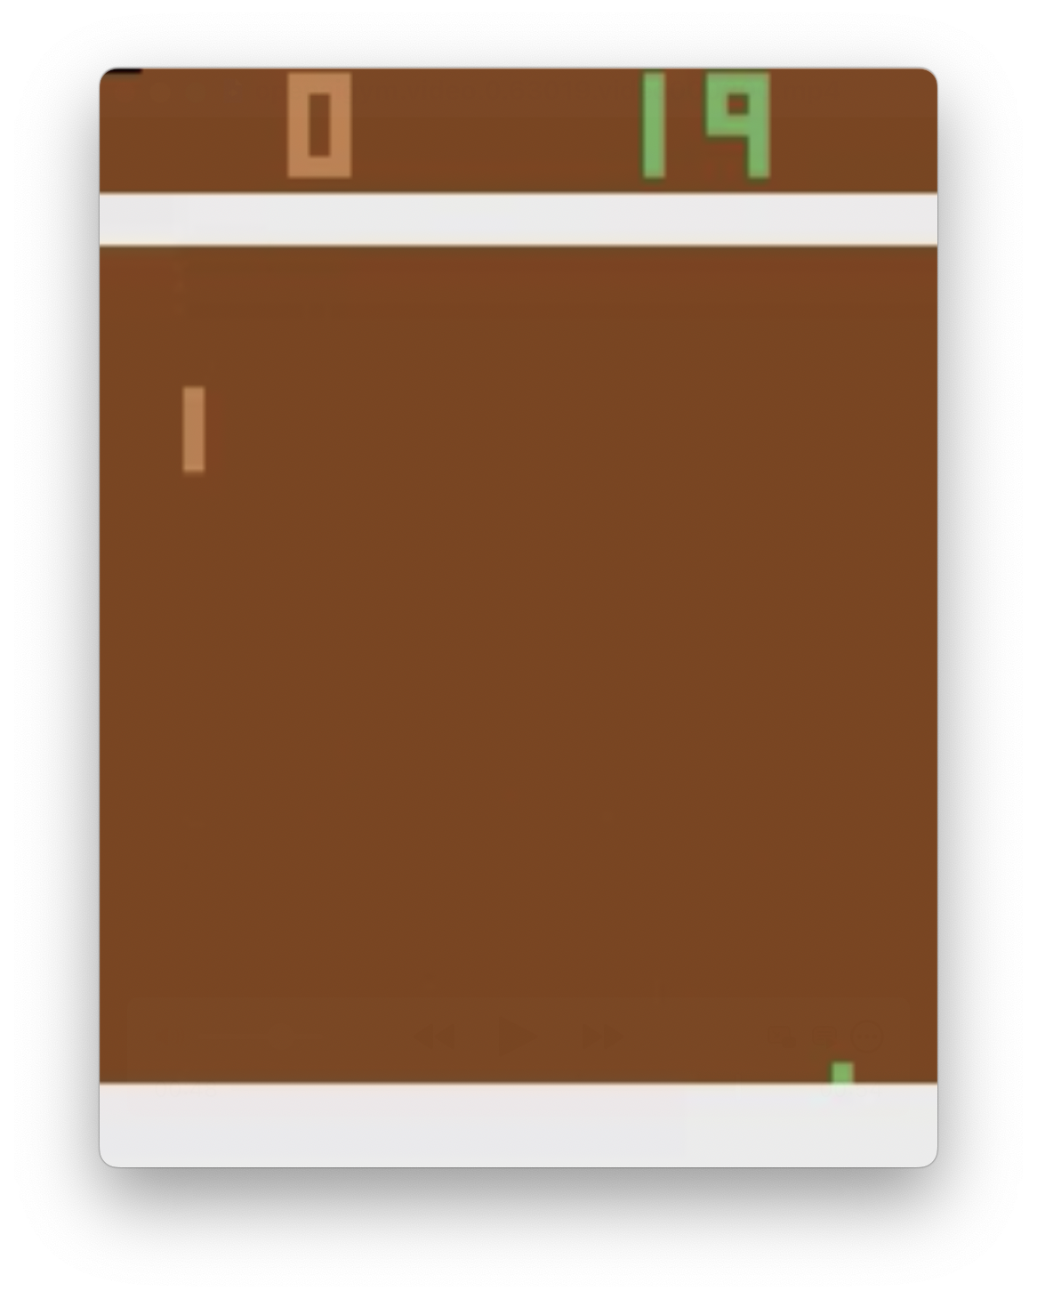
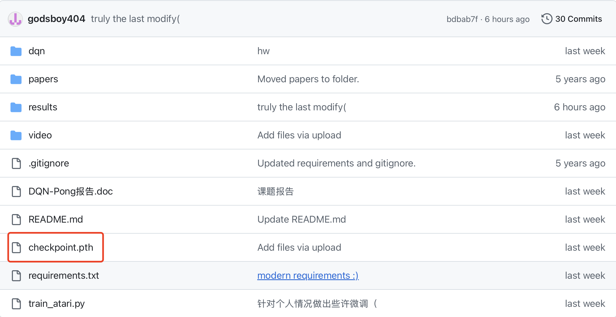

- 训练结果
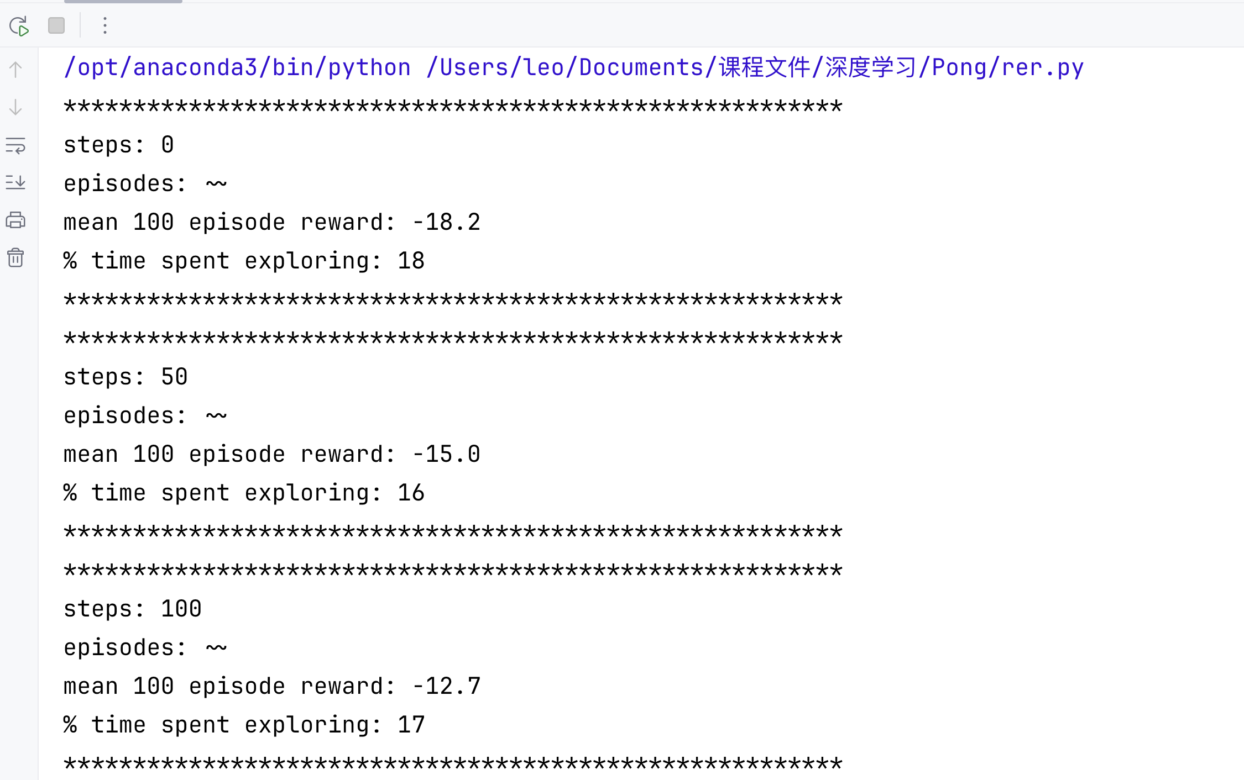
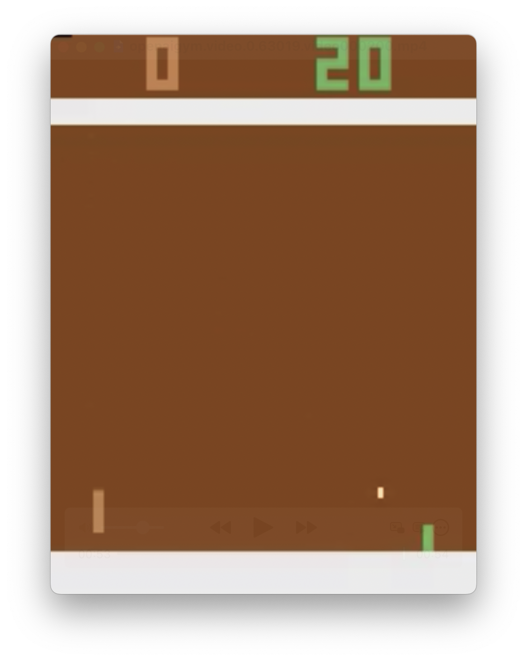
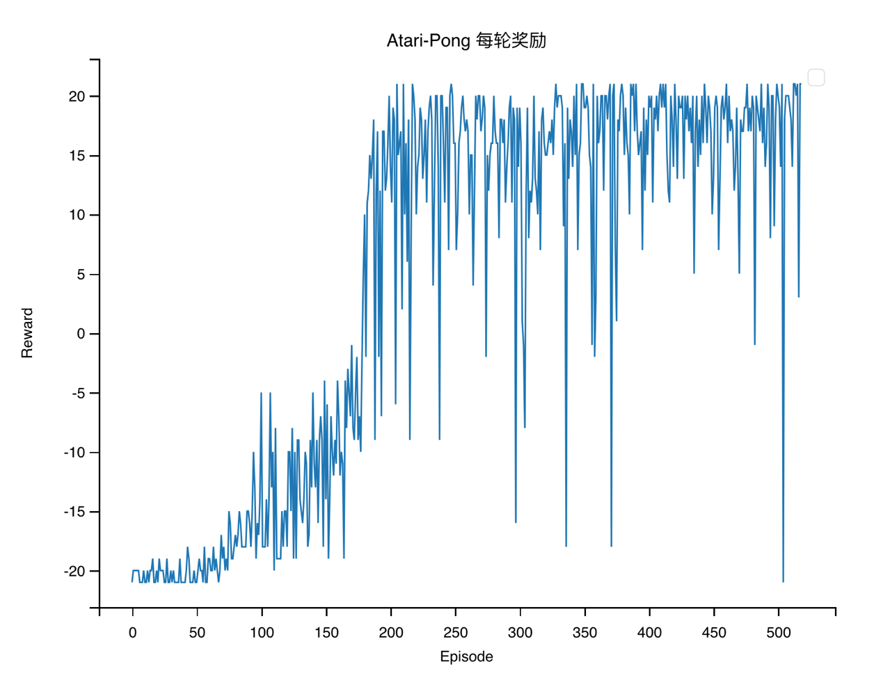
- 分析总结
在模型训练的初期，效果并不理想，在检查代码并参考相关资料后对训练的超参数做了适当调整，例如学习率，批处理大小以及目标网络更新频率等参数，最终的Agent在游戏中所获得分数在16~20间。
通过这次实践，进一步理解强化学习的概念（如状态、动作、奖励、Q 值等），提高了自身实用性编程能力，还学会了从游戏AI 的行为模式、策略
选择和学习能力。

- 参考文献
[1] Mnih, V. (2013). Playing atari with deep reinforcement learning. arXiv preprint arXiv:1312.5602.
[2] Mnih, V., Kavukcuoglu, K., Silver, D., Rusu, A. A., Veness, J., Bellemare, M. G., ... & Hassabis, D. (2015). Human-level control through deep reinforcement learning. nature, 518(7540), 529-533.

