Date of submission May 28, 2026; date of current version May 23, 2026.
Digital Object Identifier: Not applicable for course-project submission.
SCRE-Credit: Validation-Locked, Cost-Aware Credit-Risk Screening With Manual Review
Resul Ozkale, Student ID 2540041007
Student, ECE 565 - Data Mining, Spring 2026
Corresponding author: Resul Ozkale.
This report was prepared as the final project report for ECE 565 - Data Mining. The accompanying repository contains the reproducible source code, dependency files, generated tables, figures, and audit artifacts used in this report.
ABSTRACT This report presents Stability- and Cost-Regularized Ensemble for Credit Risk (SCRE-Credit), an audit-aware credit-risk screening study that combines tabular prediction, probability calibration, cost-sensitive thresholding, explanation diagnostics, and manual-review decision design. The project uses the Taiwan credit-card default dataset as the primary development setting and FICO HELOC as an external portability check. The final revised V2 policy set refers to the audited, validation-locked manual-review policies selected before held-out test reporting. SCRE-Credit is treated as a reliability-aware framework for combining discrimination, calibration, cost, stability, faithfulness, and review-prioritization evidence, not as a model that defeats every baseline. A final weakness-closing phase tested recall-constrained Taiwan policies, capacity-aware review, HELOC specificity-focused thresholds, instance-dependent cost sensitivity, and repaired manual-review metric definitions; none provided an audit-ready replacement for the final revised V2 policies. The final operational evidence therefore remains dataset-specific: CatBoost with manual review for Taiwan and a scorecard with manual review for HELOC. The intended use is screening and manual-review support, not automatic rejection.
INDEX TERMS calibration, credit risk, explainable machine learning, manual review, threshold selection.

- INTRODUCTION
Credit-risk modeling is not only a binary classification exercise. A model that catches many future defaults can still be operationally weak if it generates excessive false positives, because a false alarm can send a non-defaulting customer into unnecessary review or an unjustified adverse-decision workflow. This project therefore treats default prediction as a screening and manual-review problem rather than a direct automatic rejection problem.
The primary empirical setting is the Default of Credit Card Clients dataset from the UCI Machine Learning Repository [1], whose original study focused on probability-of-default prediction [2]. A second dataset from the FICO Explainable Machine Learning Challenge is used as external validation evidence through the cleaned OpenML mirror [3], [4]. The two datasets are not merged, because they represent different schemas and lending contexts.
The generated artifacts use three version labels that must be read carefully. V2 denotes the audit-ready validation-locked final policy set. Final Attempt denotes a later stress-test package that explored stronger alternatives. Weakness-closing denotes the final diagnostic phase that repaired manual-review metrics and tested whether recall, specificity, review capacity, and proxy-cost weaknesses could replace V2. No V3 replacement was selected because no alternative satisfied all audit and operational criteria.
The final operational recommendations are dataset-specific: CatBoost with manual review for Taiwan and a scorecard with manual review for HELOC. A reader should interpret these as screening tools. They estimate risk, route uncertain cases to human review, and reduce false-positive pressure; they do not automatically reject applicants.
This framing is deliberately conservative. It recognizes that high recall can coexist with too many false positives, that calibration affects threshold decisions more directly than ranking metrics, and that explanation plots are diagnostic rather than causal. The report therefore positions the system as review support, not as a production credit denial engine.
Main contributions. The main contributions of this report are: 1) a validation-locked credit-risk screening protocol that separates model and policy selection from held-out evidence; 2) a manual-review decision workflow that reduces false-positive pressure compared with aggressive thresholding; 3) a reliability-aware SCRE framework for combining discrimination, calibration, cost, stability, faithfulness, and review-prioritization evidence; and 4) a weakness-closing analysis showing that recall-constrained, capacity-aware, specificity-focused, and proxy-cost alternatives improve selected weaknesses but do not replace the audit-ready final revised policies.
RELATED WORK AND PROJECT SCOPE
Credit scoring has long balanced predictive accuracy with interpretability and governance. The Taiwan dataset remains a common benchmark because it includes repayment status, bills, payments, credit limit, and demographic fields [1], [2]. The HELOC challenge dataset is useful because it was released around an explainable financial decision problem [3], [4]. Together, they support a primary-development and external-validation design.
The model pool covers both standard and high-performing tabular methods. Scikit-learn estimators supply transparent baselines [5]. XGBoost [6], LightGBM [7], and CatBoost [8] represent modern gradient-boosted tree methods. Scorecard-style logistic regression is retained because transparent scorecards are still common where governance and manual review matter. The project also includes monotonic variants and interpretable middle models to test whether operational clarity can be improved without losing too much predictive strength.
Class imbalance is handled cautiously. SMOTE-style methods can be useful for minority-class learning [9], and imbalanced-learn provides practical implementations [10]. In this project, resampling is kept inside training folds or training pipelines; validation and test distributions remain natural. This prevents inflated results caused by applying synthetic sampling before splitting or evaluating on altered distributions.
Probability calibration and explanation diagnostics are also central. Calibration is evaluated because manual-review thresholds depend on probability scale, not only ranking [11]. SHAP [12] and LIME [13] are used for local and global explanation checks, while decision-curve analysis [14] is treated as decision-support evidence rather than as a replacement for cost-sensitive validation.
Table I positions the project against the closest empirical credit-default literature. The comparison is used for scope control: external papers motivate stress tests and diagnostics, but final project claims remain tied to the validation-locked evidence in this repository.
TABLE I
EMPIRICAL CREDIT-DEFAULT LITERATURE POSITIONING
Study / Theme | Why it matters | Position in this report
Yeh and Lien [2] | Defines the Taiwan probability-of-default benchmark. | Primary dataset foundation and screening task.
Alam et al. [15] | Motivates imbalance handling and GBDT/SMOTE-style reproduction. | Leakage-free reproduction did not replace the final revised V2 policy.
Chen and Zhang [16] | Motivates KMeansSMOTE and BP/MLP stress testing. | Deep/resampling attempts did not become the safest operational policy.
Talaat et al. [17] | Motivates XAI and deep-learning comparison. | XAI remains diagnostic; automatic-decision claims are avoided.
Bhandary and Ghosh [18]; Lin and Wang [19] | Motivates DNN benchmarking and SHAP/explanation stability. | Stability and XAI support diagnostics; final decisions remain validation-locked and manual-review based.
DATA AND REPRODUCIBLE PIPELINE
A. Implementation and reproducibility
The implementation is organized in a reproducible repository structure. Repository: godsoftware/Data_Mining_Project. The repository contains raw inputs, reusable source modules, numbered experiment scripts, tests, generated tables, figures, model diagnostics, and audit artifacts.
Experiments are organized as a numbered sequence from experiment 00 through experiment 47. The intended execution order is the numeric experiment order, beginning with environment and split checks and ending with locked final evaluation and audit artifacts. Main final evidence folders are outputs/decision_revision_v2/, outputs/final_frozen_v2/, and outputs/final_weakness_closing/. Environment files are requirements.txt and environment.yml. Supporting tests cover leakage, metrics, preprocessing, calibration, thresholding, subgroup reliability, and phase-output checks.

B. Datasets and cleaning
TABLE II
DATASETS AND EVALUATION ROLES
Dataset | Cleaned profile | Role in report
Taiwan credit-card default | 30,000 rows; 6,636 defaults; 23,364 non-defaults; no missing values after cleaning. | Primary development setting. ID leakage removed; anomalous education/marriage codes merged into Other categories.
FICO HELOC | 9,871 rows; 5,136 bad cases; 4,735 good cases; special missing values handled. | External validation setting. Different schema, so it tests framework portability rather than direct feature transfer.
Taiwan and HELOC were modeled separately. Taiwan was used as the primary development setting, whereas HELOC was used to test whether the evaluation framework and manual-review logic remained meaningful under a different credit-risk schema. No Taiwan-trained feature vector was directly transferred to HELOC, and no HELOC feature was forced to imitate a Taiwan column. The comparison is therefore a framework-portability check rather than a direct cross-dataset feature-matching experiment.
The two datasets were not merged and no row-level or feature-level transfer was performed. Because Taiwan and HELOC have different schemas, the mapping below is conceptual. It explains which feature groups play similar credit-risk roles, not a one-to-one column transformation.
TABLE III
CONCEPTUAL FEATURE-GROUP MAPPING BETWEEN TAIWAN AND HELOC
Credit-risk concept | Taiwan columns/features | HELOC columns/features and note
Target / outcome | default payment next month / default_next_month | RiskPerformance / bad_flag. Binary outcome; Taiwan primary, HELOC portability check.
Delinquency / repayment behavior | PAY_0, PAY_2, PAY_3, PAY_4, PAY_5, PAY_6; delay_count; max_delay; avg_delay; recent_delay | PercentTradesNeverDelq; NumTrades60Ever2DerogPubRec; NumTrades90Ever2DerogPubRec; MSinceMostRecentDelq; MaxDelqEver; MaxDelq2PublicRecLast12M. Conceptual match only.
Utilization / debt burden | LIMIT_BAL; BILL_AMT1-BILL_AMT6; utilization_proxy; total_bill; avg_bill | NetFractionRevolvingBurden; NetFractionInstallBurden; PercentTradesWBalance; NumBank2NatlTradesWHighUtilization. Conceptual burden/utilization match.
Payment / balance management | PAY_AMT1-PAY_AMT6; total_payment; avg_payment; payment_to_bill_ratio | NumRevolvingTradesWBalance; NumInstallTradesWBalance; PercentTradesWBalance. Partial conceptual match; HELOC is trade/balance-status based.
Credit history age / maturity | AGE; six-month repayment history | MSinceOldestTradeOpen; MSinceMostRecentTradeOpen; AverageMInFile. HELOC has stronger account-age history.
Recent credit activity / inquiries | No direct equivalent | NumInqLast6M; NumInqLast6Mexcl7days; NumTradesOpeninLast12M; MSinceMostRecentInqexcl7days. HELOC has bureau inquiry/activity variables absent from Taiwan.
Demographics | SEX; EDUCATION; MARRIAGE; AGE | No direct demographic equivalent in cleaned public HELOC features used here. Not transferable.
External bureau risk score | No direct equivalent | ExternalRiskEstimate. HELOC includes an external bureau-style risk score; Taiwan does not.
This table is not used to transform Taiwan features into HELOC features. It only documents how similar credit-risk concepts appear in different public schemas.

Feature engineering is row-wise and target-free. Taiwan features include delay counts, maximum and average delay severity, recent delay, total and average bill amounts, payment totals, payment-to-bill ratio, utilization proxy, and bill/payment volatility. Train-fitted preprocessing is isolated inside pipelines to avoid leakage.
C. Experiment coverage
TABLE IV
MODEL FAMILIES AND IMPLEMENTATION COVERAGE
Family | Examples evaluated | Purpose
Baselines | Majority, logistic, class-weighted logistic, decision tree, random forest. | Anchor performance and reveal class-imbalance trade-offs.
Boosting | XGBoost, LightGBM, CatBoost, monotonic variants, class-weighted variants. | High-performing tabular candidates and operational comparison.
Scorecard | WOE scorecard-style logistic regression. | Interpretable benchmark and final HELOC policy.
SCRE family | Old SCRE-Credit, SCRE-Pareto, SCRE-Optimized. | Reliability-aware framework and review-prioritization evidence.
Stress tests | Literature reproduction, imbalance boosting, deep MLP, EBM, capacity review, decision curves. | Check whether stronger or more complex attempts safely replace the audited final system.

The environment files document a Python 3.10 stack with pandas, NumPy, scikit-learn, imbalanced-learn, XGBoost, LightGBM, CatBoost, Optuna, SHAP, LIME, matplotlib, and pytest. Tests cover split leakage, cleaning, metrics, calibration outputs, threshold outputs, feature engineering, subgroup reliability, and phase outputs.
METHODOLOGY
A. Validation-locked selection
The central design rule is that training, validation, and held-out test roles must remain distinct. Training data fit preprocessing and models. Validation data choose model family, calibration method, threshold, and manual-review band. The held-out test set is opened only once after the policy is frozen. Therefore, validation tables may contain ranks and winner flags, but held-out test tables are evidence tables only.
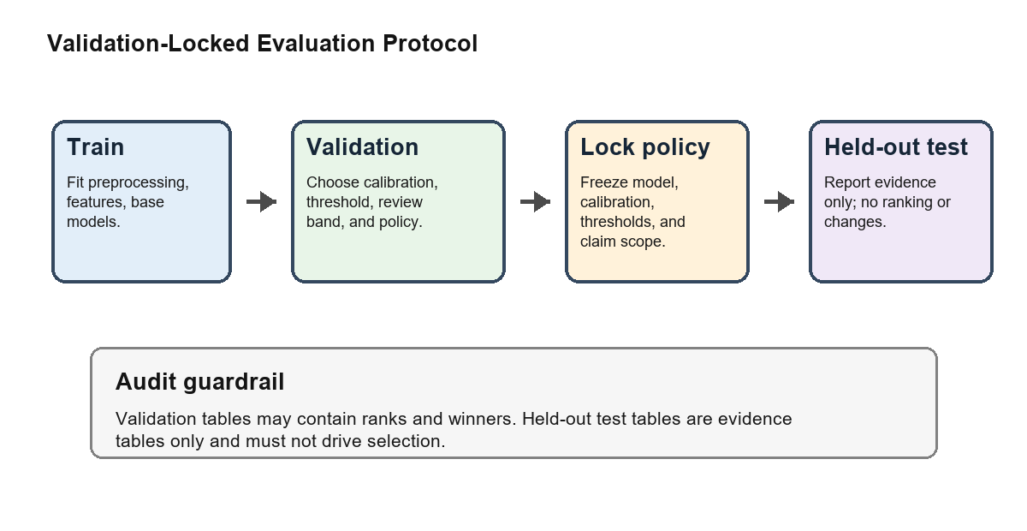
- FIGURE 1. Validation-locked selection and evaluation protocol.
B. SCRE-Credit scoring
SCRE-Credit can be interpreted as a weighted voting system for probability estimates. Each candidate model first receives a reliability score from validation evidence. The score rewards models that rank defaults well, remain calibrated enough for thresholding, reduce cost under the stated proxy assumptions, behave stably, and have plausible explanation diagnostics. All components are normalized so that larger values mean stronger reliability evidence.
R_m = 0.20 PR_m + 0.15 AUC_m + 0.15 Recall_m + 0.15 Cal_m + 0.15 Cost_m + 0.10 Stability_m + 0.10 Faithfulness_m (1)
In (1), R_m is the reliability score of model m. PR_m is the normalized PR-AUC component; AUC_m is the normalized ROC-AUC component; Recall_m is the normalized recall component; Cal_m is the calibration-quality component; Cost_m is the normalized cost component; Stability_m summarizes available rank-stability evidence; and Faithfulness_m summarizes perturbation-based explanation checks. The coefficients are validation-side design weights, so the equation ranks reliability evidence rather than retraining a new classifier.
After each model has a reliability score, the scores are turned into model weights. A model weight is its own reliability score divided by the total reliability score of all candidate models, so the weights sum to one. A model with twice the reliability score of another model receives roughly twice the voting weight in the final probability average.
w_m = R_m / SUM_k R_k
P_final(x) = SUM_m w_m p_m(x) (2)
In (2), x is one customer or applicant, p_m(x) is the default probability predicted by model m, w_m is that model's reliability weight, and P_final(x) is the final screening probability. SUM denotes summation over the candidate models. Equation (2) does not create an automatic rejection rule; it creates a calibrated screening score that can later be routed through low-risk, manual-review, or high-risk decision buckets.
C. Manual-review cost
The final policy has three actions. If the predicted risk is below t_low, the case is treated as low risk. If the predicted risk is above t_high, the case is treated as high risk. If the predicted risk falls between those two values, the case goes to manual review. The project uses two thresholds because credit screening is not safe when every uncertain customer is forced into a hard yes-or-no automatic decision.
TABLE V
MANUAL-REVIEW 3x2 DECISION STRUCTURE
Decision bucket | Non-default outcome | Default outcome
Low risk | TN_low | FN_low
Manual review | MR_nondefault | MR_default
High risk | FP_high | TP_high
Low-risk defaults are missed defaults, high-risk non-defaults are false alarms, and manual-review cases are treated as workload rather than automatic errors. This 3x2 structure is used to keep manual-review metrics separate from ordinary binary-classification metrics.
The review-adjusted cost counts three things: missed defaults, false alarms, and manual-review workload. A missed default is a real default that the system lets pass as low risk. A false alarm is a non-default customer that the system treats as high risk. A reviewed case is not counted as an automatic error, but it still has workload cost.
Review cost = 5 x missed defaults + 1 x false alarms + 0.5 x reviewed cases (3)
Equation (3) is the plain-language version of the cost rule used in the main comparison. The value 5 means that missing a true default is considered five times as costly as one false alarm. The value 0.5 means that sending a case to manual review has half the cost of one false alarm. This cost model is transparent but not claimed as a real bank loss model. Its value is to compare policies consistently and to avoid optimizing only one metric such as accuracy or recall.
With this design, the final revised system is a workflow rather than a single model score. It estimates risk, uses two thresholds to separate clear low-risk and clear high-risk cases, and sends uncertain cases to a reviewer. That is the meaning of the final system throughout the report.
MODEL COMPARISONS AND FINAL RESULTS
A. Validation-only winners
TABLE VI
VALIDATION-SELECTED POLICIES BEFORE HELD-OUT TESTING
Dataset / track | Model and policy | Val. P/R/S | Val. PR/AUC/cost
Taiwan / Manual-review | Best CatBoost; [0.14, 0.28] | P=0.529; R=0.567; S=0.857 | PR=0.560; AUC=0.786; cost=2650.5
Taiwan / Binary threshold | Old SCRE-Credit; t=0.20 | P=0.412; R=0.720; S=0.708 | PR=0.555; AUC=0.791; cost=3224.0
Taiwan / SCRE framework | SCRE-Pareto; [0.14, 0.25] | P=0.509; R=0.584; S=0.840 | PR=0.562; AUC=0.789; cost=2651.5
Taiwan / Interpretable | Best Scorecard; [0.14, 0.19] | P=0.433; R=0.662; S=0.754 | PR=0.532; AUC=0.773; cost=2993.5
HELOC / Manual-review | Best Scorecard; [0.16, 0.39] | P=0.701; R=0.842; S=0.610 | PR=0.795; AUC=0.803; cost=729.0
HELOC / Binary threshold | SCRE-Optimized; t=0.22 | P=0.569; R=0.982; S=0.194 | PR=0.806; AUC=0.808; cost=853.0
HELOC / SCRE framework | SCRE-Optimized; [0.22, 0.43] | P=0.702; R=0.823; S=0.622 | PR=0.806; AUC=0.808; cost=732.5
HELOC / Interpretable | Best Scorecard; [0.16, 0.39] | P=0.701; R=0.842; S=0.610 | PR=0.795; AUC=0.803; cost=729.0

Table VI is the validation-only selection table. Taiwan's final manual-review policy is Best CatBoost with lower threshold 0.14 and upper threshold 0.28. HELOC's final manual-review policy is Best Scorecard with lower threshold 0.16 and upper threshold 0.39. Scores below the lower threshold are treated as low risk, scores above the upper threshold are treated as high risk, and scores between them go to human review. SCRE variants remain important research-framework candidates, especially for PR-AUC and review ranking, but they are not claimed as universal operational winners.
B. Diagnostic threshold-only held-out comparisons
Tables VII and VIII are diagnostic threshold-only held-out comparisons. They were not used to select the final operational policy. The final selected manual-review policies are reported separately in Table IX.
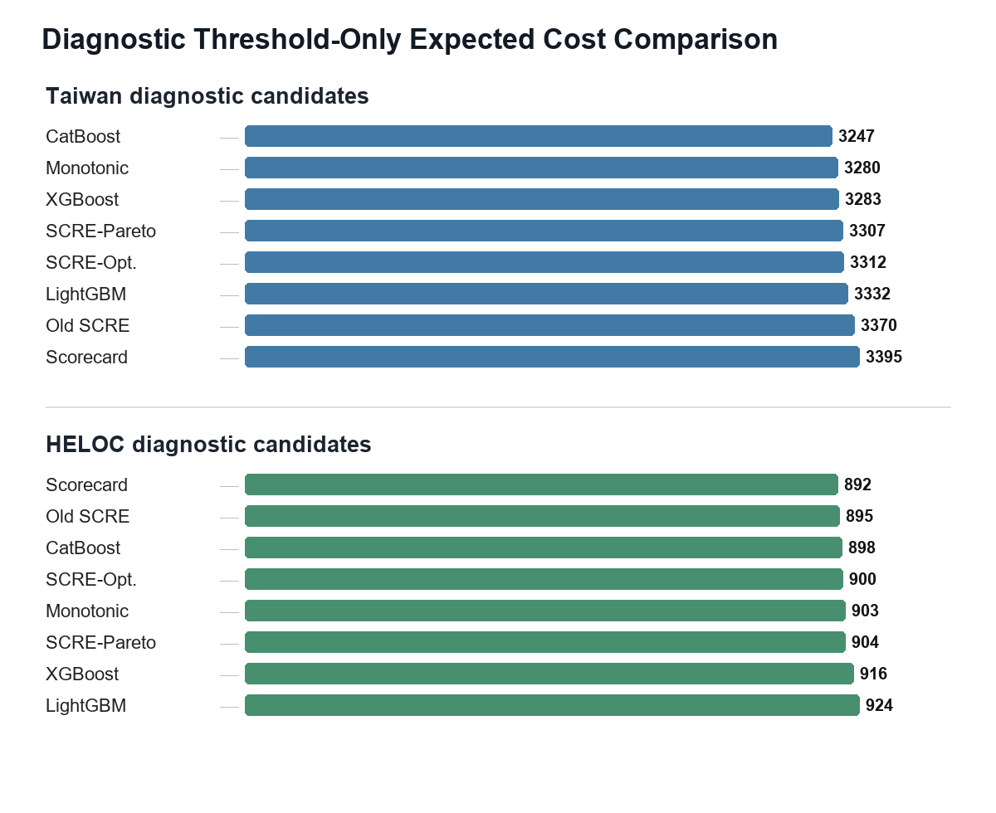
- FIGURE 2. Diagnostic threshold-only expected cost comparison for representative held-out candidates. Lower cost is better. These values are held-out diagnostic evidence only and were not used as model-selection ranks.
TABLE VII
TAIWAN DIAGNOSTIC THRESHOLD-ONLY HELD-OUT COMPARISON
Model | P/R/S | ROC/PR/ECE | Diagnostic cost
Best CatBoost | P=0.351; R=0.809; S=0.576 | ROC=0.785; PR=0.564; ECE=0.008 | cost=3247
Best Monotonic model | P=0.351; R=0.803; S=0.578 | ROC=0.781; PR=0.557; ECE=0.010 | cost=3280
Best XGBoost | P=0.336; R=0.836; S=0.530 | ROC=0.783; PR=0.562; ECE=0.010 | cost=3283
SCRE-Pareto | P=0.360; R=0.778; S=0.607 | ROC=0.784; PR=0.566; ECE=0.011 | cost=3307
SCRE-Optimized | P=0.360; R=0.777; S=0.608 | ROC=0.785; PR=0.567; ECE=0.011 | cost=3312
Best LightGBM | P=0.375; R=0.746; S=0.648 | ROC=0.778; PR=0.555; ECE=0.008 | cost=3332
Old SCRE-Credit | P=0.364; R=0.756; S=0.626 | ROC=0.782; PR=0.544; ECE=0.016 | cost=3370
Best Scorecard | P=0.369; R=0.742; S=0.640 | ROC=0.772; PR=0.543; ECE=0.014 | cost=3395

TABLE VIII
HELOC DIAGNOSTIC THRESHOLD-ONLY HELD-OUT COMPARISON
Model | P/R/S | ROC/PR/ECE | Diagnostic cost
Best Scorecard | P=0.559; R=0.982; S=0.158 | ROC=0.801; PR=0.804; ECE=0.014 | cost=892
Old SCRE-Credit | P=0.601; R=0.952; S=0.314 | ROC=0.803; PR=0.794; ECE=0.022 | cost=895
Best CatBoost | P=0.558; R=0.981; S=0.157 | ROC=0.804; PR=0.812; ECE=0.011 | cost=898
SCRE-Optimized | P=0.561; R=0.978; S=0.171 | ROC=0.805; PR=0.813; ECE=0.046 | cost=900
Best Monotonic model | P=0.550; R=0.985; S=0.126 | ROC=0.797; PR=0.801; ECE=0.013 | cost=903
SCRE-Pareto | P=0.572; R=0.969; S=0.214 | ROC=0.806; PR=0.810; ECE=0.028 | cost=904
Best XGBoost | P=0.611; R=0.942; S=0.350 | ROC=0.803; PR=0.805; ECE=0.020 | cost=916
Best LightGBM | P=0.546; R=0.983; S=0.114 | ROC=0.787; PR=0.793; ECE=0.028 | cost=924

The diagnostic threshold-only comparison shows why the report avoids one-size-fits-all claims. These rows are useful for understanding candidate behavior under held-out evidence, but they are not the basis for selecting the final operational policies. The locked manual-review results below remain the main final evidence.
C. Locked final policies
TABLE IX
LOCKED HELD-OUT TEST RESULTS FOR FINAL REVISED POLICIES
Data | Locked policy | Test P/R/S/F1 | Final operational evidence
Taiwan | Best CatBoost; isotonic; band [0.14, 0.28]. | P=0.529; R=0.575; S=0.854; F1=0.551. | FP=680; FN=564; cost=2705.5; MR=29.5%.
HELOC | Best Scorecard; sigmoid; band [0.16, 0.39]. | P=0.683; R=0.846; S=0.574; F1=0.756. | FP=403; FN=158; cost=764.5; MR=27.0%.

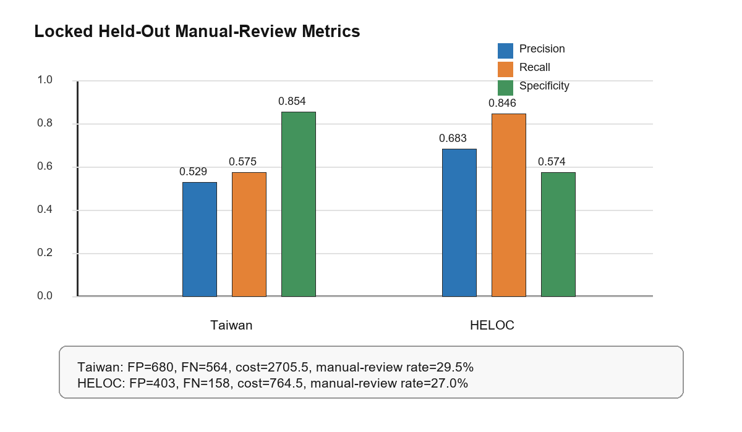
- FIGURE 3. Precision, recall, and specificity for the locked held-out final policies.
Table IX is the main final evidence. Taiwan remains harder: precision is 0.529, recall is 0.575, and the manual-review rate is 29.5 percent. HELOC has stronger precision and recall, but specificity is still 0.574, so manual review remains appropriate. Neither final policy should be described as automatic rejection.
D. Old threshold vs final manual review
TABLE X
OLD AGGRESSIVE POLICY VERSUS FINAL MANUAL-REVIEW POLICY
Data | Old aggressive reference | Final manual-review policy | Main change
Taiwan | CatBoost threshold: P=0.351; R=0.809; S=0.576; FP=1,982; cost=3247. | CatBoost manual review: P=0.529; R=0.575; S=0.854; FP=680; cost=2705.5. | False positives reduced by 1,302; cost reduced by 541.5.
HELOC | Aggressive CatBoost reference: P=0.558; R=0.981; S=0.157; FP=798; cost=898. | Scorecard manual review: P=0.683; R=0.846; S=0.574; FP=403; cost=764.5. | False positives reduced by 395; cost reduced by 133.5.

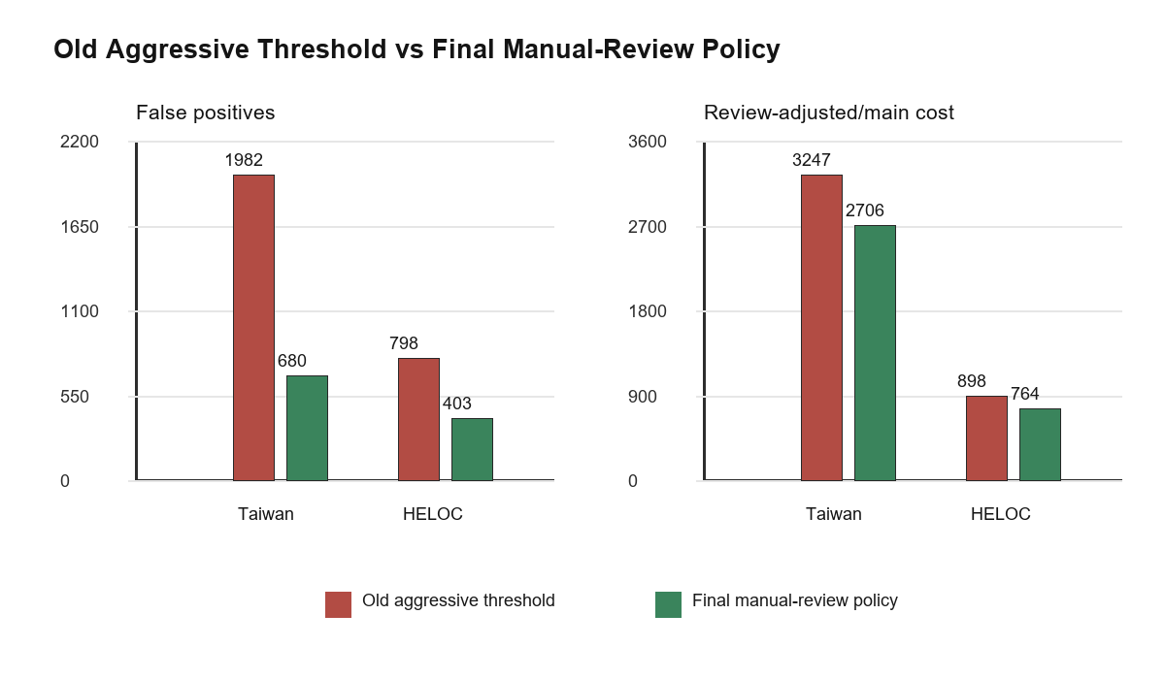
- FIGURE 4. False-positive and cost reduction versus the old aggressive threshold.
The old policy caught more defaults but created a large false-positive burden. The final manual-review policy accepts a less aggressive recall profile in exchange for substantially better precision, specificity, and review-adjusted cost. This is the key operational improvement of the project.
ROBUSTNESS, EXPLAINABILITY, AND AUDIT
A. Final-attempt stress tests
TABLE XI
SUPPORTING ROBUSTNESS AND NEGATIVE-RESULT EVIDENCE
Stress test | Best or notable result | Report interpretation
Strict literature reproduction | Taiwan XGBoost no-resampling PR=0.564, AUC=0.789, cost=3209; HELOC CatBoost balanced PR=0.799, AUC=0.803, cost=873. | Useful reproduction check, but did not replace the audited final system under the locked protocol.
Advanced imbalance boosting | Taiwan XGBoost scale_pos_weight_5 cost=2648.5 on validation; HELOC CatBoost baseline cost=747. | Found strong candidates, but final audit and policy consistency favored the revised manual-review system as the main evidence.
Deep tabular MLP | Taiwan MLP PR=0.552, AUC=0.780; HELOC MLP PR=0.811, AUC=0.804, but high binary costs at 0.50 thresholds. | Shows deep models were tried; they did not become the safest operational winner.
Interpretable middle models | EBM, monotonic boosting, and scorecards produced competitive manual-review rows. | Supports governance discussion and HELOC scorecard choice.
Decision curves | Useful threshold ranges remained broad for probability-ranking models. | Supports decision-support framing, not automatic rejection.

The earlier final-attempt audit exposed metric-consistency problems in several manual-review rows. During the final weakness-closing phase, these rows were repaired with explicit 3x2 manual-review bucket tables. The repaired alternatives were useful as robustness evidence, but they still did not provide an audit-ready operational replacement for the final revised V2 policies. Therefore, Final Attempt is retained as appendix evidence rather than final main evidence.
B. Capacity-aware review
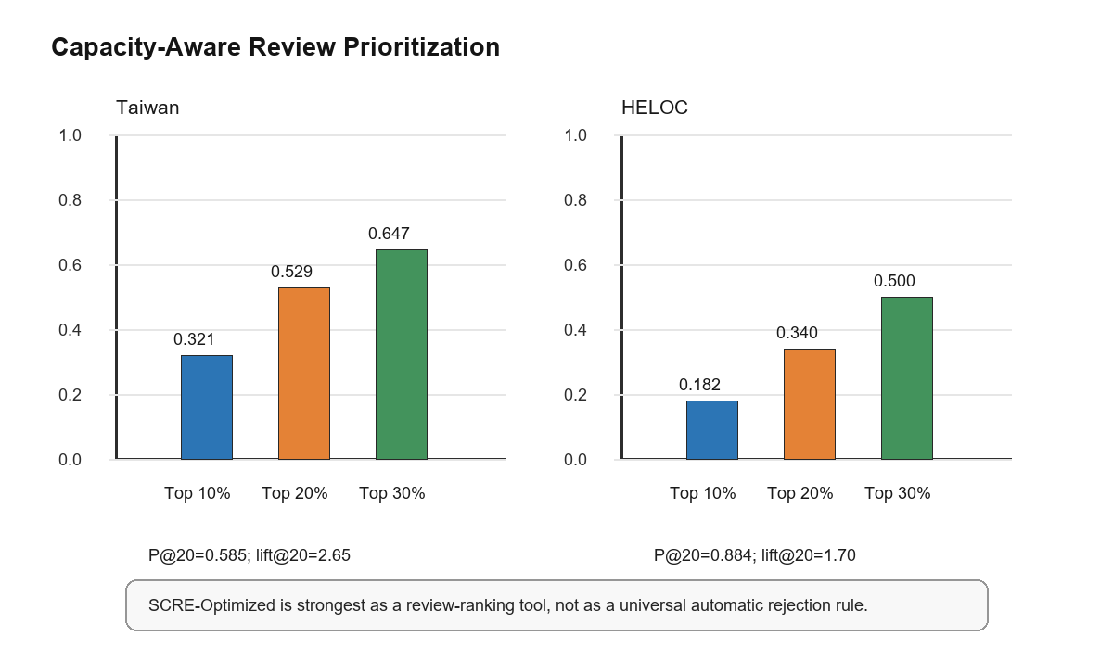
- FIGURE 5. SCRE-Optimized review-prioritization capture at top review capacities.
Capacity-aware results support the same interpretation. On validation, SCRE-Optimized captured 52.9 percent of Taiwan defaults in the top 20 percent review queue and 34.0 percent of HELOC bad cases in the top 20 percent review queue, with lift@20 of 2.65 and 1.70, respectively. This is useful for prioritizing review capacity, but it is not an automatic decision rule.
C. Weakness-closing analysis
TABLE XII
WEAKNESS-CLOSING SUMMARY
Weakness | Best diagnostic attempt | Final decision
Taiwan recall | Recall-constrained manual-review band | Appendix/V3 candidate only; V2 remains final.
Manual-review workload | SCRE top-K review | Review-prioritization evidence only.
HELOC specificity | Specificity-focused threshold | Appendix candidate only; V2 remains final.
Final Attempt metrics | 3x2 repair | Repaired, still appendix evidence.
Proxy cost uncertainty | Instance-dependent cost | Sensitivity evidence only.
Temporal validation | Timestamp availability check | Limitation / future work.
TABLE XIII
MAIN WEAKNESS-CLOSING TRADE-OFFS
Area | Improvement | Trade-off
Taiwan recall | Recall 0.575 to 0.633; FN 564 to 487. | FP 680 to 976; precision lower.
Manual review | Taiwan Capture@20 0.529; Lift@20 2.645. | Ranking evidence, not full decision policy.
HELOC specificity | Specificity 0.574 to 0.676; FP 403 to 307. | Recall lower; cost higher.
Final Attempt | Metric definitions repaired. | Did not replace V2.
Proxy cost | Taiwan candidate better under several proxy costs. | Proxy cost is not real bank loss.
Temporal | Timestamp issue documented. | No true temporal validation.
The weakness-closing phase strengthened the discussion but did not create a V3 replacement. Its role is to show that the main weaknesses were tested, not ignored.
D. Explanation and reliability checks
TABLE XIV
EXPLANATION, STABILITY, AND CLAIM-CONTROL CHECKS
Check | Evidence | Safe interpretation
SHAP seed stability | LightGBM Kendall W: Taiwan all=0.977, top5=0.893; HELOC all=0.995, top5=1.000. | Feature-rank agreement is high for the available LightGBM stability protocol.
SHAP/LIME local agreement | Local Jaccard range 0.111-0.538; average consistency 0.309. | Local explanations are diagnostic and case-dependent; they are not causal proof.
Faithfulness perturbation | Largest observed AUC drop is 0.016 for PAY_0. | Top repayment-delay features are behaviorally plausible, but perturbation tests remain model diagnostics.
Claim control | SCRE does not beat every individual model; final policies are manual-review screening policies. | Avoid universal superiority and automatic rejection claims.

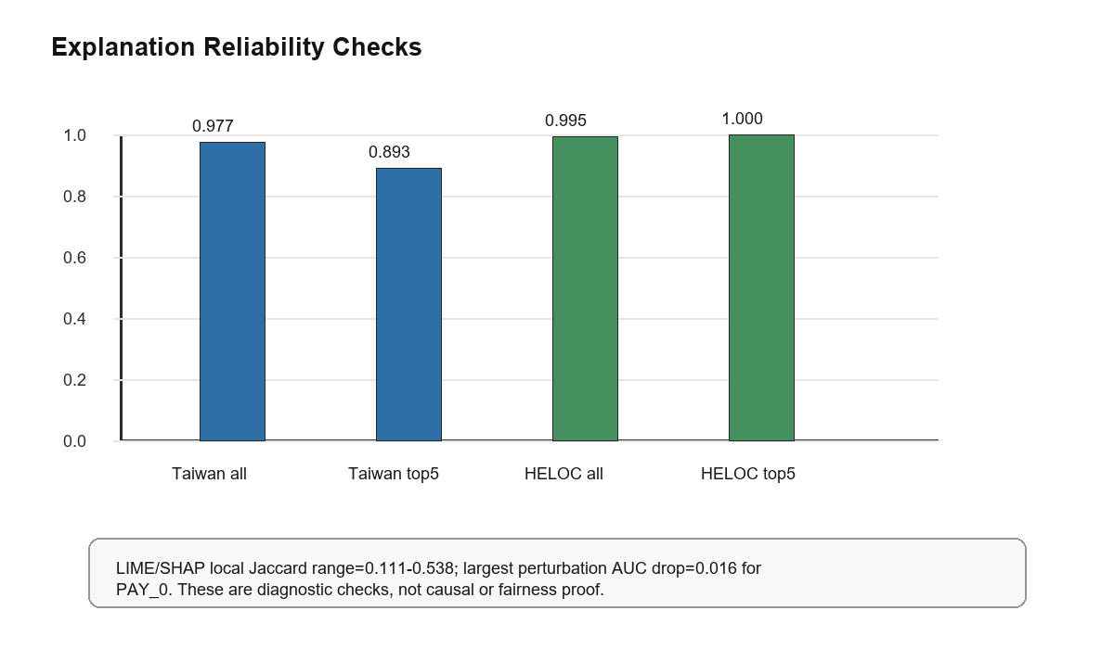
- FIGURE 6. Kendall W stability and local explanation diagnostics used as supporting evidence.
The explanation results are intentionally scoped. SHAP and LIME help inspect whether repayment, utilization, and delinquency signals influence risk scores in plausible ways. They do not establish causality, fairness compliance, or individual recourse validity. Therefore, explanations support model debugging and communication but do not replace the validation-locked decision evidence.
E. Audit status
TABLE XV
FINAL AUDIT CHECKS USED IN THE REPORT
Check | What was verified | Why it matters
Validation-only selection | Model, calibration, threshold, and manual-review bands are selected before held-out test reporting. | Prevents choosing the final result after looking at test performance.
Locked held-out evidence | The held-out test table reports evidence only after the policy is frozen; it does not contain model-selection ranks. | Keeps the final table as evaluation evidence rather than a hidden leaderboard.
Metric consistency | Precision, recall, specificity, F1, false positives, false negatives, and costs recompute consistently. | Ensures reported numbers match the displayed decision policy.
Claim-control matrix | Unsupported claims are explicitly excluded, including universal SCRE superiority and automatic rejection suitability. | Protects the report from overstating what the experiments prove.
Reproducibility | The codebase includes experiment scripts, dependency files, and tests for leakage, metrics, calibration, and thresholds. | Allows the instructor to trace the results without relying on the report alone.

The audit reports that the test set was not used for model selection, threshold selection, manual-review band selection, or calibration fitting. It also reports metric consistency for the locked final evidence. This audit trail is a major reason the revised manual-review system remains the final report version.
DISCUSSION
The results show a clear progression. The early pure cost-threshold approach maximized default capture aggressively but produced too many false positives. The final revised system uses validation-selected manual-review bands to move uncertain customers away from automatic decisions. This yields a more defensible screening workflow and a cleaner report claim.
Dataset-specific winners are expected. Taiwan favors CatBoost for the final manual-review policy, while HELOC favors a scorecard. This does not weaken the project; it demonstrates that the framework can select different operational policies when the population and feature schema change. SCRE-Credit remains valuable as a reliability-aware framework and review-ranking tool, even when a single base model is the final operational recommendation.
The conservative interpretation is central to the result. The report treats observed metrics as evidence for screening and review support, while governance, compliance, cost estimation, and deployment readiness remain separate requirements that must be validated before production use.
This is why the final recommendation favors transparent workflow language over winner-takes-all language. Taiwan and HELOC show that different datasets can prefer different operational policies, and the framework is useful because it records those trade-offs rather than hiding them behind a single leaderboard.
LIMITATIONS AND THREATS TO VALIDITY
The main threats to validity come from data age, public-dataset scope, and deployment realism. The public datasets are historical and may not represent current bank portfolios; no real production deployment was performed; and no verified timestamp or application-date field supports true temporal validation. The FN=5, FP=1, review=0.5 cost model is a transparent proxy cost model, not a real institutional loss model.
HELOC supports framework portability but not direct population generalization from Taiwan. Feature richness is limited by public datasets because income, employment, bureau-level history, and real exposure/loss variables are unavailable. Explanation tools are diagnostic and do not establish causality, fairness compliance, or recourse validity. The final system is not suitable for automatic rejection without legal, fairness, temporal, and deployment validation.
CONCLUSION AND FUTURE WORK
This project delivers an audit-aware credit-risk screening framework rather than a highest-score classifier. The final revised evidence is report-ready because selection is validation-only and held-out test results are used only after policies are locked. The final Taiwan recommendation is a CatBoost manual-review policy; the final HELOC recommendation is a Scorecard manual-review policy. Both support screening and review prioritization, not automatic rejection.
The final-attempt manual-review denominator problem was repaired during the weakness-closing phase, but the repaired alternatives remained appendix evidence because they did not outperform the final revised policies under the audit and operational criteria. Future work should estimate real operational costs, test temporal stability with timestamped application data, evaluate fairness and subgroup reliability under appropriate legal and ethical review, monitor deployment drift, implement a fully nested selection workflow, and prepare model cards for operational governance.
ACKNOWLEDGMENT
OpenAI ChatGPT/Codex was used for drafting assistance, consistency checking, and formatting automation [20]. It was not used to generate unverified experimental results. All numerical outputs, tables, interpretations, and final claims were checked by the student against the project code and generated artifacts.
REFERENCES
- I.-C. Yeh, "Default of Credit Card Clients," UCI Machine Learning Repository, 2016, doi: 10.24432/C55S3H.
- I.-C. Yeh and C.-H. Lien, "The comparisons of data mining techniques for the predictive accuracy of probability of default of credit card clients," Expert Syst. Appl., vol. 36, no. 2, pp. 2473-2480, Mar. 2009, doi: 10.1016/j.eswa.2007.12.020.
- Fair Isaac Corporation, "FICO Announces xML Challenge," Apr. 9, 2018. [Online]. Available: https://investors.fico.com/news-releases/news-release-details/fico-announces-xml-challenge. Accessed: May 23, 2026.
- OpenML, "FICO-HELOC-cleaned," data set 45554. [Online]. Available: https://www.openml.org/d/45554. Accessed: May 23, 2026.
- F. Pedregosa et al., "Scikit-learn: Machine learning in Python," J. Mach. Learn. Res., vol. 12, pp. 2825-2830, 2011.
- T. Chen and C. Guestrin, "XGBoost: A scalable tree boosting system," in Proc. 22nd ACM SIGKDD Int. Conf. Knowl. Discovery Data Mining, 2016, pp. 785-794, doi: 10.1145/2939672.2939785.
- G. Ke et al., "LightGBM: A highly efficient gradient boosting decision tree," in Adv. Neural Inf. Process. Syst., vol. 30, 2017.
- L. Prokhorenkova, G. Gusev, A. Vorobev, A. V. Dorogush, and A. Gulin, "CatBoost: Unbiased boosting with categorical features," in Adv. Neural Inf. Process. Syst., vol. 31, 2018.
- N. V. Chawla, K. W. Bowyer, L. O. Hall, and W. P. Kegelmeyer, "SMOTE: Synthetic minority over-sampling technique," J. Artif. Intell. Res., vol. 16, pp. 321-357, 2002.
- G. Lemaitre, F. Nogueira, and C. K. Aridas, "Imbalanced-learn: A Python toolbox to tackle the curse of imbalanced datasets in machine learning," J. Mach. Learn. Res., vol. 18, no. 17, pp. 1-5, 2017.
- A. Niculescu-Mizil and R. Caruana, "Predicting good probabilities with supervised learning," in Proc. 22nd Int. Conf. Mach. Learn., 2005, pp. 625-632, doi: 10.1145/1102351.1102430.
- S. M. Lundberg and S.-I. Lee, "A unified approach to interpreting model predictions," in Adv. Neural Inf. Process. Syst., vol. 30, 2017.
- M. T. Ribeiro, S. Singh, and C. Guestrin, "Why should I trust you?: Explaining the predictions of any classifier," in Proc. 22nd ACM SIGKDD Int. Conf. Knowl. Discovery Data Mining, 2016, pp. 1135-1144.
- A. J. Vickers and E. B. Elkin, "Decision curve analysis: A novel method for evaluating prediction models," Med. Decis. Making, vol. 26, no. 6, pp. 565-574, 2006, doi: 10.1177/0272989X06295361.
- T. M. Alam, K. Shaukat, I. A. Hameed, S. Luo, M. U. Sarwar, S. Shabbir, J. Li, and M. Khushi, "An investigation of credit card default prediction in the imbalanced datasets," IEEE Access, vol. 8, pp. 201173-201198, 2020, doi: 10.1109/ACCESS.2020.3033784.
- Y. Chen, R. Zhang, and B. M. Tabak, "Research on credit card default prediction based on k-means SMOTE and BP neural network," Complexity, vol. 2021, Art. no. 6618841, pp. 1-13, 2021, doi: 10.1155/2021/6618841.
- F. M. Talaat, A. Aljadani, M. Badawy, and M. Elhosseini, "Toward interpretable credit scoring: integrating explainable artificial intelligence with deep learning for credit card default prediction," Neural Comput. Appl., vol. 36, no. 9, pp. 4847-4865, 2024, doi: 10.1007/s00521-023-09232-2.
- R. Bhandary and B. K. Ghosh, "Credit card default prediction: An empirical analysis on predictive performance using statistical and machine learning methods," J. Risk Financial Manag., vol. 18, no. 1, Art. no. 23, 2025, doi: 10.3390/jrfm18010023.
- L. Lin and Y. Wang, "SHAP stability in credit risk management: A case study in credit card default model," Risks, vol. 13, no. 12, Art. no. 238, 2025, doi: 10.3390/risks13120238.
- OpenAI, "What is ChatGPT? FAQ," OpenAI Help Center. [Online]. Available: https://help.openai.com/en/articles/12677804. Accessed: May 23, 2026.

