Q1: After the Golden State Warriors acquired former MVP Kevin Durant in 2016, some NBA fans speculated that the Warriors would not lose consecutive games at any point of the season.

a) If you wanted to determine the probability that this prediction would be true (i.e., that the Warriors would never lose consecutive games at any point during an 82-game season), what is one approach (or a few approaches) you may use to solve the problem? What answer do you get? Exact answers are of course welcome, but approaches that lead to approximations (and those approximations) are fine, too (please specify the precision of your estimate). Assume the Warriors have an 80% chance of winning each individual game.

**Answer:** To determine the probability of consecutive lose in one season for a superior team as Golden State Warriors, whose winning probability was near 80%, I conducted 1,000,000 times simulation for one season to find the probability. Finally, a strong team, who could win at 80% chance, still got 94% roughly to confront a consecutive loss (defined as lose at least two times continuously.)

The code was recorded at the end of documents.

b) So, would you have agreed with that hypothesis?

**Answer:** According to estimated probability, the chance for that Warriors would not lose consecutive games at any point of the season is only 5%-6%. It was a tricky question because statistically the confidence interval is 95% normally, the hypothesis of 5%-6% probability could not be rejected. However, the selection of confidence interval should be adjusted based on business setting. At the condition of 90% confidence interval, the hypothesis could be rejected.

c) Finally, at least what % of a team's games would a team need to be expected to win (assuming that win probability stays constant from game to game) for there to be a greater than 50% chance that the team never suffers consecutive losses at any point in the season?

**Answer:** To determine the optimized winning chance of team who has less than 50% change to suffer consecutive losses. I check the linear relationship diagram of winning probability vs consecutive loss probability, which is shown below:

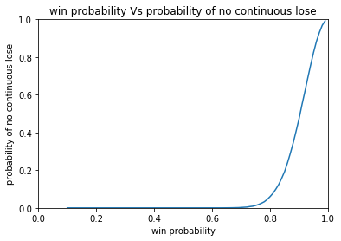

Figure(1)

The interesting trend was found that the probability of no consecutive loss increased tremendously from 0.8 of win probability. To narrow down the possible, I checked detail distribution curve between win probability from 0.8 to 1.0, which was shown below: (figure 2):

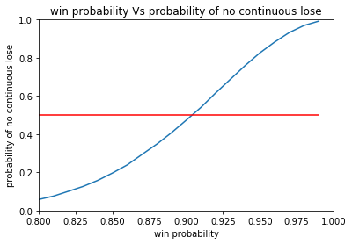

Figure(2)

The red line presented the turning point of 50% chance of no consecutive loss. So the proposed winning probability was narrowed down to the range from 0.875 to 0.925. According to programming result, shown in .py or .txt file, the team with winning chance of more than 90% could have probability of more than 50% to avoid consecutive loss.

CODE by Python:

# -*- coding: utf-8 -*-

import random

import matplotlib.pyplot as plt

'''

Calculate the probability of continuous lose of a team in a regular season. The probability of winning is 0.8 for each game.

'''

def NBALose(n,p,season):

count=0 # count the possible season in which continous lose happens.

for i in range(n):

match=1

lose=0

while match<=season:

x=random.random()

if x<=1-p:

lose+=1 # calcuate the losing game

else:

lose=0 # if team win, the lose count reset to be 0.

if lose==2:

count+=1 # if continous lose happens, count increase 1, and finish this round of simulation

break

match+=1 # if continous lose didn;t happen until current game, the regular season contunues.

return count/n # calculate the sample probability of continuous lose. result is around 94%

print('The probability of continuous lose of Warriors is', NBALose(100000,0.8,82))

# research the curve of win probability vs probability to find the turning point

# Figure (1) in docx file

p=0.1

x=[]

y=[]

while p<=1:

x.append(p)

y.append(1-NBALose(100000,p,82))

p+=0.01

plt.plot(x,y)

plt.title('win probability Vs probability of no continuous lose')

plt.xlim(0,1)

plt.ylim(0,1)

plt.xlabel('win probability')

plt.ylabel('probability of no continuous lose')

plt.show()

# the curve increase emergently between 0.8 to 1.0 of p value

# further investigation between 0.8 to 1 of win probability

# Figure (2) in docx file

p=0.8

x=[]

y=[]

while p<=1:

x.append(p)

y.append(1-NBALose(100000,p,82))

p+=0.01

plt.plot(x,y)

plt.plot(x,[0.5]*len(y),color='red')

plt.title('win probability Vs probability of no continuous lose')

plt.xlim(0.8,1)

plt.ylim(0,1)

plt.xlabel('win probability')

plt.ylabel('probability of no continuous lose')

plt.show()

# the proposed range is set from 0.875 to 0.925 of win probability

p=0.875

x=[]

y=[]

while p<=0.925:

if NBALose(100000,p,82)>0.5:

p+=0.001

print(1-NBALose(1000,p,82),'under',p)

else:

print(1-NBALose(1000,p,82),'under',p) #probability of win should exceed 90%

break