EX NO :04

UK BANK DATA ANALYSIS

AIM:
Problem Statement: You have been hired by a Bank that is currently operating in United Kingdom. The bank has asked you to help them to ease the process of analyzing its data. The management has provided with a few queries for you to solve.

- Create a Map chart showing the number of transactions processed in each region.
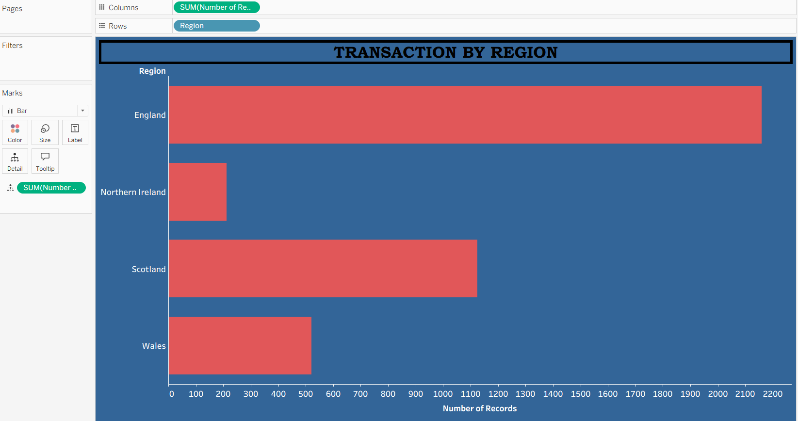
- Create a Pie chart displaying the percentage of each transaction processed between genders.
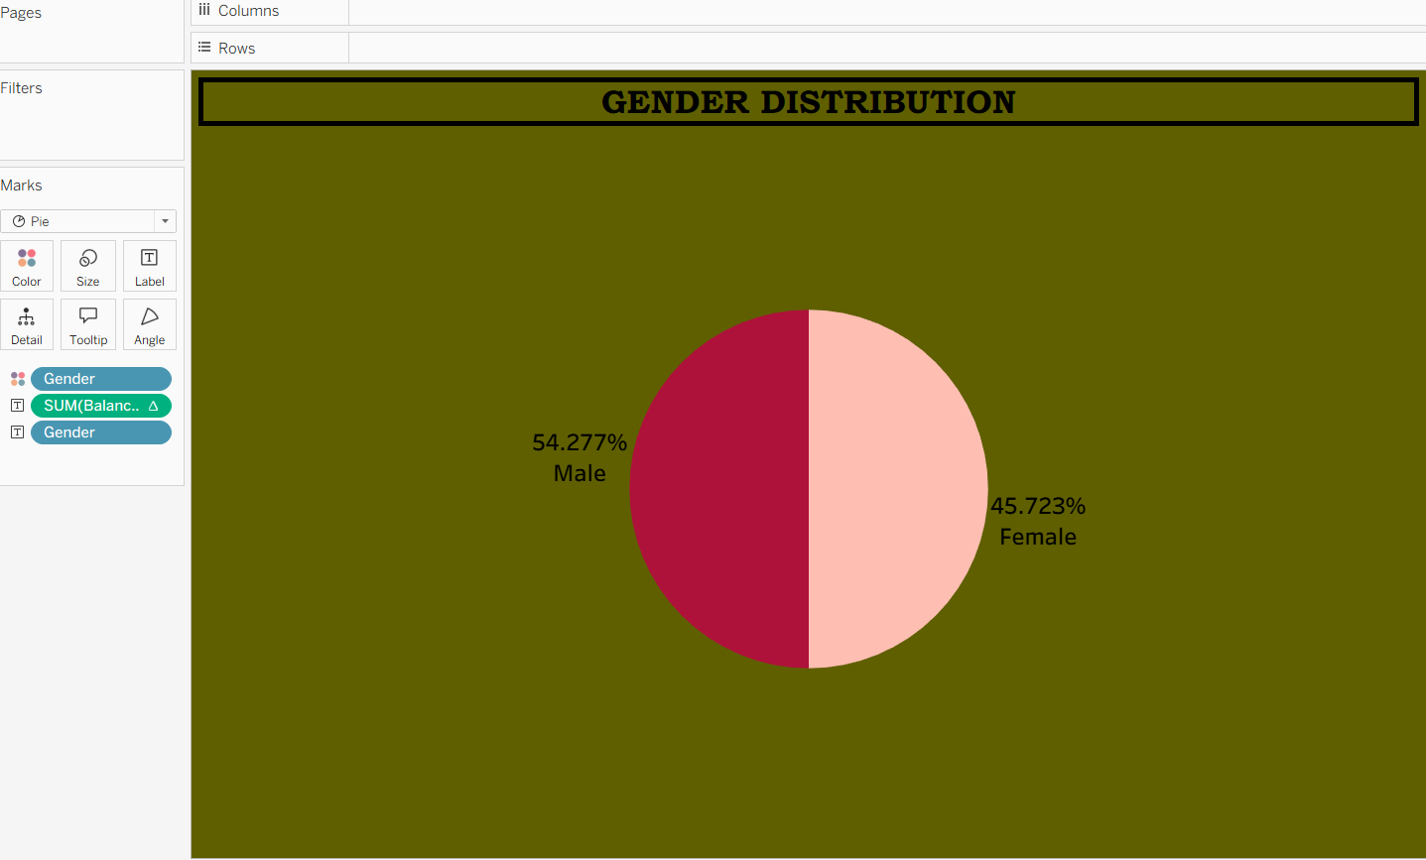
- Create a Histogram displaying the distribution of age and transactions processed.
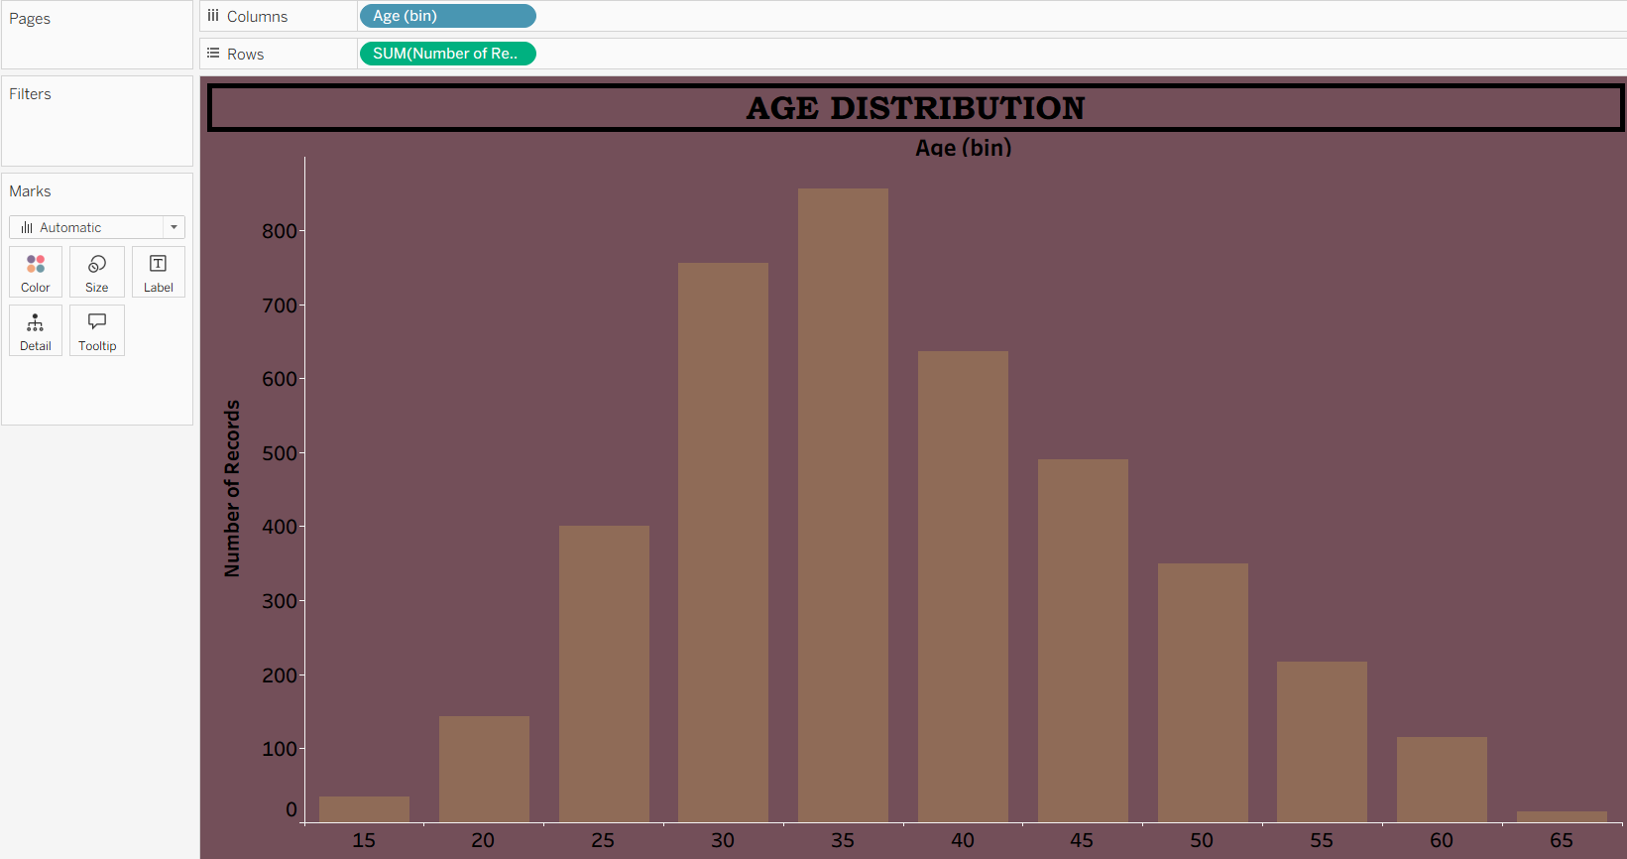
- Create a Histogram displaying the distribution of balance and transactions processed.

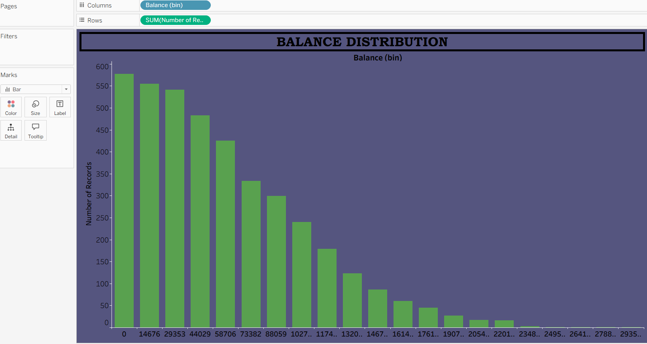

e) Create a Tree-map displaying the number of transactions processed within the classification of each job.
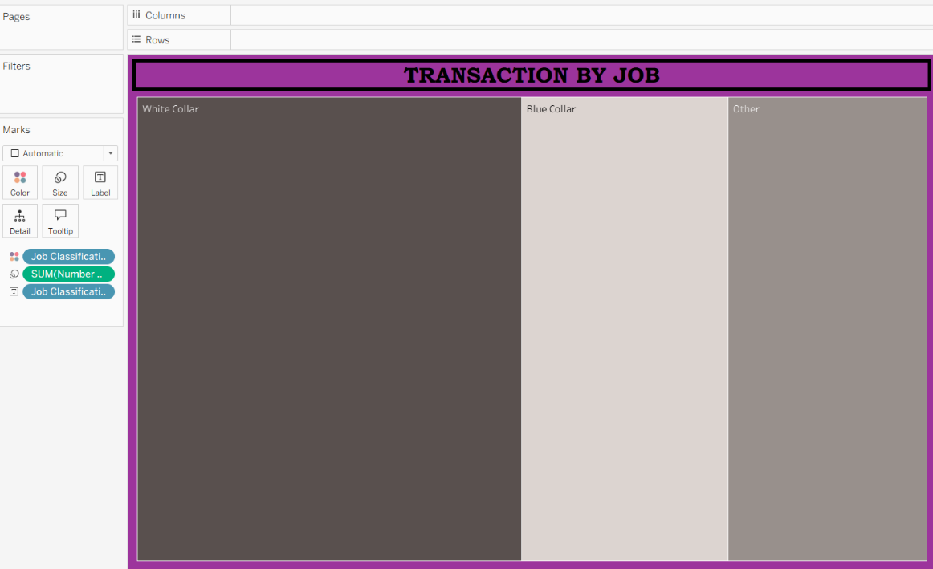

Create a Dashboard using all the charts. Make use of Action Filters as it will further improve the analyzing experience for the management. (Refer to the dataset from the file:UK BANK DATA.csv)


