EX NO :6
HALLOWEEN EVENT PLANNING DASHBOARD

AIM:
This Dashboard explains the evaluation of the individuals who participate in Halloween activities. It is used to understand the event planning. The following information we can get from this dashboard.

- Find the precipitation level
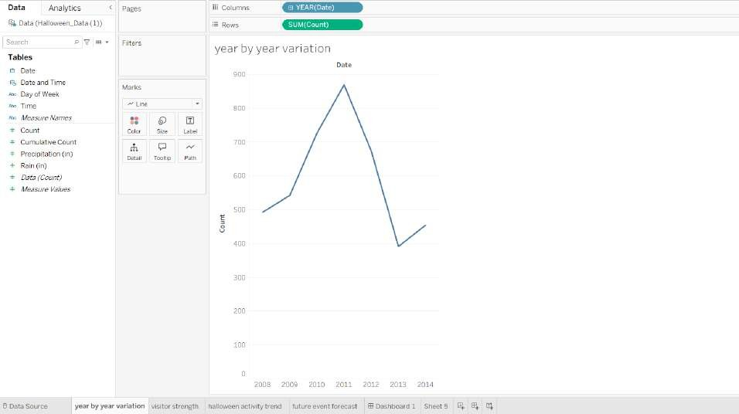
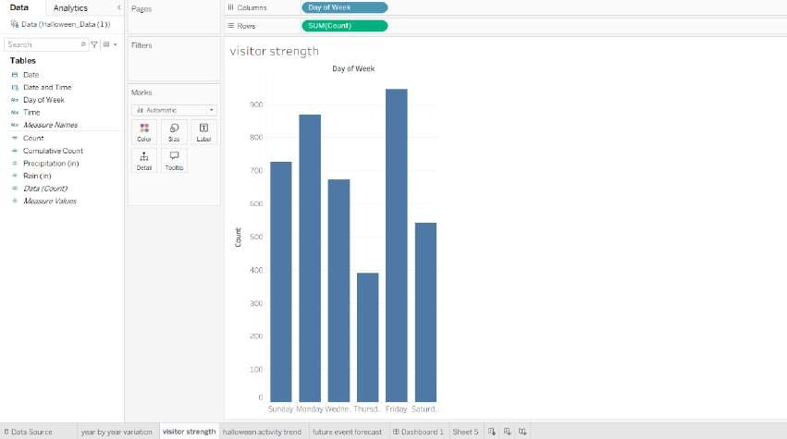
- Forecast the future event

- Show year by year variation
Display visitor strength

- Show year by year variation
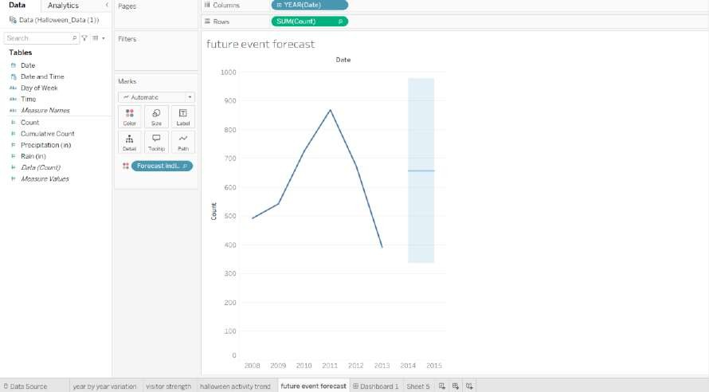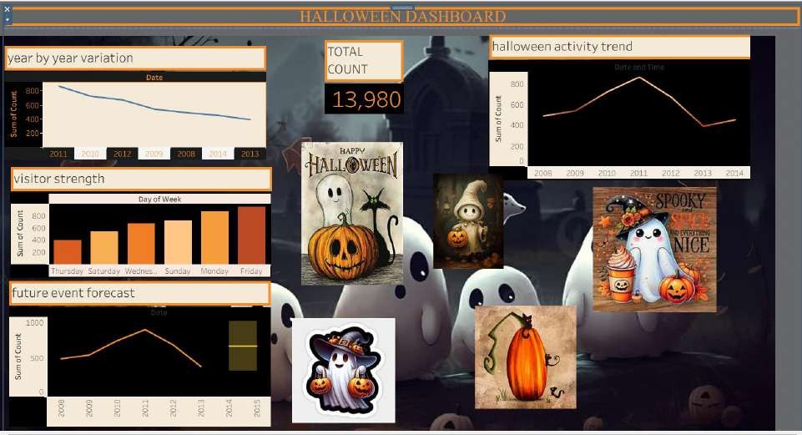
- Display visitor strength

