EX NO:08

MOVIE RATINGS AND BUDGETS ANALYSIS

AIM:
Problem Statement: Domain: Entertainment Industry:
You have been approached as an analytics consultant by a movie reviews company. They are writing up an articles analyzing movie ratings by critics and audience as well as movie budgets for the years 2007 till 2011. You have been asked to perform the tasks: Refer the dataset: Movie-Ratings .csv

Task 1: Create a chart displaying Budget of Movies across different Genres over a period of time.

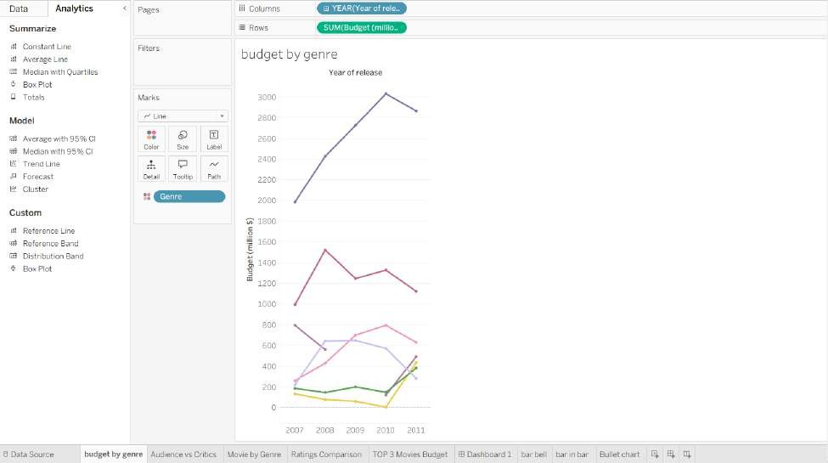
Task 2: Create a chart showing the correlation between audience and critic ratings
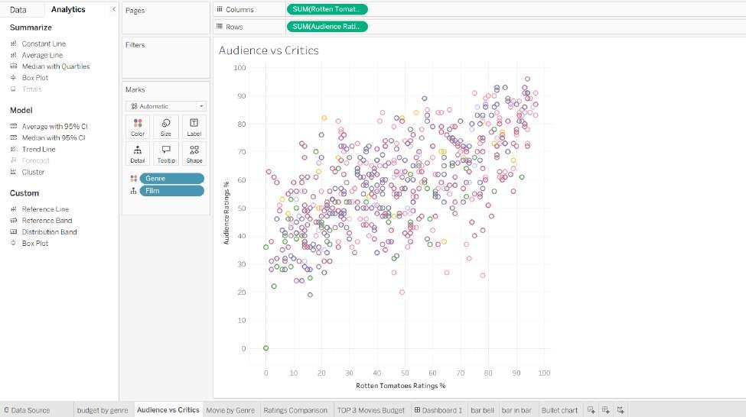

Task 3: Create a chart displaying the number of over released under every Genre over a period of time.
Task 4: Create a chart to visualize the comparison between the Ratings over a period of time.
Task 5: Create a chart that will display the Budget of Top 3 Movies by both Audience and Critics rating. Also segregate the chart by Genre.
Task 6: Create a Dashboard, using the above charts.

Task 3: Create a chart displaying the number of over released under every Genre over a period of time.
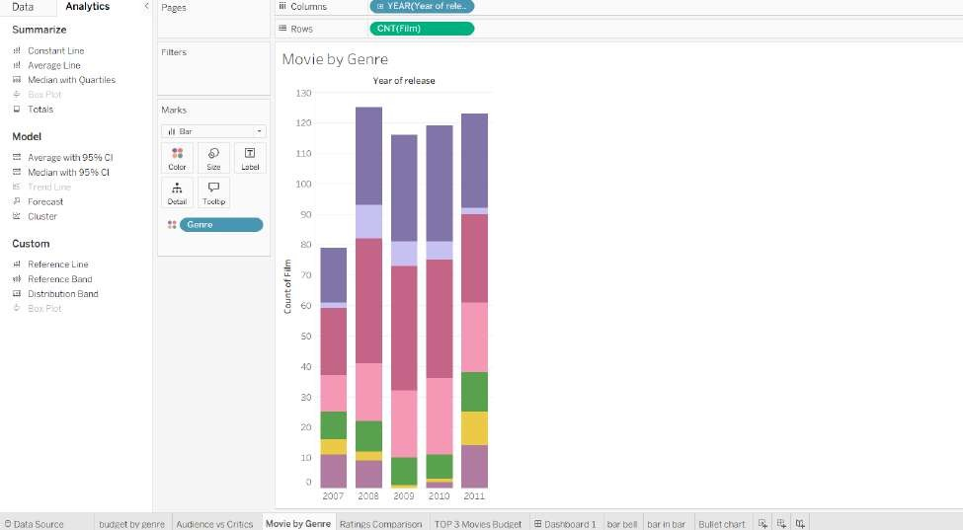
Task 4: Create a chart to visualize the comparison between the Ratings over a period of time.
Task 5: Create a chart that will display the Budget of Top 3 Movies by both Audience and Critics rating. Also segregate the chart by Genre.

Task 4: Create a chart to visualize the comparison between the Ratings over a period of time.

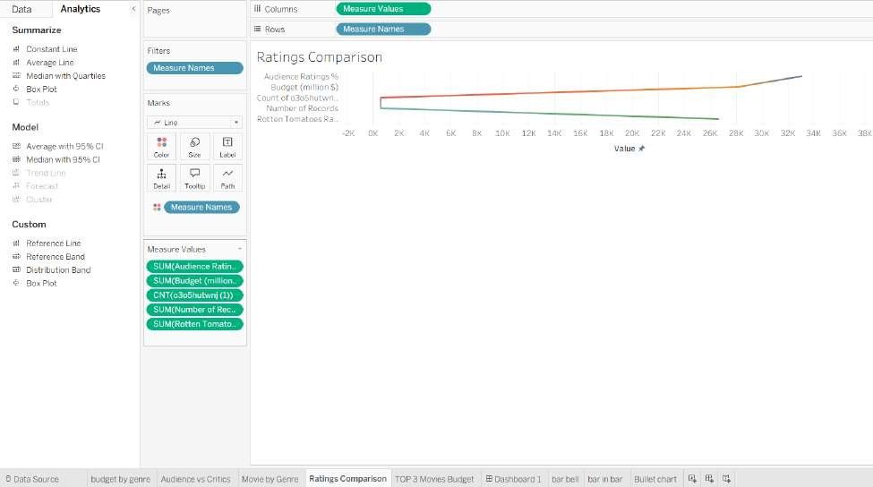
Task 5: Create a chart that will display the Budget of Top 3 Movies by both Audience and Critics rating. Also segregate the chart by Genre.

Task 5: Create a chart that will display the Budget of Top 3 Movies by both Audience and Critics rating. Also segregate the chart by Genre.

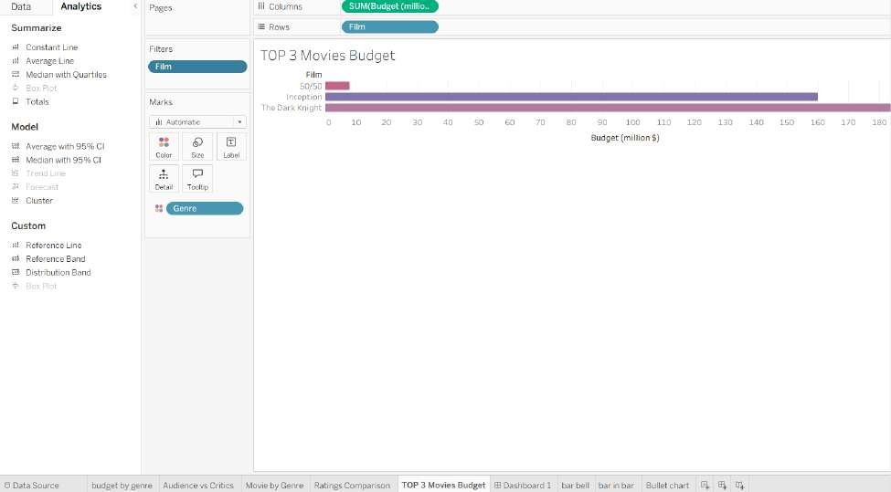

Task 6: Create a Dashboard, using the above charts



