EX NO:09

GLOBAL SUPERSTORE ADVANCED CHARTING

AIM:
Create the following chart: Using Global Superstore

- Bar in bar
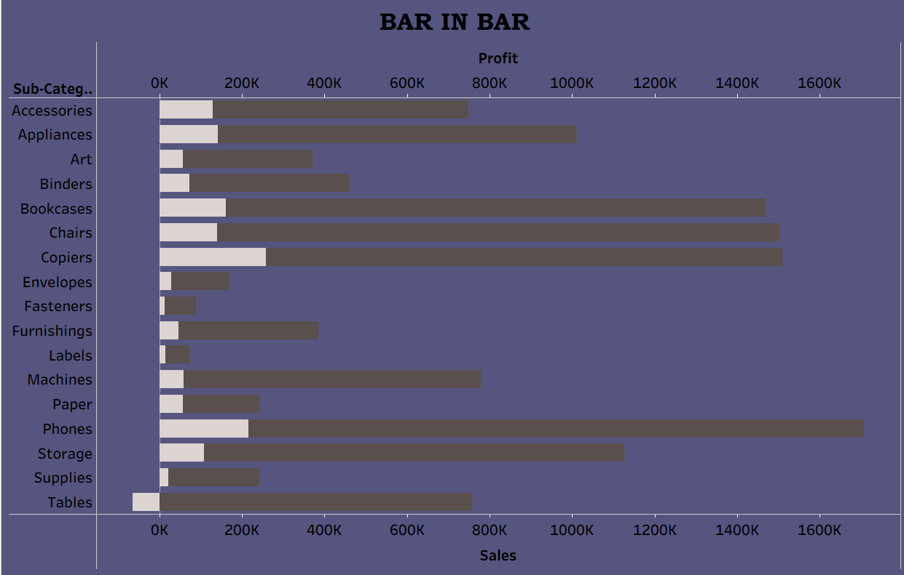
- Bullet
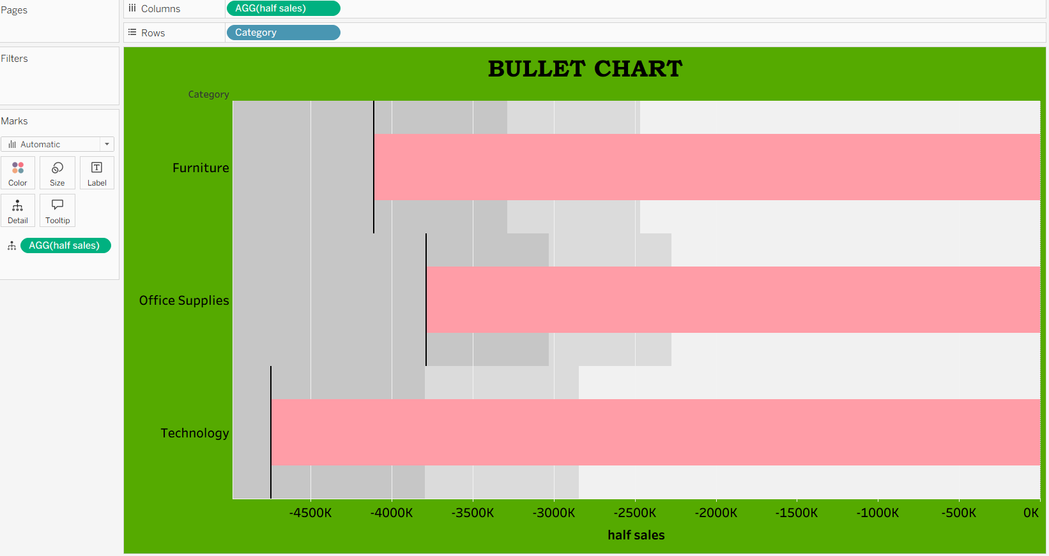
- Barbell
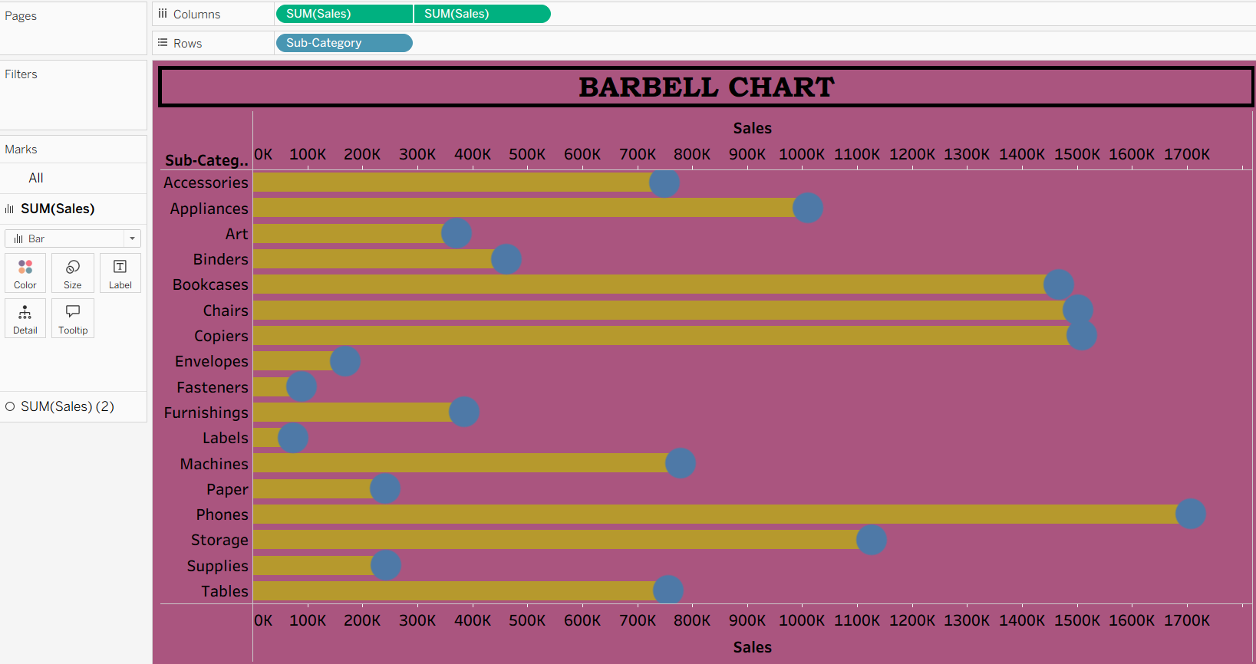
- Lollipop
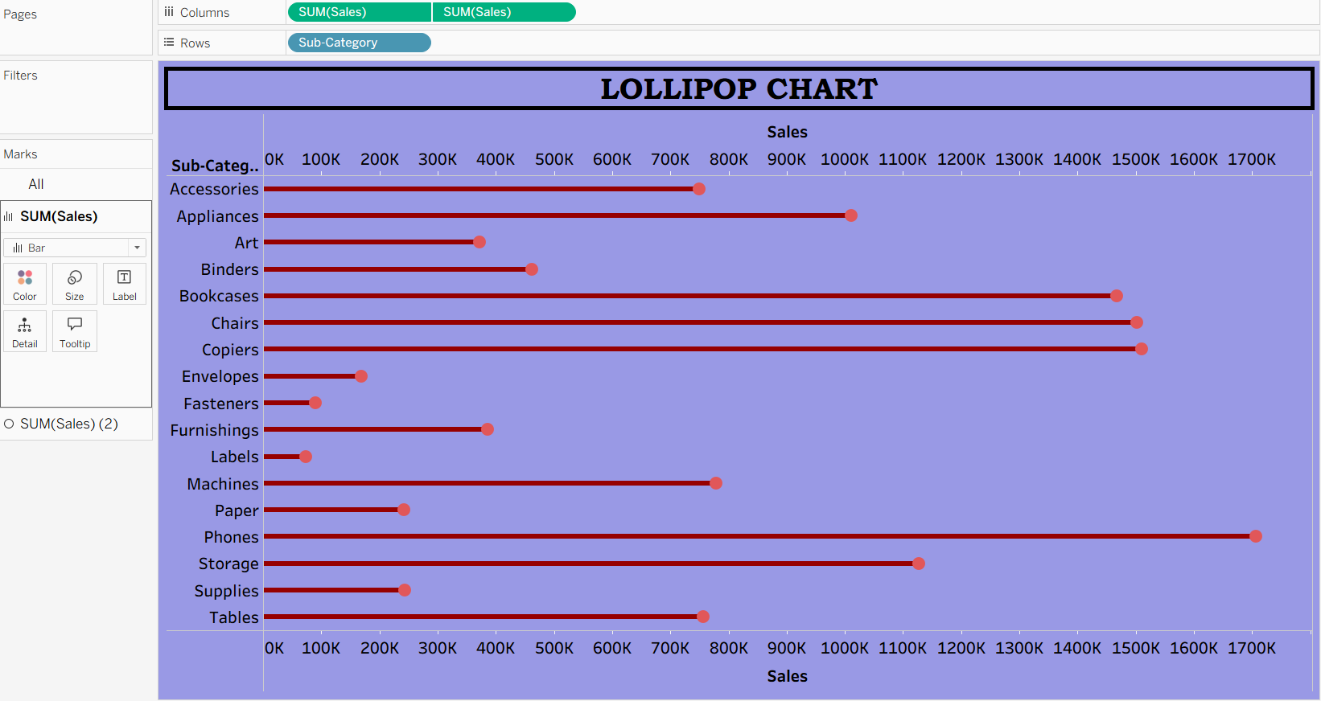

e) Bump



