AI-Based Resume Screening and AI-Assisted Interview Evaluation Framework with Proctoring System
Jeet Mehta  [AUTHOR INPUT REQUIRED: department, institution, city, country]  [AUTHOR INPUT REQUIRED: e-mail address] | Pruthvi Mehta  [AUTHOR INPUT REQUIRED: department, institution, city, country]  [AUTHOR INPUT REQUIRED: e-mail address] | Vedant Korade  [AUTHOR INPUT REQUIRED: department, institution, city, country]  [AUTHOR INPUT REQUIRED: e-mail address] | Prof. Mrunali Desai  [AUTHOR INPUT REQUIRED: department, institution, city, country]  [AUTHOR INPUT REQUIRED: e-mail address]

Abstract—Automated resume screening ranks candidates on self-reported documents and cannot revise that judgment when later evidence contradicts it. This paper investigates whether an adaptive artificial intelligence (AI) interview stage can correct the ranking errors introduced by resume-only screening, and what candidate data such a pipeline exposes. We present a locally deployable pipeline that combines a deterministic applicant tracking system (ATS) keyword pre-filter, large language model (LLM) resume scoring, an adaptive interview, proctoring-based integrity scoring, and trust-weighted score fusion. A controlled audit on a 100-candidate synthetic cohort with concealed competence values, planted over-sellers and hidden gems, and two honest control groups shows that four resume-only rankers admitted six or seven over-sellers into the top ten. Fusing the interview stage raised NDCG@10 from 0.61 to 0.94 and Kendall's τ-b from 0.17 to 0.55 on the shipped draw; across 200 cohort regenerations the mean τ-b gain was 0.38 (95% interval 0.33–0.44) and the mean NDCG@10 gain was 0.29 (0.13–0.45), positive in every regeneration. The control displacement rate was 0.62, an upper bound rather than an error rate: 93.71% of honest control pairs kept their relative order. Transport-level interception showed candidate answers in 12 of 14 model calls against two for resume text. All ranking results are simulated and test the fusion function, not the interviewer; interviewer validity, fairness, and encryption at rest were not measured.
Index Terms—Automated hiring, resume screening, large language models, adaptive interviewing, score fusion, data privacy, algorithmic auditing.

I. Introduction
Large employers rely on automated screening to reduce a large applicant pool to a shortlist that human reviewers can feasibly read. Applicant tracking systems (ATS) have traditionally performed this reduction by matching keywords or applying predefined criteria to resume text [1]. Later systems adopted semantic representations, first through word embeddings combined with stable matching [2] and then through context-aware transformer models for resume classification and resume–job matching [3]. More recently, large language model (LLM) agents have been used to summarize and grade resumes at scale [4], and multi-agent designs have added explanations to the resulting scores [5]. Because hiring decisions affect people's livelihoods, the correctness, robustness, and data handling of these systems matter well beyond engineering convenience.
Despite this progress, resume screening and interview assessment are still usually treated as separate filters. A resume-based score is computed once and gates later stages, yet nothing allows subsequent evidence to revise it. This is consequential because a resume is a self-reported document: one that overstates competence and one that understates it will each be ranked incorrectly, and a screener that reads only that document cannot detect either error. Evaluations of screening systems also typically report accuracy or efficiency for a single component. Li et al. report 73.3% competence-level accuracy and 79.2% resume–job matching accuracy, with an inter-annotator kappa of 61% [3], and Gan et al. report screening roughly elevenfold faster than manual review and an F1 score of 87.7% on resume-sentence classification [4]; neither study examines whether a later stage corrects errors made by an earlier one. Fairness and robustness research likewise analyzes screening in isolation. Fabris et al. survey bias across the algorithmic hiring pipeline and describe whether algorithmic hiring is less biased than human-driven alternatives as an open question [6]. Baxi et al. show that prompt-injection text embedded in a resume can improve an applicant's LLM-assigned ranking under some conditions, and that this advantage weakens as the tactic becomes widespread [7]; that finding concerns screening alone, not a pipeline in which a subsequent interview could counteract an inflated score.
This paper addresses that gap. We investigate whether an adaptive AI interview stage can correct ranking errors introduced by resume-only screening, and what data exposure such a pipeline entails. The contributions are as follows.
- We implement a locally deployable hiring pipeline comprising a deterministic keyword pre-filter, LLM resume scoring, an adaptive interview, proctoring-based integrity scoring, and trust-weighted score fusion. The fusion step lets an untrusted interview stop benefiting a candidate without penalizing that candidate.
- We design a controlled audit on a synthetic cohort with concealed competence values, including planted over-sellers, hidden gems, and two honest control groups, so that genuine correction can be distinguished from rank noise.
- We compare four resume-only rankers on the same cohort and report how many over-sellers each admits to the shortlist.
- We quantify data egress by intercepting the transport layer, comparing a hosted model provider with a local one.
- We release a measurement harness that labels every reported quantity by provenance and states explicitly which quantities could not be measured.
In the audit, over-sellers occupied six or seven of the top ten positions under all four resume-only rankers. Fusing the interview stage raised NDCG@10 from 0.61 to 0.94 and Kendall's τ-b from 0.17 to 0.55 on the shipped cohort draw, and every planted hidden gem moved up in rank. The cost is stated with equal prominence: the control displacement rate was 0.62, an upper bound rather than an error rate, because 93.71% of honest control pairs preserved their relative order. At the transport layer, candidate answers appeared in 12 of 14 model calls against two for resume text.
Two properties of the ranking results bound their meaning. The cohort's resume inflation and its unbiased-but-noisy interview are assumptions of the generator, not findings, so the results test the fusion function against a constructed ground truth rather than the validity of the interviewer. And the interview is an additional evidence source rather than a measurement separable from the resume: its question plan is conditioned on the same resume and screening gaps, and the same model family may screen and interview. All ranking results are simulated, and the recruiter retains responsibility for every final hiring decision.
The remainder of the paper is organized as follows. Section II reviews related work. Section III presents the system architecture, and Section IV the methodology of each stage. Section V gives the mathematical formulation and the end-to-end algorithm. Section VI describes the experimental setup and evaluation metrics, and Section VII reports and discusses the results. Section VIII covers limitations, threats to validity, and ethical considerations, and Section IX concludes with future work.

II. Related Work

A. Keyword and Semantic Matching
Early applicant tracking systems treated screening as document scoring: resumes were parsed into fields and compared with job requirements through largely deterministic logic [1]. Such designs are fast and their criteria are explicit and reproducible, but they cannot recognize that two differently worded descriptions denote the same competency, and a keyword score measures the presence of terms rather than substantiated competence. A resume that lists every requirement therefore scores well whether or not the candidate can support the claims.
Later work represented resumes and job descriptions in a shared vector space. Pudasaini et al. combined word embeddings with the Gale–Shapley stable-matching procedure, recasting screening as matching over the preferences of both sides rather than one-directional ranking [2]. Vanetik and Kogan ranked job vacancies by combining sentence embeddings, keywords, and named entities [8]. Li et al. used context-aware transformers that condition a representation on its surrounding resume section and the paired job description; on 6,492 annotated resumes for a single occupation they reported 73.3% competence-level accuracy and 79.2% resume–job matching accuracy, and their inter-annotator kappa of 61% shows that expert judgment itself does not fully converge [3]. These methods capture relatedness better than literal matching, but embedding similarity indicates how related two texts are, not whether a candidate can do the job. Like the keyword approach, they operate primarily on self-reported resume content.

B. LLM-Based Screening
Gan et al. describe an LLM-agent framework that summarizes and grades resumes, reporting screening roughly eleven times faster than manual review and an F1 score of 87.7% on resume-sentence classification after fine-tuning [4]. Lo et al. decompose screening across four agents (a resume extractor, an evaluator, a summarizer, and a score formatter) and use retrieval-augmented generation in the evaluator to ground scores in role-specific criteria; on 105 anonymized resumes rated by human-resources professionals they report higher correlation with human scores and lower mean absolute error than single-LLM baselines, and they identify LLM-driven video-interview analysis as future work [5]. Vaishampayan et al. compare human ratings with LLM resume-matching scores [9], which is directly relevant to validating a model against human judgment. These systems produce natural-language justifications alongside scores. That output is richer than a similarity value, but a fluent justification is not necessarily a faithful account of how the score was produced, which adds an evaluation burden. The reported evaluations concern efficiency, classification accuracy, or agreement for the screening step, and the model's input is primarily the resume.

C. Fairness, Bias, and Robustness
Fabris et al. survey fairness and bias across the algorithmic hiring pipeline, covering bias sources, mitigation techniques, and legal frameworks, and state that whether algorithmic hiring is less biased than the human-driven alternatives remains an open question [6]. Empirical studies probe LLM matching directly: Iso et al. evaluate the effect of gender, race, and education on job–resume matching [10], and FAIRE offers a benchmark-style test of how identity-related changes affect resume evaluation [11]. Robustness has been studied separately. Baxi et al. show that self-promotional prompt-injection text in a resume can improve an applicant's LLM-assigned ranking when few applicants use it and quality is otherwise homogeneous; the advantage weakens as the tactic spreads, and in heterogeneous settings it can occasionally invert the ranking of weaker and stronger candidates [7]. This shows that resumes can constitute an attack surface, not only an unreliable signal.

D. Interview Assessment, Proctoring, and Evaluation Methodology
Automated and video interviewing, resume-conditioned question generation, LLM interview assessment, remote proctoring, the validity of LLM-as-judge scoring, and the standard ranking measures used here (NDCG, Kendall's τ-b, BM25, TF-IDF) are not covered by the source set on which this paper is built. [LITERATURE REQUIRED: add and cite related work on automated/video interviewing, LLM interview assessment, remote proctoring, LLM-as-judge validity and human agreement, and the original references for NDCG, Kendall's tau-b, BM25 and TF-IDF.] Accordingly, no claim is made about how this work compares with prior interview-assessment or proctoring systems, and the only human-agreement evidence cited is [9]. Section VIII records the absence of human-rater agreement as a threat to validity.

E. Research Gap
Across these themes, capability has moved from literal matching to contextual and generative evaluation, but the evidence is not directly comparable: the studies use different datasets, tasks, and metrics, from competence classification [3] to sentence classification [4] to injection-induced rank change [7]. In the sources reviewed, three limitations recur. First, studies generally examine one component in isolation; screening accuracy is reported separately from robustness, and neither is examined within a pipeline. Second, screening approaches from keyword scoring to LLM agents primarily evaluate resume content, and none of the reviewed studies tests whether subsequent interview evidence can revise the resulting ranking. Third, data handling is not their focus; none measures transport-level data egress, that is, what candidate data leaves the deploying organization. The robustness finding in [7] is reported for screening alone, not for a pipeline in which an interview could counteract an inflated score.
This paper treats screening and adaptive interviewing as stages of one auditable ranking process. It plants over-sellers, hidden gems, and honest controls in a synthetic cohort with concealed competence values, so that rank revisions reflecting planted errors can be distinguished from rank noise, and it measures transport-level data egress for hosted and local model providers. Fairness auditing is outside the scope of this study; the fairness literature [6], [10], [11] is discussed as context, not as evidence that the proposed system is fair.

III. System Architecture and Proposed Framework
The pipeline is built so that a later evidence source can revise an earlier ranking. It has five processing stages: keyword pre-filter (preceded by ingestion and sanitization), model screening, adaptive interview, integrity scoring, and trust-weighted fusion into a ranked report. Every decision is made in a service layer that is independent of the user interface, so the same code drives the web application and the measurement harness. Fig. 1 shows the architecture and Fig. 2 the stage flow. After ingestion, a candidate can be removed automatically at only one point, the keyword pre-filter; a low model score routes the candidate to human review, not to rejection.

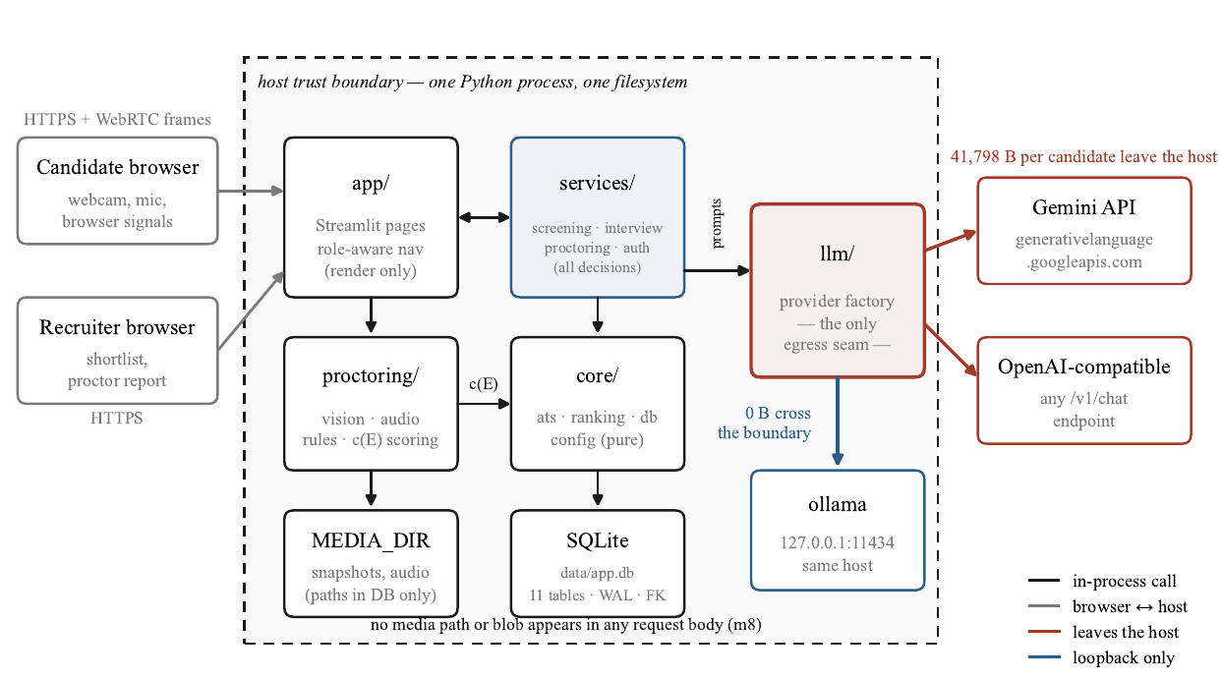
Fig. 1. System architecture and the host trust boundary. Everything inside the dashed region runs in a single process on the operator's machine; the provider factory is the one place any of it can reach the network, which is what makes the data-exposure question answerable. Under the default hosted provider 41,798 B per candidate leave the host; under the local provider the same calls terminate at a loopback address.
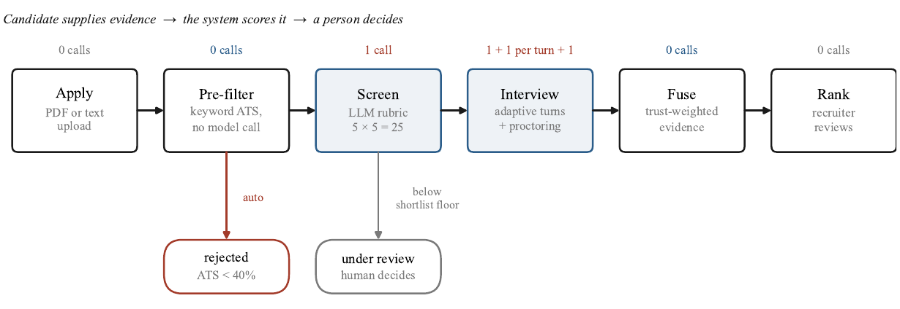
Fig. 2. The end-to-end pipeline. Two of the six stages call a language model; the keyword pre-filter, fusion, and ranking are deterministic and run without a network call, so a throttled provider can delay a decision but never lose a submission. The row above each stage counts its model calls.

A. Architecture
The system is a Python application with four kinds of module. Pages render, services decide, core modules hold pure scoring code, and a provider layer is the only path by which data can reach a model. State is stored in SQLite (11 tables, write-ahead logging, enforced foreign keys with cascading deletes). The application runs as a single process on the operator's machine (Fig. 1), and the provider factory is the single point at which a request can leave the host. Whether a request crosses the boundary depends on the configured provider endpoint.

B. Design Decisions
- Provider abstraction. Four provider types are supported: a hosted Gemini API, a local Ollama daemon, an OpenAI-compatible endpoint, and an offline fake used for testing. The first three are reached over plain REST, and the fake makes no network request. The provider is selected through configuration, and the same prompts are built in every case.
- Deterministic first. Sanitization, keyword scoring, integrity scoring, fusion, and ranking make no model call. A throttled provider can therefore delay a decision but not lose a submission.
- Recomputed totals. The model supplies five criterion scores and prose. Totals are recomputed from the clamped criteria, so a model-reported total cannot change an outcome.
- Prompts in files. Prompt templates are stored as text files and can be inspected without reading source code. Four of the five templates in the released tree are loaded by the shipped pipeline: resume evaluation, question plan, next turn, and interview score. The fifth, evaluation_prompt.txt, is reachable only from a legacy module that nothing in the shipped pipeline imports; it is reported because it is present in the released artefact, not because it lies on any measured code path.

C. Implementation
The system is written in Python 3.12 and uses PyMuPDF [12] and python-docx for resume extraction, Streamlit 1.63 [13] for the interface, and faster-whisper, a reimplementation of the Whisper architecture [14], for local speech recognition [CITATION REQUIRED: faster-whisper]. Vision uses OpenCV (YuNet [CITATION REQUIRED: YuNet] and SFace [CITATION REQUIRED: SFace]) and MediaPipe [CITATION REQUIRED: MediaPipe]. Optional object detection uses YOLO11n through ultralytics [CITATION REQUIRED: YOLO11n/ultralytics], which is AGPL-3.0 licensed and disabled by default. Passwords are hashed with scrypt [CITATION REQUIRED: scrypt]. There are 17 pinned, free and open-source dependencies, and model calls use plain REST with no vendor SDK. Recorded media, where retained, stays on the operator's local disk and is not written to the database, which stores derived event records. The test suite collects 371 cases and runs offline with the fake provider. Table I summarizes the modules.
Table I
Modules, inputs, outputs, and techniques
Module | Input | Output | Technique | Model calls
Sanitizer | resume text | cleaned text, flags | 5 regex families | none
Pre-filter | text, requirements | S_{ats}, missing list | literal word-boundary match | none
Screening | text, role | S_{resume} (0–25) | 5-criterion rubric, schema-constrained | 1
Interview | plan, answers | transcript, S_{interview} | bounded turn policy, 2-tier guardrail | plan, turns, tier 2, score
Integrity | events | c(E), verdict | per-kind worst severity, log persistence | none
Fusion | three scores | S_{final}, rank | trust-weighted convex mix | none

IV. Methodology

A. Stage 1: Ingestion, Sanitization, and Keyword Pre-Filter
Resume text is extracted with PyMuPDF for PDF, python-docx for DOCX, or by direct read for text, and then normalized. Text below a 40-word floor is refused as unparseable and is not scored. No structured field extraction of skills, roles, or years of experience is performed; the cleaned text is passed to the model in full, truncated at 18,000 characters. This avoids adding a parser as a second error source that could not be separated from screening error.
Sanitization strips instruction-like text using five regular-expression families: instruction override, persona hijack, chat markup, score demand, and verdict demand. It never rejects a resume. It removes the matched text and records a flag on the application, so a recruiter sees what was changed. This conservative handling is deliberate, because a pattern match cannot separate an attack from a security engineer describing their work.
The pre-filter score S_{ats} (Eq. (1)) is the share of a role's listed requirements found literally in the resume, using word-boundary matching. A resume with S_{ats} < τ_{ats} = 40 is rejected without a model call, and the rejection reason names the missing requirements. The filter is intentionally lexical, so every automatic rejection can be explained to the candidate as a list of terms. When a role lists no requirements the ratio is undefined and the implemented function returns 0 rather than 100. This is a consequential convention: since 0 < τ_{ats}, such a role rejects every applicant automatically and without a model call, so a deployer must populate the requirement list before publishing a role.

B. Stage 2: Model Screening
For resumes that pass the pre-filter, one schema-constrained model call scores five criteria from 0 to 5: skill match, experience, projects, communication, and culture fit. The prompt marks the resume as untrusted data and lists the requirements that the literal search did not match, so the model can credit genuine equivalents. The screening score is the sum of the clamped criteria (Eq. (2)), giving S_{resume} ∈ \{0, …, 25\}. A candidate with S_{resume} ≥ s_{min}, where s_{min} = 15 is the shortlist floor, is shortlisted and proceeds to the interview. A candidate below the floor is routed to human review; the pipeline neither rejects nor interviews that candidate automatically (Fig. 3).
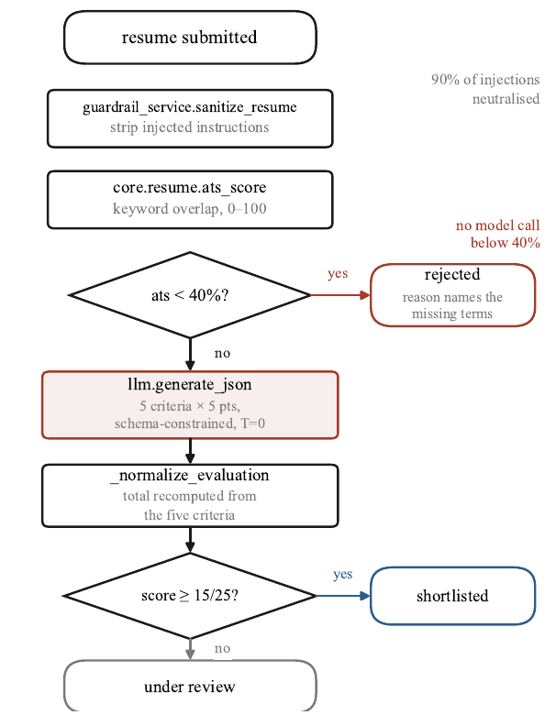
Fig. 3. Screening control flow. Sanitization and keyword scoring are deterministic and precede the only model call in that stage, so a resume carrying injected instructions is stripped before any prompt is built. The model returns five criterion scores rather than a total, and the total is recomputed from them.

C. Stage 3: Adaptive Interview
On shortlisting, a question plan of at most 12 questions is generated from the resume and job description. Each question is tagged by source: resume, job-description gap, culture, or behavioral. Requirements for which the resume provides no evidence become job-description-gap questions, so the interview probes claims the document does not substantiate and gives the candidate an opportunity to demonstrate competence the resume does not show.
Two properties of this stage limit what the interview can be said to contribute. First, the question plan is conditioned on the resume and on the requirements the literal pre-filter did not match, so the interview is constructed from the same document whose ranking it is asked to revise; it is an additional evidence source, not an independent one. Second, the same provider and model family are used for screening and interviewing, so a systematic error in one stage is not guaranteed to cancel in the other. Section VIII-A treats the consequences.
After each answer, a turn policy chooses one of four actions: probe, steer, next planned, or wrap up (Fig. 4). Bounds are checked before the model is consulted: the turn budget, the wall clock, and the unasked plan are enforced first, and at most two adaptive turns may occur in a row. Within the budget and clock, the model cannot end the interview while planned questions remain, and a planned question is asked in its exact wording. A steer is triggered by a keyword match against watch topics, so the decision to follow the candidate needs no model call.
Each answer passes a two-tier guardrail. Tier 1 is structural and pattern-based. Tier 2, a model check, runs only when word overlap with the question falls below 0.06, and it fails open with a flag if the provider is unavailable. A rejected answer returns the question without spending the turn; after three rejections the answer is accepted with a forced-accept flag, so a guardrail cannot lock a candidate out. At the end, one call scores five criteria (technical depth, problem solving, communication, culture fit, practical impact), each from 0 to 5, and the total S_{interview} (Eq. (3)) is again recomputed from the clamped criteria. The deadline is the earlier of the session duration and the window close, and a refresh resumes the interview without spending the single attempt.

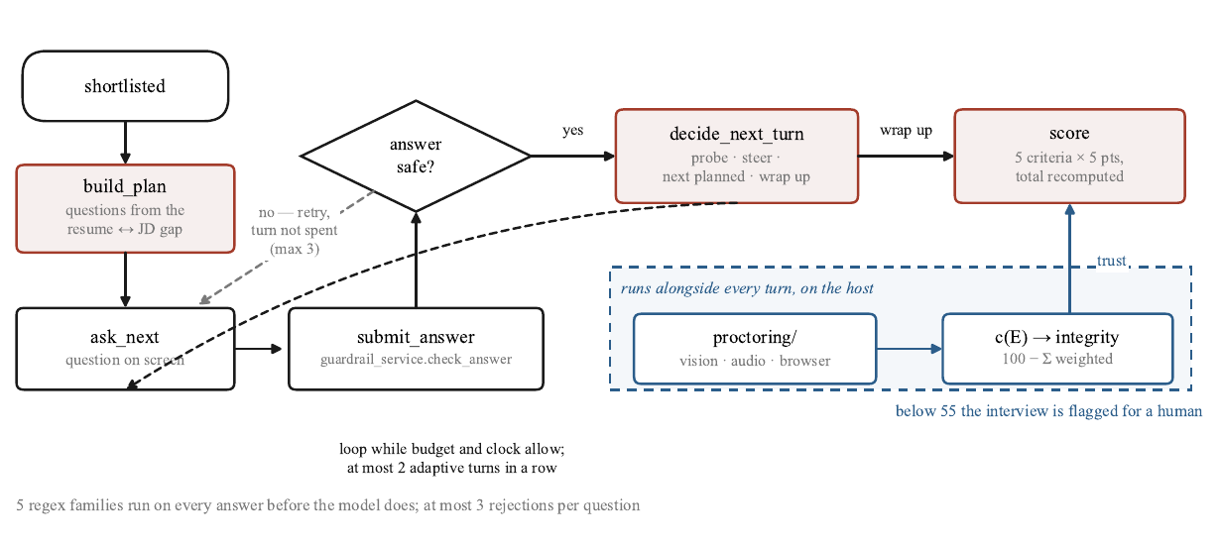
Fig. 4. The adaptive interview loop. Question selection is bounded before the model is consulted: the turn budget, the wall clock, unasked plan coverage, and a cap of two consecutive follow-ups are checked first and then re-validated against the model's choice. A guardrail rejection returns the question rather than consuming a turn.

D. Stage 4: Integrity Scoring
Proctoring runs in-process alongside the interview. It combines computer vision (face detection, head pose, identity matching, and optional object detection), audio loudness cues, and browser signals. Its output is a set of discrete events E. Each event has one of 13 kinds and one of four severities, with weights 12 (critical), 6 (high), 3 (medium), and 1 (low). The integrity score c(E) (Eqs. (4)–(5)) charges each distinct kind the weight of its most severe event, multiplied by a term that grows logarithmically with the number of events of that kind, so repetition raises the charge sublinearly; the total is then scaled by a factor that grows with the number of distinct kinds and is capped.
The verdict is flag below 55, clean at 80 or above with no critical event, and review otherwise. Any critical event precludes a clean verdict, so a single critical event, which by the arithmetic of Eqs. (4)–(5) alone leaves a score of 88, is held at review. The function is deterministic and order-independent, so it can be recomputed from stored events without the video. It reports evidence for a human reviewer and is not an automated finding of misconduct.

E. Stage 5: Trust-Weighted Fusion and Ranking
Integrity neither gates nor multiplies the final score; it determines how much weight the interview receives (Eqs. (6)–(8)). As the trust t → 0, the fused score collapses onto S_{resume}, not onto zero: an untrusted interview can stop benefiting a candidate but cannot numerically penalize one. This is the property that makes an integrity signal produced by a computer-vision heuristic advisory rather than disqualifying. It is a statement about scores, not positions: a candidate's place in the list can still change when the candidates around them are re-scored. Candidates are ordered by the key in Eq. (10). The final key, the application identifier, makes the ordering total and deterministic, which is required because the screening rubric admits only 26 distinct integer values and 97 of the 100 candidates in the audit cohort share a screening score with at least one other.

V. Mathematical Formulation and Algorithms

A. Notation and Score Scales
Let R be the resume text, J the role with its requirement list, M ⊆ J the set of requirements found literally in R, and |·| set cardinality. The functions clamp(x, a, b) = min(max(x, a), b) and round(x) (rounding to the nearest integer) are used throughout. Three scales coexist: S_{ats} is an integer in [0, 100]; S_{resume} and S_{interview} are integers in [0, 25] built from five criteria of 0–5 each; and c(E) is an integer in [0, 100]. Fusion mixes only the two 0–25 scores; c(E)/100 enters as a dimensionless weight, so the combination is scale-consistent.

B. Pre-Filter, Screening, and Interview Scores
$S_{ats} = round(100 · |M| / |J|)$ if $|J| ≥ 1$,
$S_{ats} = 0$ if $|J| = 0$ (1)
$S_{resume} = Σ_{i=1}⁵ clamp(a_{i}, 0, 5)$ (2)
$S_{interview} = Σ_{j=1}⁵ clamp(b_{j}, 0, 5)$ (3)
Here a_{i} and b_{j} are the raw criterion scores returned by the model for screening and for the interview, respectively. Any total reported by the model is discarded.

C. Integrity Score
Let K be the set of distinct event kinds observed, E_{k} the events of kind k, s_{k} the worst severity observed for kind k, and w(s) the severity weight above. Then
$d = ( Σ_{k∈K} w(s_{k}) (1 + γ ln|E_{k}|) )$
$· min(κ, 1 + σ(|K| − 1))$ (4)
$c(E) = clamp(round(100 − d), 0, 100)$ (5)
with γ = 1, σ = 0.25, and κ = 2. The quantity d is the total deduction. The logarithmic term makes repetition sublinear, and the capped multiplier makes co-occurrence of distinct kinds more costly than repetition of one.

D. Trust-Weighted Fusion and Ranking
Let t = c(E)/100 be the trust and λ ∈ [0, 1] the interview weight (default 0.5). Then
$t = c(E) / 100$ (6)
$v = t S_{interview} + (1 − t) S_{resume}$ (7)
$S_{final} = (1 − λ) S_{resume} + λ v$ (8)
$S_{final} = S_{resume} + λ t (S_{interview} − S_{resume})$ (9)
Equation (9) is Eq. (8) after substituting Eq. (7); it shows that the effective interview weight is λ t and that S_{final} → S_{resume} as t → 0. Candidates are ordered by
$(−S_{final}, −S_{resume}, −S_{ats}, application id)$ (10)
in ascending lexicographic order, so a higher fused score ranks first and ties fall through to the resume score, the keyword score, and finally the application identifier.

E. End-to-End Algorithm
Algorithm 1 combines the stages above.
Algorithm 1. End-to-end candidate evaluation
Input: resume file F, role J with requirement list, thresholds τ_{ats} and s_{min}, interview weight λ.
Output: outcome, and S_{final} for interviewed candidates.
1: R ← normalize(extract(F)) ▷ PyMuPDF / python-docx / direct read
2: if |words(R)| < 40 then return REFUSED
3: R′ ← sanitize(R) ▷ strip and flag; never reject
4: S_{ats} ← keyword_score(R′, J) ▷ Eq. (1)
5: if S_{ats} < τ_{ats} then return REJECTED (missing terms named)
6: S_{resume} ← Σ clamp(a_{i}, 0, 5) ▷ Eq. (2); one model call
7: if S_{resume} < s_{min} then return UNDER REVIEW ▷ no interview
8: plan ← build_plan(R′, J); E ← ∅; transcript ← ∅
9: while turn budget and wall clock allow do
10: q ← next_turn(plan, transcript) ▷ probe, steer, next, wrap up
11: if q = WRAP UP then break
12: a ← accept_answer(q) ▷ at most 3 rejections, then force
13: transcript ← transcript ∪ {(q, a)}; E ← E ∪ proctor_events()
14: S_{interview} ← Σ clamp(b_{j}, 0, 5) ▷ Eq. (3); one model call
15: c(E) ← integrity(E) ▷ Eqs. (4)–(5)
16: S_{final} ← fuse(S_{resume}, S_{interview}, c(E), λ) ▷ Eqs. (6)–(8)
17: return S_{final} ▷ ordered by Eq. (10)

VI. Experimental Setup and Evaluation Metrics
This section specifies the environment, the generator, the baselines, the metrics, the corpora, and the measurement procedures, and states which provenance label each reported quantity carries. Constants are read from the implementation.

A. Environment and Reproducibility
All measurements were taken at commit 11b9495 on Python 3.12.10, Windows 11 on AMD64 with an Intel64 Family 6 Model 158 Stepping 10 processor, CPU-only [AUTHOR INPUT REQUIRED: commercial CPU model name and installed RAM]. The harness ran with the provider set to the offline fake, a throwaway database, and proctoring disabled, so no reported offline figure depends on local state a reader cannot reproduce. Two classes of measurement were not taken offline and are labelled individually: the provider-contract probes (Section VII-H), issued live against the hosted Gemini API with model string gemini-2.5-flash, and the two local-deployment egress figures (Section VII-G), which are loopback-routing measurements with stubbed responses and no model inference. The harness is released with the code at [AUTHOR INPUT REQUIRED: repository URL] and is run with the command python -m metrics.run_all, which writes its results, labelled tables, and figures to a fixed directory.

B. Synthetic Cohort
Ground truth is assigned first and observations second. Each candidate is drawn with a latent competence θ; the resume and interview are then generated as noisy, biased views of θ, with the bias assigned by case. No ranker sees θ; only the scorer that computes the ground-truth ranking does. The generator uses the fixed seed 20260923, so a reader regenerates the identical cohort, and it produces 25 candidates in each of four planted cases (100 in total). Competence is drawn uniformly within a per-case band: over-sellers and honest-weak candidates from [0.05, 0.40], and hidden gems and honest-strong candidates from [0.60, 0.95]. The resume view is
$ρ = clamp(θ + β_{case} + ε_{r}, 0, 1)$, $ε_{r} ~ N(0, 0.08²)$ (11)
where β_{case} is +0.55 for an over-seller, −0.45 for a hidden gem, and 0 for both honest groups. The interview view is
$ι = clamp(θ + ε_{i}, 0, 1)$, $ε_{i} ~ N(0, 0.08²)$ (12)
that is, unbiased but noisy. This is the single most consequential assumption in the paper and it is an assumption of the generator, not a finding. The screening and interview scores are round(25ρ) and round(25ι), so their tie structure matches the shipped rubrics, and the keyword score is derived from the resume's claims rather than from competence:
$S_{ats} = round(clamp(100ρ + ε_{a}, 0, 100))$, $ε_{a} ~ N(0, 6²)$ (13)
which is why an over-seller passes the lexical gate. Integrity is fixed at 100 for every candidate, so the headline audit is run at full trust; behaviour under degraded trust is reported separately as the sensitivity sweep in Section VII-C. Mixing a guessed integrity distribution into a headline ranking result would introduce an unmeasured quantity into a measured one. For the lexical baselines, the number of requirements a candidate claims in the generated resume text is driven by the screening score rather than competence, document length is drawn independently of both, and plausible but irrelevant distractor skills are added so that length and relevance are not perfectly correlated.

C. Baselines
Four resume-only rankers are compared. Both lexical baselines are implemented directly in the harness, so their parameters are stated. The tokenizer lowercases and splits on non-alphanumeric characters while keeping characters that carry meaning in technical keywords. TF-IDF uses logarithmic term frequency, smoothed inverse document frequency log(1 + N/df), and L2-normalized cosine similarity. BM25 is Okapi BM25 with k₁ = 1.5 and b = 0.75 over the same smoothed idf and tokenizer. Smoothing is deliberate: the unsmoothed BM25 idf becomes negative for terms in more than half the documents, which in a single-role cohort is most of the vocabulary. The query is the role title, description, and requirement list concatenated. The keyword baseline is the ATS score of Eq. (1). The fourth ranker, the simulated model score, is not a real language-model run: its screening scores are read from the cohort's concealed resume view rather than obtained by prompting a model, and it is labelled simulated in every table, caption, and sentence. It is the model-shaped stand-in for the screener the pipeline itself would use; it is not evidence about how any real model scores a resume, and a real zero-shot baseline has not been run. An embedding baseline using sentence-transformers is excluded because it is not a dependency of the system and a baseline listed without a number would misrepresent the comparison.
All four rankers are run against one five-requirement role ([VERIFICATION REQUIRED: the original text names the data-engineer role but lists Python, Java, APIs, Databases, and System design, which data/roles.json assigns to the backend-developer role; the data-engineer role lists Python, SQL, ETL, Pandas, and AWS basics. Confirm which role was used]), chosen because it has the most requirements in the catalogue and therefore gives the lexical rankers the richest query. Rankers in Table II break score ties by candidate identifier, whereas the resume-only reference ranking used in the fusion audit (Section VII-B) breaks ties on the keyword score [VERIFICATION REQUIRED: confirm that this tie-break difference explains NDCG@10 0.5572 in Table II versus 0.6087 in Section VII-B for the same screening scores].

D. Evaluation Metrics
The relevant set is the top quartile of the cohort by concealed competence (25 candidates), defined on the truth and never on any score a ranker produces. NDCG@10 uses the competence vector as graded relevance; it is therefore a statement about the constructed cohort, not a transferable quality score. Kendall's τ-b measures rank agreement between a produced ordering and the concealed competence ordering and is reported because it tolerates the many ties a 0–25 integer rubric produces. Rank shift is ΔR = rank_{after} − rank_{before}, so a negative value is an improvement. Recovery rate is the share of a planted case that moved in the direction the planted error implies: an over-seller downward, a hidden gem upward. The control displacement rate is the share of honest controls displaced by more than five positions, where five is 5% of the cohort and is stated rather than tuned. Direction of movement is tested with an exact two-sided binomial sign test, ties discarded, and uncertainty is given by 95% percentile bootstrap intervals within the shipped cohort and by 95% intervals across regenerated cohorts. Precision@10 and mean reciprocal rank are computed but not reported as point estimates, because across 200 regenerations their intervals are too wide (widths 0.40, 0.40, 0.86, and 0.67) for a single draw to characterize them [VERIFICATION REQUIRED: the four widths are not mapped to precision and MRR, resume-only and fused, in the supplied material].

E. Labelled Corpora
Two corpora are hand-labelled rather than generated, because their labels are judgements a machine cannot make: whether "act as a system administrator" in a resume is an attack or a job title has to be decided by a person. Both were written by the authors. The guardrail corpus contains 31 attack strings across the five pattern families and 18 benign strings, 10 of which are hard negatives: prose that discusses instructions, administration, or scoring without attempting any of them, such as a security engineer describing prompt-injection work. They are included because a guardrail tested only against easy negatives reports a zero false-positive rate and then edits an honest candidate's resume in production. The boundary corpus contains 26 cases pairing a resume fragment with a single requirement and a hand label, each with a written justification. Three of the 26 probe synonym, abbreviation, and conceptual equivalence; because the matcher is literal by design, the corpus defines no match as correct for those three, and they measure the price of having no synonym expansion rather than matching correctness. Accuracy is therefore reported over the 23 cases decidable from character content alone as well as over all 26.

F. Egress and Latency Measurement
Data egress is measured at the transport layer rather than inferred from the design. The harness replaces the HTTP session used by the provider modules with an interceptor and drives complete candidate journeys through the real services, capturing every request body byte-for-byte before it is sent or discarded, so the numbers include prompt scaffolding, JSON schemas, rubric text, and accumulated transcript. Three configurations are driven: the hosted API, a local daemon endpoint, and the offline fake. Two resume sizes are used to recover a slope and a fixed overhead, and one further call exercises the tier-2 moderation path in isolation. Every captured body is scanned for media file paths, media extensions, data URIs, and base64 blobs. The hosted and local configurations use the real provider objects with replies stubbed, so the local configuration measures the payload and its routing to a loopback address; no inference was performed by a local model at any point.
Offline per-stage latency is measured with the provider stubbed, so every figure is the system's own overhead and none includes model inference. Each stage is warmed up for three iterations, then timed over 40 repetitions with a nanosecond-resolution monotonic clock and reported at the 50th and 95th percentiles. Four stages deviate and are timed as run: PDF extraction (10 repetitions), the scrypt operations (8), candidate registration (6), and the end-to-end service stages (15). Separately, four deterministic scoring functions are each called 50 times on a fixed input to check determinism.

G. Provenance Labels
Every quantity the harness reports carries one of five labels, assigned by the harness rather than by the authors at writing time. Measured quantities were observed by running the shipped code. Derived quantities were computed from measured values, such as ratios and deltas. Specification quantities were read out of the source and are constants rather than results. Simulated quantities were produced against a constructed cohort or a stubbed provider. Unavailable quantities were not measured; they are emitted with a machine-readable statement of what would be required and never carry a value. The released set comprises 243 quantities: 131 measured, 24 derived, 37 simulated, 35 specification, and 16 unavailable [VERIFICATION REQUIRED: the supplied results files do not reconcile with these counts. provenance.csv has 204 rows (paper: 243); unavailable.md lists 14 items (paper: 16); the m7 tests table has 13 rows (paper: 15 test files); the m1 scenarios table has 8 rows (paper: nine scenarios). Re-run the harness and confirm every count].

VII. Results and Discussion
This section reports measurements and then interprets them. Four independent evaluation sources are used: a 100-candidate synthetic cohort (seed 20260923; 25 candidates in each of four planted cases; competence concealed from all rankers) for the ranking and fusion audit; 26 hand-labelled boundary cases for the keyword pre-filter; 31 attack and 18 benign strings for the guardrail; and offline benchmarks of the implemented codebase, executed with the provider stubbed except where a live call is stated. Ranking and fusion quantities are simulated; they are not claims about real candidates. Quantities requiring a local model run, human raters, demographic labels, or labelled video or audio were not measured and are not reported.

A. Comparison of Resume-Only Rankers
Four resume-only rankers were scored against concealed competence (Table II, Fig. 5). BM25 reached an NDCG@10 of 0.6234, followed by TF-IDF at 0.5846, the simulated model score at 0.5572, and the keyword score at 0.4843. Over-sellers occupied seven of the top ten positions under the keyword score and under TF-IDF, and six under BM25 and the simulated model score. The fused ranking reached an NDCG@10 of 0.9440 on the same cohort and is included for reference. Kendall's τ-b for the four resume-only rankers was 0.1240, 0.1026, 0.0949, and 0.1681, respectively.
Table II
Resume-only rankers on the simulated cohort (simulated)
Ranker | NDCG@10 | Kendall τ-b | Over-sellers in top 10
Keyword (ATS) | 0.4843 | 0.1240 | 7
TF-IDF (cosine) | 0.5846 | 0.1026 | 7
BM25 | 0.6234 | 0.0949 | 6
Simulated model score | 0.5572 | 0.1681 | 6
Fused (reference) | 0.9440 | 0.5471 | —

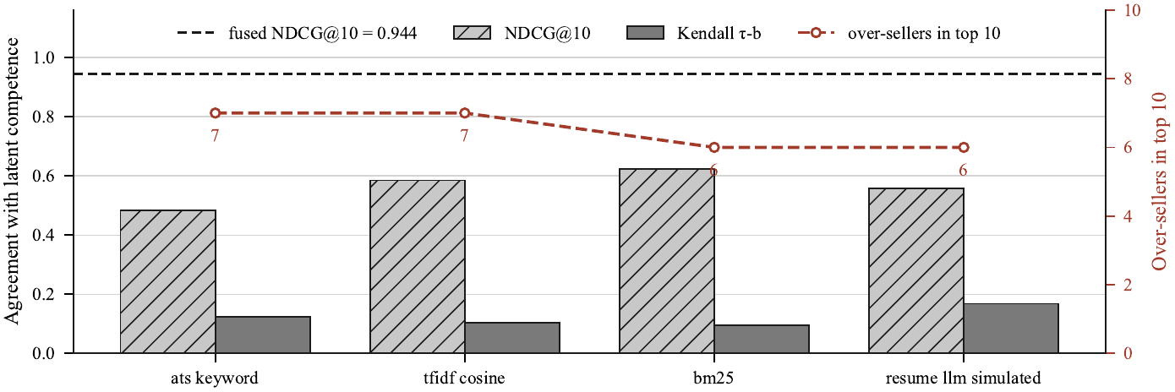
Fig. 5. Ranking quality of the keyword gate, TF-IDF cosine, BM25, and the simulated resume score against concealed competence, with the number of over-sellers each admits to the top ten on the right axis and the fused system's NDCG@10 as a reference line. All four rankers read the same self-reported document. Simulated cohort: generated documents scored against a constructed ground truth, not measurements on real candidates.

B. Rank Correction by Fusion
On the shipped cohort draw, fusion raised NDCG@10 from 0.6087 to 0.9440 and Kendall's τ-b from 0.1701 to 0.5471 (Fig. 6). All 25 hidden gems moved up and all 25 over-sellers moved down, a recovery rate of 1.00 over the 50 planted errors, with a mean gain of 21.4 positions for a hidden gem and a mean loss of 24.48 positions for an over-seller. Per-case movement, with 95% bootstrap intervals and exact two-sided sign tests, is given in Table III.
Table III
Per-case rank movement under fusion (simulated)
Case | n | Mean ΔR (places) | 95% bootstrap CI | Outcome | Sign-test p
Over-seller | 25 | +24.48 | [+21.48, +27.52] | 25/25 moved down | 5.96e-08
Hidden gem | 25 | −21.40 | [−24.52, −18.24] | 25/25 moved up | 5.96e-08
Honest strong | 25 | −10.60 | [−13.68, −7.64] | 9/25 within tolerance | 5.96e-08 (upward)
Honest weak | 25 | +7.52 | [+4.60, +10.48] | 10/25 within tolerance | 9.11e-04 (downward)

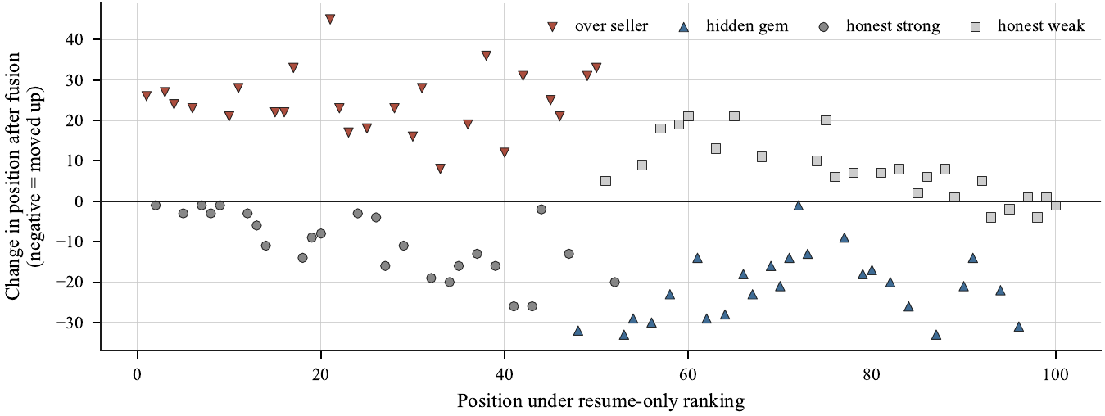
Fig. 6. Per-candidate rank change when the interview is fused into the ranking, against the position the resume alone gave them, for the shipped cohort draw. Over-sellers fall and hidden gems rise; the spread of the honest controls around zero is the cost of making that correction. Simulated cohort: this measures the fusion function on a constructed ground truth, not the validity of the interviewer.

Of the 50 honest controls, 31 moved more than the five-position tolerance, a control displacement rate of 0.62. The displacement decomposes by case: 16 of the 25 honest-strong controls moved up, by a mean of 15.25 places, and 15 of the 25 honest-weak controls moved down, by a mean of 12.27 places; the smallest displacement counted was six places. Among the controls themselves, Kendall's τ-b between their ordering and their concealed competence rose from 0.7861 before fusion to 0.8596 after it, and 1,148 of 1,225 control pairs (0.9371) preserved their relative order, leaving 77 pairs (0.0629) inverted (Table IV).
Table IV
Control displacement decomposition (simulated)
Quantity | Value
Honest controls | 50
Displaced beyond the 5-position tolerance | 31
Control-internal τ-b before fusion | 0.7861
Control-internal τ-b after fusion | 0.8596
Control pairs compared | 1,225
Control pairs, order preserved | 1,148 (0.9371)
Control pairs, order inverted | 77 (0.0629)

To assess dependence on the specific cohort draw, the cohort was regenerated 200 times using seed 20260923 and its 199 successive integer seeds, and both rankings were recomputed on each. Across the 200 regenerations the mean τ-b of the fused ranking was 0.5812 with a 95% interval of [0.5308, 0.6315], the mean τ-b gain over resume-only ranking was 0.3826 [0.3333, 0.4388], and the mean NDCG@10 gain was 0.2855 [0.1257, 0.4514]. The τ-b gain and the NDCG@10 gain were each positive in 200 of 200 draws, and all ten headline quantities for the shipped seed fall inside their own across-seed intervals (Table V).
Table V
Across-seed intervals over 200 cohort regenerations (simulated)
Quantity | Shipped draw | Mean | 95% interval | Range
τ-b, resume-only | 0.1701 | 0.1986 | [0.1268, 0.2744] | [0.0796, 0.2921]
τ-b, fused | 0.5471 | 0.5812 | [0.5308, 0.6315] | [0.5075, 0.6469]
τ-b gain | 0.3770 | 0.3826 | [0.3333, 0.4388] | [0.3156, 0.4501]
NDCG@10, resume-only | 0.6087 | 0.6699 | [0.5008, 0.8357] | [0.4222, 0.8882]
NDCG@10, fused | 0.9440 | 0.9553 | [0.9207, 0.9800] | [0.9029, 0.9852]
NDCG@10 gain | 0.3353 | 0.2855 | [0.1257, 0.4514] | [0.0672, 0.4916]

The interview-weight sweep from 0 to 1 in steps of 0.05, run on the shipped cohort, is shown in Fig. 7. τ-b reached 0.7903 at a weight of 0.95, against 0.5471 at the shipped weight of 0.5. Repeated on each of the 200 regenerations, the maximizing weight landed on five distinct grid values, took 0.95 in 132 of 200 draws, and never fell below 0.8. The shipped weight of 0.5 was fixed before the sweep was run and was not retuned in light of it.
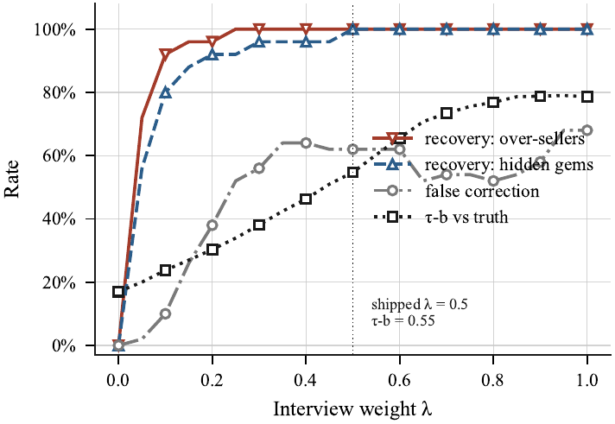
Fig. 7. Sensitivity of the ranking to the interview weight λ, swept from 0 to 1 in steps of 0.05 on the shipped cohort draw. Recovery of both planted error types rises with λ, and so does displacement of the honest controls; the parameter governs the trade. λ was fixed at 0.5 before this sweep was run, so the curve is a sensitivity analysis over a simulated cohort and carries no recommended value.

C. Integrity Scoring
An event-free session scored 100 with a clean verdict, and a single critical event scored 88 at review (Fig. 8). Six repeated no-face events scored 83 at clean; forty repeated no-face events scored 72 at review. A session with a phone, written notes, a background voice, and two glances away (five events across four distinct kinds) scored 75 at review. One glance away scored 97; three glances and one blur (four events, two kinds) scored 88; a second person in frame twice scored 90; and four tab switches with two pastes scored 76 at review. The score was non-increasing over 39 cumulative event additions, identical over 1,000 repeated calls on a fixed input, and identical across every ordering of a fixed four-event set.

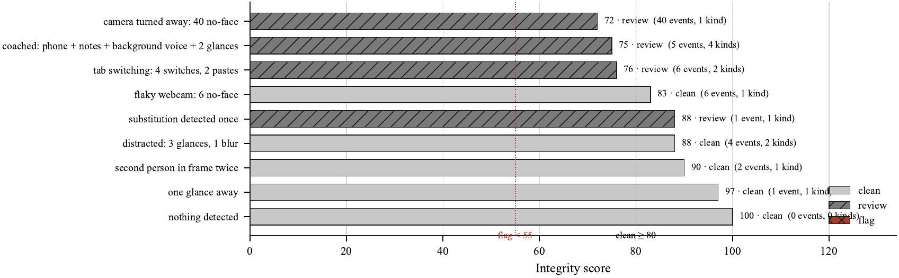
Fig. 8. Integrity score and verdict for nine worked scenarios, with the event count and the number of distinct event kinds behind each. A single critical event scores 88 and is still held at review. Six repeats of one kind cost 17 points and stay clean; forty cost 28 and reach review. The scoring function is exhaustive over its own inputs; the accuracy of the detectors that raise the events is not measured. [VERIFICATION REQUIRED: the original manuscript placed a repeated-event decay curve (score versus repeats, by severity) under this caption. This scenario chart matches the caption and text; confirm the intended figure, and note that its bottom-right legend overlaps two data labels and should be regenerated]

With integrity set to 0 for the whole cohort, every candidate's fused score equalled their resume-only score exactly (largest absolute difference 0.0), and the fused ordering coincided with the resume-only ordering at every position. Across 2,100 candidate-by-integrity pairs (100 candidates at 21 integrity levels from 0 to 100), the fused score never left the closed interval between the candidate's resume-only score and their fully trusted fused score. The headline audit fixes integrity at 100; Table VI is the sensitivity sweep around that fixed point.
Table VI
Integrity sensitivity of the fused ranking (simulated)
Integrity score applied to whole cohort | Kendall τ-b | Over-seller recovery
0 | 0.1701 | 0.00
25 | 0.2521 | 0.92
50 | 0.3382 | 1.00
55 | 0.3636 | 1.00
75 | 0.4428 | 1.00
90 | 0.5099 | 1.00
100 | 0.5471 | 1.00

D. Prompt-Injection Guardrail
The tier-1 guardrail was evaluated on 31 attack strings across five pattern families and 18 benign strings, 10 of them hard negatives (Fig. 9). It flagged 28 of 31 attacks, a detection rate of 0.9032 on this self-authored corpus. Per family, detection was 7 of 9 for instruction override, 4 of 5 for persona hijack, and 7 of 7, 5 of 5, and 5 of 5 for chat markup, score demand, and verdict demand. The three evasions were a leetspeak variant, a hyphenated variant, and a polite paraphrase with no imperative verb. Four benign strings were flagged, all four of them hard negatives, giving a false-positive rate of 0.2222 overall and 0.40 on hard negatives. Precision was 0.875, recall 0.9032, F1 0.8889, specificity 0.7778, and accuracy 0.8571; the tier-2 escalation rate on benign input was 0.7778.
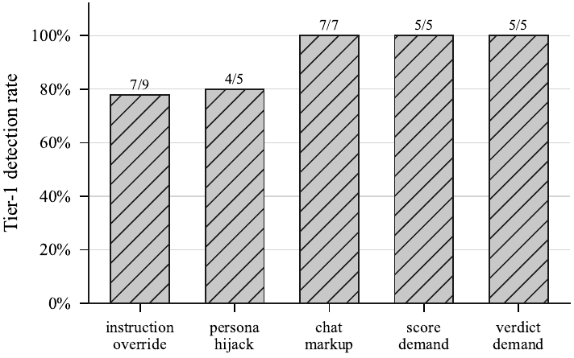
Fig. 9. Tier-1 guardrail detection rate per injection family over the labelled corpus, with detected/total counts above each bar. Tier 1 is pure regex, so these figures are exact and reproducible offline. The 0.40 false-positive rate on hard negatives is reported in the text. [VERIFICATION REQUIRED: the original caption described a dashed hard-negative line that is not in this figure; confirm whether the trade-off figure should be added]
Sanitization does not reject a hostile resume: matched instruction-like text is removed, the removal is recorded as a flag on the application, and the application proceeds through the remaining screening steps. No hostile resume among the 31 tested was rejected by sanitization. All 28 resumes whose text was rewritten carried their corresponding flags, and no resume was flagged without also being rewritten. The false-positive rate is the cost of this design: two in five hard-negative strings that merely discuss instructions were stripped, which is why the resume path flags and defers to a human rather than rejecting.

E. Keyword Pre-Filter
On the 26 hand-labelled boundary cases, the pre-filter matched the assigned label in 24, an accuracy of 0.9231, with a confusion of 11 true positives, 1 false positive, 1 false negative, and 13 true negatives. Two cases did not match their label. The first is reported as a matcher defect: for the fragment "C++ only, no plain C work" against the single-character requirement "C", the matcher returns a match and scores 100, whereas the hand label is no match [VERIFICATION REQUIRED: the fragment also contains the standalone token "C" in "plain C work", so a literal match may be correct. Confirm whether this is a boundary defect or a labelling error]. The second is a labelling error rather than a matcher failure: for "Expert in PostgreSQL" against "SQL", the hand label expects a match, but the matcher returns no match, and a direct call confirms a score of 0. The label assumed that SQL at a suffix boundary inside PostgreSQL should match; the boundary guard correctly declines it, so the matcher behaves as specified. The accuracy is reported as the authors labelled the corpus, and the disagreement is recorded here rather than silently correcting the denominator.
The three synonym, abbreviation, and conceptual cases ("relational databases" for "SQL", "ML" for "machine learning", "Infrastructure as Code" for "Terraform") were all scored correctly as no match, so they measure the price of having no synonym expansion. Restricted to the 23 cases decidable from character content, accuracy was 0.9130 (21 of 23), and both disagreements above fall inside that subset; under a corrected label for the PostgreSQL case it would be 22 of 23. A five-requirement role admits six score values (0, 20, 40, 60, 80, 100), and the threshold of 40 corresponds to at least two matched requirements.

F. Latency
Offline per-stage latency was measured with the provider stubbed; no figure includes model inference (Table VII, Fig. 10). Scrypt hashing and verification, at 119.35 ms and 119.31 ms at p50, and candidate registration, at 120.92 ms, were the slowest stages, and registration was the dominant stage. The scoring stages ran below 0.5 ms at p50: keyword scoring 0.097 ms, sanitization 0.106 ms, integrity scoring 0.0053 ms at 10 events and 0.0676 ms at 200 events, and ranking 100 candidates 0.373 ms. PDF text extraction on a 9-page document took 51.03 ms at p50. These figures are single-machine and CPU-only, and specific to the hardware named in Section VI-A. Four deterministic scoring functions (keyword pre-filter, sanitization, integrity scoring, and ranking) each returned identical output on all 50 calls; password hashing is salted by design and is expected to differ on each call, so its timing is reported without a determinism claim.
Table VII
Offline stage latency (ms), provider stubbed
Stage | n | p50 | p95
PDF text extraction (9 pages) | 10 | 51.03 | 51.34
Sanitization (hostile input) | 40 | 0.106 | 0.108
Keyword score (5 requirements) | 40 | 0.097 | 0.148
Integrity score, 10 events | 40 | 0.0053 | 0.0231
Integrity score, 200 events | 40 | 0.0676 | 0.0680
Rank 100 candidates | 40 | 0.373 | 0.513
Scrypt hash | 8 | 119.35 | 120.87
Scrypt verify | 8 | 119.31 | 120.97
Register candidate | 6 | 120.92 | 122.95
Apply (no model call) | 15 | 0.452 | 0.504
Screen (provider stubbed) | 15 | 0.506 | 0.730

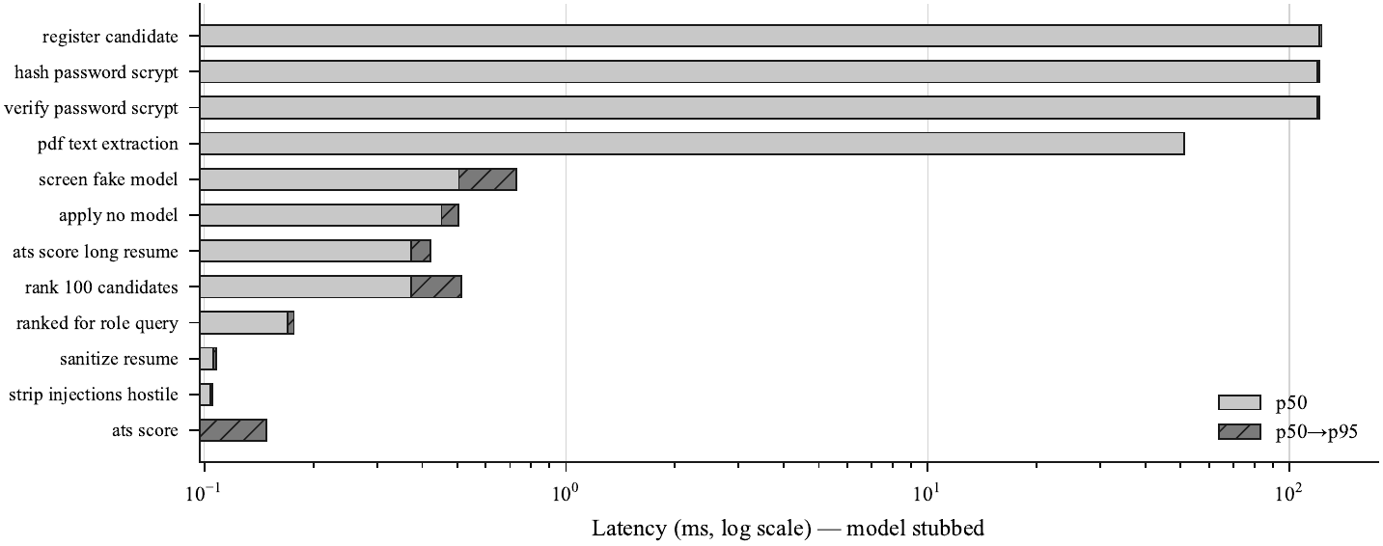
Fig. 10. Per-stage latency with the provider stubbed, so the figure shows the system's own overhead rather than model time. Everything in the scoring path is sub-millisecond; what costs time is PDF extraction, SQLite writes, and the scrypt key derivation, the last of which is slow by design.

G. Data Egress
Transport-level interception recorded every outbound request body during one complete candidate journey of 14 model calls under each of the hosted and local configurations (Table VIII, Fig. 11). The probe used a single generated resume of 546 bytes, identical under all three configurations. The hosted provider issued 14 requests carrying 41,798 bytes to one external, non-loopback host. The local provider issued 14 requests carrying 40,870 bytes to a loopback address, so its traffic was captured but did not leave the host. The fake provider issued no requests. The 0.9778 ratio between local and hosted payload sizes is reported only as a comparison of request size.
Table VIII
Egress per candidate journey
Provider | Requests | Request bytes | Non-loopback egress | Bytes crossing network
Gemini (hosted) | 14 | 41,798 | Yes | 41,798
Ollama (local) | 14 | 40,870 | No (loopback only) | 0
Fake | 0 | 0 | No | 0

Resume text appeared in 2 of the 14 calls, and candidate answers appeared in 12 of 14. Comparing the two resume sizes used (546 and 5,469 bytes), request-body size increased at a measured slope of 2.0 request bytes per resume byte, with a fixed overhead of 39,778 bytes per candidate independent of resume length; both figures derive from this two-point comparison rather than a larger sweep. Across the full run, 57 request bodies were intercepted, and the count reconciles by configuration: 0 for the fake provider, 14 for the hosted journey, 14 for the local journey, 14 for the larger-resume run, 14 for the per-call breakdown run, and 1 for the separate tier-2 moderation call. Six of the 14 calls in the journey are tier-2 guardrail calls; that count is a property of the stub, whose canned question bears no lexical relation to its canned answer, so word overlap falls below 0.06 and tier 2 fires on most turns. It is not a measured rate. No media file path, media extension, data URI, or base64 blob appeared in any of the 57 intercepted request bodies.
Seven of the 14 calls in the journey were schema-constrained. This does not contradict the two-of-five figure in Section VII-H: that figure counts code locations, and this one counts how many times those locations fire during one journey.
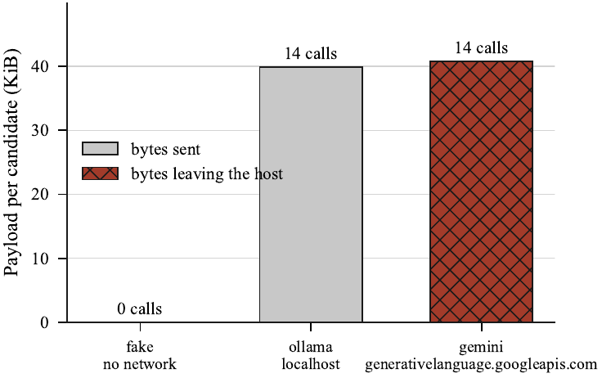
Fig. 11. Request payload per candidate (one screening call, a question plan, every interview turn, and the final grading), measured by intercepting the real provider code. The volume is the same for the local and hosted configurations because the same prompts are built; what differs is the recipient. Biometric media leaves the host under neither configuration, since vision and speech-to-text run in-process.

H. Provider Contract and Implementation Inventory
Two schemas were shipped to the hosted provider, using 11 allowed keywords. Sanitization preserved every required field and dropped no keyword the schemas use. In a live run against gemini-2.5-flash [AUTHOR INPUT REQUIRED: date of the live provider-contract run], both shipped schemas were accepted with every required field present, and both the pre-fix schema and an unsanitized schema were rejected with HTTP 400. The mean hosted round trip over the two probes was 4.146 s (5.309 s and 2.983 s). The two probes billed 603 reasoning tokens against 324 tokens of visible output; this is two observations, not a constant, and is not reported as an average. The hosted response carried no generation-time field, so the only provider reporting a server-side generation duration is the local one. Five model call sites exist in the implementation, of which two are schema-constrained.
The source comprises 33 files with 10,423 lines, of which 8,361 are code. The test suite has 15 files containing 358 test functions and 371 collected cases, the difference being parametrized expansions, giving a test-to-source-code-line ratio of 0.428. The database has 11 tables, 121 columns, 7 foreign keys with 7 cascading deletes, 22 personal-data columns, and 4 biometric-media columns. The system defines 13 proctoring event kinds and 5 guardrail pattern families, and has 17 pinned dependencies.

I. Discussion
Read together, Tables II and III describe a specific situation, not a general advantage. No resume-only method examined kept over-sellers out of the shortlist: four methods, lexical and model-shaped alike, admitted six or seven candidates whose planted resumes overstated their concealed competence into ten slots. BM25 outscored the simulated model screener, which cuts against the intuition that a model-shaped ranker should dominate a lexical one on this task. The numbers do not show that the pipeline screens better; they show that the shortlist was occupied by the wrong candidates however it was ranked, and that a second evidence source reorganized it. The direction of that reorganization is stable: the τ-b and NDCG@10 gains were positive in all 200 regenerations, and both planted error types moved in the intended direction for every member of their case, with exact sign-test probabilities of 5.96e-08.
The cost needs the same prominence as the benefit, and its own decomposition. A control displacement rate of 0.62 says that 31 of 50 honest candidates moved more than five positions; it does not say the fusion misjudged them. Half the cohort is deliberately mis-scored by the resume, so when those candidates are correctly demoted or promoted the honest controls must move to let them past. The controls' own ordering became more faithful to their concealed competence (τ-b 0.7861 to 0.8596), 93.71% of control pairs preserved their relative order, and both displaced groups moved in the direction of their own competence. The defensible cost figure is therefore the 0.0629 of pairs whose order inverted, which, unlike the displacement rate, does not grow with the number of planted errors.
The interview-weight sweep is a sensitivity analysis and nothing more. The maximizing weight never fell below 0.8 across 200 regenerations, which indicates that the interview signal carries information about the concealed competence in this generator, but the argmax itself is unstable (five grid values), so no single-draw maximum can be read as a tuned setting. Tuning a hiring weight against synthetic ground truth and shipping the result would be the overfitting this paper warns against. Finally, the egress result is about destination rather than size: the same payload either crosses the network or does not depending on one configuration value, and because candidate answers appear in 12 of 14 calls against two for resume text, a privacy analysis that considers only the resume examines the wrong surface.

VIII. Limitations and Threats to Validity

A. Threats to Validity
Circularity between generator and result. The cohort's resume inflation and its unbiased-but-noisy interview are assumptions of the generator, not measurements. The results test whether the fusion function recovers a planted resume error given interview evidence of the stated quality; they do not test whether the interviewer produces evidence of that quality. Every rate in Section VII-B is conditional on the noise parameter of 0.08 set in Section VI-B, and the unconditional form of the claim is unmeasured.
Unbiased interview noise. A real interviewer may be biased rather than merely noisy. The most obvious case is the one the pipeline exists to address: an interviewer persuaded by a confident over-seller would reproduce the error the fusion is meant to correct, and the correction would then be anti-correlated with its own target. The cohort contains no such case.
Non-independence of interview and resume. As stated in Section IV-C, the question plan is conditioned on the same resume and on the requirements the pre-filter did not match, and the same provider and model family screen and interview. The interview is therefore an additional evidence source, and its agreement with concealed competence cannot be attributed to the interview alone.
Synthetic-resume realism. Resumes are generated from templates that turn a claimed skill set into bland prose, with distractor skills added so that length and relevance are uncorrelated. Real resumes contain chronology, self-presentation, gaps, and formatting that carry signal no template reproduces, and the lexical baselines read documents whose vocabulary is controlled by construction.
Self-authored corpora. The 31 attacks, 18 benign strings, and 26 boundary cases were written by the authors, who also wrote the patterns tested. The detection rate of 0.9032 and the boundary accuracy of 0.9231 are regression figures against a corpus designed to exercise the implementation, not estimates of behaviour on adversarial input in the wild. No adaptive adversary was modelled, and the results do not support a claim that the system is secure against prompt injection.
Small n and a single role. There are 25 candidates per planted case and 50 planted errors. The sign tests are exact and the intervals are bootstrap or across-seed, but the cohort is orders of magnitude smaller than a real applicant pool and its composition is a design choice rather than a sample. All baselines were run against one five-requirement role; whether the over-seller penetration rates generalize to roles with fewer requirements or to non-technical roles is untested, and the reachable keyword scores, and hence the meaning of the threshold, differ by role.
No human raters; self-preference. Every quantity that would place the model's interview score against human judgment is absent, so the interviewer cannot be stated to be accurate. Self-preference, in which the model family that screened a candidate also rates that candidate's interview, cannot be excluded: the design does not test for it and has no independent rater to test against.
Fixed integrity in the headline audit. The ranking results in Section VII-B are computed at integrity 100 for every candidate. This deliberately excludes a guessed quantity from a headline result, and it means the headline figures describe fusion under full trust; Table VI is a sensitivity sweep, not a substitute for a cohort with integrity measured per candidate.
Stub dependence and non-transferability. The egress and latency results were measured with stubbed responses. Egress describes the payload the pipeline constructs and where it is routed, not what any model returns, and the 12-of-14 figure describes one probe journey with a 546-byte generated resume, not a rate over real candidates. Latency excludes model inference and is specific to the single CPU-only machine in Section VI-A; the scrypt work factor in particular is hardware-dependent.

B. Ethical and Regulatory Considerations
The pipeline processes identity-matching and biometric data. Face detection, head pose, and identity matching run on webcam input, answer audio is transcribed locally, and derived records are persisted in a database that holds 22 personal-data columns, 4 of which reference biometric media. Consent is recorded before a session proceeds. The integrity score and its events are advisory: they are reported to the recruiter as evidence for human review and are never an automated determination of misconduct, and because integrity enters the fusion as a mixing weight rather than a penalty, proctoring noise cannot drive a candidate's score down. The final disposition of every candidate remains a human decision, and the only automatic rejection in the pipeline is the keyword pre-filter, which is lexical so that every such rejection can be explained as a named list of missing requirements.
Under the hosted provider, the candidate's resume text and every verbatim answer reach one third-party processor, which makes that provider a processor under the data-protection framework governing personal data and places the deployment in the high-risk employment category of the EU regulatory framework for artificial intelligence [CITATION REQUIRED: GDPR processor provisions and the EU AI Act high-risk employment category]. Under the local configuration the same payload reaches no party other than the operator. Two gaps are material: the database is not encrypted at rest, so filesystem permissions are the only control on 22 personal-data and 4 biometric-media columns; and while deletion functions exist and cascade correctly, nothing schedules them, so retention is an operator action rather than a property of the system. We make no fairness claim. No demographic attribute is collected, recorded, or evaluated anywhere in the pipeline, so the system is neither audited for nor demonstrated to be fair.

IX. Conclusion and Future Work
Resume-only screening ranks candidates on a self-reported document and cannot revise its judgment when later evidence contradicts it. This work asked whether an adaptive interview stage can revise the resulting ranking errors and what such a pipeline exposes about candidate data. We built a locally deployable pipeline in which the interview is an additional evidence source combined with the resume score through trust-weighted fusion, so that low-integrity interview evidence contributes less to the final score without lowering the candidate's resume score.
On the simulated cohort, four resume-only rankers let six or seven over-sellers into the top ten. Fusion raised NDCG@10 from 0.61 to 0.94 and Kendall's τ-b from 0.17 to 0.55 on the shipped draw, with the gain positive in all 200 cohort regenerations, and every planted hidden gem moved up. The control displacement rate was 0.62, but 93.71% of honest control pairs kept their relative order and their internal agreement with concealed competence rose, so most of that displacement is a consequence of correcting others. At the transport layer, candidate answers appeared in 12 of 14 model calls against two for resume text, and routing the same payload to a loopback address reduced measured non-loopback egress from 41,798 bytes to zero. These ranking results are simulated: they characterize what the fusion function does with interview evidence of a stated quality, and do not establish that the interviewer supplies evidence of that quality.
Five extensions are preconditions for a stronger claim.
- Interviews conducted by a model should be recorded and scored independently by at least three human raters, with inter-rater agreement and model-to-human correlation reported, to replace the assumed interview-noise model with a measured one.
- The planned ablation ladder should be run with a real zero-shot language-model baseline and an embedding baseline against a local model, so that each stage's contribution can be attributed; with a stubbed provider every rung returns the same canned response and would measure nothing.
- Local deployment should be characterized by inference latency, throughput, and peak memory, alongside the specific model, quantization, and hardware. The provider layer currently discards the durations the local provider returns, so this needs no new dependency.
- Encryption at rest and a scheduled data-retention job should be implemented; until then the local-deployment egress result characterizes network exposure only, not storage-level protection.
- The generator should encode protected attributes to enable a disaggregated fairness study, and the evaluation should be repeated on technical and non-technical roles and on real resumes obtained under a documented licence.
Until these are done, the present results are confined to a constructed synthetic audit, and no claim of readiness for supervised use on real candidate data is warranted, including by organizations that process such data on their own hardware.

Acknowledgment
[AUTHOR INPUT REQUIRED: acknowledgments and the AI-assistance disclosure statement required by the target venue]

References
[1] A. Tiwari, S. Vaghela, R. Nagar, and M. Desai, "Applicant tracking and scoring system," Int. Res. J. Eng. Technol. (IRJET), vol. 6, no. 4, pp. 320–324, Apr. 2019. [VERIFICATION REQUIRED: no independent record of this paper could be found; confirm volume, issue, pages, and authors from the publisher, or replace it, since it supports a load-bearing claim in Section I]
[2] S. Pudasaini, S. Shakya, S. Lamichhane, S. Adhikari, A. Tamang, and S. Adhikari, "Scoring of resume and job description using Word2vec and matching them using Gale–Shapley algorithm," in Expert Clouds and Applications, 2022, pp. 705–713, doi: 10.1007/978-981-16-2126-0_55. [VERIFICATION REQUIRED: the project's revision guide reports year 2021 and pages 691–699 for this DOI; the manuscript gives 2022 and 705–713. Confirm against the publisher record]
[3] C. Li, E. Fisher, R. Thomas, S. Pittard, V. Hertzberg, and J. D. Choi, "Competence-level prediction and resume & job description matching using context-aware transformer models," in Proc. 2020 Conf. Empirical Methods in Natural Language Processing (EMNLP), 2020, pp. 8456–8466, doi: 10.18653/v1/2020.emnlp-main.679.
[4] C. Gan, Q. Zhang, and T. Mori, "Application of LLM agents in recruitment: A novel framework for automated resume screening," J. Inf. Process., vol. 32, pp. 881–893, 2024, doi: 10.2197/ipsjjip.32.881.
[5] F. P.-W. Lo, J. Qiu, Z. Wang, H. Yu, Y. Chen, G. Zhang, and B. Lo, "AI hiring with LLMs: A context-aware and explainable multi-agent framework for resume screening," in Proc. IEEE/CVF Conf. Computer Vision and Pattern Recognition Workshops (CVPRW), 2025, [VERIFICATION REQUIRED: page range and DOI. Three page ranges appear in the project files (4184–4193; 4223–4232; 4193–4202 in the supplied PDF), and the DOI 10.1109/cvprw67362.2025.00402 appears only in the revision guide. Entry [5] was also missing from the reference list of the manuscript]
[6] A. Fabris, N. Baranowska, M. J. Dennis, D. Graus, P. Hacker, J. Saldivar, F. Zuiderveen Borgesius, and A. J. Biega, "Fairness and bias in algorithmic hiring: A multidisciplinary survey," ACM Trans. Intell. Syst. Technol., vol. 16, no. 1, art. 16, pp. 1–54, 2025, doi: 10.1145/3696457.
[7] P. Baxi, J. Xu, J. Y. Jiang, and S. Jasin, "Prompt injection in automated résumé screening with large language models: Single and multi-injection settings," in Findings of the Association for Computational Linguistics: ACL 2026, 2026, pp. 2942–2953, doi: 10.18653/v1/2026.findings-acl.142.
[8] N. Vanetik and G. Kogan, "Job vacancy ranking with sentence embeddings, keywords, and named entities," Information, vol. 14, no. 8, p. 468, 2023, doi: 10.3390/info14080468.
[9] S. Vaishampayan, H. Leary, Y. B. Alebachew, L. Hickman, B. Stevenor, W. Beck, and C. Brown, "Human and LLM-based resume matching: An observational study," in Findings of the Association for Computational Linguistics: NAACL 2025, 2025, pp. 4823–4838, doi: 10.18653/v1/2025.findings-naacl.270.
[10] H. Iso, P. Pezeshkpour, N. Bhutani, and E. Hruschka, "Evaluating bias in LLMs for job-resume matching: Gender, race, and education," in Proc. 2025 Conf. Nations of the Americas Chapter of the Association for Computational Linguistics: Human Language Technologies, Vol. 3: Industry Track, 2025, pp. 672–683, doi: 10.18653/v1/2025.naacl-industry.55.
[11] A. Wen, T. Patil, A. Saxena, Y. Fu, S. O'Brien, and K. Zhu, "FAIRE: Assessing racial and gender bias in AI-driven resume evaluations," arXiv:2504.01420, 2025.
[12] PyMuPDF, "PyMuPDF documentation," 2023. [Online]. Available: https://pymupdf.readthedocs.io/
[13] Streamlit Inc., "Streamlit documentation," 2023. [Online]. Available: https://docs.streamlit.io/
[14] A. Radford et al., "Whisper: Robust speech recognition via large-scale weak supervision," 2022. [AUTHOR INPUT REQUIRED: complete author list, arXiv identifier or venue, and DOI/URL]

