CHAPTER 2
RELATED LITERATURE, STUDIES, AND TECHNICAL BACKGROUND

2.1 Review of Related Literature
The modern transformation of public sector administration increasingly relies on the integration of digital infrastructure, artificial intelligence (AI), data analytics, and flexible software methodologies. Across contemporary international literature, digital transition is recognized as a key driver of administrative efficiency, tax compliance, evidence-based decision-making, and enhanced citizen interaction.
2.1.1 Foreign Related Literature
- Digitalization in Tax and Revenue Administration
The digital transformation of tax and financial administration has become central to modernizing public sector fiscal management. Bassey et al. (2022) established a conceptual framework showing how digital processes replace conventional manual procedures, fundamentally improving government administrative capabilities. In empirical tax operations, Bellon et al. (2022) demonstrated that digital tools such as e-invoicing enhance tax compliance by strengthening transaction tracking and monitoring. Expanding on cross-country perspectives, Nose and Mengistu (2023) highlighted that technology
adoption in tax operations drives operational efficiency and systemic transparency globally. Furthermore, digital financial systems carry broader macroeconomic benefits; Cheng et al. (2024) observed that digital tax administration significantly influences local government debt management and fiscal governance. These shifts reflect broader international benchmarks, as the Organisation for Economic Co-operation and Development (OECD, 2025) underscored that digital transformation initiatives are continuously reshaping public revenue operations toward fully integrated, data-driven frameworks.
- AI-Powered Public Service Delivery and Citizen Engagement
Beyond backend administration, public sector modernization increasingly emphasizes artificial intelligence to enhance citizen-facing interactions. Larsen and Følstad (2024) found that AI-powered conversational tools and chatbots improve public service access and facilitate communication between citizens and agencies. However, effective implementation requires alignment with user expectations; Hemesath and Tepe (2024) demonstrated that design preferences and public value positions strongly dictate citizen acceptance of AI chatbots in e-government environments. Similarly, Kulal et al. (2024) observed that AI integration enhances total service efficiency by automating repetitive inquiries and streamlining public operations. As governments transition toward AI-supported models, Savveli et al. (2025) emphasized that public trust, accessibility, and usability remain crucial determinants of citizen adoption.
- Data Analytics, Governance, and Public Dashboards
Effective digital administration relies on robust data governance and analytical capabilities to translate raw operational data into actionable insights. Talib et al. (2024) highlighted that big data infrastructure is essential for improving public sector decision performance and strategic planning. To maximize these tools, the OECD (2023) stressed the role of structured data governance frameworks in facilitating secure, transparent, and multi-agency data utilization. Visual reporting interfaces serve as the primary medium for communicating these analytics; Shin (2026) conceptualized public dashboards as vital socio-technical governance systems that connect raw data, organizations, and public oversight. Providing operational guidance, Wu et al. (2026) illustrated how structured data dashboards allow administrators to monitor complex metrics and support timely, evidence-based decision-making.
- Agile and Adaptive Development in the Public Sector
Implementing advanced digital platforms within public institutions requires software development strategies tailored to public-sector environments. Ciancarini et al. (2024) showed that adapting agile methodologies, such as Scrum, enables public agencies to handle digital transformation through iterative progress and continuous stakeholder feedback. Similarly, Plant et al. (2025) emphasized that aligning team capabilities with organizational contexts enhances DevOps performance in public sector software deployment. Together, these studies indicate that sustainable technological integration depends as much on flexible management and software practices as it does on technological innovation itself.
2.1.2 Local Related Literature
In the Philippine context, modernizing local government units (LGUs) and state institutions focuses heavily on upgrading local revenue mechanisms, adopting artificial intelligence, implementing data-driven decision tools, and utilizing flexible software frameworks. The literature on Philippine public administration highlights both the transformative benefits and the operational challenges of implementing digital governance at the local level.
- Local Revenue Generation and E-Tax Facilities
Upgrading tax administration and local revenue generation systems serves as a primary foundation for fiscal autonomy in Philippine municipalities. Ozarraga (2022) emphasized that effective local revenue generation systems directly boost municipal development capabilities and public service funding. To improve collection efficiency, local governments have increasingly transitioned to electronic payment facilities; Mabalay (2023) demonstrated that upgrading real property tax payment options significantly strengthens tax administration systems. However, execution varies across localities. Vibora and Mandigma (2022) observed that while online tax payment facilities improve transaction convenience, their long-term success in LGUs depends heavily on user adoption, infrastructure reliability, and administrative readiness.
- E-Governance, Digital Gaps, and AI Adoption in LGUs
The broader expansion of e-government initiatives across Philippine local governance presents both opportunities and implementation gaps. De Castro and De Castro (2022) noted that e-government projects enhance local administrative responsiveness and service access, while Palma et al. (2023) highlighted the necessity of structured feature frameworks to ensure system functionality and user adoption. Despite these advances, significant gaps persist; Del Rosario et al. (2025) identified key digital transformation divides in local governance, including uneven technological infrastructure, resource limitations, and varying digital literacy rates across LGUs. To address administrative complexity, local governments are beginning to explore artificial intelligence. Pareja (2025) highlighted AI as a major driver of public operations, citing emerging trends in government automation. In regional applications, Zabala (2023) confirmed the feasibility and potential of AI tools to streamline administrative operations within LGUs in the Zamboanga Peninsula.
- Smart Analytics, Data Governance, and Smart City Planning
Transitioning to smart local governance requires robust data management systems and analytical capabilities. Santiago (2025) argued that integrating digital land use governance is essential for developing sustainable and resilient smart cities. On an operational level, Nerona et al. (2026) demonstrated that implementing information system solutions to improve LGU data management systems leads to more sustainable and efficient public service delivery. For strategic decision-making, Esbieto et al. (2026) introduced smart analytics decision-support platforms (such as iPlan Gov) designed to assist local planners in evaluating development data. However, maximizing these technologies requires workforce readiness; Yumen (2025) stressed that empowering local governance relies on data-driven capacity building, computer literacy, and fostering a strong culture of data utilization among LGU personnel.
- Software Development Methodologies in the Philippine Public Sector
Deploying enterprise-level government systems requires software development methodologies adapted to the institutional requirements of the Philippine public sector. Gamido and Mariano (2025) demonstrated that hybrid Agile-Waterfall methodologies effectively balance the strict compliance demands of public procurement with the flexibility required for software iterative design. Similarly, Lagman et al. (2025) evaluated enterprise-level digital governance systems built using Agile frameworks and standardized under ISO/IEC 25010 quality models, proving that structured, agile software practices ensure high system reliability, security, and maintainability in Philippine public institutions.
2.1.3 Review of Related Studies
Foreign Related Studies
- Digitalization of Local Revenue and Treasury Management Systems
Empirical studies demonstrate that transitioning from traditional financial workflows to integrated digital administration directly enhances government fiscal management and compliance. Cheng et al. (2024) evaluated the systemic impact of digital tax administration reforms in China, finding that digitized tax governance significantly optimizes revenue collection efficiency and mitigates local government debt risks. On a broader institutional level, an empirical evaluation of Ghana’s local government institutions examined the operational implementation of an Integrated Financial Management Information System (IFMIS), revealing that unified financial platforms drastically streamline treasury operations, budget execution, and financial reporting across municipal bodies (Exploring the use, 2022). Furthermore, investigating micro-level tax compliance, Agnesia et al. (2026) demonstrated through empirical survey data that integrating digital payment mechanisms—alongside taxpayer awareness and enforcement—significantly increases taxpayer compliance among local commercial enterprises.
- Evaluation and Citizen Adoption of Government AI Chatbots
As public institutions increasingly deploy automated assistance systems, international research evaluates both user adoption factors and implementation design principles. In a comparative usability analysis of governmental chatbots across Latin America and international contexts, Monteiro et al. (2023) identified key interaction pitfalls, emphasizing that system responsiveness, interface clarity, and transactional usability are essential to user satisfaction. Addressing adoption dynamics, Sarker (2026) empirically modeled the factors driving citizen adoption of public-sector chatbots, proving that perceived usefulness, operational transparency, and trust are fundamental predictors of automated tool usage. Expanding into advanced conversational capabilities, recent experimental findings examined how implementing government chatbots equipped with generative AI influences civic engagement, demonstrating that generative AI capabilities significantly enhance public interaction willingness and responsiveness when compared to traditional rule-based chatbots (How do government chatbots, 2026).
- Agile Frameworks and System Implementation
Executing large-scale IT projects in the public sector requires overcoming unique structural and administrative constraints. Analyzing institutional challenges in public sector technology, Baxter et al. (2023) conducted an empirical case study on agile software adoption, showing that while agile frameworks improve software delivery, success relies on adapting agile ceremonies to meet statutory governance and oversight requirements. Similarly, Johannessen (2025) conducted an in-depth ethnographic study of agile implementation within Norwegian public administration, concluding that establishing an "agile bureaucracy" requires balancing iterative software design with rigid public-sector accountability frameworks to achieve long-term system stability.

Local Related Studies
- E-Collection Systems, Revenue Generation, and Tax Efficiency in LGUs
Empirical investigations across Philippine municipalities highlight that adopting electronic collection tools directly affects local tax yields and financial performance. Examining municipal revenue operations in Iloilo Province, Convocar et al. (2026) conducted a descriptive study on local e-collection systems, finding a direct positive relationship between digitized collection workflows and overall municipal revenue efficiency. Similarly, Libradilla and Ortiz (2025) evaluated the electronic payment and collection system for real property tax in LGU Ajuy, revealing high levels of system effectiveness in transaction processing and taxpayer convenience. Evaluating broader city-level frameworks, Pescador and Caelian (2022) examined the implementation and effectiveness of city revenue generation programs, highlighting best practices as well as persistent administrative challenges in local tax enforcement. At the municipal level, Pardiñas and Ordoñez (2025) assessed real property tax implementation across first-class municipalities in Nueva Vizcaya, demonstrating that collection efficiency relies heavily on structured tax enforcement and administrative mechanisms. Further illustrating localized challenges, Fuentes and Salapa (2023) analyzed real property tax collection in Sta. Josefa, Agusan del Sur, identifying key operational bottlenecks including taxpayer delays and manual record-keeping constraints.
- Commercial Vendor Dynamics and Business Tax Baselines
Understanding local business operations and vendor financial behaviors is vital for designing effective municipal business tax and licensing administration systems. Assessing small business operators in Lucena City, Asia (2023) examined the financial management practices of public market vendors, establishing baseline administrative insights for supporting long-term commercial sustainability. Complementing these findings, Yap and Artates (2023) investigated the financial literacy levels of dry market vendors, demonstrating that vendor financial comprehension directly influences compliance with local business regulatory fees and municipal payment schedules.
- Web-Based Information Systems in Philippine LGUs
Developing dynamic, web-based software solutions enables Philippine LGUs to transition away from fragmented manual workflows toward integrated digital governance. Demonstrating open-source system implementation, Albano (2024) developed and evaluated a dynamic web-based information system for LGU Cabagan, Isabela using client-server architecture. The study proved that deploying web-based management platforms enhances administrative transparency, streamlines public service delivery, and provides reliable access to municipal financial and operational data.
literature identifies as essential for sustained fiscal performance.

2.2 Analysis of Related Studies and Existing Systems
Research carried out by both local and international sources indicates that digital transformation has become essential if government revenue collection, treasury management, taxpayer services, and financial decision-making are to be improved. The research points out that a digital tax administration system increases efficiency, transparency, accuracy, and access to government financial services. For instance, Bassey et al. (2022) emphasized the importance of integrating technology, people, processes, and data into tax administration. Bellon et al. (2022) demonstrated that electronic invoicing helps to improve tax compliance. Nose and Mengistu (2023) discovered that tools such as e-filing and digital payments strengthen tax administration. In general, these studies show that the move from manual and fragmented systems to integrated digital platforms is important.
Various studies indicate that digital technologies assist local governments in enhancing their revenue collection and treasury operations. Cheng et al. (2024) discovered that digital tax administration results in greater efficiency in tax collection and financial management. In the Philippines, Pescador and Caelian (2022) noted that electronic payment systems enable cities to raise more revenue. Convocar et al. (2026) examined the e-collection systems in Iloilo Province and found that revenue efficiency had improved. Research into real property taxes also supports the idea of digitalization. Fuentes and Salapa (2023) and Libradilla and Ortiz (2025) looked at how electronic systems improve the collection of real property taxes. Pardiñas and Ordoñez (2025) demonstrated that modernizing and integrating the systems leads to better revenue collection.
Studies also indicate that artificial intelligence (AI) can help people to interact more easily with government services. Larsen and Følstad (2024) discovered that chatbots can provide individuals with rapid access to government information. In their study of how citizens and government staff use AI chatbots in e-government, Hemesath and Tepe (2024) found that AI increases the efficiency of public services, and Kulal et al. (2024) demonstrated that AI makes public services more efficient. These findings support the idea of using conversational AI to answer common questions and to make government assistance more accessible. The system suggested to use of Gemini AI to assist taxpayers with their questions regarding revenue services and procedures.
Business intelligence and data analytics are also key in modern government systems. Studies show that just collecting data is not enough—officials need to turn data into useful insights. Talib et al. (2024) showed that big-data analytics help public-sector decision-making. Research on public dashboards highlights the value of data visualization for understanding complex information. Because of these findings, the proposed system includes a Metabase Business Intelligence Dashboard to turn revenue and treasury data into clear visual reports that help staff monitor collections and make informed decisions.
The proposed Market Stall Rental and Billing module has also been influenced by various studies concerning public markets. Asia (2023) examined the way that vendors in Lucena City handle their finances, and Yap and Artates (2023) looked into the financial knowledge of the vendors at the Subic Public Market. Nevertheless, these studies concentrate on vendor behaviour and do not address the need for a government system to manage stall accounts, billing, payments, and revenue tracking.
Research also supports using step-by-step (iterative) software development for government digital projects. Baxter et al. (2023) discussed the pros and challenges of Agile methods in public IT projects, while Ciancarini et al. (2024) described Scrum@PA, an Agile approach for public administration. These studies suggest that continuous feedback, testing, and gradual improvement work well for complex government systems with many parts.
Despite these developments, an important research gap remains. Existing local and foreign studies generally address revenue collection, real property taxation, electronic payments, public-market financial practices, AI-enabled government services, business intelligence, and treasury information systems as separate areas of investigation. Philippine studies, in particular, have examined e-collection systems, real property tax collection, revenue-generation practices, and public-market vendors; however, the reviewed studies provide limited evidence of a single integrated local government platform that combines these functions within one interconnected system. Moreover, existing studies rarely combine operational revenue-management functions with both generative AI-based taxpayer inquiry assistance and business intelligence analytics.
The proposed study addresses this gap through the Development and Implementation of an Intelligent Revenue Collection and Treasury Services System with Gemini AI-Powered Taxpayer Inquiry Assistance and Metabase Business Intelligence Dashboard for Local Government Units. The system integrates Real Property Tax Collection, Business Tax and Regulatory Fee Payment, Market Stall Rental and Billing, Digital Payment Integration, and Treasury Dashboard and Reports within a unified platform. Unlike existing studies that generally focus on individual revenue processes or technologies, the proposed system combines transaction processing, taxpayer assistance, payment integration, centralized financial information, and data visualization. Through Gemini AI, the system aims to provide accessible taxpayer inquiry assistance, while the Metabase Business Intelligence Dashboard transforms consolidated revenue and treasury data into meaningful reports and visual indicators for monitoring and decision-making. Therefore, the study seeks to bridge the identified gap by providing an integrated, intelligent, and data-driven approach to local government revenue collection and treasury service management.
2.2.1 Comparative Analysis of Existing Systems
This section presents existing systems related to revenue collection and treasury services in local government units. The selected systems were reviewed and compared based on their functions in Real Property Tax Collection, Business Tax and Regulatory Fee Payment, Market Stall Rental and Billing, Digital Payment Integration, and Treasury Dashboard and Reports. The comparison identifies the similarities, differences, and technological features of existing systems in relation to the proposed system.

System | Provider/ scope | Key Features | AI-Powered Taxpayer Assistance | Integrated BI Dashboard | Key Limitation Relative to proposed system
eGovPH App/  eLGU System | DICT  (national);  Adopted by 900+ LGUs including Caloocan | Business permit renewal, RPT/ business tax payment, civil registry, community tax certificates, single sign- on | None -static FAQ / Citizen's Charter only | no analytics layer for LGU treasury staff | General- purpose national platform; no city-specific revenue analytics, no conversational taxpayer assistant, no BI reporting for local treasury officials
QC E-Services / QC Pay Easy | Quezon City LGU | 241 online services, business tax assessment & payment, RPT payment, e-OR issuance, self-service kiosks | None | None publicly documented | Strong transactional coverage but lacks AI-based inquiry assistance and lacks a consolidated BI dashboard for revenue monitoring
Caloocan City e-OR System | Caloocan City Treasurer's Office | Automatic electronic official receipt issuance for business and RPT payments | None | None | Limited to receipting only; does not cover full online assessment, AI-assisted inquiry, or executive-level reporting
BLGF eSRE / LIFT System | DOF- Bureau of Local Government Finance (national, all LGUs) | Quarterly submission of LGU Statement of Receipts and Expenditures for fiscal oversight and benchmarking | None | Static, quarterly reports only-  not real-time, not city-operational | Built for national-level compliance reporting, not day-to-day city treasury operations, taxpayer service, or real-time decision support
iTanong | DICT (national AI assistant, pilot 2025) | Filipino/Taglish-language conversational assistant replacing the physical Citizen's Charter across national agencies | Yes — general government-service Q&A | None | Scoped to national frontline services, not LGU-specific revenue or treasury processes; not integrated with any local payment or reporting system
Chaital (EACOMM) | Private vendor product, deployable to any LGU/agency | NLP-based chatbot trained on citizen charters/manuals, multi-channel (web, Messenger, Viber) | Yes — generic FAQ-style assistance | None | Off-the-shelf commercial chatbot not connected to a city's actual revenue database or transaction system; cannot process real taxpayer account data
Table 1. Comparative Analysis of Existing Systems
The comparison shows that existing systems provide various digital services for revenue collection, tax payments, reporting, and citizen assistance. However, these functions are often implemented separately and have limited integration of AI-assisted taxpayer support and real-time business intelligence. These identified limitations provide an opportunity for the proposed system to integrate revenue and treasury services, Gemini AI-powered taxpayer inquiry assistance, and a Metabase Business Intelligence Dashboard into a unified platform for LGU operations.

2.3 Agile Scrum Methodology
The study will utilize the Agile Scrum methodology as the software development framework for the proposed Intelligent Revenue Collection and Treasury Services System. Agile Scrum follows an iterative and incremental approach in which the development process is divided into short development cycles called sprints. This approach allows the development team to design, develop, test, and improve system functionalities progressively based on identified requirements and stakeholder feedback.
Agile Scrum was selected because the proposed system consists of multiple interconnected components, including Real Property Tax Collection, Business Tax and Regulatory Fee Payment, Market Stall Rental and Billing, Digital Payment Integration, Treasury Dashboard and Reports, Gemini AI-Powered Taxpayer Inquiry Assistance, and Metabase Business Intelligence Dashboard. Developing these components incrementally allows the researchers to identify technical and functional issues early and make necessary adjustments before system implementation.
The development process will utilize a Product Backlog containing the system requirements and prioritized features. Selected requirements will be assigned to a Sprint Backlog and developed within each sprint. During the development cycle, the researchers will conduct Sprint Planning to determine the tasks to be completed, Daily Scrum meetings to monitor progress and identify development concerns, Sprint Reviews to present completed functionalities and obtain feedback, and Sprint Retrospectives to evaluate the development process and identify improvements for succeeding sprints.
2.3.1 Application of Agile Scrum Methodology
Agile Scrum will be applied throughout the development of the proposed system by dividing its major functionalities into manageable sprint cycles. Initial sprints will focus on establishing the system architecture, database, user management, and core revenue collection functions. Subsequent sprints will cover the development and integration of the Real Property Tax Collection, Business Tax and Regulatory Fee Payment, Market Stall Rental and Billing, and Digital Payment Integration modules.
Later sprint cycles will focus on integrating Gemini AI for taxpayer inquiry assistance and configuring the Metabase Business Intelligence Dashboard for revenue monitoring, visualization, and reporting. Each completed increment will undergo functional testing and evaluation before proceeding to the succeeding development cycle.
Regular Sprint Reviews will allow project advisers, intended users, and relevant stakeholders to evaluate completed functionalities and provide feedback regarding system requirements, usability, transaction processes, AI-generated responses, and dashboard information. Identified issues and additional requirements will be incorporated into succeeding sprint cycles when appropriate.
Through this iterative process, Agile Scrum will enable the researchers to continuously develop, test, evaluate, and refine the proposed system while maintaining alignment with its functional requirements and intended LGU revenue and treasury operations.

2.4 Emerging Technologies, Intelligent System, and Standards
The modernization of public sector operations relies on the strategic integration of advanced technical architecture, artificial intelligence, data analytics, and strict compliance standards. To support an automated, secure, and data-driven revenue platform for the Caloocan City Treasurer’s Office, the proposed system leverages several core technological domains. This section presents the theoretical background, architectural principles, and software engineering standards governing the system's design and implementation.

2.4.1 Microservices Architecture
Historically, public sector software was structured as a consolidated codebase implementing administration of a database, user authentication, transactional business logic, and presentation of user interface-this would typically represent a monolithic architecture. As city populations and number of digital payments increase, monolithic architectures present inefficiencies in performance (especially during highest tax assessment dates) and scaling, and are subject to single-points-of-failure (Richardson, 2021).

To address such limitation, Microservices Architecture would be recommended to be adopted in the proposed system. Microservices comprise the decomposition of software application into loosely coupled, independently deployable services by municipal specific business functions (Newman, 2021). The essential functional areas in the Caloocan City Treasury Office can be classified into independent modules:
- Real Property Tax (RPT) Assessment Service
- Business Permit and Licensing Tax Engine
- Market Stall Rental and Billing Module
- Payment Gateway Adapter
- Gemini AI Conversational Service
- Metabase Analytical Service
By having such domain boundaries separated, the computing spike derived from processing quarterly real property tax calculations doesn't affect the responsiveness and interactivity of the Gemini AI questioner or the Metabase executive dashboard (Kratzke, 2022).
In order to handle the traffic of such a set of distributed endpoints we require a complete implementation of the API Gateway pattern. It is the API Gateway and the only reverse proxy for client requests. It serves as a unique entry point and a single aggregation point for all system concerns.
Encryption in the Transport Layer Security (TLS 1.3) Termination: Secures all communications from citizen browsers to back-end endpoints.

Authentication: Ensures that any JSON Web Tokens JWT or OAuth2 Bearer token presented to the system has been authenticated by an RBAC mechanism.

Traffic Shaping and Rate Limiting: Rate limiting on client IP is an alternative method for preventing the system from getting overloaded during a DoS attack by Limiting calls made to the API.
These is facilitated by a containerization architecture, specifically Docker. Containerization assures consistency of the environment during development, test, and production stages. Each of the microservice has it's own image and has binaries, variable and library within each image to run for the application, thru it a config value cannot be different in developers machine and municipal server in context of CI/CD and security (Al-Azzawe et al., 2023; Newman, 2021).

2.4.2 Artificial Intelligence (AI)
Artificial Intelligence (AI) in public administration has evolved from deterministic rule-based expert systems to statistical Machine Learning (ML), Deep Learning (DL) neural networks and Generative AI models (Chen et al., 2024; Zhang et al., 2023). ML is good at classification and regression tasks but it does not have the human natural language understanding to parse unstructured data from all multilingual citizens .

We are entering a new era of citizen engagement with the introduction of LLMs like Google’s Gemini Pro. The LLM is skilled in English, Tagalog and Taglish working on Transformer neural network models based on multi-head self-attention. This allows a chatbot to address complex taxpayer questions about documentary requirements, tax code, payment channels, and penalties formula (Santos & Dela Cruz, 2023).
However, when applying generic LLMs in public administration, there are 2 operational risks:

- Hallucination: generating correct (syntactically and semantically) statements that are factually wrong or not legally binding.
- Knowledge Stale-ness: unable to answer with up-to-date city-specific policies information (not present in the training dataset used to train the model)
To avoid hallucinations and to guarantee the strict compliance of legal aspects in accordance with the local laws, the system follows Retrieval Augmented Generation (RAG) paradigm (Gao et al., 2024; Lewis et al., 2021). The RAG architecture not only relies on the parametric knowledge stored in the LLM, but also connects them with external knowledge sources during the generation process:
- Document Ingestion and Vectorization We load and ingest official documents of Caloocan City - including its Revenue Code, Citizen's Charter, respective tax schedules, procedural workflows. These chunks of texts are embedded using an embedding model and saved as high-dimensional vectors in a vector database (pg vector or FAISS).
- Contextual retrieval After the taxpayer poses questions for instance “What is late fee on real property tax caloocan?”, the query question was embedded (vectorized) and was searched in the database through cosine similarity method.”
This retrieves the exact legal clauses governing local tax penalties.
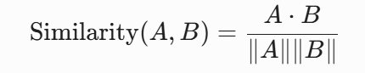
- Prompt Augmentation: The retrieved legal text is dynamically injected into a structured system prompt to form a bounded context:
Augmented Prompt = System Role + Retrieved Local Statutes + User Query
- Grounded Generation The enriched prompt is sent to Gemini Pro API. Bound strictly by the locally injected local ordinance, Gemini will produce an accurate, natural language explanation citing specific sections of Caloocan City Revenue Code.
This RAG workflow enables 24-hours instantaneous response to citizen queries while ensuring legal accuracy and preventing local government liability by misinforming citizens (Ratna et al., 2024; Reyes & Tan, 2023).

2.4.3 Data Analytics and Business Intelligence
Public sector financial management demands that raw transactional data needs to be enriched, aggregated, and summarized to become administrative analytics that are available to decision-makers. Querying an active transactional database with intensive analytical queries will hurt the performance, the transaction tables gets locked and the citizens waiting for their payments will face system timeout. So we design a rigid architecture for OLTP and OLAP engines to work separately (Ballard et al., 2022; Golfarelli & Rizzi, 2021).
OLTP Engine (Operational Layer)
The core of the transactional system OLTP system database should optimize to maximize read/writes with minimum latency with multiple users connected with strict ACID (Atomicity, Consistency, Isolation, Durability) to data consistency.
Atomicity: Ensures both tax payments and official receipt issuance either all commit as one fully completed transaction or none take place.
Consistency: Keeps account tax balances mathematically correct and in alignment with local taxing authority payment schedules.
Isolation: Stops user transactions that access the same account from clobbering the state in account ledgers.
Durability: Confirms recorded transactions cannot be lost when hardware/software failures occur.

OLAP Engine & Read-Replica Synchronization
In the analytical reporting layer the OLTP database is being replicated to a read only OLAP replica using asynchronous streaming replication. The analytical database schema is a denormalized star schema designed to easily accommodate rapid aggregation and grouping over time for millions of payment logs history. (Kimball & Ross, 2022).
Metabase Business Intelligence Integration
An embedded visual analytics platform at Caloocan City Treasurer’s Office Connected directly to our OLAP read-replica, Metabase brings our data beyond complex SQL queries and into easy to read executive dashboards that provide:
- Real-time Revenue Telemetry Visualised Auto-generating charts to break down daily, weekly and annual revenue streams across all types of tax (Property Tax, Business Tax, Market Rental,Regulatory Fees).
- Delinquency Tracking & Spatial Heatmaps Auto-detect any delinquent Properties or Business Accounts that have failed to meet established deadlines in order to facilitate enforcement and mail out of follow up notices.
- Performance Monitoring Benchmarked Comparative performance against the local Finance committee set budget targets on your actual revenue collections
The separation of these aspects ensures both swift processing of payments and provides real time insight that aids city officials in devising effective monetary strategies (Gonalves et al., 2023; Mendoza et al., 2024).

2.4.4 Polyglot Persistence
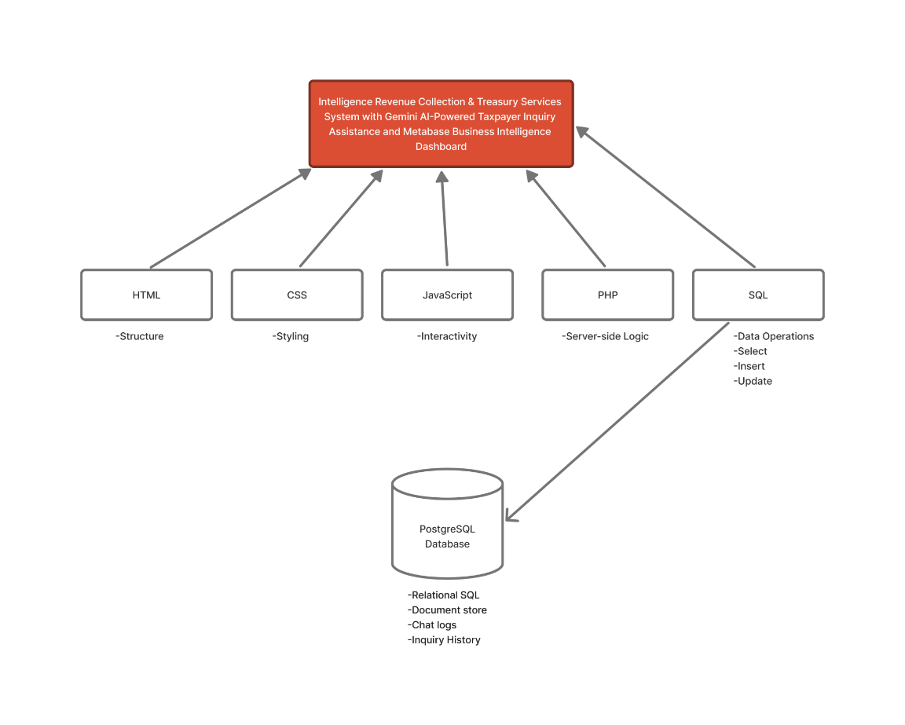
Figure 1. Polygot Persistent
As shown in the figure, five main technologies converge into the system, namely; HTML, CSS, JavaScript, PHP, and SQL, with each one contributing a distinct function that when combined, allows the platform to operate as a complete and functional system. HTML was used by the researchers to build the structure of the system's web pages. It was the base of the platform, the layout of the forms used for encoding taxpayer information, the tables used for displaying transaction records, and the dashboards used for monitoring treasury data. HTML and CSS was responsible for the styling of the system, and improve the overall visual presentation such as the arrangement of elements on the page, the fonts and colors used, and the responsiveness of the interface across different screen sizes, whether the system is accessed through a desktop computer or through a mobile device. Javascript handled the interactivity of the system. It allowed the system to validate the inputs encoded by users in real time, display notification and confirmation, such as submitting a payment and updating a record which made the system more responsive for both treasury personnel and taxpayers.
On the server side, which is PHP, served as the main programming language that carried out the business logic of the system. It processed the requests sent by users, applied the rules that governed how transactions such as real property tax payments, business tax and regulatory fee payments, and market stall rental billing, should be handled and checked user login credentials during authentication.
The system's interface was connected to its backend database using PHP and SQL for essential operations: selecting, inserting, updating, and deleting records. While Superbase with PostgreSQL managed taxpayers profile and chatbot interactions. Cloud solution simplified architecture, enhanced security, and integrated data for efficient management and reporting for the Business Intelligence dashboard for the Caloocan City Hall Treasurer.

2.4.5 Cybersecurity
Cybersecurity is still a main concern in the Philippine Government institutions as they handle a lot of sensitive information, including personal data, and financial information. Government offices in the Philippines have increasingly become targets of cyberattacks and data leaks in recent years, as more government services become available through digital platforms the risk of cyberattacks also continues to grow. A comparative study by Dacanay et al. (2024) examined that the Philippines is vulnerable to cyber attacks due to software piracy and lack of IT security. Based on the comparative study, the Philippines continues to fall behind other countries in terms of cybersecurity practices due to limited security measures and low awareness of the risks associated with cyber threats. In addition, data loss was identified as the biggest cybersecurity concern among organizations in the Philippines.
According to Rufino et al. (2025) who examined cybercrime victimization trends, specifically within Pangasinan over a five-year period and found that while overall victimization levels did not show a statistically significant change between 2020 and 2024, there remained a persistent gap between the intent to report cybercrime incidents and actual reporting behavior among victims. Their study recommended that local government units take a more active role in community level education and the establishment of clear, accessible mechanisms for reporting cyber related concerns.
Cybersecurity is essential in any system specifically in our sub-module which is Treasury Services & Revenue Collection. Without proper security measures, sensitive information can be stolen, altered or lost, resulting in financial, and reputation damage. As it protects data from various types of digital attacks, such as phishing, ransomware, malware and other cyber threats. The implementation of security measures such as data encryption, user authentication, and regular system updates helps reduce the risk of cyberattacks and unauthorized access. In addition, strong cybersecurity practices increase taxpayer confidence in the system by assuring them that their personal and sensitive information is protected. As a result, taxpayers are more willing to share their personal data and use the purpose system with trust and confidence.

2.4.6 Data Privacy
The system will handle sensitive personal and financial information belonging to taxpayers of Caloocan City, including full names, addresses, contact details, property records, business registration information, and payment history. Given the sensitivity of this data, the system will strictly implement the provisions of Republic Act No. 10173, otherwise known as the Data Privacy Act of 2012, which mandates the protection of personal information collected, processed, and stored by both government and private entities in the Philippines.
To comply with this law, the system will implement several safeguards. Access to taxpayer records will be restricted through role-based authentication, ensuring that only authorized personnel from the City Treasurer's Office can view or modify sensitive data. All data transmitted between the client interface and the PostgreSQL backend will be encrypted to prevent unauthorized interception, and stored data. This way, people who are not supposed to see this information cannot read it. Also, to lock it up when it is not used.
The system will also maintain audit trails that log user activity, allowing the office to monitor access and detect any irregular or unauthorized use of taxpayer information.
Besides, the integration of the Gemini AI-powered taxpayer inquiry assistant introduces a unique privacy consideration, since the chatbot may process natural language queries that contain personal details volunteered by the taxpayer. To address this, the display will be relevant information to the specific inquiry,
To address this, the system will be designed so that the AI assistant only retrieves and displays information relevant to the specific inquiry, and any conversation logs used for improving the assistant's performance. Similarly, the Metabase Business Intelligence dashboard will only present the summarized data to authorized staff for decision-making purposes, rather than exposing taxpayer-level records, in order to minimize the risk of data misuse.

2.4.7 Software Quality Standard
To ensure that the proposed Intelligent Revenue Collection and Treasury Services System meets acceptable levels of performance, reliability, and usability, the study will adopt the ISO/IEC 25010:2011 Software Product Quality Model as its guiding standard for evaluation. This international standard defines eight quality characteristics that will be used to assess the system both during development and in its final evaluation by end users.

Quality Characteristics | Description
Functional Suitability | The system must accurately perform the core functions required by the City Treasurer's Office, including real property tax collection, business tax and regulatory fee payment, market stall rental and billing, and AI-powered taxpayer inquiry assistance. Each function will be tested to confirm that it produces correct and complete results based on user requirements.
Performance Efficiency | The system should respond to user actions within an acceptable time frame, particularly during transaction periods such as tax deadline seasons. This includes evaluating page load times, query response times from the PostgreSQL backend, and the responsiveness of the Gemini AI chatbot when answering taxpayer inquiries.
Compatibility | The system must be able to coexist and interact with other software components, such as the Metabase Business Intelligence dashboard and existing digital payment gateways, without causing conflicts or requiring significant modification to either system.
Usability | Since the system will be used by both taxpayers with varying levels of digital literacy and City Hall personnel, the interface must be intuitive, easy to navigate, and accessible. This will be evaluated through user acceptance testing and feedback from actual staff and taxpayer respondents.
Reliability | The system must be able to maintain a specified level of performance under stated conditions, including the ability to recover quickly from unexpected errors or interruptions without loss of transaction data. This is especially critical given the financial nature of the records being processed.
Security | Given the sensitive taxpayer information involved, the system must protect data from unauthorized access, in line with the Data Privacy Act of 2012. This includes authentication mechanisms, encryption, and audit logging, as discussed in the data privacy section of this study.
Maintainability | The system should be structured in a way that allows future developers or IT staff of Caloocan City Hall to modify, update, or troubleshoot the system with minimal effort, particularly as tax regulations or reporting requirements change over time.
Portability | The system should be adaptable to different environments or infrastructure with minimal adjustment, which is particularly relevant should the City Treasurer's Office decide to migrate hosting environments or scale the system to accommodate more departments in the future.

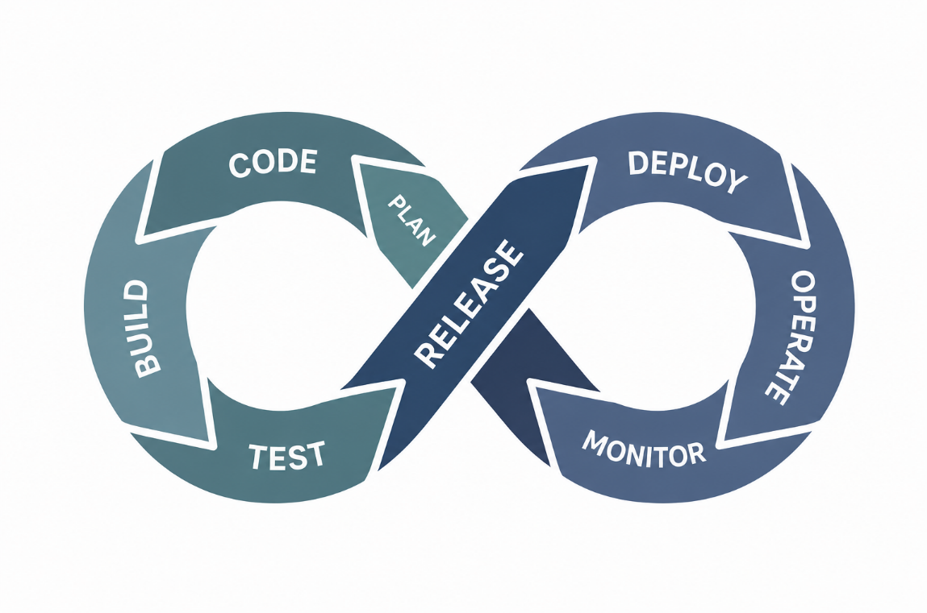
2.5 DevOps Culture and CI/CD Practices
The proposed DevOps lifecycle is based on a continuous CI/CD workflow Plan, Code, Build, Test, Release, Deploy, Operate and Monitor. CI/CD integration aids automation, continuous feedback, automated testing and improved efficiency in the software development and delivery process (Chandrashekar, 2023). They assist development teams in avoiding repetitive manual tasks and maintaining a more consistent and reliable workflow. Similarly, Ugwueze and Chukwunweike (2024) found that continuous integration and deployment allows for frequent code integration, early error detection, automated testing, reliable deployments, and ongoing monitoring. This means problems can be detected and fixed much earlier, before they affect the system materially. The proposed system's DevOps lifecycle in this study is a structured and continuous workflow of development, testing, validation, deployment and maintenance. The monitoring and feedback activities also allow the development team to assess the system performance, identify areas for improvement and implement the changes in the next development activities. Therefore, the integration of DevOps and CI/CD techniques creates a more effective, dependable and sustainable way of system development and delivery

2.6 Enterprise Architecture and System Integration
Enterprise Architecture (EA) provides an organized approach to processes, information, applications and technologies of an organization. For local governments, it can contribute to the proper alignment of the information technology with the needs and objectives of the organization. Gallegos-Baeza et al. (2023) identified that EA can help local governments to establish a proper alignment of business strategies with the information technologies while supporting the interoperability. This concept provides a basis to develop government systems with need to coordinate services and technological components. Its adoption in the government is also related with the creation of public value. Sundberg et al. (2023) have studied the EA adoption by the government and focused on the relationship with information technology’s contribution to government activities and their public services. Instead of just seeing EA from a technical architecture perspective, their work considers the contribution of EA to organizational goals and to stakeholders. This perspective applies to the proposed system as its purpose is to improve both the treasury operations and taxpayer services available. Mahendra et al. (2024) reviewed the enterprise architecture literature for E-government applications and discussed their application in application development, architectural planning, and government information integration. Their findings suggest that EA can coordinate the government applications and solve the data integration problems. For the proposed system, this would support the need for an organized structure to coordinate taxpayer information, revenue transactions, payment records and treasury-related information.
System integration becomes important when multiple functions rely on shared information. In the proposed system, the Real Property Tax Collection System, Business Tax and Regulatory Fee Payment, Market Stall Rental and Billing, and Treasury Dashboard and Reports are planned to operate as an integrated component. They can enable the use of information generated by one process by another appropriate process, reducing the need of maintaining completely separate records. However, Abubakar (2023) showed the use of technology in local government revenue collection using the Automated Revenue Collector App (ARCA). The study was on the automation of revenue collection activities, management of revenue payers' information and generation of reports for some selected local government areas. The application shows how digital systems can be used to organize revenue-related activities and reduce reliance on traditional collection procedures. This strengthens the proposed system on improving the management of local revenue and treasury transactions through a digital platform.
Digitalization is also applicable to specific tax administration activities. The research of Mandiri et al. (2024) shows that digitalization in the administration of land and building tax can enhance the administration of local taxes . This finding is specifically on the Real Property Tax Collection module of the proposed system which is intended to assist in the management of property tax information and related collection activities. The study shows that digital approaches can be applied to local tax administration to improve the handling of tax-related information and transactions. Another technological element that can be integrated into government information systems is Artificial Intelligence. Mukherjee (2022) proposed a framework of AI-based Smart Government Enterprise Architecture for the incorporation of Artificial Intelligence in the government architecture. The framework shows how standard artificial intelligence can be embedded into the government environments to support the organizational processes and decision-making. This provides a basis for including Gemini AI-powered taxpayer inquiry assistance in the proposed system as a supporting service within the overall government platform.
Rahman et al. (2024) have analyzed the application of AI in taxation and discussed the potential of AI for tax compliance, fraud detection, and revenue collection. Their study shows that AI techniques can be used in different areas of tax administration and can contribute to improving the efficiency of activities related to revenue collection. The proposed system will utilize Gemini AI to assist with the taxpayer’s inquiries so that taxpayers will be able to receive information through an automated service while revenue transactions will be processed through the system’s authorized processes.

2.7 Conceptual Framework
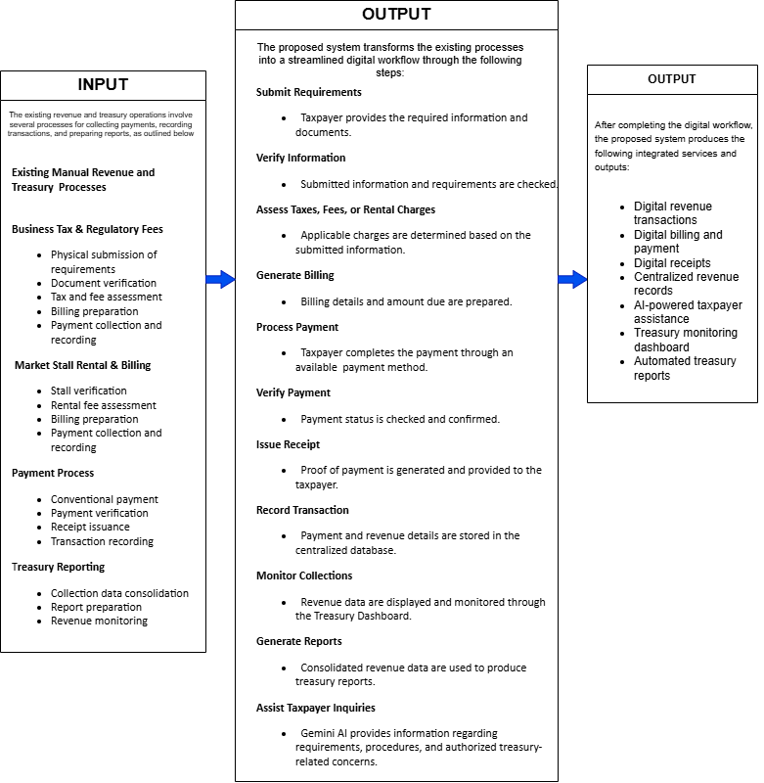 Figure 2. Conceptual framework
The framework illustrates the connection between the existing revenue and treasury processes, the steps for creating and implementing the proposed system, and the study's results. It emphasizes how current practices will be used to build the proposed digital system and the advantages it will provide
The Input component includes the existing revenue collection and treasury procedures, which will serve as the foundation for the proposed system. This involves submitting and verifying requirements, assessing taxes, fees, and levies, generating bills, collecting payments, recording, and reporting on revenue and treasury within the current manual system. Likewise, the current market stall rental and billing process, payment verification, receipt issuance, collection data consolidation, and revenue monitoring are activities that will be incorporated into the proposed system. The existing process will serve as the foundation for identifying requirements, current procedures, and areas needing improvement.

The Process component covers the actions taken in the study to transform the current manual procedures into the proposed digital system. This includes manually submitting and verifying taxpayer information, assessing taxes, fees, and rentals, generating bills, collecting payments, verifying, issuing receipts, recording, and reporting revenue and treasury. Similarly, the process involves consolidating revenue data for analysis, monitoring, and reporting on revenue status through the Treasury Dashboard, and providing taxpayer inquiry support through Gemini AI-powered assistant. Thus, the process component will consist of the activities performed in developing the integrated digital revenue and treasury services.

The Output component represents the final outcome of the study, which is the Integrated Digital Revenue and Treasury Services. The outputs contain digital revenue transactions, digital bill generation and payment, digital receipts, centralized Gemini AI-powered taxpayer inquiry assistance, treasury monitoring, and automated reports. The output will be the benefits of the new system by offering an organized approach to managing and monitoring revenue, providing centralized taxpayer services, and automating the transfer of taxpayer transaction data to relevant agencies.

The conceptual framework demonstrates that the current revenue and treasury procedures will serve as input for developing an integrated digital system, leading to benefits such as centralized taxpayer services, an organized method of revenue management, and automated delivery of taxpayer transaction data to relevant agencies. This framework can be utilized to build a system that will address the deficiencies of the current revenue and treasury procedures.

2.8 Theoretical Paradigm
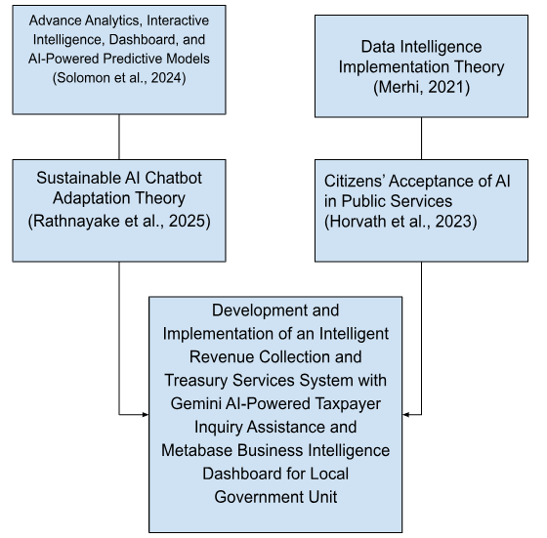
Figure 3. Theoretical Paradigm
The figure provides the theoretical framework of the study. It shows that the proposed Development and Implementation of an Intelligent Revenue Collection and Treasury Services System with Gemini AI-Powered Taxpayer Inquiry Assistance and Metabase Business Intelligence Dashboard for Local Government Unit has four theoretical basis. Solomon et al. (2024) book Advanced Analytics, Interactive Intelligence Dashboards and AI-Powered Predictive Models recommends using business intelligence, artificial intelligence and advanced analytics in order to improve operational performance and decision-making. According to Merhi (2021) in his Data Intelligence Implementation Theory, the significance of technology, business intelligence and data quality to improve operational efficiency, transparency and evidence-based decision making. In the paper “The Citizen’s Acceptance of Artificial Intelligence in Public Services,” Horvath et al. (2023) stated that the acceptance of AI by citizens in the government sector is dependent on public trust, fairness, transparency and service efficiency. Sustainable AI Chatbot Adoption Theory (Rathnayake et al., 2025) suggests that trustworthy, reliable and transparent AI chatbots boost users’ adoption of digital government services. The theoretical bases assist in the development and implementation of the proposed system through the integration of Google Gemini AI to help the taxpayer in their inquiry and the Metabase Business Intelligence Dashboard to monitor and report revenue and enable the Local Government Unit to make an informed decision.

