MediSync:
SMART HOSPITAL MANAGEMENT

A PROJECT REPORT

Submitted by
GODWIN K BENNY (SHR24CS138)
JOSEPH T JENNY (SHR24CS167)
GAUTHAM K G (SHR24CS133)
GAUTHAM K ANIL (SHR24CS132)
to

the APJ Abdul Kalam Technological University
in partial fulfillment of the requirements for the award of the Degree

of
Bachelor of Technology in
Computer Science and Engineering



Department of Computer Science and Engineering
SAHRDAYA COLLEGE OF ENGINEERING AND TECHNOLOGY (AUTONOMOUS)
KODAKARA, THRISSUR - 680684
March 2026
DECLARATION

We, undersigned, hereby declare that the project report “MediSync : Smart Hospital Management ”, submitted for partial fulfillment of the requirements for the award of degree of Bachelor of Technology in Computer Science and Engineering of the APJ Abdul Kalam Technological University, Kerala is a bonafide work done by us under the guidance of
Mr . Nikhil Narayanan , Department of Computer Science Engineering.

This submission represents our own work and ideas, and wherever the ideas or words of others have been used, we have duly acknowledged and cited the original sources. We affirm that we have maintained academic honesty and integrity throughout this work and have not misrepresented or fabricated any data, ideas, or references in this report.

We further declare that this project report has not been submitted previously, in part or full, for the award of any degree, diploma, or any other title from any university or institution.

GODWIN K BENNY (SHR24CS138)
JOSEPH T JENNY (SHR24CS167)
GAUTHAM K G (SHR24CS133)
GAUTHAM K ANIL (SHR24CS132)

Kodakara
26-03-2026
DEPARTMENT OF COMPUTER SCIENCE ENGINEERING SAHRDAYA COLLEGE OF ENGINEERING AND TECHNOLOGY (AUTONOMOUS),
KODAKARA, THRISSUR



BONAFIDE CERTIFICATE

This is to certify that the project report entitled “ MEDISYNC : SMART HOSPITAL MANAGEMENT SYSTEM ” submitted by GODWIN K BENNY (SHR24CS138), JOSEPH T JENNY (SHR24CS167) , GAUTHAM K ANIL (SHR24CS132) , GAUTHAM K G (SHR24CS133) to the APJ Abdul Kalam Technlogical University in partial fulfillment of the requirements for the award of the Degree of Bachelor of Technology in Computer Science and Engineering is a bonafide record of the project work carried out by them under our guidance and supervision. This report in any form has not been submitted to any other University or Institute for any other purpose.

GUIDE PROJECT COORDINATOR
Mr . Nikhil Narayanan Ms. Anugraha K R
Assistant Professor Assistant Professor

HEAD OF THE DEPARTMENT
Dr. Manishankar S
Associate Professor

Kodakara
26-03-2026

ACKNOWLEDGMENT
We would like to express our immense gratitude and profound thanks to all those who helped us to make this project a great success. We express our gratitude to the almighty God for all the blessings endowed on us.

We express our sincere thanks to our Executive Director Rev. Fr. Dr. Anto Chungath and Principal Dr. Ramkumar S for providing us with such a great opportunity.

We also convey our gratitude to our Head of the Department Dr. Manishankar S for having given us a constant inspiration and suggestion. We extend our deep sense of gratitude to our project coordinator Ms. Anugraha K R, Assistant Professor of Computer Science & Engineering Department for providing enlightening guidance through the project. We can hardly find words to express our deep appreciation for the help and warm encouragement that we have received from our project guide Mr . Nikhil Narayanan, Assistant Professor of Computer Science & Engineering Department for his whole-hearted support.

It was their encouragement that helped us to complete the project. We can hardly find words to express our deep appreciation of the help and warm encouragement that we received from our parents. We are extremely thankful and indebted to our friends who supported us in all aspects of the project work.

GODWIN K BENNY
JOSEPH T JENNY
GAUTHAM K G
GAUTHAM K ANIL

INSTITUTIONAL VISION

Evolve as a leading technology institute to create high caliber leaders and innovators of global standing with strong ethical values to serve the industry and society.

INSTITUTIONAL MISSION

Provide quality technical education that transforms students to be knowledgeable, skilled, innovative and entrepreneurial professionals. Collaborate with academia and industry around the globe, to strengthen the education and research ecosystem. Practice and promote high standards of professional ethics, good discipline, high integrity and social accountability with a passion for holistic excellence.

QUALITY POLICY

We at Sahrdaya are committed to provide Quality Technical Education through continual improvement and by inculcating Moral & Ethical values to mould into Vibrant Engineers with high Professional Standards.

We impart the best education through the support of competent & dedicated faculties, ex- cellent infrastructure and collaboration with industries to create ambience of excellence.
DEPARTMENTAL VISION
To be a nationally recognized centre for quality education and research in diverse areas of computer science engineering with a strong social commitment.

DEPARTMENT MISSION
- Impart relevant technical knowledge, skills and attributes along with values and ethics.
- Enhance creativity and quality in research through project based learning envi- ronment.
- Mould Computer Science Engineering Professionals in synchronization with the dynamic industry requirements.
- Inculcate essential leadership qualities coupled with commitment to the society.

PROGRAMME EDUCATIONAL OBJECTIVES (PEOS)

PEO1 | Take up challenging careers in suitable corporate, business or educational  sectors across the world, in multi-cultural work environment.
PEO2 | Continuously strive for higher achievements in life keeping moral and  ethical values such as honesty , loyalty, good relationship and best perfor- mance, aloft.
PEO3 | Be knowledgeable and responsible citizens with good team-work skills,  competent leadership qualities and holistic values.

PROGRAMME SPECIFIC OBJECTIVES (PSOS)

PSO1 | To mould students to understand, analyze and develop computer  technologies in the areas such as algorithms, system software, mul-  timedia, web design, big data analytics and networking for efficient  design of computer-based systems of varying complexity..
PSO2 | To enhance knowledge in the evolutionary changes in computing  and apply standard practices and strategies in software project de-  velopment using open-ended programming environments in order  to deliver a quality product for business success and meet the future  challenges.
PSO3 | To enable students to employ modern computer languages, environ-  ments, and platforms for creating innovative career paths to be an  entrepreneur with social accountability.

PROGRAMME OUTCOMES (POS)

PO1 | Engineering Knowledge: Apply knowledge of mathematics, natural science, computing, engineering fundamentals and an engineering specialization as specified in WK1 to WK4 respectively to develop to the solution of complex engineering problems.
PO2 | Problem Analysis: Identify, formulate, review research literature and analyze complex engineering problems reaching substantiated conclusions with consideration for sustainable development. (WK1 to WK4)
PO3 | Design/Development of Solutions: Design creative solutions for complex engineering problems and design/develop systems/components/processes to meet identified needs with consideration for the public health and safety, whole-life cost, net zero carbon, culture, society and environment as required. (WK5)

PO4 | Conduct investigations of complex problems: Conduct investigations of complex engineering problems using research-based knowledge including design of experiments, modelling, analysis and interpretation of data to provide valid conclusions. (WK8).
PO5 | Engineering Tool Usage: Create, select and apply appropriate techniques, resources and modern engineering and IT tools, including prediction and modelling recognizing their limitations to solve complex engineering problems. (WK2 and WK6).
PO6 | The Engineer and The World: Analyze and evaluate societal and environmental aspects while solving complex engineering problems for its impact on sustainability with reference to economy, health, safety, legal framework, culture and environment. (WK1, WK5, and WK7).
PO7 | Ethics: Apply ethical principles and commit to professional ethics human values, diversity and inclusion; adhere to national and international laws. (WK9)
PO8 | Individual and Collaborative Team work: Function effectively as an individual, and as a member or leader in diverse/multi-disciplinary teams.
PO9 | Communication: Communicate effectively and inclusively within the engineering community and society at large, such as being able to comprehend and write effective reports and design documentation, make effective presentations considering cultural, language, and learning differences
PO10 | Project Management and Finance: Apply knowledge and understanding of engineering management principles and economic decision-making and apply these to one's own work, as a member and leader in a team, and to manage projects and in multidisciplinary environments.
PO11 | Life-Long Learning: Recognize the need for, and have the preparation and ability for i) independent and life-long learning ii) adaptability to new and emerging technologies and iii) critical thinking in the broadest context of technological change. (WK8)

COURSE OBJECTIVE

To develop skills in conducting literature surveys, technical presentations, and report preparation.

COURSE OUTCOMES

CO1 | Define fundamental concepts of DBMS and apply the Entity-Relationship (ER) model in real-world data modeling scenarios. [Apply]
CO2 | Formulate and query relational databases using relational algebra, relational calculus, and SQL. [Apply]
CO3 | Apply normalization techniques to design efficient and anomaly-free relational schemas. [Apply]
CO4 | Analyze transaction processing concepts, concurrency control, recovery mechanisms, CO4 and file organization techniques. [Analyze]

MAPPING TO SUSTAINABLE DEVELOPMENT GOALS (SDGS)

SDG | Relevance To Project | Evidence & Justification in Implementation
SDG 3: Good Health and Well-being | The project enhances healthcare service delivery by digitizing hospital operations, reducing patient waiting time, and improving access to medical records. It replaces manual processes with an efficient system that ensures timely treatment, better coordination among healthcare staff, and improved patient care quality. | The MediSync Hospital Management System ensures efficient healthcare management by implementing a centralized digital platform using a structured database and modular backend architecture. Patient records, appointments, and medical histories are stored securely and can be accessed instantly, enabling faster diagnosis and treatment. The system includes features such as online appointment scheduling, automated patient record management, and real-time updates, which significantly reduce delays and administrative workload. Additionally, secure authentication mechanisms protect sensitive patient data, ensuring privacy and compliance with healthcare standards. By improving operational efficiency and accessibility of healthcare services, the system contributes directly to better health outcomes and overall well-being.

ABSTRACT

In many healthcare institutions, the management of patient records, appointments, billing, and inventory remains fragmented and largely dependent on paper-based systems. These traditional methods lead to inefficiencies, delays in service delivery, data redundancy, and limited transparency. As a result, healthcare professionals often struggle to access accurate, real-time information, which can negatively impact the quality of patient care.
To overcome these challenges, the proposed system, MediSync: Hospital Management System, introduces a centralized, digital, and user-friendly platform designed to streamline hospital operations. The system integrates key functionalities such as patient record management, intelligent appointment scheduling, digital prescriptions, automated billing, and inventory tracking into a unified solution. It also incorporates role-based access control, ensuring that administrators, doctors, and patients can securely access relevant information based on their roles.
MediSync is developed using modern technologies, including React with Vite for the frontend, Tailwind CSS for responsive and intuitive user interfaces, and Django with SQLite for backend processing and database management. Secure authentication is implemented using JSON Web Tokens (JWT), ensuring safe and reliable system access.
Additionally, the system supports real-time updates and efficient data handling, enabling seamless communication among stakeholders. By reducing manual workload, minimizing errors, and improving data accessibility, MediSync enhances operational efficiency and patient satisfaction. This project emphasizes the importance of digital transformation in healthcare and demonstrates how technology can be leveraged to develop scalable, secure, and efficient hospital management systems aligned with improved health outcomes.

CONTENTS

ACKNOWLEDGMENT
INSTITUTIONAL VISION, MISSION AND QUALITY POLICY
DEPARTMENTAL VISION, MISSION, PEOs, PO AND PSOs
ABSTRACT
1. INTRODUCTION
1.1 INTRODUCTION
1.2 GENERAL BACKGROUND
1.3 PROBLEM DEFINITION
1.4 MOTIVATION
1.5 OBJECTIVES
2. LITERATURE SURVEY
2.1 LITERATURE SURVEY
3. PROPOSED SYSTEM
3.1 PROPOSED SYSTEM
3.1.1 SYSTEM OVERVIEW
3.1.2 KEY MODULES
3.1.3 DATA FLOW
3.1.4 FUNCTIONAL REQUIREMENTS
3.1.5 NON-FUNCTIONAL REQUIREMENTS
3.1.6 ADAVANTAGES OF THE PROPOSED SYSTEM
4. DESIGN PHASE
4.1 SYSTEM ARCHITECTURE
4.2 MODULE DESIGN
4.3 DATABASE DESIGN
4.4 SECURITY DESIGN
5. DESIGN DIAGRAMS
5.1 SYSTEM ARCHITECTURE DIAGRAM
5.2 USE CASE DIAGRAM
5.3 ER DIAGRAM
5.4 SEQUENCE DIAGRAMS
6. REQUIREMENTS
6.1 HARDWARE REQUIREMENTS
6.2 SOFTWARE REQUIREMENTS
7. IMPLEMENTATION
7.1 PROJECT STRUCTURE
7.2 KEY IMPLEMENTATION DETAILS
7.3 ERROR HANDLING
7.4 TESTING STRATEGY
8. RESULTS AND DISCUSSION
9. CONCLUSION
9.1 CONCLUSION
9.2 FUTURE SCOPE
REFERENCES
APPENDICES

CHAPTER 1 INTRODUCTION

INTRODUCTION

The healthcare sector plays a vital role in society; however, many hospitals still rely on fragmented and paper-based systems for managing patient records, appointments, billing, and inventory. This often leads to inefficiencies, delays in service delivery, data redundancy, and lack of proper coordination among different departments. The absence of a centralized system makes it difficult to access real-time information, affecting both administrative efficiency and patient care quality.
Traditional methods of hospital management involve manual data entry, physical record maintenance, and disconnected software tools. These approaches are time-consuming, errorprone, and lack transparency. Patients face long waiting times, misplaced records, and poor communication, while hospital staff struggle with managing large volumes of data efficiently.
To address these challenges, this project proposes MediSync: Hospital Management System, a digital platform designed to streamline hospital operations through automation and centralization. The system enables efficient management of patient records, appointment scheduling, digital prescriptions, billing, and inventory tracking.
Developed using React, Vite, and Tailwind CSS for the frontend, and Django with SQLite for backend operations, the system ensures fast performance and scalability. Secure authentication is implemented using JSON Web Tokens (JWT), ensuring safe access to the system. MediSync aims to enhance healthcare delivery by improving efficiency, transparency, and coordination among all stakeholders.

GENERAL BACKGROUND
Efficient hospital management is essential for delivering quality healthcare services. Hospitals deal with multiple operations simultaneously, including patient registration, diagnosis, treatment, billing, and inventory management. Traditionally, these processes have been handled manually or through separate systems, leading to poor coordination and inefficiency.
Manual systems suffer from several limitations such as data duplication, difficulty in accessing records, lack of real-time updates, and increased chances of human error. Additionally, there is often no proper mechanism to track patient history, monitor appointments, or manage hospital resources effectively.
With advancements in technology, there is a growing need to adopt digital solutions in healthcare management. A centralized system can integrate all hospital operations into a single platform, enabling seamless communication between administrators, doctors, and patients. Such systems improve efficiency, reduce workload, and enhance the overall quality of service.
MediSync is developed to address these challenges by providing a unified platform for hospital management. It ensures that all operations are streamlined, data is securely stored, and users can access relevant information in real time. This contributes to improved decisionmaking, better patient care, and

PROBLEM DEFINITION

The lack of an integrated and efficient hospital management system leads to several operational challenges, including poor data management, delayed services, and lack of coordination among departments. Hospitals often rely on manual or semi-digital systems, which result in data inconsistencies, duplication, and difficulty in retrieving patient information.
Patients face issues such as long waiting times, appointment conflicts, and lack of transparency in billing and treatment processes. Similarly, hospital staff struggle with maintaining records, managing schedules, and ensuring smooth communication across departments.
Existing systems, if any, are often not fully integrated and fail to provide real-time updates or secure access control. Therefore, there is a need for a comprehensive digital solution that can efficiently manage hospital operations, ensure data security, and improve overall service delivery

MOTIVATION

The motivation behind developing MediSync arises from the need to overcome inefficiencies in traditional hospital management systems. The increasing demand for quality healthcare services requires a system that can handle large volumes of data efficiently while ensuring accuracy and security.
Manual processes and fragmented systems often lead to delays, errors, and poor patient experiences. There is a lack of transparency and accountability, which affects both patients and healthcare providers. Additionally, the absence of real-time data access limits the ability of hospitals to make informed decisions.
With the rapid advancement of web technologies, it has become possible to develop scalable and efficient systems that can transform healthcare management. MediSync aims to leverage these technologies to create a centralized platform that simplifies operations, improves communication, and enhances patient satisfaction.
The project is driven by the goal of digital transformation in healthcare, ensuring better resource management, reduced workload, and improved service quality.

  - OBJECTIVES
The objectives of this work are:
- To design and develop a centralized hospital management system for efficient handling of medical and administrative operations.
- To implement role-based access control for secure and controlled data access.
- To enable smart appointment scheduling to reduce waiting time and avoid conflicts.
- To provide digital prescription management for improved accuracy and record keeping.
- To automate billing processes for transparency and efficiency.
- To manage hospital inventory effectively with real-time tracking.
- To ensure secure authentication and data protection using JWT-based security mechanisms.
- To improve overall hospital efficiency, patient satisfaction, and service quality through digitalization.

CHAPTER 2 LITERATURE SURVEY
  - LITERATURE SURVEY

A review of existing hospital management systems highlights the growing importance of digital solutions in improving healthcare efficiency and patient care [1].
- Hospital Management Systems: Many hospitals use digital platforms for managing patient records and billing. While these systems improve data storage, they often lack full integration and user-friendly interfaces [4].
- Electronic Health Records (EHR): EHR systems provide centralized storage of patient medical histories, enabling better diagnosis and treatment. However, challenges such as data security, interoperability, and high implementation costs remain significant [1].
- Web-Based Applications: Modern web-based systems support appointment booking and communication between patients and doctors, but often lack integrated modules for billing and inventory management [4].
- Workflow Automation: Automation of hospital workflows such as appointment scheduling, prescription management, and billing significantly reduces manual errors and improves efficiency [5].
- Security and Access Control: Role-based access control (RBAC) and secure authentication mechanisms such as JSON Web Tokens (JWT) are essential for protecting sensitive healthcare data [2][3].
- User Interface and Experience: Modern systems focus on user-friendly interfaces to improve accessibility and usability for both patients and healthcare professionals [4].
- Identified Gaps: Despite advancements, many existing systems lack full integration of hospital operations into a single platform. Common limitations include poor user experience, lack of real-time updates, insufficient security measures, and limited scalability [1][5].
The proposed MediSync Hospital Management System addresses these gaps by providing a centralized, secure, and user-friendly platform with role-based access control and efficient workflow management.

CHAPTER 3 PROPOSED SYSTEM
  - PROPOSED SYSTEM

The proposed MediSync: Hospital Management System is a web-based application developed using React, Vite, and Tailwind CSS for the frontend, and Django with SQLite for backend operations. The system aims to provide a secure, efficient, and centralized platform to manage hospital activities such as patient records, appointments, prescriptions, billing, and inventory.
    - SYSTEM OVERVIEW

The system supports three primary user roles:
- Administrator: Manages doctors, patients, appointments, billing, and inventory. Has full control over the system.
- Doctor: Views assigned patients, manages appointments, and generates digital prescriptions.
- Patient: Registers, books appointments, views prescriptions, and tracks medical history

    - KEY MODULES

- User Management: Secure registration, login, and role-based access using JWT authentication.
- Appointment Management: Smart scheduling system to book, update, and manage appointments without conflicts.
- Prescription Management: Doctors can create and store digital prescriptions for patients.
- Billing System: Automated billing with accurate calculation and record maintenance.
- Inventory Management: Tracks medicine stock and updates availability in real time.

    - DATA FLOW

      - A user (admin, doctor, or patient) registers and logs in securely.
      - Patients book appointments through the system.
      - Doctors view appointments and provide consultation with digital prescriptions.
      - Billing is automatically generated based on services provided.
      - Inventory is updated according to medicine usage.
      - All data is stored securely and can be accessed based on user roles.
    - FUNCTIONAL REQUIREMENTS

- FR1: Secure user registration and login using JWT authentication.
- FR2: Role-based access control for admin, doctor, and patient.
- FR3: Appointment scheduling and management.
- FR4: Digital prescription generation and storage.
- FR5: Automated billing system.
- FR6: Inventory tracking and management.

    - NON FUNCTIONAL REQUIREMENTS

- NFR1: Usability — simple and responsive user interface using Tailwind CSS.
- NFR2: Reliability — consistent data storage using SQLite database.
- NFR3: Performance — fast response time with optimized frontend and backend
- NFR4: Security — JWT authentication, input validation, and secure API handling.
- NFR5: Scalability — modular architecture for future enhancements.

    - ADAVANTAGES OF THE PROPOSED SYSTEM

- Reduces manual work and paperwork in hospitals.
- Improves efficiency and coordination among staff.
- Ensures secure and accurate data management.
- Enhances patient experience through faster services.
- Provides a scalable and modern healthcare solution

CHAPTER 4 DESIGN PHASE

SYSTEM ARCHITECTURE

MediSync follows a client-server architecture that separates the frontend and backend for better scalability and maintainability.
- The frontend is developed using React (Vite) and Tailwind CSS, providing a responsive and user-friendly interface.
- The backend is built using Django and Django REST Framework, which handles business logic, API services, and data processing.
- The database layer uses SQLite to store and manage structured data efficiently.
This modular architecture ensures that each component can be developed, tested, and maintained independently.
  - MODULE DESIGN
The system is divided into several functional modules to ensure efficient operation:
- Patient Management Module: Handles patient registration, medical history, and record updates.
- Appointment Scheduling Module: Allows patients to book, reschedule, or cancel appointments.
- Doctor Management Module: Manages doctor profiles, availability, and consultation details.
- Billing and Payment Module: Automates billing and generates invoices.
- Inventory Management Module: Tracks medicines, equipment, and stock levels.
- Authentication and Authorization Module: Provides secure login using JWT and role-based access control.
Each module is designed to function independently while maintaining smooth integration with other modules.

  - DATABASE DESIGN
The database is designed using a relational model to ensure data consistency and efficient data management. The key aspects include:
- Stores structured data for entities such as Patients, Doctors, Appointments, Prescriptions, Bills, and Inventory.
- Uses primary keys to uniquely identify each record in a table.
- Uses foreign keys to establish relationships between different entities.
- Reduces data redundancy through proper normalization techniques.
- Ensures data integrity and consistency across all operations.
- Enables efficient data retrieval using optimized queries.
- Supports easy updates, insertions, and deletions of records.

  - SECURITY DESIGN
Security is a critical component of the MediSync system to protect sensitive healthcare data. The system includes:
- Implements JWT (JSON Web Token) authentication for secure user login and session management.
- Uses role-based access control to restrict access based on user roles (admin, doctor, patient).
- Protects sensitive data through encryption techniques.
- Ensures secure communication between frontend and backend.
- Prevents unauthorized access to system functionalities and patient records.
- Maintains data privacy and confidentiality.
- Enhances overall system reliability and trust.

CHAPTER 5 DESIGN DIAGRAMS

SYSTEM ARCHITECTURE DIAGRAM
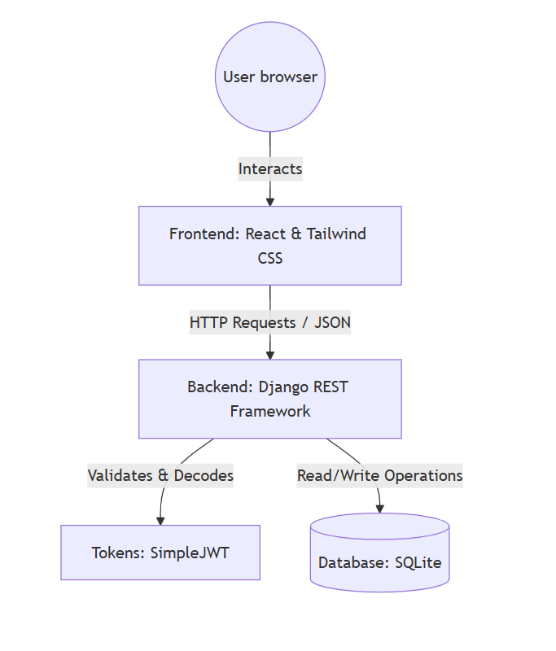
(Fig 5.1 system architecture diagram)
The system architecture diagram represents the overall structure of the MediSync Hospital Management System. It follows a three-tier client-server architecture consisting of the frontend, backend, and database layers.
  - The user interacts with the system through a web browser, which communicates with the developed using React and Tailwind CSS. The frontend provides a responsive and user-friendly interface for patients, doctors, and administrators. It sends HTTP requests in JSON format to the backend.
  - The backend is implemented using Django REST Framework, which handles business logic, request processing, and API management. It also manages authentication using JSON Web Tokens (JWT), ensuring secure access to the system.
  - The backend communicates with the SQLite database to perform read and write operations. The database stores all essential data such as patient records, appointments, prescriptions, and billing frontend information.
Overall, the architecture ensures efficient data flow, scalability, and secure communication between different system components.

  - USE CASE DIAGRAM
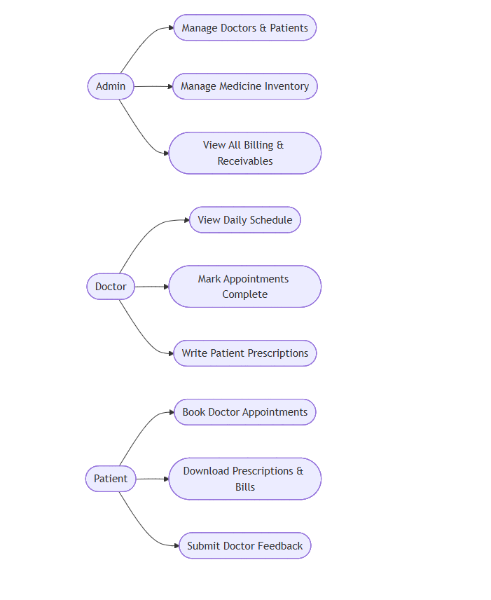
(Fig 5.2 use case diagram)

The use case diagram illustrates the interaction between different users and the MediSync system, highlighting the functionalities available to each role.
There are three main actors in the system: Admin, Doctor, and Patient.
- The Admin is responsible for managing doctors and patients, maintaining medicine inventory, and viewing billing and receivables. This ensures smooth administrative operations within the hospital.
- The Doctor can view daily schedules, mark appointments as completed, and write prescriptions for patients. These functionalities support efficient medical consultation and treatment.
- The Patient can book doctor appointments, download prescriptions and bills, and submit feedback for doctors. This enhances patient engagement and improves overall healthcare service delivery.
The use case diagram clearly defines system functionalities and user responsibilities, ensuring proper role-based access and system usability.

  - ER DIAGRAM
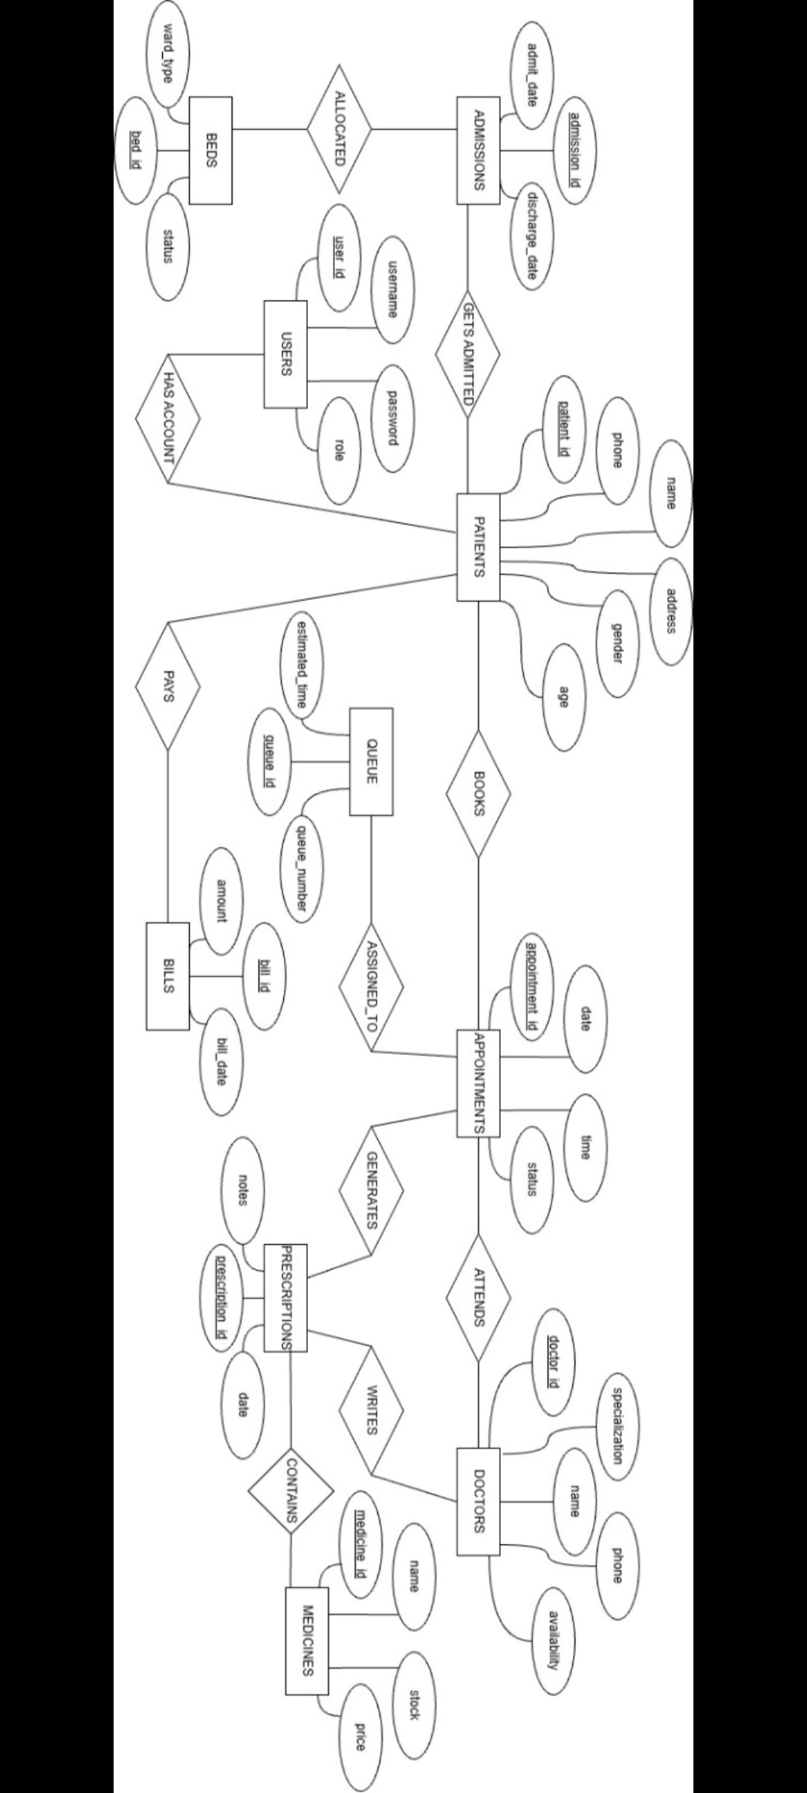
(Fig 5.3 ER diagram)
The Entity Relationship (ER) diagram of the MediSync Hospital Management System represents the logical structure of the database by illustrating the entities, their attributes, and the relationships between them. It provides a clear understanding of how data is organized, interconnected, and managed within the system.
- The core foundation of the system is the Users entity, which manages secure login credentials, including user ID, username, password, and role. This enables Role-Based Access Control (RBAC), ensuring that patients, doctors, and administrators can access only the functionalities permitted to them.
- The Patients and Doctors entities are associated with the Users entity, storing essential personal and professional details. The Patients entity includes attributes such as patient ID, name, age, gender, phone number, and address. The Doctors entity stores doctor ID, name, specialization, phone number, and availability.
- The Appointments entity plays a central role in the system by managing scheduling information such as appointment ID, date, time, and status. A patient can book multiple appointments, and each appointment is attended by a specific doctor, establishing a one-to-many relationship.
- To improve patient flow management, each appointment is associated with a Queue entity, which maintains queue number and estimated waiting time. This helps in optimizing hospital operations and reducing waiting time.
- The Prescriptions entity stores medical details such as prescription ID, date, and notes. Each prescription is generated based on an appointment and written by a doctor. Since multiple medicines can be prescribed, a many-to-many relationship exists between Prescriptions and Medicines.
- The Medicines entity manages pharmacy-related data, including medicine ID, name, price, and stock levels, ensuring proper inventory control.
- The financial operations are handled by the Bills entity, which records bill ID, amount, and billing date. Patients make payments for the services received, and this information is maintained for tracking and reporting purposes.
Overall, the ER diagram effectively models a real-world hospital management system by ensuring proper data organization, minimizing redundancy, and maintaining data integrity across all system components.
  - SEQUENCE DIAGRAM
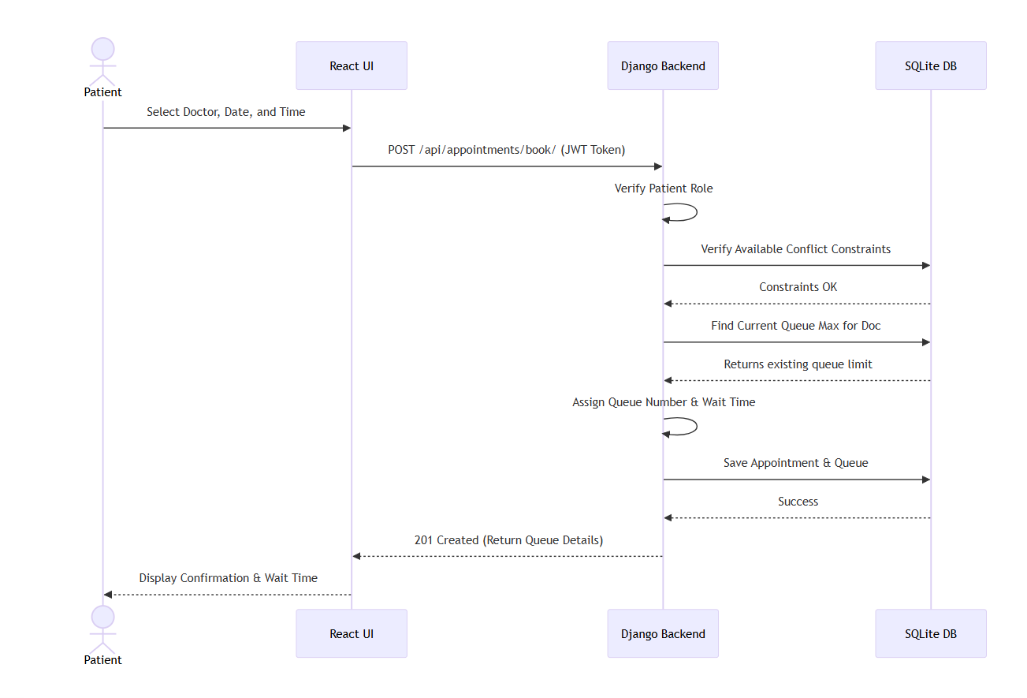
(Fig 5.4 sequence diagram)
The sequence diagram shows step-by-step interaction between system components during the appointment booking process.
- The process begins when the patient selects a doctor, date, and time through the React-based user interface. The frontend sends a POST request to the backend API along with the JWT token for authentication.
- The Django backend verifies the patient’s role and checks for any scheduling conflicts by interacting with SQLite database. It also shows the current queue limit for the selected doctor.
- After validation, the system assigns a queue number and estimated waiting time to the patient. The appointment and queue details are then saved in the database.
- Once the process is successfully completed, the backend sends a response back to the frontend with a confirmation message and queue details. The frontend then displays the confirmation and waiting time to the patient.
This diagram effectively demonstrates the flow of data and control between different components,

CHAPTER 6 REQUIREMENTS

HARDWARE REQUIREMENTS

Development Environment
- Processor: Intel Core i5 / AMD Ryzen 5 or equivalent
- RAM: 8GB minimum (16GB recommended)
- Storage: Minimum 200MB for project files; 1GB+ for database
- Display: 1080p resolution recommended
Production Environment
- Server: Cloud/Dedicated server (2 vCPUs, 4GB RAM)
- Database Host: SQLite or PostgreSQL with backup support
- Client Devices: PC, laptop, or tablet with modern web browser

SOFTWARE REQUIREMENTS

Development Tools
- Operating System: Windows, macOS, or Linux
- Languages: Python (Backend), JavaScript (Frontend)
- IDE: Visual Studio Code
- Database Tool: DB Browser for SQLite
Runtime Environment
- Node.js: Version 18 or higher
- Python: Version 3.x
- Database: SQLite3
- Browser: Chrome, Edge, Firefox, or Safari

CHAPTER 7 IMPLEMENTATION

PROJECT STRUCTURE

The MediSync system follows a modular and decoupled architecture to ensure scalability, maintainability, and clear separation of concerns. The project is divided into a React-based frontend and a Django REST Framework (DRF) backend.
- Frontend Entry & Routing (App.jsx, main.jsx): Initializes the React application and manages routing. It distinguishes between public pages (login) and protected routes for dashboards.
- Global State Management (AuthContext.jsx): Handles user authentication state, stores tokens securely, and provides role-based access data across the application.
- API Service Layer (api.js): Manages all HTTP requests using Axios. It attaches authentication tokens and handles token refresh automatically.
- Backend Logic (views.py): Contains the core application logic, including appointment scheduling, prescription handling, billing, and inventory updates.
- Database & Serialization (models.py, serializers.py): Defines database structure, relationships, and ensures secure conversion of data between database and API responses.

KEY IMPLEMENTATION DETAILS

- Secure Authentication and Role-Based Access Control
The system uses JWT-based authentication to ensure secure access. Users receive access and refresh tokens during login. Backend APIs enforce role-based permissions, ensuring that users can only access data relevant to their role. On the frontend, protected routes prevent unauthorized navigation.
- Automated Inventory and Billing
- The system integrates clinical and financial operations. When a doctor creates a prescription:
- Medicines are automatically deducted from inventory
- A bill is generated based on prescribed items
- The bill is linked to the respective patient
- This ensures accuracy and reduces manual effort.
- Unique ID Generation and Data Integrity
To maintain data integrity, unique identifiers are generated automatically for entities such as patients and doctors. This prevents duplication and ensures consistency even during high-volume operations.

- Dynamic Data Updates
The frontend uses React hooks to fetch and update data dynamically. After actions such as booking appointments or making payments, the system refreshes data instantly to reflect real-time changes.

ERROR HANDLING

The system implements error handling at both backend and frontend levels:
- Backend: Validates data and returns appropriate error responses (e.g., invalid input or unauthorized access).
- Frontend: Uses try-catch mechanisms to capture errors and display user-friendly messages such as “Invalid credentials” or “Network error”.

TESTING STRATEGY

- Unit Testing: Individual components such as database models and validation rules were tested to ensure correctness.
- Integration Testing: Interaction between frontend and backend was tested, including authentication and API communication.
- UI/UX and Security Testing: The interface was tested for responsiveness and usability. Role-based access control was verified by attempting unauthorized access to restricted feature.

CHAPTER 8 RESULTS & DISCUSSION
The MediSync Hospital Management System was successfully developed and implemented as a web-based application. The system effectively integrates key hospital operations such as patient management, appointment scheduling, prescription handling, billing, and inventory tracking into a single platform. The application provides a user-friendly interface for different users, including patients, doctors, and administrators. Patients can easily book appointments, view prescriptions, and access billing information. Doctors can manage their schedules and generate prescriptions efficiently, while administrators can monitor system activities, manage inventory, and handle billing operations. The system ensures secure access through authentication and role-based access control, preventing unauthorized usage. Real-time data updates and automated processes significantly reduce manual workload and improve overall efficiency. Overall, the system performs reliably and meets the intended objectives of improving hospital management and patient care.
The implementation of MediSync demonstrates the importance of digital transformation in healthcare systems. By replacing traditional manual processes with an automated solution, the system reduces errors, saves time, and enhances data accessibility. One of the key strengths of the system is the integration of multiple functionalities into a single platform, which improves coordination between different departments. The use of modern technologies ensures scalability and flexibility for future enhancements. However, certain limitations exist. The current system uses SQLite, which may not be suitable for large-scale deployment. Additionally, features such as advanced analytics, mobile application support, and cloud deployment can be further explored. Despite these limitations, the system provides a strong foundation for efficient hospital management and can be extended to meet real-world requirements.

CHAPTER 9 CONCLUSION
  - CONCLUSION

The MediSync Hospital Management System was successfully designed and implemented as a comprehensive digital solution to streamline hospital operations. The system integrates key functionalities such as patient management, appointment scheduling, prescription handling, billing, and inventory management into a unified platform.
By replacing traditional manual processes, the system improves operational efficiency, reduces errors, and ensures better data organization. The implementation of secure authentication and role-based access control (RBAC) protects sensitive information and ensures authorized system usage. Additionally, features such as automated appointment queuing, real-time inventory tracking, and dynamic prescription-based billing significantly reduce administrative workload. The user-friendly interface further enhances usability for patients, doctors, and administrators.
Overall, the project demonstrates how modern web technologies can be effectively utilized to improve healthcare management and deliver better service quality.
  - FUTURE SCOPE
The MediSync system can be further enhanced by incorporating advanced features and technologies to improve its functionality and scalability:
- Integration with cloud-based databases for better scalability and remote access
- Development of a mobile application for improved accessibility
- Integration of online payment gateways for seamless billing transactions
- Implementation of automated notifications (SMS/Email) for appointment reminders
- Addition of telemedicine features for remote consultations
- Use of AI-based analytics for smart diagnosis and prediction
- Support for multi-hospital or multi-branch management
These enhancements can transform MediSync into a more scalable, intelligent, and fully integrated healthcare management system.

REFERENCES

[1] World Health Organization (WHO). Global strategy on digital health 2020–2025. Geneva: WHO; 2020. https://www.who.int/publications/i/item/9789240020924
[2] Jones M, Bradley J, Sakimura N. JSON Web Token (JWT). RFC 7519. Internet Engineering Task Force (IETF); May 2015. https://datatracker.ietf.org/doc/html/rfc7519
[3] Kumar A, Singh S. Role-based access control (RBAC) in modern hospital management systems and data security. Int J Med Inform. 2021.
[4] Meta Platforms, Inc. React Documentation. https://react.dev/
[5] Django Software Foundation. Django Documentation. https://docs.djangoproject.com/

APPENDIX I

