LOYOLA COLLEGE
Chennai – 600 034

Department of Data Science
PRACTICAL RECORD

Course Title: MACHINE LEARNING LAB
Dept. No. : 26-PDS-023
Name : GODWIN RUFUS A
Semester : I
Year : I

Loyola College, Chennai – 600 034
Department of Data Science
BONAFIDE CERTIFICATE
Dept. No. : 26-PDS-023
Name : GODWIN RUFUS A
Class : 1ST M.Sc. DATA SCIENCE
This is to certify that this is the bonafide record of the practical work done in MACHINE LEARNING LAB at the Loyola College Data Centre, during the year 2026 – 2027.
Head of the Department Staff-in-Charge
Date: 14.10.2026
Submitted for the MACHINE LEARNING Data Science Practical examination held on 14.10.2026 at Loyola College, Chennai – 600 034.

Internal Examiner External Examiner

S.No | Date | Name of the Exercise | Page No.
1 | 01-07-2026 | Exploratory Data Analysis (EDA) | 1
2 | 02-07-2026 | Simple Linear Regression | 13
3 | 07-07-2026 | Multiple Linear Regression | 16
4 | 10-07-2026 | Polynomial Regression | 20
5 | 17-07-2026 | Ridge Regression | 24
6 | 24-07-2026 | Lasso Regression | 27
7 | 05-08-2026 | Logistic Regression | 31
8 | 20-08-2026 | K-Nearest Neighbors (KNN) | 37
9 | 21-08-2026 | Decision Tree | 44
10 | 25-08-2026 | Random Forest | 49
11 | 28-08-2026 | Support Vector Machine (SVM) | 55
12 | 02-09-2026 | Hyperparameter Tuning | 60
13 | 07-09-2026 | K-Means Clustering | 63
14 | 15-09-2026 | Hierarchical Clustering | 66
15 | 18-09-2026 | DBSCAN Clustering | 69
16 | 22-09-2026 | Principal Component Analysis (PCA) | 72

CONTENTS
MACHINE LEARNING LAB

EXERCISE – 01 (EXPLORATORY DATA ANALYSIS)
1. AIM
To perform Exploratory Data Analysis (EDA) on the Titanic dataset by examining its structure, missing values and statistical summaries, treating the missing data, and visualizing the distributions and relationships between passenger attributes and survival.
2. ALGORITHM
1. Load the Titanic dataset and display its first, last and randomly sampled records.
2. Inspect the shape, data types, descriptive statistics and the number and percentage of missing values; visualize the missing values with a heatmap.
3. Fill the missing Age values with the median, the missing Embarked values with the mode and the missing Cabin values with “Unknown”.
4. Check for duplicate records and remove them.
5. Plot the survival, passenger-class and gender distributions using count plots and a pie chart.
6. Analyze survival against gender, passenger class, fare, and age using count plots, a box plot, a category plot and a scatter plot.
7. Compute the correlation matrix of the numeric columns and display it as a heatmap.
3. PROGRAM
import pandas as pd
import numpy as np
import matplotlib.pyplot as plt
import seaborn as sns
data = 'Dataset/titanic.csv'
df = pd.read_csv(data)
df.head()
df.tail()
df.sample(5)
print("Rows and Columns:", df.shape)
df.info()
df.describe()
df.size
df.columns
df.isnull().sum()
missing_percentage = (df.isnull().sum() / len(df)) * 100
print(missing_percentage.sort_values(ascending=False))
plt.figure(figsize=(10, 6))
sns.heatmap(
df.isnull(),
cbar=False,
yticklabels=False,
cmap="viridis"
)
plt.title("Missing Values Heatmap")
plt.show()
df["Age"] = df["Age"].fillna(df["Age"].median())
df["Embarked"] = df["Embarked"].fillna(df["Embarked"].mode()[0])
df["Cabin"] = df["Cabin"].fillna("Unknown")
print(df.isnull().sum())
print("Number of duplicate rows:", df.duplicated().sum())
df = df.drop_duplicates()
print("Shape after removing duplicates:", df.shape)
plt.figure(figsize=(6, 4))
sns.countplot(data=df, x="Survived")
plt.title("Passenger Survival Count")
plt.xlabel("Survived")
plt.ylabel("Number of Passengers")
plt.show()
survival_counts = df["Survived"].value_counts()
plt.figure(figsize=(6, 6))
plt.pie(
survival_counts,
labels=["Did Not Survive", "Survived"],
autopct="%1.1f%%",
startangle=90
)
plt.title("Survival Distribution")
plt.show()
plt.figure(figsize=(6, 4))
sns.countplot(data=df, x="Pclass")
plt.title("Passenger Class Distribution")
plt.xlabel("Passenger Class")
plt.ylabel("Number of Passengers")
plt.show()
plt.figure(figsize=(6, 4))
sns.countplot(data=df, x="Sex")
plt.title("Gender Distribution")
plt.xlabel("Gender")
plt.ylabel("Number of Passengers")
plt.show()
plt.figure(figsize=(7, 5))
sns.countplot(
data=df,
x="Sex",
hue="Survived"
)
plt.title("Survival by Gender")
plt.xlabel("Gender")
plt.ylabel("Number of Passengers")
plt.show()
plt.figure(figsize=(7, 5))
sns.countplot(
data=df,
x="Pclass",
hue="Survived"
)
plt.title("Survival by Passenger Class")
plt.xlabel("Passenger Class")
plt.ylabel("Number of Passengers")
plt.show()
plt.figure(figsize=(8, 5))
sns.boxplot(
data=df,
x="Survived",
y="Fare"
)
plt.title("Fare Distribution by Survival")
plt.xlabel("Survived")
plt.ylabel("Fare")
plt.show()
g = sns.catplot(
data=df,
x="Pclass",
hue="Survived",
col="Sex",
kind="count",
height=5,
aspect=1
)
g.fig.suptitle(
"Survival by Passenger Class and Gender",
y=1.05
)
plt.show()
plt.figure(figsize=(9, 6))
sns.scatterplot(
data=df,
x="Age",
y="Fare",
hue="Survived",
style="Sex",
size="Pclass",
sizes=(50, 200)
)
plt.title("Age vs Fare by Survival, Gender and Class")
plt.xlabel("Age")
plt.ylabel("Fare")
plt.show()
numeric_columns = [
"Survived",
"Pclass",
"Age",
"SibSp",
"Parch",
"Fare"
]
correlation = df[numeric_columns].corr()
print(correlation)
plt.figure(figsize=(9, 7))
sns.heatmap(
correlation,
annot=True,
cmap="coolwarm",
fmt=".2f",
linewidths=0.5
)
plt.title("Correlation Heatmap")
plt.show()

4. OUTPUT
The program was executed on the Titanic dataset (titanic.csv) and produced the following output:
PassengerId Survived Pclass ... Fare Cabin Embarked
0 1 0 3 ... 7.2500 NaN S
1 2 1 1 ... 71.2833 C85 C
2 3 1 3 ... 7.9250 NaN S
3 4 1 1 ... 53.1000 C123 S
4 5 0 3 ... 8.0500 NaN S
[5 rows x 12 columns]
PassengerId Survived Pclass ... Fare Cabin Embarked
886 887 0 2 ... 13.00 NaN S
887 888 1 1 ... 30.00 B42 S
888 889 0 3 ... 23.45 NaN S
889 890 1 1 ... 30.00 C148 C
890 891 0 3 ... 7.75 NaN Q
[5 rows x 12 columns]
PassengerId Survived Pclass ... Fare Cabin Embarked
474 475 0 3 ... 9.8375 NaN S
248 249 1 1 ... 52.5542 D35 S
226 227 1 2 ... 10.5000 NaN S
127 128 1 3 ... 7.1417 NaN S
438 439 0 1 ... 263.0000 C23 C25 C27 S
[5 rows x 12 columns]
Rows and Columns: (891, 12)
<class 'pandas.core.frame.DataFrame'>
RangeIndex: 891 entries, 0 to 890
Data columns (total 12 columns):
# Column Non-Null Count Dtype
--- ------ -------------- -----
0 PassengerId 891 non-null int64
1 Survived 891 non-null int64
2 Pclass 891 non-null int64
3 Name 891 non-null object
4 Sex 891 non-null object
5 Age 714 non-null float64
6 SibSp 891 non-null int64
7 Parch 891 non-null int64
8 Ticket 891 non-null object
9 Fare 891 non-null float64
10 Cabin 204 non-null object
11 Embarked 889 non-null object
dtypes: float64(2), int64(5), str(5)
memory usage: 83.7 KB
PassengerId Survived Pclass ... SibSp Parch Fare
count 891.000000 891.000000 891.000000 ... 891.000000 891.000000 891.000000
mean 446.000000 0.383838 2.308642 ... 0.523008 0.381594 32.204208
std 257.353842 0.486592 0.836071 ... 1.102743 0.806057 49.693429
min 1.000000 0.000000 1.000000 ... 0.000000 0.000000 0.000000
25% 223.500000 0.000000 2.000000 ... 0.000000 0.000000 7.910400
50% 446.000000 0.000000 3.000000 ... 0.000000 0.000000 14.454200
75% 668.500000 1.000000 3.000000 ... 1.000000 0.000000 31.000000
max 891.000000 1.000000 3.000000 ... 8.000000 6.000000 512.329200
[8 rows x 7 columns]
10692
Index(['PassengerId', 'Survived', 'Pclass', 'Name', 'Sex', 'Age', 'SibSp',
'Parch', 'Ticket', 'Fare', 'Cabin', 'Embarked'],
dtype='object')
PassengerId 0
Survived 0
Pclass 0
Name 0
Sex 0
Age 177
SibSp 0
Parch 0
Ticket 0
Fare 0
Cabin 687
Embarked 2
dtype: int64
Cabin 77.104377
Age 19.865320
Embarked 0.224467
PassengerId 0.000000
Name 0.000000
Pclass 0.000000
Survived 0.000000
Sex 0.000000
Parch 0.000000
SibSp 0.000000
Fare 0.000000
Ticket 0.000000
dtype: float64

PassengerId 0
Survived 0
Pclass 0
Name 0
Sex 0
Age 0
SibSp 0
Parch 0
Ticket 0
Fare 0
Cabin 0
Embarked 0
dtype: int64
Number of duplicate rows: 0
Shape after removing duplicates: (891, 12)

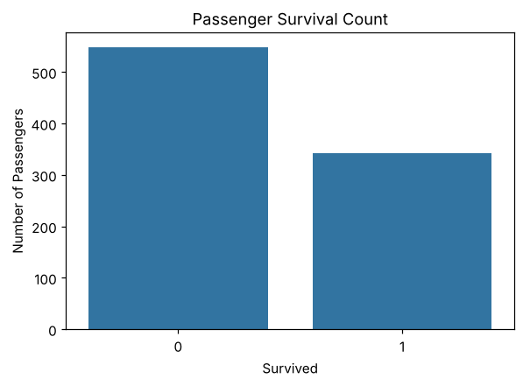
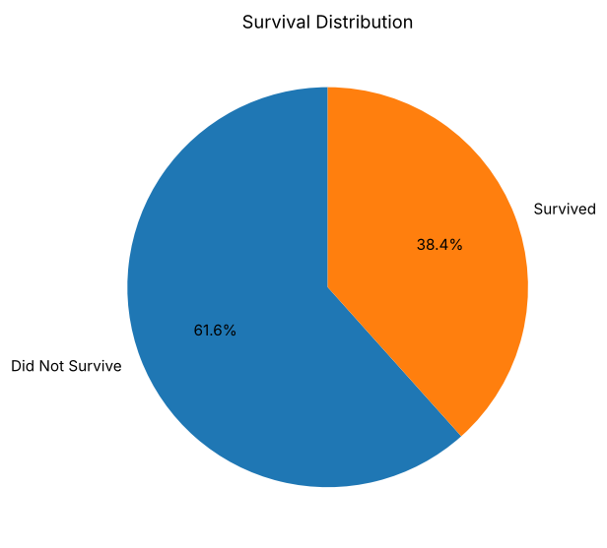
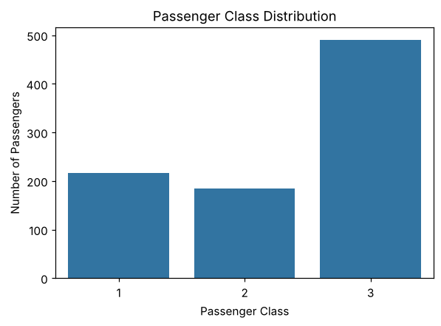
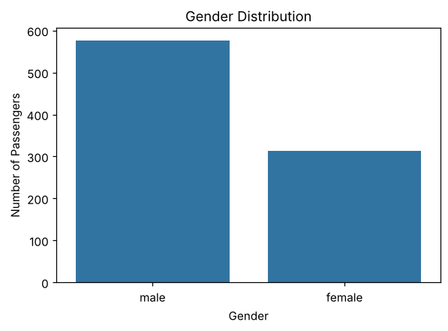
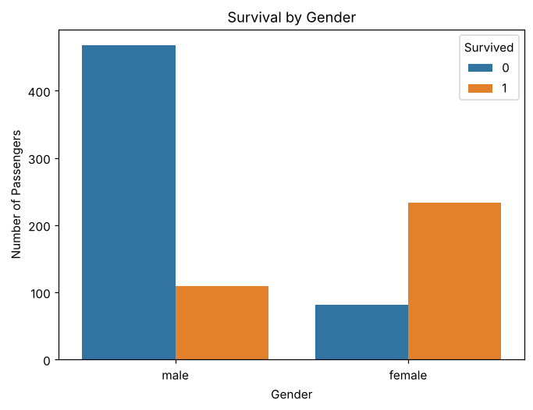
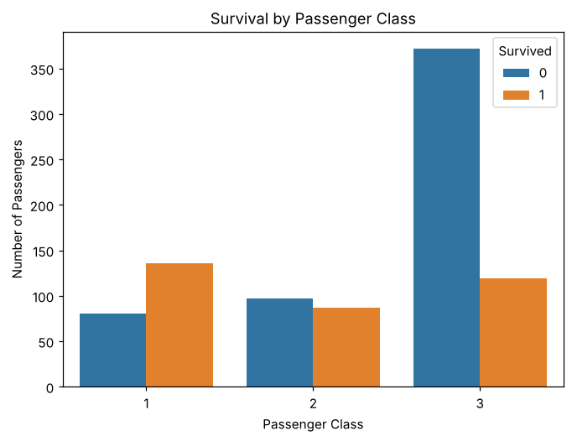
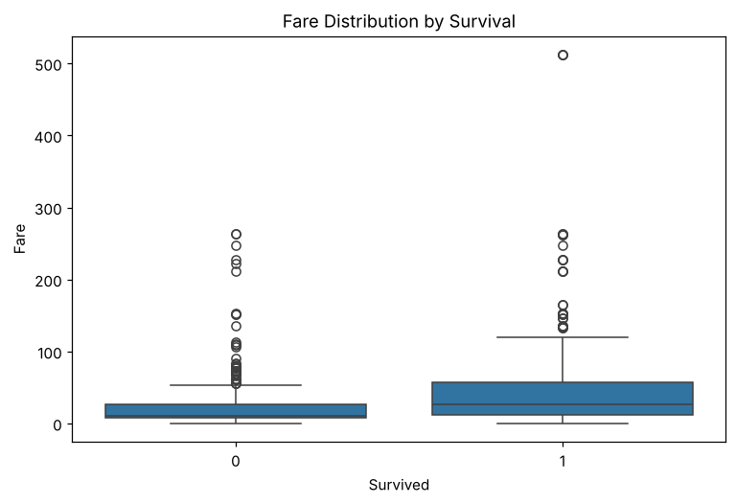
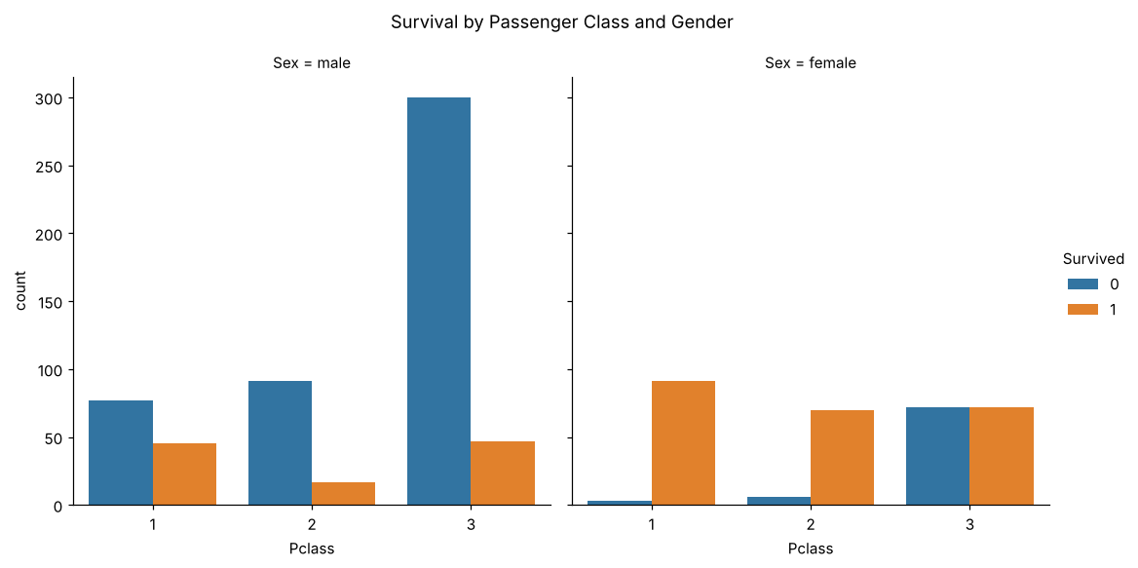
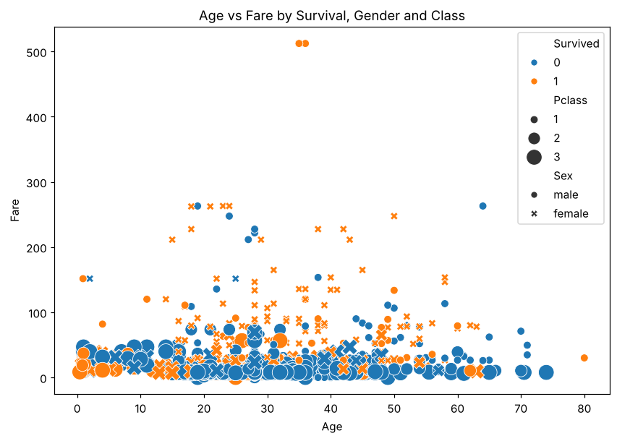
Survived Pclass Age SibSp Parch Fare
Survived 1.000000 -0.338481 -0.064910 -0.035322 0.081629 0.257307
Pclass -0.338481 1.000000 -0.339898 0.083081 0.018443 -0.549500
Age -0.064910 -0.339898 1.000000 -0.233296 -0.172482 0.096688
SibSp -0.035322 0.083081 -0.233296 1.000000 0.414838 0.159651
Parch 0.081629 0.018443 -0.172482 0.414838 1.000000 0.216225
Fare 0.257307 -0.549500 0.096688 0.159651 0.216225 1.000000
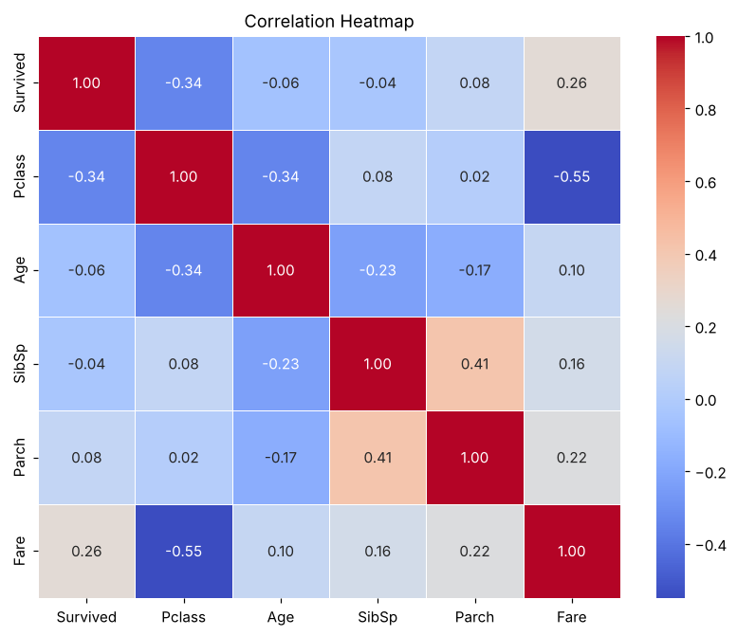

5. RESULT
Thus, the Exploratory Data Analysis on the Titanic dataset was implemented successfully. The dataset contains 891 records and 12 columns. Cabin (77.10%), Age (19.87%) and Embarked (0.22%) had missing values, which were treated, and no duplicate rows were found. Only 38.4% of the passengers survived, and the correlation analysis showed that survival is negatively correlated with passenger class (−0.34) and positively correlated with fare (0.26).

EXERCISE – 02 (SIMPLE LINEAR REGRESSION)
1. AIM
To implement Simple Linear Regression to predict an employee’s salary from the years of experience and to evaluate the fitted regression line.
2. ALGORITHM
1. Load the salary dataset and select YearsExperience as the independent variable and Salary as the dependent variable.
2. Check the size, shape and missing values of the dataset.
3. Split the data into training and testing sets in an 80:20 ratio with random_state = 42.
4. Train a Linear Regression model on the training data.
5. Predict the salaries of the test set and compare them with the actual values.
6. Display the slope, intercept, Mean Squared Error and R² score.
7. Predict the salary for 2.1 years of experience.
8. Plot the actual data points together with the regression line.
3. PROGRAM
import pandas as pd
import numpy as np
import matplotlib.pyplot as plt
import seaborn as sns
from sklearn.model_selection import train_test_split
from sklearn.linear_model import LinearRegression
from sklearn.metrics import mean_squared_error, r2_score
data = "Dataset/Salary.csv"
df = pd.read_csv(data)
df = df[['YearsExperience','Salary']]
df
df.size
df.shape
df.isnull().sum()
X = df[['YearsExperience']] # Independent Variable
y = df['Salary'] # Dependent Variable
X_train, X_test, y_train, y_test = train_test_split(X, y, random_state=42, test_size=0.2)
model = LinearRegression()
model.fit(X_train, y_train)
y_pred = model.predict(X_test)
print("Actual Values:")
print(y_test.values)
print("Predicted Values:")
print(y_pred)
print("Coefficient (Slope):", model.coef_[0])
print("Intercept:", model.intercept_)
print("Mean Squared Error:", mean_squared_error(y_test, y_pred))
print("R2 Score:", r2_score(y_test, y_pred))
YearsExperience = [[2.1]]
predicted_salary = model.predict(YearsExperience)
print("Predicted salary for 2.1 years:", predicted_salary[0])
plt.scatter(X, y, color='blue', label='Actual Data')
plt.plot(X, model.predict(X), color='red', linewidth=2, label='Regression Line')
plt.xlabel("Experience")
plt.ylabel("salary")
plt.title("Simple Linear Regression")
plt.legend()
plt.show()

4. OUTPUT
The program was executed on the Salary dataset (Salary.csv) and produced the following output:
YearsExperience Salary
0 1.2 39344.0
1 1.4 46206.0
2 1.6 37732.0
3 2.1 43526.0
4 2.3 39892.0
5 3.0 56643.0
6 3.1 60151.0
7 3.3 54446.0
8 3.3 64446.0
9 3.8 57190.0
10 4.0 63219.0
11 4.1 55795.0
12 4.1 56958.0
13 4.2 57082.0
14 4.6 61112.0
15 5.0 67939.0
16 5.2 66030.0
17 5.4 83089.0
18 6.0 81364.0
19 6.1 93941.0
20 6.9 91739.0
21 7.2 98274.0
22 8.0 101303.0
23 8.3 113813.0
24 8.8 109432.0
25 9.1 105583.0
26 9.6 116970.0
27 9.7 112636.0
28 10.4 122392.0
29 10.6 121873.0
60
(30, 2)
YearsExperience 0
Salary 0
dtype: int64
Actual Values:
[112636. 67939. 113813. 83089. 64446. 57190.]
Predicted Values:
[115791.21011287 71499.27809463 102597.86866063 75268.80422384
55478.79204548 60190.69970699]
Coefficient (Slope): 9423.815323030976
Intercept: 24380.201479473704
Mean Squared Error: 49830096.855908394
R2 Score: 0.9024461774180497
Predicted salary for 2.1 years: 44170.21365783876
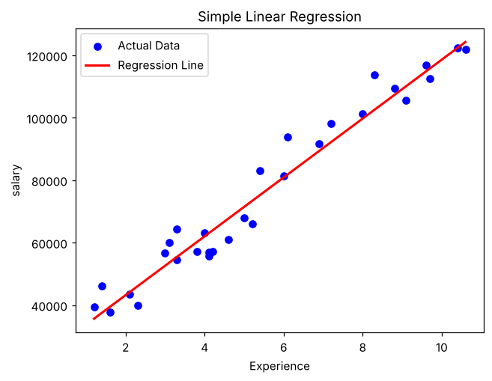

5. RESULT
Thus, the Simple Linear Regression practical was implemented successfully. The fitted line has a slope of 9423.82 and an intercept of 24380.20, giving an R² score of 0.9024 and a Mean Squared Error of 49830096.86 on the test set. The predicted salary for 2.1 years of experience is 44170.21.

EXERCISE – 03 (MULTIPLE LINEAR REGRESSION)
1. AIM
To implement Multiple Linear Regression to predict house prices from several property features and to evaluate the model using a range of regression metrics.
2. ALGORITHM
1. Load the housing dataset and inspect its structure and data types.
2. Convert the categorical columns into numeric form using LabelEncoder.
3. Separate the predictors from the target variable price.
4. Split the data into training and testing sets in an 80:20 ratio with random_state = 42.
5. Train a Linear Regression model on the training data and generate predictions for the test set.
6. Calculate MAE, MSE, RMSE, R², Adjusted R², MAPE, Explained Variance and Maximum Error.
7. Display the intercept and the coefficient of every feature, and predict the price of a new house.
8. Plot the actual prices against the predicted prices.
3. PROGRAM
import pandas as pd
import numpy as np
from sklearn.model_selection import train_test_split
from sklearn.preprocessing import LabelEncoder
from sklearn.linear_model import LinearRegression
from sklearn.metrics import (
mean_absolute_error,
mean_squared_error,
r2_score,
mean_absolute_percentage_error,
explained_variance_score,
max_error
)
data = 'Dataset/Housing.csv'
df= pd.read_csv(data)
df.head()
df.info()
le = LabelEncoder()
for col in df.select_dtypes(include="object").columns:
df[col] = le.fit_transform(df[col])
X = df.drop("price", axis=1)
y = df["price"]
x1, x2, y1, y2 = train_test_split(X, y,test_size=0.2,random_state=42)
model = LinearRegression()
model.fit(x1, y1)
y_pred = model.predict(x2)
y_pred
mae = mean_absolute_error(y2, y_pred)
mse = mean_squared_error(y2, y_pred)
rmse = np.sqrt(mse)
r2 = r2_score(y2, y_pred)
mape = mean_absolute_percentage_error(y2, y_pred)
evs = explained_variance_score(y2, y_pred)
maxerr = max_error(y2, y_pred)
n = x2.shape[0] # Number of observations
p = x2.shape[1] # Number of predictors
adj_r2 = 1 - ((1-r2)*(n-1)/(n-p-1))
print("\n========== Regression Evaluation ==========")
print(f"Mean Absolute Error (MAE): {mae:.2f}")
print(f"Mean Squared Error (MSE): {mse:.2f}")
print(f"Root Mean Squared Error (RMSE): {rmse:.2f}")
print(f"R² Score: {r2:.4f}")
print(f"Adjusted R² Score: {adj_r2:.4f}")
print(f"Mean Absolute Percentage Error (MAPE): {mape:.4f}")
print(f"Explained Variance Score: {evs:.4f}")
print(f"Maximum Error: {maxerr:.2f}")
print("\nIntercept:")
print(model.intercept_)
print("\nCoefficients:")
coef = pd.DataFrame({
"Feature": X.columns,
"Coefficient": model.coef_
})
print(coef)
new_house = [[5000,3,2,2,1,1,0,1,0,1,0,1]]
prediction = model.predict(new_house)
print("\nPredicted House Price:", prediction[0])
import matplotlib.pyplot as plt
plt.figure(figsize=(6,6))
plt.scatter(y2, y_pred)
plt.plot([y2.min(), y2.max()],
[y2.min(), y2.max()],
'r--')
plt.xlabel("Actual Price")
plt.ylabel("Predicted Price")
plt.title("Actual vs Predicted Values")
plt.show()

4. OUTPUT
The program was executed on the Housing dataset (Housing.csv) and produced the following output:
price area bedrooms ... parking prefarea furnishingstatus
0 13300000 7420 4 ... 2 yes furnished
1 12250000 8960 4 ... 3 no furnished
2 12250000 9960 3 ... 2 yes semi-furnished
3 12215000 7500 4 ... 3 yes furnished
4 11410000 7420 4 ... 2 no furnished
[5 rows x 13 columns]
<class 'pandas.core.frame.DataFrame'>
RangeIndex: 545 entries, 0 to 544
Data columns (total 13 columns):
# Column Non-Null Count Dtype
--- ------ -------------- -----
0 price 545 non-null int64
1 area 545 non-null int64
2 bedrooms 545 non-null int64
3 bathrooms 545 non-null int64
4 stories 545 non-null int64
5 mainroad 545 non-null object
6 guestroom 545 non-null object
7 basement 545 non-null object
8 hotwaterheating 545 non-null object
9 airconditioning 545 non-null object
10 parking 545 non-null int64
11 prefarea 545 non-null object
12 furnishingstatus 545 non-null object
dtypes: int64(6), str(7)
memory usage: 55.5 KB
[5203691.70963178 7257004.02115476 3062828.59668172 4559591.65374424
3332932.30559782 3563080.67918997 5645466.31219972 6413979.66873635
2755831.54819 2668938.66075229 9570600.29915353 2827431.50860062
3195686.2583409 3352263.99438471 3713879.49996131 5301088.24435749
2987920.2666968 4810799.8212371 4383031.70489929 3525092.18938646
5796259.50068013 5840000.70299301 2760214.608641 4762590.14920607
5204755.73895206 7515542.71619025 3254681.68956382 5236164.45964444
8178523.16820284 3434166.15675649 6443921.58767581 3346004.77919184
6742324.74004133 4154936.84088665 3589152.47491253 5788125.92515323
4768370.18154076 4391684.04193172 3217657.04549935 4638196.61928878
4522160.27786714 3541284.06127245 7238136.11941171 4021515.68926614
3701978.76822757 4298879.55563098 6705004.02060611 3993466.52296897
3798185.05328059 3451821.5624289 7293996.86867461 2832905.26972678
4378698.14769931 4468002.85418353 3714623.89765883 2718466.90282779
7524449.64983626 2950437.1495281 4194596.28592921 2795827.77318101
4801788.72577028 3618230.29875972 5091685.77019752 4248122.70647651
4729964.20281946 4620982.9363411 7215846.76983926 3485106.19132682
5933820.14349914 6236580.98095548 4809923.61015999 5130920.22938947
4527282.87392583 8006869.07208366 3543927.63713716 5463086.05281817
3902441.28505163 4661063.63495886 4825370.89331733 4276803.47099967
7754072.71344458 4008573.23235629 6500977.91345038 5386796.00909808
2785343.0092764 6836356.36771846 2638553.49378047 3634231.99215348
8004072.41154001 8048399.75418244 3227573.69687309 5935167.4198354
3605772.48317455 3817767.91420862 7631673.34074558 4775106.62670537
5093491.44442931 6447437.14797692 4943449.6813564 5943929.14295426
3810460.26405425 6457426.32302761 3701491.23218178 5960492.47343074
4933137.14530295 4377133.13624287 7009335.02696999 6351460.97128317
6409340.41089671]
========== Regression Evaluation ==========
Mean Absolute Error (MAE): 979679.69
Mean Squared Error (MSE): 1771751116594.03
Root Mean Squared Error (RMSE): 1331071.42
R² Score: 0.6495
Adjusted R² Score: 0.6057
Mean Absolute Percentage Error (MAPE): 0.2131
Explained Variance Score: 0.6534
Maximum Error: 5295927.59
Intercept:
293083.0691506695
Coefficients:
Feature Coefficient
0 area 2.358488e+02
1 bedrooms 7.857449e+04
2 bathrooms 1.097117e+06
3 stories 4.062232e+05
4 mainroad 3.668242e+05
5 guestroom 2.331468e+05
6 basement 3.931598e+05
7 hotwaterheating 6.878813e+05
8 airconditioning 7.855506e+05
9 parking 2.257565e+05
10 prefarea 6.299017e+05
11 furnishingstatus -2.103971e+05
Predicted House Price: 6017942.931156618
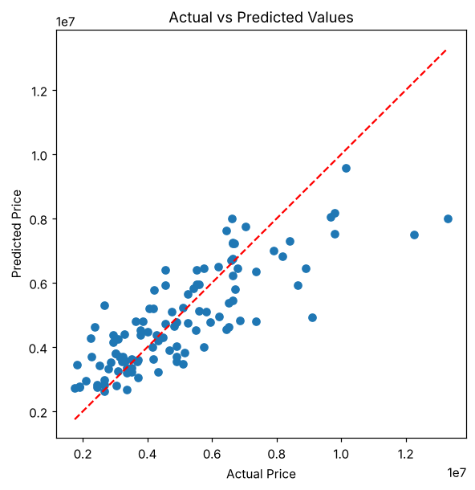

5. RESULT
Thus, the Multiple Linear Regression practical was implemented successfully. The model obtained an R² score of 0.6495 (Adjusted R² 0.6057), an MAE of 979679.69 and an RMSE of 1331071.42 on the test set. The number of bathrooms had the largest coefficient, and the predicted price for the sample house is 6017942.93.

EXERCISE – 04 (POLYNOMIAL REGRESSION)
1. AIM
To implement degree-2 Polynomial Regression to predict the weight of a fish from its measurements, evaluate the predictions with regression metrics, and visualize the fitted curve.
2. ALGORITHM
1. Load and inspect the fish dataset.
2. Encode the Species column using one-hot encoding.
3. Separate Weight as the target variable and the remaining columns as predictors.
4. Split the data into training and testing sets in an 80:20 ratio with random_state = 42.
5. Generate degree-2 polynomial features using PolynomialFeatures.
6. Train a Linear Regression model on the transformed features and predict the test set.
7. Calculate MAE, MSE, RMSE, R², MAPE, Explained Variance and Maximum Error.
8. Plot the polynomial relationship between Length3 and Weight.
3. PROGRAM
import pandas as pd
import numpy as np
import matplotlib.pyplot as plt
from sklearn.model_selection import train_test_split
from sklearn.preprocessing import PolynomialFeatures
from sklearn.linear_model import LinearRegression
from sklearn.metrics import (
mean_absolute_error,
mean_squared_error,
r2_score,
mean_absolute_percentage_error,
explained_variance_score,
max_error
)
data = 'Dataset/fish.csv'
df = pd.read_csv(data)
df.head()
df.info()
df.shape
df = pd.get_dummies(df, columns=['Species'], drop_first=True)
X = df.drop("Weight", axis=1)
y = df["Weight"]
x1, x2, y_train, y_test = train_test_split(
X,
y,
test_size=0.2,
random_state=42
)
poly = PolynomialFeatures(degree=2)
X_train_poly = poly.fit_transform(x1)
X_test_poly = poly.transform(x2)
model = LinearRegression()
model.fit(X_train_poly, y_train)
# Prediction
y_pred = model.predict(X_test_poly)
mae = mean_absolute_error(y_test, y_pred)
mse = mean_squared_error(y_test, y_pred)
rmse = np.sqrt(mse)
r2 = r2_score(y_test, y_pred)
mape = mean_absolute_percentage_error(y_test, y_pred)
evs = explained_variance_score(y_test, y_pred)
maxerr = max_error(y_test, y_pred)
# Adjusted R²
n = X_test_poly.shape[0]
p = X_test_poly.shape[1] - 1
adj_r2 = 1 - ((1-r2)*(n-1)/(n-p-1))
print("\n========== Evaluation Metrics ==========")
print("MAE :", mae)
print("MSE :", mse)
print("RMSE :", rmse)
print("R2 Score :", r2)
print("Adjusted R2 :", adj_r2)
print("MAPE :", mape)
print("Explained Variance :", evs)
print("Maximum Error :", maxerr)
X = df[['Length3']]
y = df['Weight']
poly = PolynomialFeatures(degree=2)
X_poly = poly.fit_transform(X)
model = LinearRegression()
model.fit(X_poly, y)
X_grid = np.arange(
X.min().values[0],
X.max().values[0],
0.1
).reshape(-1,1)
plt.figure(figsize=(8,6))
plt.scatter(X, y, color="blue", label="Actual Data")
plt.plot(
X_grid,
model.predict(poly.transform(X_grid)),
color="red",
linewidth=3,
label="Polynomial Curve"
)
plt.xlabel("Length3")
plt.ylabel("Weight")
plt.title("Polynomial Regression")
plt.legend()
plt.show()

4. OUTPUT
The program was executed on the Fish dataset (fish.csv) and produced the following output:
Species Weight Length1 Length2 Length3 Height Width
0 Bream 242.0 23.2 25.4 30.0 11.5200 4.0200
1 Bream 290.0 24.0 26.3 31.2 12.4800 4.3056
2 Bream 340.0 23.9 26.5 31.1 12.3778 4.6961
3 Bream 363.0 26.3 29.0 33.5 12.7300 4.4555
4 Bream 430.0 26.5 29.0 34.0 12.4440 5.1340
<class 'pandas.core.frame.DataFrame'>
RangeIndex: 159 entries, 0 to 158
Data columns (total 7 columns):
# Column Non-Null Count Dtype
--- ------ -------------- -----
0 Species 159 non-null object
1 Weight 159 non-null float64
2 Length1 159 non-null float64
3 Length2 159 non-null float64
4 Length3 159 non-null float64
5 Height 159 non-null float64
6 Width 159 non-null float64
dtypes: float64(6), str(1)
memory usage: 8.8 KB
(159, 7)
========== Evaluation Metrics ==========
MAE : 48.409823644028464
MSE : 5620.7129176326325
RMSE : 74.97141400315611
R2 Score : 0.9604841036350548
Adjusted R2 : 1.0266302779850718
MAPE : 0.24553055496984066
Explained Variance : 0.9618750799874711
Maximum Error : 266.19008812732295
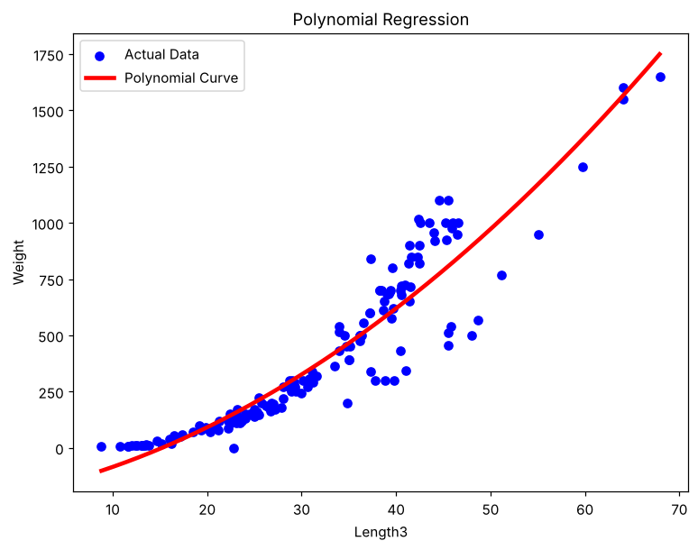

5. RESULT
Thus, the Polynomial Regression practical was implemented successfully. The degree-2 model achieved an R² score of 0.9605, an MAE of 48.41 and an RMSE of 74.97 on the test set, showing that the curved relationship between the fish measurements and weight is captured well.

EXERCISE – 05 (RIDGE REGRESSION)
1. AIM
To implement Ridge Regression (L2 regularization) on the housing dataset using fourth-degree polynomial features and to show how it reduces the overfitting of an ordinary linear regression model.
2. ALGORITHM
1. Load the housing dataset and convert the categorical columns into dummy variables.
2. Separate the predictors from the target variable price and split the data in an 80:20 ratio with random_state = 42.
3. Standardize the features using StandardScaler.
4. Expand the 13 scaled features into 2379 polynomial features of degree 4.
5. Train an ordinary Linear Regression model and record its training and testing R² scores.
6. Train a Ridge Regression model with alpha = 100 and record its training and testing R² scores.
7. Compare the two models in a table and a bar chart, and calculate the gap between training and testing R².
3. PROGRAM
import pandas as pd
import numpy as np
import matplotlib.pyplot as plt
from sklearn.model_selection import train_test_split
from sklearn.preprocessing import StandardScaler, PolynomialFeatures
from sklearn.linear_model import LinearRegression, Ridge
from sklearn.metrics import r2_score
df = pd.read_csv("Housing.csv")
df.head()
df = pd.get_dummies(df, drop_first=True)
df.head()
X = df.drop("price", axis=1)
y = df["price"]
X_train,X_test,y_train,y_test = train_test_split(
X,
y,
test_size=0.2,
random_state=42
)
scaler = StandardScaler()
X_train_scaled = scaler.fit_transform(X_train)
X_test_scaled = scaler.transform(X_test)
poly = PolynomialFeatures(
degree=4,
include_bias=False
)
X_train_poly = poly.fit_transform(X_train_scaled)
X_test_poly = poly.transform(X_test_scaled)
print("Original Features :", X_train.shape[1])
print("Polynomial Features :", X_train_poly.shape[1])
linear = LinearRegression()
linear.fit(X_train_poly, y_train)
train_pred = linear.predict(X_train_poly)
test_pred = linear.predict(X_test_poly)
train_r2 = r2_score(y_train, train_pred)
test_r2 = r2_score(y_test, test_pred)
print("LINEAR REGRESSION")
print("Training R2 :", round(train_r2,4))
print("Testing R2 :", round(test_r2,4))
ridge = Ridge(alpha=100)
ridge.fit(X_train_poly, y_train)
train_pred = ridge.predict(X_train_poly)
test_pred = ridge.predict(X_test_poly)
ridge_train = r2_score(y_train, train_pred)
ridge_test = r2_score(y_test, test_pred)
print("RIDGE")
print("Training R2 :", round(ridge_train,4))
print("Testing R2 :", round(ridge_test,4))
comparison = pd.DataFrame({
"Model":[
"Linear Regression",
"Ridge"
],
"Train R2":[
train_r2,
ridge_train
],
"Test R2":[
test_r2,
ridge_test
]
})
print(comparison)
comparison.plot(
x="Model",
y=["Train R2", "Test R2"],
kind="bar",
figsize=(10,6)
)
plt.title("Reducing Overfitting using Ridge Regularization")
plt.ylabel("R² Score")
plt.xticks(rotation=10)
plt.grid(axis="y")
plt.show()
comparison["Difference"] = comparison["Train R2"] - comparison["Test R2"]
print(comparison)

4. OUTPUT
The program was executed on the Housing dataset (Housing.csv) and produced the following output:
price area bedrooms ... parking prefarea furnishingstatus
0 13300000 7420 4 ... 2 yes furnished
1 12250000 8960 4 ... 3 no furnished
2 12250000 9960 3 ... 2 yes semi-furnished
3 12215000 7500 4 ... 3 yes furnished
4 11410000 7420 4 ... 2 no furnished
[5 rows x 13 columns]
price ... furnishingstatus_unfurnished
0 13300000 ... False
1 12250000 ... False
2 12250000 ... False
3 12215000 ... False
4 11410000 ... False
[5 rows x 14 columns]
Original Features : 13
Polynomial Features : 2379
LINEAR REGRESSION
Training R2 : 0.994
Testing R2 : -2874.767
RIDGE
Training R2 : 0.9637
Testing R2 : 0.2892
Model Train R2 Test R2
0 Linear Regression 0.994023 -2874.766987
1 Ridge 0.963736 0.289156
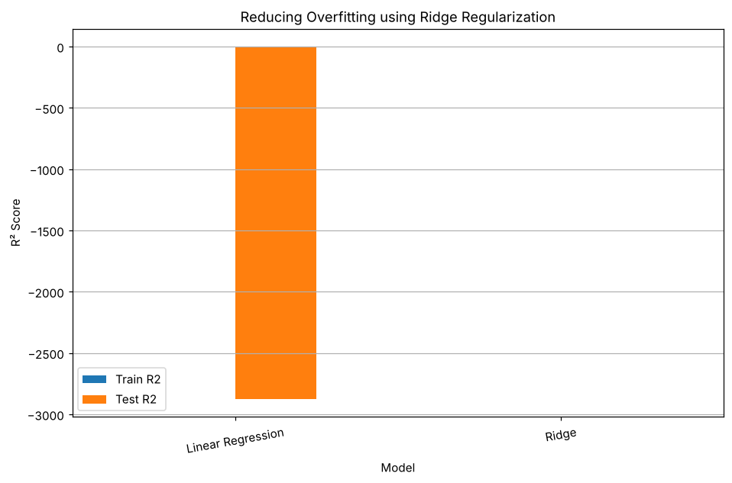
Model Train R2 Test R2 Difference
0 Linear Regression 0.994023 -2874.766987 2875.76101
1 Ridge 0.963736 0.289156 0.67458

5. RESULT
Thus, the Ridge Regression practical was implemented successfully. The ordinary linear model overfitted badly, with a training R² of 0.9940 and a testing R² of −2874.77. Ridge Regression (alpha = 100) reduced the training R² to 0.9637 and improved the testing R² to 0.2892, shrinking the gap between training and testing scores from 2875.76 to 0.67.

EXERCISE – 06 (LASSO REGRESSION)
1. AIM
To implement Lasso Regression (L1 regularization) on the housing dataset using fourth-degree polynomial features and to show how it reduces the overfitting of an ordinary linear regression model.
2. ALGORITHM
1. Load the housing dataset and convert the categorical columns into dummy variables.
2. Separate the predictors from the target variable price and split the data in an 80:20 ratio with random_state = 42.
3. Standardize the features using StandardScaler.
4. Expand the 13 scaled features into 2379 polynomial features of degree 4.
5. Train an ordinary Linear Regression model and record its training and testing R² scores.
6. Train a Lasso Regression model with alpha = 0.1 and max_iter = 50000 and record its training and testing R² scores.
7. Compare the two models in a table and a bar chart, and calculate the gap between training and testing R².
3. PROGRAM
import pandas as pd
import numpy as np
import matplotlib.pyplot as plt
from sklearn.model_selection import train_test_split
from sklearn.preprocessing import StandardScaler, PolynomialFeatures
from sklearn.linear_model import LinearRegression, Lasso
from sklearn.metrics import r2_score
df = pd.read_csv("Housing.csv")
df.head()
df = pd.get_dummies(df, drop_first=True)
df.head()
X = df.drop("price", axis=1)
y = df["price"]
X_train,X_test,y_train,y_test = train_test_split(
X,
y,
test_size=0.2,
random_state=42
)
scaler = StandardScaler()
X_train_scaled = scaler.fit_transform(X_train)
X_test_scaled = scaler.transform(X_test)
poly = PolynomialFeatures(
degree=4,
include_bias=False
)
X_train_poly = poly.fit_transform(X_train_scaled)
X_test_poly = poly.transform(X_test_scaled)
print("Original Features :", X_train.shape[1])
print("Polynomial Features :", X_train_poly.shape[1])
linear = LinearRegression()
linear.fit(X_train_poly, y_train)
train_pred = linear.predict(X_train_poly)
test_pred = linear.predict(X_test_poly)
train_r2 = r2_score(y_train, train_pred)
test_r2 = r2_score(y_test, test_pred)
print("LINEAR REGRESSION")
print("Training R2 :", round(train_r2,4))
print("Testing R2 :", round(test_r2,4))
lasso = Lasso(
alpha=0.1,
max_iter=50000
)
lasso.fit(X_train_poly, y_train)
train_pred = lasso.predict(X_train_poly)
test_pred = lasso.predict(X_test_poly)
lasso_train = r2_score(y_train, train_pred)
lasso_test = r2_score(y_test, test_pred)
print("LASSO")
print("Training R2 :", round(lasso_train,4))
print("Testing R2 :", round(lasso_test,4))
comparison = pd.DataFrame({
"Model":[
"Linear Regression",
"Lasso"
],
"Train R2":[
train_r2,
lasso_train
],
"Test R2":[
test_r2,
lasso_test
]
})
print(comparison)
comparison.plot(
x="Model",
y=["Train R2", "Test R2"],
kind="bar",
figsize=(10,6)
)
plt.title("Reducing Overfitting using Lasso Regularization")
plt.ylabel("R² Score")
plt.xticks(rotation=10)
plt.grid(axis="y")
plt.show()
comparison["Difference"] = comparison["Train R2"] - comparison["Test R2"]
print(comparison)

4. OUTPUT
The program was executed on the Housing dataset (Housing.csv) and produced the following output:
price area bedrooms ... parking prefarea furnishingstatus
0 13300000 7420 4 ... 2 yes furnished
1 12250000 8960 4 ... 3 no furnished
2 12250000 9960 3 ... 2 yes semi-furnished
3 12215000 7500 4 ... 3 yes furnished
4 11410000 7420 4 ... 2 no furnished
[5 rows x 13 columns]
price ... furnishingstatus_unfurnished
0 13300000 ... False
1 12250000 ... False
2 12250000 ... False
3 12215000 ... False
4 11410000 ... False
[5 rows x 14 columns]
Original Features : 13
Polynomial Features : 2379
LINEAR REGRESSION
Training R2 : 0.994
Testing R2 : -2874.767
LASSO
Training R2 : 0.9922
Testing R2 : -13.4971
Model Train R2 Test R2
0 Linear Regression 0.994023 -2874.766987
1 Lasso 0.992212 -13.497146
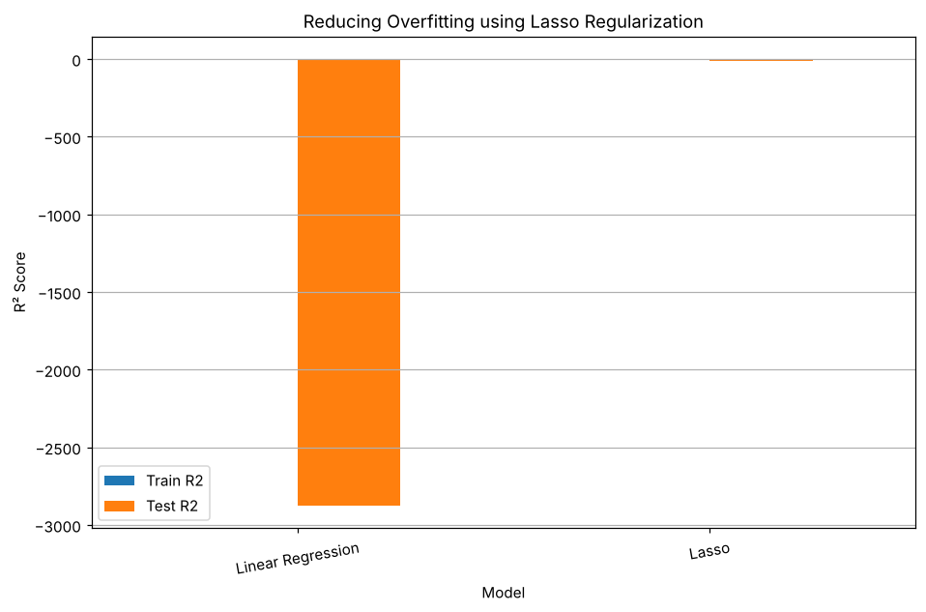
Model Train R2 Test R2 Difference
0 Linear Regression 0.994023 -2874.766987 2875.761010
1 Lasso 0.992212 -13.497146 14.489358

5. RESULT
Thus, the Lasso Regression practical was implemented successfully. Compared with the ordinary linear model (training R² 0.9940, testing R² −2874.77), Lasso Regression (alpha = 0.1) obtained a training R² of 0.9922 and a testing R² of −13.50, reducing the gap between training and testing scores from 2875.76 to 14.49. Lasso lowered the overfitting considerably, although a stronger penalty would be needed for a positive testing R².

EXERCISE – 07 (LOGISTIC REGRESSION)
1. AIM
To implement Logistic Regression for binary heart disease classification and to evaluate the model using accuracy, precision, recall, F1 score, the confusion matrix and the ROC-AUC score.
2. ALGORITHM
1. Load the heart disease dataset and separate the features from the target Heart Disease.
2. Identify the numerical and categorical columns and fill any missing values using the most frequent value.
3. Convert the categorical columns into numeric form using LabelEncoder.
4. Split the data into training and testing sets in an 80:20 ratio with random_state = 42.
5. Train a Logistic Regression model with max_iter = 1000.
6. Predict the test set and calculate accuracy, precision, recall and F1 score.
7. Display the confusion matrix and the classification report.
8. Plot the ROC curve and calculate the ROC-AUC score.
3. PROGRAM
import pandas as pd
import matplotlib.pyplot as plt
from sklearn.model_selection import train_test_split
from sklearn.impute import SimpleImputer
from sklearn.preprocessing import LabelEncoder
from sklearn.preprocessing import StandardScaler
from sklearn.preprocessing import MinMaxScaler
from sklearn.linear_model import LogisticRegression
from sklearn.metrics import (
accuracy_score,
precision_score,
recall_score,
f1_score,
confusion_matrix,
classification_report,
roc_curve,
auc
)
df = pd.read_csv("heart_disease_dataset.csv")
print("First 5 rows:")
print(df.head())
print("\nDataset Shape:")
print(df.shape)
X = df.drop("Heart Disease", axis=1)
y = df["Heart Disease"]
print("\nFeatures:")
print(X.columns)
print("\nTarget:")
print(y.name)
categorical_columns = X.select_dtypes(
include=["object"]
).columns
numerical_columns = X.select_dtypes(
exclude=["object"]
).columns
print("\nCategorical Columns:")
print(list(categorical_columns))
print("\nNumerical Columns:")
print(list(numerical_columns))
imputer = SimpleImputer(strategy="most_frequent")
X[categorical_columns] = imputer.fit_transform(
X[categorical_columns]
)
print("\nMissing values after imputation:")
print(X.isnull().sum())
label_encoders = {}
for column in categorical_columns:
encoder = LabelEncoder()
X[column] = encoder.fit_transform(
X[column]
)
label_encoders[column] = encoder
print("\nData after Label Encoding:")
print(X.head())
X_train, X_test, y_train, y_test = train_test_split(
X,
y,
test_size=0.20,
random_state=42,
stratify=y
)
print("\nTraining data:", X_train.shape)
print("Testing data :", X_test.shape)
scaler = StandardScaler()
X_train_scaled = scaler.fit_transform(X_train)
X_test_scaled = scaler.transform(X_test)
# minmax_scaler = MinMaxScaler()
# X_train_scaled = minmax_scaler.fit_transform(X_train)
# X_test_scaled = minmax_scaler.transform(X_test)
model = LogisticRegression(
max_iter=1000,
random_state=42
)
model.fit(
X_train_scaled,
y_train
)
print("\nLogistic Regression model trained successfully.")
y_pred = model.predict(X_test_scaled)
# Probability of class 1
y_probability = model.predict_proba(X_test_scaled)[:, 1]
accuracy = accuracy_score(
y_test,
y_pred
)
precision = precision_score(
y_test,
y_pred
)
recall = recall_score(
y_test,
y_pred
)
f1 = f1_score(
y_test,
y_pred
)
print("\n================================")
print("CLASSIFICATION METRICS")
print("================================")
print("Accuracy :", round(accuracy, 4))
print("Precision :", round(precision, 4))
print("Recall :", round(recall, 4))
print("F1 Score :", round(f1, 4))
cm = confusion_matrix(
y_test,
y_pred
)
print("\nConfusion Matrix:")
print(cm)
print("\nClassification Report:")
print(
classification_report(
y_test,
y_pred
)
)
# ============================================
# 15. ROC Curve
# ============================================
fpr, tpr, thresholds = roc_curve(
y_test,
y_probability
)
# ============================================
# 16. Calculate AUC
# ============================================
roc_auc = auc(
fpr,
tpr
)
print("\nROC-AUC Score:",
round(roc_auc, 4))
# ============================================
# 17. Plot ROC Curve
# ============================================
plt.figure(figsize=(8, 6))
plt.plot(
fpr,
tpr,
label="Logistic Regression (AUC = {:.3f})".format(
roc_auc
)
)
# Random classifier line
plt.plot(
[0, 1],
[0, 1],
linestyle="--",
label="Random Classifier"
)
plt.xlabel("False Positive Rate")
plt.ylabel("True Positive Rate")
plt.title(
"ROC Curve - Heart Disease Prediction"
)
plt.legend()
plt.grid()

4. OUTPUT
The program was executed on the Heart disease dataset (heart_disease_dataset.csv) and produced the following output:
First 5 rows:
Age Gender ... Chest Pain Type Heart Disease
0 75 Female ... Atypical Angina 1
1 48 Male ... Typical Angina 0
2 53 Male ... Atypical Angina 1
3 69 Female ... Non-anginal Pain 0
4 62 Female ... Asymptomatic 0
[5 rows x 16 columns]
Dataset Shape:
(1000, 16)
Features:
Index(['Age', 'Gender', 'Cholesterol', 'Blood Pressure', 'Heart Rate',
'Smoking', 'Alcohol Intake', 'Exercise Hours', 'Family History',
'Diabetes', 'Obesity', 'Stress Level', 'Blood Sugar',
'Exercise Induced Angina', 'Chest Pain Type'],
dtype='object')
Target:
Heart Disease
Categorical Columns:
['Gender', 'Smoking', 'Alcohol Intake', 'Family History', 'Diabetes', 'Obesity', 'Exercise Induced Angina', 'Chest Pain Type']
Numerical Columns:
['Age', 'Cholesterol', 'Blood Pressure', 'Heart Rate', 'Exercise Hours', 'Stress Level', 'Blood Sugar']
Missing values after imputation:
Age 0
Gender 0
Cholesterol 0
Blood Pressure 0
Heart Rate 0
Smoking 0
Alcohol Intake 0
Exercise Hours 0
Family History 0
Diabetes 0
Obesity 0
Stress Level 0
Blood Sugar 0
Exercise Induced Angina 0
Chest Pain Type 0
dtype: int64
Data after Label Encoding:
Age Gender ... Exercise Induced Angina Chest Pain Type
0 75 0 ... 1 1
1 48 1 ... 1 3
2 53 1 ... 1 1
3 69 0 ... 1 2
4 62 0 ... 1 0
[5 rows x 15 columns]
Training data: (800, 15)
Testing data : (200, 15)
Logistic Regression model trained successfully.
================================
CLASSIFICATION METRICS
================================
Accuracy : 0.865
Precision : 0.8493
Recall : 0.7949
F1 Score : 0.8212
Confusion Matrix:
[[111 11]
[ 16 62]]
Classification Report:
precision recall f1-score support
0 0.87 0.91 0.89 122
1 0.85 0.79 0.82 78
accuracy 0.86 200
macro avg 0.86 0.85 0.86 200
weighted avg 0.86 0.86 0.86 200
ROC-AUC Score: 0.9505
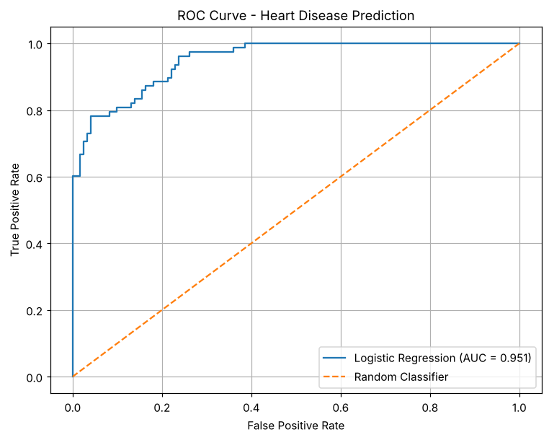

5. RESULT
Thus, the Logistic Regression practical was implemented successfully. The model achieved an accuracy of 86.5%, a precision of 0.8493, a recall of 0.7949, an F1 score of 0.8212 and a ROC-AUC score of 0.9505 on the test set.

EXERCISE – 08 (K-NEAREST NEIGHBORS)
1. AIM
To implement K-Nearest Neighbors (KNN) classification for heart disease prediction, compare several values of K and select the best-performing K.
2. ALGORITHM
1. Load the dataset and separate the features from the target Heart Disease.
2. Identify the numerical and categorical features.
3. Split the dataset into training and testing sets with stratification.
4. Scale the numerical features and one-hot encode the categorical features.
5. Train a KNN classifier for K = 1, 3, 5, 7, 9, 11, 15 and 21.
6. Calculate accuracy, precision, recall and F1 score for every K and plot them.
7. Select the best K and evaluate the final model using the confusion matrix, specificity and AUC.
3. PROGRAM
import pandas as pd
import numpy as np
import matplotlib.pyplot as plt
import seaborn as sns
from sklearn.model_selection import train_test_split
from sklearn.preprocessing import StandardScaler
from sklearn.compose import ColumnTransformer
from sklearn.preprocessing import OneHotEncoder
from sklearn.neighbors import KNeighborsClassifier
from sklearn.metrics import (
accuracy_score,
precision_score,
recall_score,
f1_score,
confusion_matrix,
classification_report,
roc_curve,
roc_auc_score
)
df = pd.read_csv("heart_disease_dataset.csv")
print("Dataset Shape:", df.shape)
print("\nFirst 5 Records:")
print(df.head())
print("\nDataset Information:")
print(df.info())
print("\nMissing Values:")
print(df.isnull().sum())
print("\nTarget Distribution:")
print(df["Heart Disease"].value_counts())
X = df.drop("Heart Disease", axis=1)
y = df["Heart Disease"]
numerical_features = X.select_dtypes(
include=["int64", "float64"]
).columns
categorical_features = X.select_dtypes(
include=["object"]
).columns
print("Numerical Features:")
print(list(numerical_features))
print("\nCategorical Features:")
print(list(categorical_features))
X_train, X_test, y_train, y_test = train_test_split(
X,
y,
test_size=0.20,
random_state=42,
stratify=y
)
print("Training Data:", X_train.shape)
print("Testing Data :", X_test.shape)
preprocessor = ColumnTransformer(
transformers=[
("num", StandardScaler(), numerical_features),
("cat", OneHotEncoder(handle_unknown="ignore"), categorical_features)
]
)
X_train_processed = preprocessor.fit_transform(X_train)
X_test_processed = preprocessor.transform(X_test)
K = 5
knn = KNeighborsClassifier(
n_neighbors=5
)
knn.fit(
X_train_processed,
y_train
)
y_pred = knn.predict(
X_test_processed
)
print("Predicted Values:")
print(y_pred[:20])
print(
classification_report(
y_test,
y_pred
)
)
k_values = [1, 3, 5, 7, 9, 11, 15, 21]
accuracy_values = []
precision_values = []
recall_values = []
f1_values = []
for k in k_values:
knn = KNeighborsClassifier(
n_neighbors=k
)
knn.fit(
X_train_processed,
y_train
)
y_pred = knn.predict(
X_test_processed
)
accuracy_values.append(
accuracy_score(
y_test,
y_pred
)
)
precision_values.append(
precision_score(
y_test,
y_pred
)
)
recall_values.append(
recall_score(
y_test,
y_pred
)
)
f1_values.append(
f1_score(
y_test,
y_pred
)
)
results = pd.DataFrame({
"K": k_values,
"Accuracy": accuracy_values,
"Precision": precision_values,
"Recall": recall_values,
"F1 Score": f1_values
})
print(results)
plt.figure(figsize=(8, 5))
plt.plot(
k_values,
accuracy_values,
marker="o"
)
plt.xlabel("K Value")
plt.ylabel("Accuracy")
plt.title("Effect of K Value on KNN Accuracy")
plt.xticks(k_values)
plt.grid()
plt.show()
best_index = np.argmax(f1_values)
best_k = k_values[best_index]
print("Best K:", best_k)
print(
"Best Accuracy:",
accuracy_values[best_index]
)
print(
"Best Precision:",
precision_values[best_index]
)
print(
"Best Recall:",
recall_values[best_index]
)
print(
"Best F1 Score:",
f1_values[best_index]
)
final_knn = KNeighborsClassifier(
n_neighbors=best_k
)
final_knn.fit(
X_train_processed,
y_train
)
final_pred = final_knn.predict(
X_test_processed
)
final_accuracy = accuracy_score(
y_test,
final_pred
)
final_precision = precision_score(
y_test,
final_pred
)
final_recall = recall_score(
y_test,
final_pred
)
final_f1 = f1_score(
y_test,
final_pred
)
final_cm = confusion_matrix(
y_test,
final_pred
)
TN, FP, FN, TP = final_cm.ravel()
final_specificity = TN / (TN + FP)
final_probability = final_knn.predict_proba(
X_test_processed
)[:, 1]
final_auc = roc_auc_score(
y_test,
final_probability
)
print("\n======================================")
print("FINAL KNN MODEL")
print("======================================")
print("Best K :", best_k)
print("Accuracy :", final_accuracy)
print("Precision :", final_precision)
print("Recall :", final_recall)
print("F1 Score :", final_f1)
print("Specificity :", final_specificity)
print("AUC :", final_auc)

4. OUTPUT
The program was executed on the Heart disease dataset (heart_disease_dataset.csv) and produced the following output:
Dataset Shape: (1000, 16)
First 5 Records:
Age Gender ... Chest Pain Type Heart Disease
0 75 Female ... Atypical Angina 1
1 48 Male ... Typical Angina 0
2 53 Male ... Atypical Angina 1
3 69 Female ... Non-anginal Pain 0
4 62 Female ... Asymptomatic 0
[5 rows x 16 columns]
Dataset Information:
<class 'pandas.core.frame.DataFrame'>
RangeIndex: 1000 entries, 0 to 999
Data columns (total 16 columns):
# Column Non-Null Count Dtype
--- ------ -------------- -----
0 Age 1000 non-null int64
1 Gender 1000 non-null object
2 Cholesterol 1000 non-null int64
3 Blood Pressure 1000 non-null int64
4 Heart Rate 1000 non-null int64
5 Smoking 1000 non-null object
6 Alcohol Intake 660 non-null object
7 Exercise Hours 1000 non-null int64
8 Family History 1000 non-null object
9 Diabetes 1000 non-null object
10 Obesity 1000 non-null object
11 Stress Level 1000 non-null int64
12 Blood Sugar 1000 non-null int64
13 Exercise Induced Angina 1000 non-null object
14 Chest Pain Type 1000 non-null object
15 Heart Disease 1000 non-null int64
dtypes: int64(8), str(8)
memory usage: 125.1 KB
None
Missing Values:
Age 0
Gender 0
Cholesterol 0
Blood Pressure 0
Heart Rate 0
Smoking 0
Alcohol Intake 340
Exercise Hours 0
Family History 0
Diabetes 0
Obesity 0
Stress Level 0
Blood Sugar 0
Exercise Induced Angina 0
Chest Pain Type 0
Heart Disease 0
dtype: int64
Target Distribution:
Heart Disease
0 608
1 392
Name: count, dtype: int64
Numerical Features:
['Age', 'Cholesterol', 'Blood Pressure', 'Heart Rate', 'Exercise Hours', 'Stress Level', 'Blood Sugar']
Categorical Features:
['Gender', 'Smoking', 'Alcohol Intake', 'Family History', 'Diabetes', 'Obesity', 'Exercise Induced Angina', 'Chest Pain Type']
Training Data: (800, 15)
Testing Data : (200, 15)
Predicted Values:
[1 0 0 0 1 0 1 1 0 0 0 0 0 0 1 1 1 0 0 1]
precision recall f1-score support
0 0.90 0.87 0.88 122
1 0.80 0.85 0.82 78
accuracy 0.86 200
macro avg 0.85 0.86 0.85 200
weighted avg 0.86 0.86 0.86 200
K Accuracy Precision Recall F1 Score
0 1 0.795 0.740260 0.730769 0.735484
1 3 0.885 0.866667 0.833333 0.849673
2 5 0.860 0.804878 0.846154 0.825000
3 7 0.885 0.866667 0.833333 0.849673
4 9 0.875 0.853333 0.820513 0.836601
5 11 0.905 0.915493 0.833333 0.872483
6 15 0.900 0.902778 0.833333 0.866667
7 21 0.900 0.902778 0.833333 0.866667
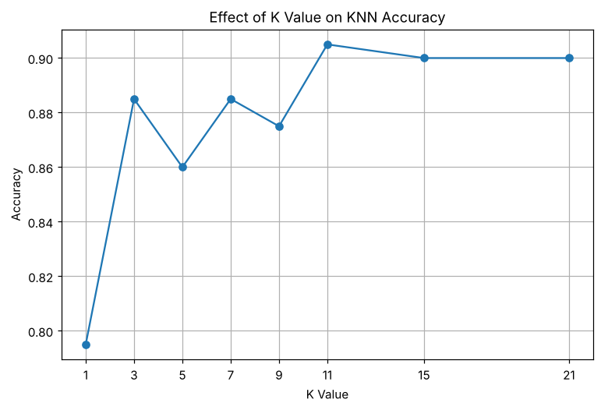
Best K: 11
Best Accuracy: 0.905
Best Precision: 0.9154929577464789
Best Recall: 0.8333333333333334
Best F1 Score: 0.87248322147651
======================================
FINAL KNN MODEL
======================================
Best K : 11
Accuracy : 0.905
Precision : 0.9154929577464789
Recall : 0.8333333333333334
F1 Score : 0.87248322147651
Specificity : 0.9508196721311475
AUC : 0.9550756620428752

5. RESULT
Thus, the K-Nearest Neighbors practical was implemented successfully. Among the K values tested, K = 11 gave the best performance, with an accuracy of 0.905, a precision of 0.9155, a recall of 0.8333, an F1 score of 0.8725 and an AUC of 0.9551.

EXERCISE – 09 (DECISION TREE)
1. AIM
To build a Decision Tree classifier for heart disease prediction and to evaluate and visualize the trained model.
2. ALGORITHM
1. Load the dataset and separate the features from the target Heart Disease.
2. Identify the numerical and categorical columns.
3. Build the preprocessing pipeline that scales the numerical features and one-hot encodes the categorical features.
4. Split the data into training and testing sets in an 80:20 ratio with stratification.
5. Train a DecisionTreeClassifier with max_depth = 4.
6. Predict the test set and calculate accuracy, precision, recall, F1 score, the classification report and the confusion matrix.
7. Visualize the confusion matrix and the trained decision tree.
3. PROGRAM
import pandas as pd
import matplotlib.pyplot as plt
from sklearn.model_selection import train_test_split
from sklearn.compose import ColumnTransformer
from sklearn.preprocessing import OneHotEncoder
from sklearn.pipeline import Pipeline
from sklearn.tree import DecisionTreeClassifier
from sklearn.tree import plot_tree
from sklearn.metrics import (
accuracy_score,
precision_score,
recall_score,
f1_score,
confusion_matrix,
classification_report,
ConfusionMatrixDisplay
)
df = pd.read_csv("heart_disease_dataset.csv")
print("First 5 rows:")
print(df.head())
print("\nDataset Shape:")
print(df.shape)
X = df.drop("Heart Disease", axis=1)
y = df["Heart Disease"]
print("\nFeatures:")
print(X.columns)
print("\nTarget:")
print(y.name)
categorical_columns = X.select_dtypes(
include=["object"]
).columns
numerical_columns = X.select_dtypes(
exclude=["object"]
).columns
print("\nCategorical Columns:")
print(list(categorical_columns))
print("\nNumerical Columns:")
print(list(numerical_columns))
preprocessor = ColumnTransformer(
transformers=[
(
"cat",
OneHotEncoder(handle_unknown="ignore"),
categorical_columns
)
],
remainder="passthrough"
)
decision_tree = DecisionTreeClassifier(
criterion="gini",
max_depth=4,
random_state=42
)
model = Pipeline(
steps=[
("preprocessor", preprocessor),
("classifier", decision_tree)
]
)
model = Pipeline(
steps=[
("preprocessor", preprocessor),
("classifier", decision_tree)
]
)
X_train, X_test, y_train, y_test = train_test_split(
X,
y,
test_size=0.20,
random_state=42,
stratify=y
)
print("\nTraining Data:", X_train.shape)
print("Testing Data:", X_test.shape)
model.fit(X_train, y_train)
print("\nDecision Tree Model Trained Successfully!")
y_pred = model.predict(X_test)
accuracy = accuracy_score(y_test, y_pred)
precision = precision_score(
y_test,
y_pred,
zero_division=0
)
recall = recall_score(
y_test,
y_pred,
zero_division=0
)
f1 = f1_score(
y_test,
y_pred,
zero_division=0
)
print("\n==========================================")
print(" DECISION TREE EVALUATION")
print("==========================================")
print("Accuracy :", round(accuracy, 4))
print("Precision :", round(precision, 4))
print("Recall :", round(recall, 4))
print("F1 Score :", round(f1, 4))
# ==========================================
# 12. Classification Report
# ==========================================
print("\nClassification Report:")
print(classification_report(y_test, y_pred))
# ==========================================
# 13. Confusion Matrix
# ==========================================
cm = confusion_matrix(y_test, y_pred)
print("\nConfusion Matrix:")
print(cm)
disp = ConfusionMatrixDisplay(
confusion_matrix=cm,
display_labels=["No Heart Disease", "Heart Disease"]
)
disp.plot()
plt.title("Confusion Matrix - Decision Tree")
plt.show()
# Get the trained classifier
tree_model = model.named_steps["classifier"]
# Get feature names after One-Hot Encoding
feature_names = model.named_steps[
"preprocessor"
].get_feature_names_out()
plt.figure(figsize=(25, 12))
plot_tree(
tree_model,
feature_names=feature_names,
class_names=["No Heart Disease", "Heart Disease"],
filled=True,
rounded=True,
fontsize=8
)
plt.title("Decision Tree for Heart Disease Classification")
plt.show()

4. OUTPUT
The program was executed on the Heart disease dataset (heart_disease_dataset.csv) and produced the following output:
First 5 rows:
Age Gender ... Chest Pain Type Heart Disease
0 75 Female ... Atypical Angina 1
1 48 Male ... Typical Angina 0
2 53 Male ... Atypical Angina 1
3 69 Female ... Non-anginal Pain 0
4 62 Female ... Asymptomatic 0
[5 rows x 16 columns]
Dataset Shape:
(1000, 16)
Features:
Index(['Age', 'Gender', 'Cholesterol', 'Blood Pressure', 'Heart Rate',
'Smoking', 'Alcohol Intake', 'Exercise Hours', 'Family History',
'Diabetes', 'Obesity', 'Stress Level', 'Blood Sugar',
'Exercise Induced Angina', 'Chest Pain Type'],
dtype='object')
Target:
Heart Disease
Categorical Columns:
['Gender', 'Smoking', 'Alcohol Intake', 'Family History', 'Diabetes', 'Obesity', 'Exercise Induced Angina', 'Chest Pain Type']
Numerical Columns:
['Age', 'Cholesterol', 'Blood Pressure', 'Heart Rate', 'Exercise Hours', 'Stress Level', 'Blood Sugar']
Training Data: (800, 15)
Testing Data: (200, 15)
Decision Tree Model Trained Successfully!
==========================================
DECISION TREE EVALUATION
==========================================
Accuracy : 1.0
Precision : 1.0
Recall : 1.0
F1 Score : 1.0
Classification Report:
precision recall f1-score support
0 1.00 1.00 1.00 122
1 1.00 1.00 1.00 78
accuracy 1.00 200
macro avg 1.00 1.00 1.00 200
weighted avg 1.00 1.00 1.00 200
Confusion Matrix:
[[122 0]
[ 0 78]]
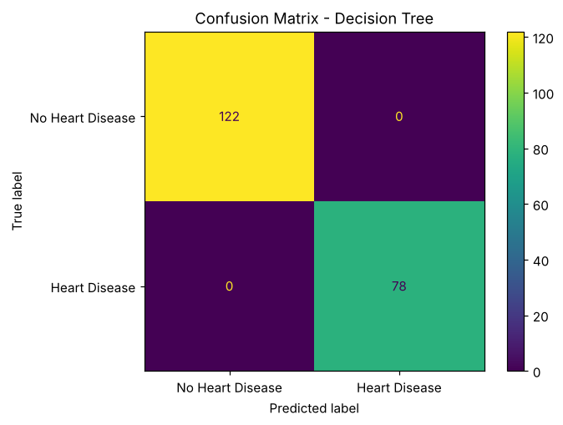
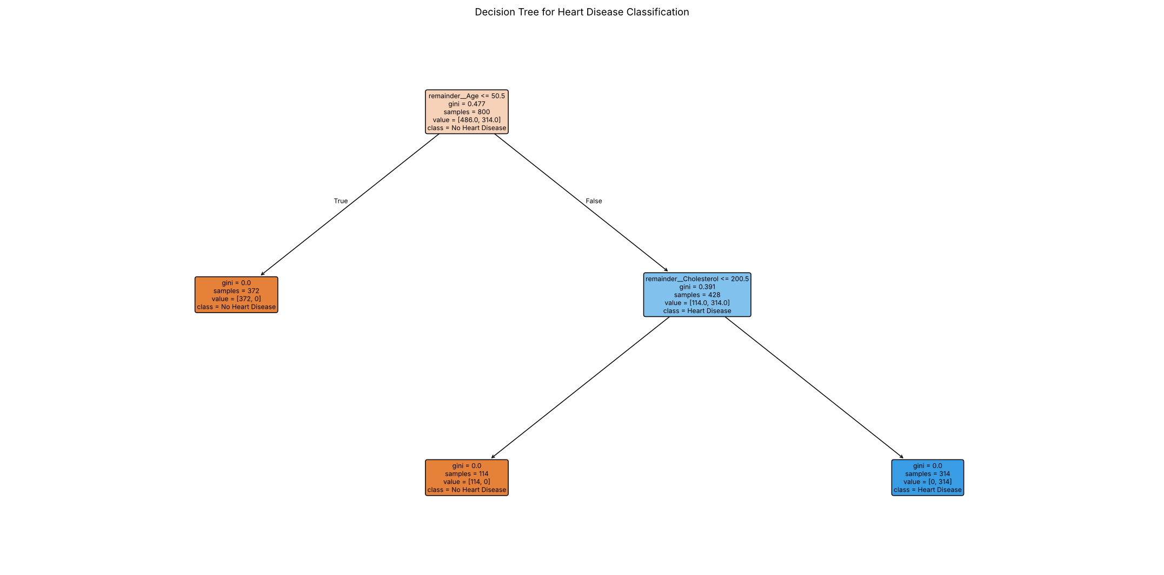

5. RESULT
Thus, the Decision Tree practical was implemented successfully. The tree of depth 4 classified all 200 test records correctly (accuracy, precision, recall and F1 score of 1.0), as shown by the confusion matrix with 122 true negatives and 78 true positives.

EXERCISE – 10 (RANDOM FOREST)
1. AIM
To build and evaluate a Random Forest classifier for heart disease prediction, including ROC-AUC analysis.
2. ALGORITHM
1. Load and inspect the dataset.
2. Check the structure, data types, missing values and target distribution.
3. Separate the features from the target Heart Disease.
4. Prepare the preprocessing for the numerical and categorical features.
5. Create a RandomForestClassifier with 100 trees and random_state = 42.
6. Split the data, train the model and generate predictions.
7. Calculate the training and testing accuracy, precision, recall and F1 score.
8. Plot the ROC curve and calculate the ROC-AUC score.
3. PROGRAM
# Import required libraries
import pandas as pd
import numpy as np
import matplotlib.pyplot as plt
import seaborn as sns
# Machine Learning libraries
from sklearn.model_selection import train_test_split
from sklearn.compose import ColumnTransformer
from sklearn.preprocessing import OneHotEncoder
from sklearn.pipeline import Pipeline
from sklearn.ensemble import RandomForestClassifier
# Evaluation metrics
from sklearn.metrics import (
accuracy_score,
precision_score,
recall_score,
f1_score,
classification_report,
confusion_matrix,
ConfusionMatrixDisplay,
roc_curve,
roc_auc_score
)
# Load the dataset
df = pd.read_csv("heart_disease_dataset.csv")
# Display first 5 rows
df.head()
# Display number of rows and columns
print("Dataset Shape:", df.shape)
# Display column names
print(df.columns)
# Display data types
df.info()
# Check missing values
print(df.isnull().sum())
# Check target class distribution
print(df["Heart Disease"].value_counts())
# X contains input features
# y contains the target variable
X = df.drop("Heart Disease", axis=1)
y = df["Heart Disease"]
print("Features Shape:", X.shape)
print("Target Shape:", y.shape)
# Identify numerical columns
numerical_features = X.select_dtypes(
include=["int64", "float64"]
).columns
# Identify categorical columns
categorical_features = X.select_dtypes(
include=["object"]
).columns
print("Numerical Features:")
print(list(numerical_features))
print("\nCategorical Features:")
print(list(categorical_features))
# Preprocessing for numerical and categorical features
preprocessor = ColumnTransformer(
transformers=[
("num", "passthrough", numerical_features),
("cat", OneHotEncoder(handle_unknown="ignore"),
categorical_features)
]
)
# Create Random Forest classifier
rf_model = RandomForestClassifier(
n_estimators=100,
criterion="gini",
max_depth=None,
min_samples_split=2,
min_samples_leaf=1,
max_features="sqrt",
random_state=42,
n_jobs=-1
)
# Combine preprocessing and Random Forest model
model = Pipeline(
steps=[
("preprocessor", preprocessor),
("classifier", rf_model)
]
)
# Split dataset into training and testing sets
X_train, X_test, y_train, y_test = train_test_split(
X,
y,
test_size=0.2,
random_state=42,
stratify=y
)
print("Training Data:", X_train.shape)
print("Testing Data:", X_test.shape)
# Train the model
model.fit(X_train, y_train)
print("Random Forest Model Trained Successfully!")
# Predict on training data
y_train_pred = model.predict(X_train)
# Predict on testing data
y_test_pred = model.predict(X_test)
print("Predictions Generated Successfully!")
# Calculate evaluation metrics
train_accuracy = accuracy_score(y_train, y_train_pred)
test_accuracy = accuracy_score(y_test, y_test_pred)
precision = precision_score(y_test, y_test_pred)
recall = recall_score(y_test, y_test_pred)
f1 = f1_score(y_test, y_test_pred)
print("Training Accuracy :", round(train_accuracy, 4))
print("Testing Accuracy :", round(test_accuracy, 4))
print("Precision :", round(precision, 4))
print("Recall :", round(recall, 4))
print("F1 Score :", round(f1, 4))
# Predict probabilities
y_test_proba = model.predict_proba(X_test)[:, 1]
# Calculate ROC curve
fpr, tpr, thresholds = roc_curve(y_test, y_test_proba)
# Calculate AUC
auc_score = roc_auc_score(y_test, y_test_proba)
print("ROC-AUC Score:", round(auc_score, 4))
# Plot ROC Curve
plt.figure(figsize=(8, 6))
plt.plot(
fpr,
tpr,
label=f"Random Forest (AUC = {auc_score:.2f})"
)
plt.plot(
[0, 1],
[0, 1],
linestyle="--",
label="Random Classifier"
)
plt.xlabel("False Positive Rate")
plt.ylabel("True Positive Rate")
plt.title("ROC Curve - Random Forest")
plt.legend()
plt.show()

4. OUTPUT
The program was executed on the Heart disease dataset (heart_disease_dataset.csv) and produced the following output:
Age Gender ... Chest Pain Type Heart Disease
0 75 Female ... Atypical Angina 1
1 48 Male ... Typical Angina 0
2 53 Male ... Atypical Angina 1
3 69 Female ... Non-anginal Pain 0
4 62 Female ... Asymptomatic 0
[5 rows x 16 columns]
Dataset Shape: (1000, 16)
Index(['Age', 'Gender', 'Cholesterol', 'Blood Pressure', 'Heart Rate',
'Smoking', 'Alcohol Intake', 'Exercise Hours', 'Family History',
'Diabetes', 'Obesity', 'Stress Level', 'Blood Sugar',
'Exercise Induced Angina', 'Chest Pain Type', 'Heart Disease'],
dtype='object')
<class 'pandas.core.frame.DataFrame'>
RangeIndex: 1000 entries, 0 to 999
Data columns (total 16 columns):
# Column Non-Null Count Dtype
--- ------ -------------- -----
0 Age 1000 non-null int64
1 Gender 1000 non-null object
2 Cholesterol 1000 non-null int64
3 Blood Pressure 1000 non-null int64
4 Heart Rate 1000 non-null int64
5 Smoking 1000 non-null object
6 Alcohol Intake 660 non-null object
7 Exercise Hours 1000 non-null int64
8 Family History 1000 non-null object
9 Diabetes 1000 non-null object
10 Obesity 1000 non-null object
11 Stress Level 1000 non-null int64
12 Blood Sugar 1000 non-null int64
13 Exercise Induced Angina 1000 non-null object
14 Chest Pain Type 1000 non-null object
15 Heart Disease 1000 non-null int64
dtypes: int64(8), str(8)
memory usage: 125.1 KB
Age 0
Gender 0
Cholesterol 0
Blood Pressure 0
Heart Rate 0
Smoking 0
Alcohol Intake 340
Exercise Hours 0
Family History 0
Diabetes 0
Obesity 0
Stress Level 0
Blood Sugar 0
Exercise Induced Angina 0
Chest Pain Type 0
Heart Disease 0
dtype: int64
Heart Disease
0 608
1 392
Name: count, dtype: int64
Features Shape: (1000, 15)
Target Shape: (1000,)
Numerical Features:
['Age', 'Cholesterol', 'Blood Pressure', 'Heart Rate', 'Exercise Hours', 'Stress Level', 'Blood Sugar']
Categorical Features:
['Gender', 'Smoking', 'Alcohol Intake', 'Family History', 'Diabetes', 'Obesity', 'Exercise Induced Angina', 'Chest Pain Type']
Training Data: (800, 15)
Testing Data: (200, 15)
Random Forest Model Trained Successfully!
Predictions Generated Successfully!
Training Accuracy : 1.0
Testing Accuracy : 0.99
Precision : 1.0
Recall : 0.9744
F1 Score : 0.987
ROC-AUC Score: 1.0
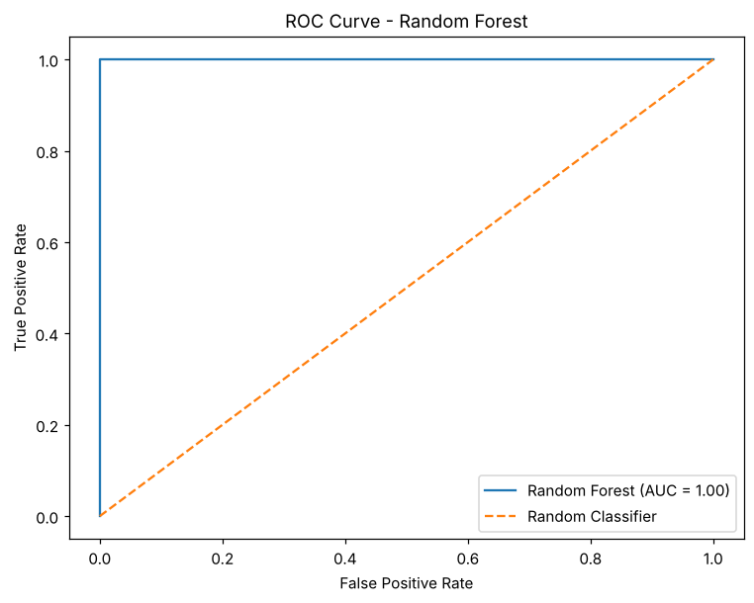

5. RESULT
Thus, the Random Forest practical was implemented successfully. The model obtained a training accuracy of 1.0 and a testing accuracy of 0.99, with a precision of 1.0, a recall of 0.9744, an F1 score of 0.987 and a ROC-AUC score of 1.0.

EXERCISE – 11 (SUPPORT VECTOR MACHINE)
1. AIM
To perform Support Vector Machine (SVM) classification using the Linear, Polynomial, RBF and Sigmoid kernels and to compare their performance.
2. ALGORITHM
1. Load the dataset and separate the features from the target Heart Disease.
2. Identify the numerical and categorical features.
3. Create the preprocessing that scales the numerical features and one-hot encodes the categorical features.
4. Split the data into training and testing sets in an 80:20 ratio with stratification.
5. Train an SVM model for each of the four kernels.
6. Calculate accuracy, precision, recall and F1 score for every kernel.
7. Compare the kernels in a table and a bar plot.
3. PROGRAM
# Step 1: Import libraries
import pandas as pd
import matplotlib.pyplot as plt
from sklearn.model_selection import train_test_split
from sklearn.compose import ColumnTransformer
from sklearn.preprocessing import StandardScaler, OneHotEncoder
from sklearn.pipeline import Pipeline
from sklearn.svm import SVC
from sklearn.metrics import (
accuracy_score,
precision_score,
recall_score,
f1_score,
classification_report,
confusion_matrix
)
df = pd.read_csv("heart_disease_dataset.csv")
print("Dataset Shape:", df.shape)
print("\nFirst 5 records:")
print(df.head())
X = df.drop("Heart Disease", axis=1)
y = df["Heart Disease"]
numeric_features = X.select_dtypes(include=["int64", "float64"]).columns
categorical_features = X.select_dtypes(include=["object"]).columns
print("\nNumerical Features:")
print(list(numeric_features))
print("\nCategorical Features:")
print(list(categorical_features))
preprocessor = ColumnTransformer(
transformers=[
("num", StandardScaler(), numeric_features),
("cat", OneHotEncoder(handle_unknown="ignore"), categorical_features)
]
)
X_train, X_test, y_train, y_test = train_test_split(
X,
y,
test_size=0.20,
random_state=42,
stratify=y
)
kernels = ["linear", "poly", "rbf", "sigmoid"]
results = []
for kernel in kernels:
model = Pipeline(
steps=[
("preprocessor", preprocessor),
("svm", SVC(kernel=kernel, random_state=42))
]
)
model.fit(X_train, y_train)
y_pred = model.predict(X_test)
accuracy = accuracy_score(y_test, y_pred)
precision = precision_score(y_test, y_pred, zero_division=0)
recall = recall_score(y_test, y_pred, zero_division=0)
f1 = f1_score(y_test, y_pred, zero_division=0)
results.append([
kernel,
accuracy,
precision,
recall,
f1
])
print("\n======================================")
print("SVM Kernel:", kernel)
print("======================================")
print("Accuracy :", accuracy)
print("Precision:", precision)
print("Recall :", recall)
print("F1 Score :", f1)
print("\nClassification Report:")
print(classification_report(
y_test,
y_pred,
zero_division=0
))
results_df = pd.DataFrame(
results,
columns=[
"Kernel",
"Accuracy",
"Precision",
"Recall",
"F1 Score"
]
)
print("\n\nKernel Comparison:")
print(results_df)
plt.figure(figsize=(8, 5))
plt.bar(
results_df["Kernel"],
results_df["Accuracy"]
)
plt.xlabel("SVM Kernel")
plt.ylabel("Accuracy")
plt.title("SVM Performance with Different Kernels")
plt.ylim(0, 1)
plt.show()
# ------------------------------------------------------------
# Result
# ------------------------------------------------------------
print("\nResult:")
print("SVM classification was successfully performed")
print("using Linear, Polynomial, RBF and Sigmoid kernels.")

4. OUTPUT
The program was executed on the Heart disease dataset (heart_disease_dataset.csv) and produced the following output:
Dataset Shape: (1000, 16)
First 5 records:
Age Gender ... Chest Pain Type Heart Disease
0 75 Female ... Atypical Angina 1
1 48 Male ... Typical Angina 0
2 53 Male ... Atypical Angina 1
3 69 Female ... Non-anginal Pain 0
4 62 Female ... Asymptomatic 0
[5 rows x 16 columns]
Numerical Features:
['Age', 'Cholesterol', 'Blood Pressure', 'Heart Rate', 'Exercise Hours', 'Stress Level', 'Blood Sugar']
Categorical Features:
['Gender', 'Smoking', 'Alcohol Intake', 'Family History', 'Diabetes', 'Obesity', 'Exercise Induced Angina', 'Chest Pain Type']
======================================
SVM Kernel: linear
======================================
Accuracy : 0.875
Precision: 0.8732394366197183
Recall : 0.7948717948717948
F1 Score : 0.8322147651006712
Classification Report:
precision recall f1-score support
0 0.88 0.93 0.90 122
1 0.87 0.79 0.83 78
accuracy 0.88 200
macro avg 0.87 0.86 0.87 200
weighted avg 0.87 0.88 0.87 200
======================================
SVM Kernel: poly
======================================
Accuracy : 0.925
Precision: 0.9315068493150684
Recall : 0.8717948717948718
F1 Score : 0.9006622516556292
Classification Report:
precision recall f1-score support
0 0.92 0.96 0.94 122
1 0.93 0.87 0.90 78
accuracy 0.93 200
macro avg 0.93 0.92 0.92 200
weighted avg 0.93 0.93 0.92 200
======================================
SVM Kernel: rbf
======================================
Accuracy : 0.905
Precision: 0.8933333333333333
Recall : 0.8589743589743589
F1 Score : 0.8758169934640523
Classification Report:
precision recall f1-score support
0 0.91 0.93 0.92 122
1 0.89 0.86 0.88 78
accuracy 0.91 200
macro avg 0.90 0.90 0.90 200
weighted avg 0.90 0.91 0.90 200
======================================
SVM Kernel: sigmoid
======================================
Accuracy : 0.825
Precision: 0.8028169014084507
Recall : 0.7307692307692307
F1 Score : 0.7651006711409396
Classification Report:
precision recall f1-score support
0 0.84 0.89 0.86 122
1 0.80 0.73 0.77 78
accuracy 0.82 200
macro avg 0.82 0.81 0.81 200
weighted avg 0.82 0.82 0.82 200
Kernel Comparison:
Kernel Accuracy Precision Recall F1 Score
0 linear 0.875 0.873239 0.794872 0.832215
1 poly 0.925 0.931507 0.871795 0.900662
2 rbf 0.905 0.893333 0.858974 0.875817
3 sigmoid 0.825 0.802817 0.730769 0.765101
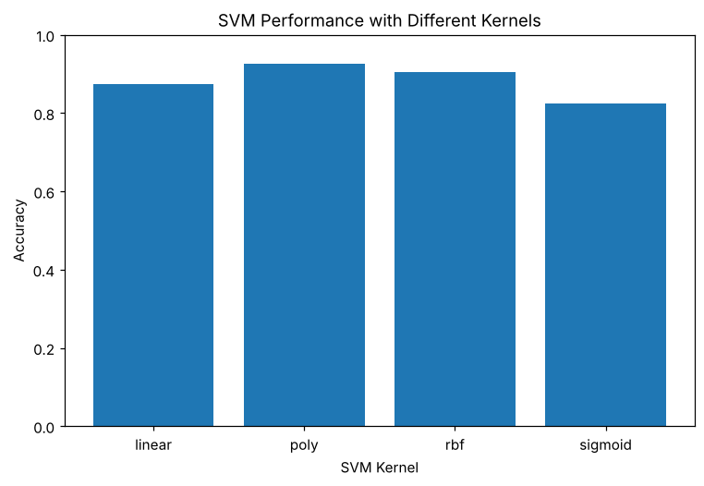
Result:
SVM classification was successfully performed
using Linear, Polynomial, RBF and Sigmoid kernels.

5. RESULT
Thus, the Support Vector Machine practical was implemented successfully. The polynomial kernel performed best with an accuracy of 0.925 and an F1 score of 0.9007, followed by the RBF kernel (0.905), the linear kernel (0.875) and the sigmoid kernel (0.825).

EXERCISE – 12 (HYPERPARAMETER TUNING)
1. AIM
To tune the hyperparameters of a Support Vector Machine classifier for heart disease prediction using GridSearchCV with cross-validation.
2. ALGORITHM
1. Load the dataset and separate the features from the target Heart Disease.
2. Build a pipeline that scales the numerical features, one-hot encodes the categorical features and applies an SVC model.
3. Split the data into training and testing sets in an 80:20 ratio with stratification.
4. Define the parameter grid for C (0.1, 1, 10, 100), kernel (linear, rbf, poly) and gamma (scale, auto).
5. Run GridSearchCV with 5-fold cross-validation using accuracy as the scoring metric.
6. Display the best parameters and the best cross-validation score.
7. Evaluate the best model on the test set using accuracy, precision, recall, F1 score and the classification report.
3. PROGRAM
import pandas as pd
from sklearn.model_selection import train_test_split, GridSearchCV
from sklearn.compose import ColumnTransformer
from sklearn.preprocessing import StandardScaler, OneHotEncoder
from sklearn.pipeline import Pipeline
from sklearn.svm import SVC
from sklearn.metrics import (
accuracy_score,
precision_score,
recall_score,
f1_score,
classification_report,
confusion_matrix
)
df = pd.read_csv("heart_disease_dataset.csv")
print("Dataset Shape:", df.shape)
print(df.head())
X = df.drop("Heart Disease", axis=1)
y = df["Heart Disease"]
numeric_features = X.select_dtypes(
include=["int64", "float64"]
).columns
categorical_features = X.select_dtypes(
include=["object"]
).columns
preprocessor = ColumnTransformer(
transformers=[
("num", StandardScaler(), numeric_features),
("cat", OneHotEncoder(handle_unknown="ignore"), categorical_features)
]
)
pipeline = Pipeline(
steps=[
("preprocessor", preprocessor),
("svm", SVC())
]
)
X_train, X_test, y_train, y_test = train_test_split(
X,
y,
test_size=0.20,
random_state=42,
stratify=y
)
param_grid = {
"svm__C": [0.1, 1, 10, 100],
"svm__kernel": [
"linear",
"rbf",
"poly"
],
"svm__gamma": [
"scale",
"auto"
]
}
grid_search = GridSearchCV(
estimator=pipeline,
param_grid=param_grid,
cv=5,
scoring="accuracy",
n_jobs=-1
)
print("\nTraining GridSearchCV...")
grid_search.fit(X_train, y_train)
print("\n====================================")
print("BEST PARAMETERS")
print("====================================")
print(grid_search.best_params_)
print("\nBest Cross Validation Score:")
print(grid_search.best_score_)
best_model = grid_search.best_estimator_
y_pred = best_model.predict(X_test)
print("Accuracy :",
accuracy_score(y_test, y_pred))
print("Precision:",
precision_score(y_test, y_pred, zero_division=0))
print("Recall :",
recall_score(y_test, y_pred, zero_division=0))
print("F1 Score :",
f1_score(y_test, y_pred, zero_division=0))
print("\nClassification Report:")
print(classification_report(
y_test,
y_pred,
zero_division=0
))
print("\nResult:")
print("SVM hyperparameters were successfully tuned")
print("using GridSearchCV.")

4. OUTPUT
The program was executed on the Heart disease dataset (heart_disease_dataset.csv) and produced the following output:
Dataset Shape: (1000, 16)
Age Gender ... Chest Pain Type Heart Disease
0 75 Female ... Atypical Angina 1
1 48 Male ... Typical Angina 0
2 53 Male ... Atypical Angina 1
3 69 Female ... Non-anginal Pain 0
4 62 Female ... Asymptomatic 0
[5 rows x 16 columns]
Training GridSearchCV...
====================================
BEST PARAMETERS
====================================
{'svm__C': 100, 'svm__gamma': 'auto', 'svm__kernel': 'rbf'}
Best Cross Validation Score:
0.9225
Accuracy : 0.915
Precision: 0.9066666666666666
Recall : 0.8717948717948718
F1 Score : 0.8888888888888888
Classification Report:
precision recall f1-score support
0 0.92 0.94 0.93 122
1 0.91 0.87 0.89 78
accuracy 0.92 200
macro avg 0.91 0.91 0.91 200
weighted avg 0.91 0.92 0.91 200
Result:
SVM hyperparameters were successfully tuned
using GridSearchCV.

5. RESULT
Thus, the Hyperparameter Tuning practical was implemented successfully. GridSearchCV selected C = 100, kernel = rbf and gamma = auto with a best cross-validation accuracy of 0.9225. On the test set the tuned model achieved an accuracy of 0.915, a precision of 0.9067, a recall of 0.8718 and an F1 score of 0.8889.

EXERCISE – 13 (K-MEANS CLUSTERING)
1. AIM
To perform K-Means clustering on the heart disease dataset and to use the Elbow Method to determine a suitable number of clusters.
2. ALGORITHM
1. Load the dataset and remove the target column Heart Disease.
2. Scale the numerical features and one-hot encode the categorical features to obtain the processed feature matrix.
3. Run K-Means for K = 1 to 10 and record the inertia of every run.
4. Plot the Elbow curve of inertia against K.
5. Select the optimal K and fit the final K-Means model.
6. Add the cluster labels to the dataset and count the records in each cluster.
3. PROGRAM
import pandas as pd
import matplotlib.pyplot as plt
from sklearn.compose import ColumnTransformer
from sklearn.preprocessing import StandardScaler, OneHotEncoder
from sklearn.cluster import KMeans
df = pd.read_csv("heart_disease_dataset.csv")
print("Dataset Shape:", df.shape)
print("\nFirst 5 records:")
print(df.head())
X = df.drop("Heart Disease", axis=1)
numeric_features = X.select_dtypes(
include=["int64", "float64"]
).columns
categorical_features = X.select_dtypes(
include=["object"]
).columns
preprocessor = ColumnTransformer(
transformers=[
("num", StandardScaler(), numeric_features),
("cat", OneHotEncoder(handle_unknown="ignore"), categorical_features)
]
)
X_processed = preprocessor.fit_transform(X)
# Check whether X_processed is sparse or already a NumPy array
if hasattr(X_processed, "toarray"):
X_processed = X_processed.toarray()
print("\nProcessed Data Shape:")
print(X_processed.shape)
# ------------------------------------------------------------
# Step 7: Apply Elbow Method
# ------------------------------------------------------------
inertia = []
K = range(1, 11)
for k in K:
kmeans = KMeans(
n_clusters=k,
random_state=42,
n_init=10
)
kmeans.fit(X_processed)
inertia.append(kmeans.inertia_)
plt.figure(figsize=(8, 5))
plt.plot(
K,
inertia,
marker="o"
)
plt.xlabel("Number of Clusters (K)")
plt.ylabel("Inertia")
plt.title("Elbow Method for Optimal K")
plt.xticks(K)
plt.grid(True)
plt.show()
# Change this value after observing the elbow plot.
optimal_k = 3
print("\nSelected Optimal K:", optimal_k)
kmeans = KMeans(
n_clusters=optimal_k,
random_state=42,
n_init=10
)
clusters = kmeans.fit_predict(X_processed)
df["Cluster"] = clusters
print("\nClustered Dataset:")
print(df.head(10))
print("\nNumber of records in each cluster:")
print(df["Cluster"].value_counts().sort_index())

4. OUTPUT
The program was executed on the Heart disease dataset (heart_disease_dataset.csv) and produced the following output:
Dataset Shape: (1000, 16)
First 5 records:
Age Gender ... Chest Pain Type Heart Disease
0 75 Female ... Atypical Angina 1
1 48 Male ... Typical Angina 0
2 53 Male ... Atypical Angina 1
3 69 Female ... Non-anginal Pain 0
4 62 Female ... Asymptomatic 0
[5 rows x 16 columns]
Processed Data Shape:
(1000, 27)
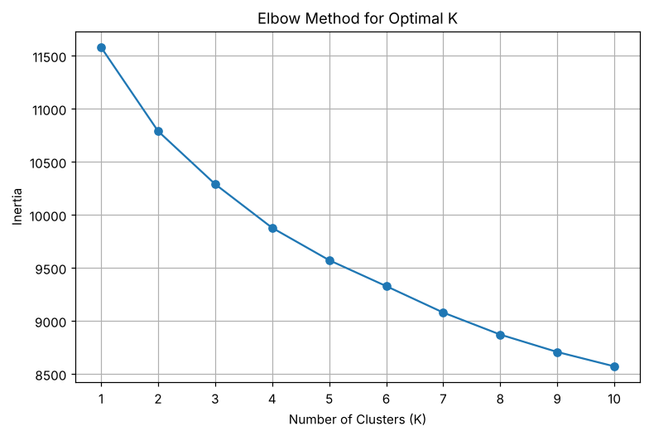
Selected Optimal K: 3
Clustered Dataset:
Age Gender Cholesterol ... Chest Pain Type Heart Disease Cluster
0 75 Female 228 ... Atypical Angina 1 0
1 48 Male 204 ... Typical Angina 0 1
2 53 Male 234 ... Atypical Angina 1 0
3 69 Female 192 ... Non-anginal Pain 0 1
4 62 Female 172 ... Asymptomatic 0 0
5 77 Male 309 ... Asymptomatic 1 0
6 64 Female 211 ... Typical Angina 1 1
7 60 Female 208 ... Asymptomatic 1 1
8 37 Female 317 ... Non-anginal Pain 0 2
9 63 Male 204 ... Asymptomatic 1 1
[10 rows x 17 columns]
Number of records in each cluster:
Cluster
0 308
1 337
2 355
Name: count, dtype: int64

5. RESULT
Thus, the K-Means Clustering practical was implemented successfully. The Elbow curve indicated K = 3 as a suitable number of clusters, and the 1000 records were grouped into clusters of 308, 337 and 355 records.

EXERCISE – 14 (HIERARCHICAL CLUSTERING)
1. AIM
To perform hierarchical clustering on the preprocessed heart disease dataset using Ward linkage and to visualize the hierarchy with a dendrogram.
2. ALGORITHM
1. Load the dataset and remove the target column Heart Disease.
2. Identify the numerical and categorical features.
3. Standardize the numerical features and one-hot encode the categorical features.
4. Convert the processed data into a dense array of 1000 records and 27 features.
5. Perform agglomerative clustering using the Ward linkage method.
6. Plot the truncated dendrogram showing the last 30 merged clusters.
3. PROGRAM
import pandas as pd
import matplotlib.pyplot as plt
from sklearn.compose import ColumnTransformer
from sklearn.preprocessing import StandardScaler, OneHotEncoder
from scipy.cluster.hierarchy import (
dendrogram,
linkage
)
df = pd.read_csv("heart_disease_dataset.csv")
print("Dataset Shape:", df.shape)
print("\nFirst 5 records:")
print(df.head())
X = df.drop("Heart Disease", axis=1)
numeric_features = X.select_dtypes(
include=["int64", "float64"]
).columns
categorical_features = X.select_dtypes(
include=["object"]
).columns
preprocessor = ColumnTransformer(
transformers=[
("num", StandardScaler(), numeric_features),
("cat", OneHotEncoder(handle_unknown="ignore"), categorical_features)
]
)
X_processed = preprocessor.fit_transform(X)
# Check whether X_processed is sparse or already a NumPy array
if hasattr(X_processed, "toarray"):
X_processed = X_processed.toarray()
print("\nProcessed Data Shape:")
print(X_processed.shape)
linked = linkage(
X_processed,
method="ward"
)
plt.figure(figsize=(14, 7))
dendrogram(
linked,
truncate_mode="lastp",
p=30,
leaf_rotation=90,
leaf_font_size=10,
show_contracted=True
)
plt.title("Hierarchical Clustering Dendrogram")
plt.xlabel("Cluster / Data Points")
plt.ylabel("Distance")
plt.show()

4. OUTPUT
The program was executed on the Heart disease dataset (heart_disease_dataset.csv) and produced the following output:
Dataset Shape: (1000, 16)
First 5 records:
Age Gender ... Chest Pain Type Heart Disease
0 75 Female ... Atypical Angina 1
1 48 Male ... Typical Angina 0
2 53 Male ... Atypical Angina 1
3 69 Female ... Non-anginal Pain 0
4 62 Female ... Asymptomatic 0
[5 rows x 16 columns]
Processed Data Shape:
(1000, 27)
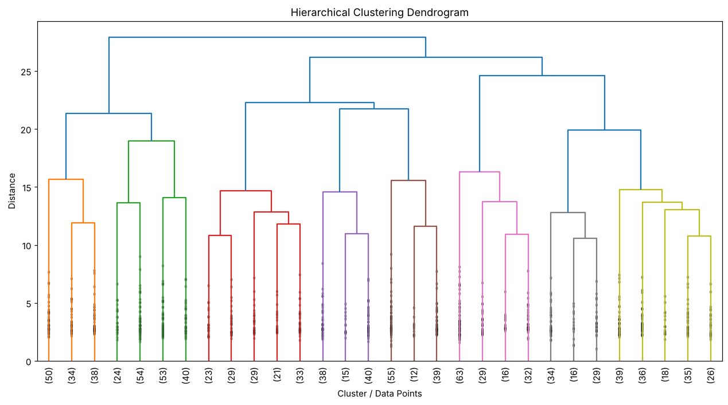

5. RESULT
Thus, the Hierarchical Clustering practical was implemented successfully. Ward linkage was applied to the 1000 records with 27 processed features, and the resulting dendrogram shows how the records are merged step by step into larger clusters.

EXERCISE – 15 (DBSCAN CLUSTERING)
1. AIM
To perform DBSCAN clustering on the heart disease dataset, identify the clusters and noise points, and visualize the clustering result using PCA.
2. ALGORITHM
1. Load the dataset and separate the target.
2. Identify the numerical and categorical features.
3. Scale the numerical features and one-hot encode the categorical features.
4. Apply DBSCAN with eps = 1.5 and min_samples = 5.
5. Assign the cluster labels, identify the noise points and count the clusters.
6. Apply PCA to reduce the data to two dimensions and plot the clustering result.
3. PROGRAM
import pandas as pd
import matplotlib.pyplot as plt
from sklearn.compose import ColumnTransformer
from sklearn.preprocessing import StandardScaler, OneHotEncoder
from sklearn.cluster import DBSCAN
from sklearn.decomposition import PCA
df = pd.read_csv("heart_disease_dataset.csv")
print("Dataset Shape:", df.shape)
print("\nFirst 5 records:")
print(df.head())
X = df.drop("Heart Disease", axis=1)
numeric_features = X.select_dtypes(
include=["int64", "float64"]
).columns
categorical_features = X.select_dtypes(
include=["object"]
).columns
preprocessor = ColumnTransformer(
transformers=[
("num", StandardScaler(), numeric_features),
("cat", OneHotEncoder(handle_unknown="ignore"), categorical_features)
]
)
X_processed = preprocessor.fit_transform(X)
X_processed = X_processed
dbscan = DBSCAN(
eps=1.5,
min_samples=5
)
labels = dbscan.fit_predict(X_processed)
df["Cluster"] = labels
print("\nCluster Labels:")
print(df["Cluster"].value_counts().sort_index())
noise_points = df[df["Cluster"] == -1]
print("\nNumber of Noise Points:")
print(len(noise_points))
print("\nNoise Points:")
print(noise_points.head(10))
number_of_clusters = len(
set(labels)
) - (1 if -1 in labels else 0)
print("\nNumber of Clusters:")
print(number_of_clusters)
pca = PCA(n_components=2)
X_pca = pca.fit_transform(X_processed)
plt.figure(figsize=(9, 6))
plt.scatter(
X_pca[:, 0],
X_pca[:, 1],
c=labels,
cmap="viridis",
s=40
)
plt.xlabel("Principal Component 1")
plt.ylabel("Principal Component 2")
plt.title("DBSCAN Clustering")
plt.colorbar(label="Cluster")
plt.show()

4. OUTPUT
The program was executed on the Heart disease dataset (heart_disease_dataset.csv) and produced the following output:
Dataset Shape: (1000, 16)
First 5 records:
Age Gender ... Chest Pain Type Heart Disease
0 75 Female ... Atypical Angina 1
1 48 Male ... Typical Angina 0
2 53 Male ... Atypical Angina 1
3 69 Female ... Non-anginal Pain 0
4 62 Female ... Asymptomatic 0
[5 rows x 16 columns]
Cluster Labels:
Cluster
-1 1000
Name: count, dtype: int64
Number of Noise Points:
1000
Noise Points:
Age Gender Cholesterol ... Chest Pain Type Heart Disease Cluster
0 75 Female 228 ... Atypical Angina 1 -1
1 48 Male 204 ... Typical Angina 0 -1
2 53 Male 234 ... Atypical Angina 1 -1
3 69 Female 192 ... Non-anginal Pain 0 -1
4 62 Female 172 ... Asymptomatic 0 -1
5 77 Male 309 ... Asymptomatic 1 -1
6 64 Female 211 ... Typical Angina 1 -1
7 60 Female 208 ... Asymptomatic 1 -1
8 37 Female 317 ... Non-anginal Pain 0 -1
9 63 Male 204 ... Asymptomatic 1 -1
[10 rows x 17 columns]
Number of Clusters:
0
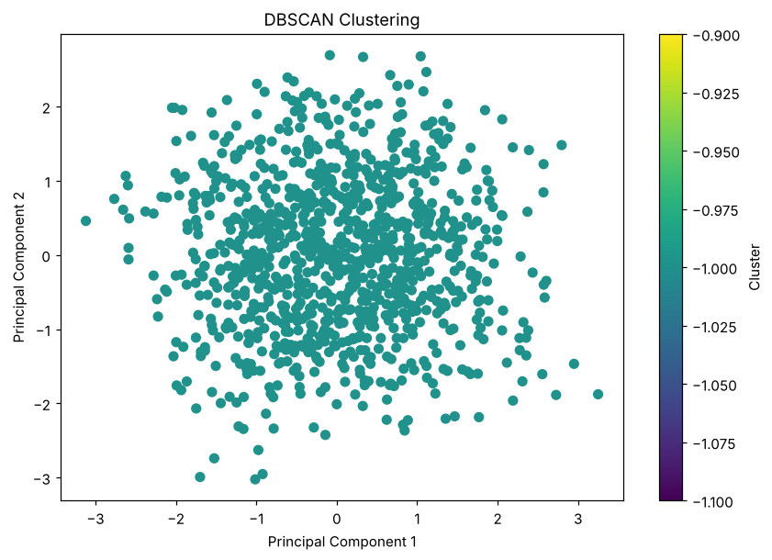

5. RESULT
Thus, the DBSCAN Clustering practical was implemented successfully. With eps = 1.5 and min_samples = 5, no point had five neighbours within that distance in the 27-dimensional feature space, so all 1000 records were labelled as noise and no cluster was formed.

EXERCISE – 16 (PRINCIPAL COMPONENT ANALYSIS)
1. AIM
To apply Principal Component Analysis (PCA) to reduce the preprocessed heart disease feature space to two components and to measure the explained variance.
2. ALGORITHM
1. Load the dataset and separate the target.
2. Identify the numerical and categorical features.
3. Scale the numerical features and one-hot encode the categorical features.
4. Convert the processed data into a dense array when required.
5. Fit PCA with two components.
6. Transform the data and calculate the explained variance of each component.
7. Plot the two principal components.
3. PROGRAM
import pandas as pd
import matplotlib.pyplot as plt
from sklearn.compose import ColumnTransformer
from sklearn.preprocessing import StandardScaler, OneHotEncoder
from sklearn.decomposition import PCA
df = pd.read_csv("heart_disease_dataset.csv")
print("Dataset Shape:", df.shape)
print("\nFirst 5 records:")
print(df.head())
X = df.drop("Heart Disease", axis=1)
numeric_features = X.select_dtypes(
include=["int64", "float64"]
).columns
categorical_features = X.select_dtypes(
include=["object"]
).columns
preprocessor = ColumnTransformer(
transformers=[
("num", StandardScaler(), numeric_features),
("cat", OneHotEncoder(handle_unknown="ignore"), categorical_features)
]
)
X_processed = preprocessor.fit_transform(X)
# Check whether X_processed is sparse or already a NumPy array
if hasattr(X_processed, "toarray"):
X_processed = X_processed.toarray()
print("\nProcessed Data Shape:")
print(X_processed.shape)
pca = PCA(
n_components=2
)
X_pca = pca.fit_transform(X_processed)
pca_df = pd.DataFrame(
X_pca,
columns=[
"Principal Component 1",
"Principal Component 2"
]
)
print("\nPCA Transformed Data:")
print(pca_df.head())
print("\nExplained Variance Ratio:")
print(pca.explained_variance_ratio_)
total_variance = pca.explained_variance_ratio_.sum()
print("\nTotal Variance Explained:")
print(total_variance)
print(
"\nPercentage of Variance Explained:",
total_variance * 100,
"%"
)
plt.figure(figsize=(9, 6))
plt.scatter(
X_pca[:, 0],
X_pca[:, 1],
s=40
)
plt.xlabel("Principal Component 1")
plt.ylabel("Principal Component 2")
plt.title("PCA Visualization")
plt.grid(True)
plt.show()

4. OUTPUT
The program was executed on the Heart disease dataset (heart_disease_dataset.csv) and produced the following output:
Dataset Shape: (1000, 16)
First 5 records:
Age Gender ... Chest Pain Type Heart Disease
0 75 Female ... Atypical Angina 1
1 48 Male ... Typical Angina 0
2 53 Male ... Atypical Angina 1
3 69 Female ... Non-anginal Pain 0
4 62 Female ... Asymptomatic 0
[5 rows x 16 columns]
Processed Data Shape:
(1000, 27)
PCA Transformed Data:
Principal Component 1 Principal Component 2
0 0.014498 0.006885
1 1.327783 -1.536746
2 -0.344586 2.189857
3 -0.724487 0.102921
4 -2.001347 -0.278023
Explained Variance Ratio:
[0.09800253 0.09356834]
Total Variance Explained:
0.1915708662733832
Percentage of Variance Explained: 19.15708662733832 %
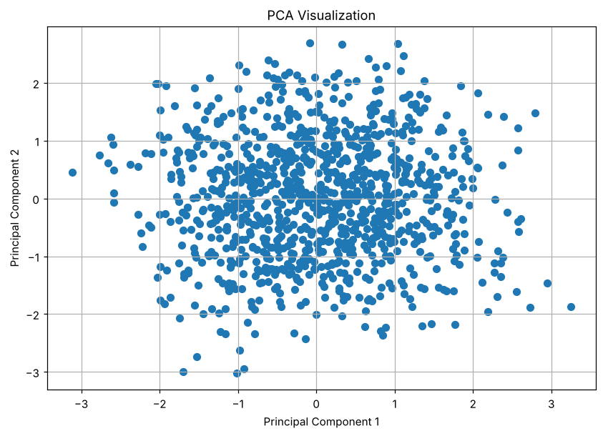

5. RESULT
Thus, the Principal Component Analysis practical was implemented successfully. The 27 processed features were reduced to two components that explain 9.80% and 9.36% of the variance, a total of 19.16%.

