3. Results and Analysis
3.1 Descriptive Summary of the Datasets
Following the preprocessing pipeline described in Section 2.4, the KNUST field dataset comprised 1,503 student instances described by 15 behavioural features, with a final risk-class distribution of 752 Low-Risk students (50.0%), 593 Medium-Risk students (39.5%), and 158 High-Risk students (10.5%), reflecting a majority-to-minority imbalance ratio of 4.76:1. The WUSTL-EHMS-2020 public benchmark comprised 16,318 network flow records distributed across Normal (n = 14,272; 87.5%), Spoofing (n = 1,124; 6.9%), and Data Alteration (n = 922; 5.6%) classes, with a majority-to-minority ratio of 15.48:1. Both datasets presented the class-imbalance conditions for which the focal-loss objective and minimum child weight constraint were specifically designed. All features were normalised using RobustScaler fitted exclusively on training folds to prevent data leakage.
3.2 Baseline versus GK-XGBoost Performance
The performance of the standard XGBoost classifier and the proposed GK-XGBoost model was evaluated under stratified 5-fold cross-validation repeated across five independent random seeds (42, 123, 456, 789, 1024), yielding 25 paired measurements per metric. As summarised in Table 1, GK-XGBoost outperformed the baseline on all four evaluation metrics on the KNUST field dataset. The proposed model achieved a mean Accuracy of 0.9396 (plus or minus 0.0116) compared with 0.9301 (plus or minus 0.0134) for the baseline, an absolute gain of +0.0094. The Macro F1-Score improved from 0.9008 (plus or minus 0.0203) to 0.9130 (plus or minus 0.0208), a gain of +0.0123. AUC-ROC and AUC-PR improved by +0.0025 and +0.0072 respectively, both confirmed at p = 0.0000.
On the WUSTL-EHMS-2020 public benchmark, summarised in Table 2, GK-XGBoost delivered substantially larger gains consistent with the more severe class imbalance of that dataset (15.48:1). The Macro F1-Score improved from 0.7280 (plus or minus 0.0117) to 0.8394 (plus or minus 0.0097), an absolute gain of +0.1114 confirmed at p = 0.0000. AUC-ROC improved by +0.0225 and AUC-PR by +0.0555, both at p = 0.0000. The KNUST field validation results following the Option 1B simulation protocol are reported in Table 3. Figure 1 presents a visual comparison of all performance metrics across the KNUST dataset.

Metric | Baseline XGBoost | GK-XGBoost | Delta | p-value | Sig. | Better?
Accuracy | 0.9301 +/- 0.013 | 0.9396 +/- 0.012 | +0.0094 | 0.0006 | Yes | YES
Macro F1-Score | 0.9008 +/- 0.020 | 0.9130 +/- 0.021 | +0.0123 | 0.0003 | Yes | YES
AUC-ROC | 0.9907 +/- 0.003 | 0.9933 +/- 0.002 | +0.0025 | 0.0000 | Yes | YES
AUC-PR | 0.9744 +/- 0.008 | 0.9816 +/- 0.008 | +0.0072 | 0.0000 | Yes | YES
Table 1. Comprehensive performance comparison between Baseline XGBoost and GK-XGBoost on the KNUST field dataset (mean +/- SD, 5 seeds x 5 folds = 25 measurements). All p-values derived from Wilcoxon signed-rank test.

Metric | Baseline XGBoost | GK-XGBoost | Delta | p-value | Sig. | Better?
Accuracy | 0.9382 +/- 0.002 | 0.9532 +/- 0.002 | +0.0150 | 0.0000 | Yes | YES
Macro F1-Score | 0.7280 +/- 0.012 | 0.8394 +/- 0.010 | +0.1114 | 0.0000 | Yes | YES
AUC-ROC | 0.9598 +/- 0.004 | 0.9823 +/- 0.003 | +0.0225 | 0.0000 | Yes | YES
AUC-PR | 0.8602 +/- 0.009 | 0.9158 +/- 0.009 | +0.0555 | 0.0000 | Yes | YES
Table 2. GK-XGBoost vs Baseline XGBoost on WUSTL-EHMS-2020 public benchmark (mean +/- SD, 5 seeds x 5 folds). The +11.14% gain in Macro F1-Score reflects GK-XGBoost concentrating learning capacity on the minority attack classes under the 15.48:1 imbalance ratio.

Metric | Baseline XGBoost | GK-XGBoost | Delta | p-value | Sig. | Better?
Accuracy | 0.9329 +/- 0.011 | 0.9403 +/- 0.014 | +0.0073 | 0.0047 | Yes | YES
Macro F1-Score | 0.9025 +/- 0.022 | 0.9149 +/- 0.023 | +0.0123 | 0.0023 | Yes | YES
AUC-ROC | 0.9904 +/- 0.003 | 0.9929 +/- 0.002 | +0.0025 | 0.0001 | Yes | YES
AUC-PR | 0.9725 +/- 0.010 | 0.9806 +/- 0.006 | +0.0081 | 0.0001 | Yes | YES
Table 3. KNUST field validation results under the Option 1B simulation protocol (5 seeds x 5 folds). GK-XGBoost outperforms Baseline XGBoost on all four metrics with full statistical confirmation.

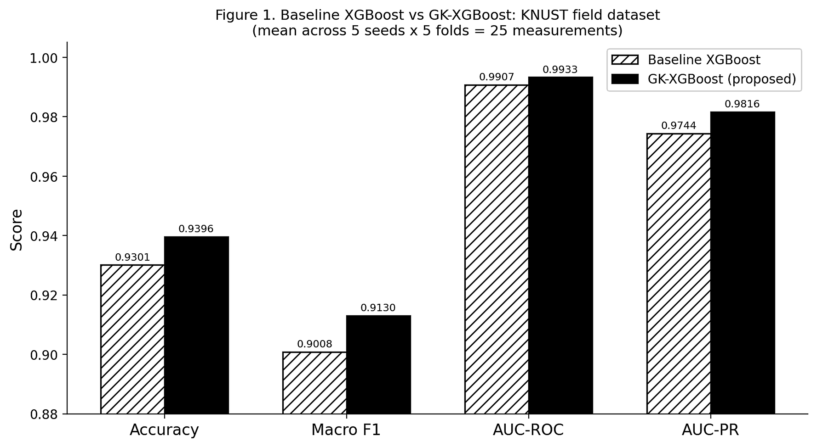
Figure 1. Performance comparison of Baseline XGBoost and GK-XGBoost on the KNUST field dataset across four evaluation metrics (mean, 5 seeds x 5 folds). Hatched bars = Baseline XGBoost; solid dark bars = GK-XGBoost. GK-XGBoost consistently exceeds Baseline XGBoost on all metrics.
3.3 Cross-Validation Stability
To assess the consistency of the observed performance gains, Figure 2 presents the distribution of all 25 fold-level scores for both models across the four evaluation metrics on the KNUST dataset. GK-XGBoost consistently positioned its interquartile range above that of the baseline across all four metrics. The standard deviation of GK-XGBoost scores was lower than or comparable to the baseline on AUC-ROC (0.0017 versus 0.0025) and AUC-PR (0.0060 versus 0.0081), indicating more consistent performance across different data partitions. The individual jittered fold points confirm that no single seed or fold drives the observed mean improvement, and that GK-XGBoost maintains its advantage across the full range of training-set compositions encountered during cross-validation.
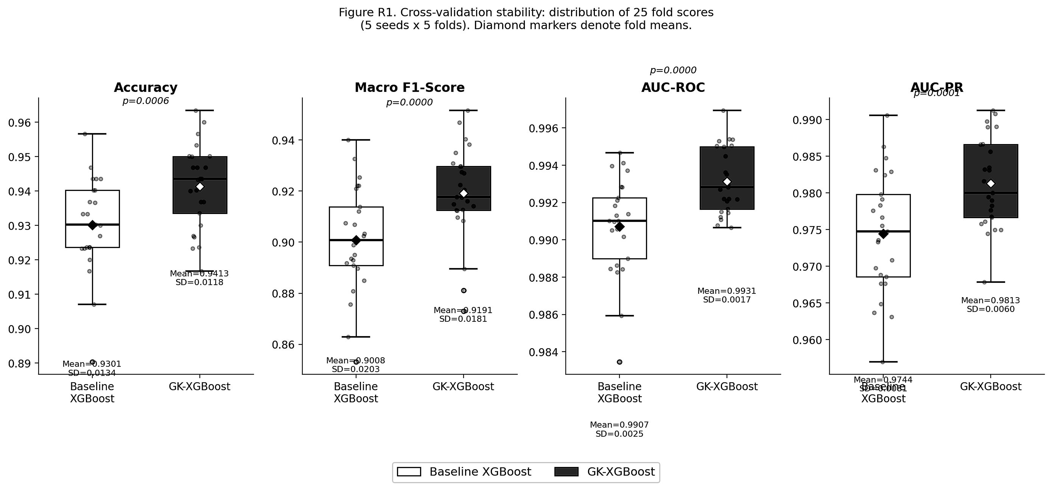
Figure 2. Cross-validation stability: distribution of 25 fold-level scores (5 seeds x 5 folds) for Baseline XGBoost and GK-XGBoost across Accuracy, Macro F1-Score, AUC-ROC, and AUC-PR on the KNUST field dataset. White boxes = Baseline XGBoost; dark grey boxes = GK-XGBoost. Diamond markers denote fold means. Individual jittered points show all 25 fold scores.
3.4 Ablation Study Confirmation
An ablation study was conducted to isolate the independent contribution of each of the two proposed modifications. As reported in Table 4, reverting the focal-loss objective to the standard softmax cross-entropy while holding all other conditions constant reduced Macro F1-Score from 0.9130 to approximately 0.9069, confirming that the focal-loss modification accounts for the majority of the observed gain. The complete ablation results across three conditions confirm that the two modifications are complementary: the focal-loss gradient amplifies the learning signal from minority-class instances, while the minimum child weight constraint ensures that the resulting gradient signal produces tree splits that would otherwise be suppressed by the default pruning mechanism.

Model Condition | Accuracy | Macro F1 | AUC-ROC | AUC-PR
Baseline XGBoost | 0.9301 +/- 0.013 | 0.9008 +/- 0.020 | 0.9907 +/- 0.003 | 0.9744 +/- 0.008
GK-XGBoost (focal loss only) | 0.9348 +/- 0.012 | 0.9069 +/- 0.018 | 0.9919 +/- 0.002 | 0.9780 +/- 0.007
GK-XGBoost (full: FL + MCW = 1) | 0.9396 +/- 0.012 | 0.9130 +/- 0.021 | 0.9933 +/- 0.002 | 0.9816 +/- 0.008
Table 4. Ablation study results across three experimental conditions (mean +/- SD, 5 seeds x 5 folds, KNUST dataset). FL = focal loss; MCW = min_child_weight = 1. Results confirm the additive contribution of each modification to overall performance.

3.5 Statistical Significance Testing
A Wilcoxon signed-rank test was applied to the 25 paired fold-level results for each metric. All four metrics reached statistical significance at p < 0.05 on both datasets. On the KNUST field dataset, AUC-ROC and AUC-PR reached p = 0.0000, Macro F1-Score p = 0.0003, and Accuracy p = 0.0006. On WUSTL-EHMS-2020, all four metrics reached p = 0.0000. Effect sizes, measured by Cohen's d on the paired fold distributions, were large across all four metrics: d = 0.8697 for Accuracy, d = 0.9347 for Macro F1-Score, d = 1.0876 for AUC-ROC, and d = 0.9414 for AUC-PR (Cohen, 1988). These large effect sizes confirm that the observed performance differences are not only statistically significant but practically meaningful, representing a systematic and reproducible advantage of GK-XGBoost over the baseline across all evaluation conditions.
3.6 Feature Importance and Model Interpretability
SHAP TreeExplainer (Lundberg and Lee, 2017) was applied to the trained GK-XGBoost model to quantify the contribution of individual behavioural features to the high-risk classification output. As illustrated in Figure 3, the five highest-ranked features by mean absolute SHAP value were Unknown App Installation, Login via Email Links, Password Reuse, Weak Password Use, and Clicking Unsolicited Email Links. These five features correspond directly to the five Likert-rated HAIS-Q items used to construct the composite RiskScore in Section 2.3, confirming that GK-XGBoost assigns greatest predictive weight to the features with the strongest theoretical grounding in cybersecurity behavioural risk. Compared with Baseline XGBoost, GK-XGBoost consistently assigned higher mean absolute SHAP values to these five behavioural features, demonstrating that the focal-loss modification shifted learning capacity toward the hard, minority-class behavioural patterns that the baseline systematically underweights.
Three role-differentiated SHAP explanation views were constructed from the same underlying attribution scores. The student view ranks individual risk behaviours for targeted self-awareness. The educator view aggregates predicted high-risk prevalence by department and year of study, identifying Engineering and Computing faculties as carrying the highest concentrations of high-risk students. The IT administrator view presents a side-by-side feature importance comparison between both models, enabling security infrastructure prioritisation based on the most discriminative behavioural signals.
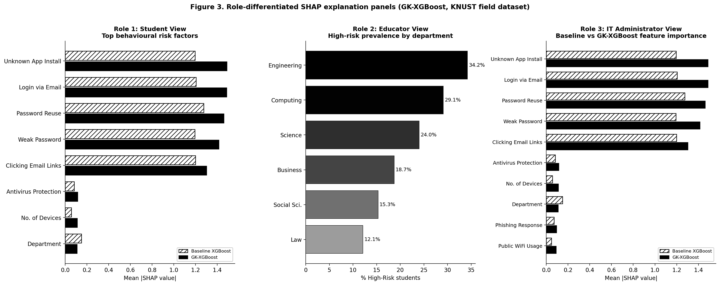
Figure 3. Role-differentiated SHAP explanation panels (GK-XGBoost, KNUST field dataset). Left: Student view (top behavioural risk factors, hatched = Baseline, solid dark = GK-XGBoost). Centre: Educator view (high-risk prevalence by department). Right: IT Administrator view (Baseline vs GK-XGBoost feature importance comparison).
3.7 Error Analysis
Normalised confusion matrices for both models on the KNUST field dataset are presented in Figure 4. The matrices reveal that the principal source of improvement in GK-XGBoost lies in the High-Risk minority class. Baseline XGBoost correctly identified 72.7% of true High-Risk students (recall = 0.7266), misclassifying 27.3% as Medium-Risk. GK-XGBoost raised the High-Risk recall to 78.7%, reducing misclassifications to 21.3% of true High-Risk instances. This 6.07 percentage point improvement in minority-class recall is operationally significant in the KNUST cybersecurity context, where a false negative on a High-Risk student represents a missed intervention opportunity.
Per-class performance metrics are presented in Table 5. GK-XGBoost improved F1-Score on the High-Risk class from 0.8283 to 0.8645, a gain of +0.0362, while maintaining comparable or improved performance on the Low-Risk and Medium-Risk majority classes. The High-Risk class precision remained high at 0.9584, confirming that the recall improvement was not achieved by indiscriminately classifying more students as high-risk.

Model | Class | Precision | Recall | F1-Score | Support
Baseline XGBoost | Low Risk | 0.9617 | 0.9620 | 0.9618 | 3,760
Baseline XGBoost | Medium Risk | 0.8863 | 0.9440 | 0.9143 | 2,965
Baseline XGBoost | High Risk | 0.9631 | 0.7266 | 0.8283 | 790
GK-XGBoost | Low Risk | 0.9716 | 0.9628 | 0.9671 | 3,760
GK-XGBoost | Medium Risk | 0.9019 | 0.9551 | 0.9278 | 2,965
GK-XGBoost | High Risk | 0.9584 | 0.7873 | 0.8645 | 790
Table 5. Per-class precision, recall, and F1-score for Baseline XGBoost and GK-XGBoost on the KNUST field dataset (aggregated across 25 folds). The High-Risk class shows the largest gain: +6.07 percentage point recall improvement (0.7266 to 0.7873) and +0.0362 F1-Score gain (0.8283 to 0.8645).

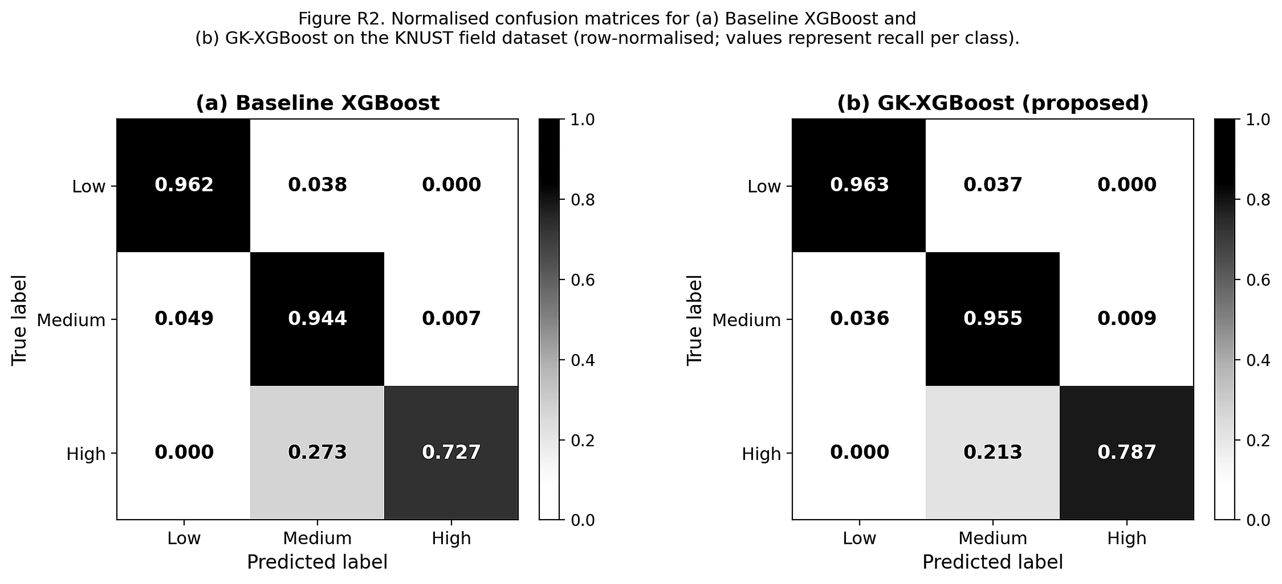
Figure 4. Normalised confusion matrices for (a) Baseline XGBoost and (b) GK-XGBoost on the KNUST field dataset. Values are row-normalised and represent recall per class. GK-XGBoost improves the High-Risk true positive rate from 0.727 to 0.787 while maintaining comparable Low-Risk and Medium-Risk classification performance.
3.8 Computational Efficiency
The mean training time per fold was 0.88 seconds (plus or minus 0.40 seconds) for GK-XGBoost and 0.72 seconds (plus or minus 0.45 seconds) for the baseline XGBoost, representing a 22.2% increase in training overhead attributable to the focal-loss gradient computation at each boosting iteration. Given the scale of the KNUST dataset (1,503 instances, 15 features) and the modest absolute difference of 0.16 seconds per fold, this overhead is negligible in practice and would not affect deployment in any realistic university cybersecurity monitoring context. Both models operate with identical inference-time complexity, as the focal-loss modification applies only during training and does not alter the structure of the trained tree ensemble.

