
IT342-Section
SYSTEMS INTEGRATION AND ARCHITECTURE 1

FUNCTIONAL REQUIREMENTS SPECIFICATION (FRS)

Project Title: Mini App – User Registration & Authentication System
Prepared By: Godwin M. Labaya
Date of Submission: 2/5/2026
Version: 1.0

Table of Contents
1. Introduction 3
1.1. Purpose 3
1.2. Scope 3
1.3. Definitions, Acronyms, and Abbreviations 3
2. Overall Description 3
2.1. System Perspective 3
2.2. User Classes and Characteristics 3
2.3. Operating Environment 4
2.4. Assumptions and Dependencies 4
3. System Features and Functional Requirements 4
3.1. Feature 1: 4
3.2. Feature 2: 4
4. Non-Functional Requirements 5
5. System Models (Diagrams) 5
5.1. ERD 5
5.2. Use Case Diagram 5
5.3. Activity Diagram 7
5.4. Class Diagram 8
5.5. Sequence Diagram 9
6. Appendices 9

Introduction

Purpose
The purpose of this document is to define the software requirements for DisasterAidConnect, a cross-platform system that facilitates direct financial aid to people affected by disasters. This document is intended for stakeholders, developers, UI/UX designers, and QA testers to guide the development of a secure, intuitive, and efficient donation platform accessible on both mobile and desktop environments.

Scope
DisasterAidConnect acts as a multi-platform donation platform connecting donors with disaster-affected individuals and communities. The system allows users to search for disaster events, view verified victims or relief campaigns, and make monetary donations directly. The boundaries of the system are limited to financial donations and disaster campaign management; it does not provide medical aid, physical disaster relief delivery, or insurance services.

Definitions, Acronyms, and Abbreviations
Donor: A user who contributes money to support disaster victims.
Recipient: An individual or community verified as affected by a disaster, eligible to receive donations.
Campaign: A structured relief fund or aid effort for a specific disaster event.
Verified Disaster Event (VDE): A disaster event confirmed by authorities or the platform’s verification team.
Payment Gateway (PG): Third-party financial service provider integrated for processing secure transactions.

Overall Description

System Perspective
DisasterAidConnect operates as a unified cross-platform system accessible via mobile devices and personal computers, utilizing cloud-based databases for storing user, donor, and campaign information. The system integrates with secure payment gateways to handle transactions and interfaces with disaster monitoring services to display verified disaster events. The application functions within the larger context of charitable donation management by allowing donors to track donations, receive receipts, and monitor campaign progress.

User Classes and Characteristics
Primary Users (Donors): Individuals seeking to donate funds efficiently to verified disaster campaigns. They are tech-savvy and expect transparency and security.
Secondary Users (Recipients): Disaster-affected individuals or communities who can register to receive aid. Verification by the platform ensures legitimacy.
Administrators: Staff or volunteers responsible for verifying disaster events, managing campaigns, and overseeing transaction security.

Operating Environment
The mobile version of the application operates on standard smartphones running Android 10 or higher and iOS 15 or higher. The desktop version requires a personal computer running Windows 10, macOS 11, or a Linux distribution with access to modern web browsers such as Chrome, Firefox, or Edge. A stable internet connection is required for viewing campaigns, processing donations, and synchronizing data across devices.

Assumptions and Dependencies
Users are expected to provide accurate information when registering as donors or recipients.
The system depends on third-party payment gateways for processing donations securely.
Campaign verification relies on data from local authorities, news outlets, or field volunteers to ensure legitimacy.
Donors will comply with legal and platform guidelines when contributing funds.

System Features and Functional Requirements
Describe each major feature of the system and its functional requirements.

Feature 1: Campaign Discovery and Donation
Description: Users can browse verified disaster campaigns, view affected recipients, and make donations via a secure interface.
Functional Requirements:
The system shall allow users to search and filter campaigns by disaster type, location, severity, or date.
The system shall display campaign details including total funds raised, target amount, and recipient information.
The system shall allow donors to make one-time or recurring donations using integrated payment gateways.
The system shall generate automatic receipts and track donation history for donors.

Feature 2: User Registration and Verification
Description: Users can register as donors or recipients, and the system ensures identity verification for recipients to prevent fraud.
Functional Requirements:
The system shall allow donors to create accounts with email, phone, or social login credentials.
The system shall allow recipients to submit identification documents for verification before receiving donations.
The system shall notify users of the verification status and display verified recipients in campaigns.

Non-Functional Requirements
• Performance: The system shall load campaign lists within 3 seconds for both mobile and desktop devices.
• Security: User and transaction data shall be encrypted in compliance with PCI DSS standards.
• Availability: The system shall be available 99% of the time, excluding scheduled maintenance.
• Usability: The user interface shall be responsive, accessible, and easy to navigate on small mobile screens and large desktop monitors.
• Scalability: The system shall support up to 100,000 concurrent users without performance degradation.

System Models (Diagrams)
Insert the necessary diagrams for the system:

ERD
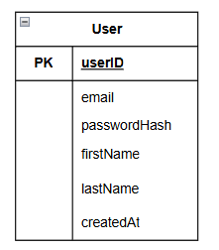

Use Case Diagram
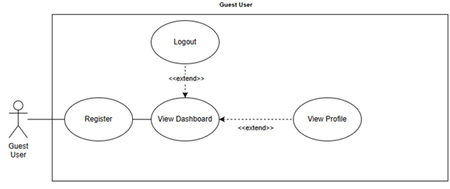
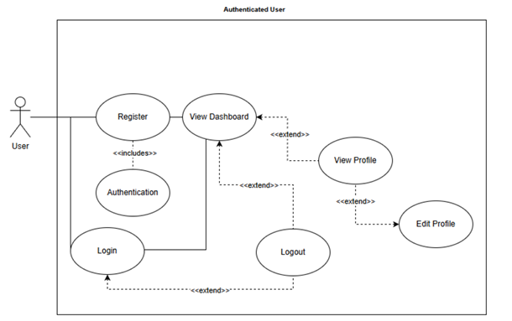

Activity Diagram
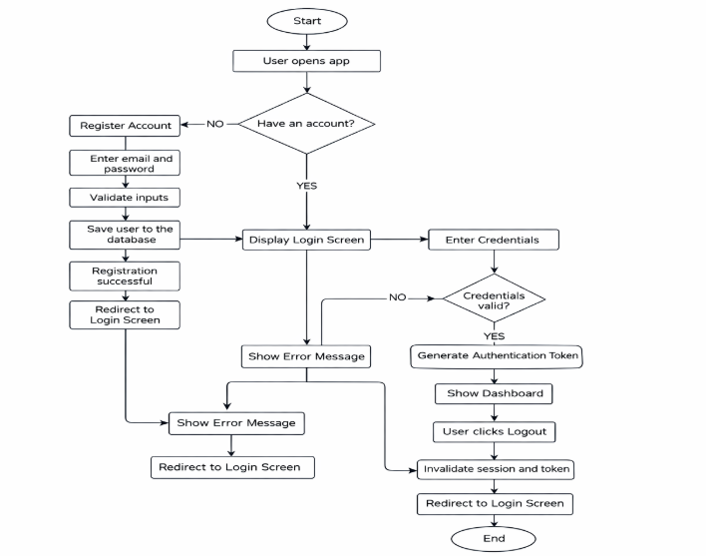

Class Diagram
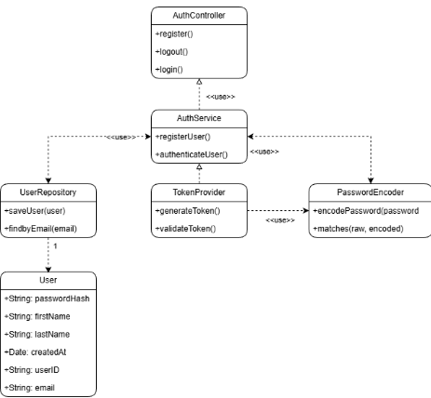

Sequence Diagram
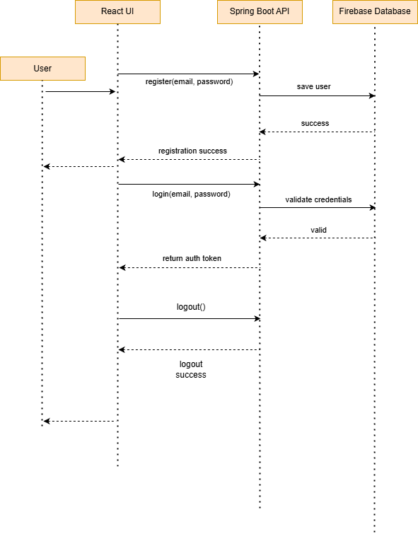

Appendices
Include any additional information, references, or support materials.

