PS2
- Aplikovat vsetky postupy z Pripadovej studie 1 (PS1) spolu s rozsireniami na riesenie komplexnej ulohy pre MOTOR
Matlab
K1 = 100;
T1 = 0.15;
tspan = [0 50];
step_t = 5;
u_des = 1;
desr = [35 40];
desr_val = 0.01;
num = K1;
den = conv([T1 1], [1 0]);
tfun = tf(num, den);
NaslinReg = NaslinPI(tfun, 2.2);
ButtwReg = ButtwPI(num, den);
GhReg = GhPI(num, den);

%% Plot step function and disorder
figure("Name", "PI Regulator")
Reg = NaslinReg;
data = sim("reg.slx");
nas_t = data.tout;
simout = data.simout.Data(:, 1);
data = data.simout.Data(:, 2);
stairs(nas_t, simout, '--', 'LineWidth', 2);
hold on;
grid on;
title("PI Regulator");
xlabel("Time");
ylabel("y(t)");

%% Naslin PI plot
plot(nas_t, data, "LineWidth", 2);

%% Butterworth PI plot
Reg = ButtwReg;
data = sim("reg.slx");
buttw_t = data.tout;
data = data.simout.Data(:, 2);
plot(buttw_t, data, "LineWidth", 2);

%% Graham-Lathrop PI plot
Reg = GhReg;
data = sim("reg.slx");
gh_t = data.tout;
data = data.simout.Data(:, 2);
plot(gh_t, data, "LineWidth", 2);
hold off;
legend("w(t)", "Naslin PI", "Butterworth PI", "Graham-Lathrop PI", "Location", "southeast");

_______________________________________________________________
Simulink
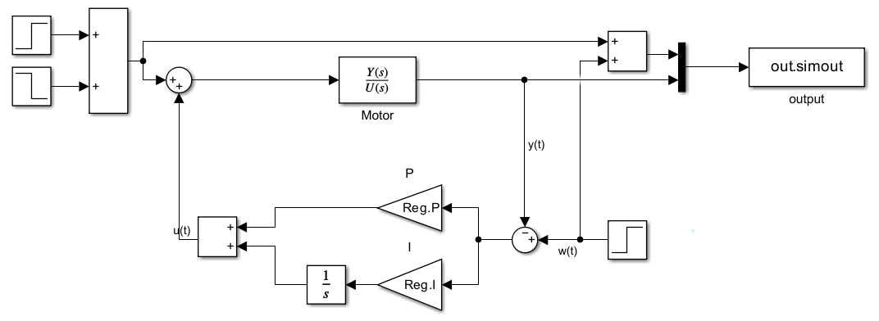
_______________________________________________________________
Vystup
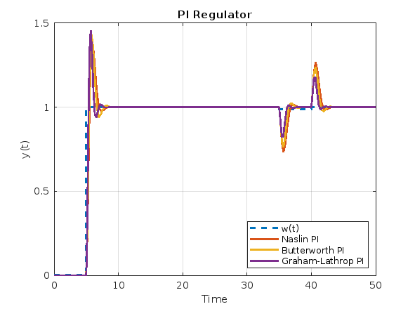
- Rozsirit postupy z PS_1:
B1) Urcenie kritickeho zosilnenia/periody Michajlovovym/Nyquistovym kriteriom v prislusnej modifikacii metody Ziegler-Nicholsa.
MicCr.m
function [r0_kr, omega_kr, T_kr] = MicCr(Gp)
[num, den] = tfdata(Gp, 'v');

omega = linspace(0.01, 100, 10000);
s = 1j * omega;

Gp_eval = polyval(num, s) ./ polyval(den, s); % Gp(jω)
phase = angle(Gp_eval);

[~, idx] = min(abs(phase + pi));

omega_kr = omega(idx);
mag = abs(Gp_eval(idx));
r0_kr = 1 / mag;

T_kr = 2 * pi / omega_kr;
end

Vstup
[r0_kr, omega_kr, T_kr] = MicCr(tfun);

fprintf('Michajlov criterion:\n');
fprintf('omega_kr = %.4f rad/s\n', omega_kr);
fprintf('r0_kr = %.4f\n', r0_kr);
fprintf('T_kr = %.4f s\n', T_kr);

Vystup
Michajlov criterion:
omega_kr = 100.0000 rad/s
r0_kr = 15.0333
T_kr = 0.0628 s

ZNFkt.m

function Reg = ZNFkt(Kr, Tkr, typ)
switch typ
case 'P'
Reg.P = 0.5 * Kr;
Reg.I = 0;
Reg.D = 0;

case 'PI'
Reg.P = 0.45 * Kr;
Reg.I = 1.2 * Reg.P / Tkr;
Reg.D = 0;

case 'PID'
Reg.P = 0.6 * Kr;
Reg.I = Reg.P / (0.5 * Tkr);
Reg.D = Reg.P * 0.125 * Tkr;

otherwise
error("Unsupported type");
end
end

Vstup

ZNPIReg = ZNFkt(r0_kr, T_kr, 'PI');

fprintf('\nZiegler-Nichols kr-m:\n');
fprintf('Kp = %.4f\n', ZNPIReg.P);
fprintf('Ki = %.4f\n', ZNPIReg.I);

Vystup

Ziegler-Nichols kr-m:
Kp = 6.7650
Ki = 129.2017

B3) Prepocet PID / PSD pre obidva systemy najst koeficienty q0, q1, q2 PSD (P/PS/PD) regulatora na zaklade uz ziskanych koeficientov PID regulatora, a to s vyuzitim lichobeznikovej aproximacie pri vhodnej volbe T_vz
NaslinPI.m

function Reg = NaslinPI(tfun, alpha)
syms s r0 r_m1;
[num, den] = tfdata(tfun);

G_p = poly2sym(cell2mat(num), s) / poly2sym(cell2mat(den), s);
G_r = r0 + r_m1 / s;
eq = 1 + (G_p * G_r) == 0;

eq_simplified = expand(lhs(eq) * poly2sym(cell2mat(den), s));
eq_final = collect(expand(eq_simplified * s), s);
coeffs_list = coeffs(eq_final, s, 'All');

eq1 = coeffs_list(2)^2 == alpha * coeffs_list(1) * coeffs_list(3);
eq2 = coeffs_list(3)^2 == alpha * coeffs_list(2) * coeffs_list(4);

sol = solve([eq1, eq2], [r0, r_m1]);

Reg.P = double(sol.r0);
Reg.I = double(sol.r_m1);
end

Motor:

Vstup

Ts_reg = 0.02;
PSDReg = PSD(NaslinReg, Ts_reg);

fprintf("\nPSD z Naslin PI (T_vz = %.3f s):\n", Ts_reg);
fprintf("q0 = %.4f\n", PSDReg.q0);
fprintf("q1 = %.4f\n", PSDReg.q1);
fprintf("q2 = %.4f\n", PSDReg.q2);

Vystup

PSD z Naslin PI (T_vz = 0.040 s):
q0 = 0.0581
q1 = -0.0355
q2 = 0.0000
Piecka:

Vstup

Ts_reg = 0.02;
PSDReg = PSD(NaslinReg, Ts_reg);

fprintf("\nPSD z Naslin PI (T_vz = %.3f s):\n", Ts_reg);
fprintf("q0 = %.4f\n", PSDReg.q0);
fprintf("q1 = %.4f\n", PSDReg.q1);
fprintf("q2 = %.4f\n", PSDReg.q2);

Vystup

PSD z Naslin PI (pec, T_vz = 0.020 s):
q0 = 2.5726
q1 = -2.5184
q2 = 0.0000

B4) Pomocou uz ziskaneho diskretneho tvaru prenosovej funkcie F_p(z) ziskat prenosovu funkciu URO (Y/W) a prenosovu funkciu riadiaceho zasahu (U/W) vzhladom na regulacny obvod s PSD regulatorom

Vstup

num = [PSDReg.q0 PSDReg.q1 PSDReg.q2];
den = [1 -1];

Rz = tf(num, den, Ts_reg);
Fpz = c2d(tfun, Ts_reg, 'tustin');

T_uro = feedback(Rz * Fpz, 1);
T_uw = feedback(Rz, Fpz);

fprintf("\nPrenosové funkcie (b4):\n");
disp("Y/W ="); disp(T_uro);
disp("U/W ="); disp(T_uw);

Vystup

Y/W =

Numerator: {[0.0137 0.0190 -0.0030 -0.0084 0]}
Denominator: {[0.0137 1.0190 -2.7678 2.5211 -0.7647]}

U/W =

Numerator: {[0.0581 -0.1380 0.1071 -0.0272 0]}
Denominator: {[0.0137 1.0190 -2.7678 2.5211 -0.7647]}

B5) Vypocet ustalenych hodnot: riadenej veliciny y(∞), akcnej veliciny u(∞), diferencnu rovnicu URO

ssPI.m

%% Steady-State value for URO (G_r + PI)
function y_inf = ssPI(tf, Reg)
syms s r0 r_m1

G_r = r0 + r_m1 / s;

[num, den] = tfdata(tf);
G_p = poly2sym(cell2mat(num), s) / poly2sym(cell2mat(den), s);
G_r = subs(G_r, [r0 r_m1], [Reg.P Reg.I]);

eq = (G_p * G_r) / (1 + (G_p * G_r));

y_inf = double(limit(s * eq * 1/s, s, 0));
end

ciPI.m

% Control-Intervention value for URO (G_r + PI)
function u_inf = ciPI(tf, Reg)
syms s r0 r_m1

G_r = r0 + r_m1 / s;

[num, den] = tfdata(tf);
G_p = poly2sym(cell2mat(num), s) / poly2sym(cell2mat(den), s);
G_r = subs(G_r, [r0 r_m1], [Reg.P Reg.I]);

eq = G_r / (1 + (G_p * G_r));

u_inf = double(limit(s * eq * 1/s, s, 0));
end

Vstup
y_inf_naslin = ssPI(tfun, NaslinReg);
y_inf_buttw = ssPI(tfun, ButtwReg);
y_inf_gh = ssPI(tfun, GhReg);

fprintf("y(inf) for Naslin: %.4f\n", y_inf_naslin);
fprintf("y(inf) for Butterworth: %.4f\n", y_inf_buttw);
fprintf("y(inf) for Graham-Lathrop: %.4f\n\n", y_inf_gh);

u_inf_naslin = ciPI(tfun, NaslinReg);
u_inf_buttw = ciPI(tfun, ButtwReg);
u_inf_gh = ciPI(tfun, GhReg);

fprintf("u(inf) for Naslin: %.4f\n", u_inf_naslin);
fprintf("u(inf) for Butterworth: %.4f\n", u_inf_buttw);
fprintf("u(inf) for Graham-Lathrop: %.4f\n", u_inf_gh);

Vystup
y(inf) for Naslin: 1.0000
y(inf) for Butterworth: 1.0000
y(inf) for Graham-Lathrop: 1.0000

u(inf) for Naslin: 0.0000
u(inf) for Butterworth: 0.0000
u(inf) for Graham-Lathrop: 0.0000

B6) V riadiacej strukture URO s PSD regulatorom simulaciou overit stabilitu a kvalitu v ustalenom stave, t.j. vykreslit priebeh y(k), u(k) a e(k) pre skokovo sa meniacu riadiacu velicinu w(t) s nulovou poruchou, resp. konstantnu riadiacu velicinu s posobenim poruchy, pripadne ine kombinacie
_______________________________________________________________
Simulink
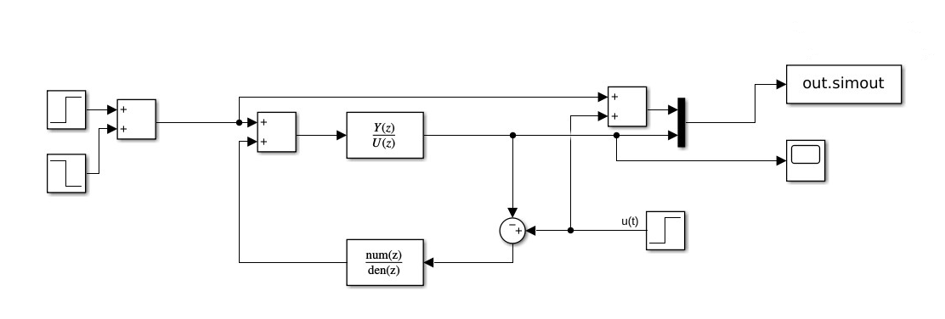
_______________________________________________________________

Vstup
u = 1;
T_vz = 0.4;
dtf = c2d(tfun, T_vz, 'tustin');

Vystup
Num = 11.4286, 22.8571, 11.4286
Den = 1, -0.8571, -0.1429
Matlab
function ZReg = PSD(SReg, Ts)
ZReg.q0 = SReg.P * (1 + (Ts / (2 * SReg.I)));
ZReg.q1 = -SReg.P * (1 - (Ts / (2 * SReg.I)));
ZReg.q2 = 0;
end

Ts_reg = 0.02;
PSDReg = PSD(NaslinReg, Ts_reg);
data = sim("dreg.slx");
nas_t = data.tout;
simout = data.simout.Data(:, 1);
data = data.simout.Data(:, 2);
stairs(nas_t, simout, '--', 'LineWidth', 2);
hold on;
grid on;
stairs(nas_t, data, 'LineWidth', 2);

%% Butterworth PS plot
Ts_reg = 0.03;
PSDReg = PSD(ButtwReg, Ts_reg);
data = sim("dreg.slx");
buttw_t = data.tout;
data = data.simout.Data(:, 2);
stairs(buttw_t, data, 'LineWidth', 2);

%% Graham-Lathrop PS plot
Ts_reg = 0.04;
PSDReg = PSD(GhReg, Ts_reg);
data = sim("dreg.slx");
gh_t = data.tout;
data = data.simout.Data(:, 2);
stairs(gh_t, data, 'LineWidth', 2);
title("PS Regulator");
xlabel("Time");
ylabel("y(k)");
legend("w(t)", "Naslin PI", "Butterworth PI", "Graham-Lathrop PI", "Location", "southeast");
hold off;

Vystup (Motor)
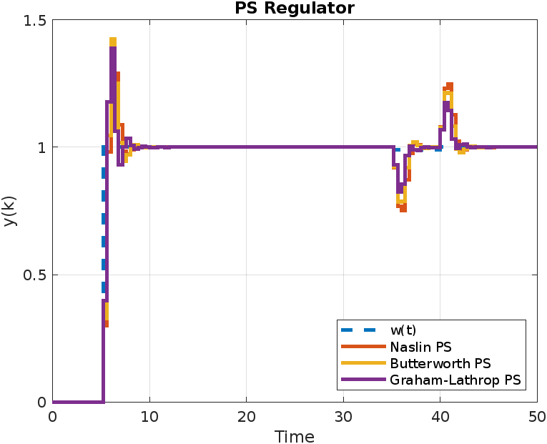

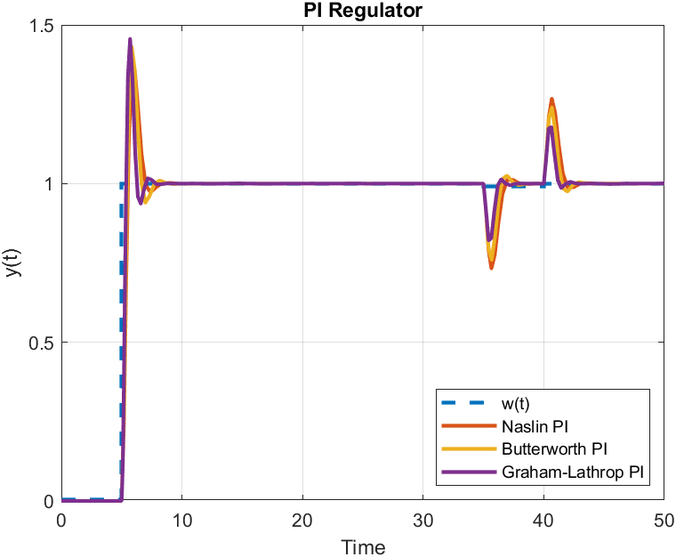

Vystup (Piecka)
