PS3

Matlab (systemy)
motor.m
function [a, b] = motor()
%% Motor - Diskrétna prenosová funkcia jednosmerného motora
%% Gp(z) = (1.79 z^-1 + 1.5 z^-2) / (1 - 1.58 z^-1 + 0.58 z^-2)
a = [-1.58, 0.58]; % menovateľ A(z) bez z^0
b = [1.79, 1.5]; % čitateľ B(z)
end

piecka.m
function [a, b] = pec()
% Piecka - Diskrétna prenosová funkcia pre systém piecky
% Gp(z) = (b1 z^-1 + b2 z^-2) / (1 + a1 z^-1 + a2 z^-2)
a = [-1.2, 0.3];
b = [0.8, 0.1];
end

vymenik.m
function [a, b] = vymenik()
% Vymenik - Diskrétna prenosová funkcia výmenníka pomocou c2d()
% G(s) = 1 / (1 + 3s)^3 → 3. rádu systém
Ts = 10;

% Spojitý systém
Gs = tf(1, conv([3 1], conv([3 1], [3 1]))); % (1+3s)^3

% Diskretizácia
Gz = c2d(Gs, Ts, 'tustin');

% Získanie koeficientov
[num, den] = tfdata(Gz, 'v');

b = num(2:end);
a = den(2:end);
end
- Urcit koeficienty diskretneho regulatora na konecny pocet krokov (dead-beat) bez ohranicenia/s ohranicenim na riadiaci zasah (vypocet + funkcia v MATLABe)
DBReg.m
function Reg = DBReg(dtf)
% DBREG - Dead-beat regulátor pre ľubovoľný rád systému
b = dtf.num;
a = dtf.den;

B = b(2:end);
A = a(2:end);
M = length(B);

q0 = 1 / sum(B);

Q = zeros(1, M+1);
Q(1) = q0;

for i = 1:M
Q(i+1) = A(i) * q0;
end

P = zeros(1, M);

for i = 1:M
P(i) = B(i) * q0;
end

P = -P;
P = [1 P];

Reg.num = Q;
Reg.den = P;
end

DBRegRest.m
function Reg = DBRegRest(dtf, u0)
% DBREGREST - Dead-beat regulátor s obmedzením na u(0) = u0
b = dtf.num;
a = dtf.den;

A = a(2:end);
B = b(2:end);
M = length(B);
q0 = u0;
Bsum = sum(B);

Q = zeros(1, M+2);
Q(1) = q0;

for i = 1:M
if i == 1
Q(i+1) = (A(i) - 1) * q0 + 1 / Bsum;
else
Q(i+1) = q0 * (A(i) - A(i-1)) + A(i-1) / Bsum;
end
end

Q(M+2) = A(M) * (-q0 + 1 / Bsum);
P = zeros(1, M+1);

for i = 1:M
if i == 1
P(i) = B(i) * q0;
else
P(i) = q0 * (B(i) - B(i-1)) + B(i-1) / Bsum;
end
end

P(M+1) = -B(M) * (q0 - 1 / Bsum);
P = [1 -P];

Reg.num = Q;
Reg.den = P;
end

main_motor.m
[a, b] = motor();
dtf.num = [0, b];
dtf.den = [1, a];

%% --- DEAD-BEAT BEZ OBMEDZENIA ---
Reg = DBReg(dtf);

disp('Dead-beat bez saturácie:');
disp('Q(z):');
disp(Reg.num);
disp('P(z):');
disp(Reg.den);

% --- DEAD-BEAT S OBMEDZENÍM NA u(0) ---
u0 = 0.2;
RegSat = DBRegRest(dtf, u0);

disp(['Dead-beat so saturáciou (u(0) = ', num2str(u0), '):']);
disp('Q(z):');
disp(RegSat.num);
disp('P(z):');
disp(RegSat.den);

Vystup:
Dead-beat bez saturácie:
Q(z): 0.3040 -0.4802 0.1763
P(z): 1.0000 -0.5441 -0.4559

Dead-beat so saturáciou (u(0) = 0.2):
Q(z): 0.2000 -0.2120 -0.0482 0.0603
P(z): 1.0000 -0.3580 -0.4861 -0.1559
main_piecka.m
[a, b] = pec();
dtf.num = [0, b];
dtf.den = [1, a];

% --- DEAD-BEAT BEZ OBMEDZENIA ---
Reg = DBReg(dtf);

disp('Dead-beat bez saturácie:');
disp('Q(z):');
disp(Reg.num);
disp('P(z):');
disp(Reg.den);

% --- DEAD-BEAT S OBMEDZENÍM NA u(0) ---
u0 = 0.2;
RegSat = DBRegRest(dtf, u0);

disp(['Dead-beat so saturáciou (u(0) = ', num2str(u0), '):']);
disp('Q(z):');
disp(RegSat.num);
disp('P(z):');
disp(RegSat.den);

Vystup:
Dead-beat bez saturácie:
Q(z): 1.1111 -1.3333 0.3333
P(z): 1.0000 -0.8889 -0.1111

Dead-beat so saturáciou (u(0) = 0.2):
Q(z): 0.2000 0.6711 -1.0333 0.2733
P(z): 1.0000 -0.1600 -0.7489 -0.0911

main_vymenik.m
[a, b] = vymenik();
dtf.num = [0, b];
dtf.den = [1, a];

% --- DEAD-BEAT BEZ OBMEDZENIA ---
Reg = DBReg(dtf);

disp('Dead-beat bez saturácie:');
disp('Q(z):');
disp(Reg.num);
disp('P(z):');
disp(Reg.den);

% --- DEAD-BEAT S OBMEDZENÍM NA u(0) ---
u0 = 0.2;
RegSat = DBRegRest(dtf, u0);

disp(['Dead-beat so saturáciou (u(0) = ', num2str(u0), '):']);
disp('Q(z):');
disp(RegSat.num);
disp('P(z):');
disp(RegSat.den);

Vystup:
Dead-beat bez saturácie:
Q(z): 0.5851 0.4389 0.1097 0.0091
P(z): 1.0000 -0.4286 -0.4286 -0.1429

Dead-beat so saturáciou (u(0) = 0.2):
Q(z): 0.2000 0.5351 0.3264 0.0753 0.0060
P(z): 1.0000 -0.1465 -0.4286 -0.3309 -0.0940

- Vypocitat prechodovy dej regulovanej veliciny y(k), akcnej veliciny u(k), (analyticky), overit simulaciou
simulate_resp onse.m
function [y, u, e] = simulate_response(a, b, Reg, w, N)
na = length(a);
nb = length(b);
nq = length(Reg.num);
np = length(Reg.den) - 1;

y = zeros(1, N);
u = zeros(1, N);
e = zeros(1, N);

for k = 1:N
e(k) = w(k) - y(k);
uk = 0;

for i = 1:min(np, k-1)
uk = uk + (-Reg.den(i+1)) * u(k-i);
end

for i = 1:min(nq, k)
uk = uk + Reg.num(i) * e(k - i + 1);
end

u(k) = uk;
yk = 0;

for i = 1:min(na, k-1)
yk = yk - a(i) * y(k-i);
end

for i = 1:min(nb, k)
yk = yk + b(i) * u(k - i + 1);
end

y(k) = yk;
end
end

Vstup:
N = 20;
w = ones(1, N);
[y1, u1, e1] = simulate_response(a, b, Reg, w, N);
[y2, u2, e2] = simulate_response(a, b, RegSat, w, N);

figure;
subplot(3,1,1); plot(0:N-1, y1, 'b', 0:N-1, y2, 'r--'); title('y(k)'); legend('bez obmedzenia','s obmedzením');
subplot(3,1,2); plot(0:N-1, u1, 'b', 0:N-1, u2, 'r--'); title('u(k)');
subplot(3,1,3); plot(0:N-1, e1, 'b', 0:N-1, e2, 'r--'); title('e(k)');
xlabel('k');

Vystup:
Motor
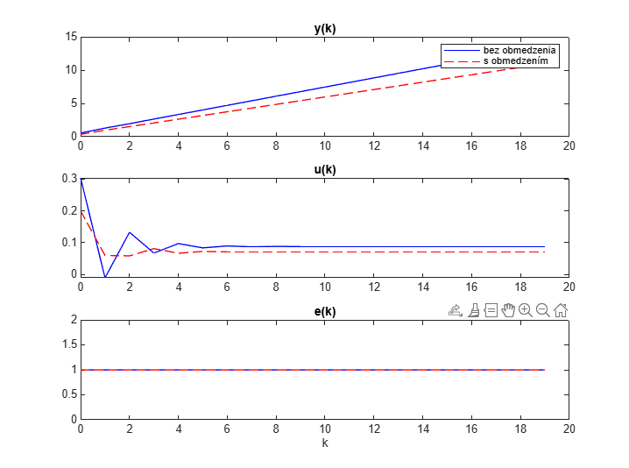
Piecka
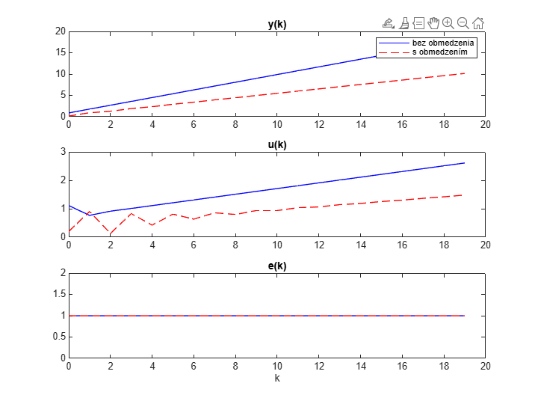
_____________________________________________________________________________________________________
Vymenik
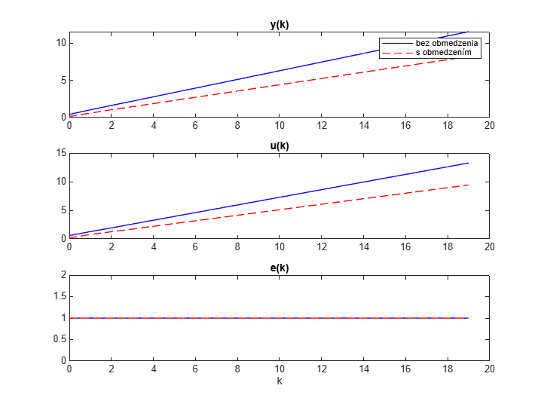
- Vypocitat ustalene hodnoty y(∞), u(∞) (vypocet + funkcia v MATLABe)
compute_steady_state.m
function [y_inf, u_inf, e_inf] = compute_steady_state(y, u, e)
tail = round(length(y) * 0.2);
y_inf = mean(y(end-tail+1:end));
u_inf = mean(u(end-tail+1:end));
e_inf = mean(e(end-tail+1:end));
end

Vstup:
[y_inf1, u_inf1, e_inf1] = compute_steady_state(y1, u1, e1);
[y_inf2, u_inf2, e_inf2] = compute_steady_state(y2, u2, e2);

fprintf('\n--- USTÁLENÉ HODNOTY ---\n');
fprintf('Bez obmedzenia:\n y(∞) = %.4f, u(∞) = %.4f, e(∞) = %.4f\n', y_inf1, u_inf1, e_inf1);
fprintf('S obmedzením:\n y(∞) = %.4f, u(∞) = %.4f, e(∞) = %.4f\n', y_inf2, u_inf2, e_inf2);
____________________________________________________________________________________
Vystup:
motor
Bez obmedzenia:
y(∞) = 12.6086, u(∞) = 0.0877, e(∞) = 1.0000
S obmedzením:
y(∞) = 10.1409, u(∞) = 0.0710, e(∞) = 1.0000
___________________________________________
piecka
Bez obmedzenia:
y(∞) = 16.6400, u(∞) = 2.4600, e(∞) = 1.0000
S obmedzením:
y(∞) = 9.3719, u(∞) = 1.3926, e(∞) = 1.0000
____________________________________________
vymenik
Bez obmedzenia:
y(∞) = 10.6667, u(∞) = 12.2667, e(∞) = 1.0000
S obmedzením:
y(∞) = 7.5720, u(∞) = 8.7087, e(∞) = 1.0000
- V riadiacej strukture uzavreteho regulacneho obvodu s dead-beat regulatorom overit riadenie na konecny pocet krokov pre definovany tvar riadiacej veliciny w(k) a poruchy z(k), graficky znazornit vysledky prechodovych dejov v URO, t.j. vykreslit priebeh y(k), u(k) a e(k) (simulacna schema v Simulinku)
________________________________________________________________________
Simulink

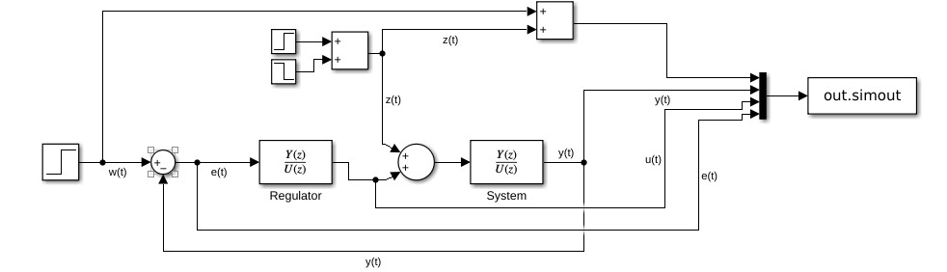
____________________________________________________________________________________
Matlab
Vstup:
tspan = 2;
desr = [1 1.1];
desr_val = 0.01;

Data = sim("reg.slx");
DataSat = sim("reg_sat.slx");

nas_t = Data.tout;

w_t = Data.simout.Data(:, 1);
y_t = Data.simout.Data(:, 2);
u_t = Data.simout.Data(:, 3);
e_t = Data.simout.Data(:, 4);
y_t_sat = DataSat.simout.Data(:, 2);
u_t_sat = DataSat.simout.Data(:, 3);
e_t_sat = DataSat.simout.Data(:, 4);

figure;
stairs(nas_t, y_t, 'LineWidth', 2, 'Color', "r");
hold on;
stairs(nas_t, y_t_sat, 'LineWidth', 2, 'Color', "g");
stairs(nas_t, w_t, 'LineWidth', 2, 'Color', "b");
legend("y(t) - bez obmedzenia", "y(t) - s obmedzením", "w(t)");
title("Vymenik y(t) - Dead-Beat Regulátor");
xlabel("Čas [s]");
ylabel("y(t)");
grid on;

figure;
stairs(nas_t, u_t, 'LineWidth', 2, 'Color', "r");
hold on;
stairs(nas_t, u_t_sat, 'LineWidth', 2, 'Color', "g");
stairs(nas_t, w_t, 'LineWidth', 2, 'Color', "b");
legend("u(t) - bez obmedzenia", "u(t) - s obmedzením", "w(t)");
title("Vymenik Riadiaca veličina u(t)");
xlabel("Čas [s]");
ylabel("u(t)");
grid on;

figure;
stairs(nas_t, e_t, 'LineWidth', 2, 'Color', "r");
hold on;
stairs(nas_t, e_t_sat, 'LineWidth', 2, 'Color', "g");
stairs(nas_t, w_t, 'LineWidth', 2, 'Color', "b");
legend("e(t) - bez obmedzenia", "e(t) - s obmedzením", "w(t)");
title("Vymenik Regulačná odchýlka e(t)");
xlabel("Čas [s]");
ylabel("e(t)");
grid on;

Vystup:
