PS4
Matlab
main.m
[a,b] = motor();
dtf.num = b;
dtf.den = [1, a];

poles = [0.1, 0.2, 0.3, 0.4];

% Výpočet regulátora
Reg = ppc(dtf, poles);
disp('Polynomiálny regulátor:');
disp('Q(z):'); disp(Reg.num);
disp('P(z):'); disp(Reg.den);

tspan = 2;
desr = [1 1.1];
desr_val = 0.01;
data = sim("reg.slx");
nas_t = data.tout;
w_t = data.simout.Data(:, 1);
y_t = data.simout.Data(:, 2);
u_t = data.simout.Data(:, 3);
e_t = data.simout.Data(:, 4);

figure;
stairs(nas_t, y_t, 'LineWidth', 2,'Color',"r");
hold on;
stairs(nas_t, w_t, 'LineWidth', 2,'Color',"b");
legend ("y(t)","w(t)");
hold off;
grid on;
title("PP Regulator");
xlabel("Time");
ylabel("y(t)");

figure;
stairs(nas_t, u_t, 'LineWidth', 2,'Color',"r");
hold on;
stairs(nas_t, w_t, 'LineWidth', 2,'Color',"b");
legend ("u(t)","w(t)");
hold off;
grid on;
title("PP Regulator");
xlabel("Time");
ylabel("u(t)");

figure;
stairs(nas_t, e_t, 'LineWidth', 2,'Color',"r");
hold on;
stairs(nas_t, w_t, 'LineWidth', 2,'Color',"b");
legend ("e(t)","w(t)");
hold off;
grid on;
title("PP Regulator");
xlabel("Time");
ylabel("e(t)");

motor.m
function [a, b] = motor()
% MOTOR - Diskrétna prenosová funkcia jednosmerného motora
% Gp(z) = (1.79 z^-1 + 1.5 z^-2) / (1 - 1.58 z^-1 + 0.58 z^-2)
a = [-1.58, 0.58];
b = [1.79, 1.5];
end

ppc.m
function Reg = ppc(dtf, poles)
syms q0 q1 q2 p1

B = dtf.num;
A = dtf.den;

Cd = poly(poles);

a1 = A(2);
a2 = A(3);

b1 = B(1);
b2 = B(2);

c1 = Cd(2);
c2 = Cd(3);
c3 = Cd(4);
c4 = Cd(5);

eq1 = a1 - (1 + p1) + q0 * b1 == c1;
eq2 = a2 - a1 * (1 + p1) + p1 + q0 * b2 + q1 * b1 == c2;
eq3 = a1 * p1 - a2 * (1 + p1) + b2 * q1 + b1 * q2 == c3;
eq4 = p1 * a2 + b2 * q2 == c4;

sol = solve([eq1, eq2, eq3, eq4], [q0, q1, q2, p1]);

q0 = double(sol.q0);
q1 = double(sol.q1);
q2 = double(sol.q2);
p1 = double(sol.p1);

Reg.num = [q0 q1 q2];
Reg.den = conv([1 -1], [1 -p1]);
end

Simulink
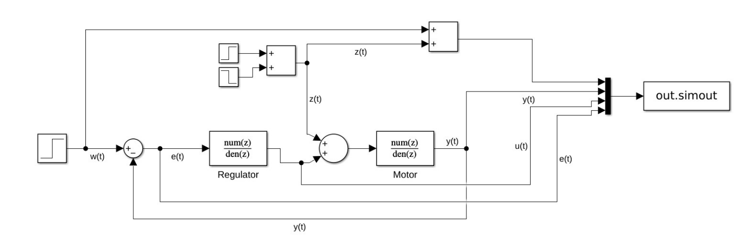
Regulator
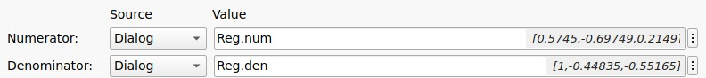
Motor
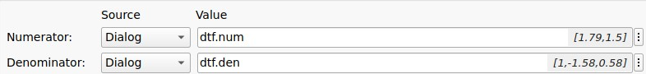
Krok
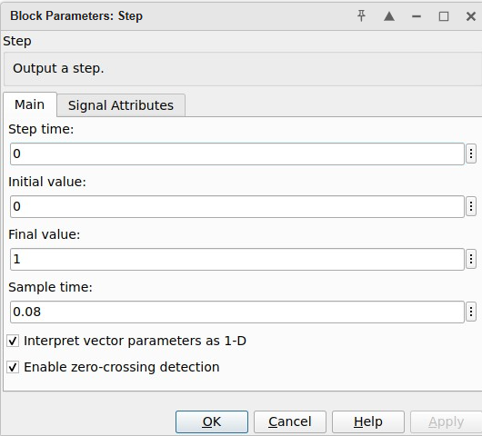
Vystup
Polynomiálny regulátor:
Q(z): 0.5745 -0.6975 0.2149
P(z): 1.0000 -0.4484 -0.5516

