PS1
- Vykreslit priebeh regulovanej veliciny y(t) v otvorenej slucke
_______________________________________________________________
Simulink
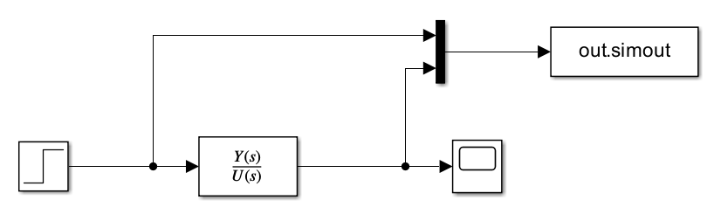
_______________________________________________________________
Matlab
tspan = [0 70];
step_t = 5;
u_des = 1;
desr = [35 40];
desr_val = 0.5;
num = 0.1;
den = [1 1 0.2];
tffun = tf(num, den);

%% a) Vykreslit priebeh regulovanej veliciny y(t) v otvorenej slucke
simdata = sim("msim.slx");
y = simdata.simout.Data(:, 1);
u = simdata.simout.Data(:, 2);
t = simdata.tout;
figure("Name", "System feedback on desired w(t)");
plot(t, y, 'r', 'LineWidth', 2);
hold on;
plot(t, u, 'b', 'LineWidth', 2);
grid on;
ylim([0 max(max(y, u)) + 0.5]);
legend("System feedback", "Desired value w(t)");
hold off;
Vystup

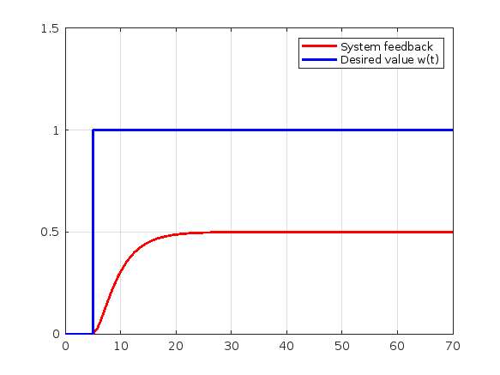

- Urcit koeficienty PID regulatora (alternativne P/PI/PD) s vyuzitim metod nepriamej syntezy.

Metoda Naslina (NaslinPI.m)
function Reg = NaslinPI(tfun, alpha)
syms s r0 r_m1;
[num, den] = tfdata(tfun);

G_p = poly2sym(cell2mat(num), s) / poly2sym(cell2mat(den), s);
G_r = r0 + r_m1 / s;

eq = 1 + (G_p * G_r) == 0;
eq_simplified = expand(lhs(eq) * poly2sym(cell2mat(den), s));
eq_final = collect(expand(eq_simplified * s), s);

coeffs_list = coeffs(eq_final, s, 'All');

eq1 = coeffs_list(2)^2 == alpha * coeffs_list(1) * coeffs_list(3);
eq2 = coeffs_list(3)^2 == alpha * coeffs_list(2) * coeffs_list(4);

sol = solve([eq1, eq2], [r0, r_m1]);

Reg.P = double(sol.r0);
Reg.I = double(sol.r_m1);
end

Vstup
PINaslinCoef = NaslinPI(tffun, 1.75);

Vystup
P: 3.7143
I: 1.8659
Metoda optimalny modul (MomPI.m)
function Reg = MomPI(tfun)
sys = tfnorm(tfun);

a1 = sys.den(2);
a2 = sys.den(3);
a3 = 0;

r0 = (1/(2*sys.num)) * ((a1^3 - 2*a1*a2 + a3) / (a1*a2 - a3));
r_m1 = (1/(2*sys.num)) * ((a1^2 - a2) / (a1*a2 - a3));

Reg.P = r0;
Reg.I = r_m1;
end

Vstup
MomPICoef = MomPI(tffun);

Vystup
P = 3
I = 0.800

Metoda Ziegler-Nichols (ZiegNicPID.m)
function Reg = ZiegNicPID(tfun, type)

K_p = tfnorm(tfun).num;
T = tfresp(tfun);

switch type
case "P"
Reg.P = T.n / (K_p*T.u);
case "PI"
Reg.P = 0.9 * (T.n / (K_p*T.u));
Reg.I = 3.5 * T.u;
case "PD"
Reg.P = 1.2 * (T.n / (K_p*T.u));
Reg.D = 0.25 * T.u;
case "PID"
Reg.P = 1.25 * (T.n / (K_p*T.u));
Reg.I = 2 * T.u;
Reg.D = 0.05 * T.u;
end
end

Vstup
ZiegNicPICoef = ZiegNicPID(tffun, 'PI');

Vystup
P = 12.7448
I = 2.0756
Metoda Graham-Lathropove (GhPI.m)
function Reg = GhPI(num, den)
syms s r0 r_m1 w0

G_p = poly2sym(num, s) / poly2sym(den, s);
G_r = r0 + r_m1 / s;

eq = 1 + G_p * G_r == 0;
eq_simplified = expand(lhs(eq) * poly2sym(den, s));
eq_final = collect(expand(eq_simplified * s), s);
coeffs_list = coeffs(eq_final, s, 'All');

c3 = coeffs_list(1);
c2 = coeffs_list(2);
c1 = coeffs_list(3);
c0 = coeffs_list(4);

w0 = solve(c2 == 1.75 * w0, w0, 'Real', true);
w0 = double(w0);

Kp = solve(c1 == 2.15 * w0^2, r0, 'Real', true);
Reg.P = double(Kp);

Ti = solve(c0 == w0^3, r_m1, 'Real', true);
Reg.I = double(Ti);
end

Vstup
GhPICoef = GhPI(num, den);

Vystup
P = 5.0204
I = 1.8659
Metoda Butterworthove mnohocleny (ButtwPI.m)
function Reg = ButtwPI(num, den)
syms s r0 r_m1 w0

G_p = poly2sym(num, s) / poly2sym(den, s);
G_r = r0 + r_m1 / s;

eq = 1 + G_p * G_r == 0;
eq_simplified = expand(lhs(eq) * poly2sym(den, s));
eq_final = collect(expand(eq_simplified * s), s);
coeffs_list = coeffs(eq_final, s, 'All');

mult = double(1 / coeffs_list(1));
coeffs_list = coeffs_list * mult;

c2 = coeffs_list(2);
c1 = coeffs_list(3);
c0 = coeffs_list(4);

w0 = solve(c2 == 2 * w0, w0, 'Real', true);
w0 = double(w0);

disp(w0)

Kp = solve(c1 == 2 * w0^2, r0, 'Real', true);
Reg.P = double(Kp);

Ti = solve(c0 == w0^3, r_m1, 'Real', true);
Reg.I = double(Ti);
end

Vstup
ButtwPICoef = ButtwPI(num, den);

Vystup
P = 3
I = 1.25
- V riadiacej strukture URO s PID regulatorom navrhnutym podla jednotlivych metod overit simulaciou stabilitu a kvalitu v ustalenom stave
_______________________________________________________________
Simulink
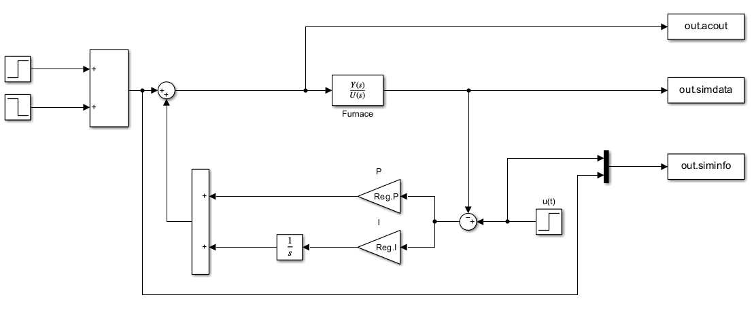
_______________________________________________________________
Matlab
%% Plot step function + disorder
figure("Name", "PI Regulator")
Reg = PINaslinCoef;
data = sim("reg.slx");
nas_t = data.tout;
siminfo = data.siminfo.Data;
stairs(nas_t, siminfo, '--', 'LineWidth', 2);
hold on;
grid on;
title("PI Regulators");

%% Naslin PI plot
simdata = data.simdata.Data;
nas_acout = data.acout.Data;
plot(nas_t, simdata, "LineWidth", 2);

%% MOM PI plot
Reg = MomPICoef;
data = sim("reg.slx");
simdata = data.simdata.Data;
mom_acout = data.acout.Data;
mom_t = data.tout;
plot(mom_t, simdata, "LineWidth", 2);

%% Ziegler-Nichols PI plot
Reg = ZiegNicPICoef;
data = sim("reg.slx");
simdata = data.simdata.Data;
zn_acout = data.acout.Data;
zn_t = data.tout;
plot(zn_t, simdata, "LineWidth", 2);

%% Graham-Lathrop PI plot
Reg = GhPICoef;
data = sim("reg.slx");
simdata = data.simdata.Data;
gl_acout = data.acout.Data;
gl_t = data.tout;
plot(gl_t, simdata, "LineWidth", 2);

%% Butterworth PI plot
Reg = ButtwPICoef;
data = sim("reg.slx");
simdata = data.simdata.Data;
bw_acout = data.acout.Data;
bw_t = data.tout;
plot(bw_t, simdata, "LineWidth", 2);
hold off;
legend("w(t)", "u(t)", "Naslin PI", "MOM PI", "Ziegler-Nichols PI", "Graham-Lathrop PI", "Butterworth PI", "Location", "southeast");

%% Plot action signal
figure("Name", "Action signal");
plot(nas_t, nas_acout, "LineWidth", 2);
hold on;
plot(mom_t, mom_acout, "LineWidth", 2);
plot(zn_t, zn_acout, "LineWidth", 2);
plot(gl_t, gl_acout, "LineWidth", 2);
plot(bw_t, bw_acout, "LineWidth", 2);
hold off;
grid on;
legend("Naslin", "MOM", "Ziegler-Nichols", "Graham-Lathrop", "Butterworth", "Location", "southeast");

Vystup
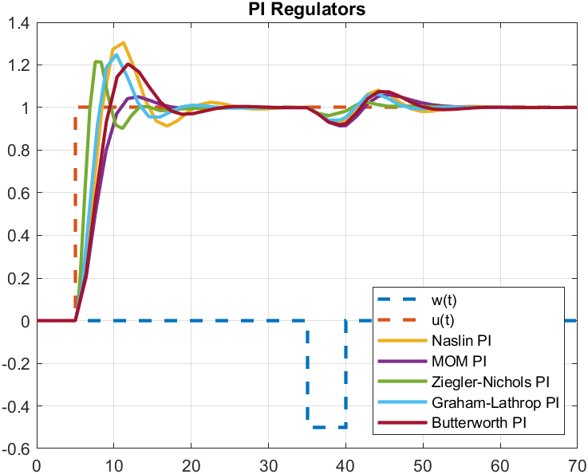

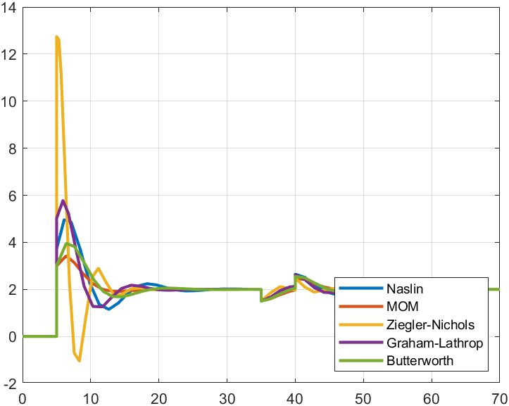
- Prepocitat prenosovu funkciu procesu F_p(s) na diskretny tvar F_p(z) pre dve hodnoty periody vzorkovania (overenie cez funkciu c2d)

Vstup
dtfun = c2d(tffun, 0.5, 'tustin');
disp(dtfun);

dtfun = c2d(tffun, 0.15, 'tustin');
disp(dtfun);

Vystup
Numerator: {[0.0050 0.0099 0.0050]}
Denominator: {[1 -1.5644 0.6040]}

Ts: 0.5000

Numerator: {[5.2271e-04 0.0010 5.2271e-04]}
Denominator: {[1 -1.8564 0.8606]}

Ts: 0.1500

