Inhalt

Planning of the software 2

Documentation and Testing 3

Main Frame 3

Add dialog 3

Fast compare dialog 4

Tests: 4

Version Control (GIT) 4

# Planning of the software

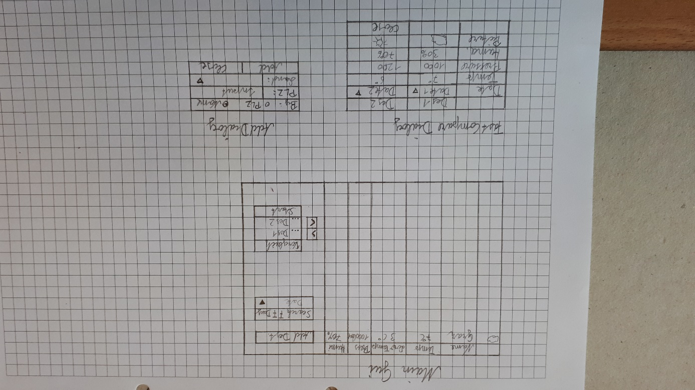

# Documentation and Testing

## Main Frame

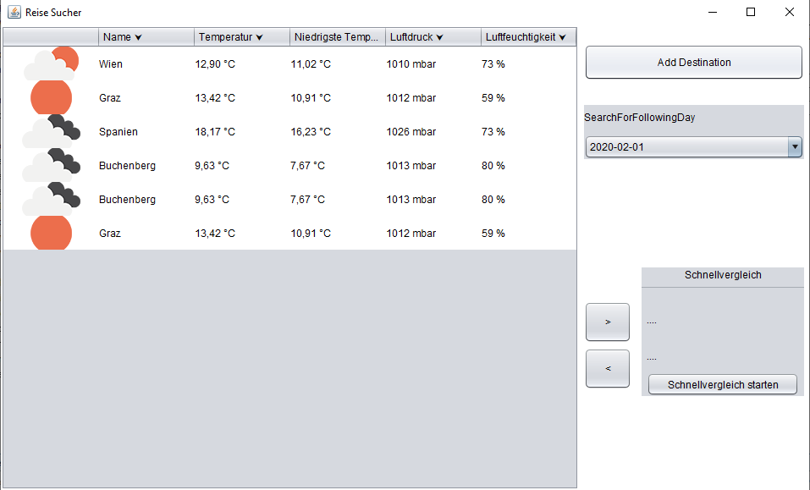

11.

10.

9.

8.

7.

6.

5.

4.

3.

2.

1.

1. Order by Name
2. Order by Temperature
3. Order by lowest Temp
4. Order by Pressure
5. Order by Humanity
6. Opens Add Destination Dialog
7. Shows the weather information’s for the selected date
8. Adds a marked destination to the fast compare list
9. Removes all destinations from the fast compare list
10. Opens the fast compare dialog
11. Right click to remove selected destination from the list

## Add dialog

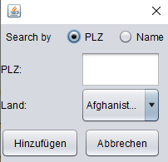

5.

4.

3.

2.

1.

1. Select searching by zip or name
2. To enter zip
3. To select country
4. To add the Destination
5. To close the add dialog

## Fast compare dialog

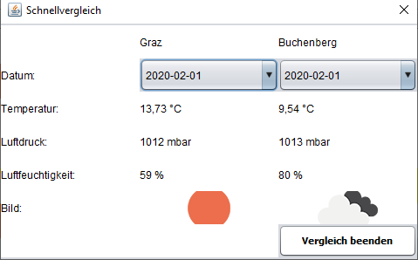

3.

2.

1.

1. To select the date for the first destination
2. To select the date for the second destination
3. To close the fast Compare dialog

## Tests:

Unit Tests in test Class

# Version Control (GIT)

