GLEAM: accessible, reproducible, and best-practice machine learning for biomedical research
Supplementary Material
Paulo Lyra Jr^{1,α}, Junhao Qiu^{1,α}, Khai Dang¹, Alyssa Pybus¹, Isis Narvaez-Bandera¹, Maansi Singh¹, Qiang Gu², Luke Sargent², Allison Creason², and Jeremy Goecks^{1,*}
¹Department of Machine Learning, Moffitt Cancer Center, Tampa, FL 33612, USA.
²Computational Biology Program, Knight Cancer Institute, Oregon Health & Science University, Portland, OR 97239, USA.
^{α}Equal contributions.
*Corresponding author: jeremy.goecks@moffitt.org
Contents
Supplementary Figures S1–S13
Supplementary Tables S1–S5

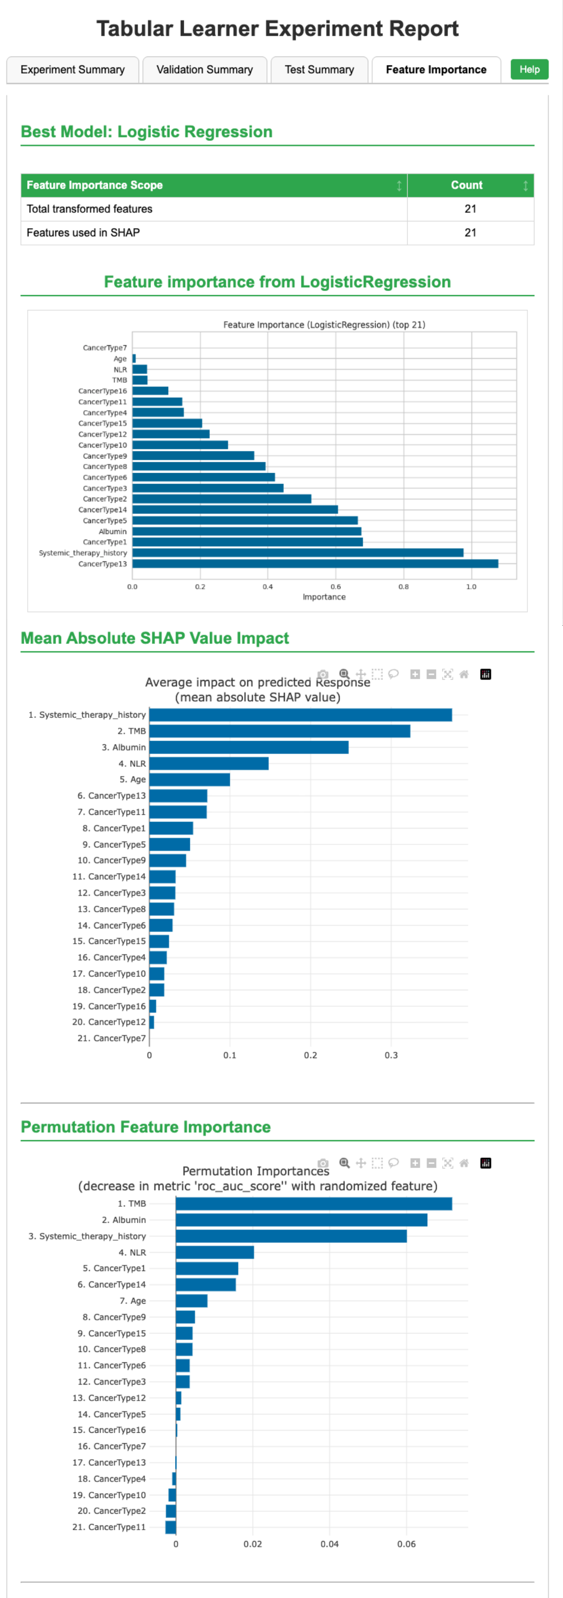
Supplementary Fig. S1 | Feature-importance analysis for Tabular Learner prediction of immunotherapy response. Feature-importance outputs for the logistic-regression model selected by Tabular Learner. The 21 transformed predictors are ranked using model-based importance, mean absolute SHAP values, and permutation importance, providing complementary measures of their contributions to model predictions. SHAP, SHapley Additive exPlanations.

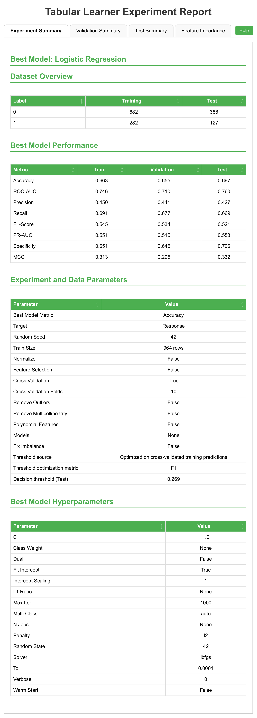
Supplementary Fig. S2 | Tabular Learner configuration for automatic decision-threshold selection. Experiment summary report for immunotherapy-response prediction using the LORIS dataset. The development dataset contained 964 patients, including 682 non-responders and 282 responders, and the predefined held-out test dataset contained 515 patients, including 388 non-responders and 127 responders. Logistic regression was selected as the best-performing model using 10-fold cross-validation with a random seed of 42. The decision threshold was optimized for F1 score using cross-validated training predictions, yielding a probability threshold of 0.269 for evaluation on the held-out test set.

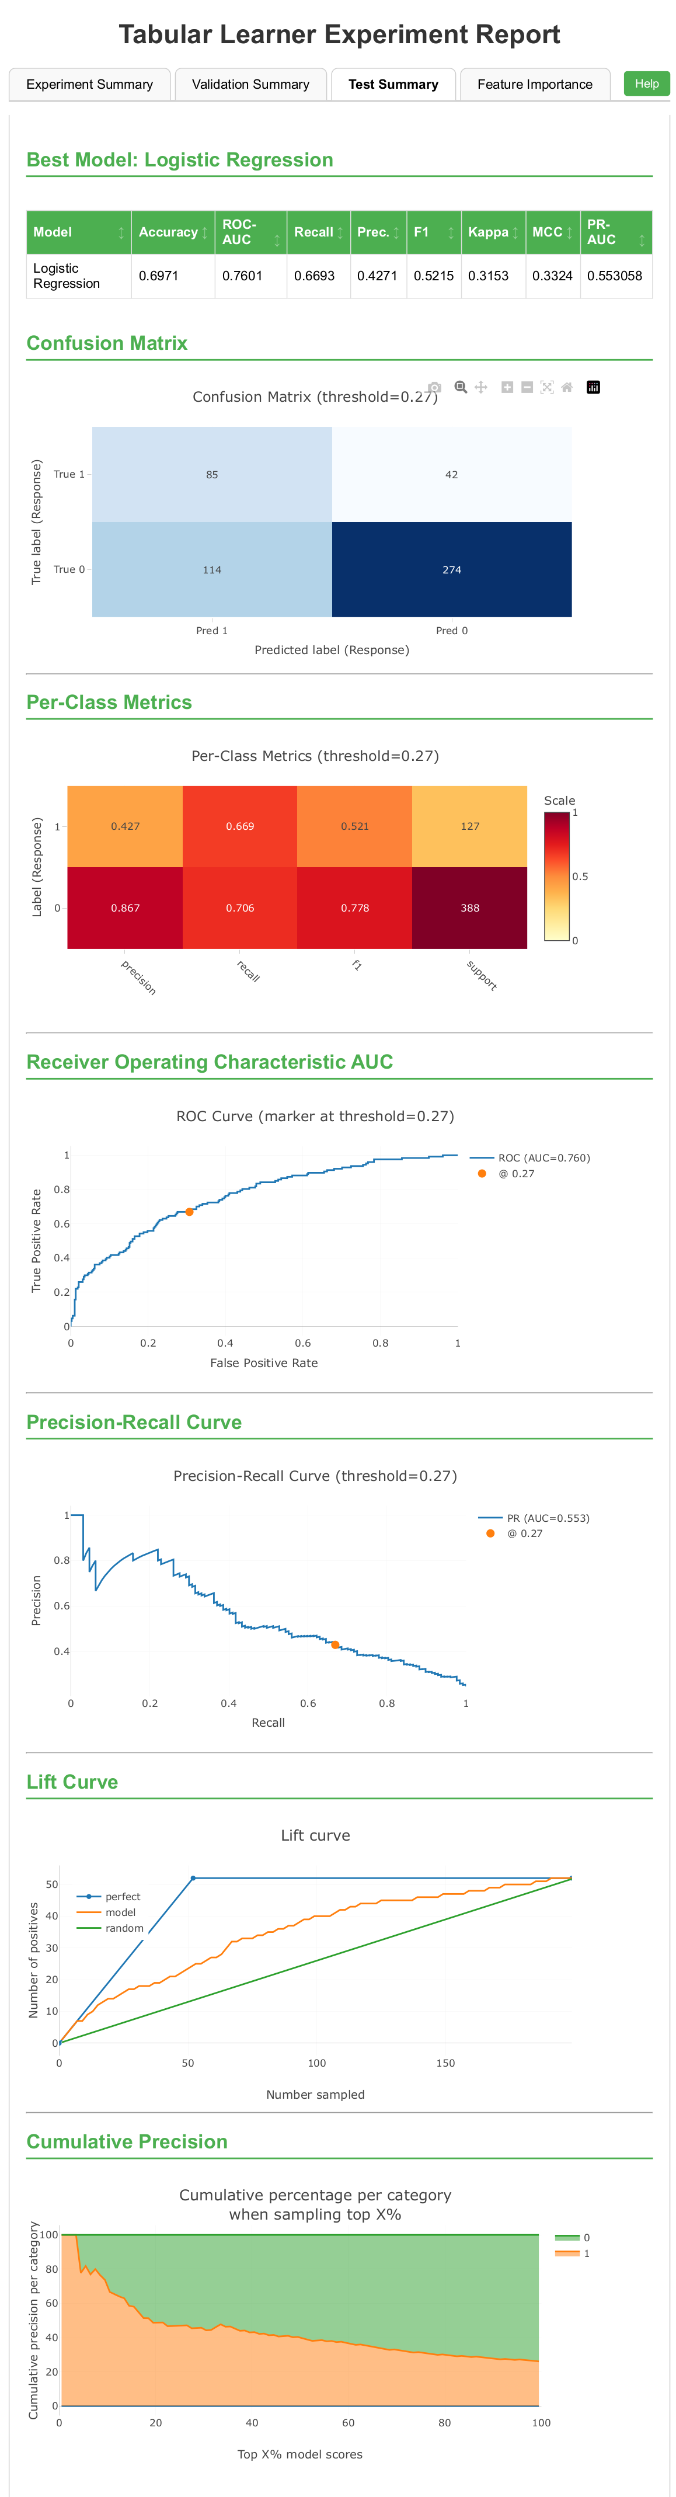
Supplementary Fig. S3 | Held-out test performance of Tabular Learner after automatic decision-threshold selection. Test summary report for the selected logistic regression model evaluated on 515 held-out patients using the training-derived probability threshold of 0.269, displayed as 0.27 in the report plots. The model achieved an accuracy of 0.697, ROC-AUC of 0.760, PR-AUC of 0.553, precision of 0.427, recall of 0.669, F1 score of 0.521, Cohen’s kappa of 0.315, and MCC of 0.332. The confusion matrix contained 85 true positives, 274 true negatives, 114 false positives, and 42 false negatives. ROC-AUC, area under the receiver operating characteristic curve; PR-AUC, area under the precision–recall curve; MCC, Matthews correlation coefficient.

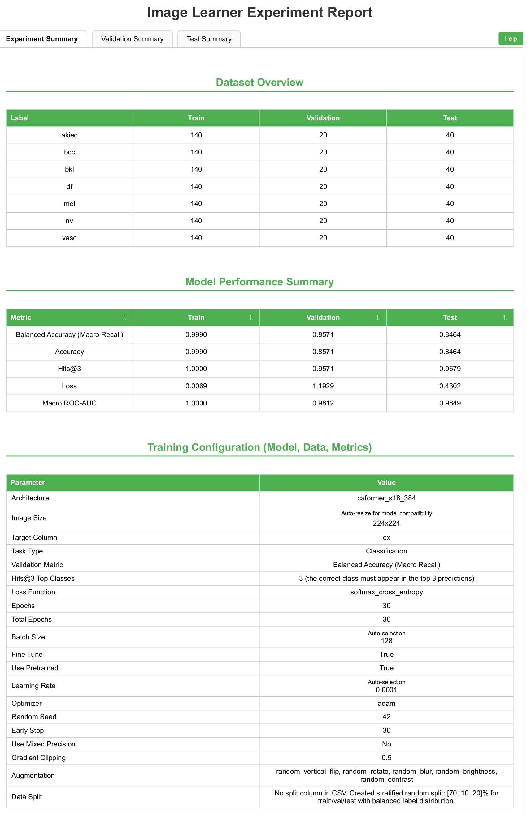
Supplementary Fig. S4 | Image Learner configuration for the class-balanced HAM10000 subset without lesion-level grouping. Experiment summary report for the class-balanced HAM10000 subset containing 1,400 dermatoscopic images, generated from 100 selected images per diagnostic class and their horizontally flipped counterparts. Stratified image-level partitioning produced 980 training, 140 validation, and 280 test images, with 140, 20, and 40 images per class, respectively. The pretrained caformer_s18_384 architecture was trained using 224 × 224-pixel inputs for 30 epochs with a batch size of 128 and a random seed of 42. Images originating from the same lesion were not constrained to the same partition.

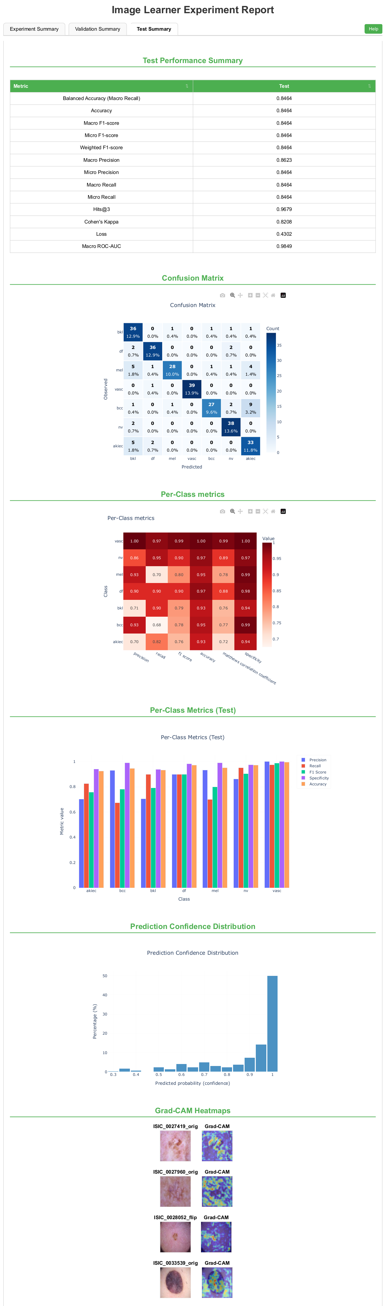
Supplementary Fig. S5 | Held-out test performance on the class-balanced HAM10000 subset without lesion-level grouping. Test summary report for the Image Learner model evaluated on 280 held-out dermatoscopic images across seven diagnostic classes. The model achieved an accuracy of 0.8464, balanced accuracy of 0.8464, macro F1 score of 0.8464, macro precision of 0.8623, macro recall of 0.8464, and macro ROC-AUC of 0.9849. The report also shows the confusion matrix, per-class metrics, prediction-confidence distribution, and representative Grad-CAM visualizations. ROC-AUC, area under the receiver operating characteristic curve; Grad-CAM, gradient-weighted class activation mapping.

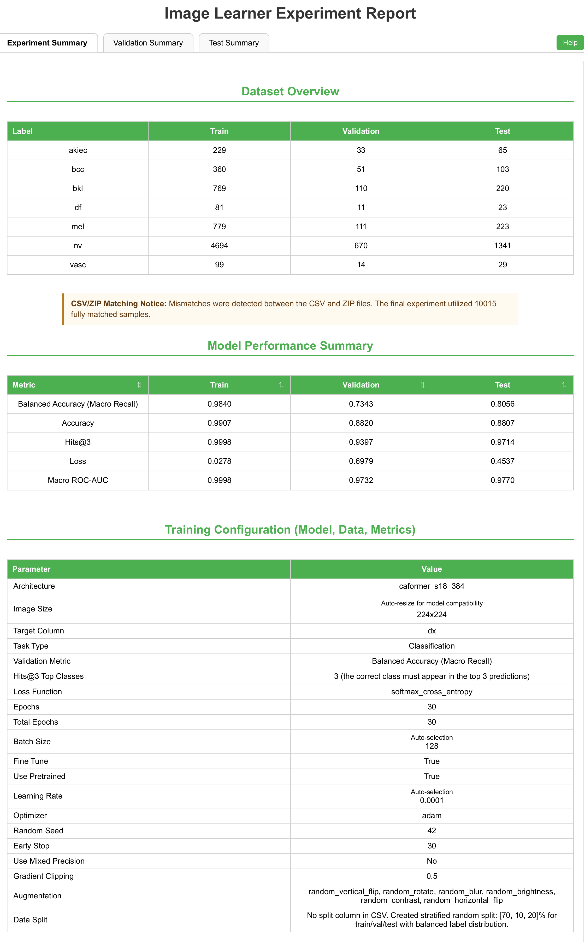
Supplementary Fig. S6 | Image Learner configuration for the full HAM10000 dataset without lesion-level grouping. Experiment summary report for the complete set of 10,015 matched HAM10000 dermatoscopic images across seven diagnostic classes. Stratified image-level partitioning produced 7,011 training, 1,000 validation, and 2,004 test images. The pretrained caformer_s18_384 architecture was trained using 224 × 224-pixel inputs for 30 epochs with a batch size of 128 and a random seed of 42. Images originating from the same lesion were not constrained to the same partition.

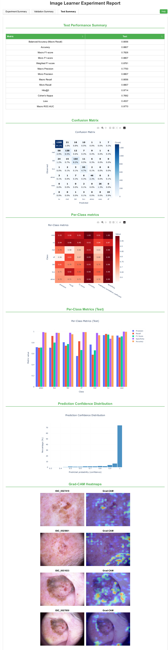
Supplementary Fig. S7 | Held-out test performance on the full HAM10000 dataset without lesion-level grouping. Test summary report for the Image Learner model evaluated on 2,004 held-out dermatoscopic images. The model achieved an accuracy of 0.8807, balanced accuracy of 0.8056, macro F1 score of 0.7826, micro F1 score of 0.8807, weighted F1 score of 0.8781, macro precision of 0.7750, macro recall of 0.8056, and macro ROC-AUC of 0.9770. The report also shows the confusion matrix, per-class metrics, prediction-confidence distribution, and representative Grad-CAM visualizations. ROC-AUC, area under the receiver operating characteristic curve; Grad-CAM, gradient-weighted class activation mapping.

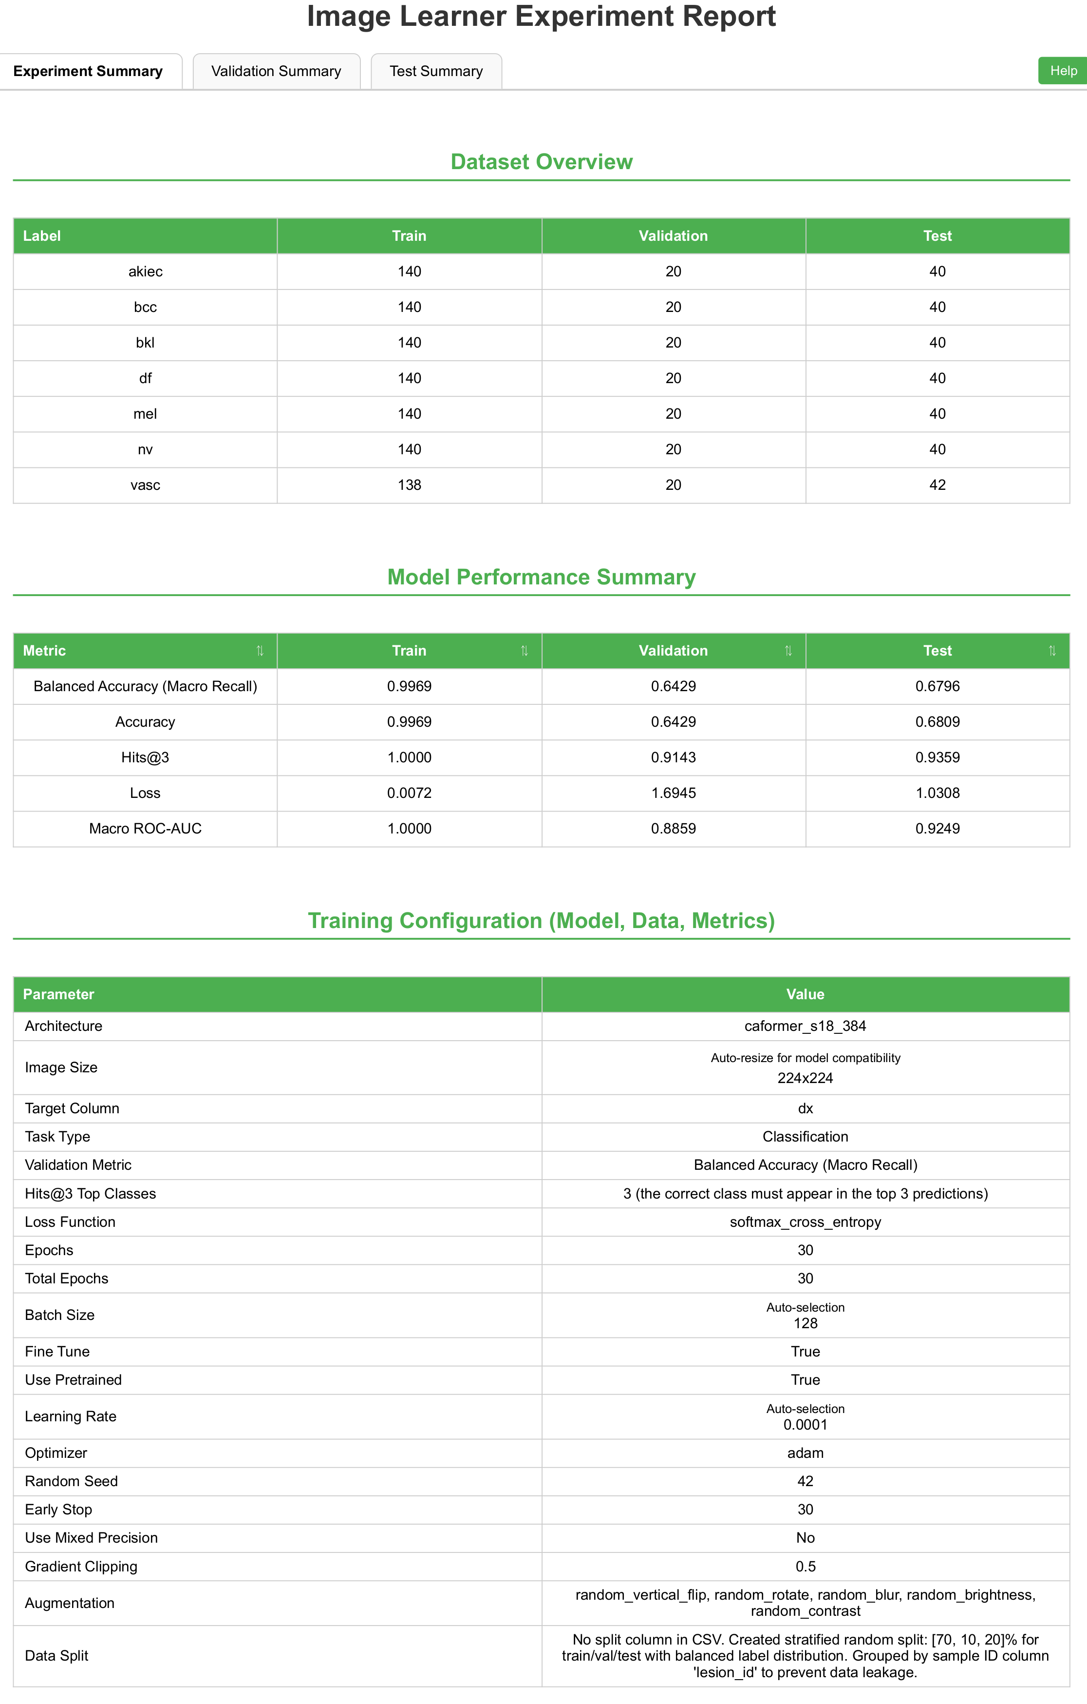
Supplementary Fig. S8 | Image Learner configuration for the class-balanced HAM10000 subset with lesion-level grouping. Experiment summary report for the class-balanced HAM10000 subset containing 1,400 dermatoscopic images after horizontal flipping. Images sharing the same lesion_id were assigned to a single partition to prevent lesion-level overlap. Group-constrained stratification produced 978 training, 140 validation, and 282 test images; the small deviation from the nominal 70:10:20 proportions resulted from retaining complete lesion groups. The pretrained caformer_s18_384 architecture was trained using 224 × 224-pixel inputs for 30 epochs with a batch size of 128 and a random seed of 42.

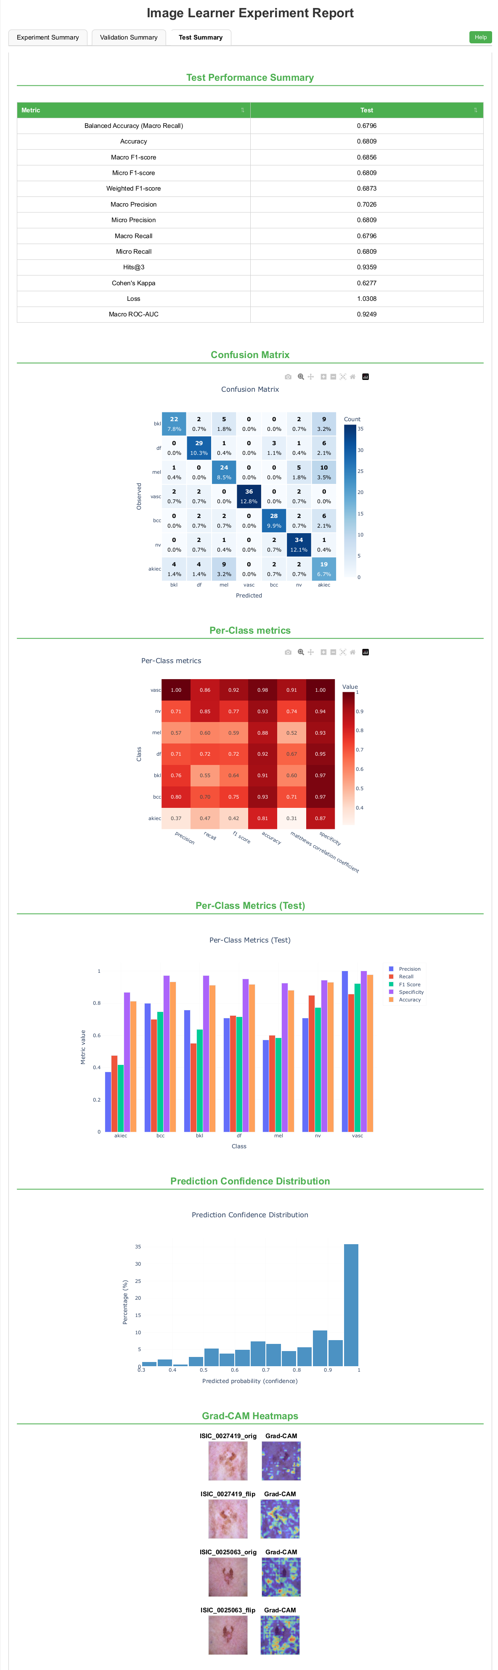
Supplementary Fig. S9 | Held-out test performance on the class-balanced HAM10000 subset with lesion-level grouping. Test summary report for the lesion-grouped Image Learner model evaluated on 282 held-out dermatoscopic images. The model achieved an accuracy of 0.6809, balanced accuracy of 0.6796, macro F1 score of 0.6856, micro F1 score of 0.6809, weighted F1 score of 0.6773, macro precision of 0.7026, macro recall of 0.6796, and macro ROC-AUC of 0.9249. The report also shows the confusion matrix, per-class metrics, prediction-confidence distribution, and representative Grad-CAM visualizations. ROC-AUC, area under the receiver operating characteristic curve; Grad-CAM, gradient-weighted class activation mapping.

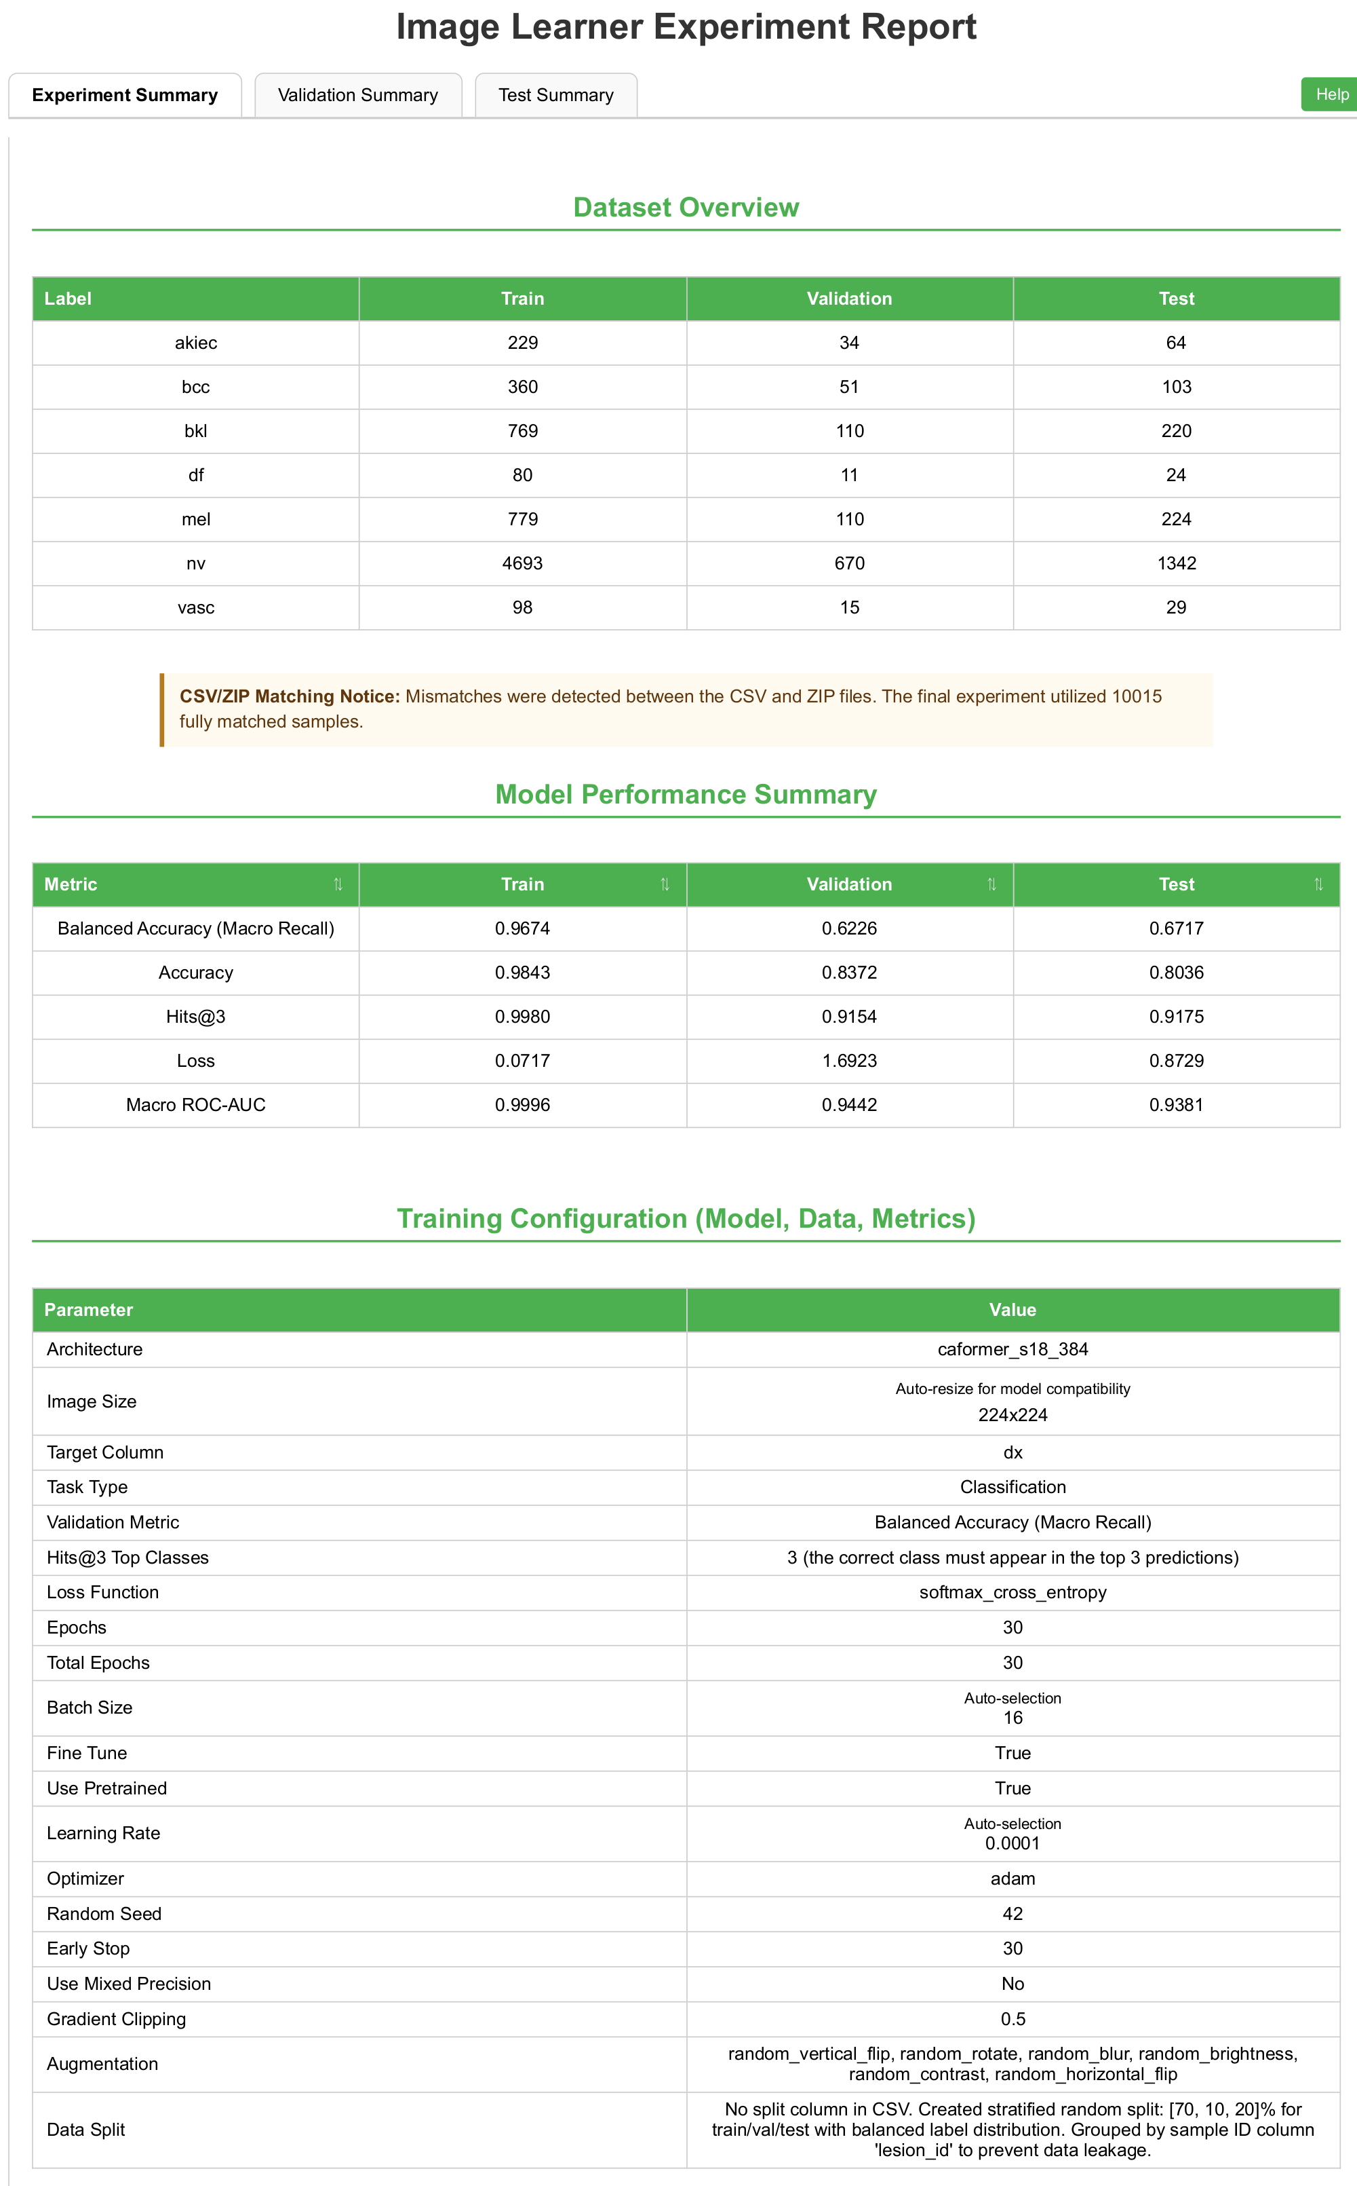
Supplementary Fig. S10 | Image Learner configuration for the full HAM10000 dataset with lesion-level grouping. Experiment summary report for the complete set of 10,015 matched HAM10000 dermatoscopic images. Images sharing the same lesion_id were assigned to a single partition to prevent lesion-level overlap. Group-constrained stratification produced 7,008 training, 1,001 validation, and 2,006 test images. The pretrained caformer_s18_384 architecture was trained using 224 × 224-pixel inputs for 30 epochs with an automatically selected batch size of 16 and a random seed of 42.

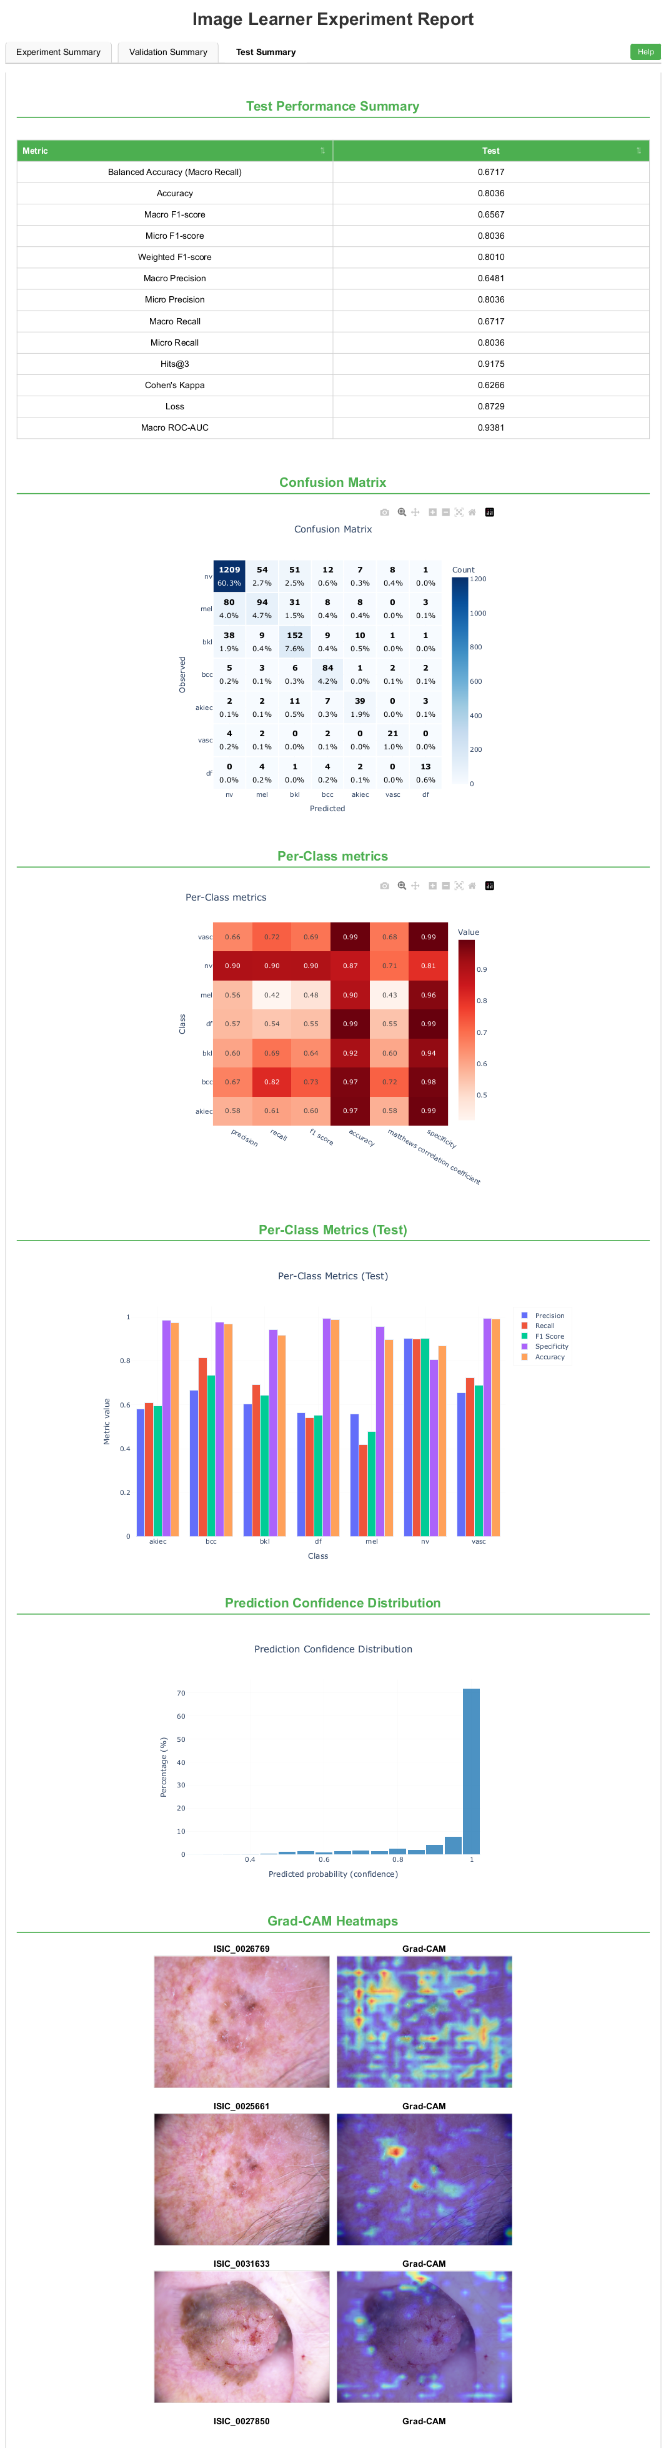
Supplementary Fig. S11 | Held-out test performance on the full HAM10000 dataset with lesion-level grouping. Test summary report for the lesion-grouped Image Learner model evaluated on 2,006 held-out dermatoscopic images. The model achieved an accuracy of 0.8036, balanced accuracy of 0.6717, macro F1 score of 0.6567, micro F1 score of 0.8036, weighted F1 score of 0.8010, macro precision of 0.6481, macro recall of 0.6717, and macro ROC-AUC of 0.9381. The report also shows the confusion matrix, per-class metrics, prediction-confidence distribution, and representative Grad-CAM visualizations. ROC-AUC, area under the receiver operating characteristic curve; Grad-CAM, gradient-weighted class activation mapping.

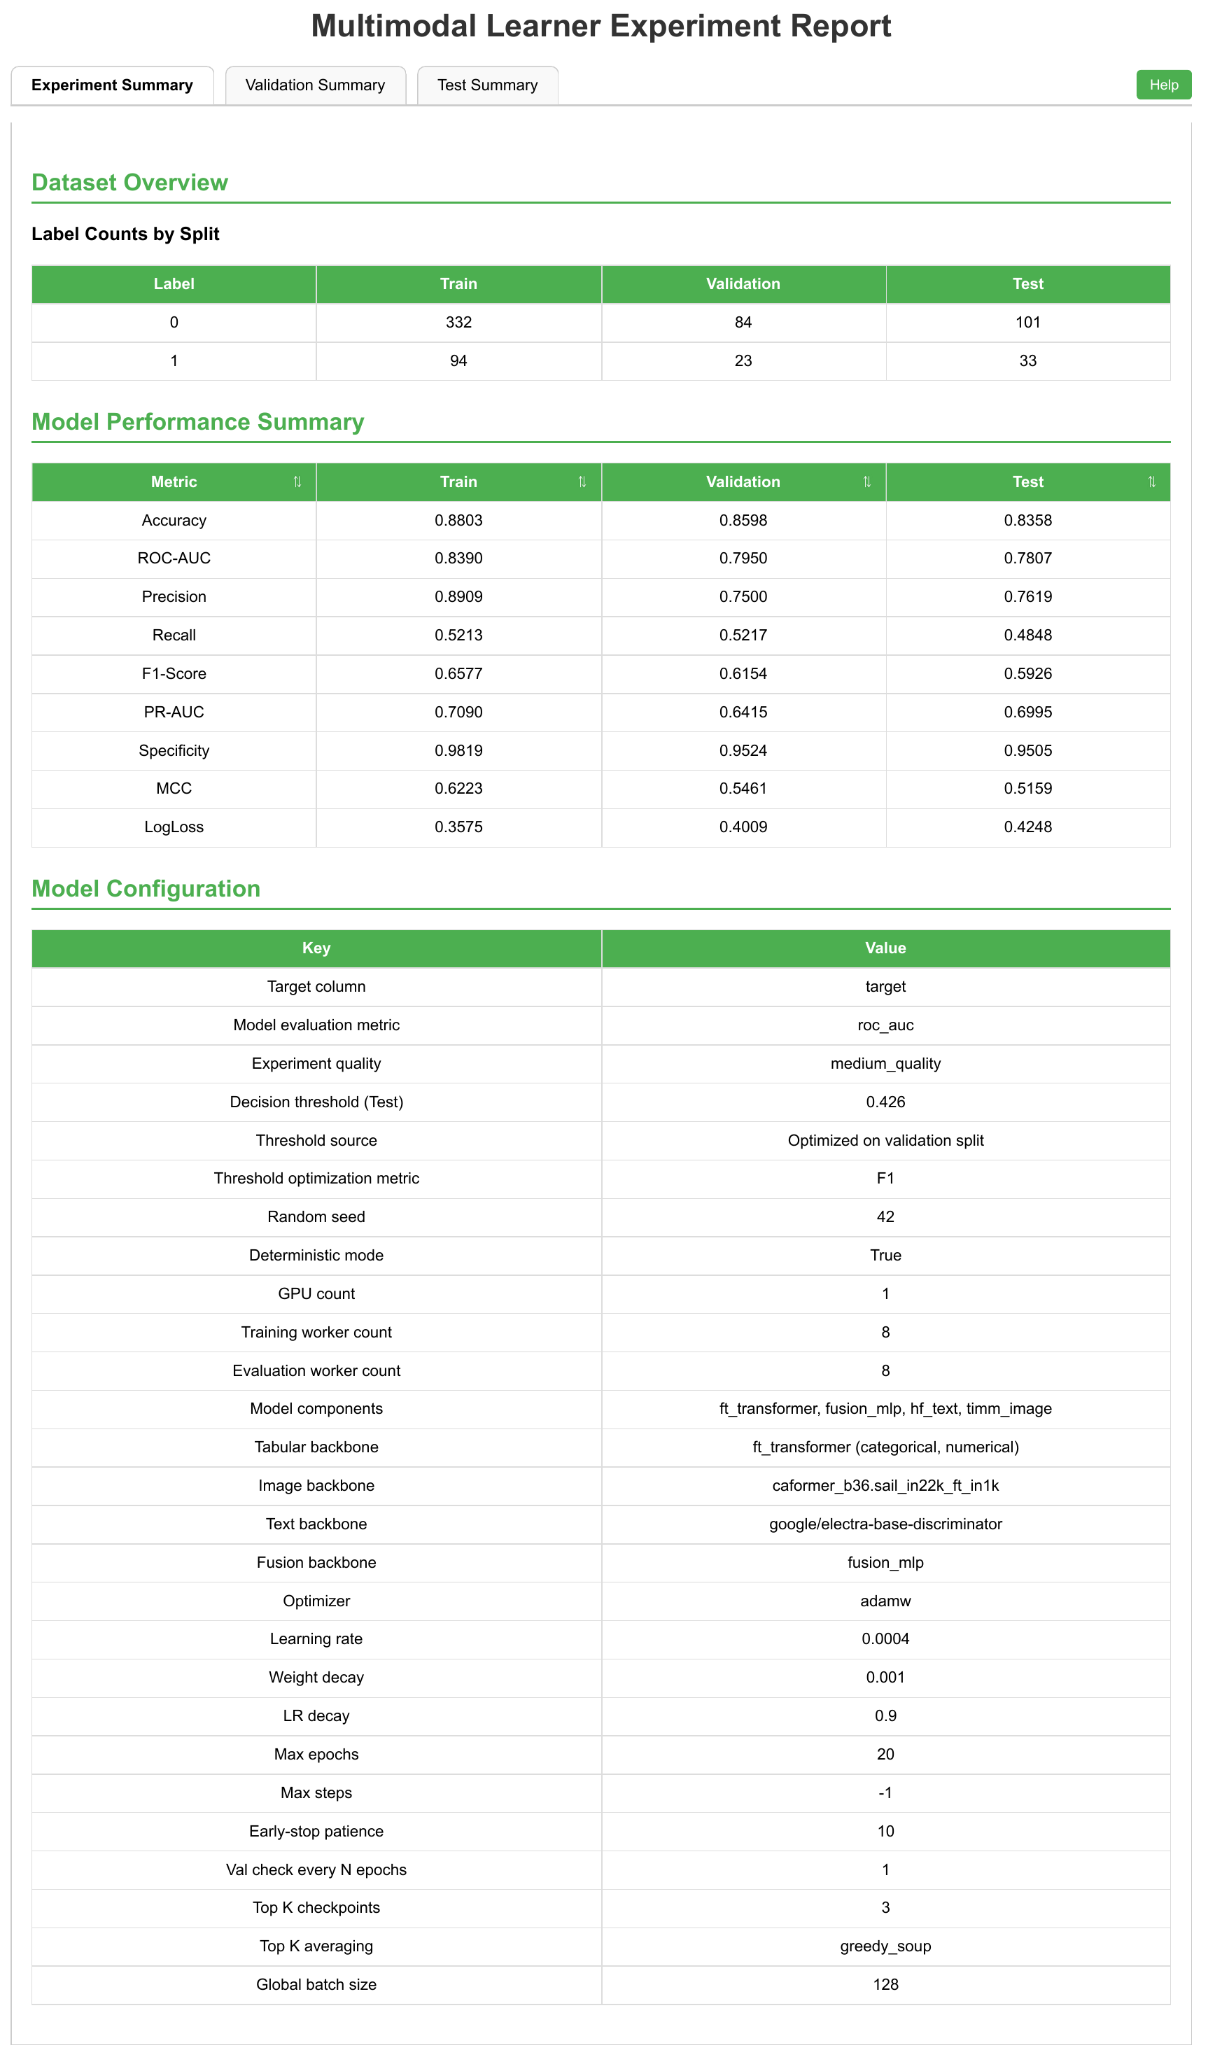
Supplementary Fig. S12 | Multimodal Learner configuration for recurrence prediction in the HANCOCK cohort. Experiment summary report for recurrence prediction using structured clinical variables, International Classification of Diseases text, and paired CD3- and CD8-stained histology images. The analyzed dataset contained 426 development, 107 validation, and 134 held-out test patients. The corresponding numbers of recurrence cases were 94, 23, and 33, and the numbers of no-recurrence cases were 332, 84, and 101. The model used google/electra-base-discriminator as the text backbone, caformer_b36.sail_in22k_ft_in1k as the image backbone, an FT-Transformer for structured variables, and multilayer-perceptron late fusion. Training used the medium-quality preset, deterministic execution, a random seed of 42, a maximum of 20 epochs, and a global batch size of 128. ROC-AUC was used as the model-evaluation metric, and a decision threshold of 0.426 was selected by optimizing F1 score on the validation partition. ROC-AUC, area under the receiver operating characteristic curve.
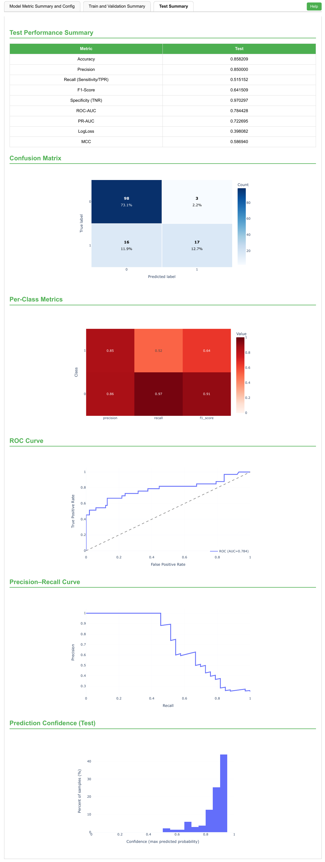
Supplementary Fig. S13 | Held-out test performance of Multimodal Learner for HANCOCK recurrence prediction. Test summary report for the Multimodal Learner model evaluated on 134 held-out patients, including 101 patients without recurrence and 33 patients with recurrence. The model achieved an accuracy of 0.858, precision of 0.850, recall of 0.515, F1 score of 0.642, specificity of 0.970, ROC-AUC of 0.784, PR-AUC of 0.723, log loss of 0.398, and MCC of 0.587. The confusion matrix contained 98 true negatives, 3 false positives, 16 false negatives, and 17 true positives. For the no-recurrence class, precision, recall, and F1 score were 0.86, 0.97, and 0.91, respectively; for the recurrence class, the corresponding values were 0.85, 0.52, and 0.64. The report also shows ROC and precision–recall curves and the test-set prediction-confidence distribution. ROC-AUC, area under the receiver operating characteristic curve; PR-AUC, area under the precision–recall curve; MCC, Matthews correlation coefficient.
Supplementary Table S1. Overview of the three GLEAM learner modules.
Aspect | Tabular Learner | Image Learner | Multimodal Learner
Module version | 0.1.5 | 0.1.6 | 0.1.9
Backend framework | PyCaret 3.3.2 | Ludwig 0.10.1 | AutoGluon MultiModalPredictor 1.4.0
Container image | quay.io/goeckslab/galaxy-pycaret:3.3.2 | quay.io/goeckslab/galaxy-ludwig-gpu:0.10.1 | quay.io/goeckslab/multimodal-learner:1.4.0
Training input | CSV or TSV table containing the target column | Image ZIP archive with a metadata CSV giving image paths and labels | CSV or TSV table with optional image ZIP archives; tabular, text and image columns
Supported tasks | Classification; regression | Binary and multi-class classification; regression | Classification; regression (task inferred from the target)
Model-selection strategy | Trains a set of candidate estimators, ranks them by a user-selected metric and optionally tunes the best model | Trains one user-selected backbone per run, pretrained or from scratch, with optional encoder fine-tuning | Preset-driven AutoGluon ensemble built over user-selected text and image backbones
Selectable models or backbonesª | 18 classification and 25 regression estimators | 129 image backbones (74 TorchVision, 55 MetaFormer) | 8 text and 76 image backbones; 3 quality presets
Representative model families | Regularized linear models, discriminant analysis, naive Bayes, k-nearest neighbours, support vector machines, multilayer perceptrons, tree ensembles and gradient boosting (XGBoost, LightGBM, CatBoost) | ResNet/ResNeXt, EfficientNet, RegNet, VGG, MobileNet, ShuffleNet, SqueezeNet, ViT, Swin, ConvNeXt, MaxViT and MetaFormer variants (IdentityFormer, RandFormer, PoolFormerV2, ConvFormer, CAFormer) | Text: DeBERTa-v3, ELECTRA, RoBERTa, BERT, ALBERT. Image: Swin, ViT, ConvNeXt, CAFormer, EVA-02, ResNet
Primary outputs | Self-contained HTML report; serialized best model (HDF5); best-model parameter table (CSV) | Self-contained HTML report; Ludwig model directory; predictions and run artefacts (ZIP) | Self-contained HTML report; metrics (JSON); training configuration (YAML); model archive (ZIP)
ªCounts refer to the options exposed in the Galaxy tool form of GLEAM suite v1.0.0; complete option lists are given in Supplementary Table S5.

Supplementary Table S2. Python software stack of the GLEAM learner modules.ª
Package | Tabular Learner | Image Learner | Multimodal Learner
pycaret | 3.3.2 | – | –
ludwig | – | 0.10.1 | –
autogluon | – | – | 1.4.0
torch | – | 2.2.1^{b} | 2.7.1
torchvision | – | 0.17.1^{b} | 0.22.1
transformers | – | 4.38.2^{b} | 4.49.0
scikit-learn | 1.4.2 | 1.4.1.post1 | 1.7.2
pandas | 2.1.4 | 2.1.4 | 2.3.3
numpy | 1.26.4 | 1.26.4 | 2.1.3
scipy | 1.11.4 | 1.12.0 | 1.15.3
matplotlib | 3.7.5 | 3.8.3 | 3.10.7
plotly | 5.24.1 | 5.19.0 | 6.5.0
shap | 0.44.1 | – | 0.49.1
joblib | 1.3.2 | – | –
h5py | 3.13.0 | – | –
PyYAML | – | 6.0 | 6.0.3
Pillow | – | 10.2.0 | 11.3.0
MetaFormer | – | vendored^{c} | –
ªVersions are those resolved by the pinned container images galaxy-pycaret:3.3.2, galaxy-ludwig-gpu:0.10.1 and multimodal-learner:1.4.0 (Supplementary Table S1). A dash indicates that the package is not part of that module's runtime stack.
^{b}Installed transitively as a Ludwig dependency.
^{c}MetaFormer model definitions are distributed with the Image Learner tool rather than installed from PyPI.

Supplementary Table S3. Number of elements in the HTML report generated by each GLEAM learner module.ª
Report element | Tabular Learner | Image Learner | Multimodal Learner
Interactive plots | 23 | 21 | 23
Summary tables | 7 | 5 | 9
ªMaximum number of elements produced for a binary-classification run. The elements generated for a particular run depend on the task type and on the options selected.

Supplementary Table S4. Best-practice safeguards and default settings of the GLEAM learner modules.
Aspect | Tabular Learner | Image Learner | Multimodal Learner
Separate external test set | Optional upload | Not supported; a single metadata CSV is used | Optional upload
User-supplied split column | Not supported | Honoured when present in the metadata CSV | Not supported
Automatic internal splitting | Yes; train fraction, default 0.7 | Yes; train/validation/test proportions, default 0.7/0.1/0.2 | Yes; train/validation/test proportions, default 0.7/0.1/0.2
Cross-validation | Yes; k-fold, default 10 folds, enabled by default | Not supported; a single train/validation/test split is used | Yes; k-fold, default 5 folds, disabled by default
Leakage-aware grouping | Optional sample ID column enforces group-aware splits and group k-fold | Optional sample ID column enforces group-aware splits when no split column is supplied | Optional sample ID column enforces group-aware splits and stratified group k-fold
Binary decision threshold | Metric-optimized or user-specified; the value and its source are reported | Metric-optimized on the validation split or user-specified | Metric-optimized on the validation split or user-specified
Transparency and explainability | Candidate-model comparison, feature importance, SHAP values, ROC and precision–recall curves, calibration curve, threshold diagnostics | Learning curves, confusion matrix, ROC and precision–recall curves, calibration curve, prediction-confidence diagnostics, Grad-CAM overlays for convolutional encoders | Feature importance, SHAP summary, force and waterfall plots, confusion matrix, ROC and precision–recall curves, calibration curve, threshold diagnostics
Reproducibility artefacts | Random seed; serialized best model; best-model parameter table; HTML report | Random seed; Ludwig model directory; per-sample predictions; training statistics; HTML report | Random seed and optional deterministic mode; model archive; metrics JSON; training configuration YAML; HTML report

Supplementary Table S5. User-configurable option groups in the Galaxy tool forms of the GLEAM learner modules.
Option group | Tabular Learner | Image Learner | Multimodal Learner
Task selection | Classification or regression | Automatic inference, binary classification, multi-class classification or regression | Inferred automatically from the target column
Model or backbone | 18 classification or 25 regression estimators; an empty selection compares all of them | 129 backbones (74 TorchVision, 55 MetaFormer); pretrained or from scratch, with optional encoder fine-tuning | Three quality presets; 8 text and 76 image backbones
Objective metric | Classification: accuracy, ROC-AUC, precision, recall, F1, Cohen's kappa, log loss, PR-AUC. Regression: R², MAE, MSE, RMSE, RMSLE, MAPE | Task-specific Ludwig validation metrics (five binary, two multi-class, five regression) or an automatic default | Automatic selection or one of 26 AutoGluon evaluation metrics
Data splitting | Optional external test set; train fraction (default 0.7); k-fold cross-validation (default 10 folds) | Split column honoured when present, otherwise train/validation/test proportions (default 0.7/0.1/0.2) | Optional external test set; validation fraction (default 0.2) or train/validation/test proportions (default 0.7/0.1/0.2); optional k-fold cross-validation (default 5 folds)
Leakage control | Optional sample ID column for group-aware splitting and group k-fold | Optional sample ID column for group-aware splitting when no split column is supplied | Optional sample ID column for group-aware splitting and stratified group k-fold
Binary threshold policy | Automatic optimization for F1, accuracy, precision, recall, Cohen's kappa or MCC, or a manual value | Automatic optimization for F1, accuracy, balanced accuracy, precision, recall or MCC, or a manual value | Automatic, or manual with a choice of seven optimization metrics or an explicit threshold value
Training regime | Optional hyperparameter tuning of the selected best model | Epochs (default 10), early-stopping patience (default 5), optional learning rate and batch size | Training time limit, optional epochs, learning rate and batch size, and free-form AutoGluon hyperparameter overrides
Preprocessing | Normalization, feature selection, outlier removal, multicollinearity removal, polynomial features, class-imbalance correction | Image resizing (13 presets) and six optional augmentations | Handling of rows with missing images (drop or placeholder)
Reproducibility | Random seed (default 42) | Random seed (default 42) | Random seed (default 42) and optional deterministic mode
MAE, mean absolute error; MAPE, mean absolute percentage error; MCC, Matthews correlation coefficient; MSE, mean squared error; PR-AUC, area under the precision–recall curve; RMSE, root mean squared error; RMSLE, root mean squared logarithmic error; ROC-AUC, area under the receiver operating characteristic curve.

