ads24x7 — Digital Ad Segmentation
A Clustering-Based Analysis for Marketing Intelligence
Business Analytics

1. Business Context & Objective
ads24x7, a digital marketing company that has recently secured $10 million in seed funding, is expanding into marketing analytics. As the newly appointed data analyst, our task is to segment their digital ad inventory into homogeneous groups using clustering, so the business can price, target, and manage different types of ads more effectively.
Three standard digital-marketing KPIs anchor the analysis:
- CPM = (Total Campaign Spend / Number of Impressions) × 1,000
- CPC = Total Cost (Spend) / Number of Clicks
- CTR = Total Measured Clicks / Total Measured Ad Impressions × 100
The dataset contains 25,857 ad records across 19 attributes, covering ad format, platform, device type, delivery volume (impressions, clicks), and financial performance (spend, revenue, fee).

2. Exploratory Data Analysis
Initial exploration (head, tail, info, describe, null and duplicate checks) confirmed:
- 25,857 rows, 19 columns; no duplicate rows.
- CTR, CPM and CPC contain missing values wherever their underlying components could not be computed directly (e.g., CPC is undefined when Clicks = 0).
- CTR is stored in the raw data as a fraction (e.g. 0.0031), not a percentage.

3. Missing Value Treatment
A single user-defined function, calculate_metrics(), was written and applied row-wise to impute CTR, CPM and CPC wherever the required inputs (Impressions, Clicks, Spend) were available:
- CTR = Clicks / Impressions (kept as a fraction, consistent with the existing column — not multiplied by 100, since doing so would create a mixed-scale column)
- CPM = Spend / Impressions × 1,000
- CPC = Spend / Clicks
Before imputation, CTR and CPM each had 219 missing values and CPC had 2,791. After running the function, all recoverable values were filled; the remaining nulls (where the formula itself is undefined — e.g., zero clicks) cannot be mathematically imputed and were excluded from the clustering dataset, leaving 23,066 usable rows.

4. Outlier Assessment
Boxplots of Clicks, Spend, Revenue, CTR, CPM and CPC (below) show heavy right-skew with clear outliers, particularly in Clicks, Spend, Revenue and CPC — typical of ad-tech data, where a small number of high-budget campaigns dwarf a long tail of small ads.
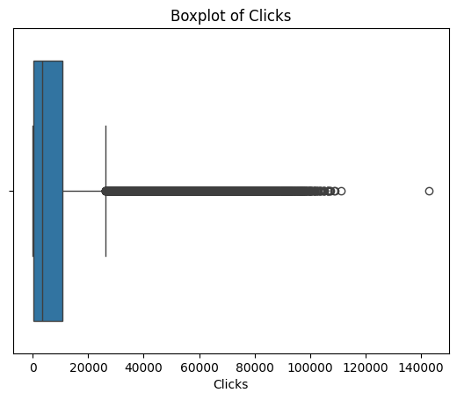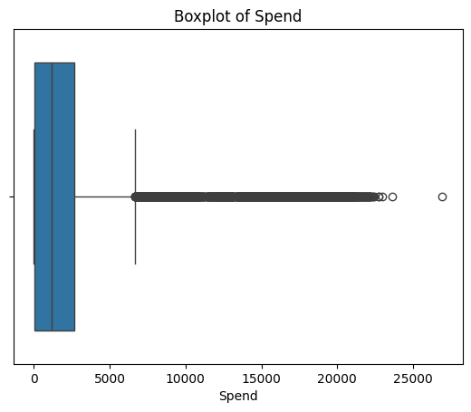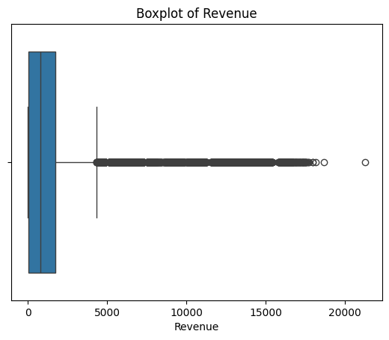
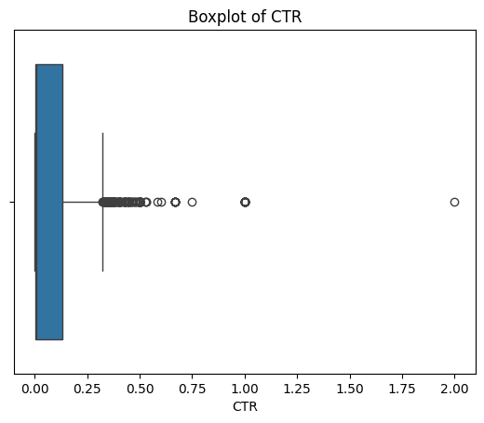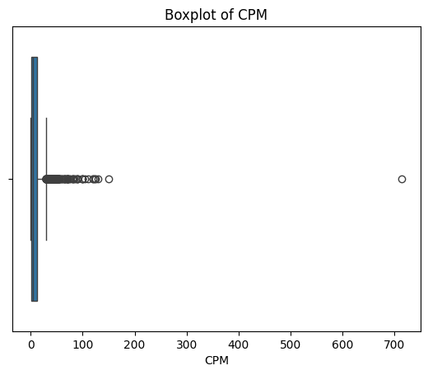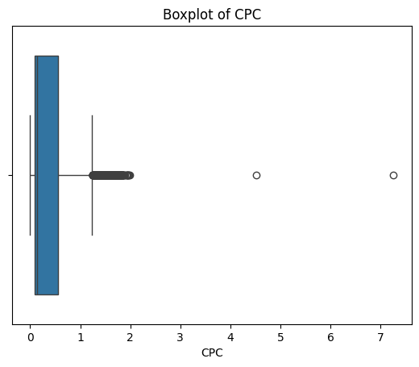
Is outlier treatment necessary for K-Means? K-Means minimizes squared Euclidean distance to centroids, so it is genuinely sensitive to extreme values — a handful of outliers can pull a centroid off-target or absorb variance that should otherwise separate meaningful groups.
Decision: we chose not to remove or cap the outliers.
- They are not data errors — they represent genuinely high-spend, high-revenue campaigns, which is exactly the type of ad ads24x7 most needs to identify and price correctly.
- Removing them would eliminate a business-relevant segment rather than noise — confirmed later, since the final clustering surfaces a distinct 'high spend / high revenue' cluster.
- Z-score scaling (next section) partially mitigates the scale distortion that originally motivated outlier treatment.
A different analyst could reasonably choose to winsorize (cap at the 1st/99th percentile) or log-transform Spend/Revenue/Clicks; we note this as a valid alternative but did not adopt it, in order to keep the 'big spender' segment visible to the business.

5. Z-Score Scaling
All six clustering features (Clicks, Spend, Revenue, CTR, CPM, CPC) were standardized using z-score scaling (mean 0, standard deviation 1) before clustering.
Effect on algorithm speed: without scaling, large-magnitude features like Spend and Revenue (in the thousands) would dominate the Euclidean distance calculation over CTR (a small fraction), effectively reducing K-Means to clustering on 1–2 features. This poorly-conditioned distance landscape typically requires more iterations (and more random restarts) to converge. Once features are standardized, every feature contributes comparably to distance, the optimization landscape is more evenly scaled, and K-Means converges faster and more stably — in addition to producing clusters that are meaningful across features measured in very different units.

6. Hierarchical Clustering — Dendrogram
Agglomerative clustering (Ward linkage, Euclidean distance) does not scale to ~23,000 rows (it is O(n²)–O(n³)), so it was run on a random sample of 1,000 rows purely to visualize the natural merge structure.
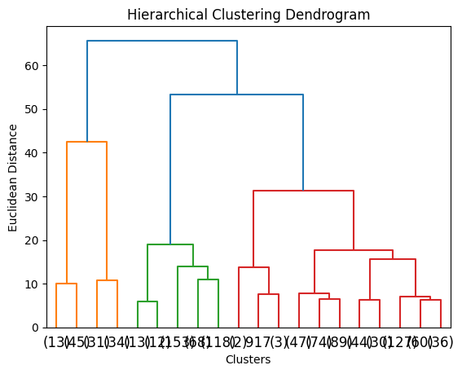
Reading the dendrogram: the largest jumps in merge distance occur fairly high up the tree, and a visual cut supports somewhere between 2 and 4 clusters — consistent with the K-Means results below.

7. K-Means: Elbow Method
Inertia (within-cluster sum of squares) was computed for k = 1 to 10 on the full scaled dataset.
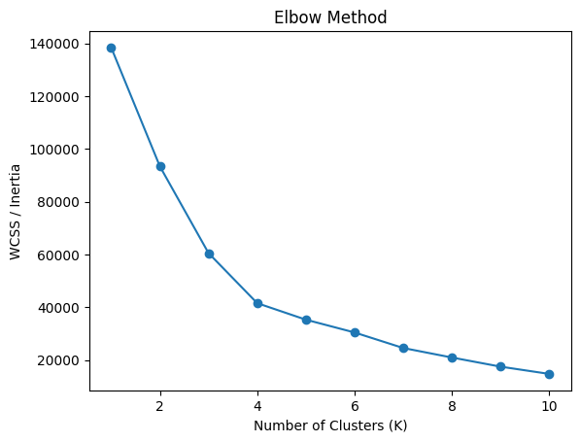
The elbow is not razor-sharp, but the rate of decrease visibly flattens around k = 3–4, after which additional clusters buy diminishing reductions in variance — consistent with the dendrogram.

8. Silhouette Analysis — Two Passes (k = 2 to 10)
As required, we evaluate the silhouette score twice: a fast approximate pass on the 1,000-row sample, and a rigorous pass on the full dataset.

8.1 Pass 1 — Sample-based (fast)
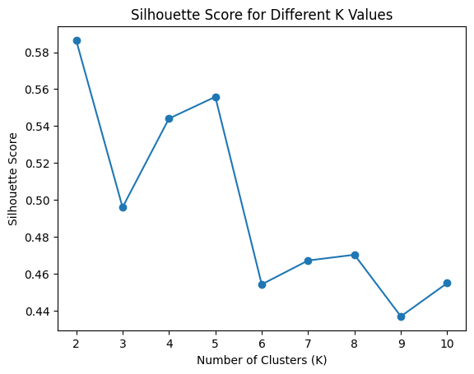
Highest silhouette score at k = 2 (0.5865).

8.2 Pass 2 — Full dataset (rigorous)
k | Silhouette Score
2 | 0.4259
3 | 0.4934
4 | 0.5392
5 | 0.5006
6 | 0.5069
7 | 0.5040
8 | 0.4104
9 | 0.4798
10 | 0.4510

Highest silhouette score at k = 4 (0.5392).
Reconciling the two passes: the sample-based silhouette (Pass 1) is noisier — 1,000 points is a small, potentially unrepresentative draw given how skewed Spend/Clicks/Revenue are. We treat k = 4, measured on the full data, as the authoritative choice: it gives a materially higher silhouette than k = 2 and, as shown below, produces four business-interpretable segments instead of one coarse split.

9. Cluster Profiling — k = 2 (Required Check)
Cluster | Clicks | Spend | Revenue | CTR | CPM | CPC
0 | 13,993.9 | 1,394.1 | 963.3 | 0.148 | 13.67 | 0.097
1 | 6,487.8 | 4,365.7 | 3,138.9 | 0.003 | 1.73 | 0.639

Cluster 0: much higher click volume, healthy CTR, low CPM/CPC — a large, efficient bucket of ads. Cluster 1: fewer ads but far higher Spend and Revenue, much lower CTR, much higher CPC — bigger, more expensive campaigns.
This is a coarse split — 'small/efficient' vs. 'big/expensive' — and hides finer structure, motivating the k = 4 check below.
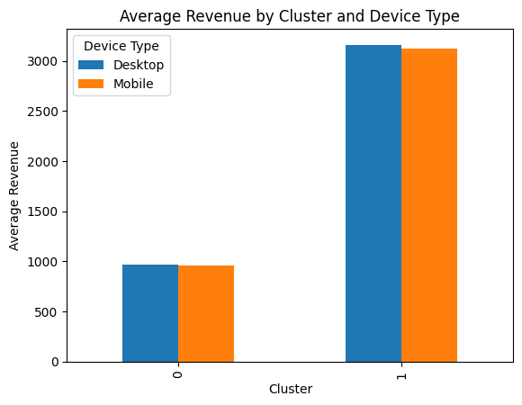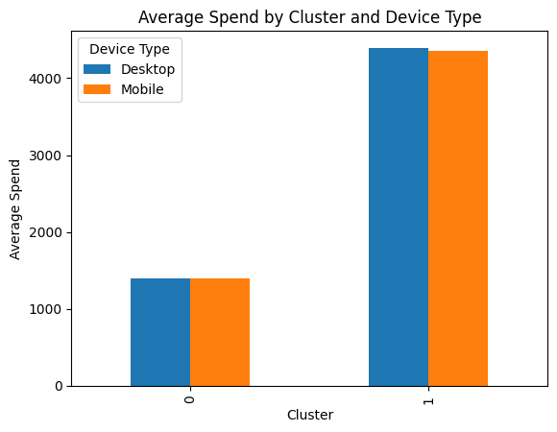
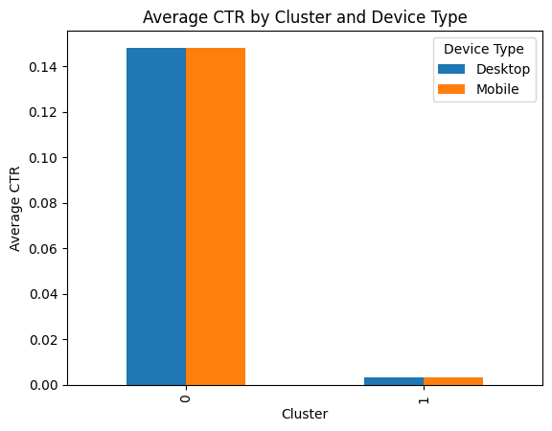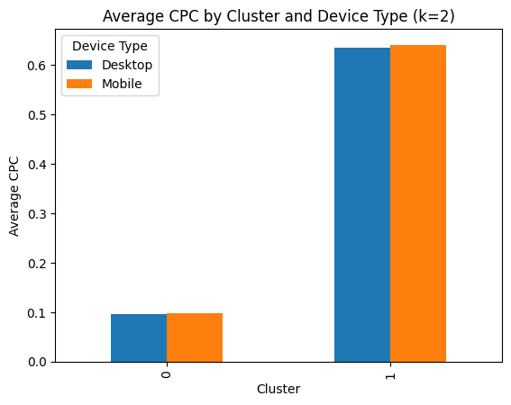

10. Cluster Profiling — k = 4 (Final, Chosen Solution)
Cluster | n (ads) | Clicks | Spend | Revenue | CTR | CPM | CPC
0 | 8,976 (38.9%) | 4,528.2 | 2,466.8 | 1,654.2 | 0.0036 | 1.71 | 0.586
1 | 11,330 (49.1%) | 7,422.9 | 695.0 | 453.7 | 0.1513 | 13.67 | 0.097
2 | 1,375 (6.0%) | 69,897.4 | 7,329.7 | 5,283.2 | 0.1386 | 15.37 | 0.109
3 | 1,385 (6.0%) | 18,379.5 | 16,127.3 | 12,369.4 | 0.0019 | 1.71 | 0.909

Device Type mix (Desktop / Mobile) is nearly identical across all four clusters (~35% / 65%) — device is not a driver of these segments; the segmentation is behavioral, based on spend and efficiency.

10.1 Total Business Contribution by Cluster (sum-based view)
The per-ad averages above hide how much of the total business each cluster actually accounts for. Grouping by cluster and taking the sum (as the assignment's hint suggests, alongside the mean) gives that picture:
Cluster | n (ads) | % of ads | Total Spend | Spend share | Total Revenue | Revenue share | Total Clicks | Clicks share
0 | 8,976 | 38.9% | 22.14M | 35.5% | 14.85M | 33.5% | 40.6M | 16.5%
1 | 11,330 | 49.1% | 7.87M | 12.6% | 5.14M | 11.6% | 84.1M | 34.1%
2 | 1,375 | 6.0% | 10.08M | 16.1% | 7.26M | 16.4% | 96.1M | 39.0%
3 | 1,385 | 6.0% | 22.34M | 35.8% | 17.13M | 38.6% | 25.5M | 10.3%

This changes the read: Clusters 2 and 3 each hold only 6% of all ads by count, yet Cluster 2 drives 39% of all clicks and Cluster 3 drives 38.6% of total revenue — a small number of ads carrying a disproportionate share of volume/value. Clusters 0 and 1 make up 88% of the inventory by count but a comparatively smaller combined revenue share (45.1%). This sharpens the recommendation: Cluster 3 is small but accounts for well over a third of total revenue despite low efficiency, so improving its CTR/CPC has an outsized impact on the bottom line — it should be a priority audit, not a background segment.
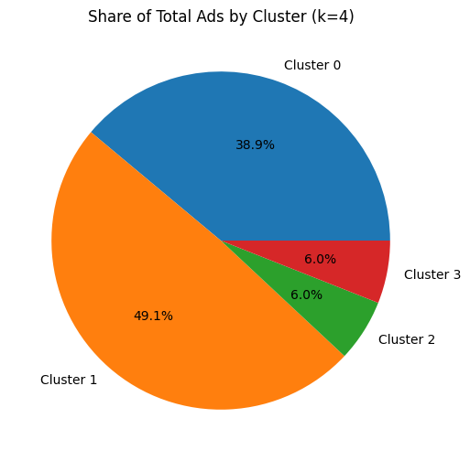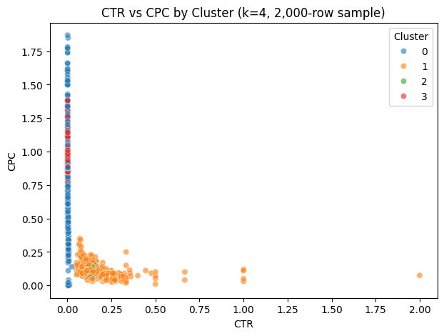

Cluster 0 — "Underperformer"
38.9% of all ads (8,976). Lowest click volume, low-to-mid Spend and Revenue, and the lowest CTR of all clusters (0.0036) — these ads are simply not generating engagement or scale. Despite being over a third of the inventory, they contribute only 16.5% of clicks.
Recommendation: candidates for pausing, creative refresh, or renegotiating placement/pricing — not worth incremental investment as-is.

Cluster 1 — "Efficient, Small-Scale"
49.1% of all ads (11,330) — the largest single group. Lowest Spend and Revenue per ad, but the best CTR (0.15) and lowest CPC (0.10) — small ads that punch well above their weight on efficiency, contributing 34.1% of all clicks.
Recommendation: prime candidates to scale up; if efficiency holds as spend increases, this is the best incremental-budget opportunity in the portfolio.

Cluster 2 — "High-Volume Workhorse"
Only 6.0% of ads (1,375) but disproportionately important: by far the highest click volume (~70k average), strong CTR (0.14), low CPC (0.11) — this small group alone drives 39.0% of all clicks across the entire portfolio.
Recommendation: the core of the ad portfolio; protect and maintain, and use as the benchmark for evaluating new inventory.

Cluster 3 — "Big Spender, Low Efficiency"
Also just 6.0% of ads (1,385), but the highest Spend and highest Revenue by a wide margin, with the lowest CTR (0.0019) and the highest CPC (0.91) of any cluster — this small group alone accounts for 38.6% of total revenue, despite weak per-click engagement.
Recommendation: audit creative/targeting quality; the spend is justified by revenue today, but improving CTR or lowering CPC here would materially improve margin. Good candidate for A/B testing new formats before committing further budget.

10.2 Device-Level Visualizations (k = 4)
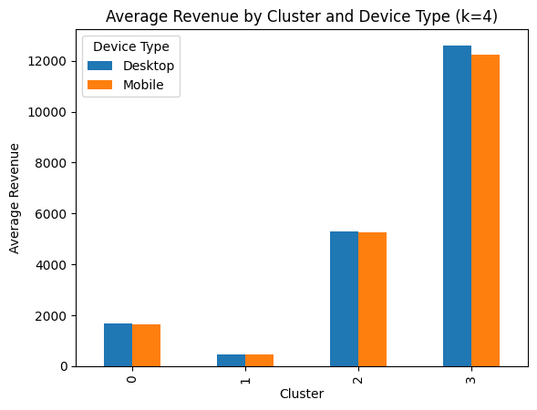
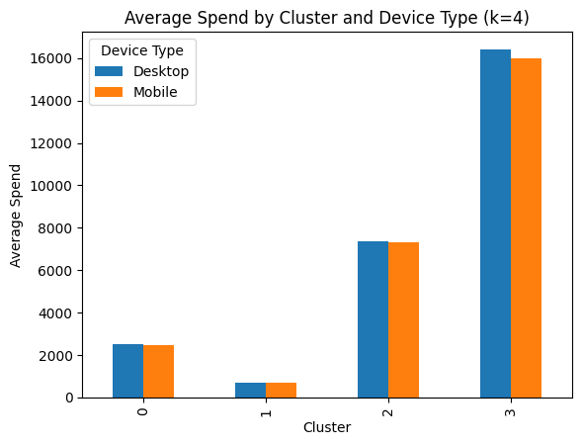
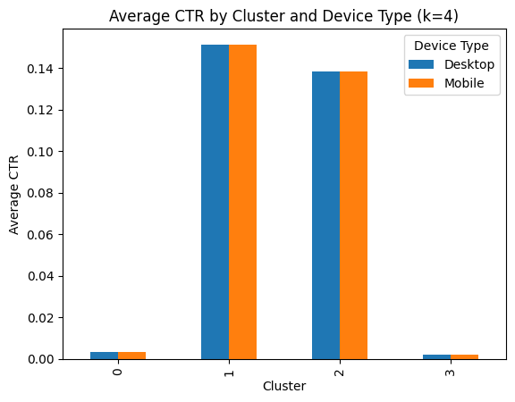
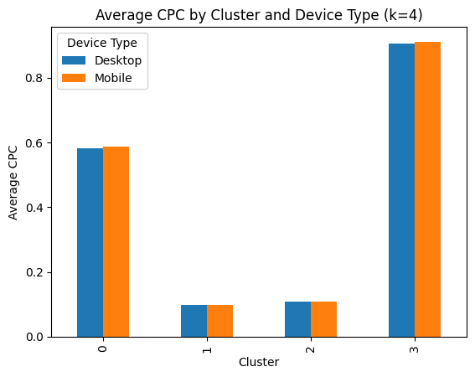
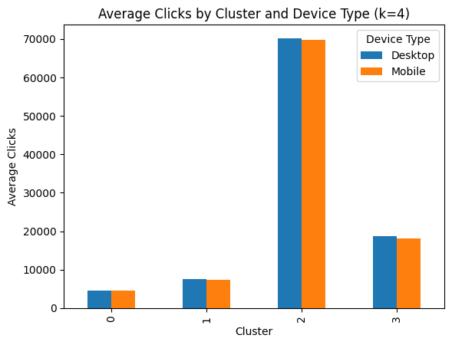
Across every metric (Revenue, Spend, CTR, CPC, Clicks), Desktop and Mobile track each other closely within each cluster — reinforcing that Device Type does not meaningfully differentiate the segments.

11. Hierarchical vs. K-Means — Method Selection
Both methods were run, and they agree on the broad structure of the data: the dendrogram (Ward linkage) supports a natural cut in the 2–4 cluster range, consistent with the K-Means elbow and silhouette results.
We select K-Means (k = 4) as the final method for the business deliverable because:
- Hierarchical clustering (Ward) is O(n²)–O(n³) in memory/time, so it could only be run on a 1,000-row sample here — it does not scale to the full ~23,000-row dataset without heavy sampling, limiting confidence in it as a final label assignment.
- K-Means scales linearly and was run on the full dataset, giving every ad a cluster label rather than only a sample.
- The full-data silhouette score at k = 4 (0.539) indicates well-separated, cohesive clusters, and the resulting segments are directly actionable for the business.
The dendrogram's role here is confirmatory — validating that 'somewhere around 2–4 groups' is sensible — while K-Means (k = 4) delivers the actual, full-population segmentation used for the recommendations above.

12. Conclusion — Summary of Learnings
- Missing CTR/CPM/CPC were recovered from Spend/Clicks/Impressions using a single reusable, formula-driven function; the small remainder of nulls was mathematically undefined (e.g., zero clicks) and excluded rather than force-imputed.
- Outliers in Spend/Revenue/Clicks were deliberately not removed, since they represent a real, business-relevant 'big spender' segment rather than noise — validated by the final clustering, which isolates exactly such a segment (Cluster 3).
- Z-score scaling was necessary both to make distances meaningful across features of very different units, and to help K-Means converge faster and more stably.
- Checking k = 2 and k = 4 (as required) showed k = 2 gives only a coarse 'small vs. big' split, while k = 4 — supported by a materially higher full-data silhouette score (0.539 vs 0.426) — resolves this into four actionable segments: underperformer, efficient/small-scale, high-volume workhorse, and big spender/low efficiency.
- A sum-based view (in addition to the mean-based profile) showed cluster size and business contribution do not move together: Clusters 2 and 3 are each only 6% of ads by count, yet Cluster 2 alone drives 39% of all clicks and Cluster 3 alone drives 38.6% of total revenue — the mean-only view would have understated how much these two small clusters matter.
- Device Type (Desktop vs. Mobile) does not meaningfully differentiate the segments; the real differentiation is behavioral (spend, clicks, efficiency).
- Business impact: ads24x7 can now scale the efficient, high-volume ads, protect the workhorse segment, investigate/optimize the big-spend-low-efficiency segment to improve margin, and deprioritize or refresh the underperforming segment — turning one undifferentiated ad inventory into four clearly-targeted management actions.

Appendix — Code
The complete, commented Python implementation (data loading, imputation function, outlier check, scaling, hierarchical and K-Means clustering for both k = 2 and k = 4, and all visualizations) is provided in the accompanying Jupyter notebook (BA_Assignment_Final.ipynb), submitted alongside this report.

