CSE3002 – Internet & Web Programming

Winter Semester – 2021 ~ 2022

Embedded Lab

L37 + L38 - Slot

E- Record

Digital Assignment - 2

Submitted By

Name of the Student : Aman Goel

Registration Number : 18BCE0895

BTECH (CSE) – 3rd YEAR

SCOPE



VELLORE INSTITUTE OF TECHNOLOGY

VELLORE – 632014

TAMIL NADU

INDIA

DATE: 23rd--February– 2021

**Question**

Write a script to take three numbers from the user and display the greatest number out of three.

**Solution**

**Code**

<!-- Write a script to take three numbers from the user and display the greatest number out of three. -->

<!DOCTYPE html>

<html lang="en">

<head>

    <meta charset="UTF-8">

    <meta http-equiv="X-UA-Compatible" content="IE=edge">

    <meta name="viewport" content="width=device-width, initial-scale=1.0">

    <title>Document</title>

    <script>

        function calculateLargest(){

            var first = document.getElementById("firstinput").value;

            var second = document.getElementById("secondinput").value;

            var third = document.getElementById("thirdinput").value;

            var answer = Math.max(first,Math.max(second,third));

            document.getElementById("answer").innerHTML = answer;

        }

    </script>

</head>

<body>

    <!-- <form onsubmit="calculateLargest()"> -->

        <label for="firstinput">Enter the first Number</label>

        <input type="number" id="firstinput" name="firstNumber">

        <br><br>

        <label for="secondinput">Enter the second number</label>

        <input type="number" id="secondinput" name="secondNumber">

        <br><br>

        <label for="thirdinput">Enter the Third number</label>

        <input type="number" id = "thirdinput" name="thirdNumber">

        <button onclick="calculateLargest()">Click Me</button>

    <!-- </form> -->

    <p>Therefore the largest among all three number is : <span id="answer"></span></p>

</body>

</html>

**Output**

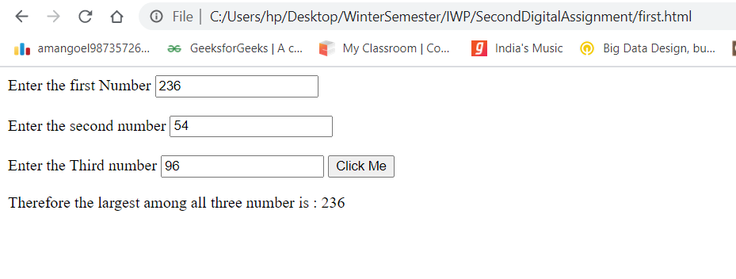

**Question**

Complete the following function called count that takes an array of integers and the size of the array, and return the number of items in the array that is greater than 13 and less than 29.

**Solution**

**Code**

<!-- Complete the following function called count that takes an array of integers and the

size of the array, and return the number of items in the array that is greater than 13

and less than 29. -->

<!DOCTYPE html>

<html lang="en">

<head>

    <meta charset="UTF-8">

    <meta http-equiv="X-UA-Compatible" content="IE=edge">

    <meta name="viewport" content="width=device-width, initial-scale=1.0">

    <title>Document</title>

    <script>

        function count(w){

            var siz = w.length;

            var ans = 0;

            for(var i = 0; i < w.length;i++){

                if(w[i] < 29 && w[i] > 13){

                    ans++;

                }

            }

            document.getElementById("answer").innerHTML = ans;

        }

        function getAnswer(){

            var inputString = document.getElementById("inputArray").value;

            var array = inputString.split(" ");

            for(var i = 0;i < array.length;i++){

                array[i] = parseInt(array[i]);

            }

            count(array);

        }

    </script>

</head>

<body>

    <label for="inputArray">Please Enter all the elements seperated by space </label>

    <br><br>

    <input type="text" name="elements" id="inputArray">

    <br><br>

    <button onclick="getAnswer()">Click Me</button>

    <br><br>

    <div>Number of items in the array that is greater than 13 and less than 29 is : <span id="answer"></span></div>

</body>

</html>

**Output**

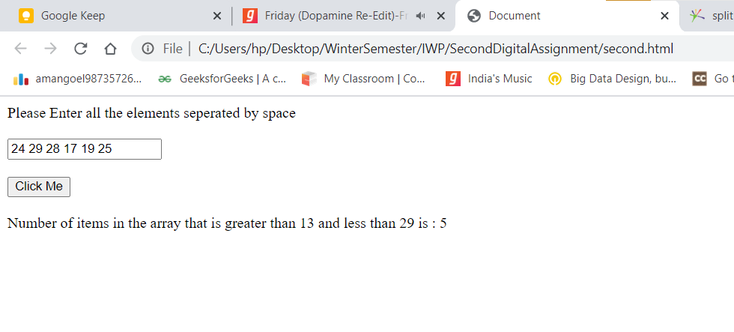

**Question**

Write a program that reads number of miles, cost of a gallon of gas, and car gas consumption (miles per gallon) and then determines the cost of a specific trip. The output should be displayed using document.writeln

SSS

**Solution**

<!DOCTYPE html>

<html lang="en">

<head>

    <meta charset="UTF-8">

    <meta http-equiv="X-UA-Compatible" content="IE=edge">

    <meta name="viewport" content="width=device-width, initial-scale=1.0">

    <title>Document</title>

    <script>

        var costt;

        function myFunc(){

            var totalMiles = parseInt(document.getElementById("miles").value);

            var CostPerGallon = parseInt(document.getElementById("costOfgallons").value);

            var gasConsumption = parseInt(document.getElementById("consumption").value);

            var totalNumberOfConsumedGallons = totalMiles / gasConsumption;

            var cost = totalNumberOfConsumedGallons * CostPerGallon;

            costt = cost;

            calledMe();

        }

    </script>

</head>

<body>

    <!--Write a program that reads number of miles, cost of a gallon of gas, and car gas

consumption (miles per gallon) and then determines the cost of a specific trip. The

output should be displayed using document.writeln -->

    <label for="miles">Enter the number of Miles</label>

    <br><br>

    <input type="number" name="InputMiles" id="miles">

    <br><br>

    <label for="costOfgallons">Enter the Cost of a gallon of gas</label>

    <br><br>

    <input type="number" name="inputCost" id="costOfgallons">

    <br><br>

    <label for="consumption">Car gas consumption (miles per gallon) and then determines the cost of a specific trip.</label>

    <br><br>

    <input type="number" name="inputConsumption" id="consumption">

    <br><br>

    <button onclick="myFunc()">Click Me</button>

    <script>

        function calledMe(){

            document.writeln("<p> Therefore total cost is : ",costt,"</p>")

            document.writeln("<p> Therefore total cost is : ",costt,"</p>");

        }

    </script>

</body>

</html>

**Output**

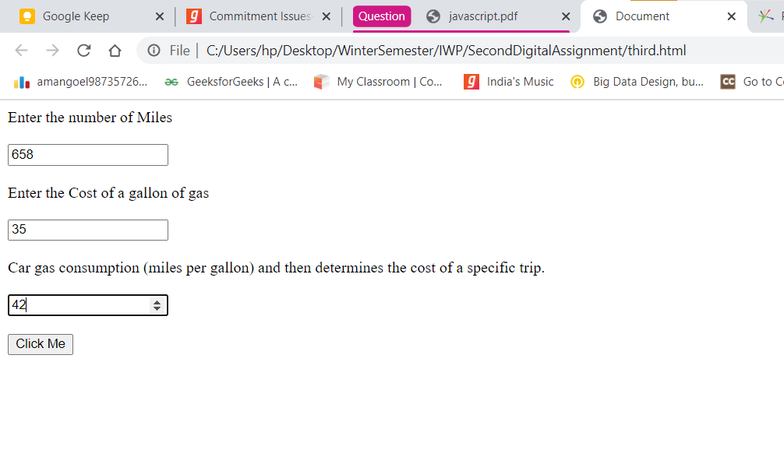

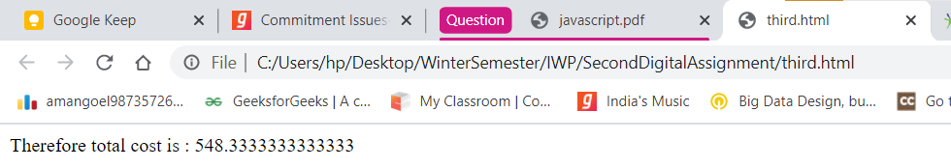

**Question**

According to Wikipedia a happy number is defined by the following process : "Starting with any positive integer, replace the number by the sum of the squares of its digits, and repeat the process until the number equals 1 (where it will stay), or it loops endlessly in a cycle which does not include 1. Those numbers for which this process ends in 1 are happy numbers, while those that do not end in 1 are unhappy numbers (or sad numbers).Write a JavaScript program to find and print the first 5 happy numbers

**Solution**

**Code**

<!-- 4. According to Wikipedia a happy number is defined by the following process :

"Starting with any positive integer, replace the number by the sum of the squares of

its digits, and repeat the process until the number equals 1 (where it will stay), or it

loops endlessly in a cycle which does not include 1. Those numbers for which this

process ends in 1 are happy numbers, while those that do not end in 1 are unhappy

numbers (or sad numbers).Write a JavaScript program to find and print the first 5

happy numbers. -->

<!DOCTYPE html>

<html lang="en">

<head>

    <meta charset="UTF-8">

    <meta http-equiv="X-UA-Compatible" content="IE=edge">

    <meta name="viewport" content="width=device-width, initial-scale=1.0">

    <title>Document</title>

    <script>

        function happy_number(num) {

            var m, n;

            var c = [];

            while (num != 1 && c[num] !== true) {

                c[num] = true;

                m = 0;

                while (num > 0) {

                    n = num % 10;

                    m += n * n;

                    num = (num - n) / 10;

                }

                num = m;

            }

            return (num == 1);

        }

        var cnt = 5;

        var num = 1;

        var f5 = '';

        while (cnt-- > 0) {

            while (!happy_number(num))

                num++;

            f5 = f5 + (num + ", ");

            num++;

        }

        // document.getElementById("answer").innerHTML = f5;

        window.onload = function what(){

            document.getElementById("answer").innerHTML = f5;

        };

        console.log('First 5 happy numbers are : ' + f5);

    </script>

</head>

<body>

    <div>Therefore First five happy number are : <span id="answer"></span></div>

</body>

</html>

**Output**

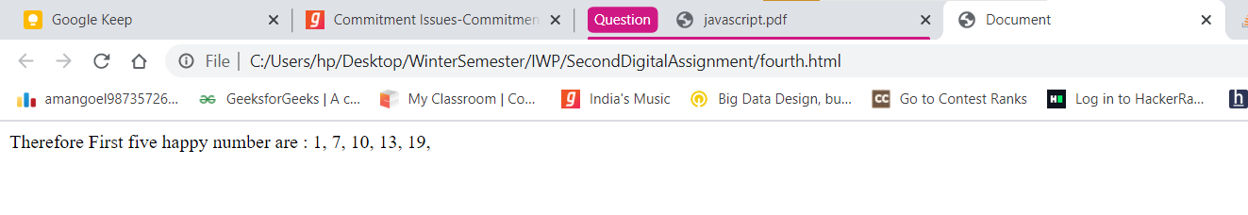

**Question 5**

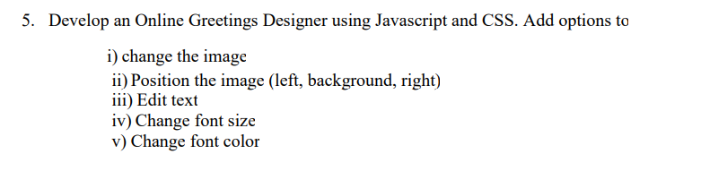

**Code**

<!-- Develop an Online Greetings Designer using Javascript and CSS. Add options to

i) change the image

ii) Position the image (left, background, right)

iii) Edit text

iv) Change font size

v) Change font color -->

<!DOCTYPE html>

<html lang="en">

<head>

    <meta charset="UTF-8">

    <meta http-equiv="X-UA-Compatible" content="IE=edge">

    <meta name="viewport" content="width=device-width, initial-scale=1.0">

    <title>Document</title>

</head>

<body>

    <h1>Online Greetings Designer</h1>

    <img src="first.jpg" alt="" id="myImage">

    <p id="textvalue">the image is very beautiful</p>

    <button onclick="changeImage()">Change Current Image</button>

    <button onclick="leftImage()">Left Image</button>

    <button onclick="backgroundImage()">Background Image</button>

    <button onclick="rightImage()">Right Image</button>

    <button onclick="editText()">Edit Text</button>

    <button onclick="changeFontSize()">Change Font Size</button>

    <button onclick="ChangeFontColor()">Change Font Color</button>

    <script>

        function changeImage(){

            document.getElementById("myImage").src = 'third.jpg';

        }

        function leftImage(){

            console.log("hello");

            document.getElementById("myImage").style.marginRight = 10 + "px";

        }

        function backgroundImage(){

            document.body.style.backgroundImage = "url('first.jpg')";

        }

        function rightImage(){

            document.getElementById("myImage").style.marginLeft = 800 + "px";

        }

        function editText(){

            document.getElementById("textvalue").innerHTML = "the world is very beautiful .......";

        }

        function changeFontSize(){

            document.getElementById("textvalue").style.fontSize = 50 + "px";

        }

        function ChangeFontColor(){

            document.getElementById("textvalue").style.color = "blue";

        }

    </script>

</body>

</html>

**Output**

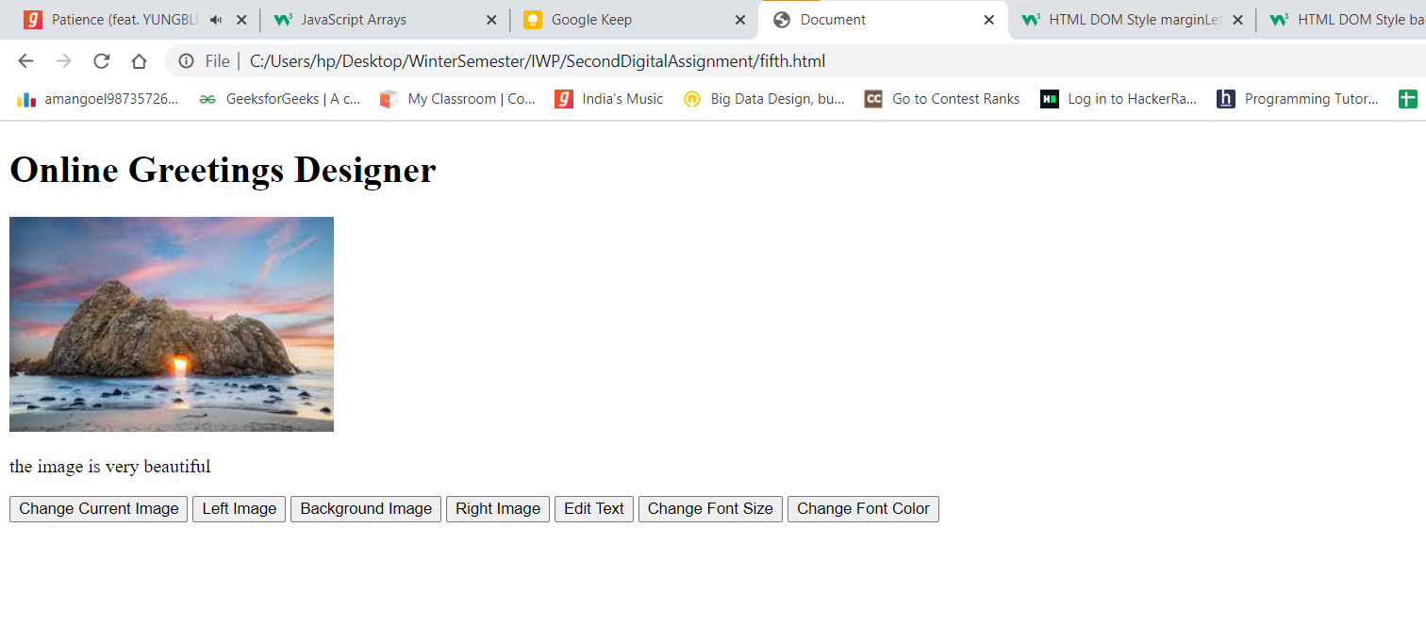

**After pressing change current image**

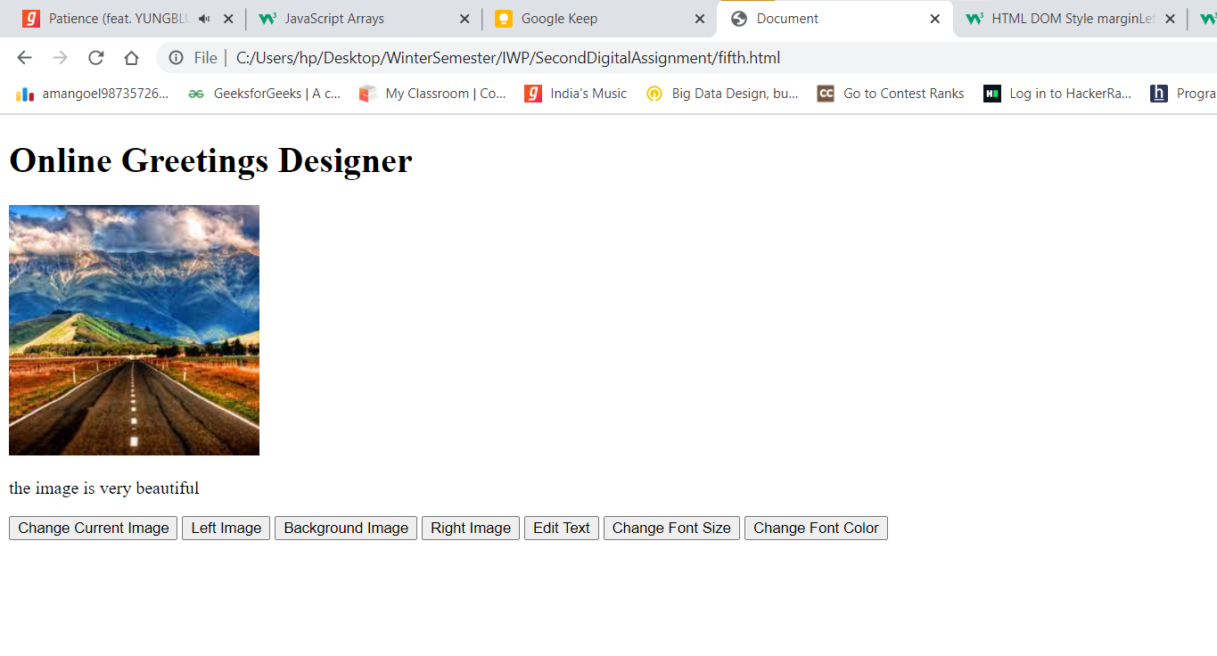

**After pressing right image button**

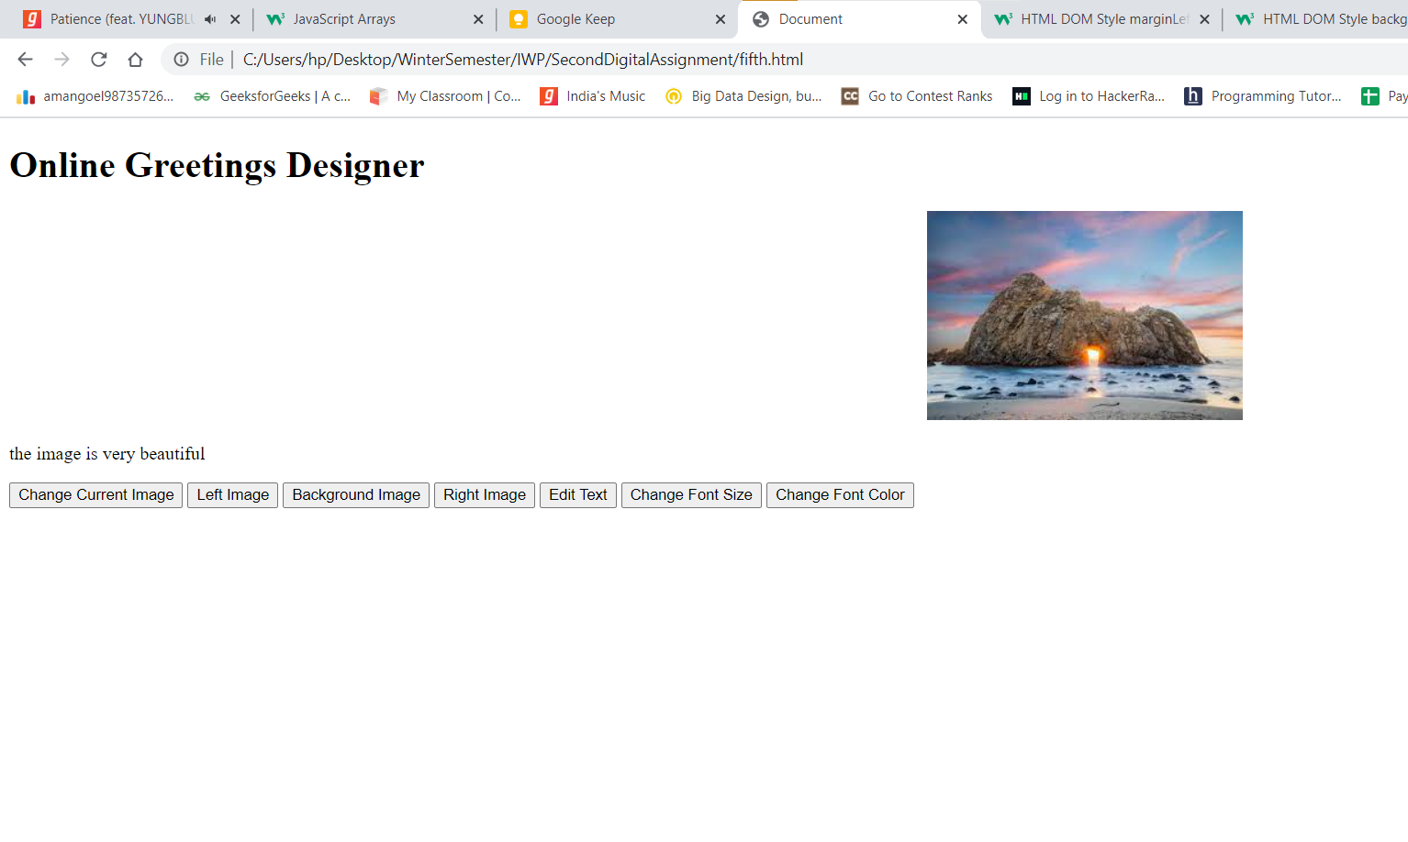

**After pressing edit Text Message**

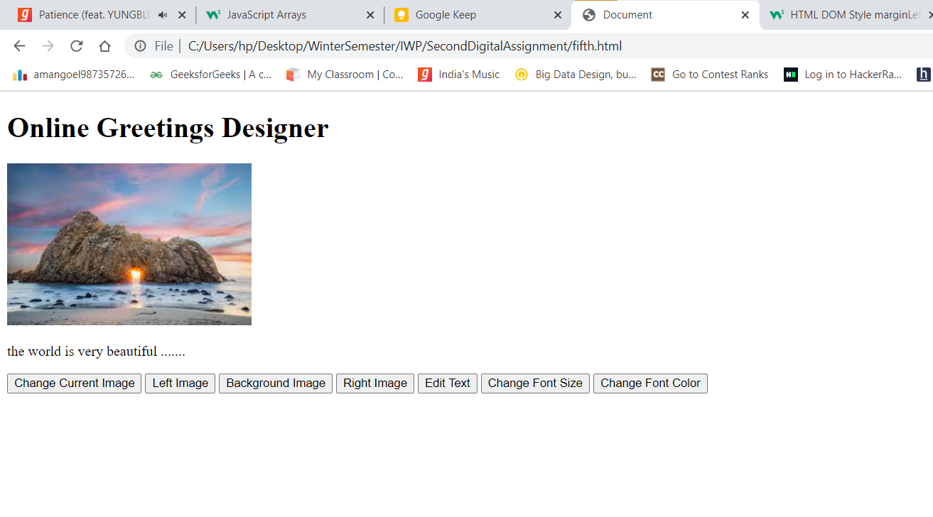

**After pressing change Font Size Button**

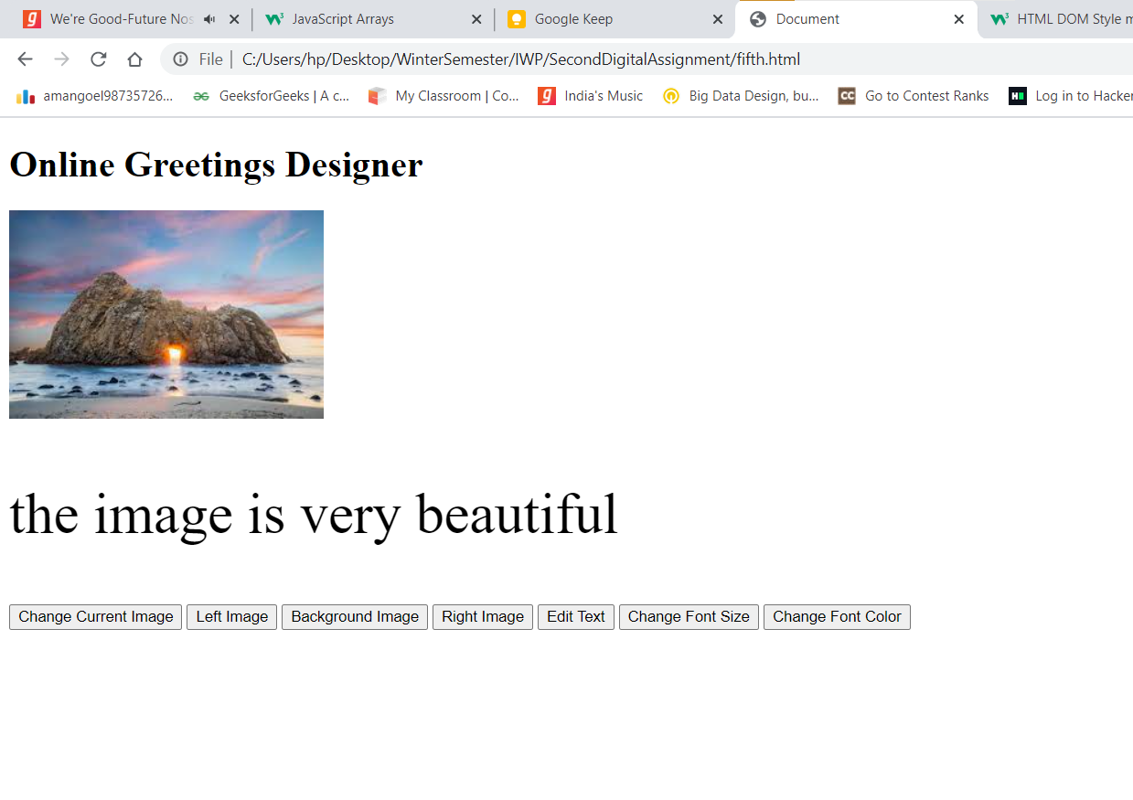

**After pressing change font color button**

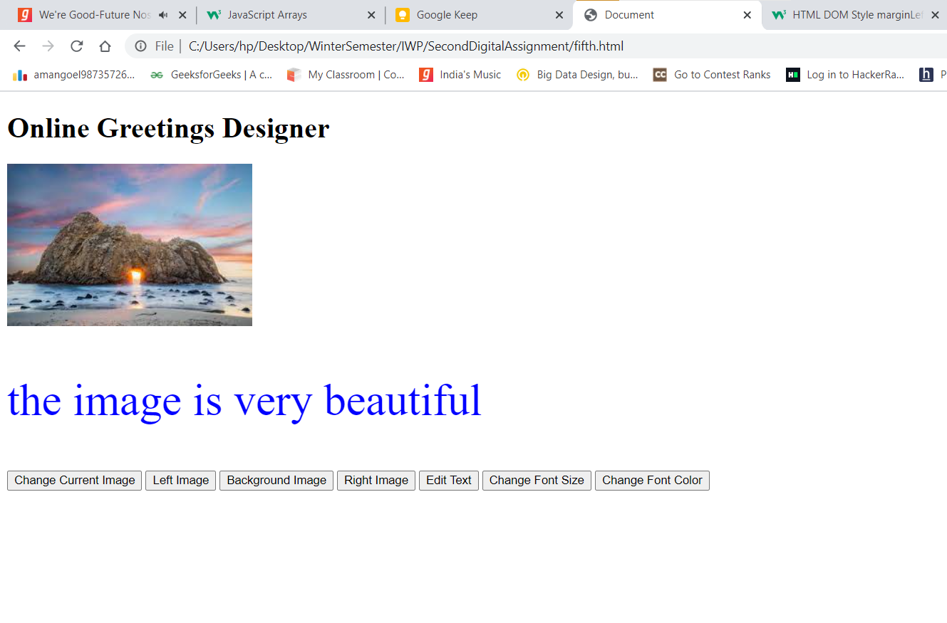

**Question 9**

A parking garage charges a $2.00 minimum fee to park for up to three hours. The garage charges an additional $0.50 per hour for each hour or part thereof in excess of three hours. The maximum charge for any given 24-hour period is $10.00. Assume that no car parks for longer than 24 hours at a time. Write a script that calculates and displays the parking charges for each customer who parked a car in this garage yesterday. You should input from the user the hours parked for each customer. The program should display the charge for the current customer and should calculate and display the running total of yesterday's receipts. The program should use the function calculate-Charges to determine the charge for each customer. Use a text input field to obtain the input from the user

**Code**

<!-- A parking garage charges a $2.00 minimum fee to park for up to three hours. The garage charges an additional $0.50 per

hour for each hour or part thereof in excess of three hours. The maximum charge for any given 24-hour period is $10.00.

Assume that no car parks for longer than 24 hours at a time. Write a script that calculates and displays the parking

charges for each customer who parked a car in this garage yesterday. You should input from the user the hours parked for

each customer. The program should display the charge for the current customer and should calculate and display the

running total of yesterday's receipts. The program should use the function calculate-Charges to determine the charge for

each customer. Use a text input field to obtain the input from the user -->

<!DOCTYPE html>

<html lang="en">

<head>

    <meta charset="UTF-8">

    <meta http-equiv="X-UA-Compatible" content="IE=edge">

    <meta name="viewport" content="width=device-width, initial-scale=1.0">

    <title>Document</title>

</head>

<body>

    <label for="hourParked">For how many hours the car was parked ??</label>

    <input type="text" id="hourParked">

    <div id="answer"></div>

    <button onclick="calculateCharges()">Compute Result</button>

    <script>

        function calculateCharges(){

            var totalCost = 0;

            var hoursParked = parseInt(document.getElementById("hourParked").value);

            if(hoursParked <= 3){

                totalCost = 2;

            }

            else{

                totalCost = 2;

                hoursParked -= 3;

                totalCost += (hoursParked * 0.5);

                if(totalCost > 10){

                    totalCost = 10;

                }

            }

            document.getElementById("answer").innerHTML = "total cost is : " + totalCost;

        }

    </script>

</body>

</html>

**Output**

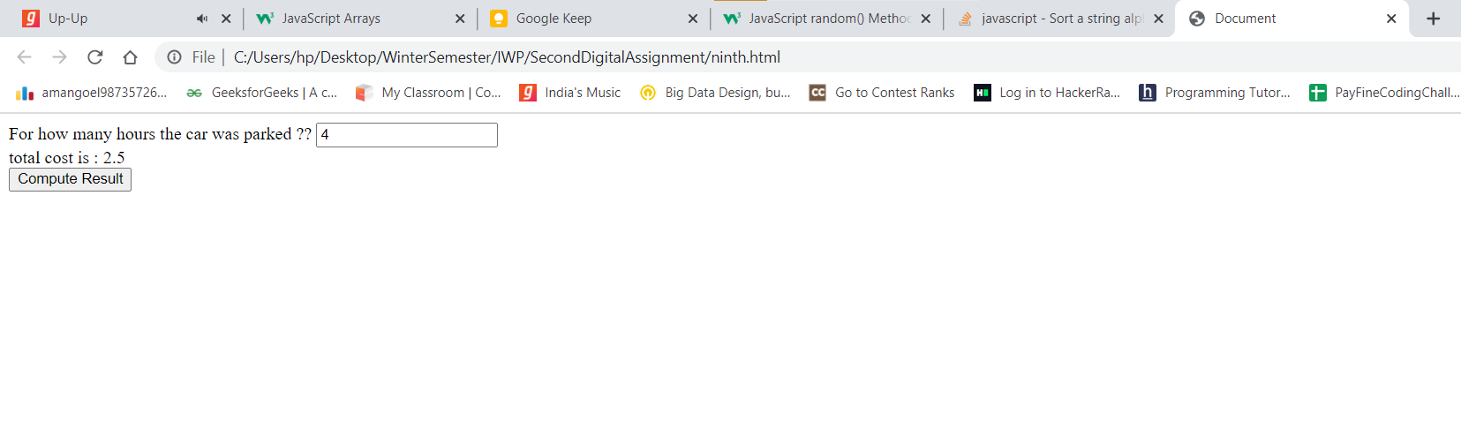

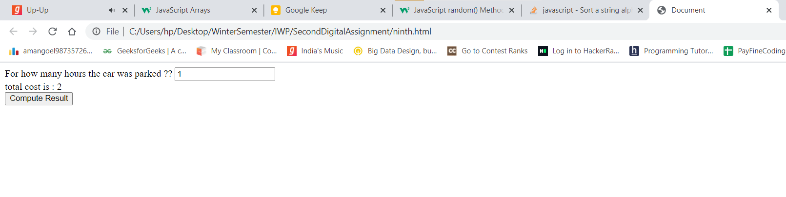

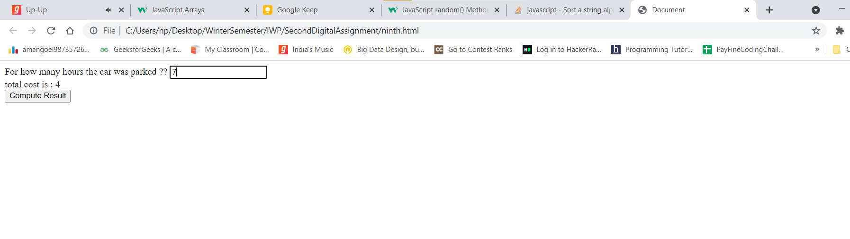

**Question 11**

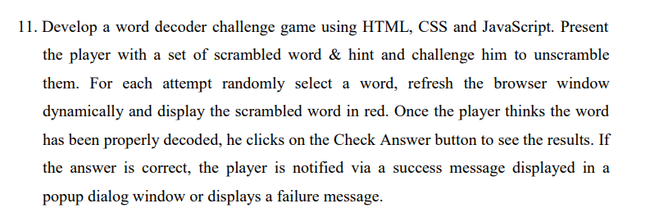

**Code**

<!DOCTYPE html>

<html lang="en">

<head>

    <meta charset="UTF-8">

    <meta http-equiv="X-UA-Compatible" content="IE=edge">

    <meta name="viewport" content="width=device-width, initial-scale=1.0">

    <title>Document</title>

</head>

<body>

    <h2>Scrambled Word Game</h2>

    <br>

    <br>

    <h4>Decode the word : </h4>

    <div id="randomWord"></div>

    <h5>Enter the word after decoding it</h5>

    <input type="text" id="inputValue">

    <button onclick="computeAnswer()">Compute Result</button>

    <script>

        var words = ["india","Book","newYork","English","Vacine","coronavirus"];

        var index = parseInt(Math.random() * words.length);

        console.log(index);

        document.getElementById("randomWord").innerHTML = words[index].split('').sort().join('');

        console.log("hello");

        function computeAnswer(){

            var inputValue = document.getElementById("inputValue").value;

            if(inputValue == words[index]){

                alert("Correct Answer");

            }else{

                alert("Wrong Answer");

            }

        }

    </script>

</body>

</html>

**Output**

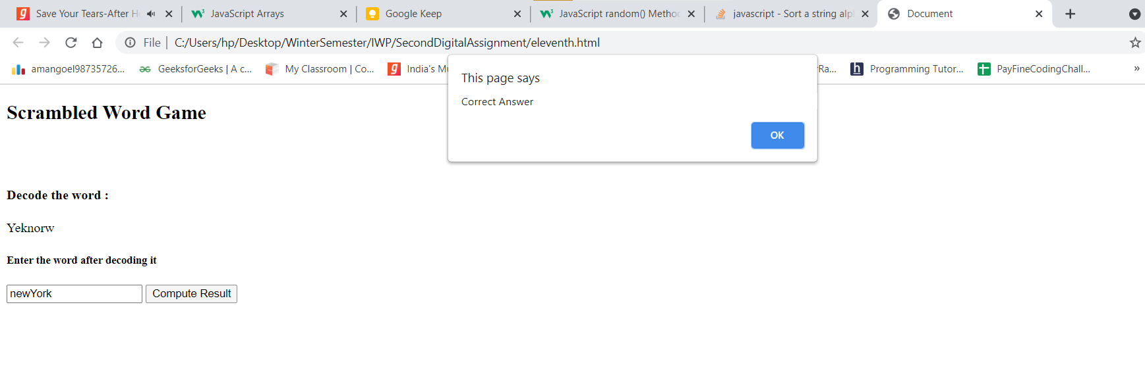

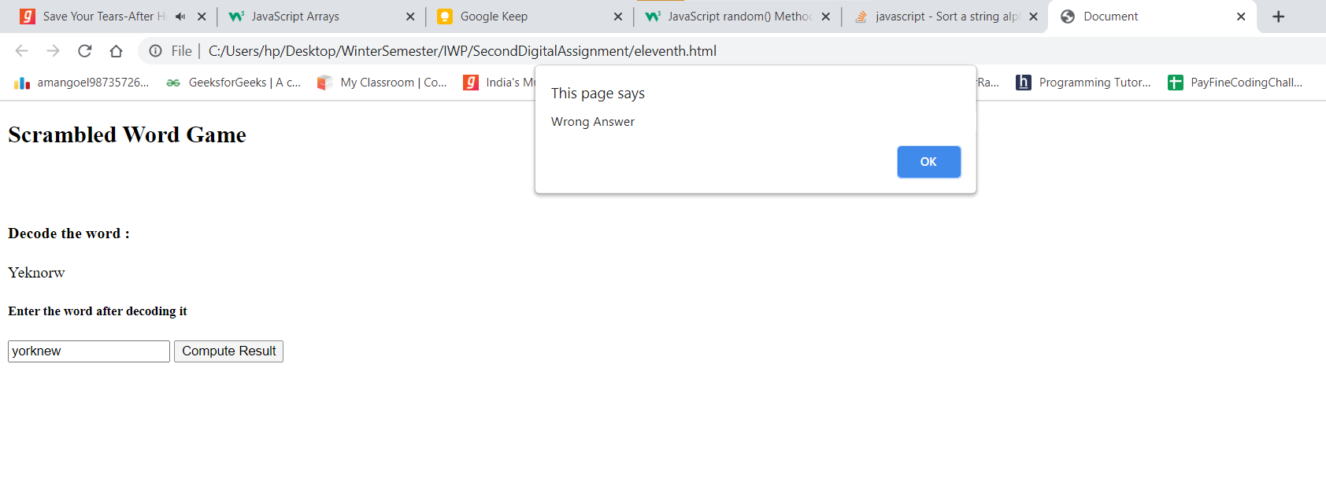

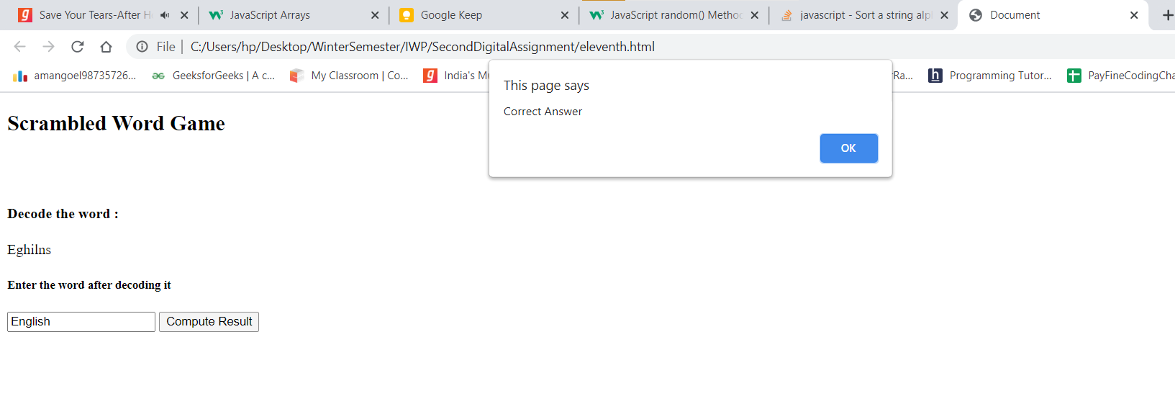

**Question 12**

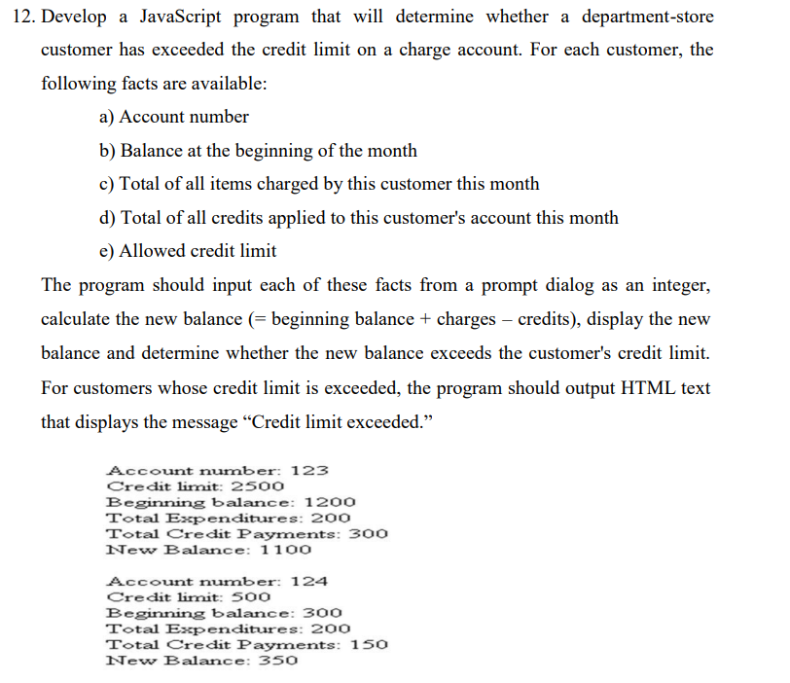

**Code**

<!-- Develop a JavaScript program that will determine whether a department-store

customer has exceeded the credit limit on a charge account. For each customer, the

following facts are available:

a) Account number

b) Balance at the beginning of the month

c) Total of all items charged by this customer this month

d) Total of all credits applied to this customer's account this month

e) Allowed credit limit

The program should input each of these facts from a prompt dialog as an integer,

calculate the new balance (= beginning balance + charges – credits), display the new

balance and determine whether the new balance exceeds the customer's credit limit.

For customers whose credit limit is exceeded, the program should output HTML text

that displays the message ―Credit limit exceeded. -->

<!DOCTYPE html>

<html lang="en">

<head>

    <meta charset="UTF-8">

    <meta http-equiv="X-UA-Compatible" content="IE=edge">

    <meta name="viewport" content="width=device-width, initial-scale=1.0">

    <title>Document</title>

    <script>

        function newBalance(){

            var beginingBalance = document.getElementById("balance").value;

            var charges = document.getElementById("totalCost").value;

            var credits = document.getElementById("totalcreditApplied").value;

            var creditLimit = document.getElementById("creditLimit").value;

            var newBalance = beginingBalance + charges - credits;

            if(newBalance > creditLimit){

                document.getElementById("output").innerHTML = "Credit limit Exceed";

            }else{

                document.getElementById("output").innerHTML = "New Balance is : " + newBalance;

            }

        }

    </script>

</head>

<body>

    <h2>Departmental Store Management System</h2>

    <label for="accountNumber">Account Number</label>

    <br>

    <input type="number" id="accountNumber">

    <br><br>

    <label for="balance">Balance at the begining of the month</label>

    <br>

    <input type="text" id="balance">

    <br><br>

    <label for="totalCost">Total of all items charged by this customer this month</label>

    <br>

    <input type="number" id="totalCost">

    <br><br>

    <label for="totalcreditApplied">Total of all credits applied to this customer's account this month</label>

    <br>

    <input type="number" id="totalcreditApplied">

    <br><br>

    <label for="creditLimit">Allowed Credit Limit</label>

    <br>

    <input type="number" id="creditLimit">

    <button onclick="newBalance()">Click Me</button>

    <div id="output"></div>

</body>

</html>

**Output**

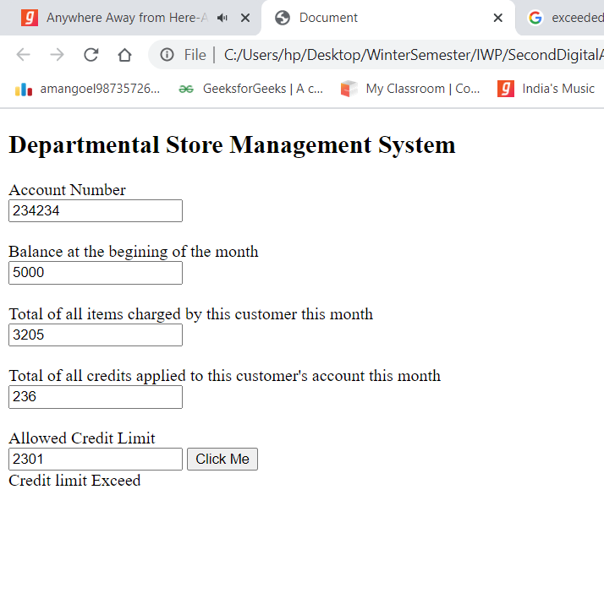

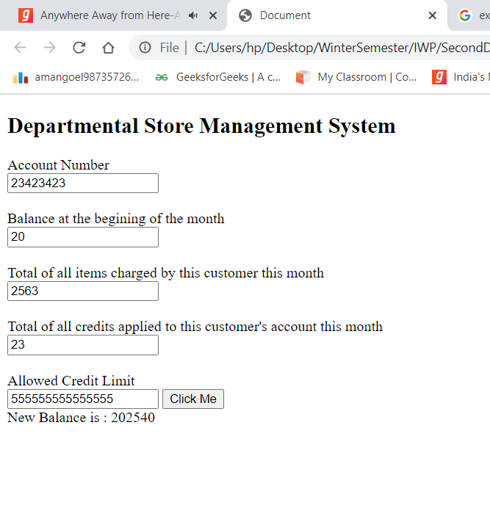

**Question 13**

Implement an online quiz application. The timer is set for each question .If timer elapses the next question is automatically displayed .Going back to previous question is disabled and going to next question before time should also be possible. The app should display the results of the user at the end of quiz.

**Code**

<html>

<head>

    <title>"QUIZ"</title>

    <script type="text/javascript">

        function cal() {

            var x, x1, x2, x3;

            var count = 0;

            x = document.quiz.capital.value;

            if (x == "delhi") {

                count++;

            }

            x1 = document.quiz.continents.value

            if (x1 == "7") {

                count++;

            }

            x2 = document.quiz.oceans.value;

            if (x2 == "5") {

                count++;

            }

            x3 = document.quiz.vizag.value;

            if (x3 == "false") {

                count++;

            }

            alert("YOUR SCORE IS: " + count);

        }

    </script>

</head>

<body>

    <form name="quiz" method="GET" action="Quiz.html">

        <h1>"QUIZ1 QUESTIONS"</h1>

        <p><b>1.What is the capital of India?</b></p><br>

        <input type="radio" name="capital" value="mumbai">Mumbai<br><input type="radio" name="capital"

            value="delhi" />Delhi<br>

        <p><b>2.Number of continents in the world?</b></p><br>

        <input type="radio" name="continents" value="7">7<br><input type="radio" name="continents" value="10" />10</br>

        <p><b>3.Number of oceans in the world?</b></p><br>

        <input type="radio" name="oceans" value="5">5<br><input type="radio" name="oceans" value="3" />3</br>

        <p><b>4.Vizag is located in Tamilnadu?</b></p><br>

        <input type="radio" name="vizag" value="true">true<br><input type="radio" name="vizag"

            value="false" />false</br>

        <br><br> <input type="button" onclick="cal();" name="score" value="submit" /><br><br>

        <!--Score: <input type="Text" id="score" /> -->

    </form>

</body>

</html>

**Output**

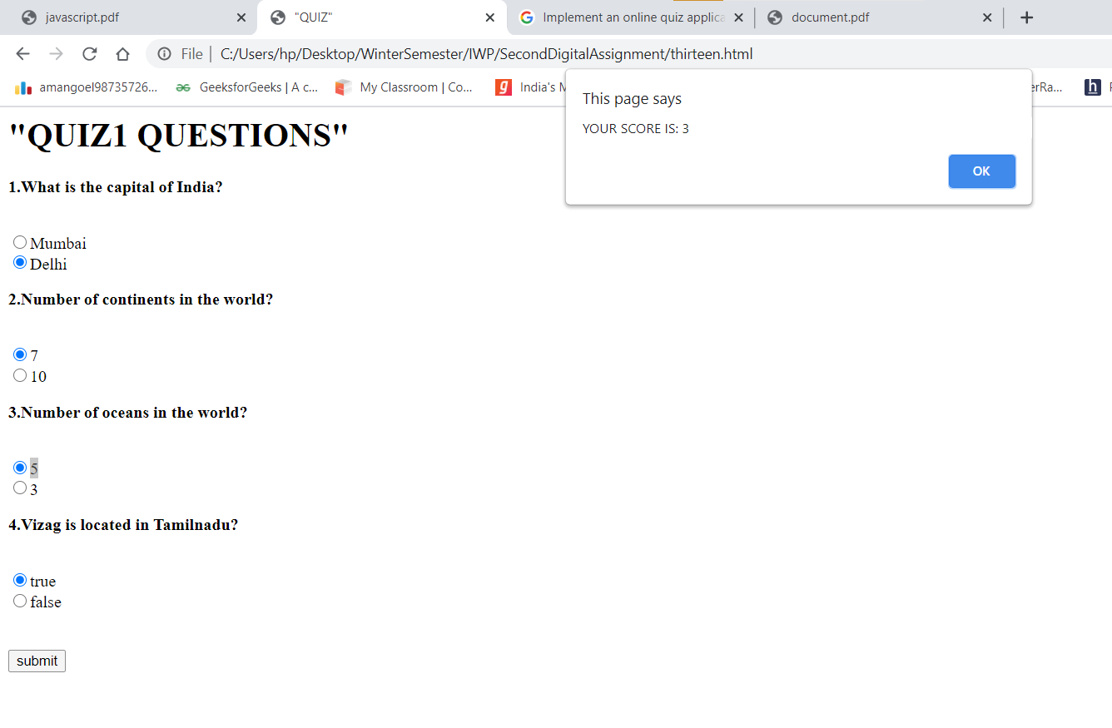

**Question 14**

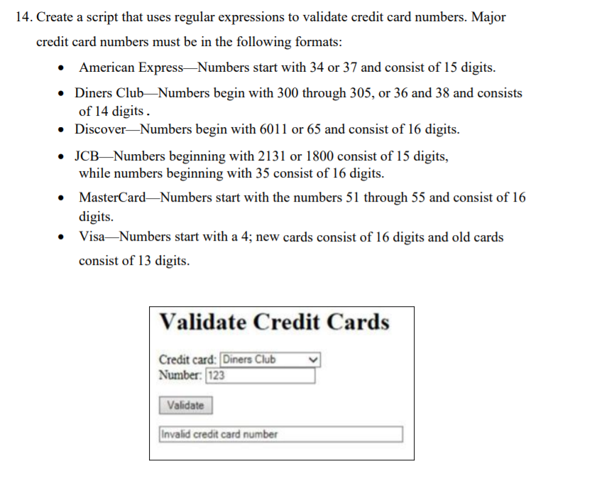

**Code**

<!DOCTYPE html>

<html lang="en">

<head>

    <meta charset="utf-8">

    <title>JavaScript form validation - checking non-empty</title>

    <style>

    </style>

</head>

<body>

    <div class="mail">

        <h2>Validate Credit Cards</h2>

        <input type='text' name='text1' id="firstinput">

        <label for="card">Choose a credit Card:</label>

        <select id="card" name="card">

            <option value="American">American Express</option>

            <option value="Diners">Diners</option>

            <option value="Discover">Discover

            </option>

            <option value="JCB">JCB</option>

            <option value="MasterCard">Master Card</option>

            <option value="Visa">Visa</option>

        </select>

        <button onclick="DecideCompany()"> Click Me</button>

    </div>

    <script>

        function DecideCompany() {

            inputtxt = document.getElementById("firstinput").value;

            console.log(inputtxt);

            company = document.getElementById("card").value;

            console.log(company);

            console.log("Inside Decide company :  ", inputtxt, " company name : ", company);

            if (company == "American") {

                return AmericanExpress(inputtxt);

            }

            if (company == "Diners") {

                return DinersClub(inputtxt);

            }

            if (company == "Discover") {

                return DiscoverCard(inputtxt);

            }

            if (company == "JCB") {

                return JCB(inputtxt);

            }

            if (company == "MasterCard") {

                return MasterCard(inputtxt);

            }

            if (company == "Visa") {

                return Visa(inputtxt);

            }

        }

        function Visa(inputtxt) {

            var cardno = /^(?:4[0-9]{12}(?:[0-9]{3})?)$/;

            if (inputtxt.match(cardno)) {

                alert("Valid Visa Credit Card Number");

                return;

            }

            else {

                alert("Not a valid Visa credit card number!");

                return;

            }

        }

        function AmericanExpress(inputtxt) {

            console.log("hello from america");

            var cardno = /^(?:3[47][0-9]{13})$/;

            if (inputtxt.match(cardno)) {

                alert("Valid American Express Card");

                return;

            }

            else {

                alert("Not a valid Amercican Express credit card number!");

                return;

            }

        }

        function MasterCard(inputtxt) {

            var cardno = /^(?:5[1-5][0-9]{14})$/;

            if (inputtxt.match(cardno)) {

                alert("valid Mastercard number");

                return;

            }

            else {

                alert("Not a valid Mastercard number!");

                return;

            }

        }

        function DiscoverCard(inputtxt) {

            var cardno = /^(?:6(?:011|5[0-9][0-9])[0-9]{12})$/;

            if (inputtxt.match(cardno)) {

                alert("valid Discover card number");

                return;

            }

            else {

                alert("Not a valid Discover card number!");

                return;

            }

        }

        function DinersClub(inputtxt) {

            var cardno = /^(?:3(?:0[0-5]|[68][0-9])[0-9]{11})$/;

            if (inputtxt.match(cardno)) {

                alert("valid Dinners Club card number");

                return;

            }

            else {

                alert("Not a valid Dinners Club card number!");

                return;

            }

        }

        function JCB(inputtxt) {

            var cardno = /^(?:(?:2131|1800|35\d{3})\d{11})$/;

            if (inputtxt.match(cardno)) {

                alert("valid JCB card number");

                return;

            }

            else {

                alert("Not a valid JCB card number!");

                return;

            }

        }

    </script>

</body>

</html>

**Output**

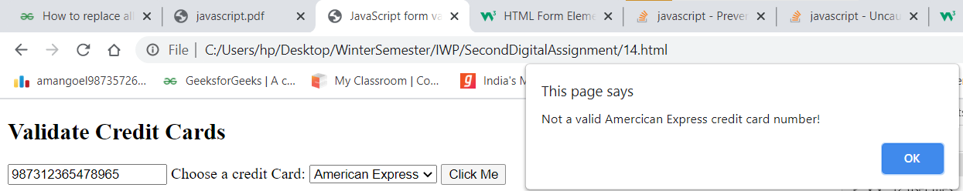

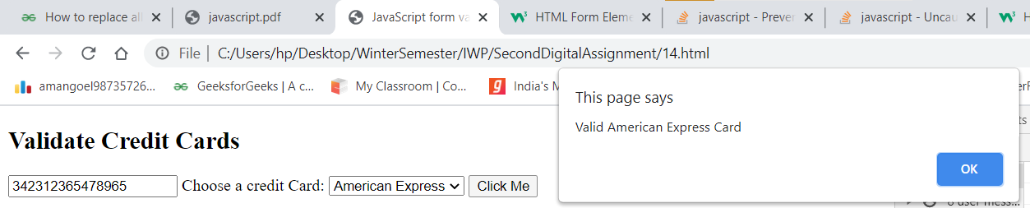

**Question 15**

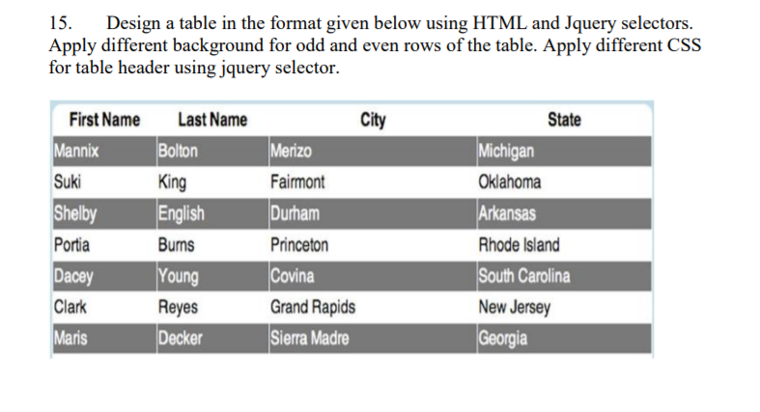

**Code**

<!-- 15. Design a table in the format given below using HTML and Jquery selectors.

Apply different background for odd and even rows of the table. Apply different CSS

for table header using jquery selector. -->

<!DOCTYPE html>

<html lang="en">

<head>

    <meta charset="UTF-8">

    <meta http-equiv="X-UA-Compatible" content="IE=edge">

    <meta name="viewport" content="width=device-width, initial-scale=1.0">

    <title>Document</title>

    <style>

        table,

        th,

        td {

            border: 1px solid black;

        }

    </style>

    <script src="https://ajax.googleapis.com/ajax/libs/jquery/3.5.1/jquery.min.js"></script>

</head>

<body>

    <table id="table">

        <tr>

            <th>

                First Name

            </th>

            <th>

                Last Name

            </th>

            <th>

                City

            </th>

            <th>

                State

            </th>

        </tr>

        <tr>

            <td>Mannix</td>

            <td>Bolton</td>

            <td>Merizo</td>

            <td>Michigan</td>

        </tr>

        <tr>

            <td>Suki</td>

            <td>King</td>

            <td>Fairmont</td>

            <td>Oklahoma</td>

        </tr>

        <tr>

            <td>Shelby</td>

            <td>English</td>

            <td>Durham</td>

            <td>Arkansas</td>

        </tr>

        <tr>

            <td>Portia</td>

            <td>Burns</td>

            <td>Princeton</td>

            <td>Rhode Island</td>

        </tr>

        <tr>

            <td>Dacey</td>

            <td>Young</td>

            <td>Covina</td>

            <td>South Carolina</td>

        </tr>

        <tr>

            <td>Clark</td>

            <td>Reyes</td>

            <td>Grand Rapids</td>

            <td>New Jersey</td>

        </tr>

        <tr>

            <td>Maris</td>

            <td>Decker</td>

            <td>Sierra Madre</td>

            <td>Georgia</td>

        </tr>

    </table>

    <script>

        $("#table tr").css("background-color", function (index) {

            return index % 2 == 0 ? "white" : "lightgrey";

        });

        $("#table th")

            .css({ "color": "black" })

            .filter(":even")

            .css({ "font-size": "25px" });

    </script>

</body>

</html>

**Output**

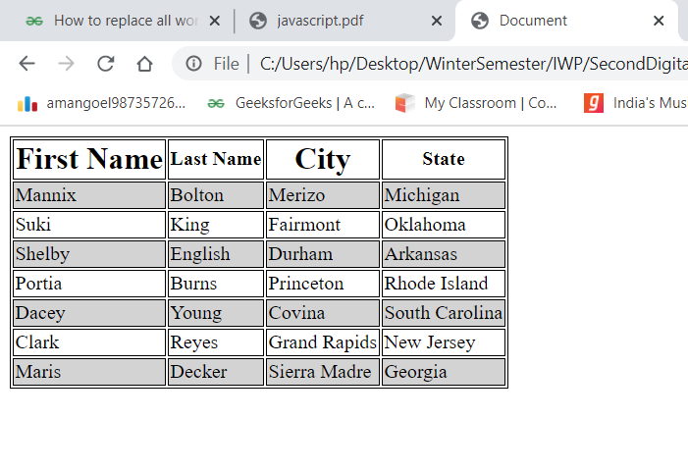

**Question 16**

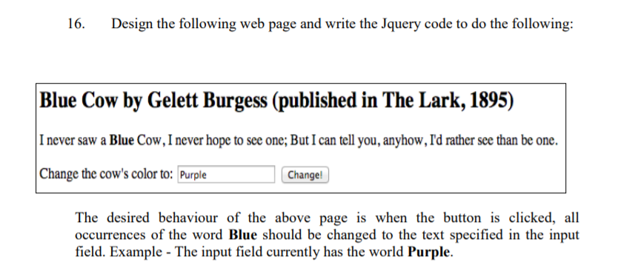

**Solution**

**Code**

<!-- 16. Design the following web page and write the Jquery code to do the following:

The desired behaviour of the above page is when the button is clicked, all

occurrences of the word Blue should be changed to the text specified in the input

field. Example - The input field currently has the world Purple. -->

<!DOCTYPE html>

<html lang="en">

<head>

    <meta charset="UTF-8">

    <meta http-equiv="X-UA-Compatible" content="IE=edge">

    <meta name="viewport" content="width=device-width, initial-scale=1.0">

    <title>Document</title>

    <script src="https://ajax.googleapis.com/ajax/libs/jquery/3.5.1/jquery.min.js"></script>

    <script>

        function pressed() {

            var val = document.getElementById("colorinput").value;

            document.body.innerHTML

                = document.getElementById("content").innerHTML

                    .replaceAll("Blue", val);

        }

    </script>

</head>

<body>

    <div id="content">

        <h1>

            Blue Cow by Gelett Burges (published in the lark , 1895)

        </h1>

        <p>

            i never saw a Blue Cow, I never hope to see one;But i can tell you,anyhow,I'd rather see than be one.

        </p>

        <p>

            Change the cow's color to : <input type="text" id="colorinput" name="color">

            <button onclick="pressed()">Click</button>

        </p>

    </div>

</body>

</html>

**Output**

