Predicting Player Ratings of
European Soccer Players
Mehul Goel
Machine Learning | European Soccer Database (Kaggle)

1. Introduction and Background
This project applies machine learning to predict overall FIFA-style ratings for professional European soccer players. The data comes from the European Soccer Database on Kaggle, which tracks player attribute snapshots across multiple seasons.
The project addresses two predictive tasks: (1) a regression task to estimate a player's numerical overall rating, and (2) a multi-class classification task to assign players to one of five quality tiers. Both tasks use the same set of FIFA in-game attributes as features.

2. Dataset
The Player_Attributes table from the European Soccer Database contains approximately 184,000 rows across 42 columns. Each row represents a single seasonal snapshot of a player's attribute ratings. Since the same player appears 7–8 times across different seasons, only the peak-rated snapshot per player is retained, resulting in 11,060 unique players after cleaning.

Feature Categories
- Technical attributes: dribbling, ball control, crossing, finishing, heading accuracy, short passing
- Physical attributes: sprint speed, stamina, strength, agility, jumping
- Mental attributes: vision, reactions, aggression, positioning, composure
- Work rate: attacking and defensive work rate (categorical: low / medium / high)

3. Data Cleaning and Preparation

3.1 Deduplication
To retain one representative row per player, the dataset is sorted by overall rating in descending order and deduplicated on player ID, keeping the highest-rated entry. Players with no rating at all are dropped. This approach is simpler and more robust than the original implementation, which used idxmax() and was sensitive to pandas version changes.

3.2 Column Removal
Goalkeeper-specific attributes (gk_diving, gk_handling, gk_kicking, gk_positioning, gk_reflexes) are dropped. These attributes are near-zero for all outfield players and would introduce noise into the models. A separate goalkeeper-specific model would require them.

3.3 Categorical Cleaning
The attacking_work_rate and defensive_work_rate columns contain several garbled values (‘stoc’, ‘le’, ‘y’, ‘norm’) that appear to be data entry errors. These are recoded as NaN and handled via imputation downstream.

3.4 Missing Value Treatment
Numeric columns are imputed using the column median rather than the mean. The median is more robust to outliers and skewed distributions, which are common in athletic performance data. Categorical columns are imputed with the most frequent value. Null value counts before imputation are shown below.

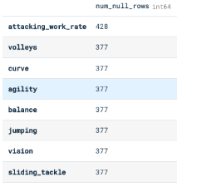
Figure 1: Null value counts per column prior to imputation

3.5 Quality Tier Creation
A five-class quality tier column is created from the overall_rating variable to serve as the classification target. The tier boundaries are informed by the quantile distribution of the rating column to produce roughly balanced classes.

Tier | Label | Rating Range
1 | Elite | ≥ 82
2 | Good | 73 – 81
3 | Average | 67 – 72
4 | Below Average | 60 – 66
5 | Poor | < 60
Table 1: Quality tier definitions

4. Exploratory Data Analysis

4.1 Correlation Analysis
A correlation heatmap is computed across 15 key outfield attributes. The upper triangle is masked to avoid redundancy. The heatmap reveals several notable relationships:
- dribbling and ball_control share the strongest correlation (≈0.90), suggesting they measure overlapping technical skill.
- vision, ball_control, and reactions are most strongly correlated with overall_rating, suggesting elite players are distinguished more by technical and cognitive attributes than by raw physical ones.
- strength and agility have a moderate negative correlation (≈−0.35), reflecting the physical trade-off between bulk and quickness.

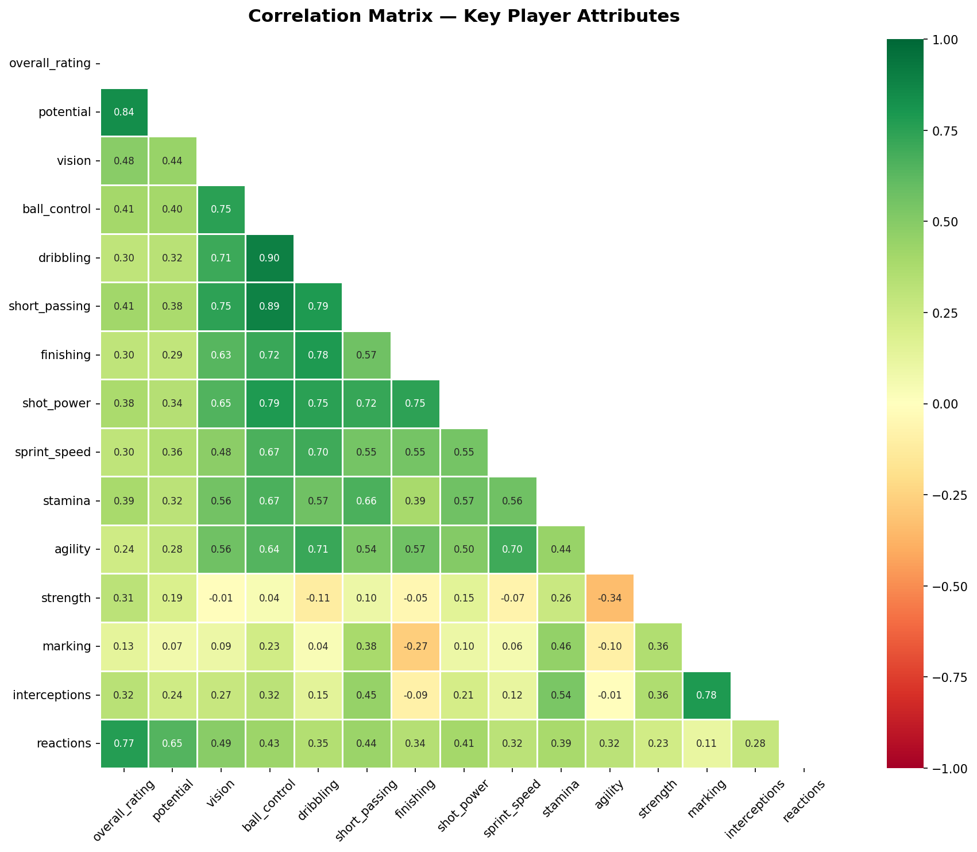
Figure 2: Correlation heatmap for 15 key player attributes

4.2 Histograms and Distributions
The distributions of overall_rating, the quality tier, and key attribute variables are shown below. The overall_rating variable is approximately normally distributed with a mean around 70. The four key attributes (agility, stamina, strength, dribbling) are all slightly left-skewed, with most values concentrated between 60 and 80.

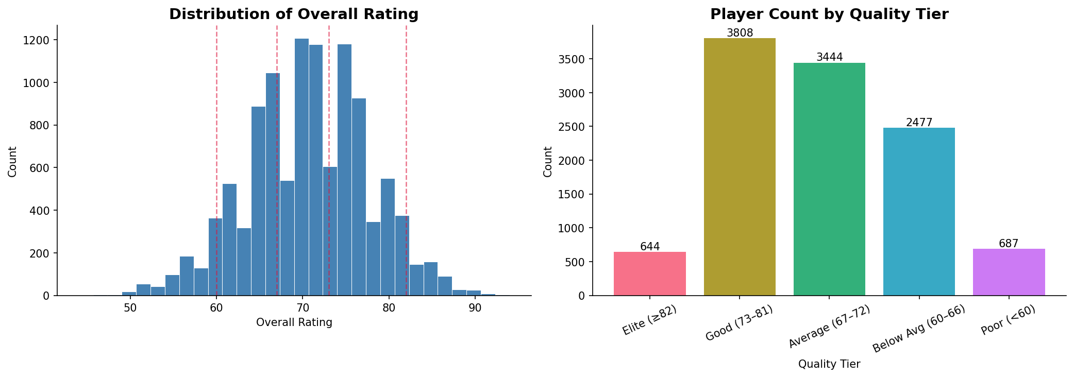
Figure 3: Overall rating distribution and player count by quality tier

4.3 Analysis of Variance (ANOVA)
One-way ANOVA tests are conducted to assess whether the means of the four most correlated attributes (vision, ball_control, shot_power, stamina) differ significantly across the five quality tiers. The null hypothesis is that the group means are equal.
For all four attributes, the p-value is effectively 0 (p << 0.001), and the F-statistics are very large, allowing us to confidently reject the null hypothesis in all cases. This confirms that the attribute means are statistically significantly different across quality tiers — a necessary condition for a classifier to distinguish between them.

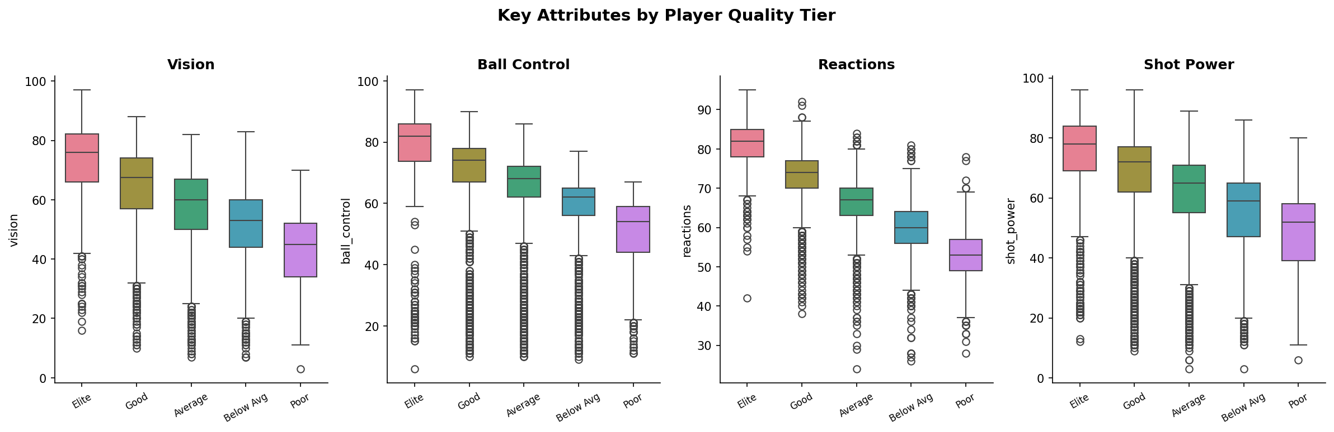
Figure 4: Key attribute distributions by quality tier — all four show clear separation

5. Modeling Approach

5.1 Preprocessing Pipeline
A scikit-learn ColumnTransformer pipeline handles all preprocessing in a single pass:
- Numeric columns: median imputation followed by StandardScaler normalization (zero mean, unit variance)
- Categorical columns: mode imputation followed by OneHotEncoder
Crucially, the pipeline is fitted only on the training set. The test set is transformed using the fitted parameters — not re-fitted — to prevent data leakage.

5.2 Train/Test Split
An 80/20 stratified train-test split is used, stratified on the quality tier label to preserve class proportions in both splits. This is especially important given the imbalanced class sizes. Five-fold cross-validation is also applied on the training set to validate model performance before touching the test set.

5.3 Evaluation Metrics
A key lesson from the original project is that accuracy alone is an insufficient metric, particularly for multi-class classification with unequal class sizes. The following metrics are used instead:
- Regression: R², RMSE, MAE, and 5-fold cross-validated R²
- Classification: Macro F1-score (unweighted mean across all 5 classes), per-class precision and recall, and the train/test performance gap as an overfitting indicator
Macro F1 is the primary classification metric because it penalizes the model equally for poor performance on any tier — including the minority “Elite” class. A model that ignores Elite players entirely would still achieve high weighted accuracy but would have a low macro F1.

6. Results

6.1 Regression
Three regression models are trained and evaluated. The original project used only Linear Regression, achieving approximately 77% accuracy within ±3 rating points. The improved models are compared below.

Model | Test R² | CV R² (5-fold) | RMSE | MAE
Linear Regression | 0.8240 | 0.8212 | 2.980 | 2.309
Ridge Regression | 0.8240 | 0.8212 | 2.981 | 2.309
Gradient Boosting | 0.9449 | 0.9379 | 1.667 | 1.205
Table 2: Regression model comparison

The Gradient Boosting Regressor explains 94.5% of variance in overall rating with an average miss of just 1.2 points, and 93.2% of predictions land within ±3 rating points. The close agreement between test R² (0.9449) and CV R² (0.9379) confirms minimal overfitting.

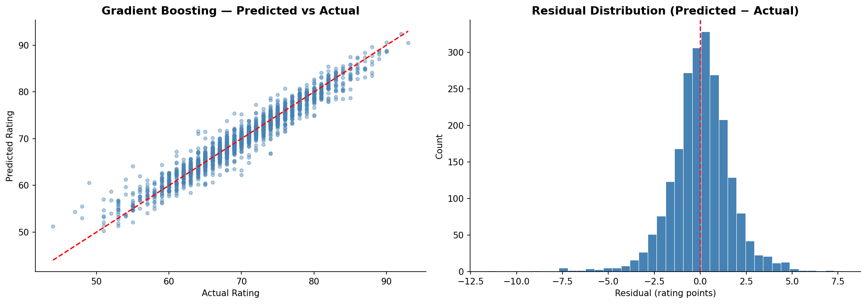
Figure 5: Gradient Boosting — predicted vs actual ratings and residual distribution

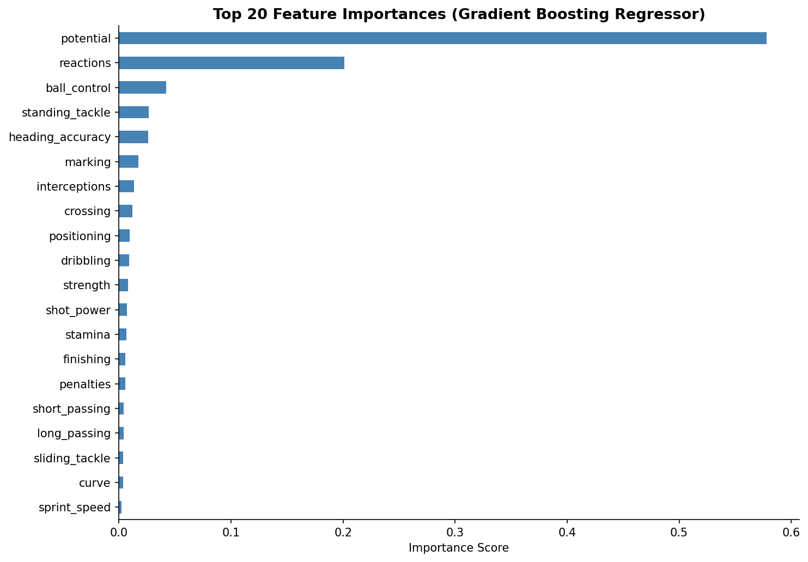
Figure 6: Top 20 feature importances from Gradient Boosting Regressor

6.2 Classification
Five classifiers are evaluated and compared against a soft voting ensemble. All models are regularized to prevent overfitting — for example, Decision Trees use max_depth and min_samples_leaf constraints.

Model | Train F1 | Test Macro F1 | Test Accuracy | Overfit Gap
Logistic Regression | 0.6787 | 0.6707 | 0.6980 | 0.0080
K-Nearest Neighbors | 0.7966 | 0.7157 | 0.7473 | 0.0809
Decision Tree | 0.7683 | 0.6750 | 0.7152 | 0.0933
Random Forest | 0.8704 | 0.7929 | 0.8345 | 0.0775
Gradient Boosting | 0.9878 | 0.8373 | 0.8553 | 0.1506
Soft Voting Ensemble | 0.9353 | 0.8284 | 0.8495 | 0.1070
Table 3: Classification model comparison — macro F1 is the primary metric

The Soft Voting Ensemble achieves 84.95% accuracy and a macro F1 of 0.83. Notably, Random Forest (gap=0.08) generalizes more reliably than Gradient Boosting (gap=0.15), making it the safer choice if the priority is minimizing overfitting. The “Elite” tier is the hardest to classify correctly (F1=0.79, recall=0.70) due to its small size (644 players, 5.8% of dataset).

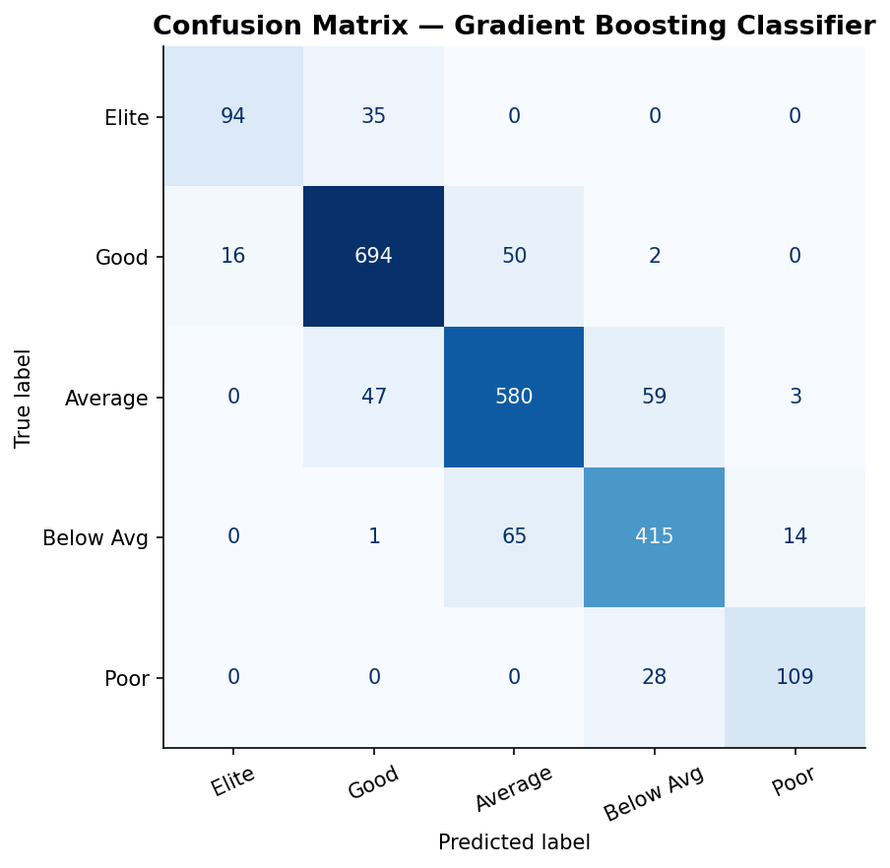
Figure 7: Confusion matrix — Gradient Boosting Classifier

7. Limitations
- The dataset covers only European players from a specific historical period. Models trained on this data may not generalize to other leagues or eras.
- GK-specific attributes were excluded from this analysis. A separate goalkeeper model would be needed for end-to-end player coverage.
- The quality tier boundaries are defined heuristically. Different boundary choices would change the class distribution and potentially the classification difficulty.
- Median imputation is a simple missing data strategy. For columns with high missingness (such as curve, agility, and vision at ~4%), more sophisticated approaches like KNN imputation could yield better estimates.
- Apply SMOTE oversampling or cost-sensitive learning to improve recall on the “Elite” tier (currently F1=0.79, recall=0.70 with only 644 players in the class).

8. Future Work
- Integrate match-level and team-level features from other tables in the European Soccer Database to improve rating prediction.
- Train a separate goalkeeper model using gk_* attributes to produce full-squad coverage.
- Apply hyperparameter tuning via Optuna or GridSearchCV to push Gradient Boosting performance further.
- Explore SHAP (SHapley Additive exPlanations) values for interpretable feature attribution on individual player predictions.
- Deploy the best regression model as a lightweight FastAPI service that returns a predicted rating given a set of player attributes.

9. Conclusion
This project demonstrates that FIFA player overall ratings can be predicted with high accuracy from in-game attribute data. The Gradient Boosting models outperform the original linear regression and hard-voting ensemble approaches on both tasks, achieving an R² of 0.9449 and 93.2% within-±3 accuracy for regression, and a macro F1 of 0.8284 with 84.95% overall accuracy for multi-class classification.
Beyond the raw results, the revised project applies several best practices that were absent in the original version: stratified cross-validation, explicit overfitting analysis, macro F1 as the primary classification metric, and regularized model configurations. These changes produce more reliable and honest performance estimates.
The analysis also confirms through ANOVA that vision, ball control, shot power, and reactions are statistically significant discriminators across quality tiers — suggesting that elite players are defined more by technical and cognitive attributes than by physical ones alone.

