**UE20CS207 - DATA STRUCTURES AND ITS APPLICATIONS LABORATORY**

**Week 10 : 18 Nov 2021**

|  |  |  |  |
| --- | --- | --- | --- |
| Vanshika Goel | **PES1UG20CS484** | H Section | Roll No: 40 |

**Code:**

**Output:**

**Code:**

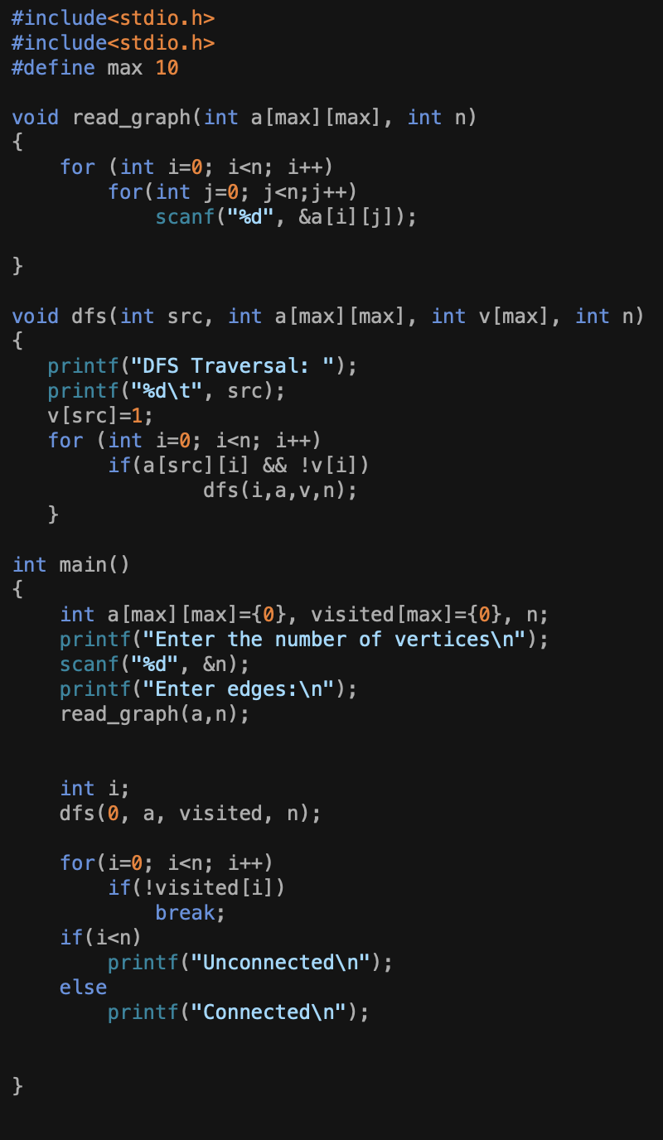

**Output:**

