Linux Basics
DevOps Assignment 1 | Command Log and Evidence
Student name: Aditya Goel
Operating system: Manjaro Linux
GitHub repository: [PASTE YOUR GITHUB REPOSITORY URL HERE]

Objective
Demonstrate Linux command-line operations for file and directory management, viewing and searching text files, archiving, downloading, file permissions, and environment variables.

Evidence
The screenshots below were captured during manual execution on Manjaro Linux. Each task includes its commands, a short explanation, and terminal evidence.

Task 01 — Creating a directory
Assignment command
mkdir test_dir
Verification
ls -ld test_dir
Explanation: The mkdir command creates the test_dir directory. ls -ld confirms that the directory exists and displays its permissions and ownership.
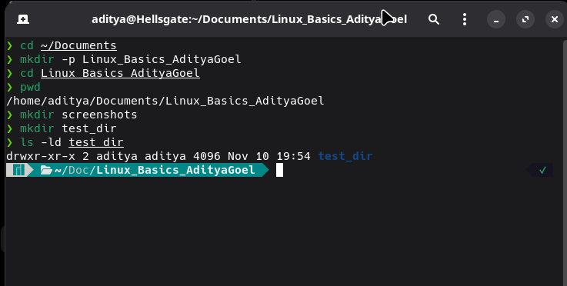

Task 02 — Creating an empty file
Assignment command
touch test_dir/example.txt
Verification
ls -l test_dir
Explanation: touch creates example.txt inside test_dir if the file does not already exist. ls -l confirms the new empty file.
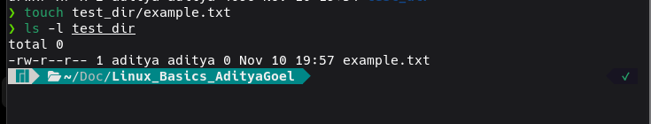

Task 03 — Renaming a file
Assignment command
mv test_dir/example.txt test_dir/renamed_example.txt
Verification
ls -l test_dir
Explanation: mv renames example.txt to renamed_example.txt within the same directory. The listing confirms the new filename.
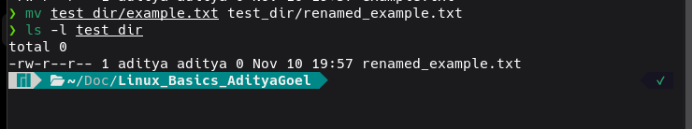

Task 04 — Viewing file contents with cat
Assignment command
cat /etc/passwd
Verification
Observe the displayed account records
Explanation: cat displays the contents of /etc/passwd. This system file contains local account information; its contents vary between installations.
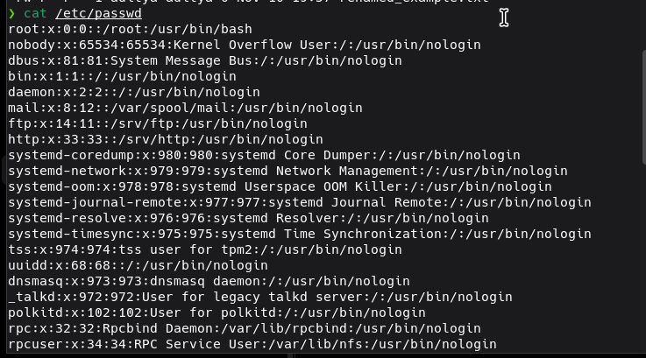

Task 05 — Viewing the first five lines
Assignment command
head -n 5 /etc/passwd
Verification
Observe exactly five lines
Explanation: head -n 5 prints only the first five lines of /etc/passwd.
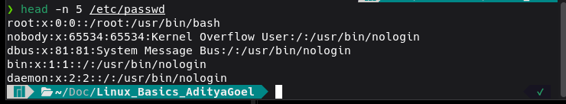

Task 06 — Viewing the last five lines
Assignment command
tail -n 5 /etc/passwd
Verification
Observe exactly five lines
Explanation: tail -n 5 prints only the last five lines of /etc/passwd.
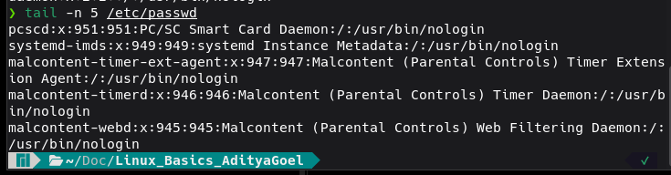

Task 07 — Searching for root
Assignment command
grep 'root' /etc/passwd
Verification
Observe matching lines
Explanation: grep searches for the case-sensitive text root and prints matching lines. It may match more than the root account.

Task 08 — Compressing a directory
Assignment command
zip -r test_dir.zip test_dir
Verification
unzip -l test_dir.zip
Explanation: zip -r creates a recursive archive of test_dir and its contents. unzip -l lists the files stored in the resulting archive.
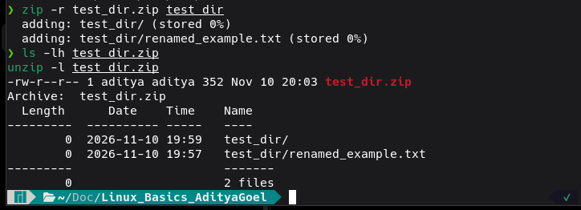

Task 09 — Extracting the archive
Assignment commands
mkdir unzipped_dir
unzip test_dir.zip -d unzipped_dir
Verification
find unzipped_dir -type f -print
Explanation: The -d option tells unzip to extract into unzipped_dir. The archived file is extracted to unzipped_dir/test_dir/renamed_example.txt.
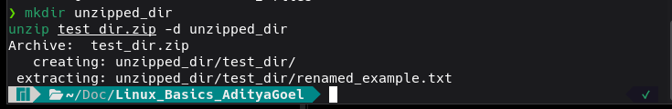

Task 10 — Downloading a file
Assignment command
wget -O downloaded_gpl.txt 'https://www.gnu.org/licenses/gpl-3.0.txt'
Verification
ls -lh downloaded_gpl.txt
head -n 3 downloaded_gpl.txt
Explanation: wget downloads a public text file over HTTPS. -O sets the local filename. The downloaded file was verified by listing it and displaying its opening lines.
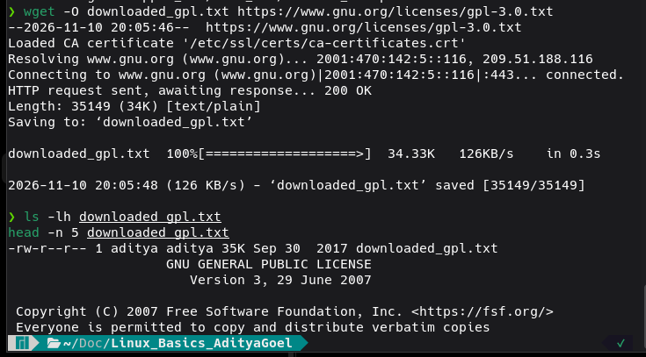

Task 11 — Setting read-only permissions
Assignment commands
touch secure.txt
chmod 444 secure.txt
Verification
ls -l secure.txt
stat -c '%a %n' secure.txt
Explanation: chmod 444 grants read permission to the owner, group, and others, without write or execute permissions. The expected numeric permission mode is 444.
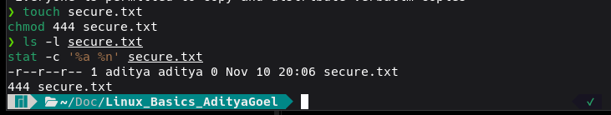

Task 12 — Setting an environment variable
Assignment command
export MY_VAR='Hello, Linux!'
Verification
echo "$MY_VAR"
printenv MY_VAR
Explanation: export makes MY_VAR available to child processes of the current shell. Both verification commands display Hello, Linux!.
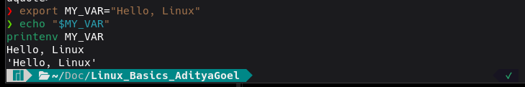

Conclusion
All 12 Linux Basics tasks were executed manually, and their commands and outputs are documented above. The complete project files and screenshots are included in the submission archive.

