Python & Bash
DEVOPS | ASSIGNMENT 2
Submitted by: Aditya Goel
Environment: Visual Studio Code | Python | Git Bash (MINGW64) on Windows

Objective
Practice core Python programming concepts: conditional statements, dictionaries, and file handling through four practical tasks.

Task 1 | Grade Checker
Aim: Accept a score and display its grade using if / elif / else. Scores of 90 or above receive A; 80–89 B; 70–79 C; 60–69 D; and below 60 F.
Command: python grade_checker.py
Implementation: The program reads an integer score, checks that it is between 0 and 100, and evaluates grade thresholds in descending order.
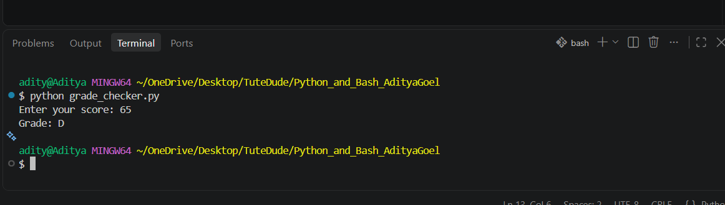
Figure 1. Score 65 produces Grade D in the VS Code terminal.
Result: The observed output is Grade: D for the input 65, consistent with the required grading criteria.

Task 2 | Student Grades
Aim: Maintain a dictionary of student names and grades with options to add a student, update a grade, display all records, and exit.
Command: python student_grades.py
Implementation: A menu-driven while loop accepts user choices. The dictionary stores each name as a key and its grade as a value; membership checks handle existing and missing students.
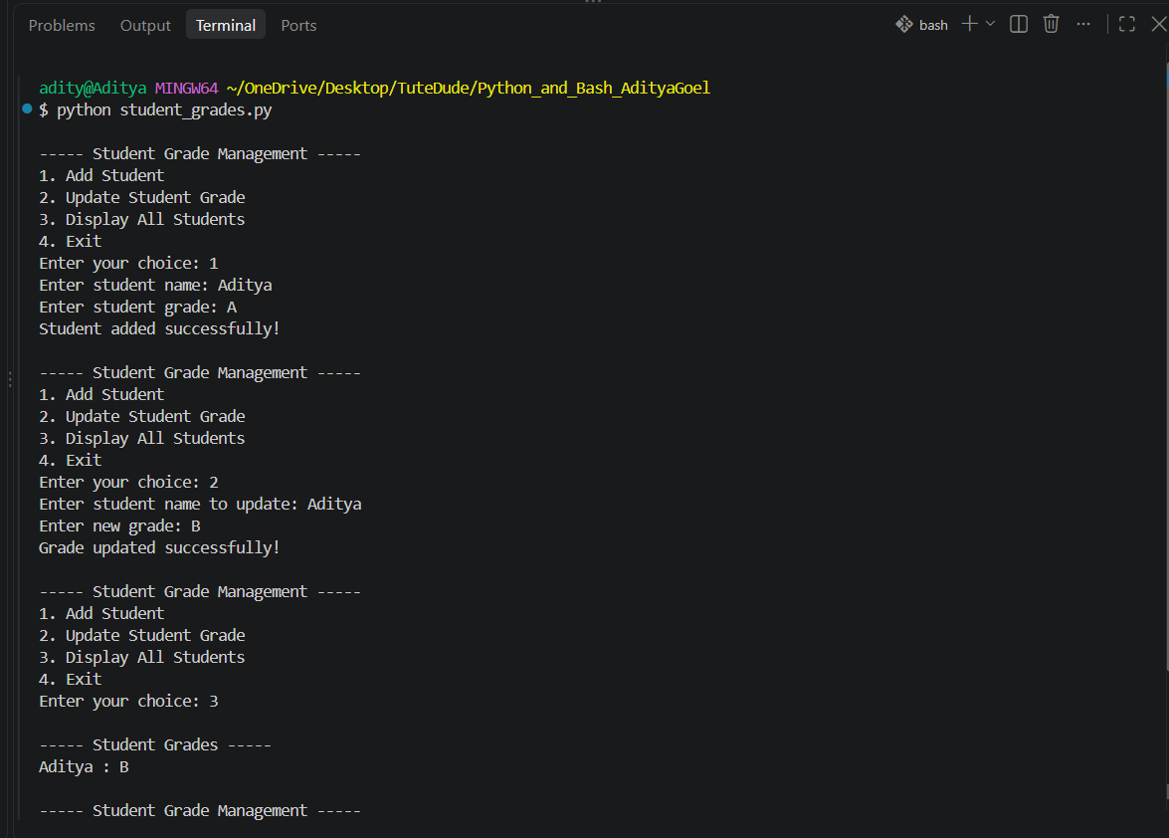
Figure 2. A student is added, the grade is updated from A to B, and the updated record is displayed.
Result: The screenshot confirms successful addition, update, and display of the student record Aditya : B.

Task 3 | Write to a File
Aim: Create a text file and write multiple lines using open() and write().
Command: python write_file.py
Implementation: The program opens sample.txt in write mode ("w"), writes four lines of text, closes the file, and prints a success message. Write mode creates the file if it does not exist and overwrites previous contents if it does.
Figure 3. Successful execution of the file-writing program.
Result: The terminal confirms that the file was created and its content written successfully.

Task 4 | Read from a File
Aim: Open the text file in read mode and display its contents using file.read().
Command: python read_file.py
Implementation: The program opens sample.txt in read mode ("r"), reads the entire contents with read(), prints the text, and closes the file.
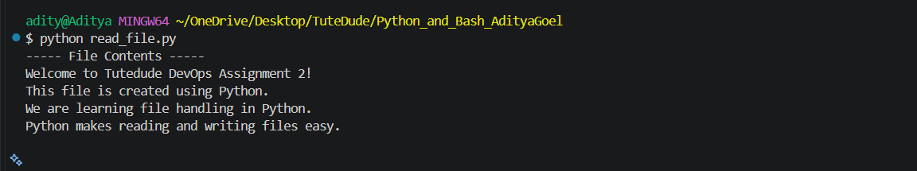
Figure 4. Terminal output displaying the text read from sample.txt.
Result: The program displays the four lines written in Task 3, demonstrating successful file reading.

Conclusion
All four required Python tasks were executed in the VS Code terminal. The screenshots demonstrate conditional grading, dictionary-based student grade management, text-file writing, and text-file reading.
Project files: grade_checker.py, student_grades.py, write_file.py, read_file.py, sample.txt.

