What is this stage?

This is the stage when a product is conceived for realization

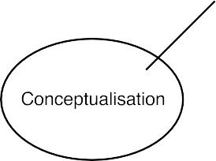

Outcome of this stage: may be a dam, a rodaway or a manufactured product.

Idea for this stage:

* It involves developing an idea into a conceivable product.
* Example-A dam is conceived to be built for power generation or irrigation.
* It is a craetive stage and the full ramnifications of project may not be known.

However, the idea can be abandoned even at this stage if tehre are obstacles or cost-benefit factors that make it unviable.

Ethical responsibilties of engineers during conceptualisation phase:

* Is the project useful?
* Does it satisfy a felt need?

Case study: Building a dam for irrigating hectares of land and for generating thousands of watts of power:

* Is the project useful? Even if apparently useful have the downsides of the project such as displacement to ecosystem and displacement of communities considered before going ahead?
* Does the benefits of the project outweigh the damages?