Error ‘Archive is corrupted’ While Unzipping through Pentaho

Occasionally, this issue occurs when you are trying to unzip the archive file you received through FTP transfer. Resolution for this is two-step process.

Step 1: Checking the FTP transfer data type of file. Please follow the below steps:

* Open your FileZilla FTP client.
* Click on ‘Edit’ tab and select ‘Settings’. This will open pop up.
* Under ‘Transfers’ section, select ‘File Types’.
* Please choose ‘Binary’ as your Default transfer type.

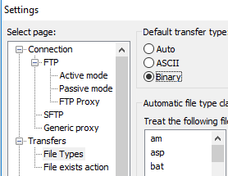

Setting the Binary as your default transfer type will prevent your files to become corrupted while ftp transit.

Step 2: Binary Mode check box under ‘Get a File with FTP’ component before ‘Unzip file’ component in Pentaho should be marked as check.

* Once you tick the Binary Mode under ‘Get a File with FTP’ component, it will download the zip file in Binary format preventing your archive files to become corrupted. Please refer below snippet:

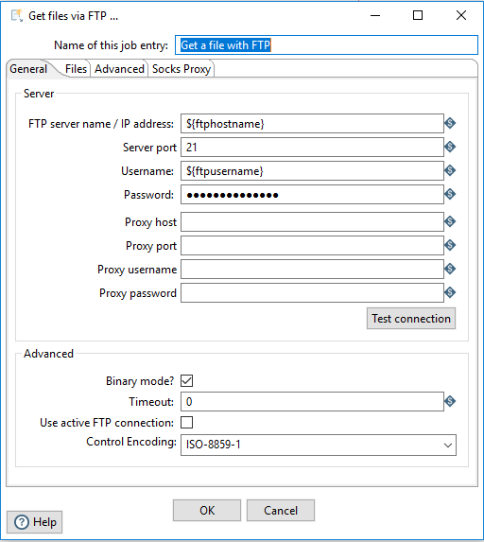

* So, now when you will try to Unzip a file in next ‘Unzip file’ component of your pentaho job it will work fine. Kudos.