Project Report
of
Data Management and AI Integration
(ABAI2009L)

BACHELOR OF TECHNOLOGY
In
ARTIFICIAL INTELLIGENCE



Session 2026-27

Submitted to: - Submitted by: -
Dr. Biswadip Bandyopadhyay Kartik Goel
Assistant Professor A25ARIU0019
School of AI Keshav Garg
Bennett University A25ARIU0021

SCHOOL OF ARTIFICIAL INTELLIGENCE
BENNETT UNIVERSITY

August-December 2026

Abstract
This project presents a web-based system that lets users retrieve information from a MySQL student database by entering questions in everyday English. A Python rule-based natural-language processor recognizes supported query patterns and constructs SQL SELECT statements. A Flask application receives user input, calls the query processor, executes the query through a database connection, and displays the returned records in a browser. The dataset contains 30 synthetic student records with student ID, name, department, semester, marks, city, and an optional attendance percentage field if the database schema has been updated. The interface includes light/dark themes, example-question shortcuts, result tables, and error handling for unsupported questions. This is a rule-based prototype, not a general-purpose natural-language model.

1. Introduction
Relational databases usually require users to know SQL syntax to retrieve information. Natural-language database interaction aims to reduce this barrier by allowing users to describe the information they need in ordinary language. This project demonstrates that workflow with a student database and a browser-based interface.
A user enters a question such as “Show students from Mumbai” or “Show students whose marks are above 80.” The application maps supported patterns to SQL, executes the query, and presents the result.

2. Problem Statement
The project addresses the difficulty that non-technical users may face when querying relational databases directly. The system should interpret a defined set of natural-language patterns, generate suitable read-only SQL queries, connect to MySQL, and display results. Unsupported requests should produce a helpful message rather than silently returning unrelated records.

3. Objectives
- Build a web interface for entering natural-language questions.
- Convert supported question patterns into SQL SELECT statements.
- Connect the Python application to a MySQL database containing 30 student records.
- Support filters for city, department, semester, marks, and attendance when the relevant field exists.
- Support selected aggregate queries, including counts, average marks, maximum/minimum marks, and department averages.
- Display results and understandable error messages.
- Test supported queries, unsupported questions, and interface features.

4. Methodology and System Workflow
The workflow is: user question → Flask interface → rule-based NLP processor → SQL query → MySQL database → results → web page. The processor normalizes text, recognizes keywords and numeric conditions, and builds a query. The query handler executes the query and returns column names and rows. Flask passes those values to the HTML template, which displays a result table or an error message.
The implementation uses rules and regular expressions rather than a trained language model. Its coverage is therefore limited to patterns explicitly implemented in the processor.

5. Technologies Used
- Python — application logic and rule-based text processing.
- Flask — web server and request handling.
- MySQL — relational database.
- mysql-connector-python — Python-to-MySQL connectivity.
- HTML — page structure and forms.
- CSS — styling, responsive layout, and light/dark appearance.
- JavaScript — theme switching and example-question shortcuts.

6. Database Design
The database is named dmai_nlp and the main table is Students. The original schema includes Student_ID, Name, Department, Semester, Marks, and City. Student_ID is the primary key. The project dataset was expanded to 30 synthetic records with IDs 101–130.
Column | Purpose | Type / example
Student_ID | Unique identifier and primary key | INT
Name | Sample student name | VARCHAR(100)
Department | Department code | AI / CSE / ECE
Semester | Semester number | INT
Marks | Sample marks | DECIMAL(5,2)
City | City in the sample record | VARCHAR(50)
Attendance | Sample attendance percentage; optional schema extension | DECIMAL(5,2)
The attendance field must exist and contain populated values before attendance queries can return meaningful results. Student and attendance values are synthetic demonstration data, not official records.

7. NLP-to-SQL Implementation
The processor uses keyword matching and regular expressions to identify supported intents and values. It can handle selected requests involving city, department, semester, marks comparisons and ranges, top-N results, sorting, counts, averages, maximum/minimum marks, and students above the class average.
- “Show students from Mumbai” → SELECT * FROM Students WHERE City = 'Mumbai';
- “Show students in semester 3” → SELECT * FROM Students WHERE Semester = 3;
- “Show students whose marks are above 80” → SELECT * FROM Students WHERE Marks > 80;
- “Show the top 3 students” → SELECT * FROM Students ORDER BY Marks DESC LIMIT 3;
- “Show students with attendance below 75%” → requires an Attendance column with values.
The query handler should allow only intended read-only queries and safely handle unsupported questions. The processor does not understand every possible wording.

8. Website Features
- Natural-language question input form.
- Clickable example questions.
- Display of the generated SQL query.
- Tabular display of database results.
- Light/dark theme toggle with browser persistence.
- Responsive layout for smaller screens.
- Error messages for empty or unsupported requests.

9. Experimental Results and Screenshots
Insert the actual screenshots captured from the running application below. Use readable images and ensure that screenshots show genuine application output. Add captions and refer to each figure in the text.
Figure 1. Homepage in light mode.
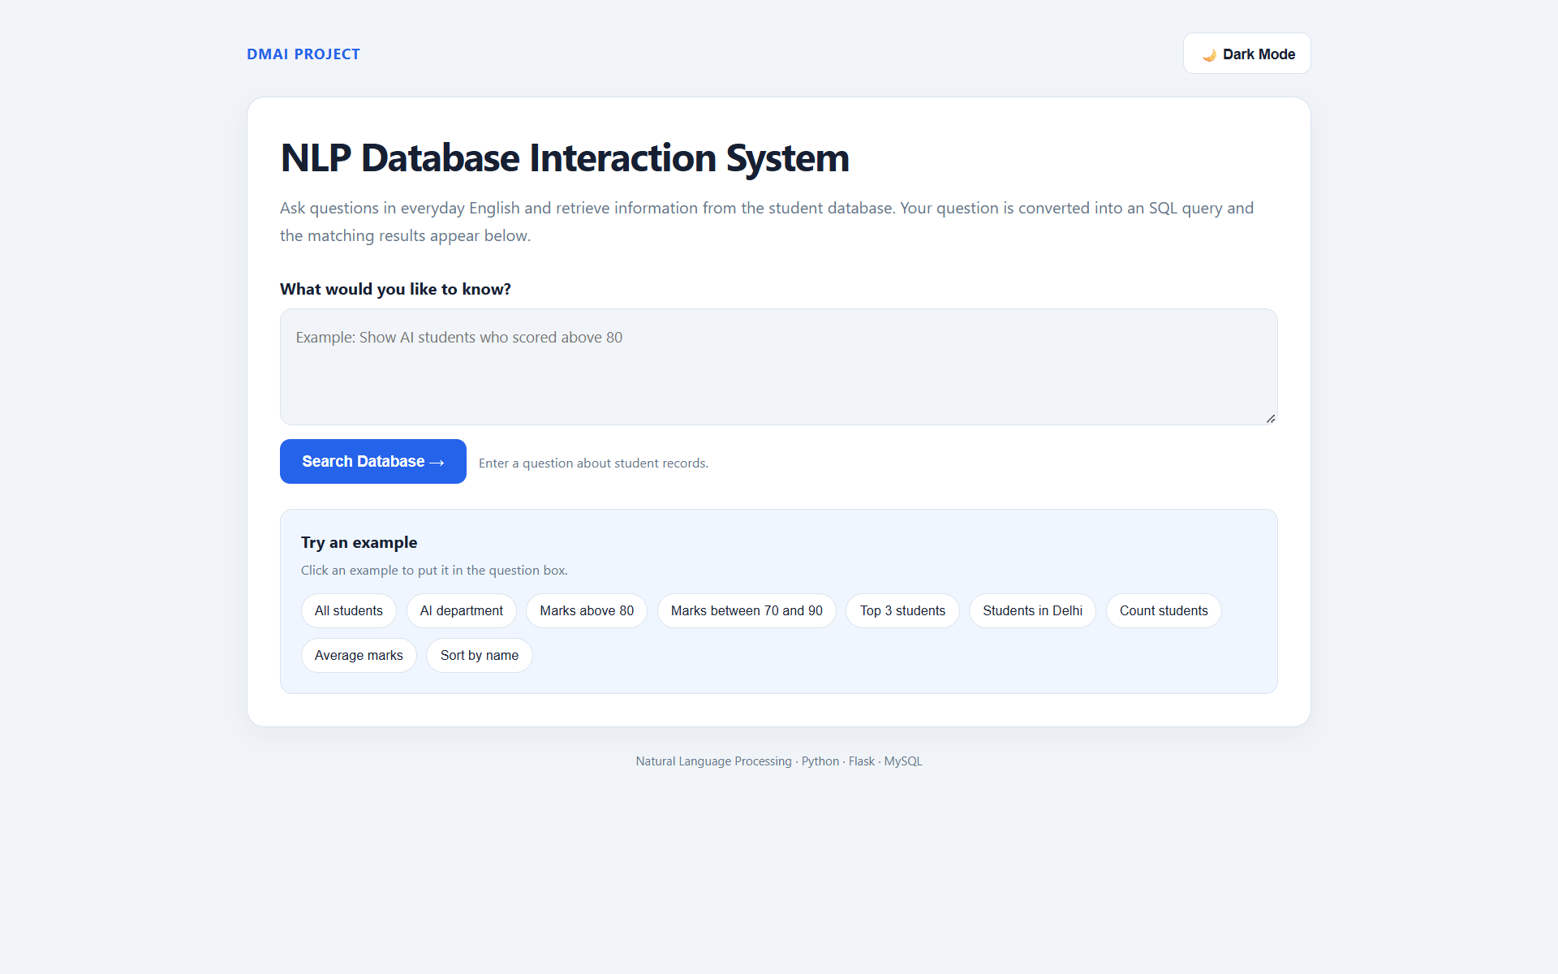
Figure 2. Homepage in dark mode.
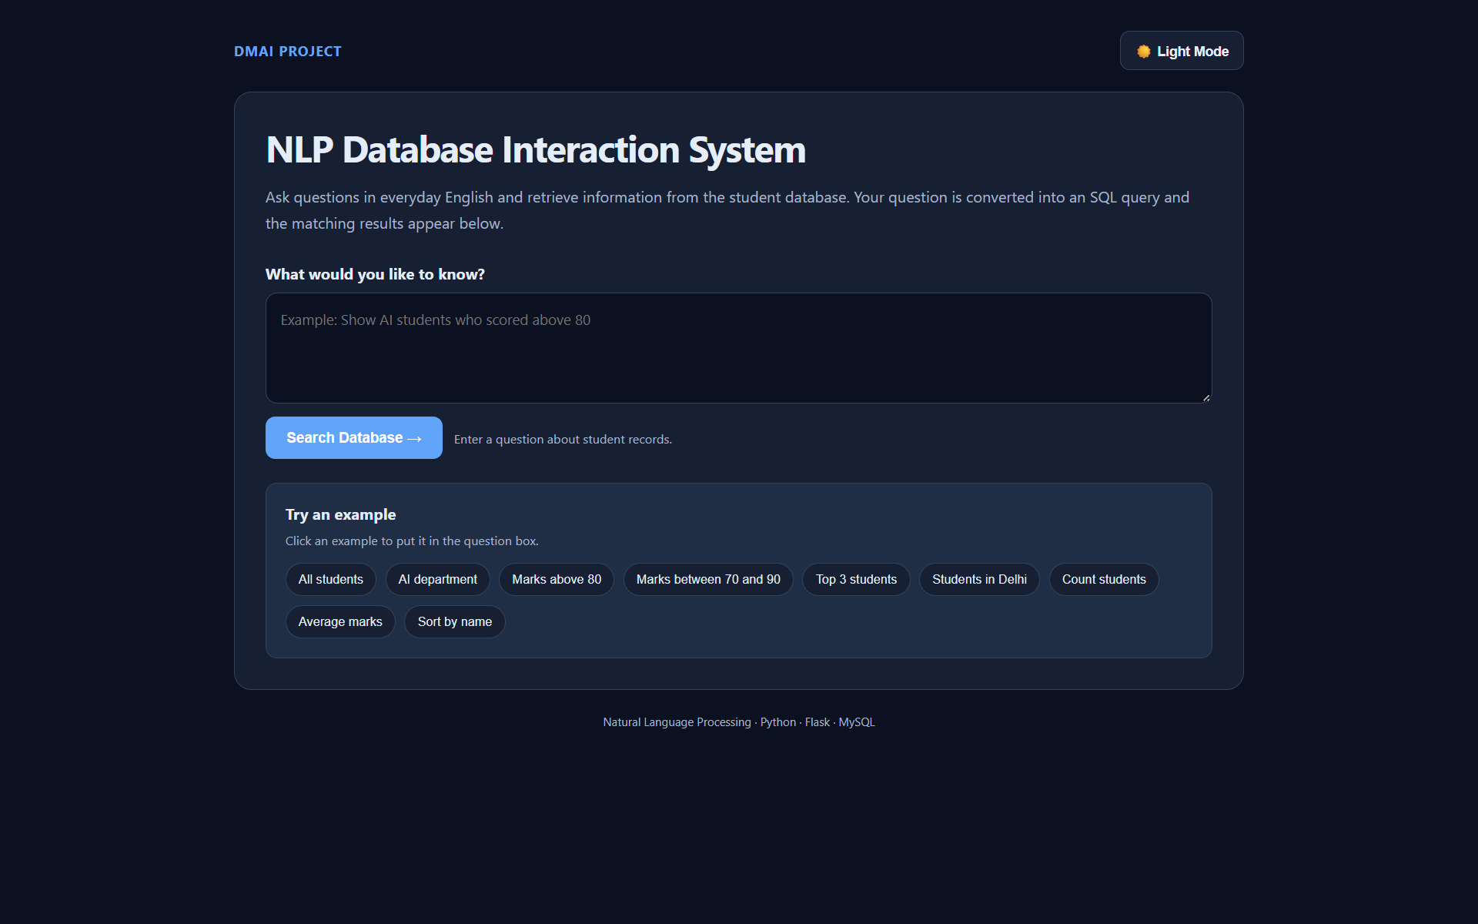
Figure 3. Student records displayed in the application.
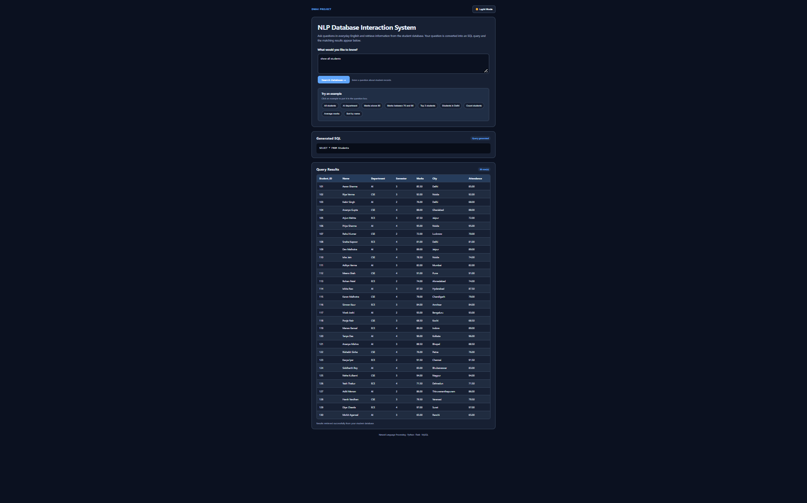
Figure 4. Example city-filtering result.
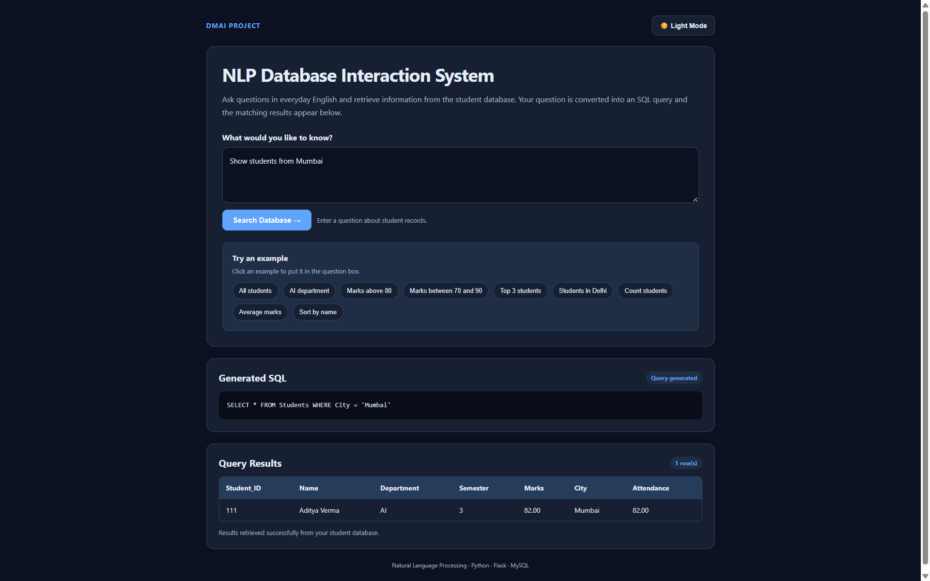
Figure 5. Attendance-filtering result.
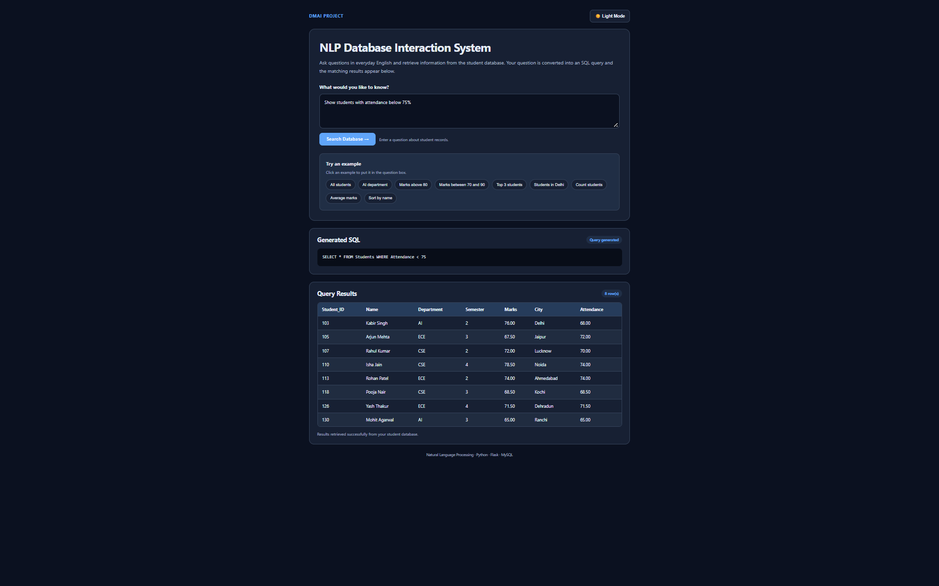
Figure 6. Unsupported-question error handling.
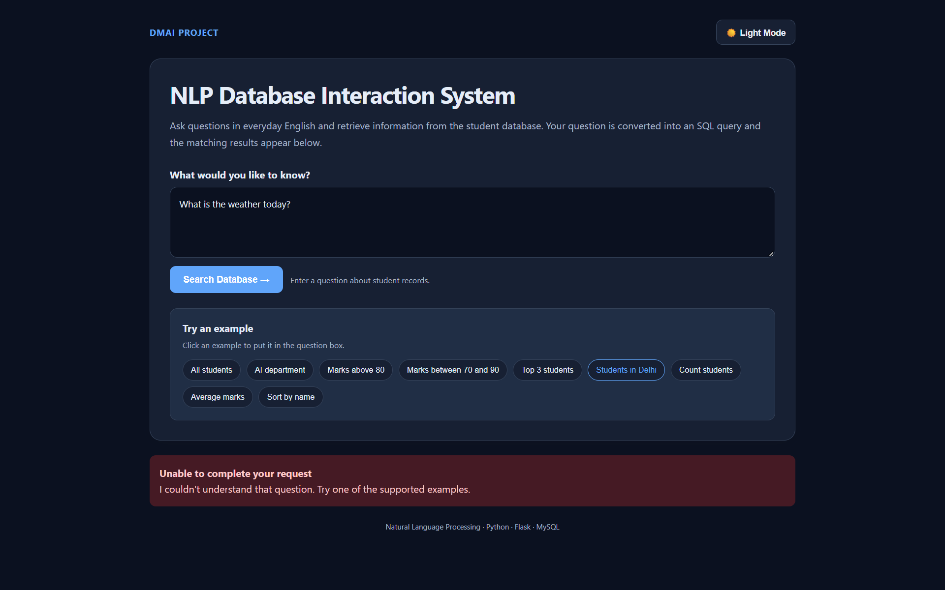

10. Testing
Test | Example question | Expected behavior
List records | Show all students | Returns all 30 sample records.
City filter | Show students from Mumbai | Returns only Mumbai records.
Department filter | Show AI students | Returns only AI department records.
Semester filter | Show students in semester 3 | Returns semester 3 records.
Marks filter | Show students whose marks are above 80 | Returns records satisfying the threshold.
Attendance filter | Show students with attendance below 75% | Requires Attendance column and populated values.
Top-N query | Show the top 3 students | Returns up to three records ordered by marks descending.
Unsupported question | What is the weather today? | Shows an error rather than unrelated records.
Record the actual outcome of each test using the final application version. Mark a test as passed only after verifying its result.

11. Limitations
- The processor is rule-based and supports only defined patterns.
- The dataset contains synthetic records and should not be treated as real student data.
- Attendance queries require an Attendance column and populated values.
- An unrepresented city may return no records; the application should show a friendly no-results message.
- The prototype requires additional security, validation, and deployment testing before real-world use.

12. Future Scope
- Expand supported language patterns and improve intent detection.
- Use parameterized query construction and stronger validation.
- Add more database tables and support joins.
- Improve explanations of generated SQL and returned results.
- Add authentication and role-based access control if required.
- Deploy the application and test it in a production configuration.

13. Conclusion
The project demonstrates a prototype for interacting with a relational database through natural-language questions. Python, Flask, rule-based text processing, and MySQL work together to retrieve selected student information without requiring users to write SQL manually. The interface displays generated queries and results and includes usability features such as example questions and theme switching. The project also demonstrates why unsupported questions and database schema assumptions must be handled carefully.

14. References
- Python documentation: https://docs.python.org/3/
- Flask documentation: https://flask.palletsprojects.com/
- MySQL documentation: https://dev.mysql.com/doc/
- MySQL Connector/Python documentation: https://dev.mysql.com/doc/connector-python/en/
- MDN Web Docs: https://developer.mozilla.org/

Appendix A. GitHub Repository
Insert the final public GitHub repository URL after uploading the project code, database setup script, requirements, and README.

Appendix B. Group Contribution
Student | Enrollment number | Contribution
Kartik Goel | A25ARIU0019 | Describe the work actually completed by this student.
Keshav Garg | A25ARIU0021 | Describe the work actually completed by this student.

