**ARTHA – Multilingual support for PG-1000 Application**

**Mentor:**

Mr. Anand SN

Team Manager, IAPG, ABB

**Submitted By:**

Mr. Mayank Goel

Research Intern, ABB

Table of Contents

**1.** **Introduction** 3

**2.** **Business Impact** 3

**3.** **Advantages** 3

**4.** **Features** 4

**5.** **Technology / Software Platform** 4

**6.** **How it works** 4

**7.** **Installation** 8

**8.** **API References** 8

**9.** **Acknowledgments** 8

1. **Introduction**

Working on a software built with the focus on utility rather than scalability can be challenging because it involves dealing with the heterogeneity that exists in the language preferences across various work cultures. Secondly, programmers involved in the development of large scale applications have to address issues pertaining to diﬀerent life-cycles ranging from design implementation to deployment. Making it compatible for overseas use may be easily ignored. Given the world emerging as a global community, a critical challenge is to build support applications to reduce the language barrier between the software and the Client using the software.

Several approaches to tackle this challenge have been proposed in the fields of UI Automation. However, existing approaches only cover limited subsets of the above mentioned challenges as they are developed to target text, image or audio data. In view of this, in this report, we have discussed about the existing frameworks as precursors to this framework for multilingual UI automation with substantial utility features for easy management and scalability in a high-level programming language, and we present a comparative evaluation result with existing approaches. This provides the UI Automation community for further benchmarking. The evaluation is carried out on ABB-Bailey Japan’s PG 1000 software which has its UI in Japanese language. Our experimental analysis and results demonstrate that our approach makes it possible to work on such **a** software without any dependence on the knowledge of the native language used in the software and thereby reduces the application engineering efforts for application engineers.

Industries have various engineering and research centers and there may arise a scenario wherein an application might not have been developed to be used overseas and could be in local native language. Hence, without having the knowledge of the native language, using the software shall be challenging.

1. **Business Impact**

Can be currently used in T1R project where only 1 out of 4 project members is proficient in Japanese language

Can reduce approximately 3% of the overall project efforts.

Can reap productivity savings out of future projects where PG-1000 software is used.

1. **Advantages**

Simple and easy to use.

Good tool to expand business opportunities with various ABB affiliates where country’s local language is a major challenge.

Translated word can be seen in multiple languages at a time.

Easily configurable database of words with secured login.

Can be extended to other applications with similar challenge

1. **Features**

##### **Multiple privileges to ensure data protection**

ARTHA has multiple user authentications, namely admin, editor and user. User can only use the application, Editor can edit the database and Admin cannot just edit the database but add users and modify the privileges.

##### 

##### **Support for 9 different languages**

ARTHA can support for 9 languages, namely Arabic, English, German, Italian, Japanese, Korean, Norwegian, Spanish and Swedish.

##### **Easy database handling**

The Admin and Editor can easily manipulate the word database by copy and paste of the words from Microsoft Excel file. Unwanted or duplicated words in the database can be easily deleted by selecting the rows in the word database.

##### **Word searching in database**

ARTHA allows admin and editors to search for words in different languages in the database and further modify or delete them.

##### **Word fetching from UI**

ARTHA works on the principle of grabbing the text from the user interface of any windows application and then displaying it to the user in their chosen language.

1. **Technology / Software Platform**

ARTHA has been developed in C# programming language using Visual Studio. The database is in XML format.

1. **How it works**

##### **User Login & Signup**

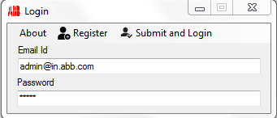

* The user logs in using his/her registered email id and password.
* The user can also signup with a new email id.
* After the user clicks on submit, he/she is redirected to the choose language window or the conversion data table window based on his/her user privileges.

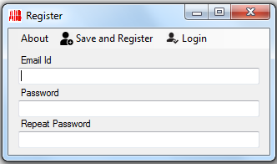

* The default privilege of newly registered users is "user"
* Users with "Admin" and "Editor" privileges are redirected to the conversion data table window while those with "User" privilege are directed to the choose language window

##### **Choose Language**

* The user has to choose one of the 9 languages as the source language of the software.
* The user can chose one or more of the 9 languages as the target language. 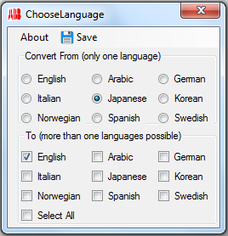
* The source language of the software refers to the language of the software's user interface
* The target language refers to the language in which the user is comfortable in or wants for the software's user interface

##### **Main Form**

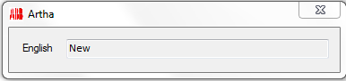

* In the background, one or more language dictionary(s) has been created with a list of source language (key) and target language (value) pairs.
* It displays one or more text boxes with corresponding label(s) of the language(s) that has been selected as target language by the user.
* As the user starts using the source software, ARTHA application reads the text below the mouse.
* In the background, the application compares the text it has thus read with the source language (key) values in the respective language dictionary.
* If there is a match, it replaces it with its target language pair value from the corresponding dictionary.
* It then displays the text in the textbox for the corresponding language.
* To change language preferences, user needs to close the window and login again.
* The number of dictionaries that are formed is dependent on the number of target languages chosen by the user.
* The source language values in each dictionary is from the words or phrases that are pre-defined in the database for the language that has been selected as the source language.
* The target language values in each dictionary is from the words or phrases that are pre-defined in the database for the language that has been selected as the target language.
* Each language dictionary is named after the target language since there is one common source language.

##### **Word Database**

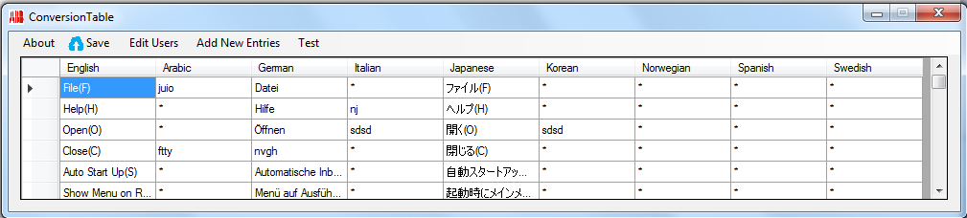

* The table reads from the database and lists all the key value conversion pairs.
* Only the admin and editor have access to it. While the editor can only add new rows of data, the admin can edit the database and even access the editor privilege table.
* To delete one or more rows of data, one should select the entire rows by clicking on the empty space on the left of each of the rows.
* Shortcut keys like Ctrl + C and Delete and mouse select options are enabled on the table to copy and delete the data.
* As soon as admin makes any change to any data column, it turns red until the user clicks on the save button.
* The user can chose one or more of the 9 languages as the target language.
* The save button is a misnomer as it only serves to reload the table from the database. All the changes to the database are live and happen as soon as user makes any change.

##### **Add new words to database**

##### 

* The table allows editor/admin to enter new data rows.
* Besides copy and delete functionality like in the previous table, Paste is also enabled.
* To paste data, user must click on the first column entry of the table and paste data using Ctrl + V or right click and select Paste option.

##### **User Privilege Table**

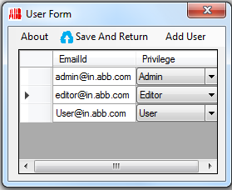

* The table is accessible only by the admin.
* Admin can view the name and the privilege of registered users.
* Admin can also access the “Add user” option.
* Privilege of a user can be only be set through a drop down menu from one of the 3 choices, namely, User, Editor and Admin.

##### **Add User Table**

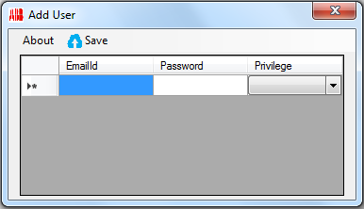

* The table allows Admin to add new users and set their password and privileges. The user can chose one or more of the 9 languages as the target language.

##### **Search Table**

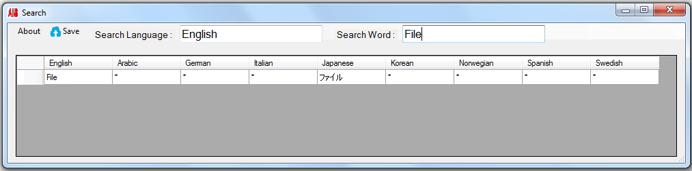

* The table allows Admin and Editor to look up words in different languages in the database. Only Admin is allowed to delete from the database while both Admin and Editor can copy the row entries.

1. **Installation**

The application has no prerequisites. One however needs to check that the relative path of the XML files are not disturbed.

1. **API References**

### [*https://msdn.microsoft.com/en-us/library/ms747327(v=vs.110).aspx*](https://msdn.microsoft.com/en-us/library/ms747327(v=vs.110).aspx)

* [*https://code.msdn.microsoft.com/windowsapps/c-getting-the-windows-da1bd524*](https://code.msdn.microsoft.com/windowsapps/c-getting-the-windows-da1bd524)

1. **Acknowledgments**

On the very outset of internship at ABB Corporate Research India, It is my radiant sentiment to place on record my best regards, deepest sense of gratitude to Mr. Anand SN for his careful and precious guidance which are extremely valuable for my study both theoretically and practically. Without his active guidance, help, cooperation, and encouragement, I could not have made headway in the project.

I express my deepest thanks to Mr. Sudarsan SD and Mr. Pravin Kumar, for taking part in useful decision & giving necessary advices, guidance and arranged all facilities to make my internship successful. I choose this moment to acknowledge their contribution gratefully. I would like to express my deepest gratitude and special thanks to the Mr. Ravi Prakash and Ms. Devina Mohan who in spite of being extraordinarily busy with their duties, took time out to hear, guide and keep me on the correct path.

I extend my gratitude to ABB Corporate Research, India for giving me this opportunity. I will strive to use gained skills and knowledge in the best possible way, and I will continue to work on their improvement, in order to attain desired career objectives.