**CSCI 5521: Homework 2 Solution**

1. 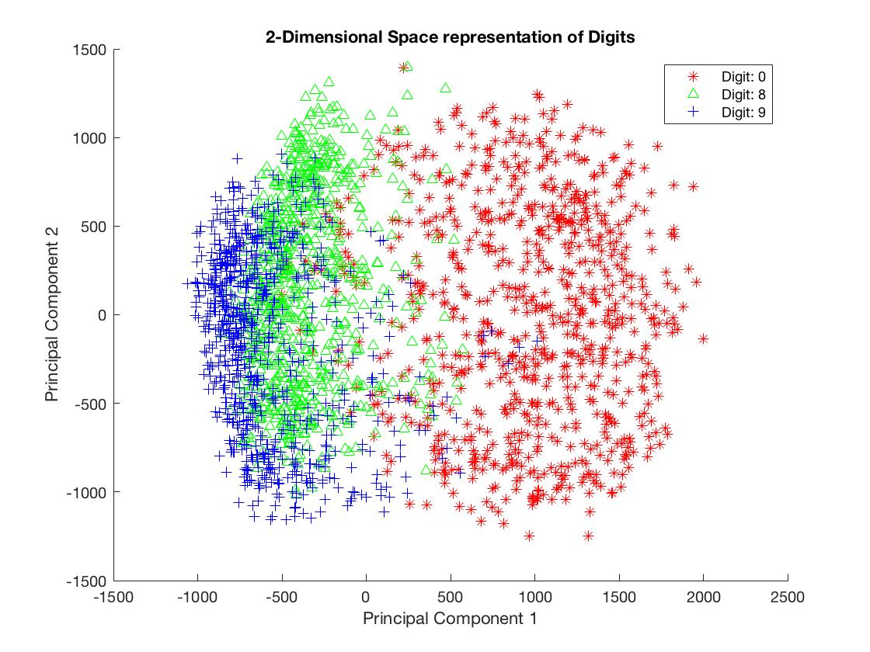 For the solution to our first problem, we build a MATLAB script that implements PCA on the MNIST data set. We implement the following functions to plot features from class 8 or 9 in a 2-D space using PCA.

Figure : Scatter plot of the Principal Components of class 0, 8 and 9

1. 



Figure 2: Most misclassified 9 - LDA classifier

Figure : Most misclassified 8 - LDA classifier

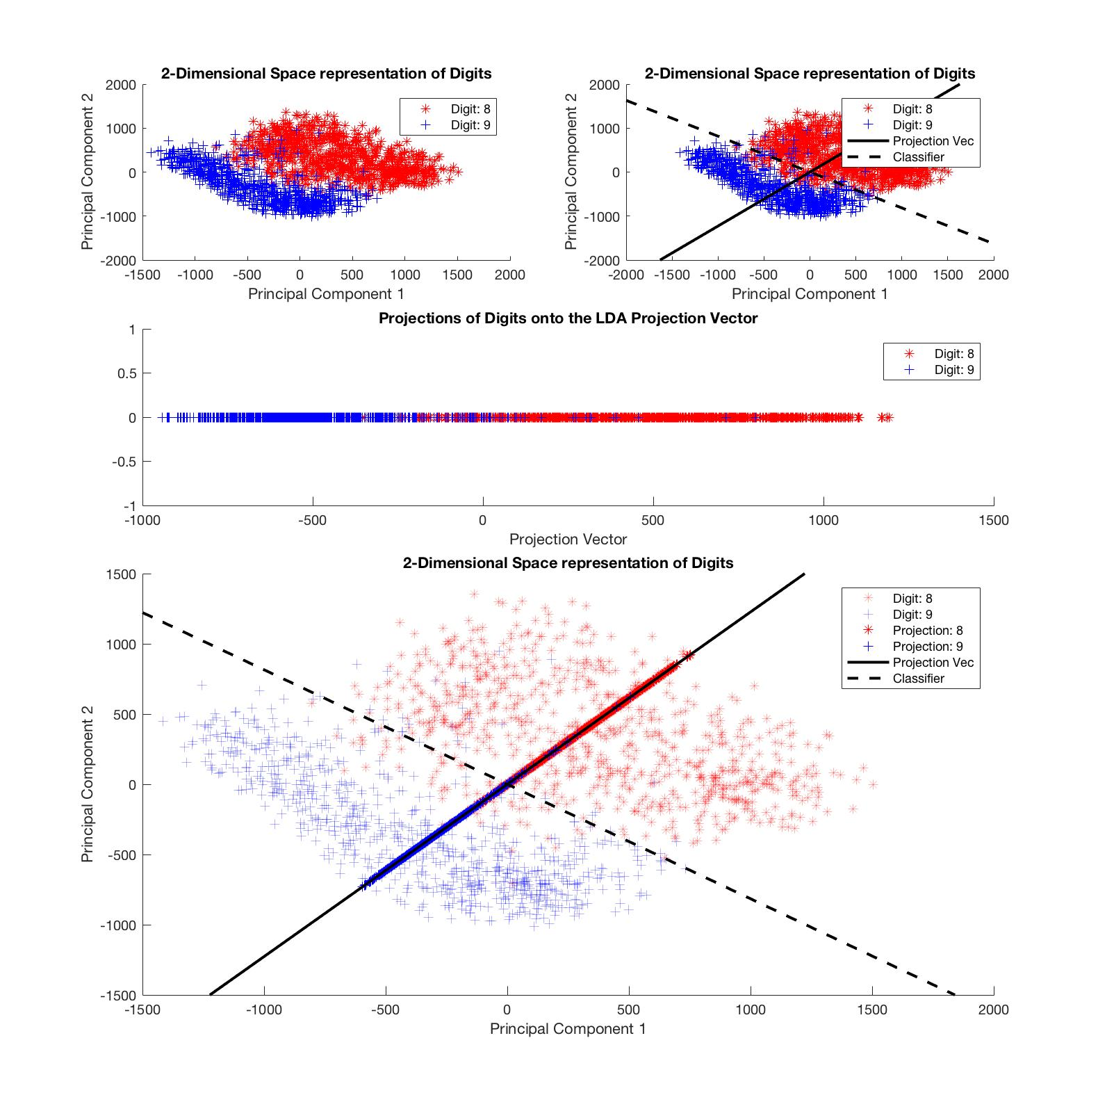

Figure : Scatter plot with LDA vector and classifier vector