**PROGRAM 23**

**Table:SchoolBus**

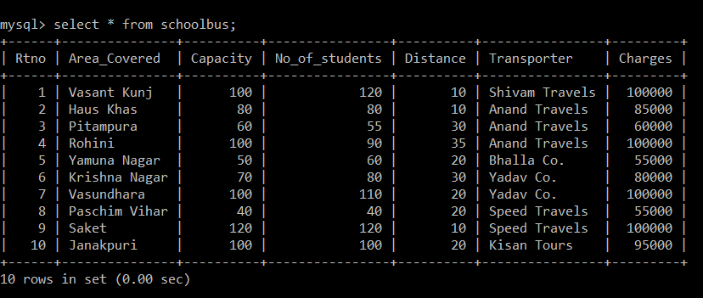

1. To show all information of students where capacity is more than the no. of students in order of rtno.

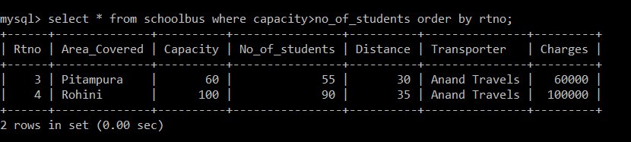

2. To show area_covered for buses covering more than 20 km., but charges less than Rs. 80000.

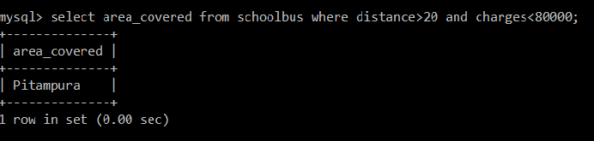

3. To show transporter-wise total no. of students travelling.

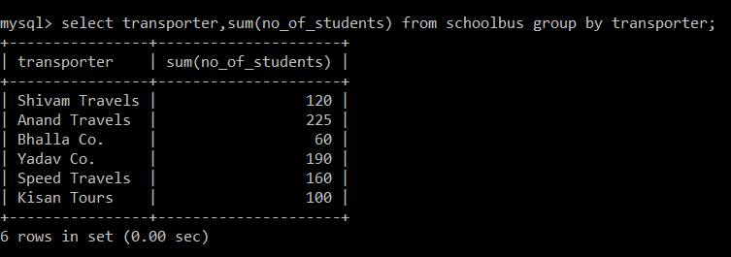

4. To show rtno ,area_covered and average cost per student for all routes where average cost per student is – charges/no. of students.

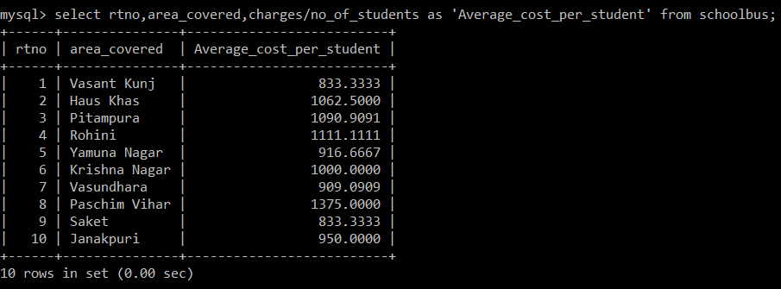

5. Add a new record with the following data:(11, “Moti Bagh”, 35, 32, 10, “Kisan Tours”, 35000)

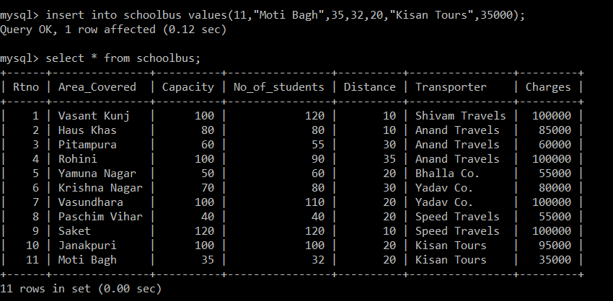

**OUTPUT**

1. SELECT SUM(DISTANCE) FROM SCHOOLBUS WHERE TRANSPORTER = „YADAV CO.”;

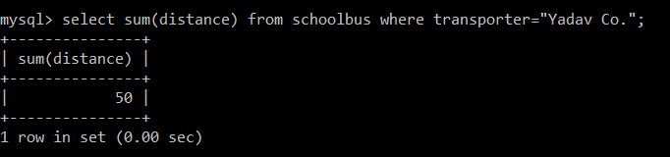

2. SELECT MIN(NOOFSTUDENTS) FROM SCHOOLBUS;

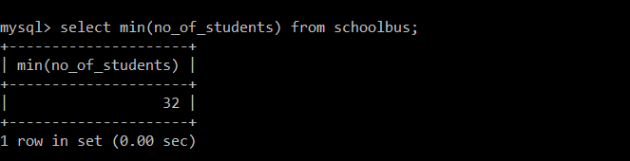

3. SELECT AVG(CHARGES) FROM SCHOOLBUS WHERE TRANSPORTER = “ANAND TRAVELS”;

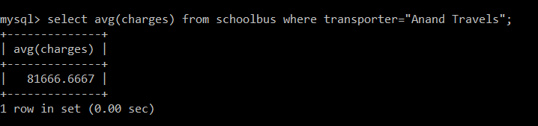

4.SELECT DISTINCT TRANSPORTER FROM SCHOOLBUS;

