**PROGRAM 24**

**Table:Stores**

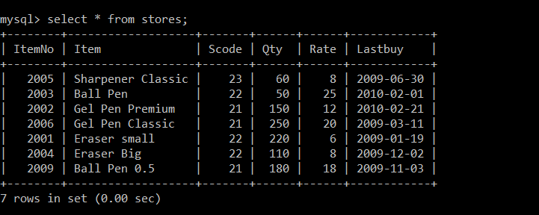

**Table:Suppliers**

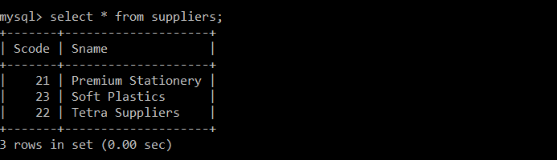

1.To display details all the items in the Stores table in ascending order of LastBuy.

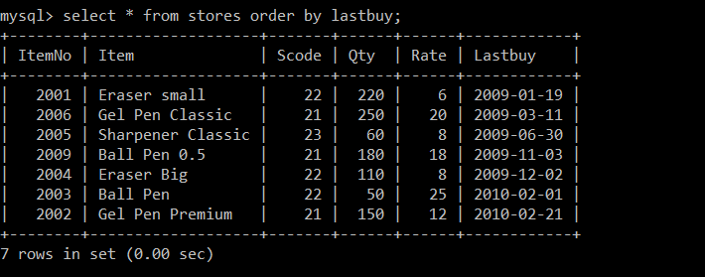

2. To display Itemno and Itemname of those items from stores table whose rate is more than 15 rupees.

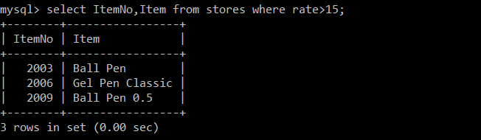

3.To display the details of those items whose supplier code is 22 or Quantity in store is more than 110 from the table Stores.

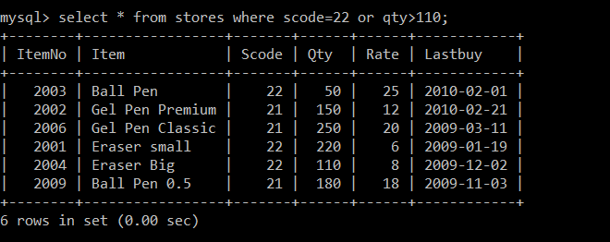

4. To display minimum rate of Items whose Supplier individually as per Scode from the table Stores.

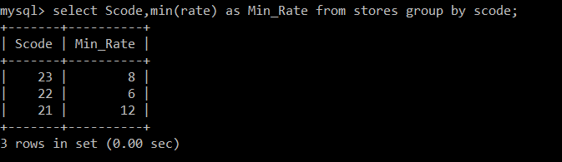

5.To display the details of all the items in ascending order of LastBuy.

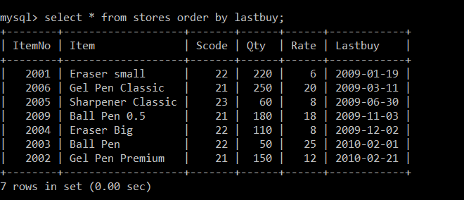

6.To display the details of the supplier TETRA SUPPLIERS from both the tables.

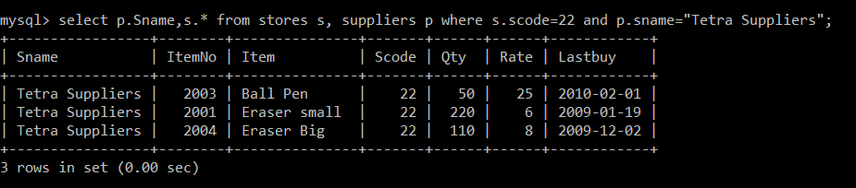

7.To depreciate the rate of items by 2%.

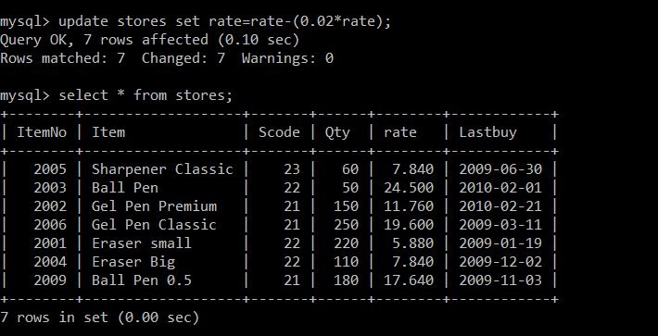

8. To display the details of the items whose last purchase date was before November 2009.

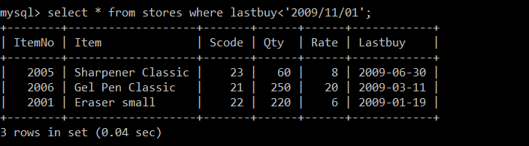

**OUTPUT**

1. SELECT COUNT(DISTINCT SCODE) FROM STORE.

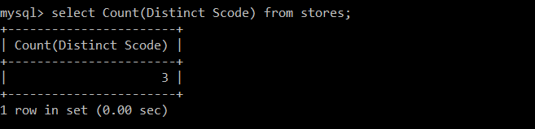

2. SELECT RATE * QTY FROM STORE WHERE ITEMNO = 2004;

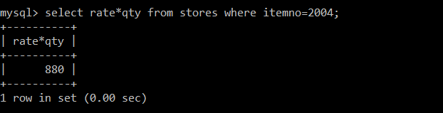

3.SELECT ITEM, SNAME FROM STORE S, SUPPLIER P WHERE S.SCODE = P.SCODE AND

ITEMNO = 2006;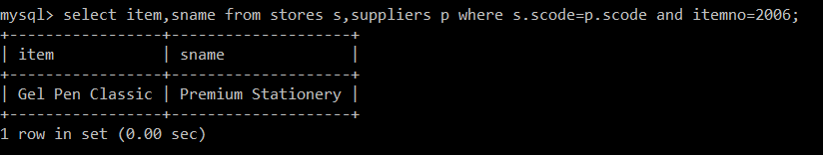

4. SELECT MAX(LASTBUY) FROM STORE;

