

**Department of Electrical and Electronics Engineering**

**SRM IST, Kattankulathur – 603 203**

**Sub Code & Name: 18EEC301J – Control Systems**

|  |  |
| --- | --- |
| **Experiment No** | 03 |
| **Title of Experiment** | Generation Of Standard Test Signals |
| **Name of the candidate** | ADARSH GOENKA |
| **Register Number** | RA1811005010037 |
| **Date of Experiment** | 26.08.2020 |

**Mark Split Up**

|  |  |  |  |
| --- | --- | --- | --- |
| **S.No** | **Description** | **Maximum Mark** | **Mark Obtained** |
| 1 | Oral Viva / Online Quiz | 5 |  |
| 2 | Execution | 10 |  |
| 3 | Model Calculation / Result Analysis | 5 |  |
| **Total** | | **20** |  |

**Staff Signature with date**

**AIM:**

To generate the following test signals

1. Step
2. Ramp
3. Parabolic
4. Impulse
5. Sinusoidal with MATLAB-SIMULINK software.

**APPARATUS/SOFTWARE/EQUIPMENTS REQUIRED:**

1. Computer/Desktop with MATLAB ( Standard Versions) Package

**THEORY:**

**REF:http://engineering.electrical-equipment.org/panel-building/typical-test-signals-in-time-domain-analysis.html**

* The dynamic behavior of a system is manipulated and judged under the application and working of standard and typical test signals.
* The characteristics of an input signal are constant acceleration, constant velocity, a sudden change or a sudden shock.
* There are four types of typical test signals: Impulse Step, Ramp, Parabolic and another important signal is sinusoidal signal

1. ***STEP SIGNAL***

* The step signal defines the sudden change in properties of actual signal.
* When A=1, the step is called unit step signal.

[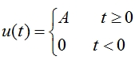](http://engineering.electrical-equipment.org/wp-content/uploads/2014/03/Typical-Test-Signals-in-Time-Domain-Analysis-4.jpg)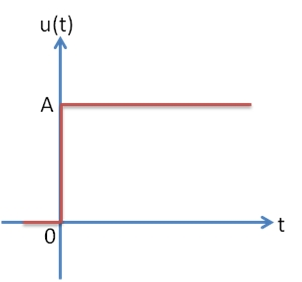

1. ***RAMP SIGNAL***

* The ramp signal tells you the constant velocity attribute of actual input signal.
* When A=1, ramp signal is called unit ramp signal.

[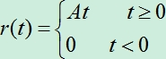](http://engineering.electrical-equipment.org/wp-content/uploads/2014/03/Typical-Test-Signals-in-Time-Domain-Analysis-6.jpg) 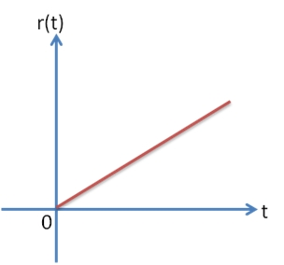

1. ***PARABOLIC SIGNAL***

* Parabolic signal gives the constant acceleration distinction of actual input signal.
* When A=1, the parabolic signal is called unit parabolic signal

[[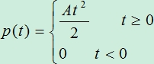](http://engineering.electrical-equipment.org/wp-content/uploads/2014/03/Typical-Test-Signals-in-Time-Domain-Analysis-9.jpg)](http://engineering.electrical-equipment.org/wp-content/uploads/2014/03/Typical-Test-Signals-in-Time-Domain-Analysis-9.jpg) 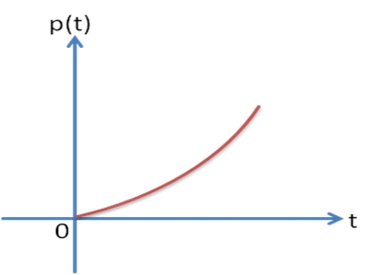

1. ***IMPULSE SIGNAL***

* Impulse response in control system imitates sudden shock quality of actual input signal.
* When A=1 then the impulse signal is called Unit impulse signal.

[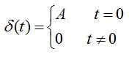](http://engineering.electrical-equipment.org/wp-content/uploads/2014/03/Typical-Test-Signals-in-Time-Domain-Analysis-1.jpg) 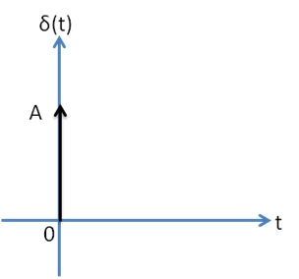

**PROCEDURE:**

1. ***SIMULINK MODELING***
2. Click open the shortcut to MATLAB icon on desktop of computer.
3. On the top tool bar, click the Simulink library browser icon.

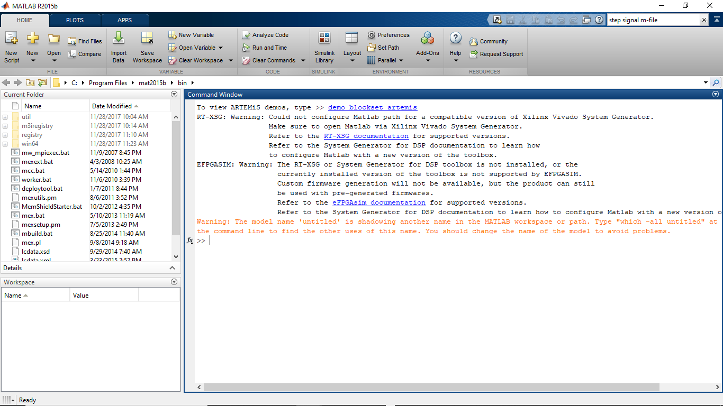

1. Open the new model from the library browser window’s top tool bar.

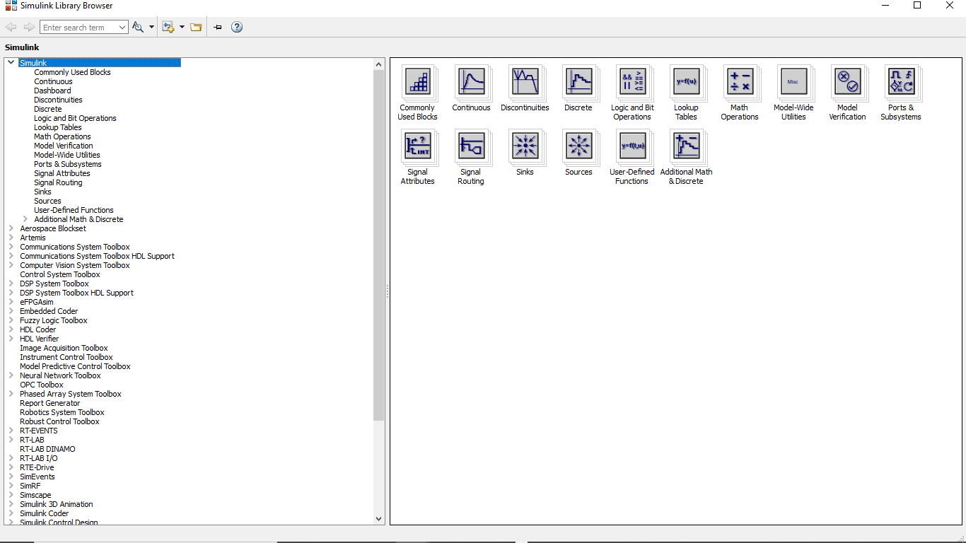

1. Drag and drop the following blocks from the library to the new file.

* Simulink--- Sources---Step
* Simulink---Sources-Ramp
* Simulink-Sources-Sinusoidal
* Simulink---Sinks---Scope
* Simscape---Powerlib- Powergui

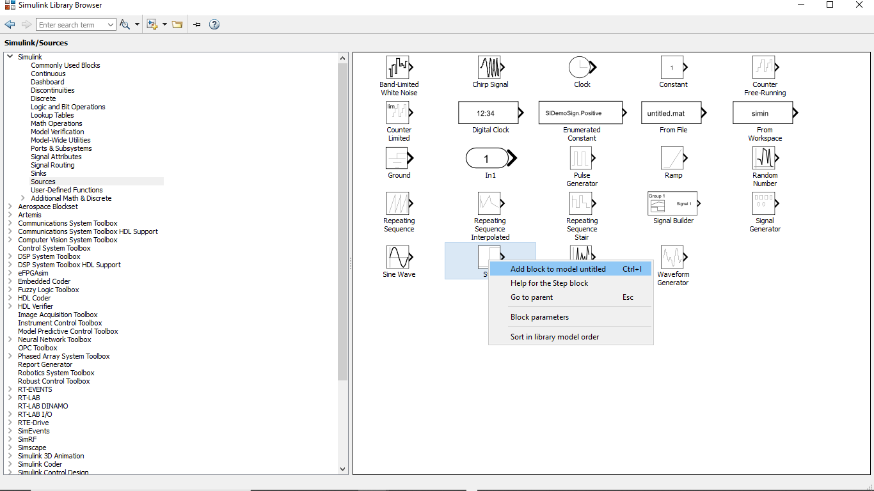

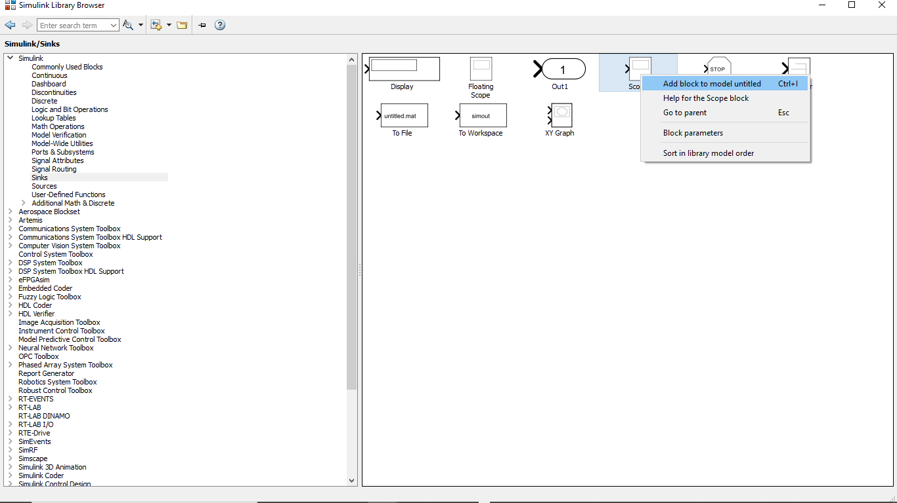

1. Connect the blocks as per schematic connection diagrams given below.
2. ***STEP, RAMP AND SINUSOIDAL TEST SIGNAL GENERATION***

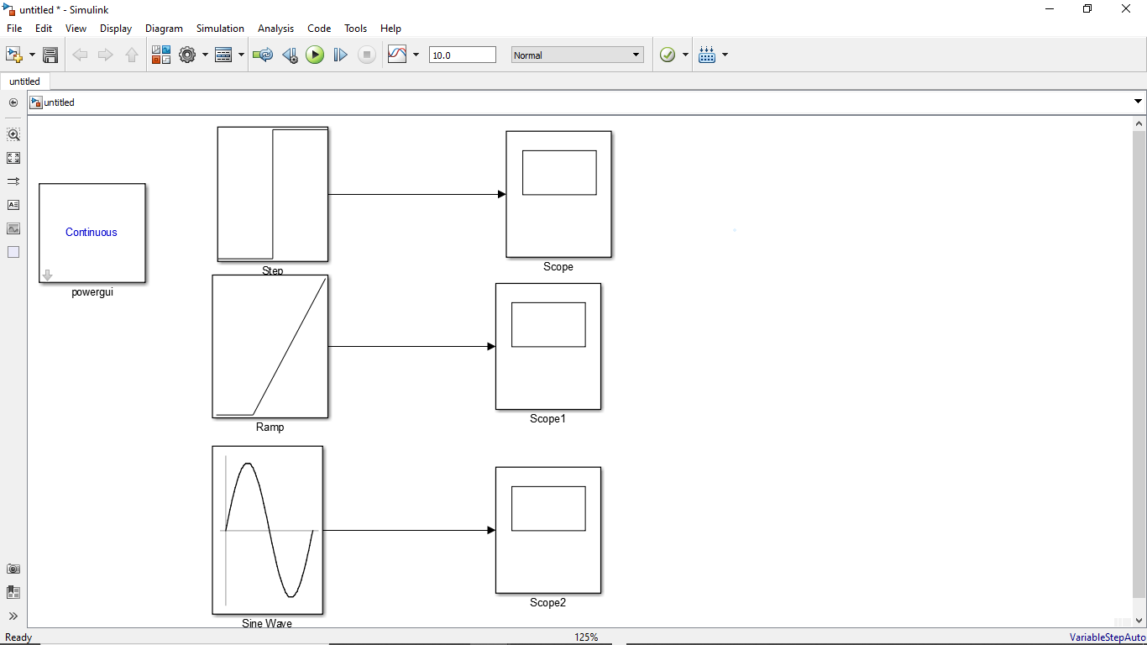

SAVE THE FILE BY GIVING A NAME

RUN

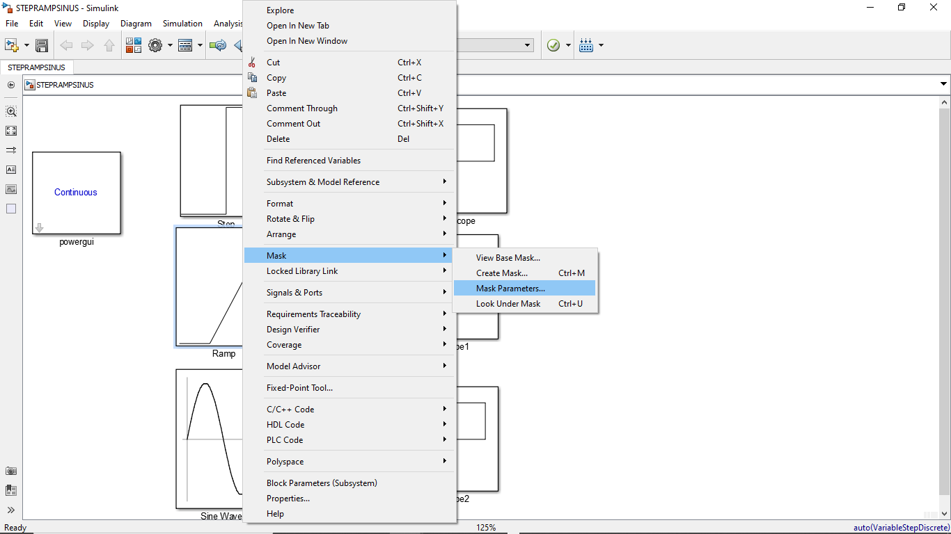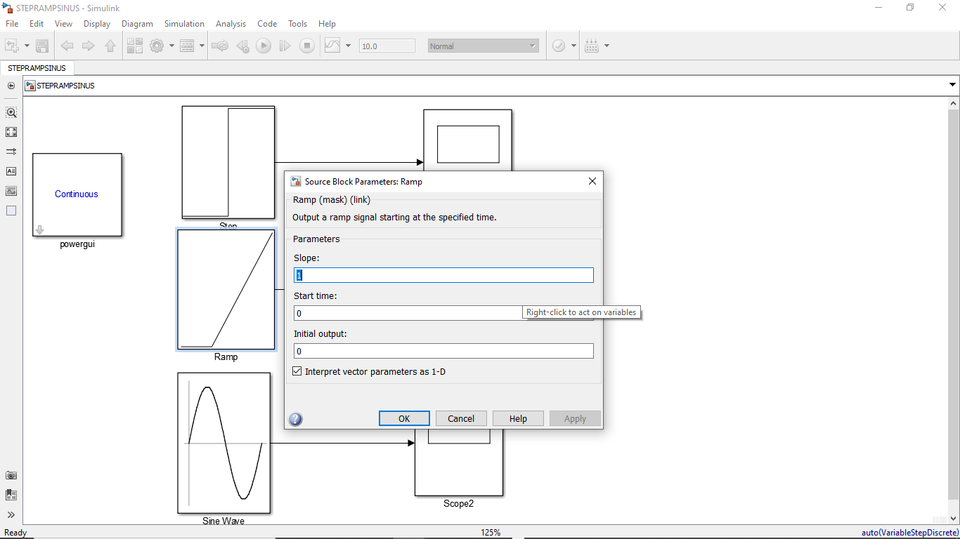

YOU COULD CHANGE VALUES

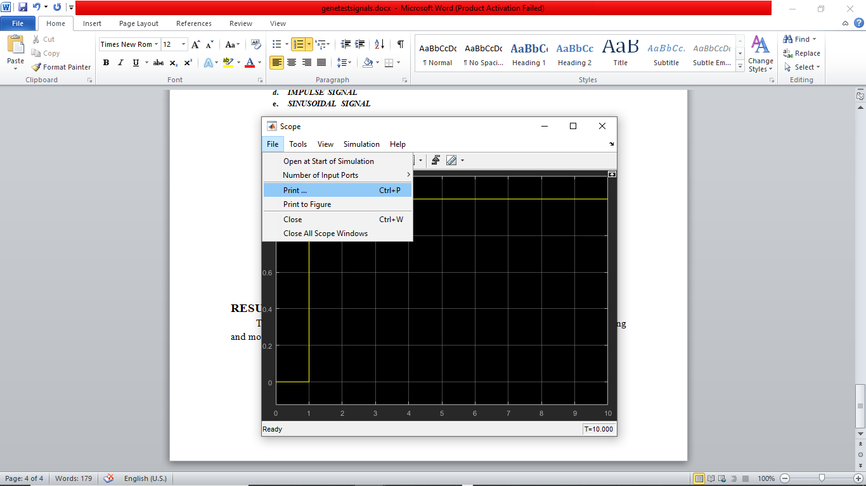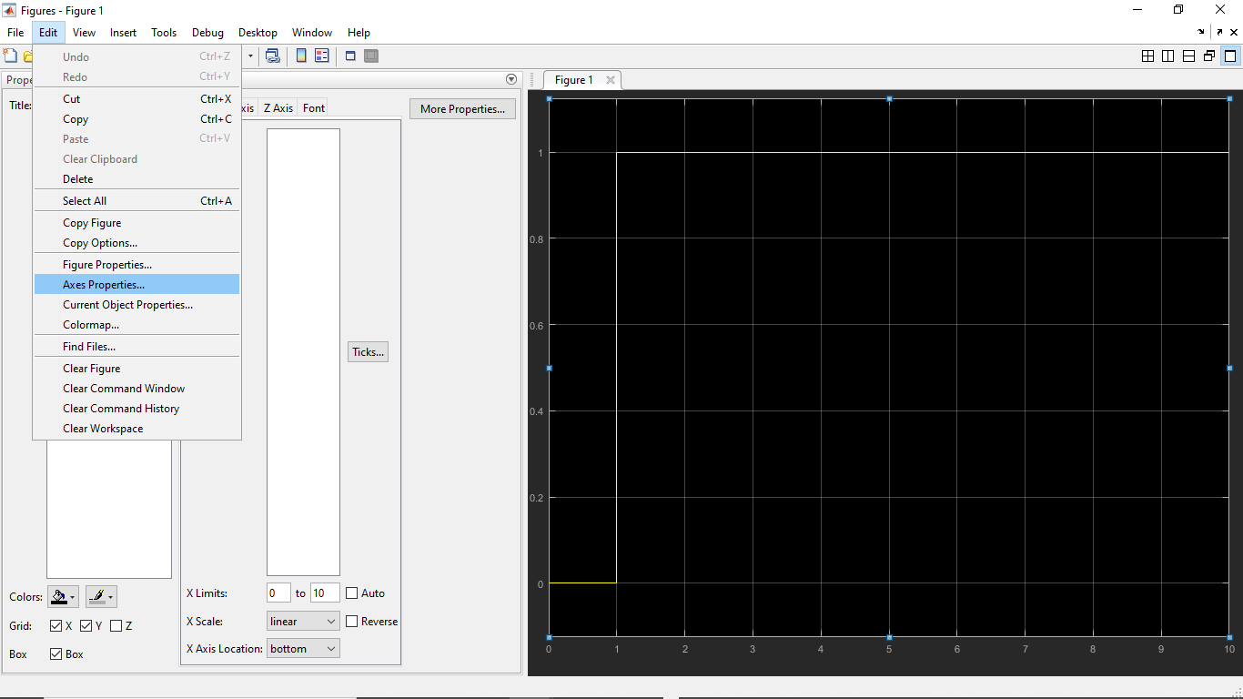

Click on curve to change colour and thickness of line

CHANGE TO WHITE

EDIT AXES PROPERTIES

PRINT TO FIGURE

**C:\Users\appa\Desktop\controlsystems2020odd\ramp.tifModel Outputs:**

**C:\Users\appa\Desktop\controlsystems2020odd\step.tif**

**C:\Users\appa\Desktop\controlsystems2020odd\sinee.tif**

1. ***m-FILE CODING***
2. ***PARABOLIC AND IMPULSE TEST SIGNAL GENERATION***
3. Click open the shortcut to MATLAB icon on desktop of computer.
4. On the top tool bar, click the new icon to open editor window as shown
5. Key in the program.
6. Save the file and run the program

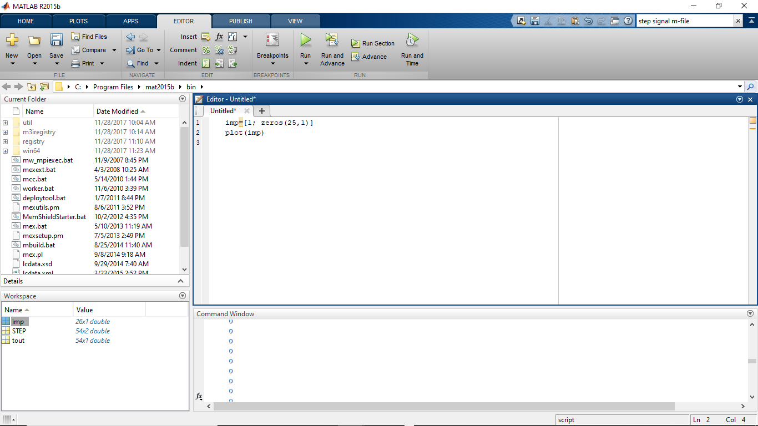

EDITOR WINDOW FOR CODING

WORKSPACE

COMMAND WINDOW

***C:\Users\appa\Desktop\controlsystems2020odd\all.tif***

UNIT STEP

UNIT IMPULSE

UNIT RAMP

UNIT PARABOLIC

**Program/m-code**

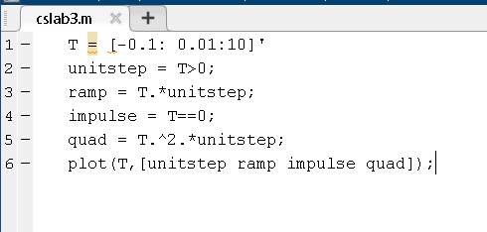

**Simulation Output Waveforms:**

**Using Simulink:**

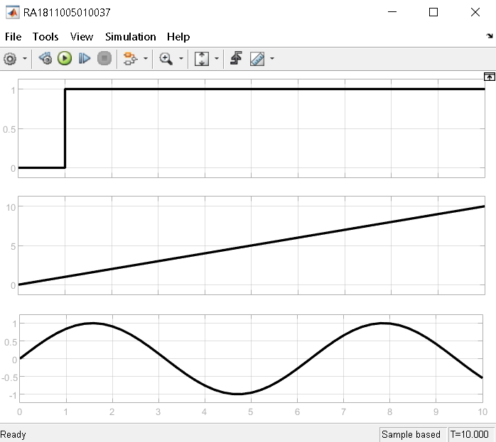

**Using M file coding:**

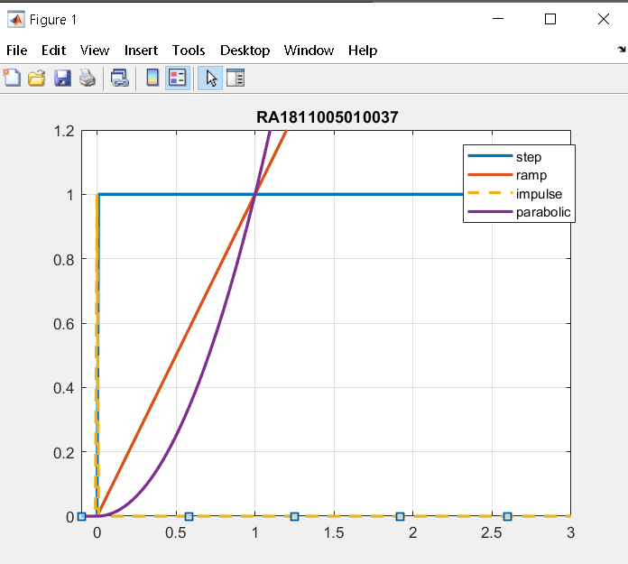

**RESULT:**

Thus the various standard test signals are generated, observed and plotted by programming and modeling with MATLAB.

**VIVA –VOCE**

1. Define time response. Time response of the system is defined as the output of a system when subjected to an input which is a function of time.
2. Distinguish between transient and steady state response.

**The steady state** is the state that is established after a certain time in your system.   
**The transient state** is basically the state between the beginning of the event and the steady state.

1. List the standard test signals.

Standard input signals are:

1) Impulse

2) Step

3) Ramp

4) Parabolic input

1. What do you mean by a step signal?

A signal with magnitude one for time greater than zero .

1. Mathematically formulate a unit step signal.

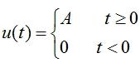

1. What is ramp signal?

A signal whose magnitude increases same as time . It can be   
 obtained by integrating unit step.

1. Draw the graphical representation of a ramp signal.

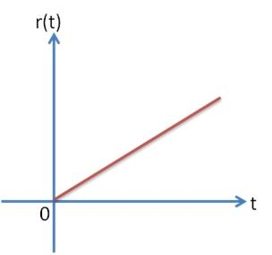

1. Define parabolic and impulse signals.

**Impulse** : A signal which has infinite magnitude at time equal to zero only. We can assume it as a lightning pulse which acts for a short duration with infinite magnitude of voltage.

**Parabolic** :A signal whose magnitude increases with the square of time . It can be obtained by integrating unit ramp

1. Express the mathematical model of an impulse signal.

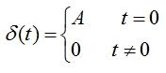

1. Match the following
2. Sudden change –Impulse
3. Constant velocity- Step
4. Sudden shock- Parabolic
5. Constant acceleration- Ramp
6. Sudden change –step
7. Constant velocity- ramp
8. Sudden shock- impulse
9. Constant acceleration- parabolic