## 

# Jet Fighter

The

Game

Fly

On the edge

Fire missiles and cannons to devastate your enemies in this full Phaser Game available for desktop/pc on the web now.

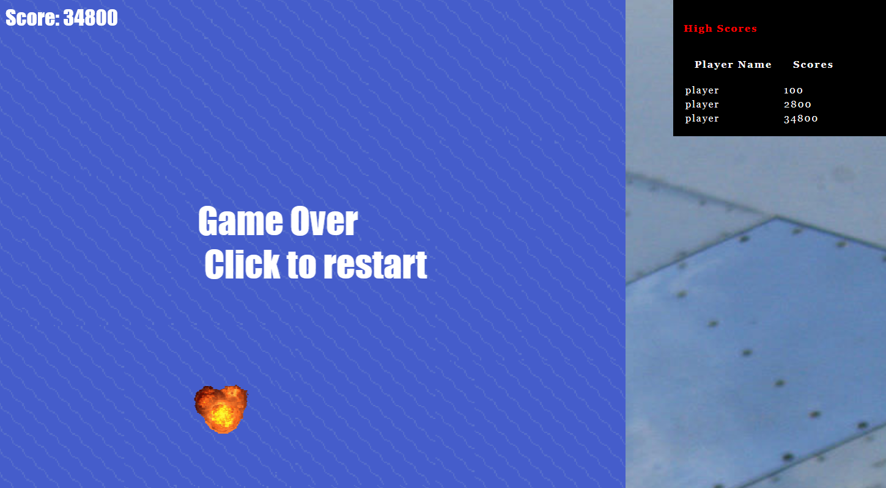

This web base game will keep you up all night with challenging levels, boss encounters, and a score board to show off how good of a pilot you are. Do you have what it takes to be the best?

