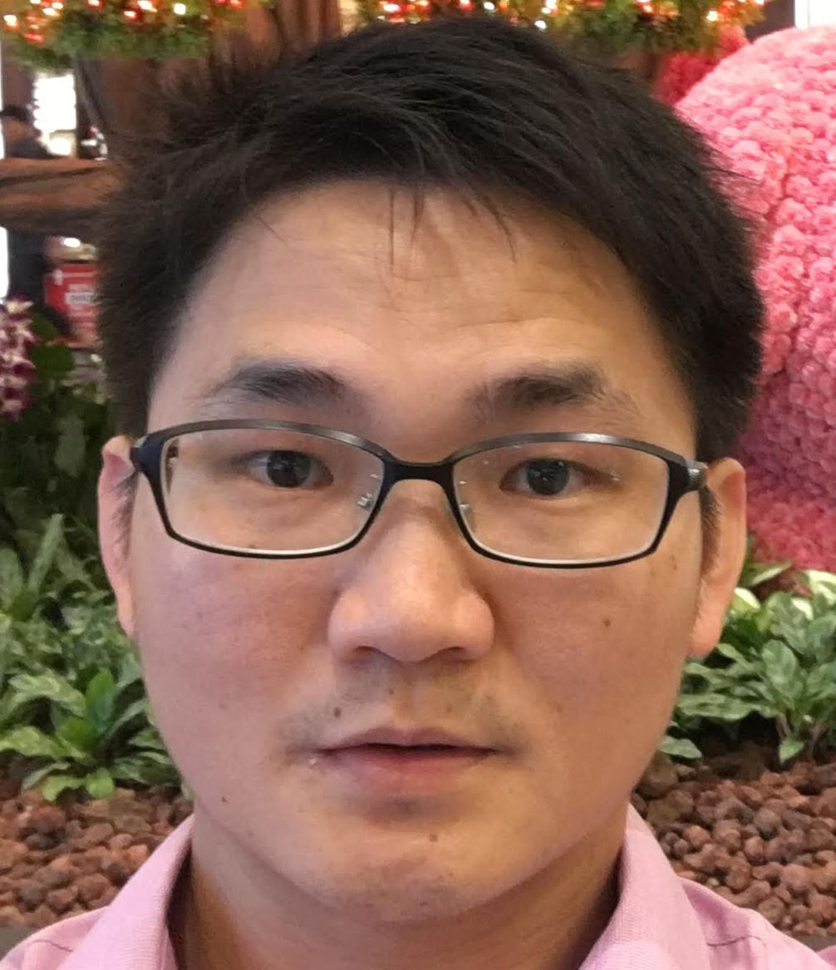
Goey, Choong Hong
Contact Details

Address : BK 675C, Yishun Ave 4, #07-798, Singapore 763675
Telephone No. : --
Mobile No. : 97771491
Email : chgoey@yahoo.com

Personal Particulars

Age :39 years
Date of Birth : 12 March 1981
Nationality : Malaysia ( Singapore PR)
Gender : Male
Marital Status : Married

Qualification

Qualification : Diploma
Field of Study : Mechatronics

Major : PRECISION ENGINEERING MECHATRONICS AND ROBOTICS TRACK
Institute/University : SINGAPORE POLYTECHNIC
Grade : Competent (WSQ)
Graduation Date : 2013

Experience

Employment History

Company Name : Hoya Surgical
Position Title : Assistant Engineer (Equipment Maintenance)
Industry : Healthcare / Medical
Duration : 2018 – Presenting
Monthly Salary : SGD
Work Description :

Responsibilities:
- Plan maintenance schedule of production equipment
- Improve production yield based on historical production data.
- Manage equipment inventory.
- Troubleshoot daily production machine issues.
- Assist and coordinate with process engineer in performing IOQ for new equipment.
- Carry out root cause analysis in any process deviation.

Languages
(Proficiency: 0=Poor - 10=Excellent)

Language Spoken Written
-------------------------------------------------------------------------------------
Chinese 8 5
English 5 5
Bahasa Malaysia 5 5

Text Resume / Additional Info

FUNCTIONAL SKILL AREAS
System Analyst - Quality Assurance Analyst - Inventory Controller
Technical Operations Liaison - Technical Supervisor / Machine troubleshooting and preventive maintenance.
COMPUTER SKILLS
Microsoft Office Suite
VB / Macro programming

EMPLOYMENT HISTORY
Flextronics Technology (Malaysia) SDN. BHD
Test Technician
2002-May2005
Assist Engineers in the setting up and maintaining of test processes and procedures.
Assisting in training of operators for testing and repair processes.
Production yield failures analysis.
Maintaining and setting up of testing accessories and equipment.
Carry out equipment maintenance
Perform equipment trouble shooting on demand to ensure that manufacturing processes meet product requirements.
Prepare test process flow and translate this test to standard operation procedures.

HOYA MEDICAL SINGAPORE PTE LTD
Position: R&D Technician
Period:2005 - 2008
Ensure the new Process is transfer smoothly from R&D to Production.
Setting up the new equipment of the new processes and created the process procedures for production.
Conduct new process training to production personnel.
Understand basic machine mechanical and NC program test methodologies.

HOYA MEDICAL SINGAPORE PTE LTD
Position: R&D Assistant Engineer
Period: 2008 -2010
Ensure the new Process is transfer smoothly from R&D to Production.
Setting up the new equipment of the new processes and created the process procedures for production.
Prepared charts and presented at R&D monthly meeting.
Conduct new process training to production personnel.
Production yield failures analysis.
Internal Audited manufacturing processes and procedures.
Carry out supporting activities - instrument calibration & maintenance, housekeeping, replenish supplies etc
Prepare process flow and translate into standard operation procedures.

Flextronics Medical
Position: Quality Assistant Engineer
Period: 2010 –2015
Ensure the new Process is transfer smoothly from customer to Production.
Setting up the new equipment of the new processes and created the process procedures for production.
Prepared charts and presented at QA monthly meeting.
Conduct new process training to production personnel.
Production yield failures analysis.
Prepare process flow and translate into standard operation procedures.
Prepared, evaluation the effectiveness, maintain and update Quality Checklist from time to time.
Ensure the finished product comply with FDA, UL,CE and customer requirement.

HOYA MEDICAL SINGAPORE PTE LTD
Position: ME Assistant Engineer
Period: 2015 ~ 2018
Transfer new product from R&D to Production.
Validate new equipment
Verify new process procedures based on R&D Process Control Parameter.
Production yield failures analysis and yield improvement.
Carry out supporting activities –In-house instrument calibration & maintenance, housekeeping etc
Coordinate all sample built

EDUCATION
Diploma in Mechatronics , SINGAPORE POLYTECHNIC (Jan2012 – Nov 2013)
Certificate in Mechatronics (NTC), Institute of Technical Education.(Jun2007 – Jun2010)
Certificate in material & Purchasing Management, Singapore Institute of material Management. ( Years from Apr 08 to Aug08)
Diploma In Information Technology, Kolej Komuniti , Pulau Pinang Malaysia.
( Year s from 2000 to 2002)
O level, Ministry of education, Malaysia.
(years from 1994 to 1999)

Reason for Leaving:
Looking for opportunity and challenge where I can share and contribute my knowledge and competency in a fast growth environment.

Expected salary:
SGD
_____________________________________________________________________________________
Availability :1 month notice

Job Preferences

Expected Monthly Salary :Negotiation
Willing to Travel : Yes
Willing to Relocate : Yes
Possess Own Transport : No

References
- Name: Dennis Lee
Position: Senior Process Engineer
HP no. 9832 8122

- YEO ThianHock (Yeo)
Position: Equipment Assistant Manager
HP no. 9169 0977

