Eclipse RCP (Rich Client Platform)

SWT (Standard Widget Toolkit)

GEF (Graphical Editing Framework)

Eclipse Project Update

**https://wiki.eclipse.org/Eclipse_Project_Update_Sites**

4.18.x releases (2020-12) **https://download.eclipse.org/eclipse/updates/4.18/**

4.6.x releases (Neon) **https://download.eclipse.org/eclipse/updates/4.6/**

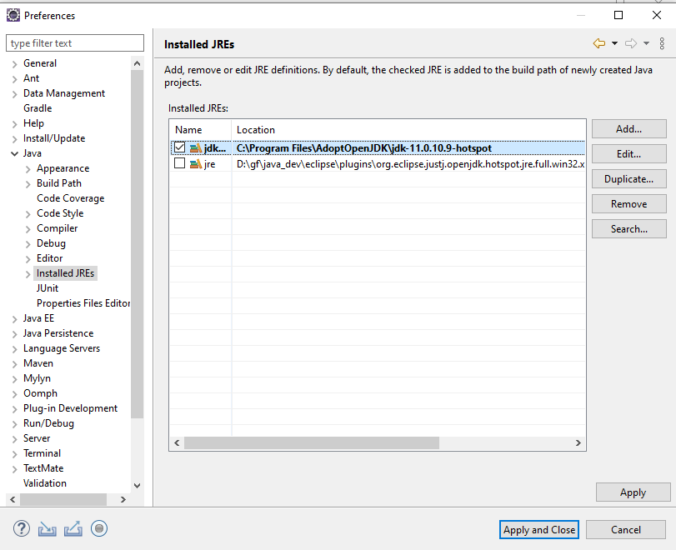

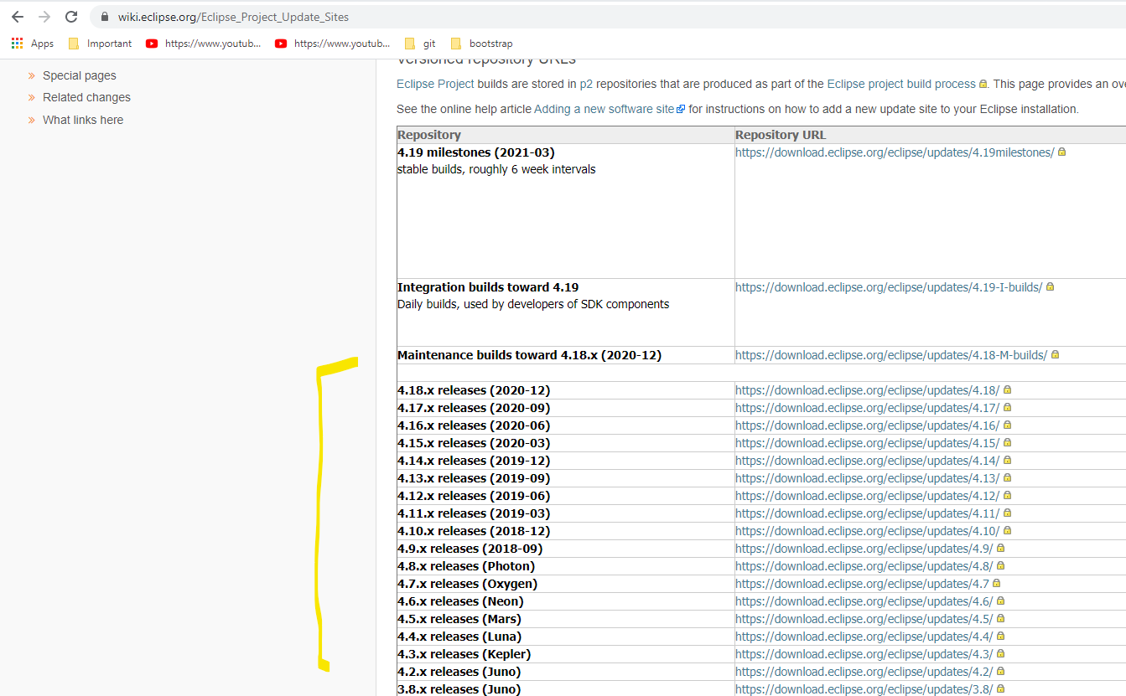

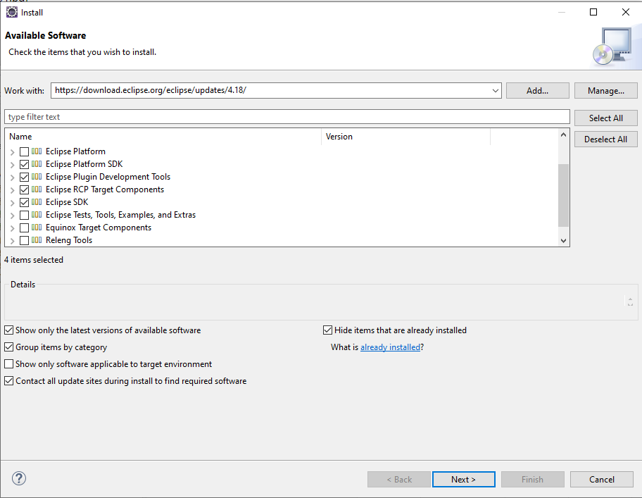

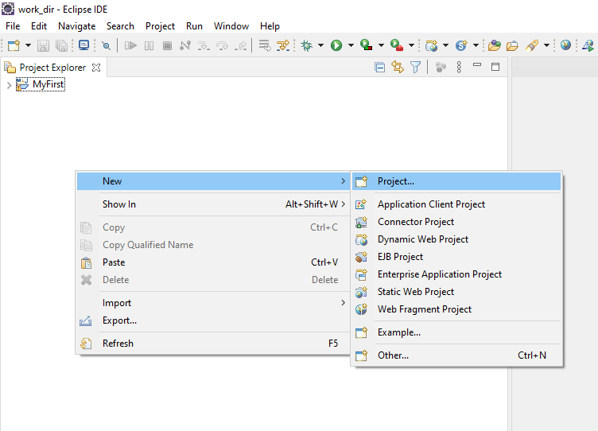

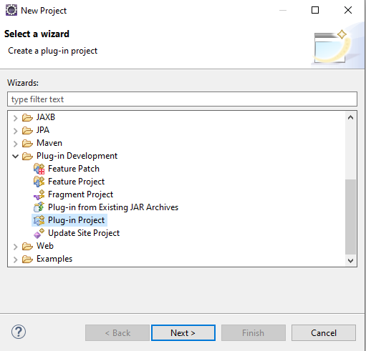

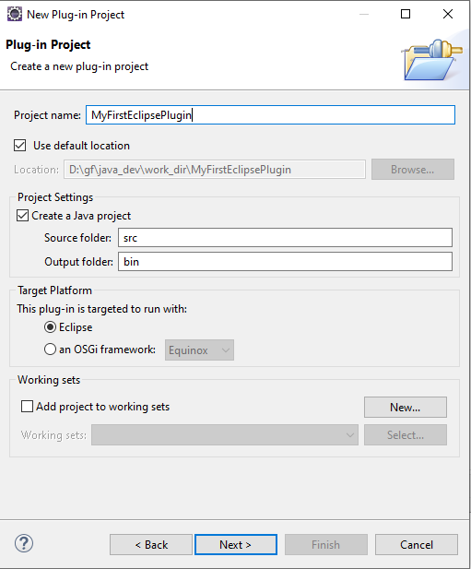

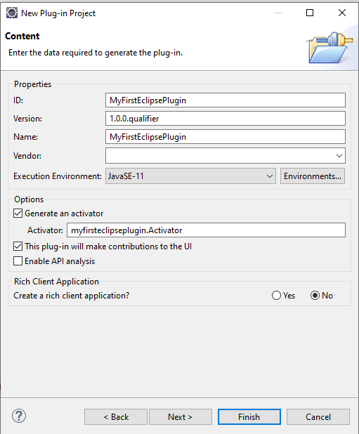

Rich Client Application : Yes

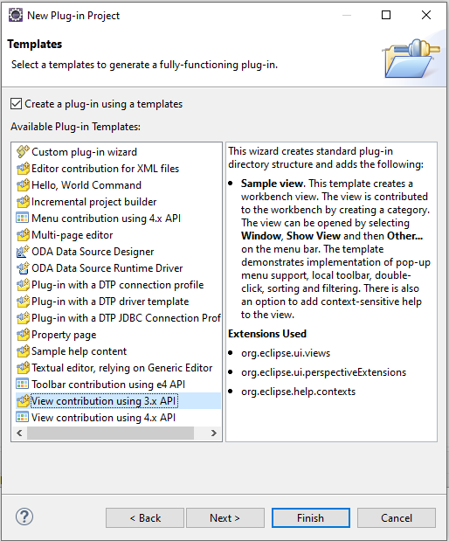

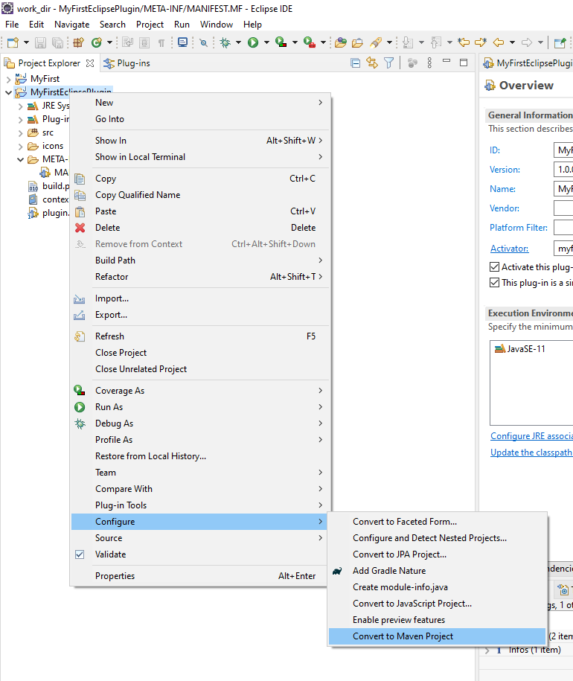

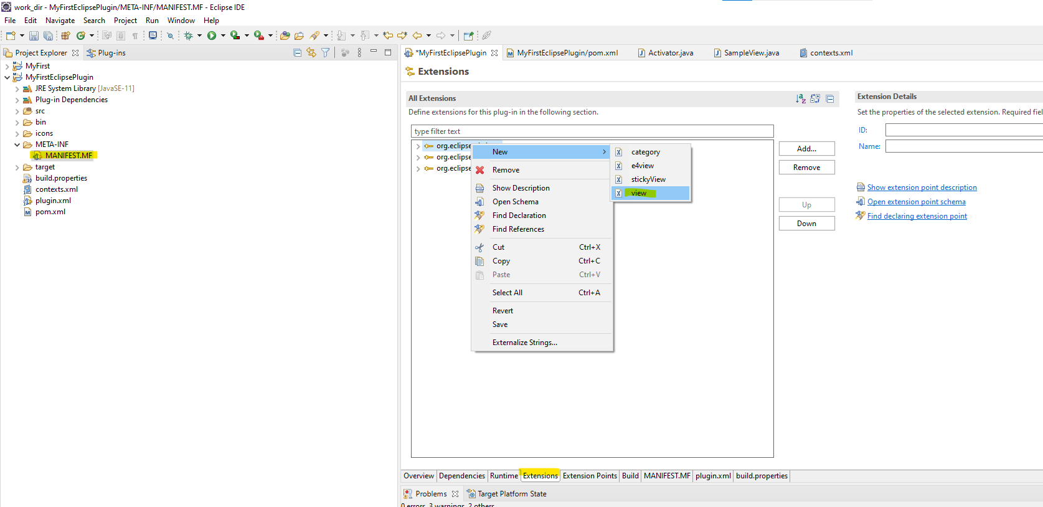

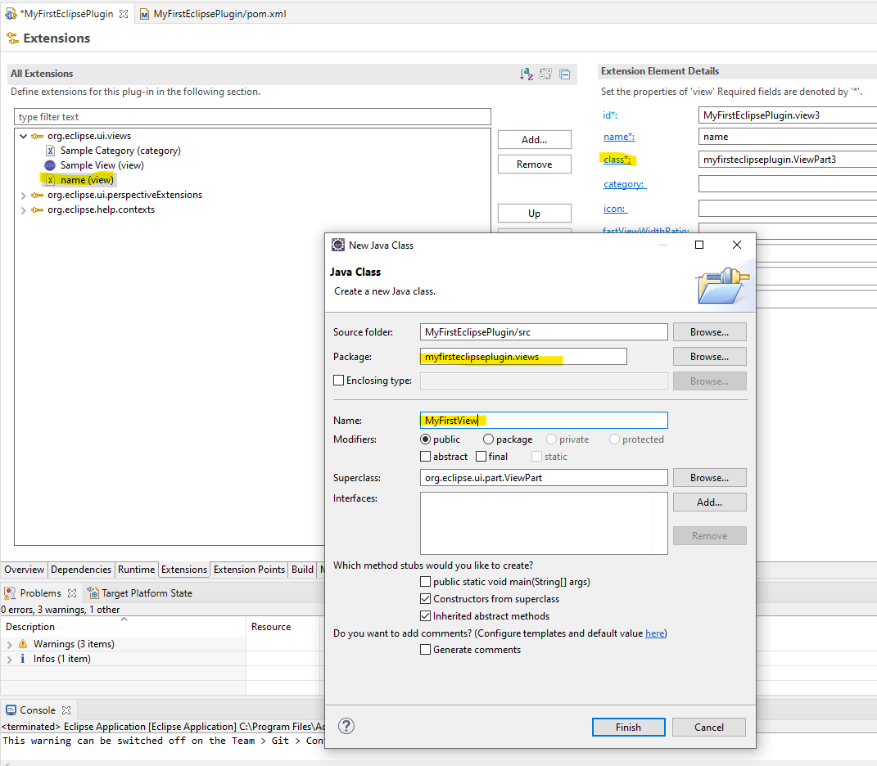



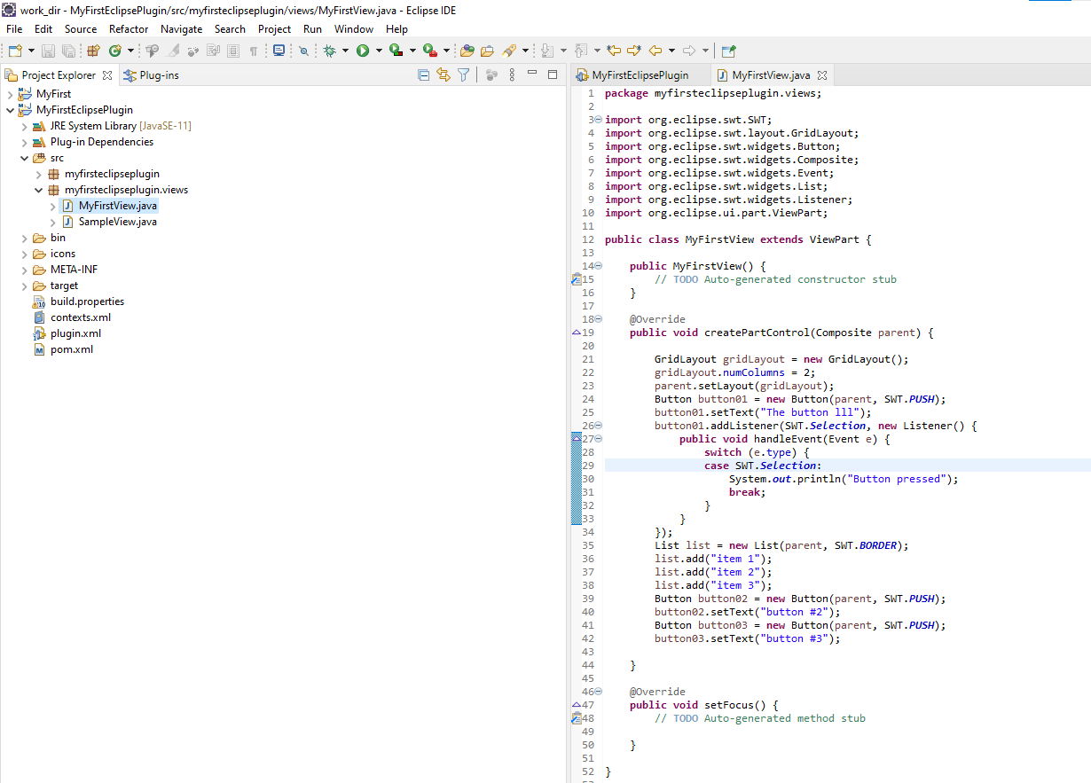

**import** org.eclipse.swt.SWT;

**import** org.eclipse.swt.layout.GridData;

**import** org.eclipse.swt.layout.GridLayout;

**import** org.eclipse.swt.widgets.Button;

**import** org.eclipse.swt.widgets.Composite;

**import** org.eclipse.swt.widgets.Event;

**import** org.eclipse.swt.widgets.Label;

**import** org.eclipse.swt.widgets.List;

**import** org.eclipse.swt.widgets.Listener;

**import** org.eclipse.swt.widgets.Text;

**import** org.eclipse.ui.part.ViewPart;

**public** **class** MyFirstView **extends** ViewPart {

**public** MyFirstView() {

// **TODO** Auto-generated constructor stub

}

@Override

**public** **void** createPartControl(Composite parent) {

GridLayout gridLayout = **new** GridLayout();

gridLayout.numColumns = 2;

parent.setLayout(gridLayout);

Button button01 = **new** Button(parent, SWT.PUSH);

button01.setText("The button lll");

button01.addListener(SWT.Selection, **new** Listener() {

**public** **void** handleEvent(Event e) {

**switch** (e.type) {

**case** SWT.Selection:

System.***out***.println("Button pressed");

**break**;

}

}

});

List list = **new** List(parent, SWT.BORDER);

list.add("item 1");

list.add("item 2");

list.add("item 3");

Button button02 = **new** Button(parent, SWT.PUSH);

button02.setText("button #2");

Button button03 = **new** Button(parent, SWT.PUSH);

button03.setText("button #3");

}

@Override

**public** **void** setFocus() {

// **TODO** Auto-generated method stub

}

}

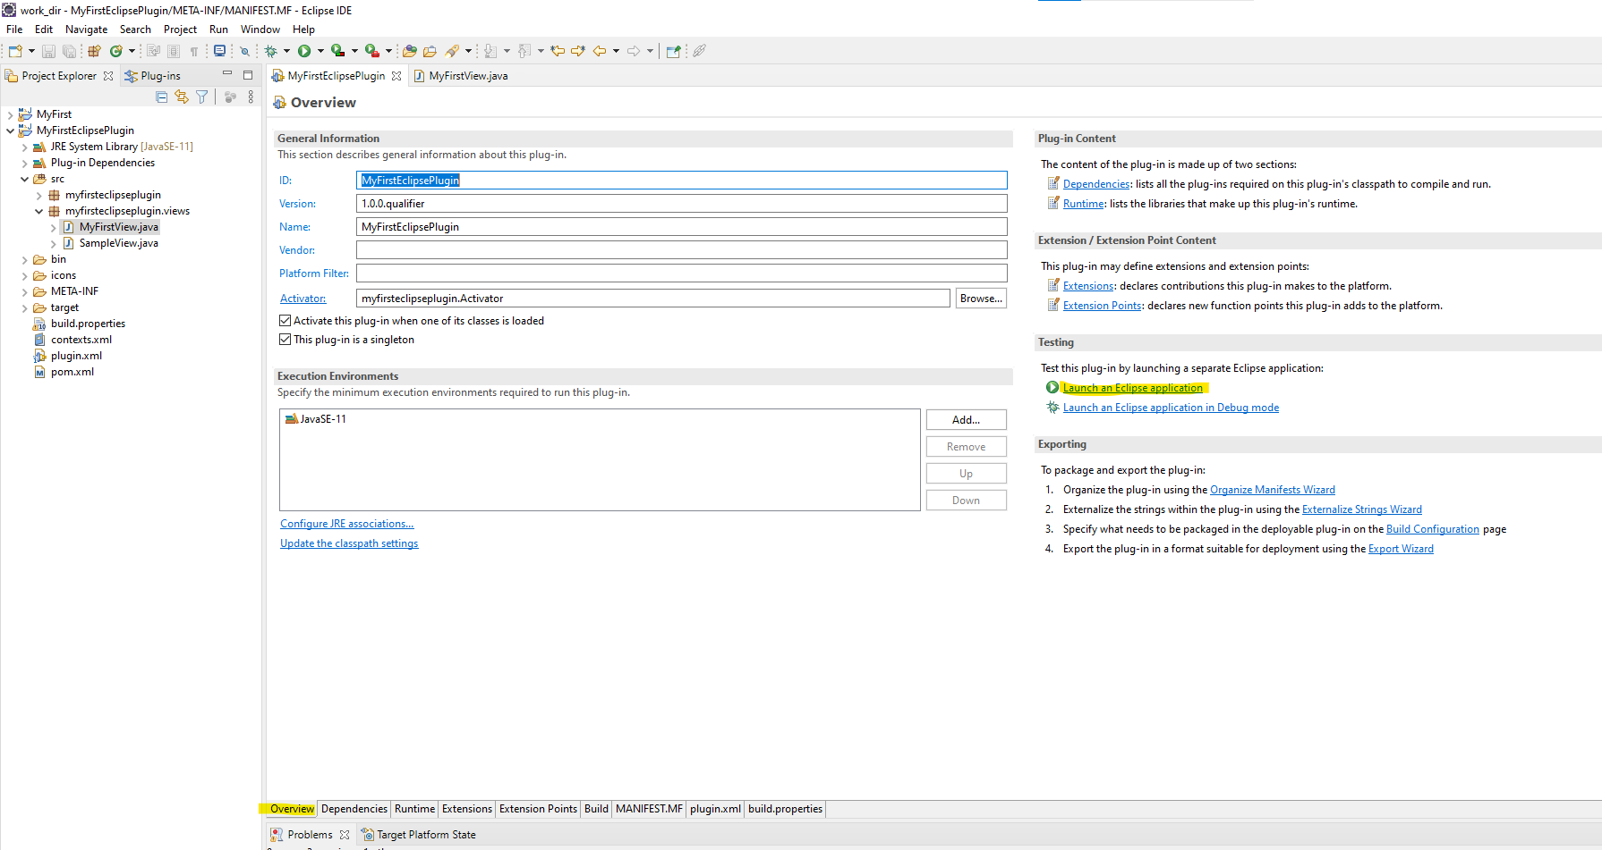

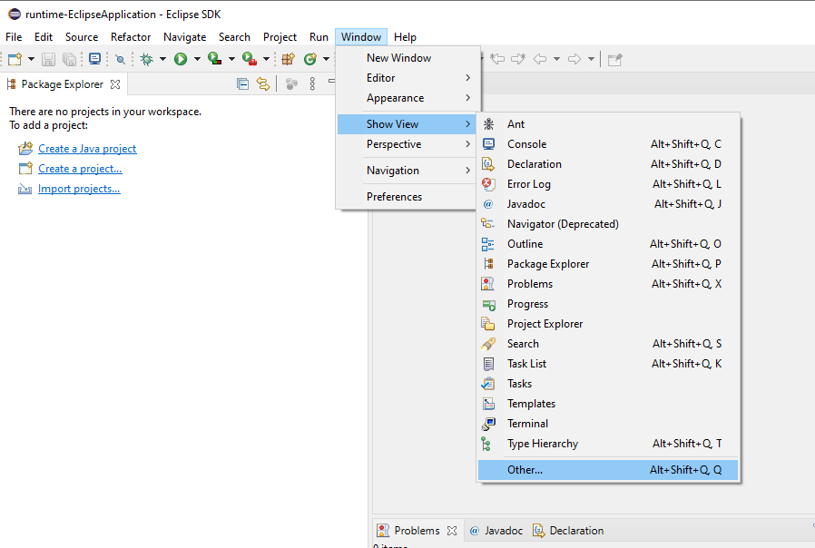

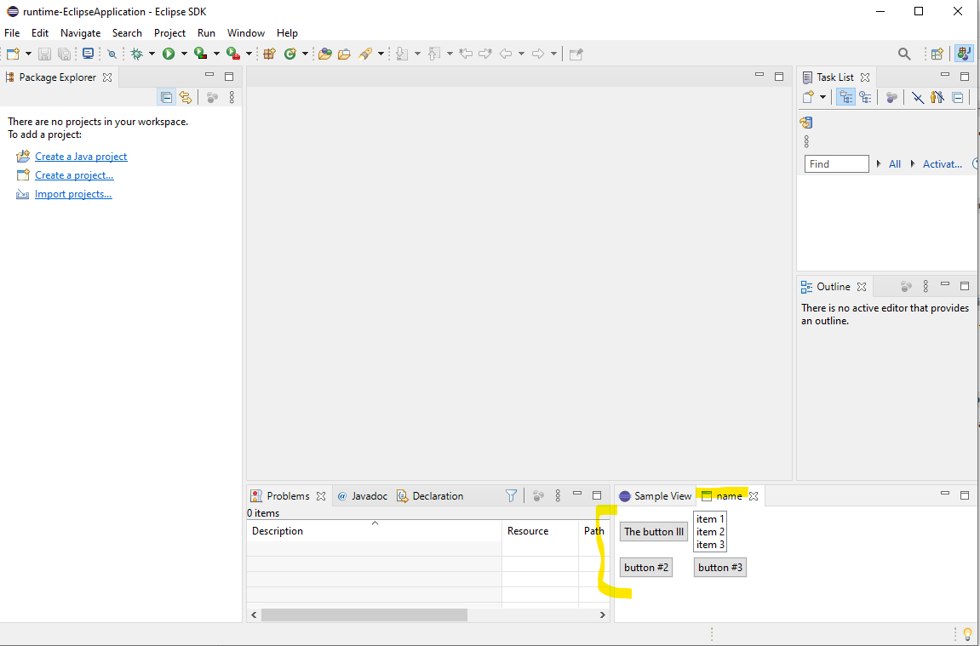

---------------------------------------------------------

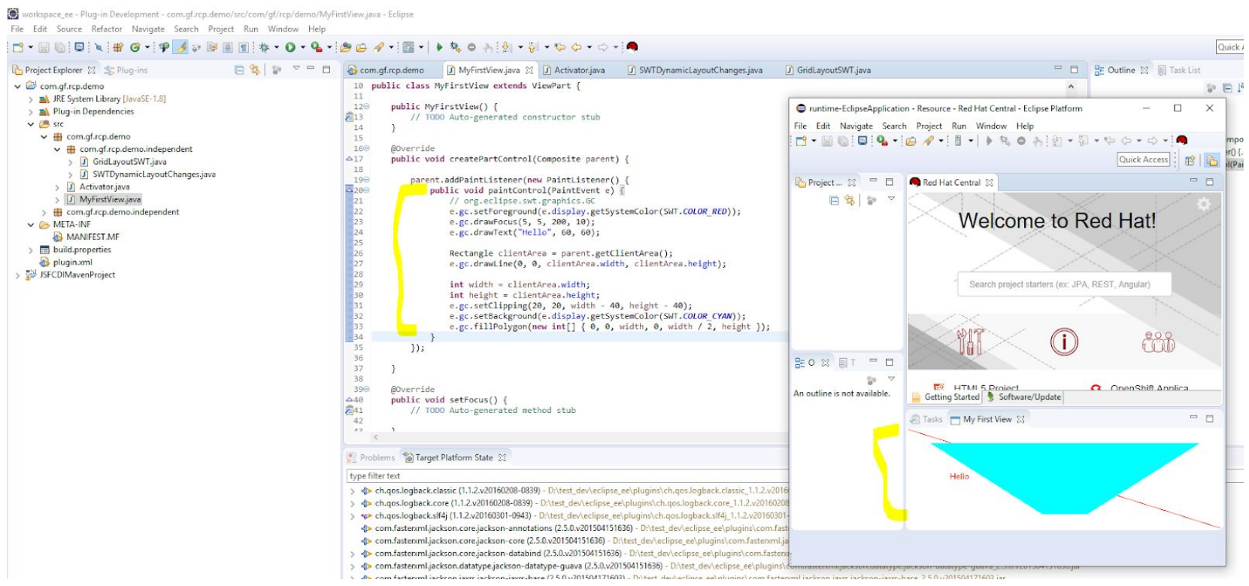

**import** org.eclipse.swt.SWT;

**import** org.eclipse.swt.events.PaintEvent;

**import** org.eclipse.swt.events.PaintListener;

**import** org.eclipse.swt.graphics.Rectangle;

**import** org.eclipse.swt.widgets.Composite;

**import** org.eclipse.ui.part.ViewPart;

**public** **class** MyFirstView **extends** ViewPart {

**public** MyFirstView() {

// **TODO** Auto-generated constructor stub

}

@Override

**public** **void** createPartControl(Composite parent) {

parent.addPaintListener(**new** PaintListener() {

**public** **void** paintControl(PaintEvent e) {

// org.eclipse.swt.graphics.GC

e.gc.setForeground(e.display.getSystemColor(SWT.COLOR_RED));

e.gc.drawFocus(5, 5, 200, 10);

e.gc.drawText("Hello", 60, 60);

Rectangle clientArea = parent.getClientArea();

e.gc.drawLine(0, 0, clientArea.width, clientArea.height);

**int** width = clientArea.width;

**int** height = clientArea.height;

e.gc.setClipping(20, 20, width - 40, height - 40);

e.gc.setBackground(e.display.getSystemColor(SWT.COLOR_CYAN));

e.gc.fillPolygon(**new** **int**[] { 0, 0, width, 0, width / 2, height });

}

});

}

@Override

**public** **void** setFocus() {

// **TODO** Auto-generated method stub

}

}

---------------------------------------------------------

