Java web applications

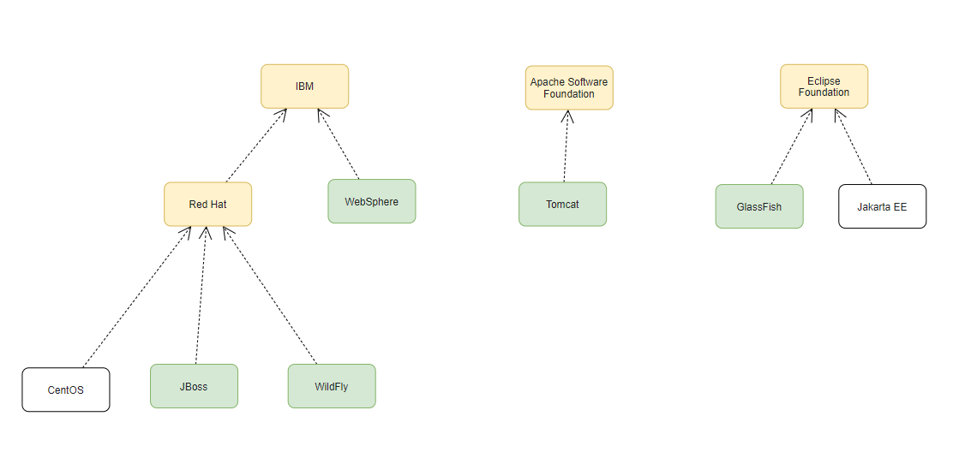

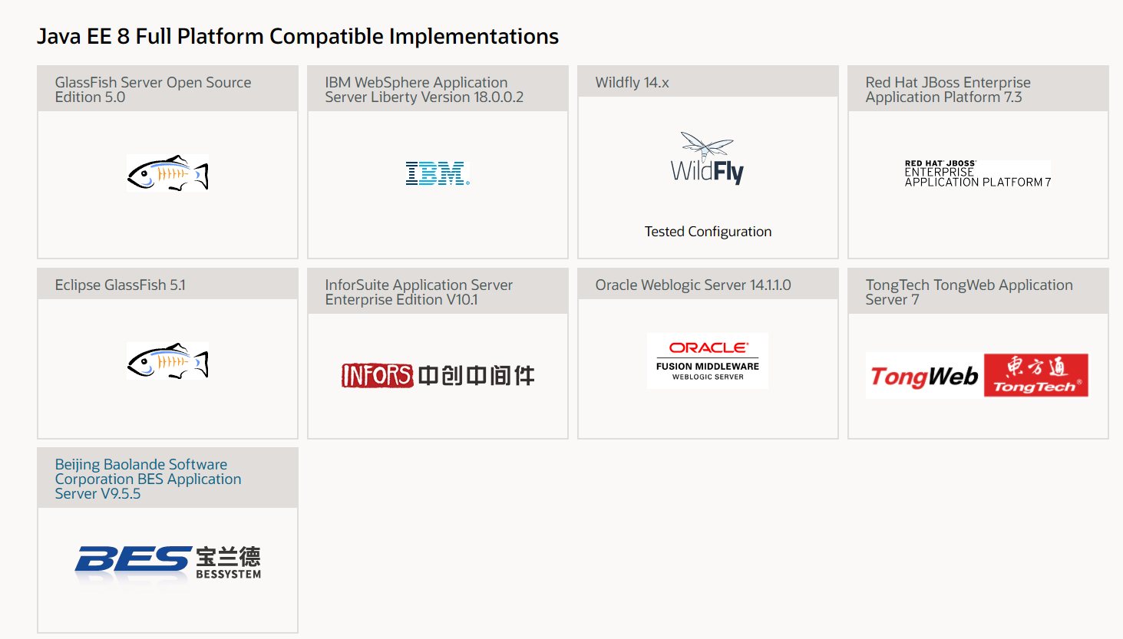

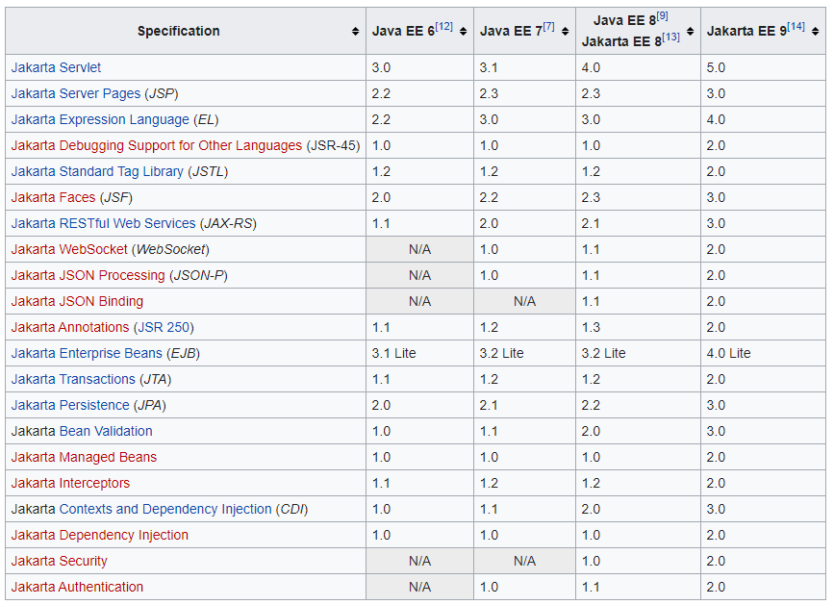

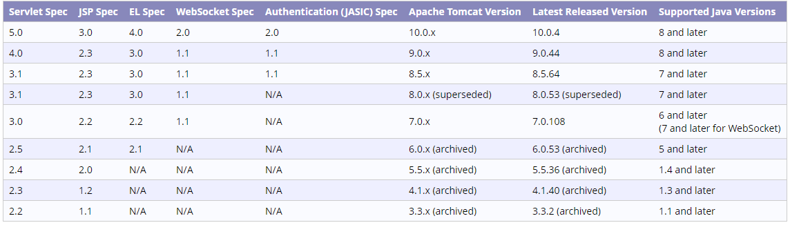

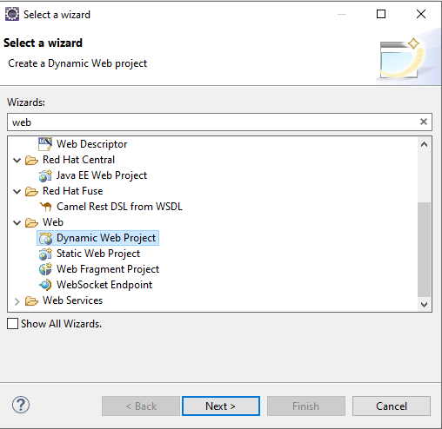

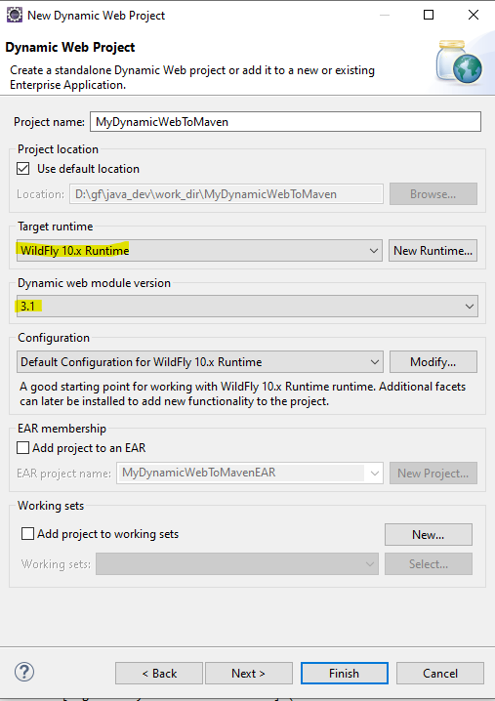

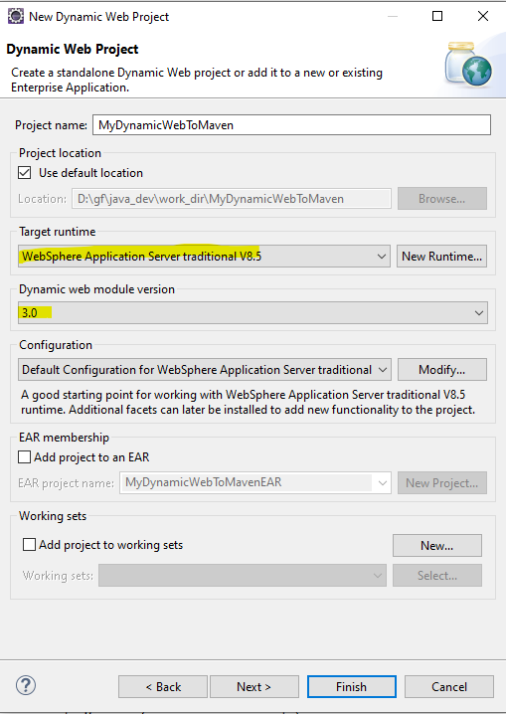

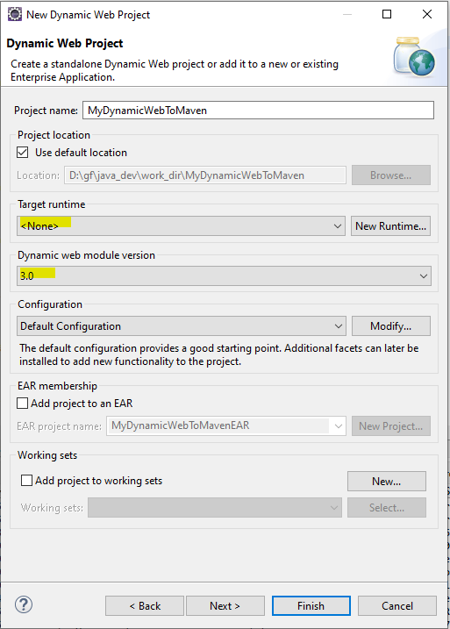

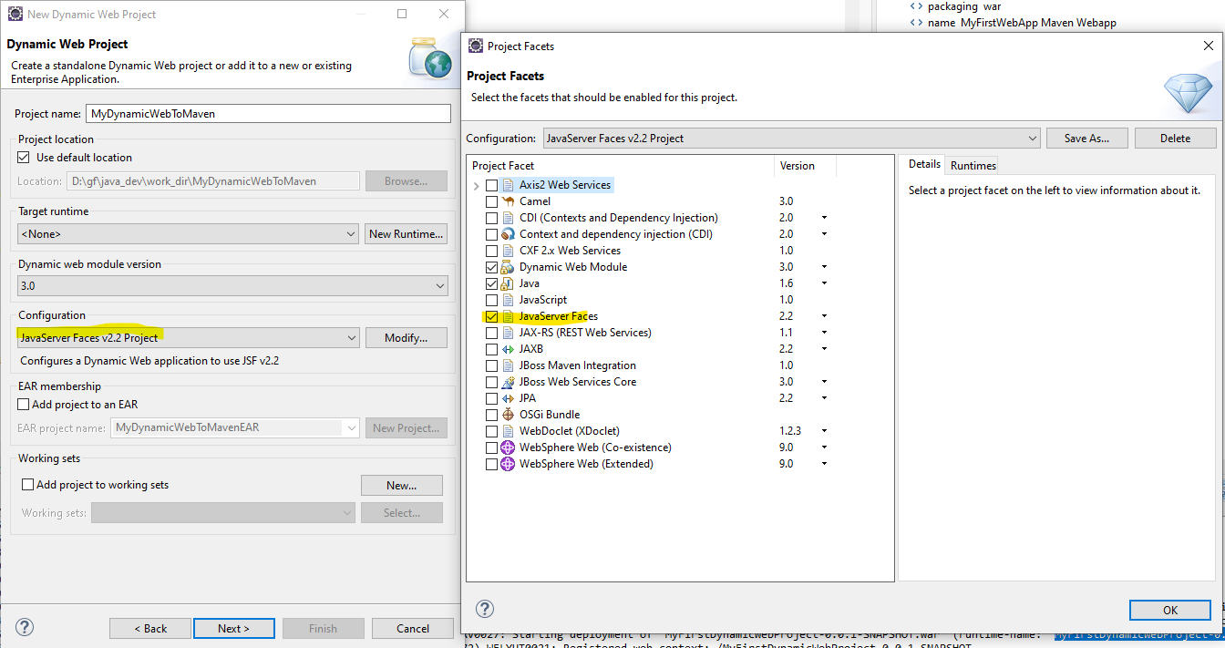

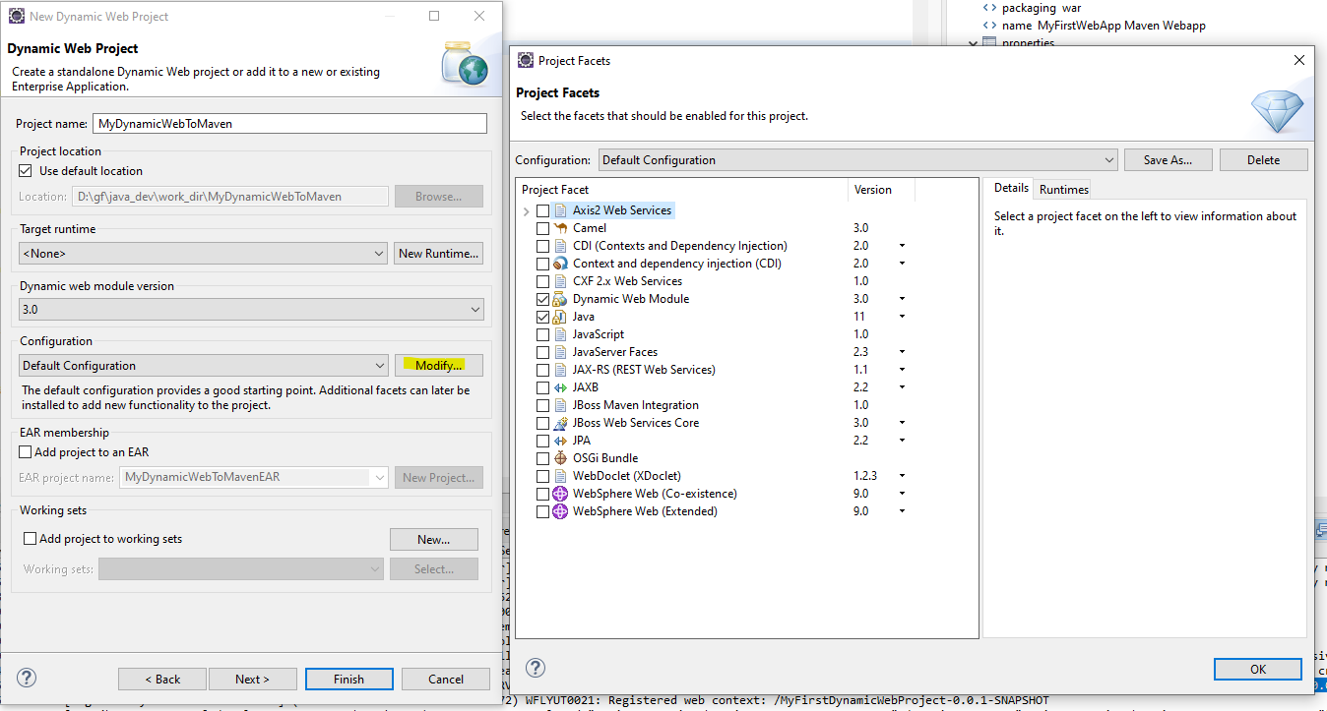

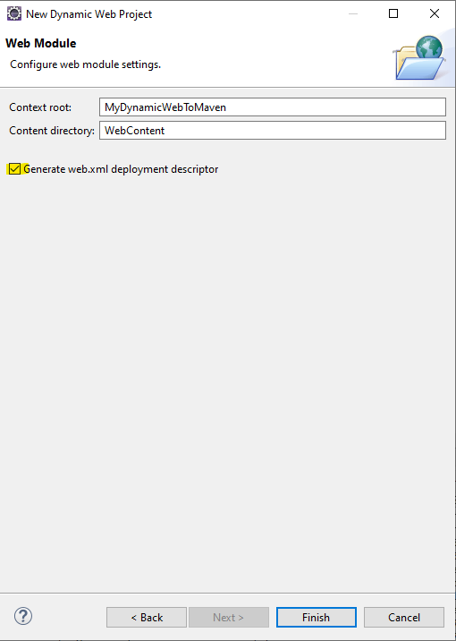

Apache Tomcat v8.0 (3.1)

WildFly 10.0 (3.1)

WebSphere Application Server v8.5 (3.0)

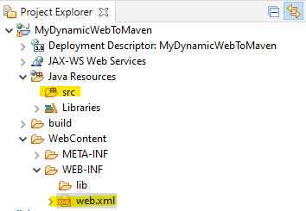

tree /F

├───src

└───WebContent

├───META-INF

│ MANIFEST.MF

│

└───WEB-INF

│ web.xml

│

└───lib

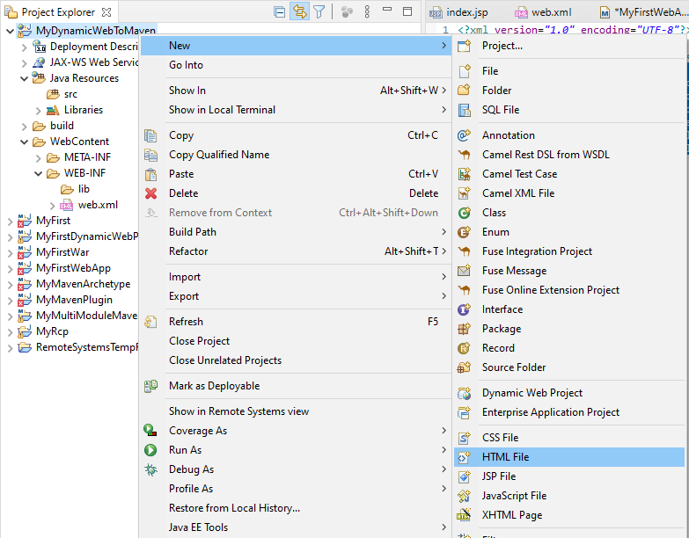

--------------------------------

index.html

--------------------------------

<!DOCTYPE html>

<html>

<head>

<meta charset=*"ISO-8859-1"*>

<title>Hello</title>

</head>

<body>

<h1>HELLO</h1>

</body>

</html>

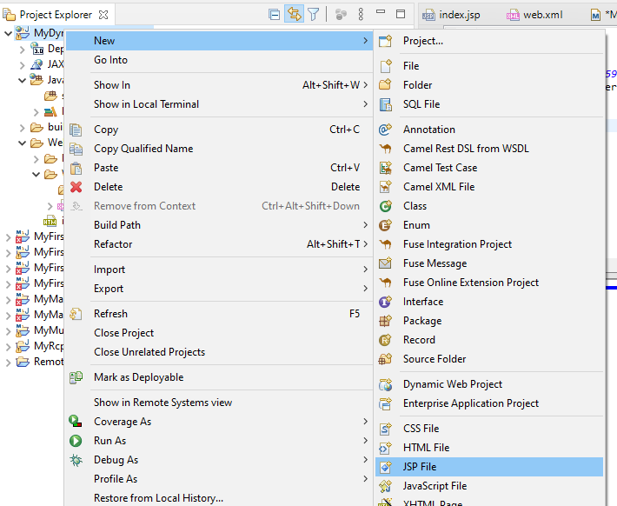

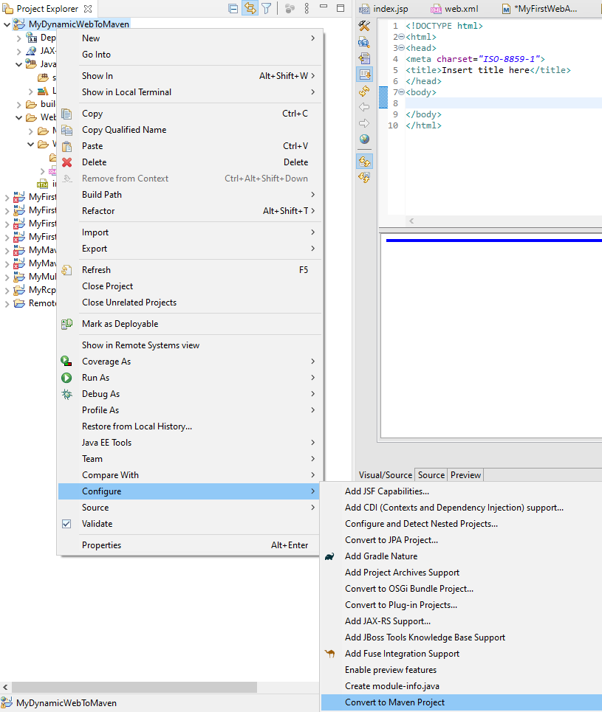

├───src

└───WebContent

│ index.html

│

├───META-INF

│ MANIFEST.MF

│

└───WEB-INF

│ web.xml

│

└───lib

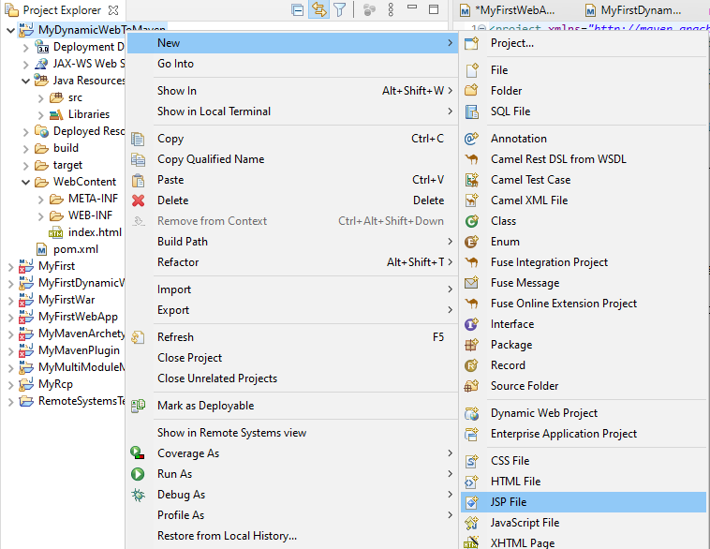

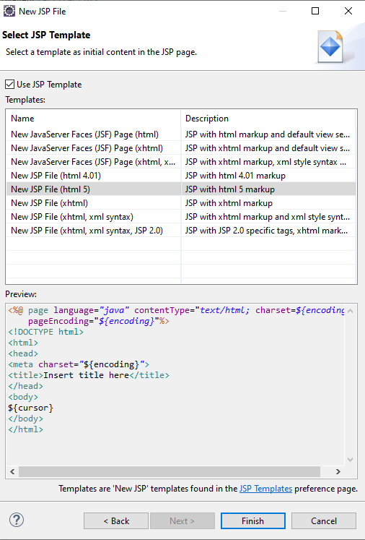

--------------------------------

MyHelloJSP.jsp

--------------------------------

<%@ page language=*"java"* contentType=*"text/html; charset=ISO-8859-1"*

pageEncoding=*"ISO-8859-1"*%>

<!DOCTYPE html>

<html>

<head>

<meta charset=*"ISO-8859-1"*>

<title>Hello</title>

</head>

<body>

<%

**double** num = Math.random();

%>

<h2>random number in JSP: <%= num %></h2>

</body>

</html>

--------------------------------

pom.xml

--------------------------------

<project xmlns=*"http://maven.apache.org/POM/4.0.0"*

xmlns:xsi=*"http://www.w3.org/2001/XMLSchema-instance"*

xsi:schemaLocation=*"http://maven.apache.org/POM/4.0.0 https://maven.apache.org/xsd/maven-4.0.0.xsd"*>

<modelVersion>4.0.0</modelVersion>

<groupId>gf</groupId>

<artifactId>MyDynamicWebToMaven</artifactId>

<version>0.0.1-SNAPSHOT</version>

<packaging>war</packaging>

<dependencies>

<dependency>

<groupId>javax.servlet</groupId>

<artifactId>javax.servlet-api</artifactId>

<version>3.1.0</version>

</dependency>

<dependency>

<groupId>javax.servlet.jsp</groupId>

<artifactId>javax.servlet.jsp-api</artifactId>

<version>2.3.1</version>

</dependency>

</dependencies>

<build>

<sourceDirectory>src</sourceDirectory>

<plugins>

<plugin>

<artifactId>maven-compiler-plugin</artifactId>

<version>3.8.1</version>

<configuration>

<release>11</release>

</configuration>

</plugin>

<plugin>

<artifactId>maven-war-plugin</artifactId>

<version>3.2.3</version>

<configuration>

<warSourceDirectory>WebContent</warSourceDirectory>

</configuration>

</plugin>

</plugins>

</build>

</project>

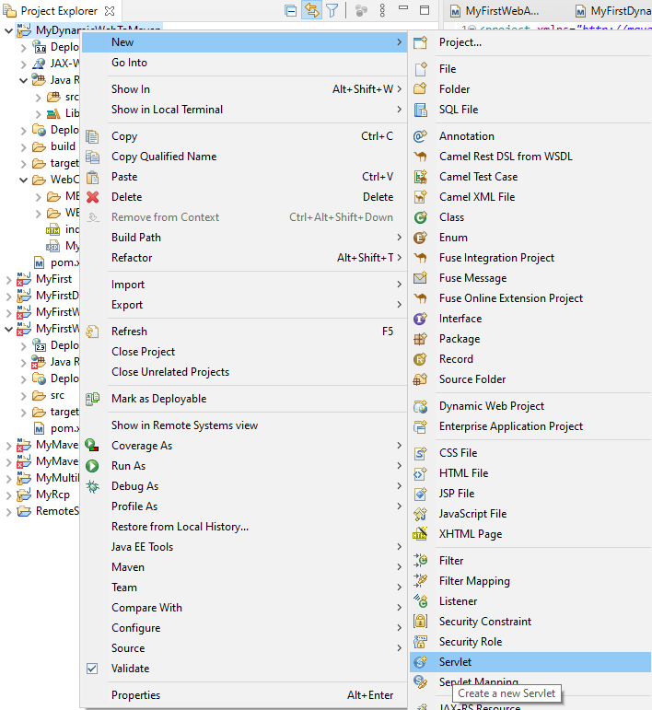

------------------------------------------------------------------------------------------------------

New way: Annotation

------------------------------------------

**import** java.io.IOException;

**import** javax.servlet.ServletException;

**import** javax.servlet.annotation.WebServlet;

**import** javax.servlet.http.HttpServlet;

**import** javax.servlet.http.HttpServletRequest;

**import** javax.servlet.http.HttpServletResponse;

@WebServlet("/MyHelloServlet")

**public** **class** MyHelloServlet **extends** HttpServlet {

**private** **static** **final** **long** ***serialVersionUID*** = 1L;

**public** MyHelloServlet() {

**super**();

}

**protected** **void** doGet(HttpServletRequest request, HttpServletResponse response) **throws** ServletException, IOException {

response.getWriter().append("Served at: ").append(request.getContextPath());

}

**protected** **void** doPost(HttpServletRequest request, HttpServletResponse response) **throws** ServletException, IOException {

doGet(request, response);

}

}

------------------------------------------------------------------------------------------------------

Old way: web.xml

------------------------------------------

**import** java.io.IOException;

**import** javax.servlet.ServletException;

**import** javax.servlet.http.HttpServlet;

**import** javax.servlet.http.HttpServletRequest;

**import** javax.servlet.http.HttpServletResponse;

**public** **class** MyHelloOldServlet **extends** HttpServlet {

**private** **static** **final** **long** ***serialVersionUID*** = 1L;

**public** MyHelloOldServlet() {

**super**();

}

**protected** **void** doGet(HttpServletRequest request, HttpServletResponse response) **throws** ServletException, IOException {

response.getWriter().append("Served at: ").append(request.getContextPath());

}

**protected** **void** doPost(HttpServletRequest request, HttpServletResponse response) **throws** ServletException, IOException {

doGet(request, response);

}

}

------------------------------------------

web.xml:

<?xml version=*"1.0"* encoding=*"UTF-8"*?>

<web-app id=*"WebApp_ID"* version=*"3.0"*

xmlns=*"http://java.sun.com/xml/ns/javaee"*

xmlns:xsi=*"http://www.w3.org/2001/XMLSchema-instance"*

xsi:schemaLocation=*"http://java.sun.com/xml/ns/javaee http://java.sun.com/xml/ns/javaee/web-app_3_0.xsd"*>

<display-name>MyDynamicWebToMaven</display-name>

<servlet-mapping>

<servlet-name>MyHelloOldServletName</servlet-name>

<url-pattern>/MyHelloOldServletUrl</url-pattern>

</servlet-mapping>

<servlet>

<servlet-name>MyHelloOldServletName</servlet-name>

<servlet-class>MyHelloOldServlet</servlet-class>

</servlet>

</web-app>

-----------------------------------------------------------------------------

├───src

│ MyHelloOldServlet.java

│ MyHelloServlet.java

│

└───WebContent

│ index.html

│ MyHelloJSP.jsp

│

├───META-INF

│ MANIFEST.MF

│

└───WEB-INF

│ web.xml

│

└───lib

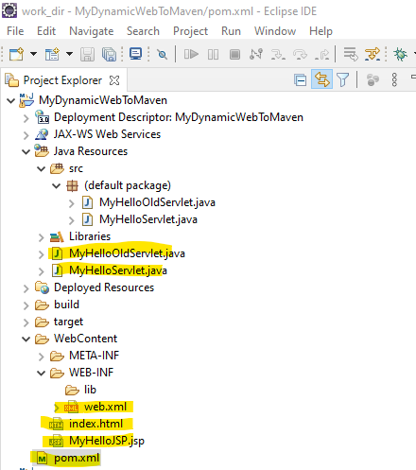

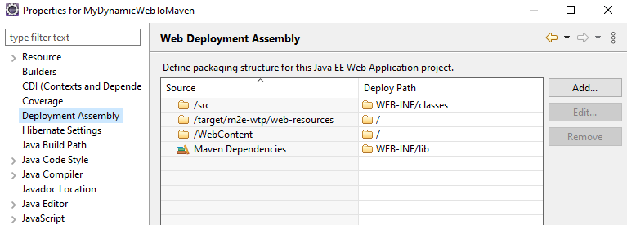

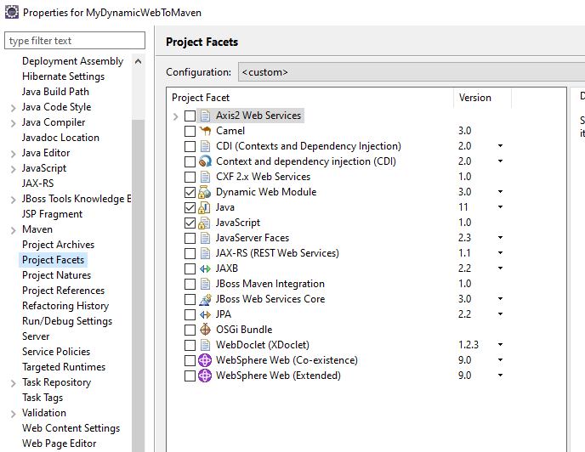

---------------------------------------------------------------------------

WildFly deploy

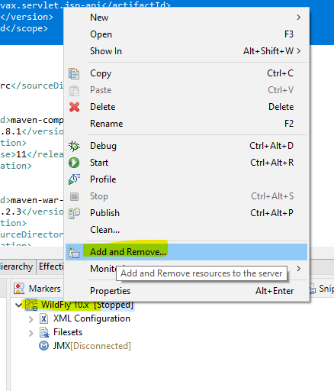

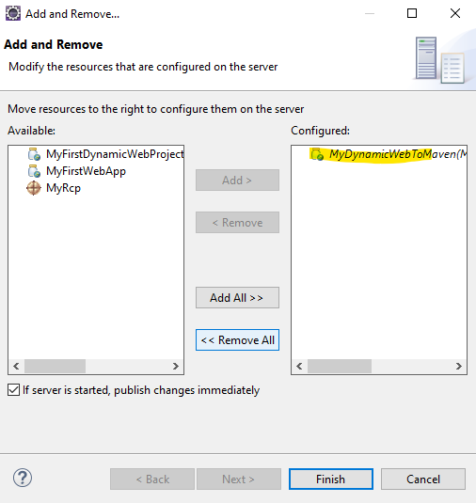

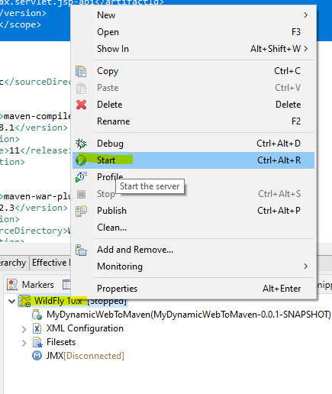

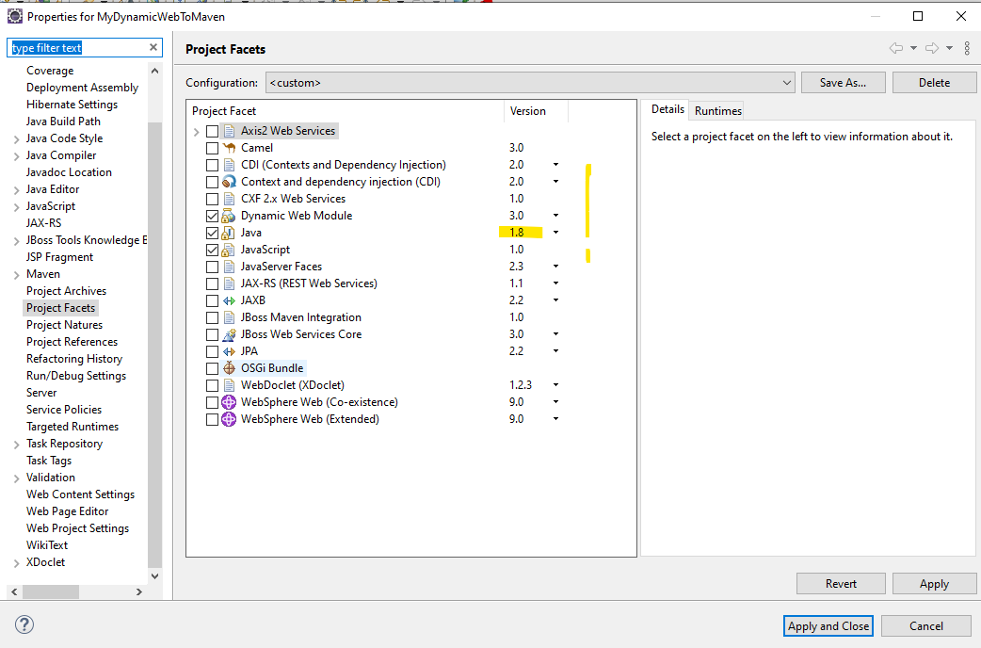

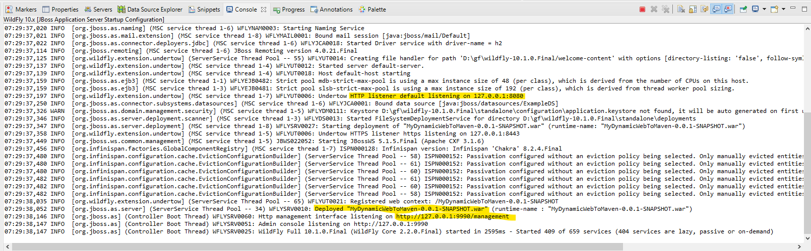

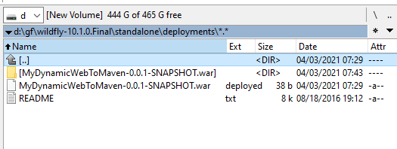

---------------------------------------------------------------------------

<http://127.0.0.1:8080/MyDynamicWebToMaven-0.0.1-SNAPSHOT/index.html>

<http://127.0.0.1:8080/MyDynamicWebToMaven-0.0.1-SNAPSHOT/MyHelloJSP.jsp>

<http://127.0.0.1:8080/MyDynamicWebToMaven-0.0.1-SNAPSHOT/MyHelloServlet>

<http://127.0.0.1:8080/MyDynamicWebToMaven-0.0.1-SNAPSHOT/MyHelloOldServletUrl>

---------------------------------------------------------------------------

WebSphere deploy

[**https://desktop-dj4f3e1:9043/ibm/console/logon.jsp**](https://desktop-dj4f3e1:9043/ibm/console/logon.jsp)

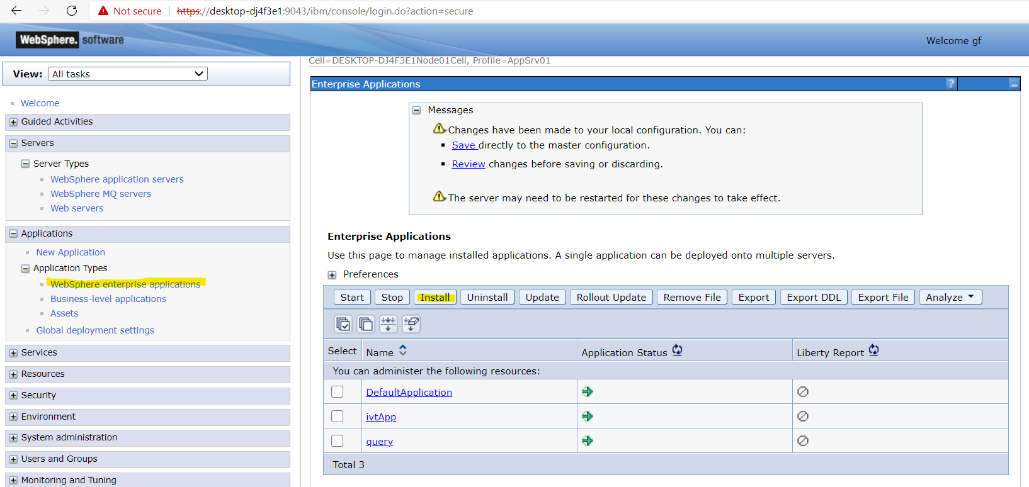

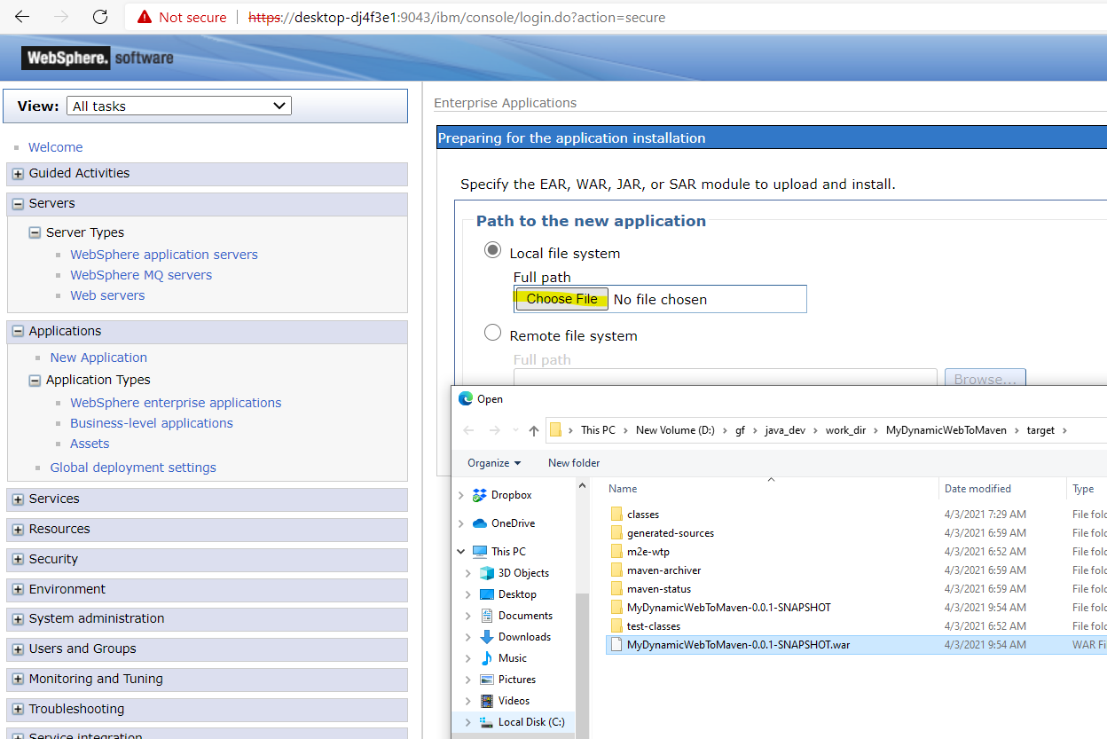

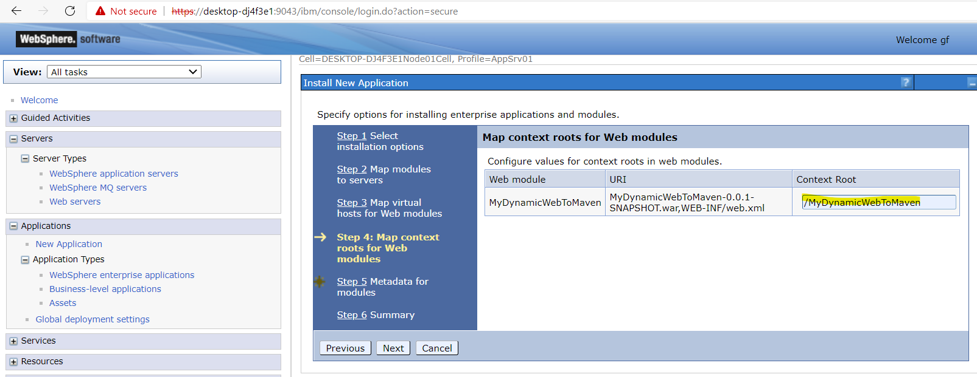

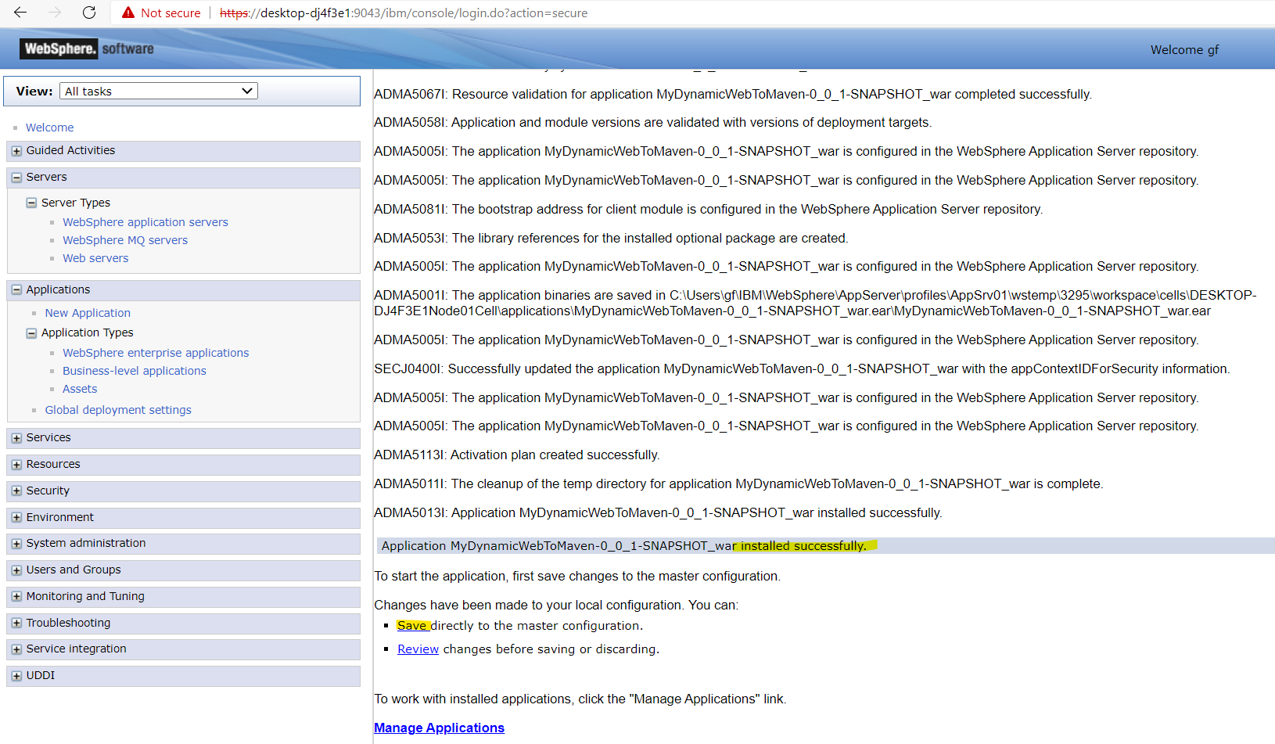

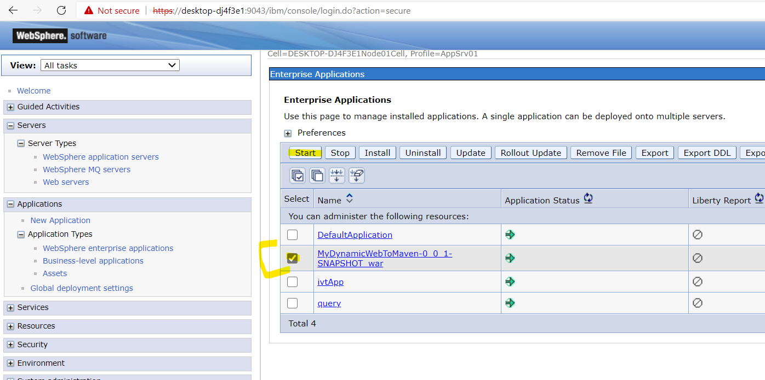

**log:**

**c:\Users\gf\IBM\WebSphere\AppServer\profiles\AppSrv01\logs\server1\ SystemOut.log**

<http://desktop-dj4f3e1:9080/MyDynamicWebToMaven/index.html>

[http://desktop-dj4f3e1:9080/MyDynamicWebToMaven/MyHelloJSP.jsp](http://desktop-dj4f3e1:9080/MyDynamicWebToMaven/index.html)

[http://desktop-dj4f3e1:9080/MyDynamicWebToMaven/MyHelloServlet](http://desktop-dj4f3e1:9080/MyDynamicWebToMaven/MyHelloServlet%20)

<http://desktop-dj4f3e1:9080/MyDynamicWebToMaven/MyHelloOldServletUrl>