SVN

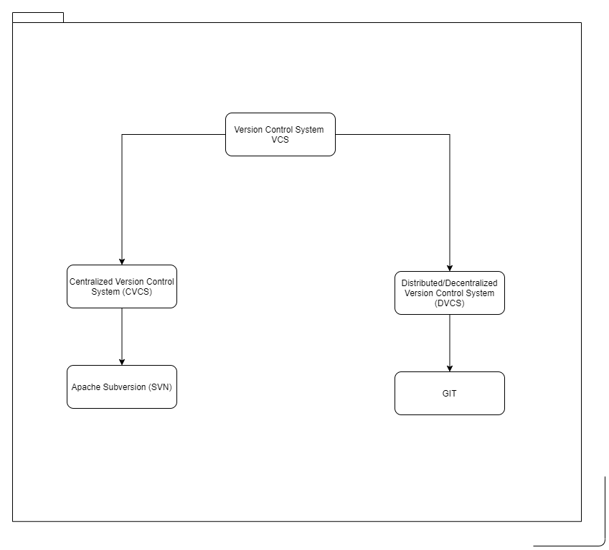

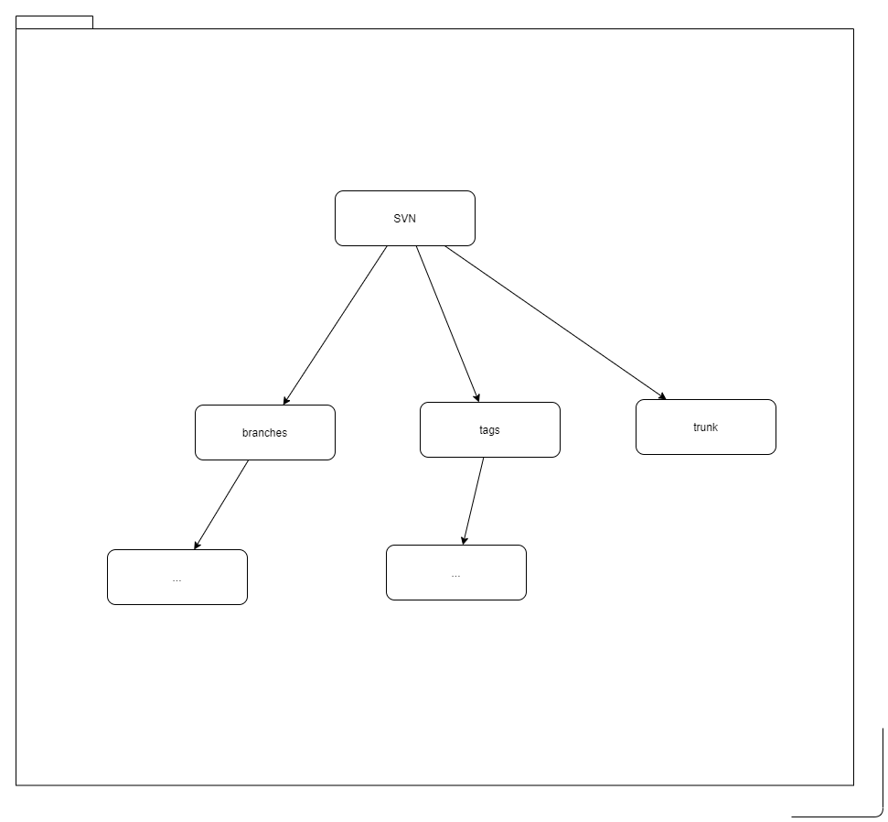

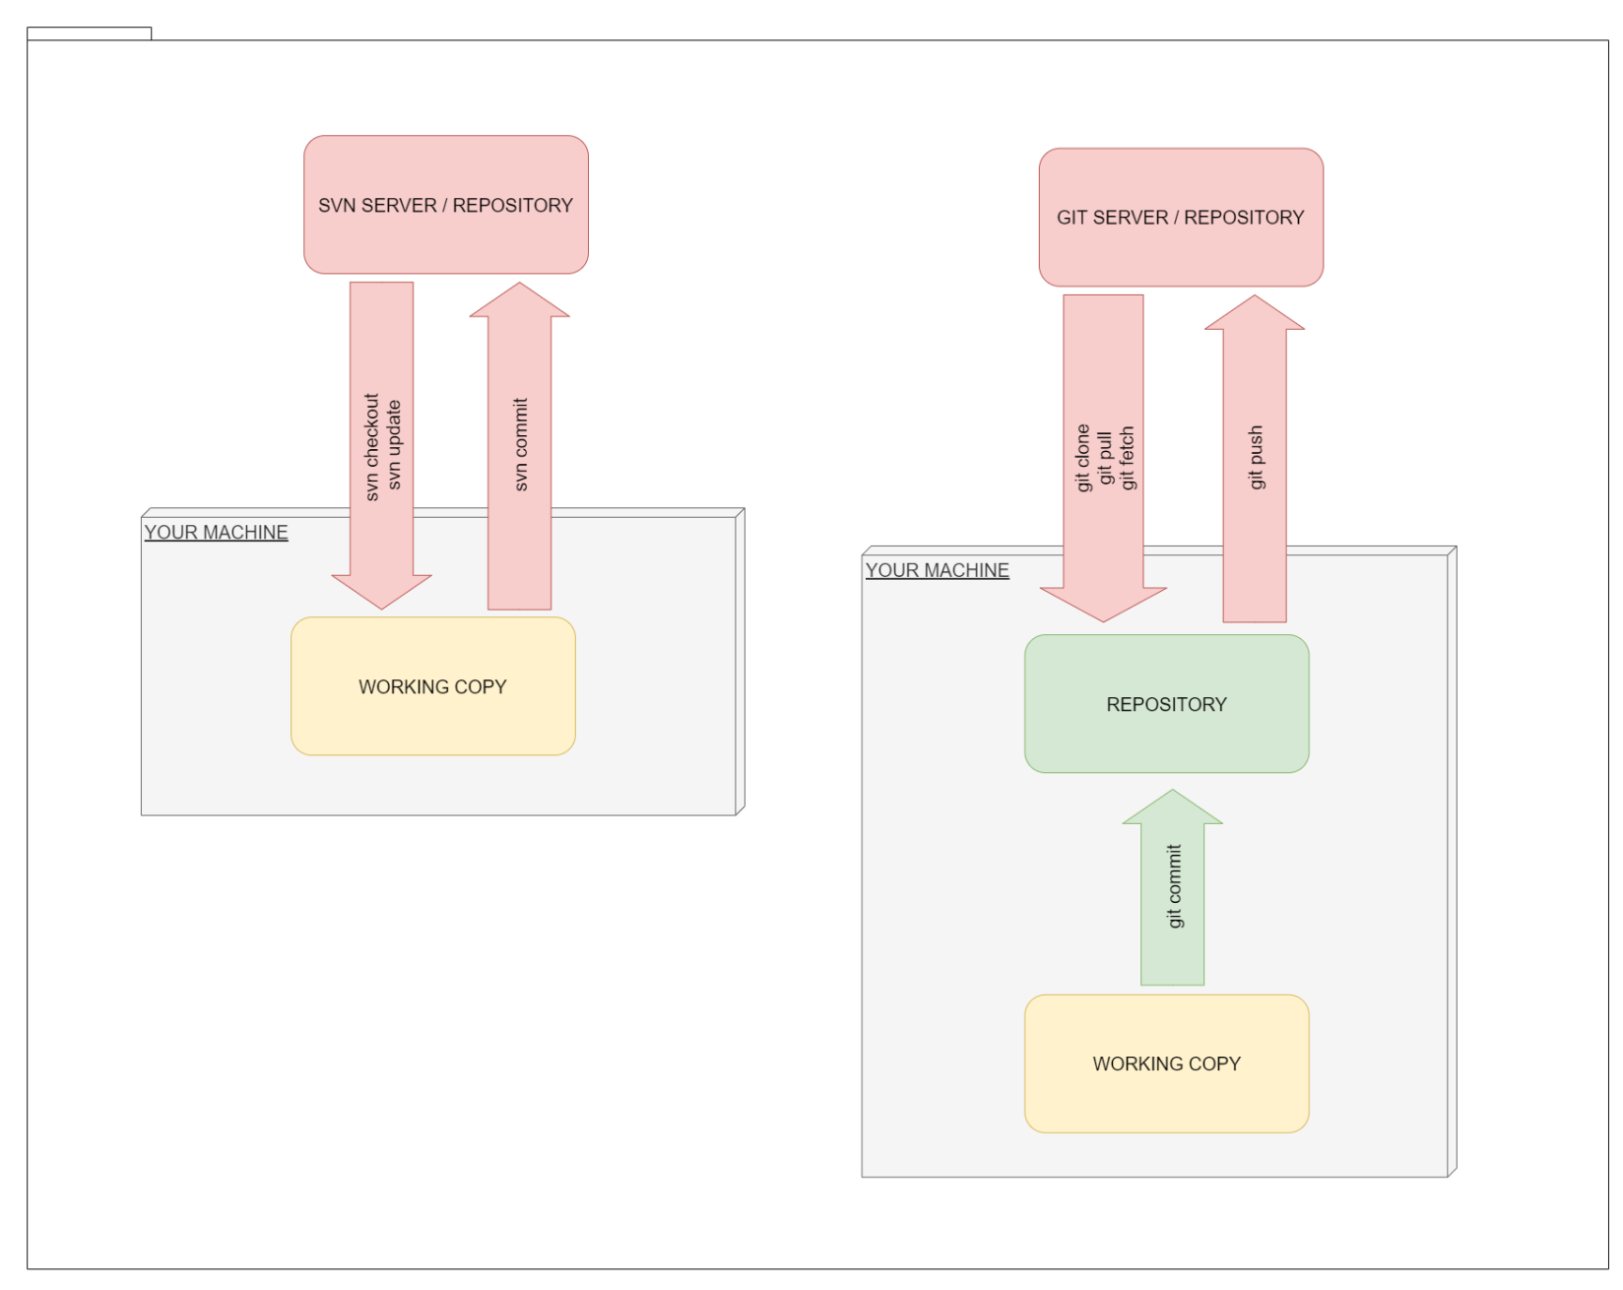

----------------------------------------------------------------------

delta data is binary

FSFS also uses a SQLite database for tracking hashes of file content

FSFS repository stores the changes associated with a revision in a single file

:: Repository URL:

:: https://DESKTOP-DJ4F3E1/svn/my_central_svn_repo

:: file:///D:/svn_playground/my_central_svn_repo

:: create repo.

d:\svn_playground&gt; svnadmin create --fs-type fsfs my_central_svn_repo

:: create trunk, tags, branches

svn mkdir -m "Initial setup" ^

file:///D:/svn_playground/my_central_svn_repo/trunk

:: and

svn mkdir -m "Initial setup" ^

file:///D:/svn_playground/my_central_svn_repo/tags

:: and

svn mkdir -m "Initial setup" ^

file:///D:/svn_playground/my_central_svn_repo/branches

:: local working directory

d:\svn_playground&gt; svn checkout ^

file:///D:/svn_playground/my_central_svn_repo/trunk ^

my_local_svn_trunk_work_dir

:: new a.txt file

d:\svn_playground\my_local_svn_trunk_work_dir&gt; echo first line &gt;&gt; a.txt

:: status

d:\svn_playground\my_local_svn_trunk_work_dir&gt; svn status

A Added in your working copy

C Conflicted, because of an update or merge

D Deleted in your working copy

G Merged with changes from the repository

I Ignored in your working copy

M Modified in your working copy

R Replaced in your working copy

? Not under version control

! Missing from your working copy (removed by non-svn command) or incomplete

:: add

:: add the items to the working copy

d:\svn_playground\my_local_svn_trunk_work_dir&gt; svn add a.txt

:: diff

d:\svn_playground\my_local_svn_trunk_work_dir&gt; svn diff a.txt

:: import

d:\some_old_project&gt; svn import -m "Initial import" ^

file:///D:/svn_playground/my_central_svn_repo/trunk

:: commit

:: commit, checking in to the repository, revision

:: message: describe why you made the changes instead of what the changes are

d:\svn_playground\my_local_svn_trunk_work_dir&gt; svn commit -m "First commit"

d:\svn_playground\my_local_svn_trunk_work_dir&gt; echo second line &gt;&gt; a.txt

d:\svn_playground\my_local_svn_trunk_work_dir&gt; svn commit -m "Second commit"

d:\svn_playground\my_local_svn_trunk_work_dir&gt; echo third line &gt;&gt; a.txt

d:\svn_playground\my_local_svn_trunk_work_dir&gt; svn commit -m "Third commit"

:: log

svn log file:///D:/svn_playground/my_central_svn_repo/trunk

:: or

d:\svn_playground\my_local_svn_trunk_work_dir&gt; svn update

d:\svn_playground\my_local_svn_trunk_work_dir&gt; svn log

d:\svn_playground\my_local_svn_trunk_work_dir&gt; svn log a.txt

:: blame

:: who did the changes

d:\svn_playground\my_local_svn_trunk_work_dir&gt; svn blame a.txt

:: revert

:: Reverting Working Copy Changes

d:\svn_playground\my_local_svn_trunk_work_dir&gt; echo bad line &gt;&gt; a.txt

d:\svn_playground\my_local_svn_trunk_work_dir&gt; svn revert a.txt

::svn revert -R .

:: update

:: update working copy to the latest revision

d:\svn_playground\my_local_svn_trunk_work_dir&gt; svn update

:: conflict

p Postpone

df Show a full diff

e Edit the merged file using an editor

r Mark the conflict as resolved

mf My file ignore their

tf Their file ignore my

l Launch an external merge tool

:: after p "postpone"

svn resolved a.txt

:: checkout 4th revision

d:\svn_playground&gt; svn checkout ^

file:///D:/svn_playground/my_central_svn_repo/trunk@4 ^

my_local_svn_trunk_4_rev_work_dir

:: or

d:\svn_playground&gt; svn checkout -r 4 ^

file:///D:/svn_playground/my_central_svn_repo/trunk ^

my_local_svn_trunk_4_rev_work_dir

:: reverse merge

:: you can not delete history from the repository

d:\svn_playground\my_local_svn_trunk_work_dir&gt; svn merge -r 5:4 .

d:\svn_playground\my_local_svn_trunk_work_dir&gt; svn commit -m "Revert revision 5"

:: branch

:: always use repository URL when creating a branch !

svn copy -m "Create 1.0 release branch" ^

file:///D:/svn_playground/my_central_svn_repo/trunk ^

file:///D:/svn_playground/my_central_svn_repo/branches/RB_1.0

:: checkout this new release branch

d:\svn_playground&gt; svn checkout ^

file:///D:/svn_playground/my_central_svn_repo/branches/RB_1.0 ^

my_local_svn_release_branch_1.0_work_dir

:: log

svn log file:///D:/svn_playground/my_central_svn_repo

:: merge

:: merge a single revision to a branch

:: merge trunk -&gt; branch

d:\svn_playground\my_local_svn_release_branch_1.0_work_dir&gt; svn merge -c 7 file:///D:/svn_playground/my_central_svn_repo/trunk

d:\svn_playground\my_local_svn_release_branch_1.0_work_dir&gt; svn commit -m "Merged r7 (fix bug-1) from the trunk"

:: merge a range of revisions to a branch

d:\svn_playground\my_local_svn_release_branch_1.0_work_dir&gt; svn merge -r 7:12 file:///D:/svn_playground/my_central_svn_repo/trunk

d:\svn_playground\my_local_svn_release_branch_1.0_work_dir&gt; svn commit -m "Merged r7-12 (fix bugs 9 and 11) from the trunk"

:: mereg branch -&gt; trunk

d:\svn_playground\my_local_svn_trunk_work_dir&gt; svn merge -c 4 file:///D:/svn_playground/my_central_svn_repo/branches/RB_1.0

d:\svn_playground\my_local_svn_trunk_work_dir&gt; svn commit -m "Merged r4 (fix bug-1) from the RB_1.0"

:: tag

:: tagging a release

d:\svn_playground\my_local_svn_release_branch_1.0_work_dir&gt; svn update

d:\svn_playground\my_local_svn_release_branch_1.0_work_dir&gt; svn copy . ^

file:///D:/svn_playground/my_central_svn_repo/tags/REL_1.0.0 ^

-m "Create REL_1.0.0 tag"

----------------------------------------------------------------------

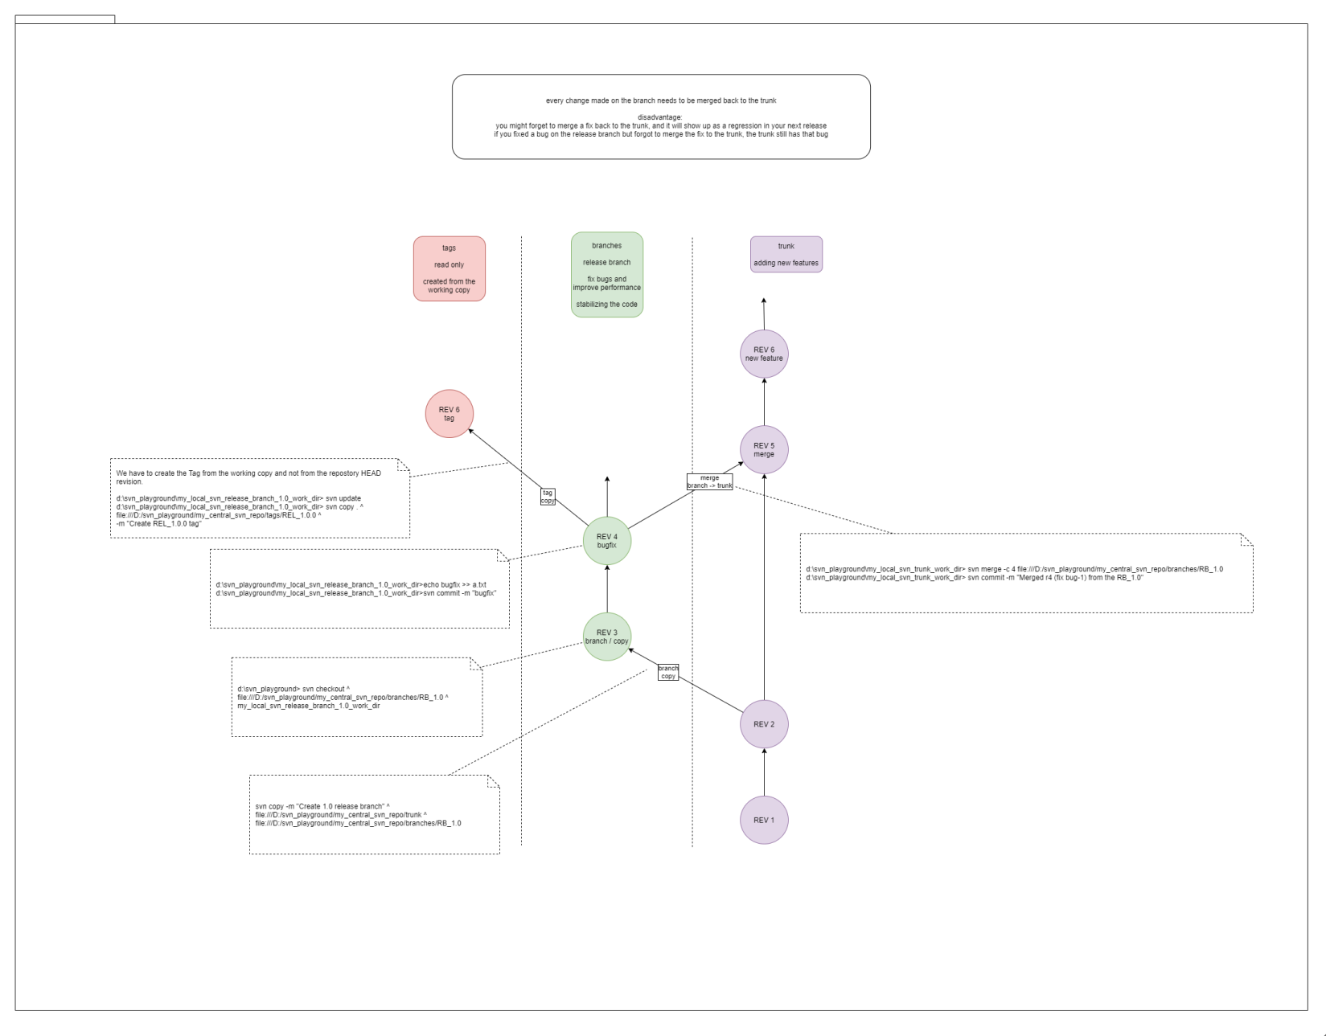

:: create repo.

svnadmin create --fs-type fsfs my_central_svn_repo

:: create trunk, tags, branches

svn mkdir -m "Initial setup" ^

file:///D:/svn_playground/my_central_svn_repo/trunk

:: and

svn mkdir -m "Initial setup" ^

file:///D:/svn_playground/my_central_svn_repo/tags

:: and

svn mkdir -m "Initial setup" ^

file:///D:/svn_playground/my_central_svn_repo/branches

:: local working directory

svn checkout ^

file:///D:/svn_playground/my_central_svn_repo/trunk ^

my_local_svn_trunk_work_dir

cd my_local_svn_trunk_work_dir

:: new a.txt file

echo first line trunk &gt;&gt; a.txt

svn add a.txt

svn commit -m "First commit"

echo second line trunk &gt;&gt; a.txt

svn commit -m "Second commit"

echo third line trunk &gt;&gt; a.txt

svn commit -m "Third commit"

:: branch

svn copy -m "Create 1.0 release branch" ^

file:///D:/svn_playground/my_central_svn_repo/trunk ^

file:///D:/svn_playground/my_central_svn_repo/branches/RB_1.0

:: checkout this new release branch

cd ..

svn checkout ^

file:///D:/svn_playground/my_central_svn_repo/branches/RB_1.0 ^

my_local_svn_release_branch_1.0_work_dir

cd my_local_svn_release_branch_1.0_work_dir

echo fourth line branch &gt;&gt; a.txt

svn commit -m "Fourth commit"

::-------------------------

svn diff -c 8 file:///D:/svn_playground/my_central_svn_repo

svn diff -c 8 file:///D:/svn_playground/my_central_svn_repo/trunk

svn diff -r 8:5 file:///D:/svn_playground/my_central_svn_repo

svn log -r 8 -v -l 1 -q file:///D:/svn_playground/my_central_svn_repo

:: display logs for revisions 5 through 19 in chronological order

svn log -r 1:8

:: display logs for revisions 5 through 19 in reverse chronological order

svn log -r 8:1

:: display logs for revision 8 only

svn log -r 8

svn log -r 1:8 file:///D:/svn_playground/my_central_svn_repo

svn log -r 1:8 -v file:///D:/svn_playground/my_central_svn_repo

svn log -r 8 -v

svn list file:///D:/svn_playground/my_central_svn_repo

svn list --verbose file:///D:/svn_playground/my_central_svn_repo

svn status

svn blame a.txt

svn blame file:///D:/svn_playground/my_central_svn_repo/trunk/a.txt

svn info -rHEAD

----------------------------------------------------------------------